## 12. ASSESSMENT AND ANALYSIS OF WATER SUPPLY AND DEMAND IN THE ARARAT RIVER BASIN MANAGEMENT AREA

### 12.1 Water resource supply by individual water resources

The water sector legislation of the Republic of Armenia emphasizes the importance of economic and financial mechanisms in the management of water resources. Article 5 of the Water Code of Armenia highlights that water possesses both environmental and economic value, regardless of its utilization. The economic value of water encompasses its contributions to drinking water supply, environmental preservation, energy production, and agricultural activities. As such, the economic value of water must be considered in the processes of water use, distribution, and protection. The Water Code of Armenia lays down principles for the economic regulation of water resource management, water supply, sanitation systems, restoration, and protection. Article 76 emphasizes the need for efficient water distribution and the establishment of fair pricing for water. Article 79 addresses the setting of tariffs for water use, taking into account different river basins, various categories of water use, and quality indicators based on water resource classification.

For the economic analysis of water use in the Ararat River Basin (Ararat RBD), the System of Environmental-Economic Accounting for Water (SEEA-Water) and Article 5 of the Water Framework Directive (WFD) recommend analyzing the following five sectors: agriculture, industry, energy, fisheries, and households.

The Ararat River Basin Management (RBM) area encompasses a diverse hydrological landscape, with both surface and groundwater resources playing crucial roles in the region's water supply. This section provides an in-depth analysis of the water resources within the Ararat RBM, based on data collected from 2020 to 2023.

As illustrated in table 1, surface water is the main contributor to the annual water intake volume in the Ararat River Basin. The table demonstrates the distribution of water intake between surface waters and groundwaters in 2023, providing a clear visual representation of the basin's water resource utilization.

According to the available data for the year 2023 (in thousand m³), the annual water abstraction in the Ararat RBD is distributed among these sectors as follows:

Table 1. The Annual Water Abstraction in Ararat RBD by Sectors and Water Source (2023, Thousand m³).

| Sector | Groundwater | Surface water | Grand Total | Grand Total (%) |
| --- | --- | --- | --- | --- |
| Absorption | 6.80 | 0.00 | 6.80 | 0.28% |
| Bottling | 0.25 | 0.00 | 0.25 | 0.01% |
| Fishing | 7.17 | 22.86 | 30.03 | 1.25% |
| Household | 24.76 | 0.00 | 24.76 | 1.03% |
| Industry | 4.24 | 1.68 | 5.91 | 0.25% |
| Irrigation | 23.72 | 414.60 | 438.33 | 18.22% |
| Electricity | 0.00 | 1,899.41 | 1,899.41 | 78.96% |
| Grand Total | 66.93 | 2,338.56 | 2,405.48 | 100.00% |

#### 12.1.1 Surface water resources

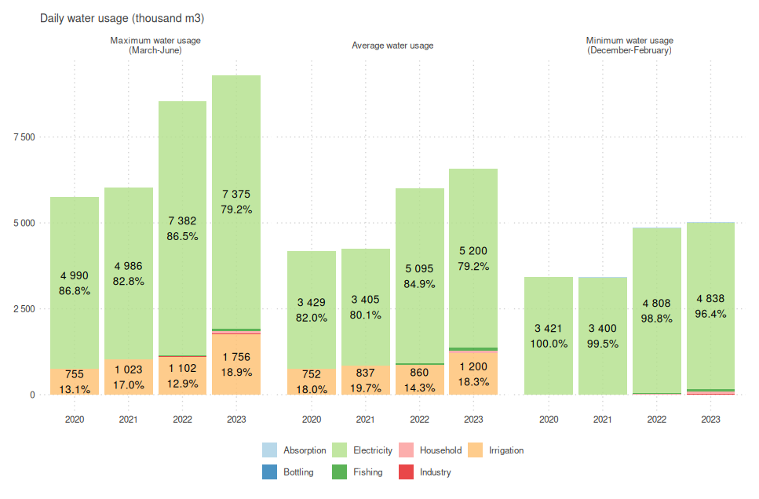

Figure 1. **Daily Seasonal Use by Sectors in the Ararat RBD (2020-2023).**

*Source: RA MNP WRMA, 01.12.2024*

Surface water resources play a dominant role in the Ararat River Basin's water supply system. As evidenced by the data in Table 3, surface waters contribute significantly to various sectors, particularly electricity generation and irrigation. In 2023, surface water accounted for 2,338.56 thousand m³ of the total water abstraction in the basin, representing 97.22% of the total water use.

Key observations for surface water use include:

1. Electricity Generation: This sector is by far the largest user of surface water, accounting for 1,899.41 thousand m³ (78.96% of total water use) in 2023. However, it's crucial to note that this use is largely non-consumptive, as discussed in the special consideration for hydropower plants.
2. Irrigation: The second-largest consumer of surface water, using 414.60 thousand m³ (17.22% of total surface water use) in 2023.
3. Fishing sector also relies significantly on surface water, using 22.86 thousand m³ in 2023.
4. Industrial use of surface water is relatively small at 1.68 thousand m³.

The distribution of surface water use across different administrative regions (as shown in Chart 2) indicates that Vayots Dzor and Ararat regions are the primary users of surface water resources, particularly for electricity generation and irrigation.

#### 12.1.2 Groundwater resources

While groundwater resources constitute a smaller portion of the water supply in the Ararat River Basin compared to surface water, they play a crucial role in certain sectors. According to Table 3, groundwater abstraction in 2023 totaled 66.93 thousand m³, which is 2.78% of the total water usage.

Key points regarding groundwater use include:

1. Household use is the largest consumer of groundwater, using 24.76 thousand m³ in 2023. This suggests that groundwater is a critical source for domestic water supply in the basin.
2. Irrigation is the second-largest user of groundwater, abstracting 23.72 thousand m³ in 2023.
3. Fishing, industry, and absorption also utilize groundwater resources, though to a lesser extent.
4. Notably, the electricity generation sector does not use groundwater resources according to this data.

The reliance on groundwater for household use and irrigation underscores the importance of sustainable management and monitoring of these resources to prevent overexploitation and ensure long-term availability for these critical needs.

Key findings from the regional analysis include:

1. Vayots Dzor: This region consistently shows the highest water intake, primarily due to its significant use of surface water for electricity generation and irrigation. In 2023, Vayots Dzor accounted for 1,769,396 thousand m³ (83.51%) of surface water used for electricity and 318,966 thousand m³ (15.05%) for irrigation.
2. Ararat: The Ararat region shows diverse water use, with significant volumes for irrigation (117,616 thousand m³ or 55.82% in 2023) and electricity generation (56,268 thousand m³ or 26.70% in 2023).
3. Kotayk: This region primarily uses surface water for electricity generation, with 52,767 thousand m³ (95.96%) used for this purpose in 2023.
4. Lori: While Lori shows relatively lower water intake volumes, it's notable that 100% of its recorded water use in 2023 (20,980 thousand m³) was for electricity generation.

By examining the water abstraction volumes and associated costs in these critical sectors, we can gain valuable insights into the water utilization patterns and financial implications within the Ararat River Basin. This analysis serves as a fundamental component in formulating effective water resource management strategies, ensuring the sustainable and equitable distribution of water resources while considering the economic value of water for the overall socio-economic development of the basin.

#### Water Use in Hydropower Plants: A Special Consideration

It is important to note that the calculation of water volume used in the electricity generation sector, particularly by Hydropower Plants (HPPs), requires special consideration. Unlike other sectors such as irrigation, industry, or household use, water used in hydropower generation is not consumed in the same way. This leads to what can be termed as "double use" of water in HPPs.

In hydropower generation, water is diverted through turbines to generate electricity, but this process does not typically result in significant water loss or consumption. After passing through the turbines, the water is returned to the river system, often at a point downstream from where it was initially diverted. This means that the same volume of water can potentially be used multiple times as it flows through a series of HPPs along a river.

Therefore, when interpreting the data presented in Table 3, it's crucial to understand that the 1,899.41 thousand m³ (78.96% of total water use) attributed to electricity generation does not represent consumed or lost water in the same way as the water used in other sectors. While this volume accurately reflects the amount of water passing through HPPs, it does not equate to water removed from the system.

This distinction has several important implications for water resource management in the Ararat River Basin:

1. Water Availability: The water used in HPPs remains available for downstream users, including other HPPs, irrigation systems, and ecosystems.
2. Environmental Impact: The impact of HPP water use on overall water availability is generally less severe than that of consumptive uses, though other environmental considerations (such as changes in flow regimes) must still be taken into account.
3. Water Use Efficiency: Traditional measures of water use efficiency may not apply directly to hydropower generation, necessitating different approaches to assessing and optimizing water use in this sector.
4. Policy and Planning: Water management policies and plans must account for this non-consumptive use, ensuring that water allocations and environmental flow requirements are based on a clear understanding of how water is used and reused within the basin.

In future sections of this report, when we discuss water demand and supply balances, we will provide more detailed analysis that takes into account this unique aspect of water use in the hydropower sector. This will include examining the cascade effect of multiple HPPs along river systems and assessing the net impact on water availability throughout the Ararat River Basin.

### Methodology for Water Usage Data Analysis

The analysis of water usage in the Ararat River Basin was conducted using water use permit databases provided by the Republic of Armenia Ministry of Environment. This methodology was developed to ensure a comprehensive and accurate assessment of water consumption patterns across various sectors, with a particular focus on Small Hydropower Plants (SHPPs) due to their significant water usage in the basin.

Data Collection and Preparation: Water use permit data was collected for the period from 2016 to 2024. This timeframe was selected to provide a comprehensive view of water usage trends over recent years and to capture the most up-to-date information available. The data included information on permit holders, water sources (surface or groundwater), permitted volumes, and usage purposes.

Data Cleaning and Estimation: During the analysis, it was observed that some records, particularly those related to SHPPs, contained incomplete or missing data. To address this issue, a series of data cleaning and estimation techniques were employed. These techniques included:

1. Estimating annual water usage for SHPPs where this data was not provided, using available monthly data.
2. Estimating monthly water usage patterns for SHPPs where only annual data was available, based on average monthly usage patterns observed in complete records.
3. Filling in missing daily and per-second flow rate data using the available annual or monthly data.

Time Series Analysis: To understand the temporal patterns of water usage, the data was aggregated into monthly time series from 2016 to 2024. This approach allowed for the identification of seasonal trends and long-term changes in water consumption across different sectors.

Limitations: It's important to note several limitations of this methodology:

1. The accuracy of the analysis is dependent on the completeness and accuracy of the original water use permit data.
2. Estimates for missing data, while based on observed patterns, may not perfectly reflect actual usage.
3. The methodology assumes that water usage aligns with permitted volumes, which may not always be the case in practice.
4. Future projections based on this data may be limited, as they do not account for potential changes in water permit issuance policies or environmental conditions.

Recommendations for Future Data Collection: To improve the accuracy and comprehensiveness of future water usage analyses, we recommend the following to the Ministry of Environment:

1. Implement a standardized and comprehensive data collection system for all water use permits, ensuring all relevant fields are consistently filled.
2. Require regular reporting of actual water usage data from permit holders, not just permitted volumes.
3. Establish a digital platform for real-time or near-real-time reporting of water usage data, particularly for high-volume users like SHPPs.
4. Conduct periodic audits of water usage reporting to ensure accuracy and compliance with permitted volumes.
5. Consider implementing automated measurement systems at key water abstraction points to improve data accuracy and timeliness.

By addressing these recommendations, future analyses can provide even more accurate and actionable insights for water resource management in the Ararat River Basin.

This methodology provides a robust framework for analyzing water usage patterns while acknowledging the challenges and limitations inherent in the available data. The insights gained from this analysis serve as a valuable tool for informed decision-making in water resource management and policy development.

#### 2.2 Time Period Selection for Water Usage Calculation

For the calculation of water usage from 2020 to 2023, a specific time range was chosen based on the available water use permit data. This selection was determined by considering the earliest starting date and the latest ending date of all water permits in the dataset.

To ensure comprehensive coverage of all water permit data, the time frame was set from the beginning of 2020 to the end of 2023. This selection was made because the maximum reliable starting date of any water permit was found to be at the beginning of 2020, while the minimum reliable ending date of any water permit was at the end of 2023.

By encompassing the period from 2020 to the end of 2023, it was ensured that all water use permit data were included in the analysis. This approach provides a complete and consistent dataset for estimating the annual water usage over the specified years, allowing for a thorough assessment of water consumption patterns in the Ararat River Basin.

#### 2.2. Seasonal Variation in Water Use in Ararat River Basin

As evidenced by Figure 1, the registered usage of water has increased in recent years in the Ararat River Basin. This growth is primarily attributed to an increase in water permits and the construction of Small Hydropower Plants (SHPPs).

Based on the figure's data interpretation, the maximum water use for all sectors except Electricity is calculated by considering the hourly water use from active contracts, representing the peak months of irrigation. The average daily water use is determined by dividing the annual use data by 365 days, providing an average value. The minimal water use is estimated by considering the difference between the maximal and average values, representing the use during winter months when there is no irrigation.

For SHPPs, the monthly water usage data is provided. The maximum water usage is calculated as the weighted average daily value for the months from March to July, while the minimum is the weighted average daily value for winter months when water supply is at its lowest. It's important to note that SHPP water usage follows a seasonal pattern, with higher usage during spring and early summer due to increased river flow from snowmelt and rainfall, and lower usage in winter when river flows are reduced.

It is justifiable to set the minimal water usage for winter months in the irrigation sector to 0 due to the substantial difference between the maximum and average values. The high disparity indicates that during the peak irrigation months, water demand significantly increases, while during the winter months, the need for water decreases, especially in the agricultural sector, where water is primarily used for irrigation purposes. This seasonal variation in water use is a common phenomenon in regions with pronounced climatic changes, where water demands fluctuate based on agricultural activities and climate conditions.

As observed from Figure 1, the electricity sector, which includes SHPPs, shows the highest water usage across all seasons, with a noticeable increase from 2020 to 2023. The irrigation sector demonstrates the most significant seasonal variation, with peak usage during the maximum water usage period (March-June) and minimal to no usage during the minimum water usage period (December-February).

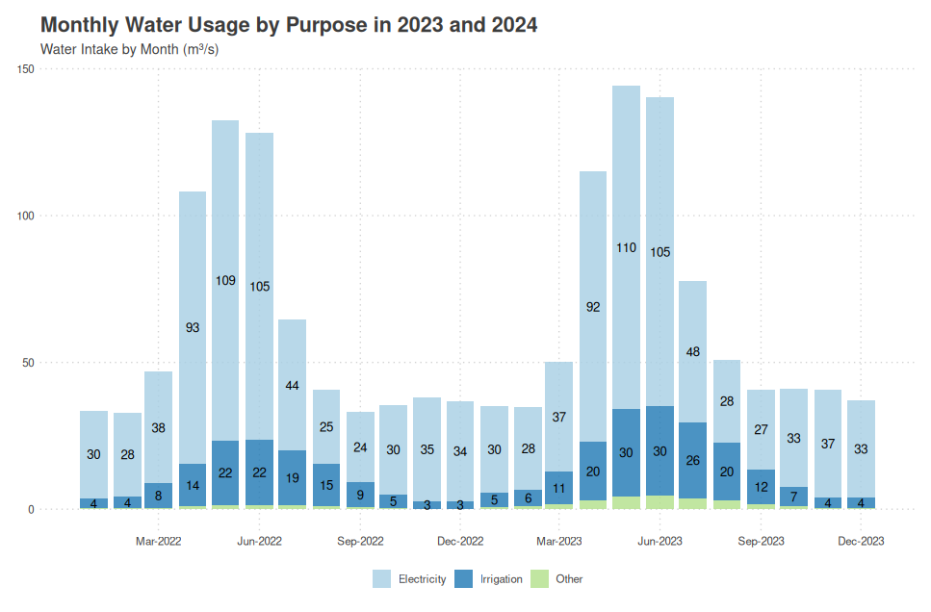Figure 2. Monthly Water Usage by Purpose in 2023 and 2024

Source: RA MNP WRMA

Figure 2 provides a more detailed view of the monthly water intake by main sectors in the Ararat River Basin, primarily Electricity and Irrigation. It's important to note that while the data for monthly usage in the Electricity sector is available and reliable, the data for Irrigation is estimated based on a few monthly data points.

The chart clearly illustrates the seasonal pattern of water usage in the basin. For the Electricity sector, which is dominated by SHPPs, water usage peaks during the spring and early summer months (March to July), coinciding with increased river flow from snowmelt and spring rains. The usage then decreases during the late summer and autumn months, reaching its lowest point in winter.

The Irrigation sector shows a complementary pattern, with water usage increasing sharply from April to August, peaking in the summer months when crop water requirements are highest. The usage then drops off rapidly in autumn and winter when irrigation needs are minimal.

It's worth noting that as no new water usage permits are expected to be granted in this River Basin District (RBD) in the medium-term, the water intake pattern is likely to remain similar to what is shown in the chart, with some potential seasonal variations due to climate factors. This stability in permit issuance provides a degree of predictability for water resource management but also highlights the importance of optimizing water use within the existing allocation framework.

The seasonal patterns observed in both figures underscore the need for effective water resource management and allocation strategies. Understanding these patterns is crucial for developing adaptive approaches to ensure adequate water supply during peak demand periods and to optimize water utilization throughout the year. By considering the sector-specific seasonal water use patterns, stakeholders can make informed decisions and implement targeted measures to enhance water use efficiency and sustainable management in the Ararat River Basin.

**12.1 Water Resource Supply by Individual Water Resources**

The Ararat River Basin demonstrates a significant disparity between the volume of water intake and the number of active licenses across different sectors. This section analyzes the trends in water intake volumes and the distribution of active licenses from 2020 to 2024.

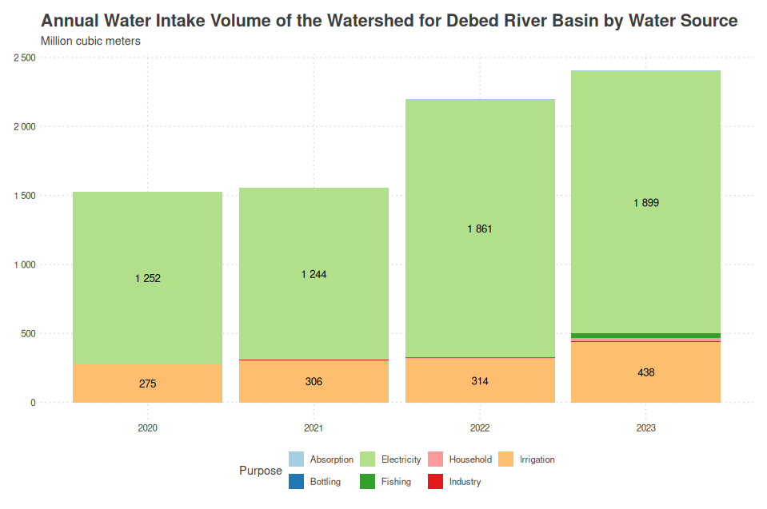

Figure 1. Annual Water Intake Volume of the Watershed for Ararat River Basin by Main Water Source (2020-2023)

Figure 1 illustrates the annual water intake volume in the Ararat River Basin from 2020 to 2023, focusing on the two main water users:

1. Electricity Generation: This sector, primarily driven by Small Hydropower Plants (SHPPs), is the largest water user. In 2023, it accounted for 1,899 million cubic meters of water intake. The volume used for electricity generation has shown a steady increase over the four-year period, reflecting the growing importance of hydropower in the region.
2. Irrigation: The second-largest water user, irrigation consumed 438 million cubic meters in 2023. This sector also shows an upward trend in water usage from 2020 to 2023, indicating expanding agricultural activities in the basin.

It's important to note that other sectors such as household use, industry, fishing, bottling, and absorption consume relatively small amounts of water and are not visible in this figure due to their negligible volumes compared to electricity and irrigation.

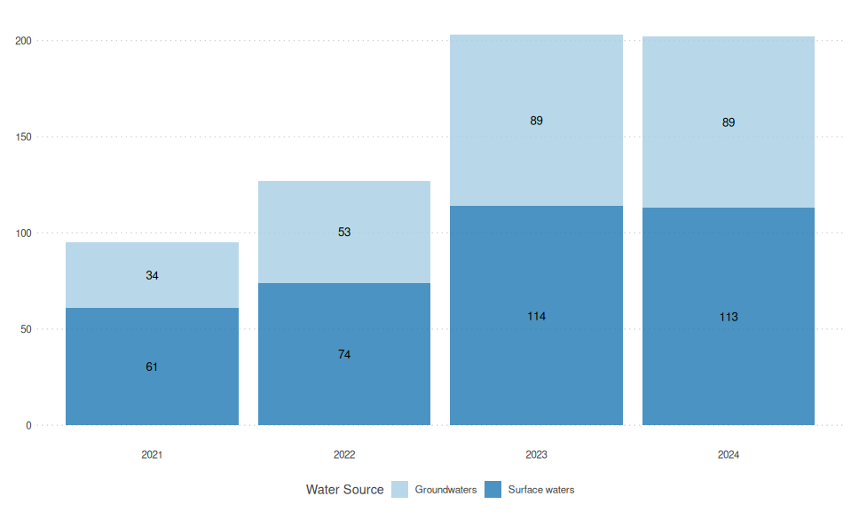

Figure 2. Number of Active Licenses by Water Source in the Ararat River Basin (2021-2024)

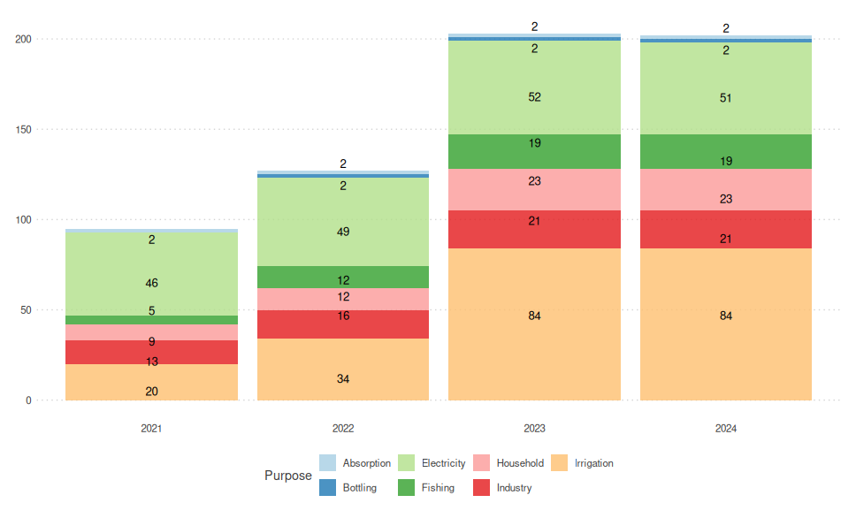

Figure 3. Number of Active Licenses by Purpose in the Ararat River Basin (2021-2024)

Figures 2 and 3 provide insight into the distribution of active water use licenses in the Ararat River Basin. These figures do not represent water usage volumes, but rather the number of permits issued for different water sources and purposes.

Key observations from these figures include:

1. Despite the high number of groundwater permits, the actual volume of groundwater used is negligible compared to the total water intake in the basin. This discrepancy highlights that the number of permits does not necessarily correlate with the volume of water used.
2. Similarly, while there may be numerous permits for fishing, industry, and household activities, their actual water consumption is minimal compared to the dominant sectors of electricity and irrigation.
3. The number of surface water permits, though fewer than groundwater permits, corresponds to the majority of water intake in the basin, primarily due to their use in electricity generation and irrigation.
4. The trends in the number of active licenses provide insight into the regulatory landscape and potential areas of growth or change in different sectors, even if they don't directly reflect water usage volumes.

This analysis underscores the importance of considering both the number of permits and the actual water intake volumes when assessing water resource utilization in the Ararat River Basin. While smaller users may have a significant number of permits, their impact on overall water consumption is limited. Conversely, the sectors with the largest water intake - electricity and irrigation - may operate under fewer but higher-volume permits.

These insights are crucial for effective water resource management, highlighting the need to focus on high-volume users while also maintaining comprehensive oversight of all water use activities in the basin. Future water management strategies should consider both the number of permits and the volumes of water used to ensure sustainable and equitable use of the basin's water resources.

**Analyzing Household Living Conditions in Ararat and Vayots Dzor Marzes**

It is evident that Ararat Vayots Dzor marz play pivotal roles in the water dynamics of the Ararat River Basin. The variations in water discharge over the years emphasize the importance of sustainable water resource management in this marz to ensure their environmental and socio-economic well-being.

By assessing the water discharge trends in these key administrative divisions, policymakers and stakeholders can develop targeted strategies to address any imbalances and optimize water allocation, especially in sectors with significant water usage. It is essential to consider the variations in water needs and the specific challenges faced by each marz to devise effective and region-specific water management policies for the Ararat River Basin.

Analyzing the Household's Integrated Living Conditions Survey anonymized microdata databases for Ararat and Vayots Dzor marzes from 2004 to 2022 is crucial in gaining a comprehensive understanding of dwelling conditions and water usage in this marz. As these marzes account for most of the Ararat RB water intake, the information obtained from these databases provides valuable insights into the living conditions and water-related practices of the majority of the basin's population.

The following key variables from the databases are of particular significance in the context of Ararat RB:

1. Type of Dwelling: Understanding the types of dwellings prevalent in Ararat and Vayots Dzor marzes provides insights into the housing infrastructure in these regions. Different types of dwellings may have varying water usage patterns and access to water sources, which can impact water demand and availability in the basin.
2. Main Source of Water for Drinking: Identifying the primary source of drinking water for households in these marzes is essential in assessing the dependency on local water sources. This information can shed light on the reliability and quality of the water supply and the potential for water scarcity or contamination issues.
3. Water Tap Location: Knowing where the water taps are located in households can reveal the accessibility and convenience of water supply. It can also highlight disparities in access to water infrastructure, especially in rural areas, where water availability may be limited or inconsistent.
4. Principal Method of Garbage Disposal: The garbage disposal method used by households is relevant in understanding waste management practices in Ararat and Vayots Dzor marzes. Proper waste disposal can impact water quality and ecosystem health, as improper waste management can lead to water pollution and environmental degradation.

By analyzing this data, policymakers and researchers can identify specific challenges related to water usage, sanitation, and waste management in Ararat and Vayots Dzor marz, which are crucial components of the Ararat River Basin. The insights gained from this analysis can inform the development of targeted interventions and policies to address water-related issues and improve living conditions in the basin.

Moreover, understanding the dwelling conditions and water practices in these marzes can aid in identifying vulnerable populations and areas with higher water-related risks, enabling the implementation of equitable and inclusive water resource management strategies. This comprehensive approach ensures that water management plans consider not only the physical aspects of water supply and demand but also the socio-economic and environmental dimensions, ultimately contributing to the sustainable development and conservation of the Ararat River Basin's water resources.

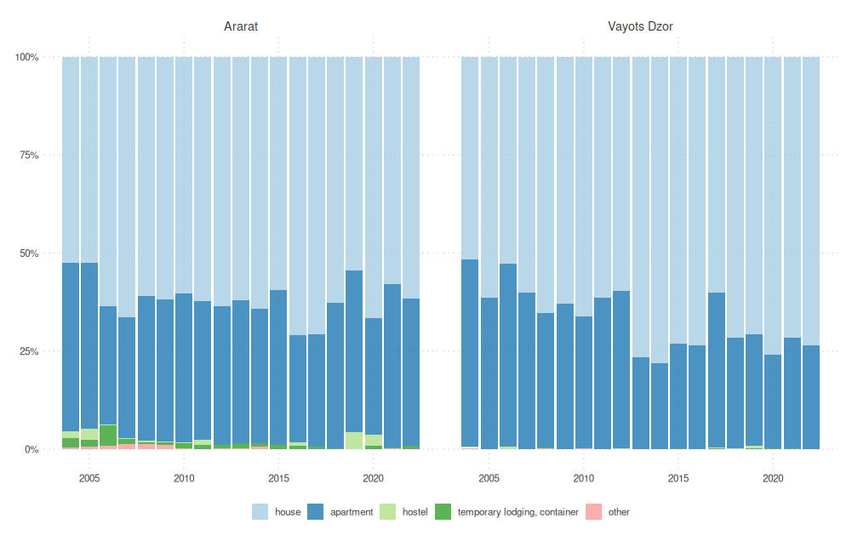

[Insert Figure 1 here] Figure 1. Residence Types in Ararat and Vayots Dzor Marzes (2005-2022)

Figure 1 illustrates the evolution of residence types in Ararat and Vayots Dzor marzes:

1. Ararat Marz:
   1. Houses have remained the predominant dwelling type, increasing from 53% in 2005 to 62% in 2022.
   2. Apartments have decreased from 43% in 2005 to 38% in 2022.
   3. Temporary lodgings and containers have significantly decreased from 4% in 2005 to less than 1% in 2022.
2. Vayots Dzor Marz:
   1. Houses have become increasingly prevalent, rising from 52% in 2005 to 73% in 2022.
   2. Apartments have decreased from 48% in 2005 to 27% in 2022.
   3. Temporary lodgings have been virtually non-existent throughout the period.

The trend towards individual houses in both marzes may have implications for water distribution and usage patterns in the Ararat River Basin.

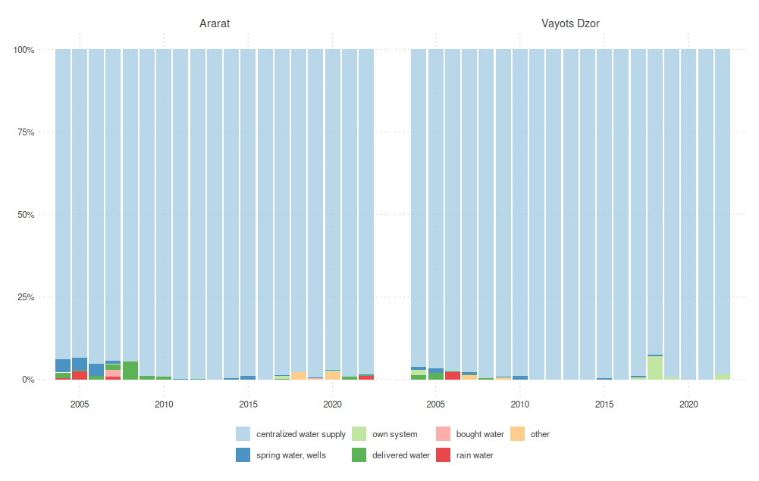

Figure 2 shows the primary sources of drinking water:

1. Ararat Marz:
   1. Centralized water supply has been the dominant source, increasing from 94% in 2005 to 98% in 2022.
   2. Own water systems and other sources have decreased from 6% to about 2%.
2. Vayots Dzor Marz:
   1. Centralized water supply has also been predominant, increasing from 96% in 2005 to 98% in 2022.
   2. Other sources, including own systems, have decreased from 4% to about 2%.

The high reliance on centralized water systems in both marzes indicates a well-developed water infrastructure in the Ararat River Basin.

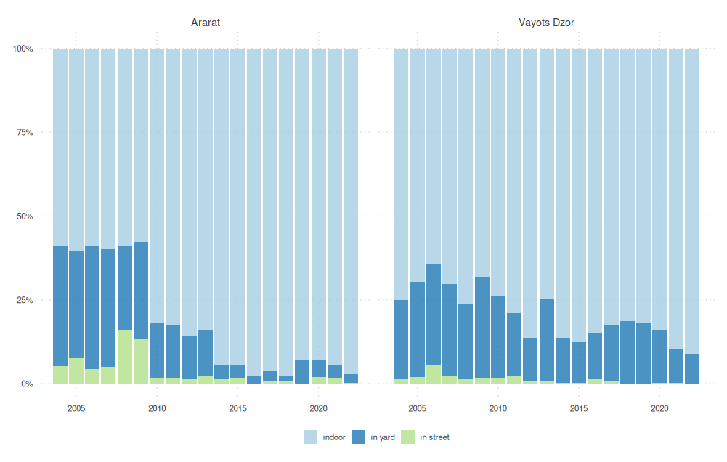

Figure 3 demonstrates significant improvements in water tap locations:

1. Ararat Marz:
   1. Indoor taps have increased dramatically from 59% in 2005 to 97% in 2022.
   2. Yard taps have decreased from 38% to 3%.
   3. Street taps have been almost completely eliminated, dropping from 3% to nearly 0%.
2. Vayots Dzor Marz:
   1. Indoor taps have increased from 75% in 2005 to 91% in 2022.
   2. Yard taps have decreased from 23% to 9%.
   3. Street taps have been virtually eliminated, decreasing from 2% to 0%.

These improvements indicate enhanced water accessibility and potentially more efficient water use in both marzes.

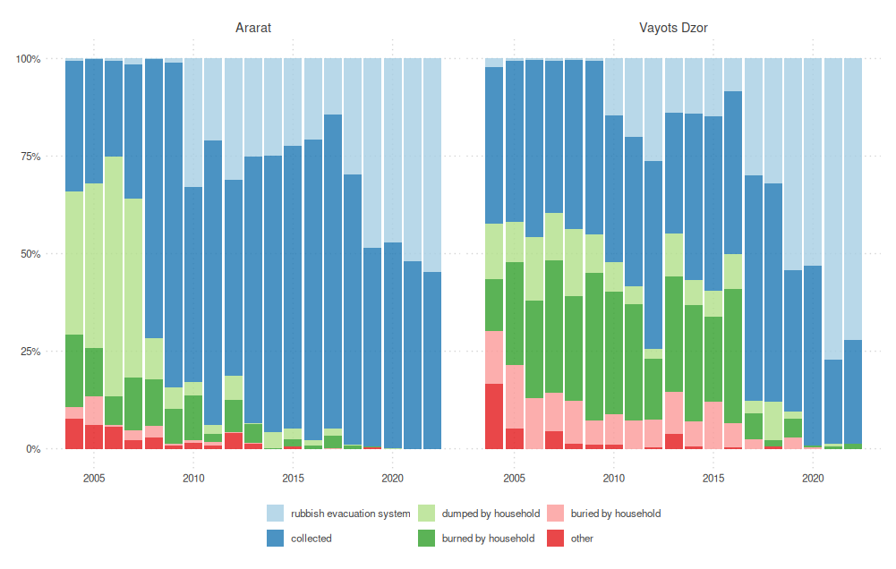

**Figure 10. Garbage Collaction in Ararat and Vayuts Dzor Marzes**

*Source: Statistical Committee of Armenia*

Figure 4 shows significant progress in waste management:

1. Ararat Marz:
   1. Use of rubbish evacuation systems increased from 33% in 2005 to 55% in 2022.
   2. Garbage collection services increased from 33% to 45%.
   3. Dumping by households decreased dramatically from 37% to 0%.
   4. Burning by households reduced from 19% to 0%.
2. Vayots Dzor Marz:
   1. Rubbish evacuation systems usage grew from 40% in 2005 to 72% in 2022.
   2. Garbage collection services decreased slightly from 40% to 27%.
   3. Household dumping reduced significantly from 14% to 1%.
   4. Burning by households decreased from 13% to 0%.

This improvement in waste management practices is crucial for protecting water resources and overall environmental health in the Ararat River Basin.

These trends provide valuable insights for policymakers and stakeholders in the Ararat River Basin. They highlight areas of substantial progress, particularly in water infrastructure and waste management. The shift towards more houses and improved water access suggests changing water demand patterns that need to be considered in future water management strategies. The advancements in waste management practices contribute significantly to protecting water quality in the basin.

By integrating these socio-economic factors with hydrological data, decision-makers can develop more comprehensive and effective strategies for sustainable water management in the Ararat River Basin. The focus should be on maintaining the positive trends in water access and waste management while addressing any emerging challenges related to changing residence patterns and water demand.

## 13. Economic analysis of water use

### 13.1 Economic analysis of different water use sectors

#### 13.1.1. Water Users in the Ararat River Basin in 2023

Figure X provides a comprehensive overview of the major water users in the Ararat River Basin for the year 2023. This treemap visualization offers valuable insights into the distribution of water usage among various entities, categorized by volume and purpose.

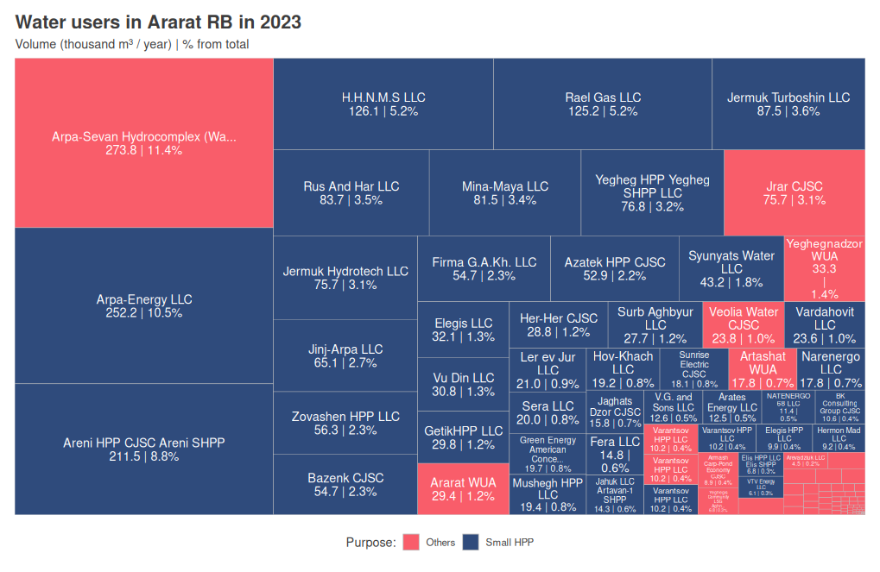

Key Observations:

1. Dominant Water Users:
   1. The Arpa-Sevan Hydrocomplex (Water) is the largest single water user, consuming 273.8 thousand m³ per year, which accounts for 11.4% of the total water usage in the basin.
   2. Arpa-Energy LLC follows closely, using 252.2 thousand m³ (10.5% of the total).
   3. Areni HPP CJSC Areni SHPP is the third-largest consumer, utilizing 211.5 thousand m³ (8.8%).
2. Small Hydropower Plants (SHPPs):
   1. SHPPs collectively form a significant portion of water users. Notable among these are:
      1. H.H.N.M.S LLC (126.1 thousand m³, 5.2%)
      2. Rael Gas LLC (125.2 thousand m³, 5.2%)
      3. Jermuk Turboshin LLC (87.5 thousand m³, 3.6%)
3. Other Significant Users:
   1. Jrar CJSC (75.7 thousand m³, 3.1%)
   2. Syunyats Water LLC (43.2 thousand m³, 1.8%)
   3. Various smaller entities each consuming between 1-3% of the total water volume
4. Distribution by Purpose:
   1. The chart distinguishes between "Small HPP" (shown in blue) and "Others" (shown in red).
   2. Small HPPs collectively account for a substantial portion of water usage, highlighting the importance of hydropower in the basin's water consumption pattern.
5. Diverse User Base:
   1. The visualization reveals a diverse range of water users, including energy companies, water utilities, and various local enterprises.
   2. This diversity suggests a complex water management landscape in the Ararat River Basin, requiring tailored approaches for different user types.
6. Implications for Water Management:
   1. The concentration of water usage among a few large consumers (particularly in hydropower) suggests that targeted efficiency improvements in these sectors could have significant impacts on overall water consumption in the basin.
   2. The presence of numerous smaller users indicates the need for comprehensive water management strategies that can address both large-scale and small-scale consumption patterns.

This detailed breakdown of water users provides crucial information for policymakers and water resource managers. It highlights the need for balanced strategies that can address the needs of major consumers like hydropower plants while also considering the collective impact of numerous smaller users. Future water management plans in the Ararat River Basin should take into account this diverse user base to ensure sustainable and equitable water distribution.

#### 13.1.2. Monthly Water Usage of Small Hydropower Plants in the Ararat River Basin

Figure X illustrates the monthly water usage of Small Hydropower Plants (SHPPs) in the Ararat River Basin from 2016 to 2024, along with the number of operating licenses for these plants.

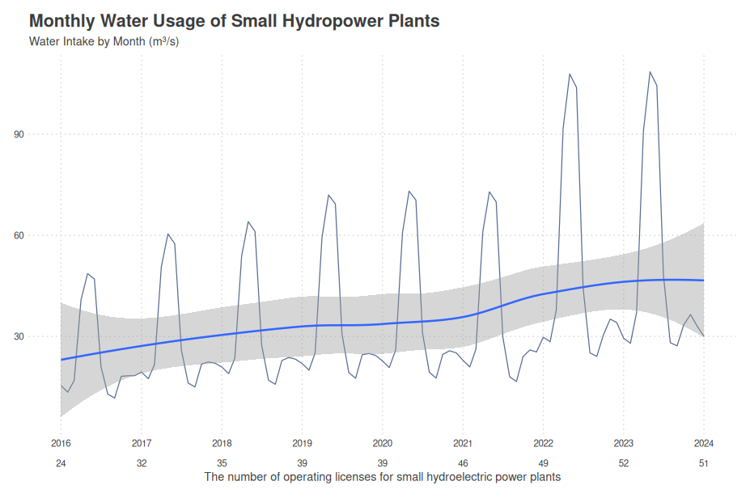

Key Observations:

1. Seasonal Variation:
   * The graph shows pronounced seasonal fluctuations in water usage, with peaks typically occurring in spring and early summer (April to June).
   * These peaks likely correspond to periods of increased river flow due to snowmelt and spring rains.
   * Lower usage is observed in late summer, autumn, and winter months, reflecting reduced water availability.
2. Long-term Trend:
   * The blue trend line indicates a gradual increase in average monthly water usage over the years.
   * This upward trend correlates with the increasing number of operating licenses, as shown at the bottom of the graph.
3. License Growth:
   * The number of operating licenses for SHPPs has more than doubled, from 24 in 2016 to 51 in 2024.
   * This increase in licenses has contributed to the overall growth in water usage.
4. Variability:
   * The gray shaded area represents the range of variability in water usage.
   * This variability has increased over time, particularly from 2022 onwards, suggesting greater fluctuations in water availability or demand.
5. Recent Developments:
   * Notable spikes in water usage are observed in 2023 and 2024, with peaks reaching nearly 110 m³/s.
   * These recent increases coincide with the highest number of operating licenses.

Special Considerations:

It's crucial to interpret this data with the understanding that water use in hydropower plants differs fundamentally from consumptive uses in other sectors. As noted in the previous analysis:

1. Non-consumptive Use: Water used for hydropower generation is not consumed but rather diverted through turbines and returned to the river system.
2. Potential for Reuse: The same volume of water can be used multiple times as it flows through a series of HPPs along a river.
3. Impact on Water Balance: While the volumes shown represent significant water use, they do not equate to water removed from the system in the same way as irrigation or industrial uses.
4. Cascade Effect: The potential for water reuse in cascading HPPs means that the actual impact on water availability downstream may be less than the total volume used suggests.

Implications for Water Management:

1. While the graph shows increasing water usage by SHPPs, this trend cannot be directly extrapolated to predict future water use in the Ararat River Basin. The growth has been primarily driven by the increase in the number of licenses, a factor that may not continue at the same rate.
2. The seasonal variation in water use by SHPPs aligns with natural hydrological cycles, potentially minimizing conflicts with other water uses during low-flow periods.
3. The recent spikes in usage (2023-2024) warrant close monitoring to ensure they do not negatively impact other water users or ecological flows.
4. Future water management strategies should consider the non-consumptive nature of hydropower water use while also addressing potential impacts on river flow regimes and aquatic ecosystems.
5. Coordination among SHPP operators, especially in cascading systems, could optimize water use efficiency and minimize environmental impacts.

This analysis underscores the complexity of water resource management in the Ararat River Basin, highlighting the need for a nuanced understanding of different water uses and their impacts on the overall water balance.

### 13.2 Analysis of the application of cost recovery principles and water supply services

# **13.2.1****. Water use forecasts and costs Recovery for Ararat RBD**

## 2.2. Economic Analysis of Water Use and Water Costs Recovery in Ararat RB

There are still many issues in the economic management of the water resources in Ararat RBD. There are significant losses in the water system that are not clearly calculated, which significantly affects the cost of water. The irrigation system is not efficient, the level of drip irrigation is low, which in turn affects the price of agricultural products.

The water costs should be considered in these directions:

1. Cost of ensuring the quantity and reliability of water supply. This makes it possible to fully satisfy the demand for water. Water supply must be completed on time, depending on the demand;

2. Costs to reduce water losses. These costs allow to conserve water resources. The reduction of leakages substantially increases the profitability of a water supplier, which creates conditions for lower water prices;

3. Costs to improve water quality. These costs allow to significantly reduce the risk of disease outbreaks and spread. It also significantly increases household water use. This measure can decrease the use of bottled water, which is harmful to environment due to disposable plastic bottles;

4. Projects for wastewater treatment. These costs are mainly aimed at protecting the environment. They have major ecological and environmental importance and are needed to maintain water quality. These costs also prevent the spread of diseases.

It should be noted the assistance of international organizations, including the European Union, is mainly aimed at solving the environmental problems of the Ararat RBD. It is necessary to evaluate the economic efficiency of costs solely aimed at the environmental problems. It should be done with a systematic view of water use issues, including from the point of environmental protection.

In most cases, the supplies of water which can be used for forecasts resulted from long-termed observations and analyses of the current situation. Several water management tasks have to rely on prediction, quantification and assessment of possible scenarios which could influence the decision-making process in complex water management systems. For purposes of the forecast, it is essential to evaluate and apply an educated qualitative estimate with quantitative data for current development of water needs and water consumption. As it is difficult to include all variables in individual models, it is necessary to make an early preparation and time-optimised planning of water demand for the sources of water. For this, all available means should be used. A theoretical basis for all estimates and plans is the prognostic work which considers trends in water economy and water supplies for that territory. An important part is the statistics which makes it possible to forecast the future situation with a certain degree of probability for a certain phenomenon.[1]

## 3.2. Current and Future Water Supply in Ararat RBD

This section focuses on the assessment of surface water supply within the primary river basins of the Ararat River Basin District (RBD). Table X presents the surface water supply data for various hydrological observation points across the Ararat RBD. These data provide crucial insights into the availability and distribution of water resources throughout the basin.

It is important to note that comprehensive data for groundwater resources in the Ararat RBD are currently limited. Moreover, groundwater discharge represents only a small fraction of the overall water usage in the basin. Due to these factors, a detailed calculation of groundwater supply and demand cannot be accurately performed at this stage.

The focus on surface water is justified by its predominant role in the basin's water dynamics, as evidenced by the water usage data presented earlier. Surface water sources, particularly those utilized by the hydropower and irrigation sectors, constitute the majority of water use in the Ararat RBD.

This analysis of surface water supply serves as a foundation for understanding the basin's water resources and will inform subsequent discussions on water allocation, management strategies, and potential challenges in meeting various sectoral demands.

To calculate the seasonal water supply in the Ararat RBD for the year 2023, the main characteristics of average annual and seasonal runoff have been considered. The Ararat River exhibits distinct stages throughout the year, including spring high water, summer-autumn flow, and low water periods. The majority of the annual flow, approximately 70%, occurs during the flood season. The remaining 30% of the annual flow takes place during other months. The table below outlines the seasonal water supply based on monthly percentages.

**Table 6. Average Seasonal Water Supply in the Ararat RBD.**

|  |  |  |  |  |  |  |  |  |  |  |  |  |  |
| --- | --- | --- | --- | --- | --- | --- | --- | --- | --- | --- | --- | --- | --- |
| **Month** |  | **XII** | **I** | **II** | **III** | **IV** | **V** | **VI** | **VII** | **VIII** | **IX** | **X** | **XI** |
| **Seasonal %** | 100% | 14% | | | 70% | | | | 16% | | | | |
| **Monthly %** | 100% | 4.7% | 4.7% | 4.7% | 17.5% | 17.5% | 17.5% | 17.5% | 3.2% | 3.2% | 3.2% | 3.2% | 3.2% |
| Annual Use (mil m3) | | Daily seasonal use (thousand m3) | | | | | | | | | | | |
| **Azat-Garni** | 129 | 6 | 6 | 6 | 23 | 23 | 23 | 23 | 4 | 4 | 4 | 4 | 4 |
| **Vedi-Urtsadzor** | 57 | 3 | 3 | 3 | 10 | 10 | 10 | 10 | 2 | 2 | 2 | 2 | 2 |
| **Arpa-Jermuk** | 127 | 6 | 6 | 6 | 22 | 22 | 22 | 22 | 4 | 4 | 4 | 4 | 4 |
| **Arpa-Yeghegnadzor** | 438 | 21 | 21 | 21 | 77 | 77 | 77 | 77 | 14 | 14 | 14 | 14 | 14 |
| **Arpa-Areni** | 730 | 34 | 34 | 34 | 128 | 128 | 128 | 128 | 23 | 23 | 23 | 23 | 23 |
| **Vaik-Zaritap** | 13 | 1 | 1 | 1 | 2 | 2 | 2 | 2 | 0 | 0 | 0 | 0 | 0 |
| **Yeghegis-Hermon** | 159 | 7 | 7 | 7 | 28 | 28 | 28 | 28 | 5 | 5 | 5 | 5 | 5 |
| **Yeghegis-Shatin** | 271 | 13 | 13 | 13 | 47 | 47 | 47 | 47 | 9 | 9 | 9 | 9 | 9 |
| **Selimaget-Shatin** | 66 | 3 | 3 | 3 | 12 | 12 | 12 | 12 | 2 | 2 | 2 | 2 | 2 |
| **Artabun-Artabyunk** | 34 | 2 | 2 | 2 | 6 | 6 | 6 | 6 | 1 | 1 | 1 | 1 | 1 |
| **Total Supply** | 2024 | 95 | 95 | 95 | 354 | 354 | 354 | 1354 | 65 | 65 | 65 | 65 | 65 |

* The average is calculated on the observation data from 2010 to 2023

Furthermore, the groundwater supply, specifically the usable groundwater resources, is derived from various sources within the Ararat RBD. The table below presents the usable groundwater and surface water resources for the individual rivers within the region.

This assessment is based on data from the year 2023 and provides valuable insights into the current and future water supply scenario within the Ararat River Basin District.

13.2 Analysis of the application of cost recovery principles and water supply services

## 3.3. Current and Future Water Demand in Ararat RBD

Water demand in Ararat RBD for different sectors was calculated using different norms and regulations, as well as population growth forecast developed by UN. The analysis of water demand showed that it should be differentiated into two types: (1) the actual water demand and (2) actual water demand plus NRW that should be abstracted from water source to satisfy the actual water demand. Within this analysis “actual water demand plus NRW" is considered as “water demand".

Demand of water for drinking and household use was calculated by taking into account the forecast of AWSC (“Total Management Plan" document developed in 2014). The water demand forecast is derived from a statistical analysis of AWSC data for the managed rural areas and is based on the assumption that each person consumes currently 250 l/cap/d. On the long run, it is expected that the average water demand will drop down to 150 l/cap/d for the planning horizon of 2040, with a linear reduction for years in-between. At the same time the margin of non-revenue water will be reduced, too.

For the present analysis, we assume that the average daily consumption of water will remain constant at 250l/cap/day both for urban and rural areas (although in urban areas it is at 150 l/cap/day level). The reason for taking into account average water consumption is that up to now many consumers use drinking water for small scale irrigation and prefer not to be metered. However, as soon as water becomes a commodity people will emphasize on cost saving measures.

The water usage demand forecast for the River Basin Management Plan in the Ararat River Basin in Armenia considers different sectors, including SHHP, Household, Irrigation, Industry, and Bottling. The forecast aims to estimate future water consumption based on specific factors relevant to each sector.

**Household Water Usage Forecast:**

The forecast for Household water usage in the Ararat River Basin is estimated using the following equation:

Future Household Water Usage = Current Household Water Usage * (Projected Population / Current Population) * (Projected Household Water Consumption per Capita)

The "Projected Population" represents the estimated population for the future year under consideration, and "Current Population" corresponds to the current population in the basin. The factor "Projected Household Water Consumption per Capita" is assumed to increase at a rate of 0.995 per year, representing a 0.5% improvement in water efficiency annually. This increase is in line with the development path of European countries with similar socio-economic characteristics.

**Irrigation Water Usage Forecast:**

The forecast for Irrigation water usage in the Ararat River Basin is estimated using the following equation:

Future Irrigation Water Usage = Current Irrigation Water Usage * (Projected Population / Current Population) * (Projected Irrigation Efficiency Factor)

The "Projected Population" represents the estimated population for the future year, and "Current Population" corresponds to the current population in the basin. The factor "Projected Irrigation Efficiency Factor" is assumed to increase at a rate of 0.995 per year, reflecting a 0.5% improvement in irrigation efficiency annually. This value is based on the average water usage in irrigation in European countries with similar agricultural practices.

**SHHP Water Usage Forecast:**

The water usage forecast for Small Hydropower Plants (SHHP) in the Ararat River Basin requires a distinct approach due to its unique characteristics. Unlike other sectors, SHHP water usage is not directly linked to population growth but is influenced by broader national energy demands and regulatory factors.

In the short term (0-10 years), SHHP water usage is expected to remain constant at current levels, reflecting the stabilization of SHHP licenses in the region and the full utilization of existing capacities. During this period, the forecast can be expressed as:

Future SHHP Water Usage (0-10 years) = Current SHHP Water Usage

For long-term projections beyond 10 years, the forecast considers the interplay between national electricity demand trends and efficiency improvements in the hydropower sector. The future SHHP water usage is calculated using the following equation:

Future SHHP Water Usage (10+ years) = Current SHHP Water Usage * Electricity Demand Factor * Efficiency Factor

Where: Electricity Demand Factor = Projected National Electricity Demand / Current National Electricity Demand Efficiency Factor = (1 - Annual Efficiency Improvement)^(Number of Years from Base Year)

The Electricity Demand Factor is derived from projected national electricity demand, taking into account the adoption of electric vehicles, shifts to electric heating, and the growing contribution of solar energy to the national grid. The Efficiency Factor incorporates anticipated technological advancements and infrastructure modernization in the hydropower sector.

This methodology also accounts for potential impacts of climate change on water availability for hydropower generation. Regular updates to the forecast based on actual data, policy changes, and energy sector developments are essential for maintaining its accuracy and relevance.

By employing this approach, the SHHP water usage forecast aligns with the broader trends in Armenia's energy sector while providing a flexible framework that can adapt to future changes in the country's energy landscape.

**Industry Water Usage Forecast:**

The forecast for Industrial water usage in the Ararat River Basin is estimated using the following equation:

Future Industrial Water Usage = Current Industrial Water Usage * (Projected Population / Current Population)

The "Projected Population" represents the estimated population for the future year, and "Current Population" corresponds to the current population in the basin. The water usage for the Industry sector is assumed to be directly linked to population growth without additional factors due to the difficulty in evaluating future industrial water demands accurately.

**Bottling Water Usage Forecast:**

The forecast for Bottling water usage in the Ararat River Basin is estimated using the following equation:

Future Bottling Water Usage = Current Bottling Water Usage * (Projected Population / Current Population) * (Projected Bottled Water Consumption per Capita)

**Absorption Water Usage Forecast:**

The water usage for Absorption in the Ararat River Basin, which includes water absorbed by natural ecosystems, is relatively stable and not directly linked to population growth or human activities. Therefore, the forecast for Absorption water usage remains constant over time:

Future Absorption Water Usage = Current Absorption Water Usage

Natural ecosystems have well-established water absorption and regulation mechanisms, which are influenced more by environmental factors, precipitation patterns, and climate conditions rather than changes in human population or activities. As a result, the absorption of water by natural ecosystems is assumed to remain relatively constant in the forecast period.

**Fishing Water Usage Forecast:**

Similarly, the water usage for Fishing in the Ararat River Basin is relatively stable and not directly influenced by population growth. Fishing water usage is closely related to the natural fish populations in the river and surrounding water bodies. Therefore, the forecast for Fishing water usage also remains constant over time:

Future Fishing Water Usage = Current Fishing Water Usage

While factors like climate and environmental changes can affect fish populations and, in turn, fishing activities, the direct link to population growth is minimal. As a result, the water usage for Fishing is assumed to remain relatively stable throughout the forecast period.

The "Projected Population" represents the estimated population for the future year, and "Current Population" corresponds to the current population in the basin. The factor "Projected Bottled Water Consumption per Capita" is assumed to increase at a rate of 0.005 per year, reflecting a 0.5% growth in bottled water usage annually. This increase is based on observed trends in the growth of bottled water consumption.

It is important to acknowledge that while these forecasts provide valuable insights, they are subject to uncertainties and changes in factors beyond population projections. As more data becomes available, regular updates to the forecasted values are essential for effective water resource management and planning in the Ararat River Basin. Additionally, conducting sensitivity analyses can help assess the impact of varying factors on water usage demand projections.

In summary, the water usage forecast for Absorption and Fishing in the Ararat River Basin remains unchanged over time due to the stability of natural ecosystems and the direct relationship to environmental conditions. Conversely, other sectors, such as Household, Irrigation, Industry, and Bottling, are influenced by population growth and other factors, which necessitates consideration and incorporation of projected changes in population and efficiency factors in their respective water usage forecasts. Regular monitoring of environmental conditions and fish populations will be crucial for assessing any potential changes in Fishing water usage in the future.

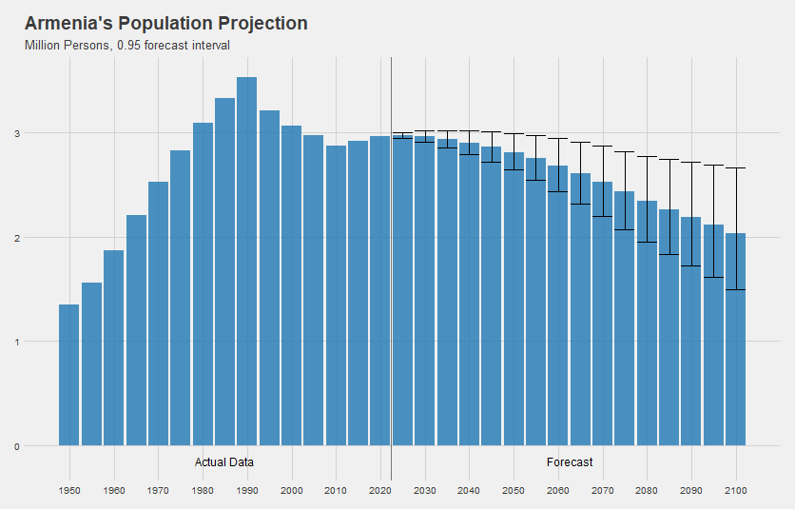

**Figure 12. Armenia’s Population Projection**

*Source: World Population Prospects 2019*

Based on the population projections and the implementation of forecast for different sectors the river demand forecast figures are given below.

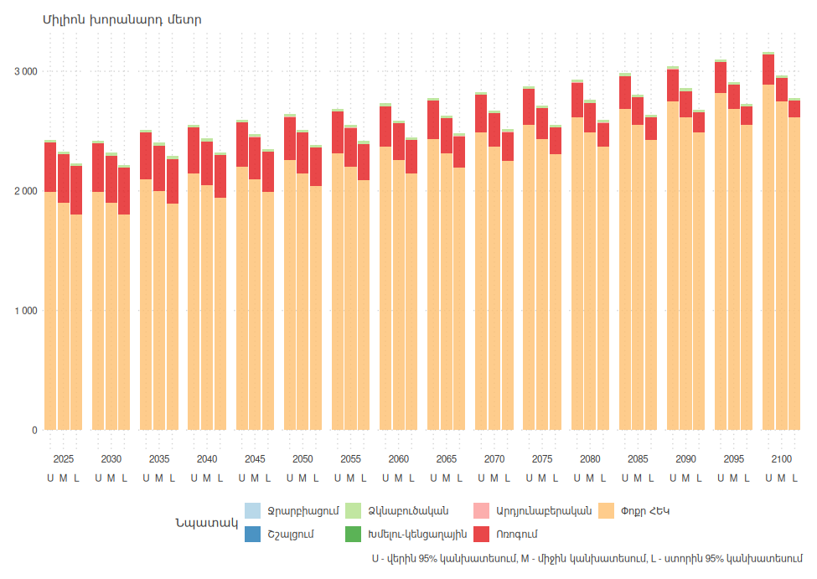

**Figure 15. Ararat Water Basin Surface Water Demand Projection by Sectors**

*Source: The calculations are done using the mythology and data described in this chapter*

## 3.4. Projected Water Balance Between Water Supply and Demand in Ararat RBD

The water balance allows to determine the water demand and water supply of a RBD or its individual parts. The water balance determines the surplus or deficit of water resources in a given river basin or any part of it.

The water balance is important for decision-makers, enabling water use permits to be issued based on reliable information as well as realistic objectives of river basin management and conservation, thereby contributing to identifying the environmental objectives required for the implementation of the river basin management plan.

Water supply in the tables bellow is analysed for the multi-year period (average, high-water year, low-water year), as well as projected till 2100. Two climate change scenarios were used for water supply projection: optimistic (IPCC RCP6.0) and pessimistic (IPCC RCP8.5).

July-September is a critical season for water use, as in this period the supply is critically low, due to low precipitations and the demand is high, with the maximum water use. It is necessary to analyse the possible water shortages in these months.

**Table 8. Current and Future Annual Surface Water Supply and Demand in Ararat RBD (mil m3).**

|  |  |  |  |  |  |  |  |  |  |  |  |  |  |  |  |  |  |  |  |  |
| --- | --- | --- | --- | --- | --- | --- | --- | --- | --- | --- | --- | --- | --- | --- | --- | --- | --- | --- | --- | --- |
| **Surface Water Supply& Demand** | **Sector** |  | **Upper Bound Projection** | | | | | | | | | **Lower Bound Projection** | | | | | | | | |
|  | **2021** | **2025** | **2030** | **2040** | **2050** | **2060** | **2070** | **2080** | **2090** | **2100** | **2025** | **2030** | **2040** | **2050** | **2060** | **2070** | **2080** | **2090** | **2100** |
| **Water Supply** | **Arpa-Areni** | 730 | 722 | 720 | 714 | 702 | 689 | 677 | 666 | 655 | 645 | 712 | 705 | 693 | 666 | 640 | 615 | 579 | 545 | 513 |
| **Arpa-Jermuk** | 127 | 127 | 127 | 128 | 128 | 128 | 128 | 128 | 129 | 130 | 126 | 125 | 125 | 123 | 121 | 120 | 117 | 115 | 112 |
| **Arpa-Yeghegnadzor** | 438 | 423 | 418 | 408 | 388 | 369 | 350 | 330 | 311 | 293 | 416 | 409 | 395 | 363 | 334 | 307 | 270 | 237 | 209 |
| **Artabun-Artabuynq** | 34 | 34 | 35 | 35 | 35 | 35 | 36 | 36 | 37 | 38 | 34 | 34 | 33 | 33 | 33 | 32 | 32 | 31 | 30 |
| **Azat-Garni** | 129 | 128 | 127 | 126 | 124 | 121 | 119 | 116 | 114 | 112 | 126 | 126 | 124 | 119 | 115 | 111 | 105 | 100 | 94 |
| **Selimaget-Shatin** | 66 | 66 | 66 | 65 | 64 | 63 | 62 | 62 | 62 | 61 | 64 | 63 | 62 | 58 | 55 | 53 | 48 | 45 | 41 |
| **Vayq-Zaritap** | 13 | 13 | 13 | 13 | 13 | 14 | 14 | 14 | 15 | 15 | 13 | 13 | 13 | 12 | 12 | 12 | 12 | 12 | 12 |
| **Vedi-Urcadzor** | 57 | 56 | 56 | 56 | 56 | 55 | 55 | 55 | 55 | 55 | 55 | 55 | 54 | 52 | 50 | 49 | 46 | 44 | 41 |
| **Yeghegis-Hermon** | 159 | 159 | 159 | 159 | 159 | 159 | 158 | 159 | 160 | 161 | 156 | 156 | 154 | 150 | 147 | 144 | 139 | 134 | 130 |
| **Yeghegis-Shatin** | 271 | 272 | 273 | 274 | 275 | 276 | 277 | 281 | 284 | 288 | 268 | 267 | 266 | 262 | 259 | 256 | 251 | 246 | 242 |
| **Total Supply** | 2,024 | 2,001 | 1,993 | 1,978 | 1,943 | 1,910 | 1,877 | 1,849 | 1,822 | 1,797 | 1,970 | 1,952 | 1,918 | 1,840 | 1,767 | 1,698 | 1,599 | 1,508 | 1,424 |
| **Water Demand** | **Fishing** | 23 | 23 | 23 | 23 | 23 | 23 | 23 | 23 | 23 | 23 | 23 | 23 | 23 | 23 | 23 | 23 | 23 | 23 | 23 |
| **Industry** | 2 | 2 | 2 | 2 | 2 | 2 | 2 | 2 | 2 | 2 | 2 | 2 | 2 | 1 | 1 | 1 | 1 | 1 | 1 |
| **Irrigation** | 415 | 410 | 402 | 382 | 361 | 338 | 313 | 288 | 268 | 250 | 403 | 387 | 354 | 318 | 279 | 239 | 202 | 170 | 141 |
| **SHHP** | 1,899 | 1,994 | 1,994 | 2,148 | 2,256 | 2,371 | 2,491 | 2,617 | 2,749 | 2,888 | 1,804 | 1,804 | 1,943 | 2,042 | 2,145 | 2,253 | 2,367 | 2,487 | 2,613 |
| **TOTAL** | 2,339 | 2,429 | 2,421 | 2,555 | 2,642 | 2,733 | 2,828 | 2,929 | 3,042 | 3,163 | 2,232 | 2,216 | 2,321 | 2,384 | 2,448 | 2,517 | 2,594 | 2,681 | 2,778 |
| ***Surplus - Deficit*** | | -315 | -428 | -428 | -576 | -699 | -823 | -951 | -1,080 | -1,220 | -1,366 | -262 | -264 | -404 | -544 | -681 | -819 | -994 | -1,173 | -1,354 |
| ***Surplus – Deficit (withou SHHP)*** | | 1,585 | 1,566 | 1,566 | 1,571 | 1,558 | 1,547 | 1,540 | 1,537 | 1,530 | 1,523 | 1,542 | 1,540 | 1,539 | 1,498 | 1,464 | 1,434 | 1,373 | 1,314 | 1,260 |

July-September is a critical season for water use, as in this period the supply is critically low, due to low precipitations and the demand is high, with the maximum water use. It is necessary to analyse the possible water shortages in these months.

**Table 8. Current and Future Annual Surface Water Supply and Demand in Ar**

Conclusion:

In the Ararat River Basin District (RBD), the projected water balance between water supply and demand reveals critical insights into the region's future water resource management. The water balance serves as a vital tool for policymakers and decision-makers, enabling the issuance of water use permits based on accurate information and realistic objectives for effective river basin management and conservation.

The comprehensive analysis of water supply presented in the tables underscores the multi-year perspective of water availability. The inclusion of average, high-water year, and low-water year scenarios, coupled with projections until 2100 under optimistic (IPCC RCP6.0) and pessimistic (IPCC RCP8.5) climate change scenarios, offers a comprehensive view of the challenges and opportunities that lie ahead.

The analysis of current and projected water supply and demand in the Ararat River Basin District (RBD) reveals complex dynamics that require careful interpretation and management. Several key points emerge from this analysis:

1. Apparent Water Deficit: At first glance, the water balance (supply minus demand) appears negative and worsening over time. However, this initial impression is misleading due to the unique nature of water use in Small Hydropower Plants (SHPPs).
2. Special Consideration for SHPPs: Unlike consumptive uses such as irrigation, water used in hydropower generation is not depleted from the system. The same water can be reused multiple times in cascading SHPPs, leading to a "double counting" effect in usage statistics. This explains the large volumes attributed to SHPPs in the demand projections.
3. Adjusted Water Balance: When excluding SHPP usage, the water balance becomes significantly positive. Only about 22% of usable water in the Ararat RBD in 2023 is actually discharged for consumptive purposes. This suggests a more sustainable water use scenario than initially apparent.
4. Climate Change Impact: Both upper and lower bound projections indicate a gradual decrease in water supply over time, likely due to climate change effects. This trend underscores the need for adaptive management strategies.
5. Sectoral Demands: While SHPP usage dominates the demand figures, irrigation remains the largest consumptive water user. Projected decreases in irrigation demand could be due to anticipated improvements in irrigation efficiency or changes in agricultural practices.
6. Seasonal Considerations: The critical period of July-September, characterized by low supply and high demand, requires special attention in water management planning.
7. Long-term Sustainability: Despite the overall positive water balance (excluding SHPPs), the declining trend in water supply and potential increases in demand necessitate proactive management approaches.

In conclusion, while the Ararat RBD appears to have sufficient water resources to meet future demands, the challenges posed by climate change, seasonal variability, and the complex dynamics of hydropower water use necessitate vigilant, adaptive, and innovative approaches to water resource management. The goal should be to balance economic development with environmental sustainability, ensuring the long-term health of the Ararat River Basin ecosystem.

1. EEA European Environment Agency: Towards efficient use of water resources in Europe, EEA Report, Luxembourg, 2012, ISBN 978-92-9213-275-0