CDISC Simulated Sponsor
Protocol CDSC-ALZ-201
A Phase 2, Randomized, Double-Blind, Placebo-Controlled Study of Xanomeline Transdermal Therapeutic System in Subjects with Mild-to-Moderate Alzheimer's Disease
Tables, Listings, and Figures Shells
Version 1.0 - 2026-07-03
CONFIDENTIAL
(Synthetic mock for illustration - pharmaverseadam, Apache-2.0. No real patient data.)
Red italic text = programming annotation: data source as DATASET.VARIABLE. Not part of the final output.

Table 14.1.1
Subject Disposition
All Subjects Enrolled (ADSL; all enrolled subjects - no ITTFL/DCSREAS in this ADSL)
Category | Placebo | Xanomeline Low | Xanomeline High
Subjects enrolled | xx | xx | xx
Screen failures | xx | xx | xx
Randomized / treated (Safety) | xx | xx | xx
Completed study | xx | xx | xx
Discontinued study | xx | xx | xx
(End-of-study status) | xx | xx | xx
Percentages based on number of subjects enrolled in each treatment group.
Source: ADSL.
Subjects enrolled -> count of ADSL.USUBJID
Screen failures -> ADSL.TRT01P = 'Screen Failure'
Randomized / treated (Safety) -> ADSL.SAFFL = 'Y'
Completed / Discontinued -> ADSL.EOSSTT (COMPLETED / DISCONTINUED)
Treatment columns -> ADSL.TRT01A

Table 14.1.2
Demographics and Baseline Characteristics
Safety Population (ADSL.SAFFL='Y')
Characteristic | Placebo | Xanomeline Low | Xanomeline High
Age (years) - Mean (SD) | xx | xx | xx
Min, Max | xx | xx | xx
Age group, n (%) | xx | xx | xx
Sex, n (%) - Female | xx | xx | xx
Male | xx | xx | xx
Race, n (%) | xx | xx | xx
Ethnicity, n (%) | xx | xx | xx
Source: ADSL.
Age (years) -> ADSL.AGE (unit ADSL.AGEU)
Age group -> ADSL.AGEGR1
Sex -> ADSL.SEX
Race -> ADSL.RACE ; Ethnicity -> ADSL.ETHNIC
Column N and treatment -> ADSL.TRT01A

Table 14.3.1
Overview of Treatment-Emergent Adverse Events
Safety Population (ADSL.SAFFL='Y')
Category | Placebo | Xanomeline Low | Xanomeline High
Any TEAE | xx (xx.x) | xx (xx.x) | xx (xx.x)
Serious TEAE | xx (xx.x) | xx (xx.x) | xx (xx.x)
TEAE leading to discontinuation | xx (xx.x) | xx (xx.x) | xx (xx.x)
TEAE by maximum severity - Mild | xx (xx.x) | xx (xx.x) | xx (xx.x)
Moderate | xx (xx.x) | xx (xx.x) | xx (xx.x)
Severe | xx (xx.x) | xx (xx.x) | xx (xx.x)
TEAE related to study drug | xx (xx.x) | xx (xx.x) | xx (xx.x)
n (%) of subjects. A subject is counted once at maximum severity. Percentages use column N as denominator.
Source: ADAE.
Any TEAE -> ADAE.TRTEMFL = 'Y'
Serious TEAE -> ADAE.AESER
TEAE leading to discontinuation -> ADAE.AEACN
Maximum severity (Mild/Moderate/Severe) -> ADAE.ASEV / ASEVN
Related to study drug -> ADAE.AEREL
Treatment -> ADAE.TRT01A ; denominator N -> ADSL.SAFFL='Y'

Table 14.3.2
Treatment-Emergent Adverse Events by System Organ Class and Preferred Term
Safety Population (ADSL.SAFFL='Y')
System Organ Class / Preferred Term | Placebo | Xanomeline Low | Xanomeline High
Subjects with any TEAE | xx (xx.x) | xx (xx.x) | xx (xx.x)
<System Organ Class> | xx (xx.x) | xx (xx.x) | xx (xx.x)
<Preferred Term> | xx (xx.x) | xx (xx.x) | xx (xx.x)
<Preferred Term> | xx (xx.x) | xx (xx.x) | xx (xx.x)
<System Organ Class> | xx (xx.x) | xx (xx.x) | xx (xx.x)
<Preferred Term> | xx (xx.x) | xx (xx.x) | xx (xx.x)
Subjects counted once per SOC and once per PT. Sorted by descending frequency in the total xanomeline group.
Source: ADAE.
System Organ Class -> ADAE.AESOC
Preferred Term -> ADAE.AEDECOD
Row inclusion -> ADAE.TRTEMFL = 'Y'
Once-per-subject counting -> ADAE.AOCCIFL
Treatment -> ADAE.TRT01A

Table 14.2.1
Study Drug Exposure
Safety Population (ADSL.SAFFL='Y')
Statistic | Placebo | Xanomeline Low | Xanomeline High
Duration of exposure (days) | xx | xx | xx
Mean (SD) | xx | xx | xx
Median | xx | xx | xx
Min, Max | xx | xx | xx
Total exposure (subject-days) | xx | xx | xx
Average daily dose | xx | xx | xx
Source: ADEX.
Duration of exposure -> ADEX.TRTDURD
Dose -> ADEX.AVAL by ADEX.PARAMCD (ADEX.EXDOSE / EXDOSU)
Treatment -> ADEX.TRT01A ; denominator -> ADSL.SAFFL='Y'

Listing 16.2.7.1
Listing of Adverse Events
Safety Population (ADSL.SAFFL='Y')
Subject | Treatment | AE (PT) | SOC | Start/Stop | Sev | Ser | Rel | Outcome
xxx-xxx | xxxx | xxxx | xxxx | dd-mmm / dd-mmm | x | x | x | xxxx
Source: ADAE.
Subject -> ADAE.USUBJID ; Treatment -> ADAE.TRT01A
AE (PT) -> ADAE.AEDECOD ; SOC -> ADAE.AESOC
Start/Stop -> ADAE.ASTDT / AENDT
Sev -> ADAE.ASEV ; Ser -> ADAE.AESER ; Rel -> ADAE.AEREL ; Outcome -> ADAE.AEOUT
Row inclusion -> one row per record where ADAE.TRTEMFL='Y'

Listing 16.2.4.1
Listing of Concomitant Medications
Safety Population (ADSL.SAFFL='Y')
Subject | Treatment | Reported term | WHODrug PT | Class | Indication | Start/Stop
xxx-xxx | xxxx | xxxx | xxxx | xxxx | xxxx | dd-mmm / dd-mmm
Source: ADCM.
Subject -> ADCM.USUBJID ; Treatment -> ADCM.TRTA
Reported term -> ADCM.CMTRT ; WHODrug PT -> ADCM.CMDECOD
Class -> ADCM.CMCLAS ; Indication -> ADCM.CMINDC
Start/Stop -> ADCM.ASTDT / AENDT

Figure 14.3.1
Mean (+/- SE) Pulse Rate Over Time by Treatment
Safety Population; on-treatment records (ADSL.SAFFL='Y', ADVS.ANL01FL='Y')
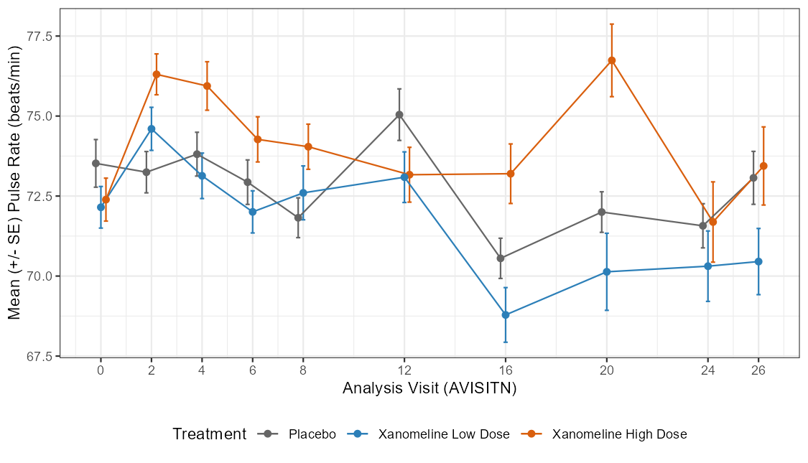
Points show arithmetic mean pulse rate at each analysis visit; error bars show +/- 1 standard error. Rendered from real pharmaverseadam ADVS data.
Source: ADVS (PARAMCD='PULSE').
X axis -> ADVS.AVISITN (label ADVS.AVISIT)
Y axis -> mean of ADVS.AVAL
Series (colour) -> ADVS.TRTA
Filter -> ADVS.PARAMCD='PULSE', ADVS.SAFFL='Y', analysis records (ADVS.DTYPE missing)
Error bars -> SE = sd(ADVS.AVAL) / sqrt(n)

