NATIONAL ECONOMICS UNIVERSITY
ADVANCED EDUCATION PROGRAM

COURSE: FINANCIAL RISK MANAGEMENT
TOPIC:
RISK–RETURN ANALYSIS AND PORTFOLIO OPTIMISATION OF MWG AND VNM USING CAPM AND VALUE AT RISK
Evidence from the Vietnamese stock market, January 2023 – December 2025
Class: Corparate Finance 65A
Lecturer: Dr. Dinh Thi Hong Theu
Group members:
Name | Student ID
Tạ Vân Anh | 11231039
Chu Bảo Khánh | 11236827

TABLE OF CONTENTS
1. Introduction 4
1.1. Background and motivation 4
1.2. Why MWG and VNM 4
1.3. Why the period January 2023 – December 2025 4
1.4. Research questions and structure 5
2. Theoretical framework 6
2.1. Return and stand-alone risk 6
2.2. Portfolio theory and the efficient frontier 6
2.3. Single-index model, beta and risk decomposition 6
2.4. CAPM, the Security Market Line and Jensen’s alpha 6
2.5. Value at Risk 7
3. Data and methodology 8
3.1. Sample and sources 8
3.2. Data validation 8
3.3. Methodology in Excel 8
4. Market and company context, 2023–2025 10
4.1. Macroeconomic and market background 10
4.2. Company profiles 10
5. Empirical results 11
5.1. Price performance 11
5.2. Stand-alone risk and return 11
5.3. Correlation, covariance and diversification 12
5.4. Portfolio optimisation and the efficient frontier 13
5.5. Capital Allocation Line 15
5.6. Beta estimation 15
5.7. Systematic versus non-systematic risk 16
5.8. CAPM, the Security Market Line and Jensen’s alpha 17
5.9. Value at Risk 18
5.10. Scenario and sensitivity analysis 19
6. Overall analysis and conclusion 21
6.1. Answers to the research questions 21
6.2. Limitations 21
6.3. Recommendations and further research 22
References 23
Appendix A. Main Excel formulas 25
Appendix B. Workbook map 25

LIST OF TABLES
No. | Table / Figure Title | Page
1 | Table 1: Data validation checks | 5
2 | Table 2: Descriptive statistics of daily returns (747 observations) | 6
3 | Table 3: Correlation and annualised covariance matrices of daily returns | 7
4 | Table 4: Comparison of portfolios (annualised) | 9
5 | Table 5: Single-index regression results: (Ri – Rf) = α + β (Rm – Rf) + ε | 10
6 | Table 6: CAPM required return and Jensen’s alpha (annualised) | 11
7 | Table 7: One-day Value at Risk, expected shortfall and backtest | 12
8 | Table 8: Sensitivity of CAPM required returns | 13
9 | Table 9: Estimated loss in a market fall (per VND 1 billion invested) | 13

LIST OF ABBREVIATIONS
Abbreviation | Full Term (English)
CAGR | Compound Annual Growth Rate
CAL | Capital Allocation Line
CAPM | Capital Asset Pricing Model
ES | Expected Shortfall
HOSE | Ho Chi Minh Stock Exchange
MRP | Market Risk Premium
MWG | Mobile World Investment Corporation
MVP | Minimum-Variance Portfolio
Rf | Risk-free rate
Rm | Market return
Rp | Portfolio return
SML | Security Market Line
VaR | Value at Risk
VNM | Vietnam Dairy Products JSC (Vinamilk)

ABSTRACT
This report analyses the risk and return of two Vietnamese stocks, Mobile World Investment Corporation (MWG) and Vietnam Dairy Products JSC (VNM), over 748 trading sessions from 3 January 2023 to 31 December 2025. Using daily closing prices, the VN-Index and the 10-year government bond yield as the risk-free rate, the study estimates stand-alone return and volatility, the correlation structure, the long-only efficient frontier and Capital Allocation Line, single-index betas, CAPM required returns, Jensen’s alpha, Value at Risk (VaR) and scenario sensitivities. MWG earned 29.32% a year with 32.11% volatility (Sharpe ratio 0.814), whereas VNM lost 2.90% a year (Sharpe ratio -0.283); the VN-Index achieved a higher Sharpe ratio (0.947) than either stock. Betas are 1.200 for MWG and 0.648 for VNM, and the market explains only 42.1% and 27.6% of their variance. Because VNM’s excess return was negative, the long-only tangency portfolio is 100% MWG, while the minimum-variance portfolio holds 21.7% MWG and 78.3% VNM. Diversification works in normal times (MWG–VNM correlation 0.217) but weakens in stress (0.758 on the 42 days when the VN-Index moved more than 2%).
Keywords: portfolio risk, efficient frontier, CAPM, beta, Value at Risk, Vietnam stock market.

1. Introduction

1.1. Background and motivation
Between 2023 and 2025 Vietnam moved from a weak start to one of its strongest growth phases in over a decade: GDP grew a little over 5% in 2023, 7.09% in 2024 and about 8% in 2025 (SSIAM, 2025; AFP, 2026). The equity market reflected this recovery but not evenly. The VN-Index rose from 1,043.90 to 1,784.49 points (70.9% over the sample), yet the path included a sharp one-day fall of 6.68% on 3 April 2025 after the United States announced a 46% reciprocal tariff on Vietnamese goods (VinaCapital, 2025). For an investor, a strong market does not mean that every stock carries the same risk or earns the same reward. This report asks how much of the risk and return of two very different stocks is explained by the market, and whether combining them improves the risk–return trade-off.

1.2. Why MWG and VNM
MWG and VNM are both consumer-oriented, liquid, large-capitalisation stocks listed on the Ho Chi Minh Stock Exchange (HOSE), but they sit at opposite ends of the business cycle.
- MWG is Vietnam’s largest electronics and grocery retailer (The Gioi Di Dong, Dien May Xanh, Bach Hoa Xanh). Its sales depend on discretionary spending and it went through a deep downturn followed by a strong recovery: revenue fell about 20% in the first half of 2023 (The Investor, 2023), then rose to VND134.3 trillion in 2024 (KB Securities Vietnam, 2025a) and by more than 16% to roughly VND157.4 trillion in 2025 (Tuoi Tre News, 2026). It is a cyclical, recovery-driven stock.
- VNM (Vinamilk) is the dairy market leader and the textbook defensive stock. Its earnings were broadly flat: 2025 revenue grew only 3% to VND63.6 trillion and net profit stayed near VND9.4 trillion (Shinhan Securities Vietnam, 2026), with domestic demand weak and exports growing about 25% (The Saigon Times, 2026). It is a mature, low-growth business.
The pairing is therefore deliberate: both are exposed to Vietnamese household consumption, yet one is a cyclical recovery story and the other a defensive, stagnant one. Theory suggests that their returns should be only moderately correlated and that VNM should have the lower beta. These expectations are tested in Section 5.

1.3. Why the period January 2023 – December 2025
The sample starts on 3 January 2023, close to the low point of the 2022–2023 market correction, and ends on 31 December 2025. Three years of daily data (748 sessions) are enough for reliable estimates of beta and VaR, and the window contains the full range of conditions an FRM analysis should handle: the weak 2023 consumer cycle, the 2024 recovery, the April 2025 tariff shock (when the VN-Index fell 17% in four sessions, VinaCapital, 2025) and the rebound that followed (the index rose 33% from its 10 April low to 11 July; The Investor, 2025a). The period therefore covers both calm and stressed markets, which is necessary to test whether diversification still works when it is most needed.

1.4. Research questions and structure
The report addresses four questions:
- How did MWG and VNM perform, in return and risk, relative to the VN-Index?
- How large is their systematic risk (beta), how much of their volatility does the market explain, and did they earn the return that CAPM requires?
- Can a portfolio of MWG and VNM improve the risk–return trade-off, and what is the optimal allocation?
- How large are the downside risks (VaR) and how sensitive are required returns and portfolio values to changes in interest rates, risk premia and market falls?
Section 2 summarises the theoretical framework. Section 3 describes the data, validation and Excel methodology. Section 4 gives the market and company context. Section 5 presents the empirical results. Section 6 concludes with limitations and recommendations.

2. Theoretical framework

2.1. Return and stand-alone risk
The daily simple return of asset i on day t is computed from closing prices:
R(i,t) = P(i,t) / P(i,t–1) – 1
Expected return is estimated by the sample mean and risk by the sample standard deviation (Excel STDEV.S, divisor n–1). Daily figures are annualised with 252 trading days: the mean is multiplied by 252 and the standard deviation by √252, which assumes returns are approximately independent over time (Bodie, Kane and Marcus, 2021). Risk-adjusted performance is measured by the Sharpe ratio, [E(R) – Rf] / σ, the excess return earned per unit of total risk.

2.2. Portfolio theory and the efficient frontier
Following Markowitz (1952), the expected return of a two-asset portfolio is the weighted average of the asset returns, while its variance also depends on the covariance:
E(Rp) = w1·E(R1) + w2·E(R2) σp² = w1²σ1² + w2²σ2² + 2·w1·w2·Cov(1,2)
The lower the correlation, the more risk is cancelled by combining the assets. The portfolio with the lowest variance is the minimum-variance portfolio (MVP); the portfolio with the highest Sharpe ratio is the tangency portfolio. The straight line from the risk-free rate through the tangency portfolio is the Capital Allocation Line (CAL), whose slope is the maximum attainable Sharpe ratio. Short selling is not allowed in this study (weights between 0 and 1), which reflects practical restrictions for retail investors in Vietnam.

2.3. Single-index model, beta and risk decomposition
The single-index model regresses the excess return of a stock on the excess return of the market:
R(i,t) – Rf(t) = α(i) + β(i)·[R(m,t) – Rf(t)] + ε(i,t)
Beta measures sensitivity to the market. Because the residual is uncorrelated with the market, total variance splits into systematic risk, β²σm², and non-systematic (firm-specific) risk, σ²(ε). The share of systematic risk equals the regression R².

2.4. CAPM, the Security Market Line and Jensen’s alpha
The Capital Asset Pricing Model (Sharpe, 1964) states that investors are rewarded only for systematic risk:
E(Ri) = Rf + βi · [E(Rm) – Rf]
Plotting the required return against beta gives the Security Market Line (SML). The vertical distance between a stock’s realised return and the SML is Jensen’s alpha (Jensen, 1968). Because realised returns over a short window are noisy, alpha is interpreted together with the statistical significance of the regression intercept.

2.5. Value at Risk
Value at Risk (VaR) is the loss that will not be exceeded over a given horizon with a given confidence level (Jorion, 2007). The parametric approach assumes normally distributed returns, VaR = –[μ + z·σ], with z = –1.645 at 95% and –2.326 at 99%. Historical simulation reads the loss directly from the empirical distribution. Expected shortfall (ES) is the average loss on days when VaR is breached. Multi-day VaR is scaled by the square root of time. Comparing the two methods and counting exceptions (backtesting) shows whether the normal distribution understates tail risk.

3. Data and methodology

3.1. Sample and sources
The sample comprises daily closing prices of MWG and VNM on HOSE, the daily closing level of the VN-Index and the daily yield of the Vietnamese 10-year government bond, from 3 January 2023 to 31 December 2025. This gives 748 price observations and 747 daily returns per series. The data were downloaded as historical price tables (Investing.com) and combined in one Excel workbook. The bond yield is matched to each trading date with an approximate match (the latest yield on or before the trading date). The average yield over the sample is 3.16% per year (range 2.30%–5.03%) and is used as the risk-free rate. The market return in CAPM is the annualised mean return of the VN-Index over the same sample (19.61%).

3.2. Data validation
Before any estimation, the following checks were run in the workbook (sheet “Data Check”) and all were passed.
Table 1: Data validation checks
Check | Result | Status
Number of daily observations | 748 | OK
Dates not in ascending order / duplicated dates | 0 / 0 | OK
Error or missing cells in price and Rf columns | 0 of 2,992 | OK
Daily returns beyond the HOSE ±7% limit (MWG, VNM, VN-Index) | 0 / 0 / 0 | OK
Correlation of MWG and VNM with the VN-Index | 0.649 / 0.526 | OK (not near zero)
Rf range (annual) | 2.30% – 5.03% | OK
Source: Author’s calculations (workbook sheet “Data Check”).
The correlation check is important: a near-zero correlation between a large stock and the index would signal misaligned rows, which can distort beta and correlations. Non-trading days (weekends and holidays) are not filled; returns are always computed between consecutive trading sessions. Filling them by repeating the previous price would create artificial zero returns and understate volatility.

3.3. Methodology in Excel
All calculations are carried out in Excel so they can be traced and updated; every result is a formula linked to the data. Means, standard deviations, skewness and kurtosis use AVERAGE, STDEV.S, SKEW and KURT. Covariances and correlations use COVARIANCE.S and CORREL. Portfolio variance uses the full two-asset formula over a grid of 21 weights (0%, 5%, …, 100% in MWG); the MVP weight is obtained analytically and the tangency portfolio by maximising the Sharpe ratio over the grid. Betas come from SLOPE, with standard errors, t-statistics and confidence intervals computed from STEYX and DEVSQ and cross-checked with Cov(i,m)/Var(m). Parametric VaR uses NORMSINV; historical VaR uses PERCENTILE; expected shortfall uses AVERAGEIF. Appendix A lists the main formulas and Appendix B maps the workbook.
Two further conventions apply. First, the market model is estimated on excess returns (return minus the daily risk-free rate, Rf/252). Second, p-values and confidence intervals use the t-distribution with n–2 degrees of freedom.

4. Market and company context, 2023–2025

4.1. Macroeconomic and market background
Economic growth accelerated from just over 5% in 2023 to 7.09% in 2024 (SSIAM, 2025) and about 8% in 2025 despite US tariffs (AFP, 2026). The stock market, however, was volatile. On 2 April 2025 the United States announced a 46% reciprocal tariff on Vietnamese goods; the VN-Index fell 17% over four trading sessions from 3 to 9 April, until a 90-day suspension was announced on 9 April (VinaCapital, 2025). The index was one of the worst performers worldwide in April (The Investor, 2025b), then recovered sharply as tariffs were postponed and a trade understanding was reached (The Investor, 2025a). In our data the VN-Index closed 3 April 2025 down 6.68%, the largest one-day fall in the sample, and ended 2025 up 40.9% for the calendar year, after +12.1% in 2024 and +8.2% in 2023.

4.2. Company profiles
MWG. The retailer’s sales fell about 20% in the first half of 2023, with the electronics chains (The Gioi Di Dong and Dien May Xanh) down 27% (The Investor, 2023). Its share price in this dataset reached a low of VND34,823 on 1 November 2023 and ended 2023 down 1.7% from the first session. The recovery that followed was strong: 2024 revenue reached VND134.3 trillion with net profit of VND3.7 trillion, well above plan (KB Securities Vietnam, 2025a); in 2025 revenue rose more than 16% to about VND157.4 trillion, nine-month net profit rose 73% to a record VND4.99 trillion, and the Bach Hoa Xanh grocery chain grew revenue by about 14% (Tuoi Tre News, 2025; 2026). Share-price returns in the sample were +44.9% in 2024 and +45.9% in 2025.
VNM. Vinamilk’s results were stable but not growing. Domestic sales fell about 1.9% in 2024, which analysts linked to a customer base concentrated in rural areas where spending was weak (KB Securities Vietnam, 2025b). In the first quarter of 2025 revenue fell 8.3% and net profit 28.1% during a restructuring of the distribution system (Phu Hung Securities, 2025). The company recovered over the rest of the year: full-year revenue was a record VND63.6 trillion (+3%) while net profit was flat at about VND9.4 trillion (Shinhan Securities Vietnam, 2026), with export revenue up 25.4% to VND7.1 trillion (The Saigon Times, 2026). The share price in the dataset fell from VND71,391 to VND61,200 over the sample, with calendar-year returns of –10.4% (2023), –0.9% (2024) and –3.5% (2025).
In short, MWG’s share price followed an earnings recovery, whereas VNM’s reflected flat earnings in a mature market. This difference is the economic backdrop to the statistical results below.

5. Empirical results

5.1. Price performance
Figure 1 rebases the three price series to 100 on 3 January 2023. Over the whole sample the VN-Index gained 70.9%, MWG 104.7% and VNM lost 14.3%. The paths differ: MWG fell until November 2023, then more than doubled from its trough, rising strongly in 2024 and again in 2025; VNM drifted sideways to lower levels; the index rose slowly until 2024 and accelerated in 2025. The tariff shock of April 2025 is visible as a sharp drop in all three series.
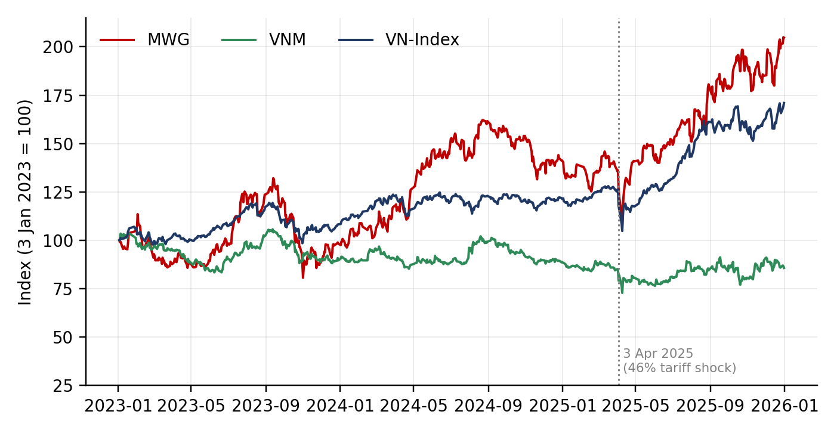
Figure 1: Prices rebased to 100, 3 January 2023 – 31 December 2025
Source: Author’s calculations.

5.2. Stand-alone risk and return
Table 2: Descriptive statistics of daily returns (747 observations)
Statistic | MWG | VNM | VN-Index
Mean daily return | 0.1163% | -0.0115% | 0.0778%
Daily standard deviation | 2.02% | 1.35% | 1.09%
Skewness | 0.09 | 0.16 | -0.91
Excess kurtosis | 1.77 | 4.24 | 7.76
Minimum / maximum daily return | -6.97% / 6.99% | -6.84% / 6.92% | -6.68% / 6.77%
Annualised mean return | 29.32% | -2.90% | 19.61%
Annualised standard deviation | 32.11% | 21.43% | 17.37%
Sharpe ratio (Rf = 3.16%) | 0.814 | -0.283 | 0.947
Holding-period return | 104.7% | -14.3% | 70.9%
CAGR | 27.0% | -5.0% | 19.6%
Jarque–Bera statistic (p-value < 0.001 for all) | 99 | 562 | 1,976
Source: Author’s calculations (sheets “Return” and “Descriptive”).
MWG offered by far the highest return (29.32% a year) but also the highest volatility (32.11%), almost twice that of the index (17.37%). VNM was less volatile (21.43%) but earned a slightly negative return (-2.90%). The Sharpe ratios rank the three assets clearly: VN-Index 0.947, MWG 0.814, VNM -0.283. The key result is that neither stock beat the market on a risk-adjusted basis: MWG’s higher return was earned with disproportionately higher risk, and VNM’s Sharpe ratio is negative because its return was below the risk-free rate.
All three series are non-normal. The VN-Index is clearly negatively skewed (-0.91) with very high excess kurtosis (7.76); VNM also has fat tails (4.24). The Jarque–Bera test rejects normality for all three (Jarque and Bera, 1987), so parametric VaR based on the normal distribution is expected to understate extreme losses (Section 5.9). Minimum and maximum daily returns cluster at about ±7%, the HOSE daily price limit, which truncates the largest moves and pushes part of the volatility into the following sessions.
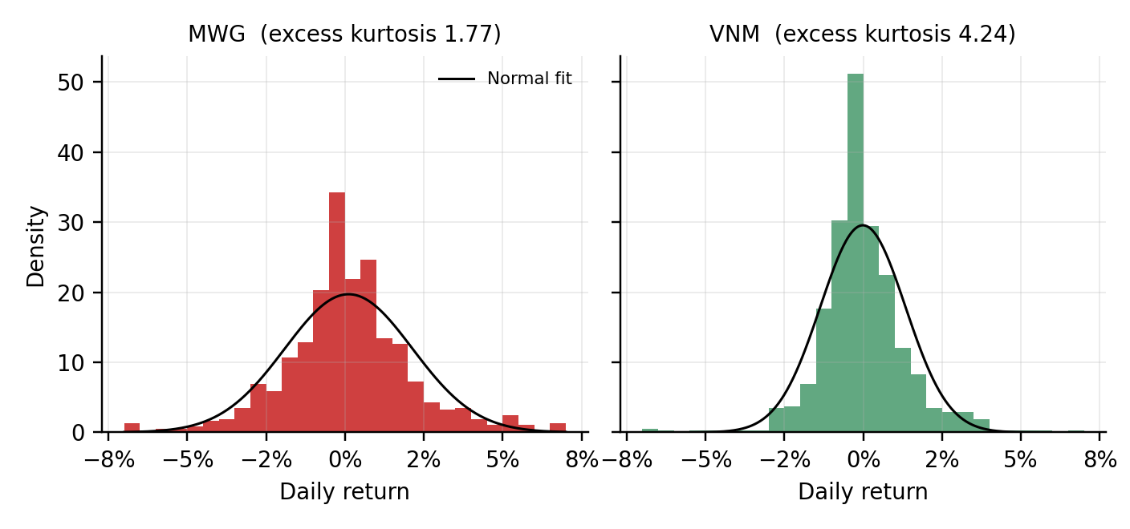
Figure 2: Distribution of daily returns of MWG and VNM against a normal curve
Source: Author’s calculations.

5.3. Correlation, covariance and diversification
Table 3: Correlation and annualised covariance matrices of daily returns
 | Correlation: MWG | VNM | VN-Index | Covariance (×252): MWG | VNM | VN-Index
MWG | 1.000 | 0.348 | 0.649 | 0.1031 | 0.0240 | 0.0362
VNM | 0.348 | 1.000 | 0.526 | 0.0240 | 0.0459 | 0.0196
VN-Index | 0.649 | 0.526 | 1.000 | 0.0362 | 0.0196 | 0.0302
Source: Author’s calculations (sheet “Covariance và Correlation”).
The correlation between MWG and VNM is 0.348, moderate and well below one, consistent with their different business cycles: MWG with discretionary retail demand and VNM with stable household staples. MWG is the more market-driven stock (correlation with the VN-Index 0.649) than VNM (0.526). A moderate correlation implies a real but limited diversification benefit. An equal-weight portfolio has an annualised standard deviation of 22.19%, which is 4.58 percentage points (17%) below the simple average of the two stand-alone volatilities (26.77%).
The average correlation hides an important asymmetry. Figure 2 splits the sample into 42 stress days, on which the VN-Index moved by more than 2% in either direction, and 705 normal days. On normal days the correlation between MWG and VNM is only 0.217; on stress days it rises to 0.758. Correlations with the index also jump (MWG 0.536 to 0.912; VNM 0.386 to 0.829). This is the well-documented increase of correlations in market downturns (Longin and Solnik, 2001): in a sell-off, foreign and retail investors sell broadly and the ±7% price limit forces many stocks to fall together. Diversification across these two stocks therefore protects the portfolio in normal times much better than in a crisis, exactly when protection is most needed.
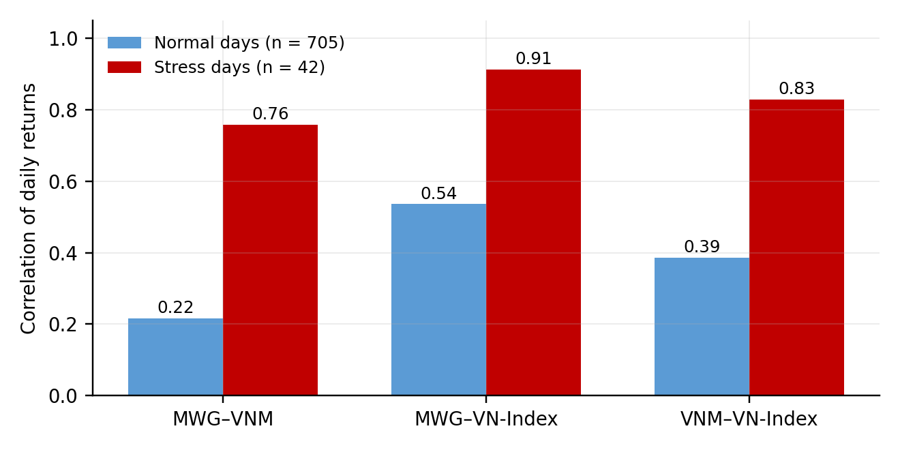
Figure 3: Correlation of daily returns on normal days and stress days (|VN-Index return| > 2%)
Source: Author’s calculations.

5.4. Portfolio optimisation and the efficient frontier
Figure 3 shows the feasible long-only portfolios obtained by varying the weight in MWG from 0% to 100%. The minimum-variance portfolio holds 21.7% MWG and 78.3% VNM. It has a standard deviation of 20.29%, below that of VNM alone (21.43%) and far below MWG (32.11%), but its expected return is only 4.09% and its Sharpe ratio just 0.045. Moving from the MVP towards MWG raises both return and risk, and the Sharpe ratio rises monotonically with the weight in MWG (Figure 4).
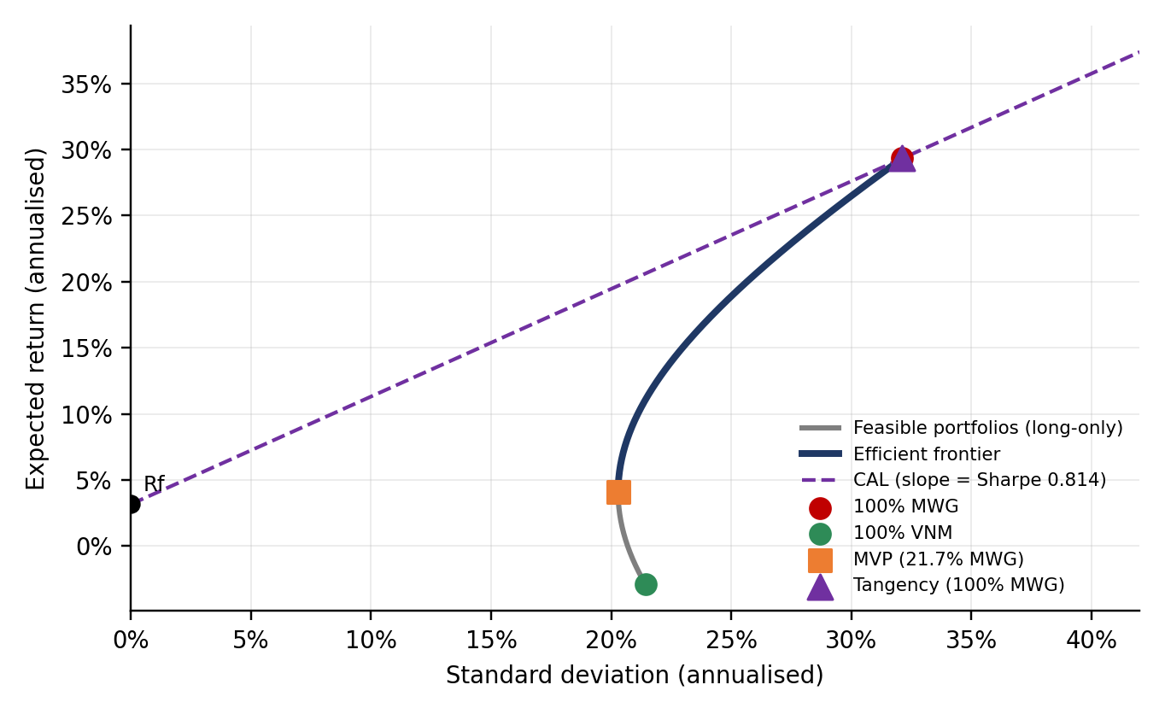
Figure 4: Efficient frontier, Capital Allocation Line and optimal portfolios (annualised, long-only)
Source: Author’s calculations.
Table 4: Comparison of portfolios (annualised)
Portfolio | w MWG | w VNM | E(Rp) | σp | Sharpe | Beta
100% VNM | 0.0% | 100.0% | -2.90% | 21.43% | -0.283 | 0.648
Minimum variance (MVP) | 21.7% | 78.3% | 4.09% | 20.29% | 0.045 | 0.768
Equal weight | 50.0% | 50.0% | 13.21% | 22.19% | 0.452 | 0.924
Tangency (max Sharpe, long-only) | 100.0% | 0.0% | 29.32% | 32.11% | 0.814 | 1.200
100% MWG | 100.0% | 0.0% | 29.32% | 32.11% | 0.814 | 1.200
Source: Author’s calculations (sheet “Portfolio”). Weights constrained to 0–100%.
The tangency portfolio, found by maximising the Sharpe ratio, is 100% MWG (return 29.32%, risk 32.11%, Sharpe 0.814). This is a corner solution and it should be read with care. It arises because VNM’s excess return over the risk-free rate was negative in this sample (-2.90% against Rf of 3.16%), so no positive weight in VNM raises the Sharpe ratio. If short selling were allowed, the unconstrained optimum would require a 1,444% weight in MWG and -1,344% in VNM, which is economically meaningless and illustrates how sensitive mean–variance optimisation is to estimated mean returns. The weights describe the past three years rather than a recommendation: VNM’s average return depends on a period of flat earnings (Section 4.2) and could be very different in the future.
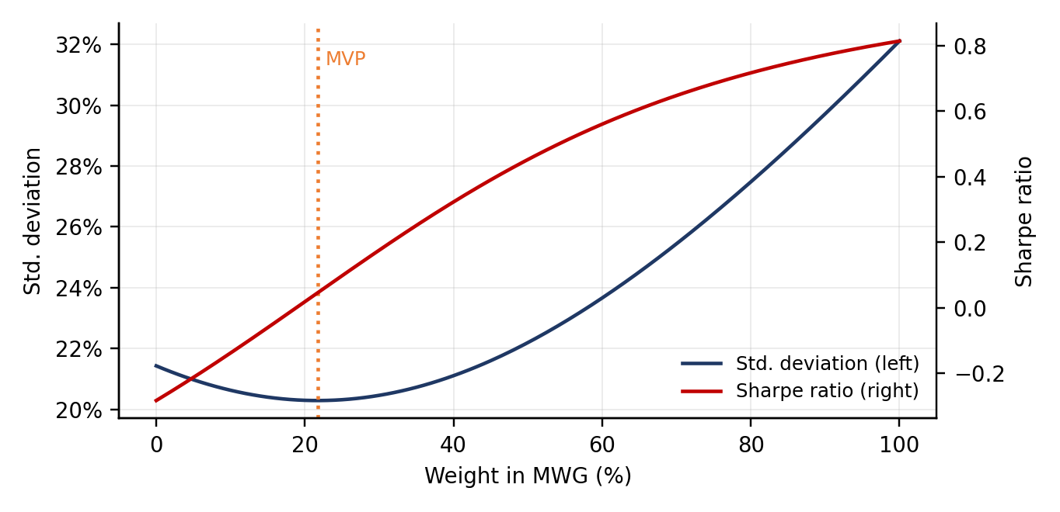
Figure 5: Portfolio standard deviation and Sharpe ratio by weight in MWG
Source: Author’s calculations.

5.5. Capital Allocation Line
With a risk-free rate of 3.16% and the tangency portfolio (return 29.32%, standard deviation 32.11%), the CAL is E(Rp) = 3.16% + 0.814 × σp. The slope of 0.814 means that each additional percentage point of risk is expected to earn about 0.814 percentage points of return. A risk-averse investor can hold, for example, 50% in the risk-free asset and 50% in the tangency portfolio, for an expected return of 16.24% and a standard deviation of 16.05%; an investor with higher risk tolerance can allocate more to the tangency portfolio or, if borrowing is possible, lever it. Because the tangency portfolio is entirely MWG, the CAL is simply the line through the risk-free rate and MWG.

5.6. Beta estimation
Table 5: Single-index regression results: (Ri – Rf) = α + β (Rm – Rf) + ε
 | MWG | VNM
Beta (β) | 1.200 | 0.648
Standard error of β | 0.0515 | 0.0384
t-statistic of β | 23.30 | 16.86
95% confidence interval of β | 1.099 – 1.301 | 0.573 – 0.724
Daily α | 0.0255% | -0.0664%
Annualised α | 6.41% | -16.73%
t-statistic / p-value of α | 0.45 / 0.652 | -1.58 / 0.115
R-squared | 0.421 | 0.276
Observations | 747 | 747
Source: Author’s calculations (sheet “Regression”).
Both betas are highly significant (t-statistics 23.30 and 16.86). MWG has a beta of 1.200: when the market moves by 1%, MWG moves by about 1.2% on average, so it amplifies market movements, consistent with a cyclical retailer. VNM has a beta of 0.648, clearly defensive, consistent with stable demand for dairy products. Both expectations stated in Section 1.2 are confirmed. The three estimation methods (SLOPE, regression formula and Cov/Var) give identical betas.
The intercepts are not statistically different from zero at the 5% level (p-values 0.652 for MWG and 0.115 for VNM). VNM’s annualised alpha of -16.73% is large but its daily residuals are volatile, so the evidence of underperformance is only suggestive. Figure 5 shows the data and fitted lines; the wide cloud around the lines anticipates the risk decomposition below.
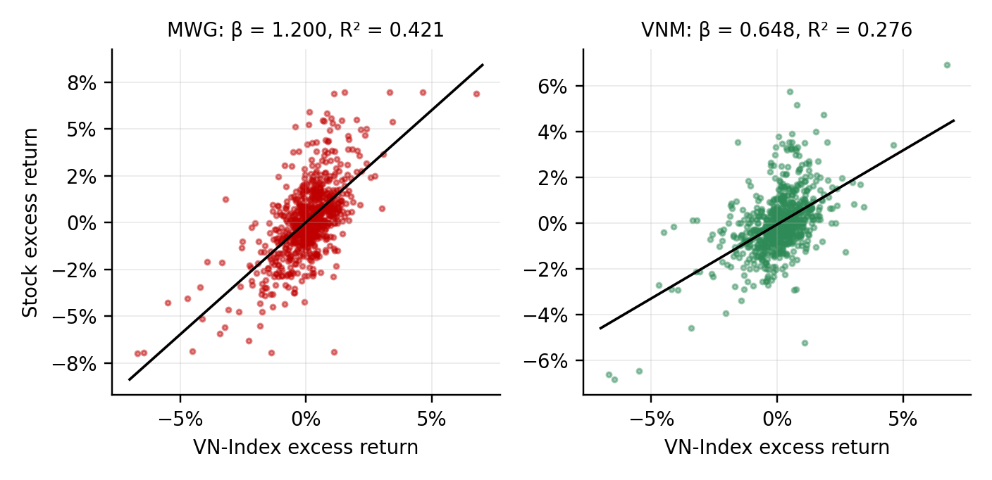
Figure 6: Daily excess returns of MWG and VNM against the VN-Index with fitted regression lines
Source: Author’s calculations.

5.7. Systematic versus non-systematic risk
Applying σi² = β²σm² + σ²(ε) to annualised variances (Figure 6), systematic risk accounts for 42.1% of MWG’s total variance (0.0435 of 0.1031) and 27.6% of VNM’s (0.0127 of 0.0459). The remaining 57.9% and 72.4% are non-systematic: they come from factors the index does not capture, such as MWG’s store expansion and the Bach Hoa Xanh business, or VNM’s distribution restructuring and export growth (Section 4.2). For a well-diversified investor most of this risk can be diversified away and, according to CAPM, is not rewarded. For an investor who holds only these two stocks, however, firm and industry risk is the dominant source of volatility, which is why understanding the company fundamentals matters more than refining the beta estimate.
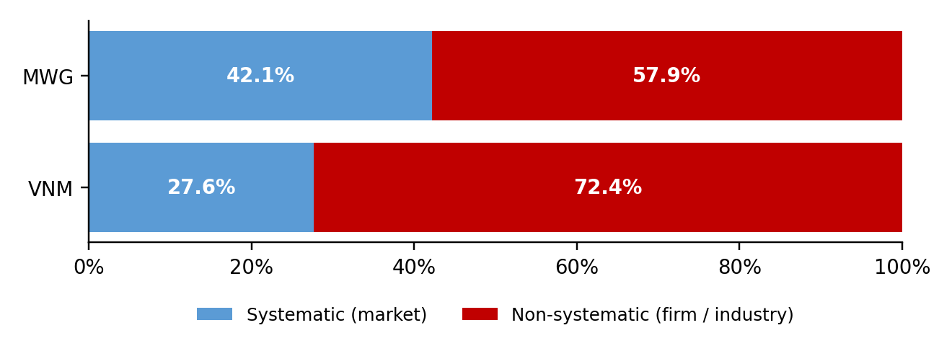
Figure 7: Decomposition of total variance into systematic and non-systematic risk
Source: Author’s calculations.

5.8. CAPM, the Security Market Line and Jensen’s alpha
With a risk-free rate of 3.16% and a market return of 19.61%, the market risk premium is 16.45%. This premium is very high by international standards and mainly reflects the exceptional 2025 rally of the VN-Index (+40.9% in the calendar year). The CAPM required returns below are therefore best read as an ex-post benchmark for this sample, not as a forward-looking cost of equity.
Table 6: CAPM required return and Jensen’s alpha (annualised)
Asset | Beta | Required return (CAPM) | Realised return | Jensen’s alpha | Position vs SML
MWG | 1.200 | 22.90% | 29.32% | +6.41% | Above SML
VNM | 0.648 | 13.83% | -2.90% | -16.73% | Below SML
MVP portfolio | 0.768 | 15.80% | 4.09% | -11.71% | Below SML
Equal-weight portfolio | 0.924 | 18.37% | 13.21% | -5.16% | Below SML
Source: Author’s calculations (sheet “CAPM & SML”).
MWG earned 6.41% a year more than its beta justified (realised 29.32% against 22.90% required), so it plots above the SML. VNM is the clear outlier: despite a low required return of 13.83%, it delivered -2.90%, an alpha of -16.73%. Because VNM’s beta is low, its shortfall cannot be blamed on market risk; it points to company- and industry-specific factors, in line with the flat earnings described in Section 4.2. Both alphas, however, are not statistically significant (Table 6), so they are indications rather than proof of mispricing. The MVP and equal-weight portfolios also lie below the SML because they contain VNM.
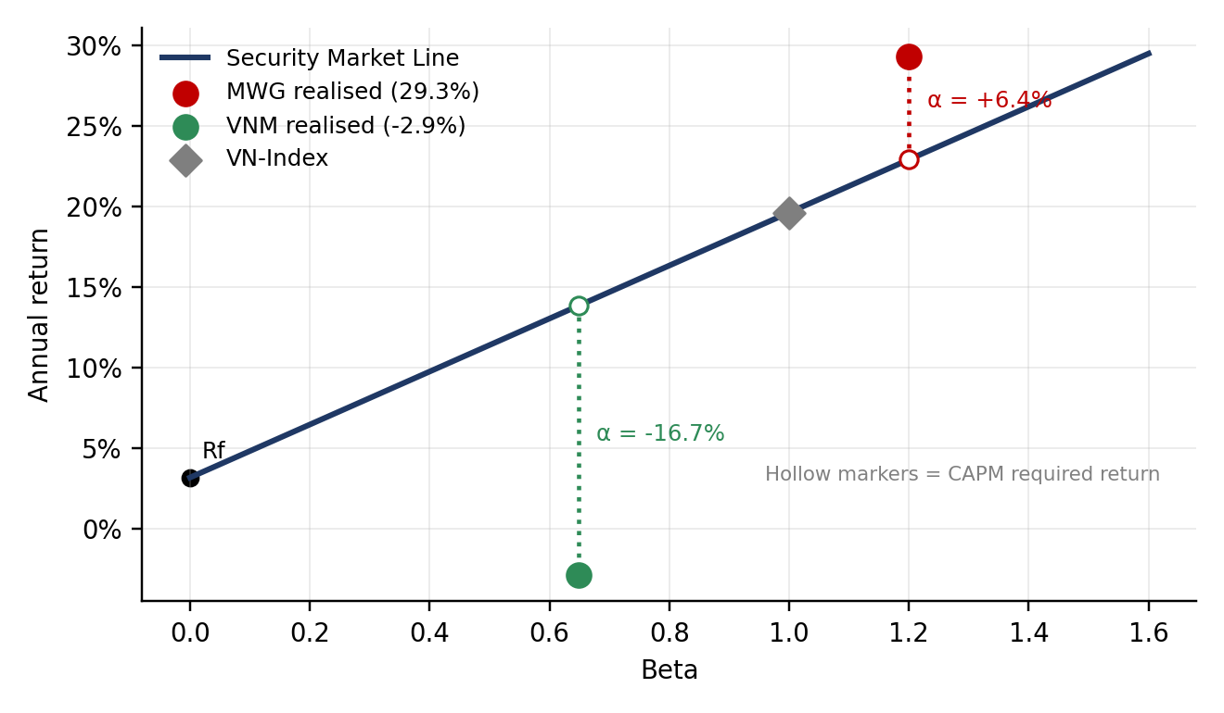
Figure 8: Security Market Line and realised returns of MWG and VNM
Source: Author’s calculations.

5.9. Value at Risk
Table 7: One-day Value at Risk, expected shortfall and backtest
Measure (1 day) | MWG | VNM | MVP | Equal weight
Parametric VaR 95% | 3.21% | 2.23% | 2.09% | 2.25%
Parametric VaR 99% | 4.59% | 3.15% | 2.96% | 3.20%
Historical VaR 95% | 3.07% | 1.95% | 1.81% | 2.01%
Historical VaR 99% | 5.54% | 2.92% | 3.05% | 3.62%
Expected shortfall 95% | 4.44% | 2.94% | 2.82% | 3.11%
Expected shortfall 99% | 6.54% | 5.00% | 4.74% | 4.89%
10-day parametric VaR 95% (√10 rule) | 10.15% | 7.06% | 6.60% | 7.11%
VaR 95% on VND 1 billion (VND million) | 32.1 | 22.3 | 20.9 | 22.5
Days beyond 95% VaR (expected 37.4) | 36 (4.8%) | 27 (3.6%) | 25 (3.3%) | 29 (3.9%)
Days beyond 99% VaR (expected 7.5) | 13 | 7 | 10 | 13
Source: Author’s calculations (sheet “VaR”). The tangency portfolio equals 100% MWG, so its VaR equals that of MWG.
On one trading day in twenty, an investor in MWG can expect to lose at least 3.21% (parametric) and in VNM 2.23%. For a VND 1 billion position this is about VND 32.1 million for MWG and VND 22.3 million for VNM; the 10-day VaR is about VND 101.5 million and VND 70.6 million. The MVP has the lowest VaR (2.09%). The parametric VaR of the MVP is 0.36 percentage points below the weighted average of its components’ VaRs (2.44% against 2.09%), the diversification benefit expressed in risk terms; for the equal-weight portfolio the reduction is 0.47 points.
Comparing methods confirms the fat tails found in Section 5.2. At 95%, the historical VaR is slightly below the parametric figure for every asset, so the normal model is conservative in the body of the distribution. At 99%, however, the historical VaR of MWG (5.54%) is well above the parametric figure (4.59%), and the same is true for the equal-weight portfolio. The backtest agrees: at 95% the number of exceptions (36 for MWG, 27 for VNM) is at or below the 37.4 expected, but at 99% MWG has 13 exceptions against 7.5 expected, about 1.7 times too many. Parametric VaR is therefore reasonable at 95% but understates the extreme-loss risk of MWG at 99%. Expected shortfall (4.44% for MWG at 95%) is a more informative measure of what happens beyond the VaR threshold.
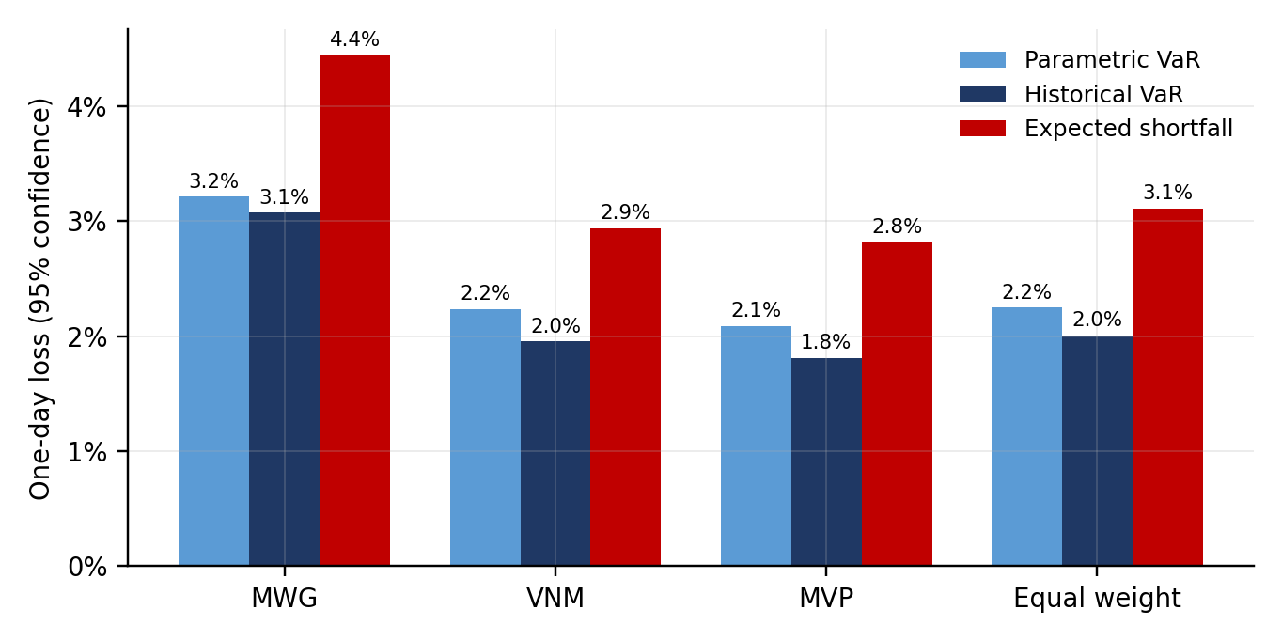
Figure 9: One-day parametric VaR, historical VaR and expected shortfall at 95% confidence
Source: Author’s calculations.

5.10. Scenario and sensitivity analysis
Following the structure of the course template, two shifts of the Security Market Line are tested. A parallel rise of the risk-free rate by 2 percentage points raises every required return by exactly 2 points. A rise of the market risk premium by 2 points steepens the line, so the increase equals β × 2%: larger for MWG, smaller for VNM (Table 7). Defensive stocks are less exposed to changes in risk appetite, while all stocks are equally exposed to changes in the risk-free rate.
Table 8: Sensitivity of CAPM required returns
Asset | Base case | Rf + 2 pp | Change (pp) | MRP + 2 pp | Change (pp)
MWG | 22.90% | 24.90% | +2.00 | 25.30% | +2.40
VNM | 13.83% | 15.83% | +2.00 | 15.12% | +1.30
MVP portfolio | 15.80% | 17.80% | +2.00 | 17.33% | +1.54
Equal-weight portfolio | 18.37% | 20.37% | +2.00 | 20.21% | +1.85
Source: Author’s calculations (sheet “Scenarios”).
A second scenario applies a market fall of 10% and 20%, with the loss approximated by beta times the market move (Table 8 and Figure 8).
Table 9: Estimated loss in a market fall (per VND 1 billion invested)
Asset | Beta | VN-Index –10% | Loss (VND m) | VN-Index –20% | Loss (VND m)
MWG | 1.200 | -12.0% | 120.0 | -24.0% | 240.0
VNM | 0.648 | -6.5% | 64.8 | -13.0% | 129.7
MVP portfolio | 0.768 | -7.7% | 76.8 | -15.4% | 153.6
Equal-weight portfolio | 0.924 | -9.2% | 92.4 | -18.5% | 184.9
Source: Author’s calculations (sheet “Scenarios”).
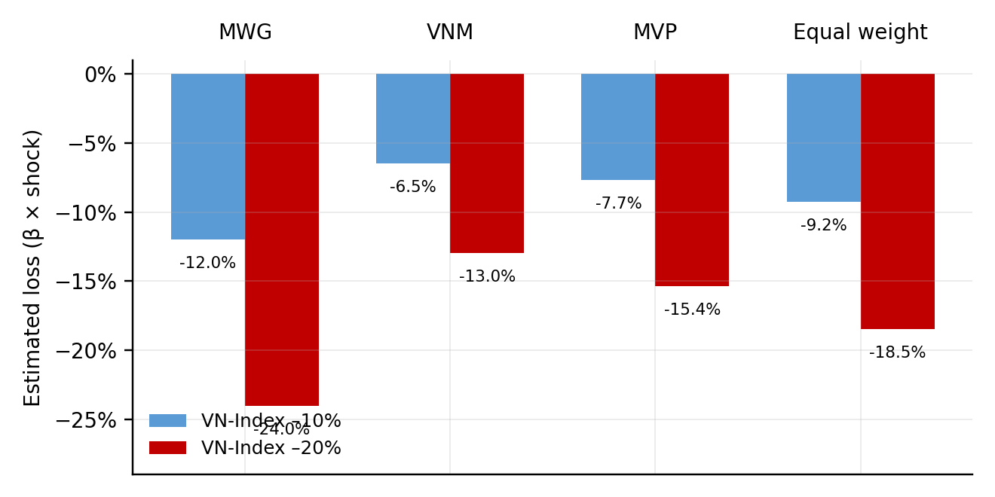
Figure 10: Estimated loss of each asset when the VN-Index falls by 10% and 20%
Source: Author’s calculations.
The beta-based estimate can be checked against the worst day in the sample, 3 April 2025, when the VN-Index fell 6.68%. MWG fell 6.97% against 8.01% predicted by its beta, while VNM fell 6.61% against only 4.33% predicted. The defensive stock fell almost as much as the market on the day of the shock, which confirms the stress-day correlation result of Section 5.3: betas estimated on average conditions understate co-movement in a crash, so the table above is a lower bound on tail losses for VNM.

6. Overall analysis and conclusion

6.1. Answers to the research questions
Performance relative to the market. MWG returned 29.32% a year and VNM -2.90%, against 19.61% for the VN-Index. MWG’s extra return came with 32.11% volatility versus 17.37% for the index, so its Sharpe ratio (0.814) was below the market’s (0.947); VNM’s was negative (-0.283). Holding either stock alone did not pay for the risk taken compared with holding the index. This performance mirrors the fundamentals: MWG’s price followed a strong earnings recovery after the 2023 downturn, whereas VNM’s earnings were flat.
Systematic risk and CAPM. Beta is 1.200 for MWG (aggressive) and 0.648 for VNM (defensive), both highly significant. The market explains only 42.1% of MWG’s and 27.6% of VNM’s variance, so most of the risk is company- and industry-specific. Against a very high CAPM benchmark (market premium 16.45%), MWG earned +6.41% more than required and VNM 16.73% less, but neither alpha is statistically significant.
Diversification and optimal portfolio. The correlation of 0.348 gives a moderate diversification benefit: the equal-weight portfolio has 17% lower volatility than the average of its components and the MVP (21.7% MWG, 78.3% VNM) has the lowest risk of 20.29%. The long-only tangency portfolio is 100% MWG (Sharpe 0.814) because VNM’s excess return was negative. Diversification fails when most needed: the MWG–VNM correlation rises from 0.217 on normal days to 0.758 on stress days.
Downside risk and scenarios. One-day 95% VaR is 3.21% for MWG, 2.23% for VNM and 2.09% for the MVP. The normal assumption holds at 95% but understates MWG’s tail at 99% (13 exceptions against 7.5 expected). A 2-point rise in the risk-free rate raises all required returns by 2 points, while a 2-point rise in the risk premium raises MWG’s by 2.40 points and VNM’s by 1.30 points. A 20% market fall would cost about VND 240.0 million per billion in MWG and VND 129.7 million in VNM, and VNM would likely lose more than its beta suggests.

6.2. Limitations
- The sample covers only three years, and the market return in CAPM is taken from the same period; the high risk premium reflects the exceptional 2025 rally, so required returns are ex-post benchmarks.
- Optimal weights use historical mean returns, which are very noisy; the corner solution (100% MWG) reflects VNM’s weak return in this sample and is not a stable feature of the two stocks.
- CAPM is a single-factor model, and both regression alphas are statistically insignificant, so the alphas are indications rather than evidence of mispricing.
- Parametric VaR assumes normality, which the data reject in the tails; daily returns are also truncated by the ±7% price limit and affected by non-synchronous trading.
- The 10-year bond yield is only a proxy for the risk-free rate; whether each price series is fully adjusted for dividends and bonus shares should be confirmed against the data source; a two-stock portfolio is far less diversified than a realistic portfolio.

6.3. Recommendations and further research
For an investor holding these stocks, the analysis suggests three practical points: do not rely on low average correlations for protection in a crash; use historical VaR or expected shortfall rather than normal VaR for tail risk, especially for MWG; and monitor company fundamentals (retail demand and margins for MWG, domestic sales and export growth for VNM) as closely as the market index, since most of the risk is not explained by the market. These findings describe the past three years and are not investment advice. Further work could add stocks from other sectors, estimate rolling-window betas, test the stability of the results with weekly or monthly returns, add multi-factor regressions with industry and macroeconomic variables, apply GARCH-based VaR, and test the optimal weights out of sample.

REFERENCES
- AFP (2026) ‘Vietnam says economy grew 8% in 2025 despite US tariffs’, The Daily Star, January. Available at: https://tds-images.thedailystar.net/business/global-economy/news/vietnam-says-economy-grew-8-2025-despite-us-tariffs-4074186
- Bodie, Z., Kane, A. and Marcus, A.J. (2021) Investments. 12th edn. New York: McGraw-Hill Education.
- Investing.com (2026) Historical data: MWG, VNM, VN-Index and Vietnam 10-year government bond yield. [Data downloaded by the author.]
- Jarque, C.M. and Bera, A.K. (1987) ‘A test for normality of observations and regression residuals’, International Statistical Review, 55(2), pp. 163–172.
- Jensen, M.C. (1968) ‘The performance of mutual funds in the period 1945–1964’, Journal of Finance, 23(2), pp. 389–416.
- Jorion, P. (2007) Value at Risk: The New Benchmark for Managing Financial Risk. 3rd edn. New York: McGraw-Hill.
- KB Securities Vietnam (2025a) Mobileworld (MWG): 4Q24 results update. Available at: https://kbsec.com.vn/pic/Service/KBSV_MWG_4Q24FTM_Eng.pdf
- KB Securities Vietnam (2025b) Vinamilk (VNM): 4Q24 results update, 11 March. Available at: https://www.kbsec.com.vn/pic/Service/KBSV_VNM_4Q24Update_Eng.pdf
- Longin, F. and Solnik, B. (2001) ‘Extreme correlation of international equity markets’, Journal of Finance, 56(2), pp. 649–676.
- Markowitz, H. (1952) ‘Portfolio selection’, Journal of Finance, 7(1), pp. 77–91.
- Phu Hung Securities (2025) VNM: 1Q25 business results update. Available at: https://www.phs.vn/en/research-file/4359
- Sharpe, W.F. (1964) ‘Capital asset prices: a theory of market equilibrium under conditions of risk’, Journal of Finance, 19(3), pp. 425–442.
- Shinhan Securities Vietnam (2026) VNM: Revenue reaching new high, 9 February. Available at: https://shinhansec.com.vn/uploads/report/REPORT_VNM_-_EN_-_Q4_2025.pdf
- SSIAM (2025) Market insights – January 2025. Available at: https://ssiam.com.vn/en/news/view-detail/market-insights-january-2025
- The Investor (2023) ‘Retail major Mobile World posts $2.3 bln revenue in first 6 months’. Available at: https://theinvestor.vn/retail-major-mobile-world-posts-23-bln-revenue-in-first-6-months-d6006.html
- The Investor (2025a) ‘Riding out tariff turbulence, investment funds in Vietnam report strong growth gains’. Available at: https://theinvestor.vn/riding-out-tariff-turbulence-investment-funds-in-vietnam-report-strong-growth-gains-d16324.html
- The Investor (2025b) ‘Vietnam’s VN-Index world’s second-worst performer in Apr amid US tariff turmoil’, 3 May. Available at: https://theinvestor.vn/vietnams-vn-index-worlds-second-worst-performer-in-apr-amid-us-tariff-turmoil-d15527.html
- The Saigon Times (2026) Vinamilk 2025 full-year results report. Available at: https://english.thesaigontimes.vn/?p=518622
- Tuoi Tre News (2025) ‘Vietnam’s Mobile World reports record quarterly profit as revenue rises 17%’, 24 October. Available at: https://news.tuoitre.vn/vietnams-mobile-world-reports-record-quarterly-profit-as-revenue-rises-17-103251024125145235.htm
- Tuoi Tre News (2026) ‘Vietnam retailer Mobile World posts strong 2025 profit, boosted by financial income’, 4 February. Available at: https://news.tuoitre.vn/vietnam-retailer-mobile-world-posts-strong-2025-profit-boosted-by-financial-income-103260204160919933.htm
- VinaCapital (2025) VinaCapital Insights Balanced Fund (VIBF) monthly factsheet, 31 March 2025, 15 April. Available at: https://vinacapital.com/wp-content/uploads/2025/04/20250415-VINACAPITAL-VIBF_Monthly-Factsheet_Mar-2025-EN.pdf

Appendix A. Main Excel formulas
Item | Excel formula (example)
Daily simple return | ='Raw Data'!B3/'Raw Data'!B2-1
Excess return | =B3-$E3 (E = Rf / 252)
Annualised mean / standard deviation | =AVERAGE(B3:B749)*252 / =STDEV.S(B3:B749)*SQRT(252)
Sharpe ratio | =(Return_year − Rf) / SD_year
Covariance / correlation | =COVARIANCE.S(x,y) / =CORREL(x,y)
Portfolio standard deviation | =SQRT(w1^2*s1^2+w2^2*s2^2+2*w1*w2*252*Cov)
MVP weight in MWG | =(σ2² − σ12) / (σ1² + σ2² − 2σ12)
Tangency portfolio | =INDEX(w, MATCH(MAX(Sharpe), Sharpe, 0))
Beta / R² / regression std. error | =SLOPE(y,x) / =RSQ(y,x) / =STEYX(y,x)
Std. error of β / p-value | =STEYX/SQRT(DEVSQ(x)) / =TDIST(ABS(t), n−2, 2)
CAPM required return | =Rf + β*(Rm − Rf)
Parametric VaR | =-(AVERAGE(r)+NORMSINV(0.05)*STDEV.S(r))
Historical VaR | =-PERCENTILE(r, 0.05)
Expected shortfall | =-AVERAGEIF(r, "<="&PERCENTILE(r, 0.05))
Backtest exceptions | =COUNTIF(r, "<"&-VaR)

Appendix B. Workbook map
Sheet | Content
Summary | Key results linked to the calculation sheets; list of corrections and assumptions
MWG / VNM / Bond Yield / VNindex – Raw | Raw downloaded data and date / number conversion
Raw Data | Aligned daily series: prices, VN-Index, risk-free rate
Data Check | Validation checks (Step 0)
Return | Daily returns, excess returns, rebased prices, descriptive statistics
Descriptive | Descriptive statistics, Jarque–Bera test, histogram
Covariance và Correlation | Covariance and correlation matrices
Portfolio / CAL | Efficient frontier, MVP, tangency, equal weight; Capital Allocation Line
Regression | Beta, alpha, t-tests, confidence intervals, risk decomposition
CAPM & SML | Required returns, Jensen’s alpha, Security Market Line
VaR / Port Returns | Parametric and historical VaR, expected shortfall, backtest
Stress Corr | Correlations on normal and stress days
Scenarios | Rf and market-risk-premium shifts, market-fall losses, worst-day check

