Working Paper on Carbon Market Frameworks for Brazil

AUGUST 2025

# Introduction

Brazil’s climate finance landscape is at a strategic turning-point. With significant strides by enacting the Brazilian Emissions Trading Scheme (SBCE), the launching of the Brazilian Sustainable Taxonomy[1] and the development of a new Climate Plan,[2] the country has the potential of establishing a solid foundation framework to attract green investment and drive a just transition.

On the global stage, the conclusion of the Article 6 of the Paris Agreement rulebook at COP29 provided to cooperative approaches and the Paris Agreement Crediting Mechanism (PACM) clear and credible processes to avoid double counting and ensure the integrity of transactions, facilitating the pathway for international climate investments to flow into developing economies.

This conjunction of domestic and international developments together with the COP30 in Belém create a unique opportunity for Brazil to unlock private funding to support the country’s climate commitments with a clear strategy on carbon markets. To seize this moment, three strategic imperatives are vital: i. develop a clear carbon market framework through a collaborative design process to ensure transparency; ii. support the harmonization between market-based instruments to promote market confidence; and iii. build a robust MRV and accountability infrastructure, underpinned by sound legal and governance structures, as backbone for high integrity.

To support this process, this working paper is part of an ongoing IETA effort which aims to assess options for promoting a coherent and impactful carbon market landscape in Brazil. In summary, it presents Brazil’s emissions context, climate targets, key economic aspects and global developments and discuss key challenges that carbon markets could help address in Brazil. Finally, it proposes potential pathways that the country could consider based on international experiences, outlining critical aspects for further qualitative and quantitative studies involving Brazilian economic sectors and key stakeholders.

# Setting the Scene

Brazil’s emissions profile is very particular, compared to the global context. Understanding those specificities is essential to underpin the analysis of market-based mechanisms in the country. While most of the world’s emissions come from the energy processes and product use sector, most of Brazil’s emissions are related to agriculture (30%) and land use change aspects (40%).

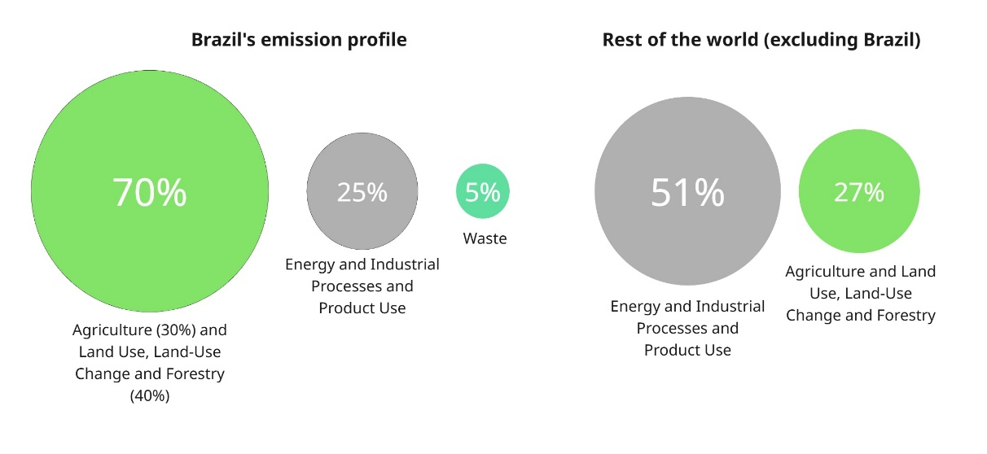

Figure 1 - Brazil's emissions profile per sector, compared to rest of the world's emissions.

Source: MCTI, 2022[3].

Brazil’s economic structure is heavily shaped by its natural endowments and comparative advantages in primary goods. Commodity-intensive sectors such as agribusiness, mining, and oil and gas remain critical engines of economic growth, exports, and regional employment. In 2024, agriculture alone accounted for 21% of total exports, specially led mostly by soy[4]. This export-led model is reflected in Brazil’s greenhouse gas emissions profile (land use emissions are directly linked to the expansion of commodity production into forested areas, particularly in the Amazon and Cerrado biomes). Hard-to-abate sectors totalled around 18% of Brazilian exports in 2024, included both in the extractive industry (~9% for iron ore and its concentrates) and in the manufacturing industry (1,4% for aluminium and aluminium oxides, 3% for other forms of iron and steel, 3,1% for pulp and paper and a combined 1,5% in chemicals) [5].

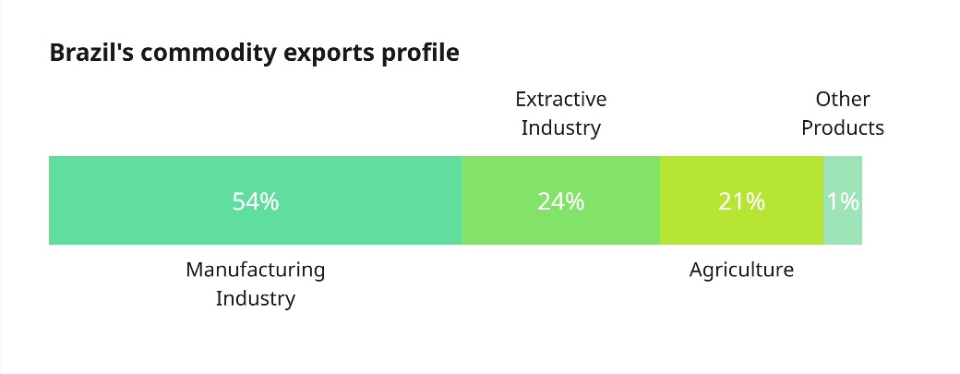

Figure 2 - Brazil's commodity export profile.

Source: ComexStat (2025) iv.

Despite these sectoral challenges, Brazil is not considered a carbon-intensive economy in per capita or per GDP terms. According to 2022 data, Brazil positioned as 128 when considered emissions per USD of GDP, below the global average[6]. This relative efficiency is largely due to Brazil’s low-emission electricity matrix, where nearly than 90% of power comes from renewables, especially hydro, wind, and bioenergy.[7]

Figure 3 - Major economies' carbon intensity, measured in kgCO2/USD of GDP, as of 2022v.

Source: Global Carbon Budget (2024); Bolt and van Zanden - Maddison Project Database 2023 – with major processing by Our World in Data.

Given the role of emissions-intensive commodities in Brazil’s export portfolio, particularly in sectors like iron, steel and aluminium, the country faces growing exposure to emerging international carbon pricing frameworks. One of the most prominent is the European Union’s Carbon Border Adjustment Mechanism (CBAM), which aims to equalize the carbon cost of imports and domestic production within the EU. Estimated impacts include up to US$444.3 million lost in exports of energy-intensive goods and a 1.49% GDP reduction in relation to a scenario without CBAM[8].

Additionally, Brazil’s agricultural sector is impacted by the EU Deforestation-Free Regulation (EUDR), which prohibits imports of products linked to deforestation, including legally deforested land after December 31, 2020. This creates significant challenges for Brazilian agribusiness, requiring strict compliance and due diligence for exports of agricultural commodities. According to MapBiomas[9], only in the Cerrado biome, it is estimated that about 93 million hectares, around 47% of the biome’s total area, are currently legally in use for agriculture & livestock production. This is due to the Forest Code allowing deforestation of up to 65% of the total area on private rural lands in the Cerrado[10].

**National response to international policy: a glimpse of Europe's CBAM**

The Brazilian government has been a vocal critic of the EU’s CBAM. According to World Bank data, 11.5% of Brazil’s CBAM-related exports go to Europe, mainly iron and steel (92%), followed by aluminum (3%). Some experts suggest that Brazil’s relatively low-carbon production processes could give it a short-term competitive edge in the EU market, as the bloc relies on imports of certain goods. However, a key concern is that CBAM considers only direct emissions, overlooking Brazil’s cleaner energy mix. Including Scope 2 emissions (from electricity use) would better reflect the lower carbon footprint of Brazilian industry. While a Brazilian CBAM could protect local industry and showcase its clean energy advantage, it risks prompting similar measures globally. Although Brazil is currently less exposed than some peers, broader CBAM adoption by trade partners could harm its export competitiveness—making Brazil hesitant to introduce its own.

Brazil’s updated 2024 NDC[11] sets an absolute emissions reduction target of 59% to 67% by 2035 compared to 2005 levels, translating to about 850 to 1,050 million tons of CO₂e across the economy. The NDC does not include conditional targets; instead, it adopts a "band target" format, allowing for flexibility in emissions reduction depending on factors such as international cooperation and technological progress. This positions Brazil in line with broader Paris Agreement coals and on track to achieve neutrality by 2050.

In the international context, low-carbon transition efforts face increasing complexity due to geopolitical pressures. Many nations have shifted focus to energy security, as ongoing conflicts and trade disruptions have affected global energy markets, increasing renewable energy financing costs. Political shifts in major economies also hinder international climate cooperation, risking slowing climate ambition and deepening implementation gaps. [12]

Despite growing fiscal, political and geopolitical pressures and uncertainties, domestic carbon pricing instruments continue to expand globally, generating government revenue and driving private investments in mitigation. By January 2025, 38 systems were in force worldwide, with another 20 under development or consideration, covering jurisdictions that that constitute one-third of the global population and 58% of global GDP. In 2024, these systems generated roughly USD 70 billion in revenue,[13] remaining an important stream of climate finance.

However, harmonizing domestic carbon pricing systems with international mechanisms while addressing national needs remains challenging for establishing a transparent and efficient global carbon price. Despite renewed momentum following COP29’s Article 6 outcomes, international cooperation via market-based tools like ITMOs has gained importance for countries to efficiently achieve their NDCs and increase ambition, host country participation in Article 6 remains slow, even with rising demand. While total cumulative demand for ITMOs by both buying countries and airlines compliant to CORSIA shall reach 685 MtCO₂e by 2030, [14] by June 2025, only about over 11.000 ITMOs had been issued in the world, with a single transfer of ITMOs registered, between Thailand and Switzerland.[15]

Offsets and domestic crediting mechanisms are gaining prominence in ETS frameworks. Currently, 24 ETSs allow carbon credits for compliance, each with its own limits[16]. Key emerging economies, such as China, Indonesia, and India are developing rules to promote domestic credits, targeting sector-specific mitigation to attract private capital to support their NDCs goals.

Brazil faces a similar situation, where it tries to harmonize its recently approved ETS with the ongoing activities of the private sector in the VCM, while seeking for clearance on how to engage with Article 6. To efficiently achieve its NDC, securing competitiveness and expanding market access worldwide, the country needs to identify how to promote each carbon market instrument in alignment with international standards and best practices.

In light of this context, this working paper aimed at discussing how to shape Brazil’s approach across three main market instruments — ETSs, Article 6 cooperation, and the Voluntary Carbon Markets, considering: (i) the overall market potential, (ii) the critical challenges for achieving Brazil’s NDCs (iii) the need to keep industrial competitiveness, and (iv) the international references that can support the process.

# Discussion

The assessment of Brazil’s emissions profile, economic structure, and climate commitments in light of international and carbon market developments can support in identifying pathways to guide the efficient achievement of its NDC while remaining competitive. In this process, identifying critical challenges and how each market instrument can best contribute to them becomes an environmental imperative and a strategic trade and industrial policy aspect. In that sense, reducing deforestation, increasing native vegetation restoration and promoting the decarbonization of hard-to-abate sectors are critical challenges that a well-structured carbon market framework based on international references could significantly contribute to address.

As benchmarks that can support the development of an efficient carbon market framework in Brazil, Colombia and Singapore’s offset provision in their compliance systems, building on independent standard infrastructures, can inform on how to streamline implementation of high-integrity mitigation projects in the short term, create stable market demand and ensure attractiveness for increasing private climate finance.[17] Moreover, while Ghana provides cases for operational models, with clear authorization rules and supply signals that bring predictability to ITMO buyers and support long-term investments into mitigation projects,[18] Japan’s Joint Crediting Mechanism (JCM)[19] exemplifies how cooperative approaches under Article 6 can catalyse capital mobilization for industrial transformation, unlocking financing to hard-to-abate projects.

Considering such opportunities and the fact that a large share of Brazilian exports are also related to hard-to-abate sectors, to safeguard the Brazilian industry competitiveness and expand its market access worldwide, it becomes crucial not only to adapt such international benchmarks to local circumstances, but also align domestic climate instruments with international standards, providing the right balance between “sticks and carrots”, or constraints and incentives, with comprehensive carbon market framework that allow the private sector to channel investments to where they are most needed.

In the context of the SBCE, while the emission caps will work as “sticks” for part of the regulated entities, it can also work as “carrots” for those regulated entities that invest in further emission reductions and have higher climate ambition. However, a key aspect in this process will be to understand whether Brazil will consider Article 6 as a “carrot” that could promote technology transfers and help to finance decarbonization in hard-to-abate sectors, and if so, provide clarity on how it will be considered to allow the private sector to strategize its investments.

While the forthcoming SBCE’s managing body is expected to establish rules to operationalize the system, it is worth noting that having clarity in advance on the rules related to CRVEs and ITMOs have the potential to contribute to unlock private sector investments and drive climate finance towards Brazil’s NDC achievement much before SBCE becomes fully operational. In that sense, engagement with Article 6 alongside the SBCE regulatory development process could be key to not only streamline the decarbonization of hard-to-abate sectors, but also to promote high-integrity and the harmonization of carbon markets in the country.

Moreover, Article 6 creates important pathways for international cooperation and financial flows that support the deployment of decarbonization technologies in hard-to-abate sectors. Indirect mechanisms, such as pilot projects executed through affiliated but non-regulated entities, allow regulated industries to benefit from innovation while preserving industrial competitiveness. In short, the regulatory development process is better informed and more likely to succeed if it embraces the strategic role these Article 6 mechanisms play in fostering innovation and finance, rather than treating SBCE and Article 6 as isolated systems. An additional opportunity for Brazil to lever under the Article 6 context is the consideration of ITMO exports as a potential countermeasure for exports subject to carbon border adjustments.

Given its smaller coverage compared to land-use emissions, the SBCE offers only a limited demand signal for reductions and removals in non-regulated sectors. While it can spur short-term climate investments and create stable domestic demand, it falls short of the scale needed to address deforestation and restoration targets in line with Brazil’s NDC. More importantly, SBCE’s regulatory development process on offsets could provide a high-integrity label for Brazilian carbon credits, boosting market confidence, attracting international investment, and supporting voluntary commitments in the country—thereby contributing more directly and significantly to Brazil’s NDC.

Still, how each type of mitigation should be promoted depends on each country’s economic structure and Marginal Abatement Cost Curves (MACCs), considering the risk of countries selling off their cheapest abatement opportunities while absorbing more expensive and complex decarbonization solutions. However, it is important to recognize that Article 6 also allows for flexibility to develop frameworks that ensure that part of the higher returns on ITMOs transactions are reinvested into further mitigation domestically. Ghana, for example applies a 1% share of proceeds for OMGE and a flat USD 5 per ITMO fee, directing international cooperation toward sectors needing finance and technology to realize mitigation potential[20].

Considering the critical challenges above mentioned, while halting deforestation alone could meet Brazil’s 2030 NDC[21], expansion of agriculture and livestock continue to pressure forests. Market-based REDD+ is usually considered a low hanging fruit, given relatively cheaper implementation cost, and can be an important tool to curb both legal and illegal deforestation. However, it often struggles to match the opportunity costs of competing activities and competes internationally with lower-price REDD+ credits from countries that do not face the same economic pressures. Strategies must ensure credit integrity while boosting demand and prices to drive real behaviour change in at-risk areas. Beyond this, with upcoming subnational jurisdictional programs and unclear program–project interplay, harmonization is needed to align approaches and strengthen market confidence to increase the support of private investments aligned with Brazil’s climate goals.

On the other hand, the country must urgently foster ARR projects to meet its goal of restoring 12 million hectares of native vegetation by 2030[22]. Long payback periods, high upfront costs and risks from unforeseen events deter investors, despite some projects currently selling credits in the VCM at relatively high prices. In the long term. voluntary demand alone may not scale activities sufficiently, and seed supply, seedling production, and technical capacity tend to remain limited. While Article 6 could help attract private sector investments, mobilize concessional finance and even results-based payments for high-cost restoration efforts, the roles of PACM and IC-VCM in terms of helping to provide clarity to this process remain uncertain amid debates on ensuring long-term permanence without compromising financial viability. In that sense, an efficient carbon market framework in Brazil should consider an integrity criteria that endorse diverse international benchmarks, aligned internationally, but also sovereign to ensure an approach that address its national priorities and safeguard its NDC. Eventually, a more proactive role in this process could also make the country an integrity reference for other jurisdictions and systems.

Moreover, the use of Article 6 may be strategic for “high-hanging fruit” projects. In that sense, hard-to-abate sectors may find in Article 6 a path to access international capital to streamline their decarbonization. However, it is important to note that usually sources and installations from such sectors tend to fall under compliance systems, undermining their capacity to generate credits. Thus, it is important to consider how such hard-to-abate activities could use Article 6 to finance projects related to the development of low-carbon technologies which, in the future, can enhance the emission performance of regulated sources and installations.

Based on the points discussed above, the following diagram presents potential pathways that the country could consider for the implementation of its Carbon Market Framework — combining SBCE implementation, VCM promotion, and Article 6 engagement — in a way that positions Brazil as a global leader in climate-aligned industrial development, while contributing to the cooperative achievement of the Paris Agreement’s goals.

The three pathways outlined in the diagram are not intended to function in isolation; rather, they are mutually reinforcing pillars of an integrated carbon market architecture – able to enhance investment signals, expand financing opportunities, and ensure that all efforts contribute coherently toward the cost-effective achievement of Brazil’s NDC. They would ideally fit into the time frame of the initial phases of implementation of the SBCE, and are intended to remain dynamic, evolving alongside the implementation of sectoral allocation plans and other regulatory developments. As such, they are particularly relevant to the current context of the country, while allowing for adjustments as market conditions, technologies and policies evolve.

Pathway 1 positions the SBCE as a high-integrity compliance system that can also serve as a quality label for scaling voluntary market activities domestically. Pathway 2 focuses on using Article 6 for mitigation in hard-to-abate sectors, enabling technology transfer and attracting international finance. Pathway 3 leverages Article 6 for nature-based solutions removals under a streamlined approach, where revenues from authorization fees would be reinvested to support deforestation reduction and further large-scale restoration efforts. Export of ITMOs along with Brazilian exports subject to international Carbon Border Adjustments (CBAs) can be a further pathway to be eventually discussed in future phases of this study.

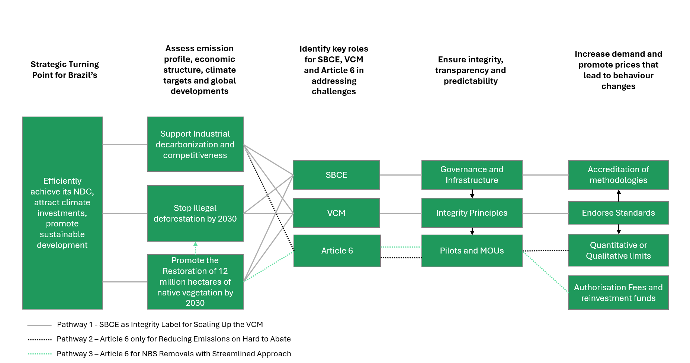

Such exercise aims to serve as an initial reference for collecting feedback from key stakeholders to refine potential pathways for Brazil. As next steps, a quantitative analysis on the economic, environmental and social impacts of the different carbon market frameworks here presented is planned to inform the development of regulations, governance and infrastructure required for the operationalization of an efficient and integrated system in the country.

As part of a broader crosscutting study on Brazil’s major challenges to meet its NDC, the country’s carbon market potential and the existing international benchmarks on integrated carbon market approaches, the first insights of this working paper highlight that early action on Article 6 engagement and VCM promotion should not be contingent upon the full completion of the SBCE regulatory process.

Strategic pilot initiatives and specific market promotion measures can already be deployed in the process of SBCE operationalization to generate credible market signals that increase private sector climate investments and provide learnings to refine policies and operational arrangements. In conclusion, advancing in parallel with the different market-based instruments that the country has at disposal to help achieve its climate commitments can boost efficiency, facilitate policy harmonization, and position Brazil to timely seize investment and development opportunities while advancing toward its NDC and long-term climate goals.

# Endnotes

1. The [Brazilian Sustainable Taxonomy](https://www.gov.br/fazenda/pt-br/orgaos/spe/taxonomia-sustentavel-brasileira#:~:text=Taxonomia%20Sustent%C3%A1vel%20Brasileira,-Info&text=%C3%89%20um%20cat%C3%A1logo%20que%20identifica,sociais%20estabelecidos%20pela%20sociedade%20brasileira.) is a classification system that identifies which economic activities, assets and projects can be considered sustainable according to clearly defined, science‑based criteria aligned with the country's environmental, climate and social objectives.
2. The [Climate Plan](https://www.gov.br/mma/pt-br/composicao/smc/plano-clima) is the guideline for the climate action in Brazil until 2035.
3. Annual estimates of GHG emissions in Brazil. Ministry of Science, Technology and Innovation. Available [here](https://www.gov.br/mcti/pt-br/acompanhe-o-mcti/sirene/publicacoes/estimativas-anuais-de-emissoes-gee).
4. ComexStat (2025). Available [here](https://comexstat.mdic.gov.br/pt/comex-vis).
5. ComexStat (2025). Available [here](https://comexstat.mdic.gov.br/pt/comex-vis).
6. Global Carbon Budget (2024); Bolt and van Zanden - Maddison Project Database 2023 – with major processing by Our World in Data.
7. EPE (2024). Balanço Energético Nacional 2024 – Ano base 2023. Available [here](https://www.epe.gov.br/pt/publicacoes-dados-abertos/publicacoes/balanco-energetico-nacional-2024).
8. International Chamber of Commerce Brazil. (2023). *The Brazilian carbon market: A pathway to sustainable competitiveness*. Available [here](https://www.iccbrasil.org/wp-content/uploads/2023/12/231201_REPORT_ICCBR_2023_IN.pdf).
9. MapBiomas database (latest version, Collection 9 released August 2024):  
   MapBiomas Project. (2024). *Collection 9 of the Annual Land Use Land Cover Maps of Brazil*. Available [here](https://brasil.mapbiomas.org/en/).
10. Brazilian Forest Code (Law No. 12,651 of May 25, 2012, latest consolidated version):  
    Brazil. (2012). *Law No. 12,651, of May 25, 2012*. Presidency of the Republic. Available [here](http://www.planalto.gov.br/ccivil_03/_ato2011-2014/2012/lei/l12651.htm).
11. Brazil. (2024). *Second Nationally Determined Contribution under the Paris Agreement* [NDC submission]. United Nations Framework Convention on Climate Change. Available [here](https://unfccc.int/documents/643337).
12. The implementation gaps can be related to the Global Stocktake - a five-yearly assessment prescribed intended to evaluate collective progress toward its long-term goal. It shows that the current climate commitment is not sufficient to meet the Paris Agreements goals and that approximately USD 4 trillion per year in climate action funding would be needed for that purpose. More information [here](https://www.climateworks.org/report/financing-the-future-we-want/?utm_source=chatgpt.com).
13. ICAP (2025). *Emissions Trading Worldwide: Status Report 2025*. Available [here](https://icapcarbonaction.com/system/files/document/250409_icap_sr25_final.pdf).
14. The Nature Conservancy. (2025). *Article 6 explainer*. Available [here](https://www.nature.org/content/dam/tnc/nature/en/documents/c/m/CM-TNC-Article-6-Explainer.pdf).
15. UNEP Copenhagen Climate Centre. (2025). Article 6 Pipeline: Insights on the development of Article 6 projects and cooperation under the Paris Agreement. Available [here](https://unepccc.org/article-6-pipeline/).
16. World Bank (2025). States and Trends of Carbon Pricing Dashboard. Available [here.](https://www.worldbank.org/en/publication/state-and-trends-of-carbon-pricing)
17. Abatable. (2024). *VCM Investment Attractiveness Index 2024*. Available [here](https://abatable.com/blog/top-40-vcm-investment-attractiveness-index).
18. Ghana’s Article 6.2 Framework Development. Available [here](https://unfccc.int/sites/default/files/resource/Article%206.2%20framework%20development_%20Ghana.pdf).
19. Ministry of Foreign Affairs of Japan. (2025). *The Joint Crediting Mechanism (JCM)*. Available [here](https://www.mofa.go.jp/ic/ch/page1we_000105.html).
20. Environmental Protection Agency Ghana. (2022). *Ghana Carbon Market Framework for public release*. Available [here](https://cmo.epa.gov.gh/wp-content/uploads/2022/12/Ghana-Carbon-Market-Framework-For-Public-Release_15122022.pdf).
21. Observatório do Clima. (2024). Analysis based on IPCC methodology and Climate Equity Reference Project.
22. National Plan for the Native Vegetation Restoration (Planaveg). Available [here](https://www.gov.br/mma/pt-br/composicao/sbio/dflo/plano-nacional-de-recuperacao-da-vegetacao-nativa-planaveg/planaveg_2025-2028_2dez2024.pdf).