caBIG™ Hack-a-thon: Orchestrating caGrid Services in Taverna
June, 2008

Context

The intent of this demonstration is to show how the Taverna GT4 plug-in, developed at the University of Chicago, can be used for Taverna to query and invoke various caGrid services. With the help of the plug-in Taverna can be used to orchestrate caGrid services into workflows.
The Taverna Workbench allows users to construct complex workflows which consists multiple types of components, each type of component is called a processor. These components may locate on different machines, are orchestrate by Taverna, and the results are gathered and shown in the workbench. Current version of Taverna (1.7.1.0) supports many types of processors, including apiconsumer processor, beanshell processor, biomart processor, biomody processor, java processor, soaplab processor, wsdl processor, etc.
Taverna also provides a set of Service Provider Interfaces (SPI) which are extending points for the developers to provide additional functionality for a specific purpose. Using SPI, a plug-in is developed for the CaGrid users to add grid services in a Taverna workflow, and this plug-in is called taverna-gt4-processor. With this processor, a Taverna workflow is aware of the CaGrid services, and could orchestrate the grid services in CaGrid.
This demo intends to provide guidance on how to build caGrid workflows using Taverna. The users are recommended to read Taverna Users Manual at http://www.mygrid.org.uk/usermanual1.7/user_guide.html to get detailed instructions.

Scenario

This demo highlights how to install Taverna 1.7.1.0 and the gt4-plugin, how to query caGrid services with semantic support, how to build a workflow using the services obtained by semantic, and how to execute the workflow and get results.

- Install Taverna and the gt4-plugin. This demonstration will show that, with gt4-plugin, caGrid services over the net are accessible inside Taverna. First we need to install Taverna the latest release of Taverna and the gt4-plugin developed by us.
- Query caGrid services with semantic support. As caBIG aims to connect data and tools from 50+ disparate cancer centers and many other institutions, a critical requirement of its infrastructure is that it supports the ability of researchers to discover these resources. caGrid enables this ability by taking advantage of the rich structural and semantic descriptions of data models and services that are available. As the Index Service contains the service metadata of all the currently advertised and available services in caBIG, the expressivity of service discovery scenarios is limited only by the expressivity of the service metadata. Building on this information, the gt4-plugin supports a set of discovery APIs that facilitate the querying of this information toward the aim of discovering service End Point References (EPRs).
- Build a workflow using the services obtained by semantic query. Once the services’ EPRs have been identified, we use Taverna workbench to add these services into a workflow.
- Execute the workflow and get results. The Taverna workflow that consists of caGrid services, other third party services (like wsdl services, Biomart services, etc), and “shim” processors (like beanshell processors, xmlSplitters, etc) can be executed from the workbench. The execution trace and results are shown in a GUI.

Step 1. Install Taverna and the gt4-plugin.
- The latest version of Taverna workbench can be found at the following URL: http://taverna.sourceforge.net/download. The installation requirement at: http://taverna.sourceforge.net/requirements. Basically, Java 1.5 and internet access is required. Besides, Taverna Linux version makes use of the 'dot' application from the GraphViz (available from: http://www.research.att.com/sw/tools/graphviz/download.html )
- Start Taverna by clicking on “runme.bat” in the install directory. (or typing “sh runme.sh” from a terminal window if you are using OSX or Linux.) The first time Taverna starts, it may take a while to download Maven artifacts (jars and pom files) from remote repositories.

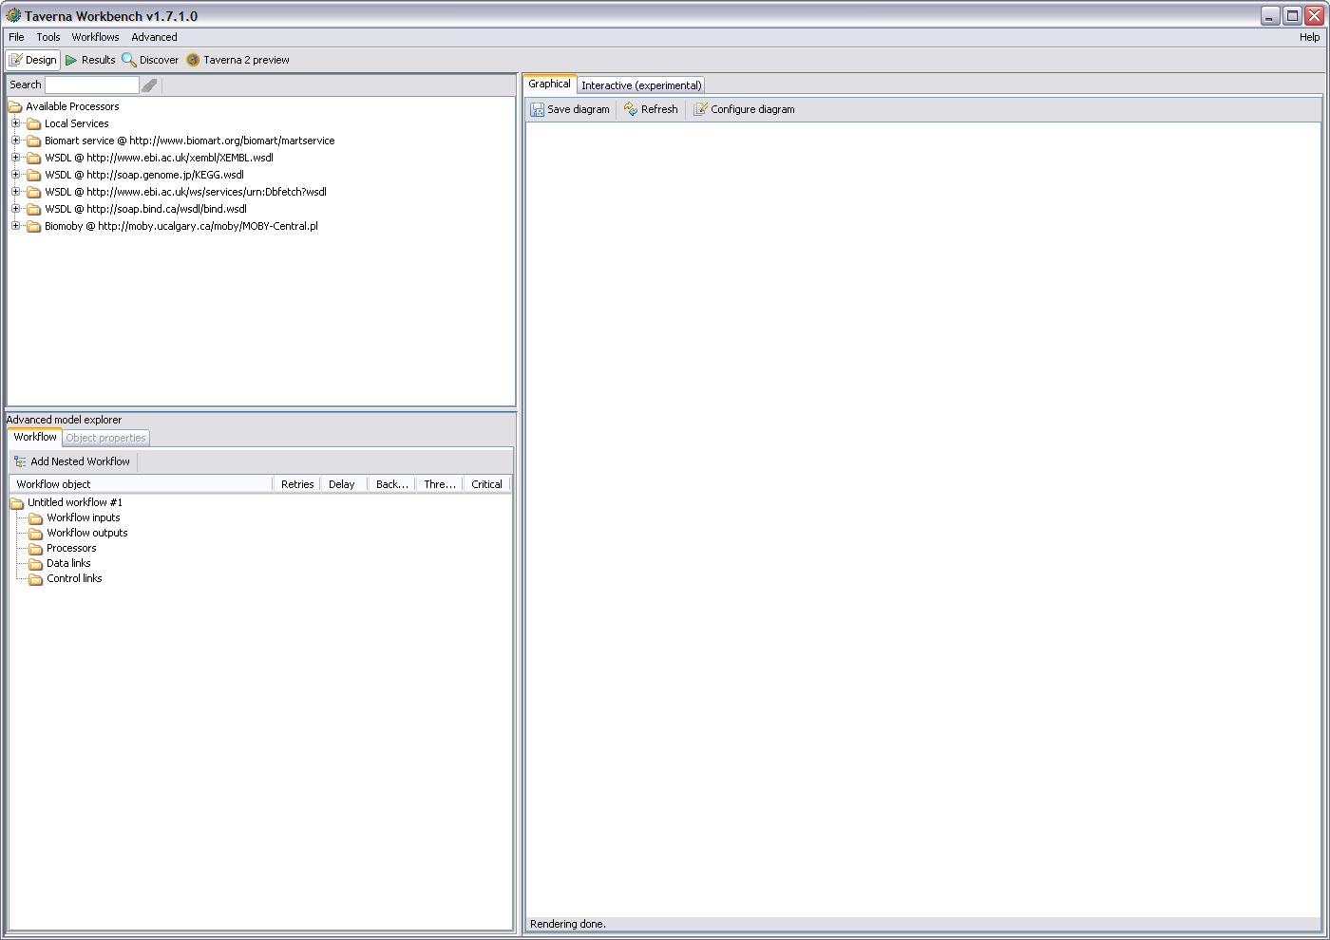

- In order to use the GT4 processor, first we should add it into Taverna workbench. From the main menu, click Tools→Plugin manager→Find New Plugins→Add Plugin Site, and add the name and URL of the plgu-in: “GT4” and “http://www-unix.mcs.anl.gov/~madduri/taverna/”, respectively).
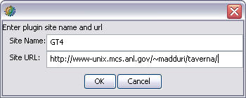
- Select “GT4 Processor 1.7.1.0” and click install. Again, it may take a while to download Maven artifacts (jars and pom files) from remote repositories.
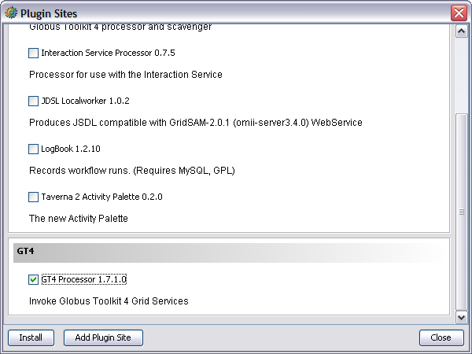
- Now, right-click on “Available Processors” in the top left-hand panel. If you can see to “Add new GT4 Scavenger…” that means the GT4 plug-in is installed successfully.
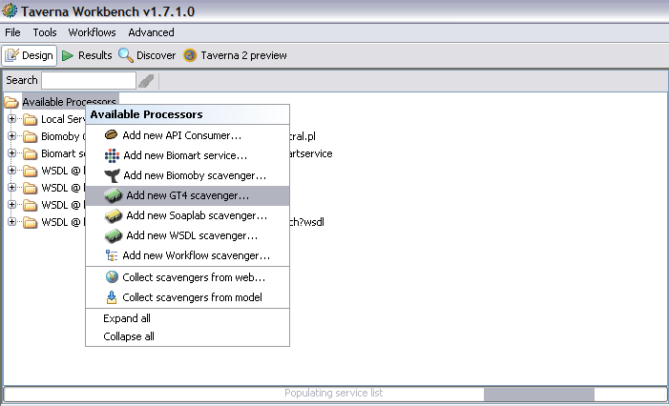

Step 2. Query caGrid services with semantic support.
Often the URL of a service of interest is not a “well known” value, and is something that is discovered at runtime. To locate the caGrid services, we integrate caGrid discovery API in the GT4 plug-in’s scavenger. The GT4 scavenger has two usage scenarios:

- The simplest discovery scenario is to just query the Index Service for all registered services. The scavenger returns an array of EPRs, and the operations belonging to each EPR. Each EPR represents a valid caGrid service, and can be used to by Taverna to create processors to invoke operations on the corresponding services (detailed later). Right-click on “Available Processors” in the top left-hand panel and then “Add new GT4 Scavenger…”, input the URL of the default caGrid index service: http://cagrid-index.nci.nih.gov:8080/wsrf/services/DefaultIndexService in “Location (URL) of the index service” (and keep other fields unchanged) then Taverna workbench will list all the register services together with their operations.

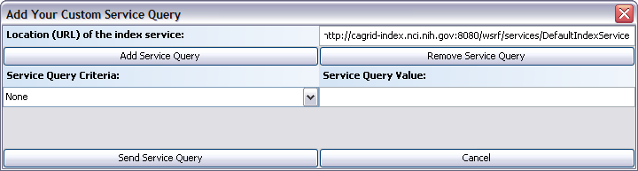

Then the GT4 scavenger is added to the “Available Processors” list in the workbench panel.
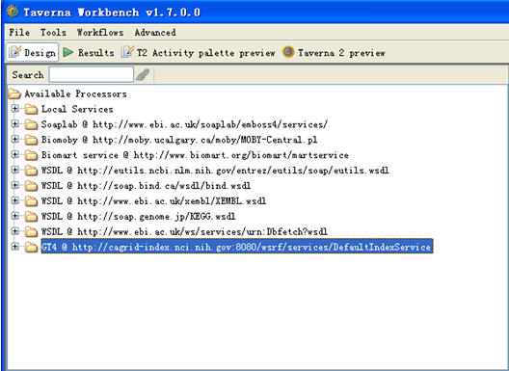

Double click the GT4 Scavenger and get services & operations list in the newly added scavenger
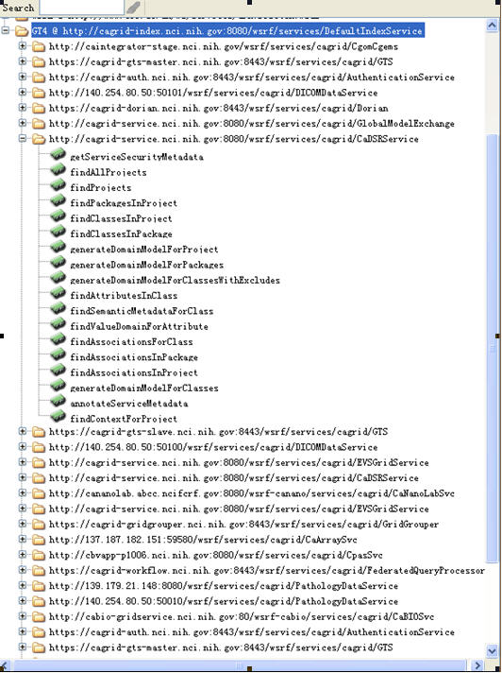

Now the user could add GT4 processors in the scavenger into Taverna workflow. We’ll show how to do this in Step 3.
- Semantic based service query. caGrid discovery APIs provide many discovery capabilities, from “full text search” suitable for a freeform webpage-like interface, simple text-based criteria such as specifying operation names or concept code, and complex criteria (“query by example”) such as specification of point of contact information or UML class criteria.

The GT4 plug-in support semantic based service query. Users can input multiple (up to three, in current scenario three is enough. We can add more in our program upon request) service query criteria and input the corresponding value.

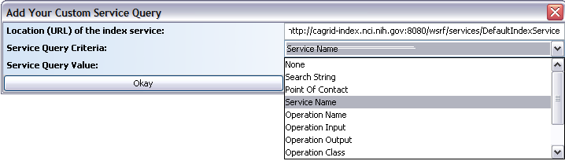

For example, to query the registered service whose “Research Center” name is “Ohio State University”.

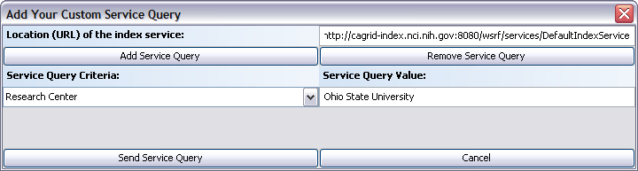

We got the services and their operations like this:

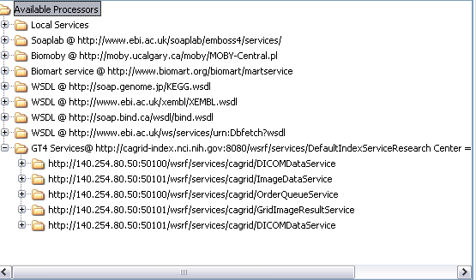

Another example, to query services that have an operation defined that produces the given UML Class “Project”.

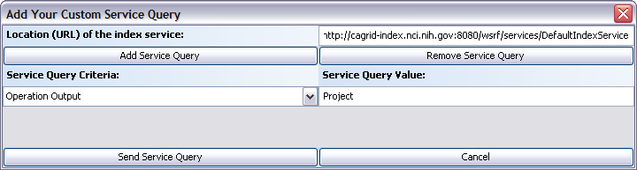

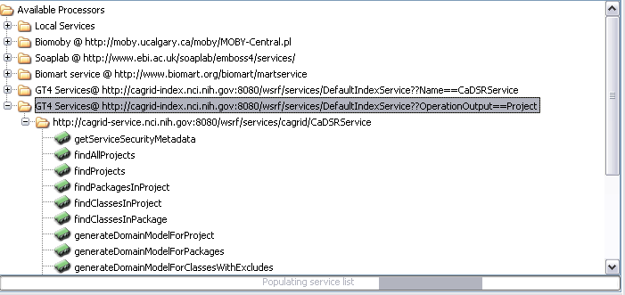

Other semantic based service queries supported by GT4 plug-in include discovery of services by Search String, Point of Contact, Operation Name, Operation Input, Operation Class, Research Center, etc.
We can combine multiple criteria. The initial GUI only shows one query criteria, but more can be added by clicking “Add Service Query” button. For example, we can query the caGrid services whose “Research Center” name is “Ohio State University”, with Service Name “DICOMDataService”, and has operation “PullOp”.

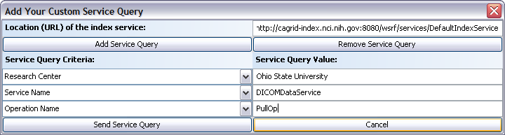

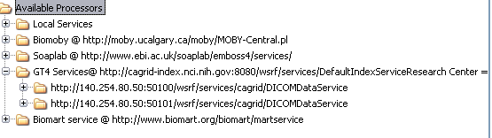

Step 3 Build a workflow using the services obtained by semantic query.
A typical Taverna workflow is made up of:
- Processors that actually perform invocation to services/resources outside.
- “shim services”, like XML splitters that aggregate/split processors’ input and output data, beanshell processors that is a segment of Java code, etc.
- Workflow input and output node.
- Data links.
- Control links.
Here we will not explain these concepts in detail, again, the users are recommended to read Taverna Users Manual to get instructions.
- Add a processor. We can add a new processor into an empty workflow. See the figure below, we add a processor “findProjects”. Find the operation “findProjects” in “Available Processors”, right click and choose “Add to model”, the processor is added into a new workflow which is shown in the diagram in the right.

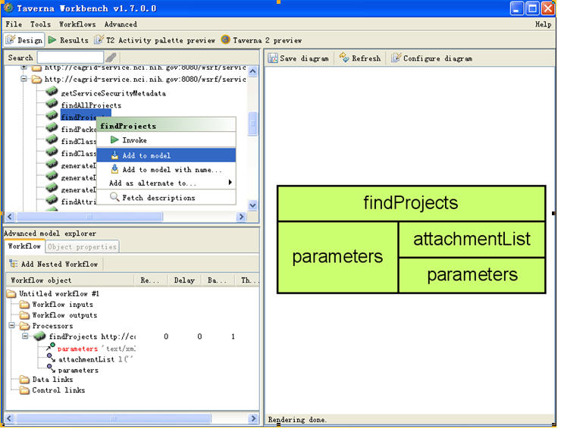

- Add a XML Splitter. In Taverna it is possible to directly provide the XML data needed by WSDL services, but sometimes users might find some XML data elements are too verbose to handle. Taverna provides XML splitters which interrogate the data structure and present to the user the internal data elements. One XML splitter will resolve the input XML data structure by a single level, so multiple splitters might be needed when the XML data contains multiple-level complex types. For example, the XML element parameters is the input of processor findProjects, it contains a text node context as its sub-element, by adding an XML splitter in the input port of processor findProjects, the user could directly input the value of element context. Double click the data element on which you want to add the XML splitter, choose Add XML splitter.

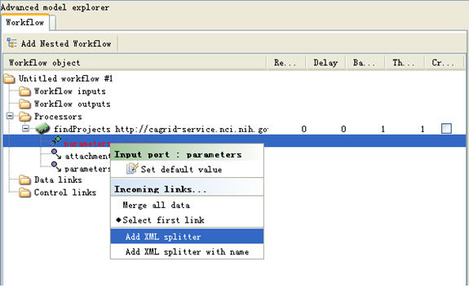
A new splitter is added, with a data link to the processor to which the data element belongs.

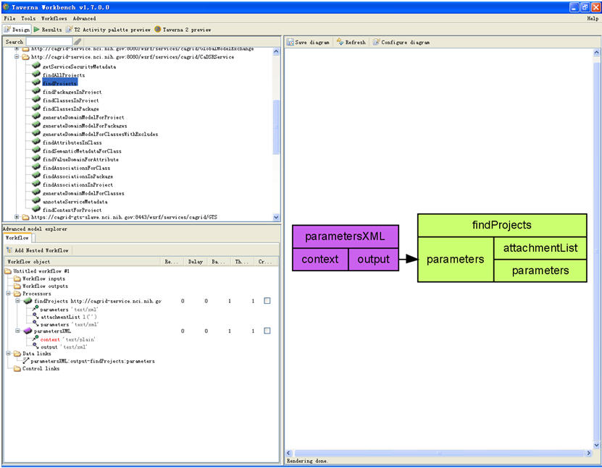

- Assign a default value to a parameter. We can assign a default value to a parameter. For example, we can assign value “caCore” to parameter context (the input of XML splitter parametersXML). Each time the workflow is initiated, the default value is assigned to the parameter.

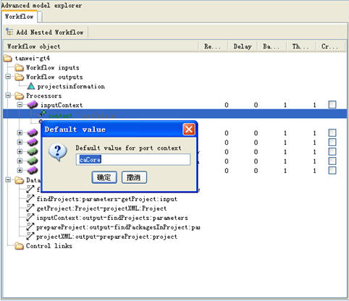
- Add a data link. Data links exist between workflow inputs, processors and workflow outputs. For example, a data link between processor A and B will feed the output of A to the input of B. In the figure below we could see many data links, and these data links are added automatically when we add XML splitters for processors.

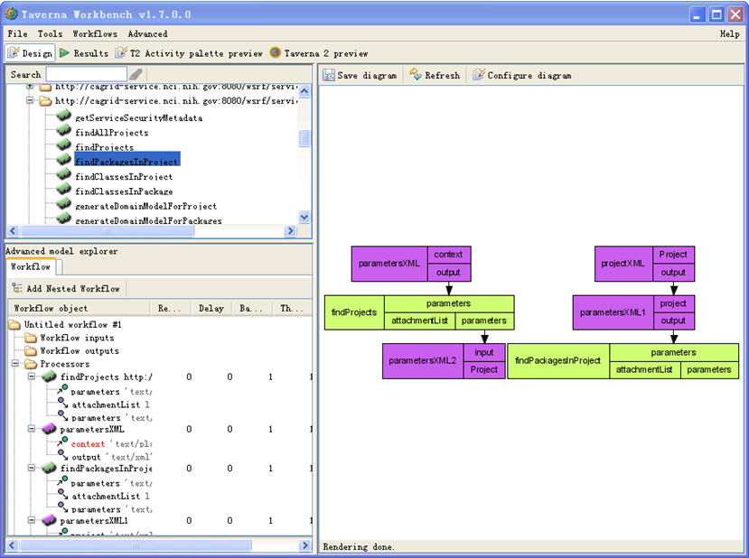

Data links can also be added manually. For example, if we want to feed the output of XML splitter parametersXML2 (i.e., XML element Project) to the input of XML splitter projectXML (also XML element Project), we can find the output in the Advanced model explorer panel, right click and choose the target to connect to.
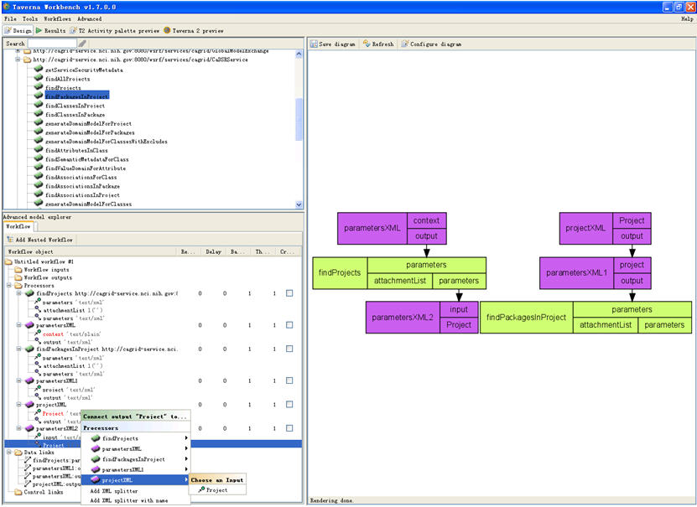
In the figure below we can see that a data link between parametersXML2 and projectXML is added.

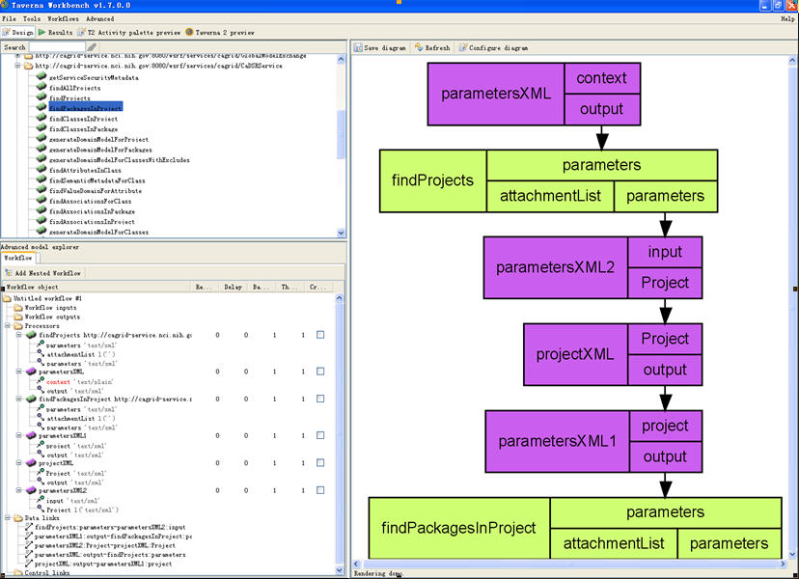

- Add a control link. Control links represents the control flow between processors. The target processor of a control link cannot start until the source processor completes.
- Add workflow input/output nodes. In Advanced model explorer, Workflow inputs and Workflow outputs nodes are used to create workflow inputs and outputs respectively. Right click Workflow inputs/outputs, select Create new input or Create new output. After these nodes are created, the users can connect them to the processors.

A sample workflow
The sample workflow is made up of two processors, findProjects and findPackagesInProject, together with some XML splitters to process their input/output. The purpose of this workflow is straightforward. Step 1: use processor findProjects to get a list of projects related to a context, and in Step2: findPackagesInProject use processor find all the packages in each of the projects. Because the input and output data of these two steps do not fit exactly, we add three xml splitters to transform the output of findProjects into the input of findPackagesInProjects. These three XML splitters are getProject, projectXML and prepareProject, and they are with color purple. The processors are with color green. We use another XML splitter, inputContext, to help the user input the context of the projects to query. In this example, variable context has a default value of caCore. An output node, projectsinformation, is created to store the packages information for multiple projects.

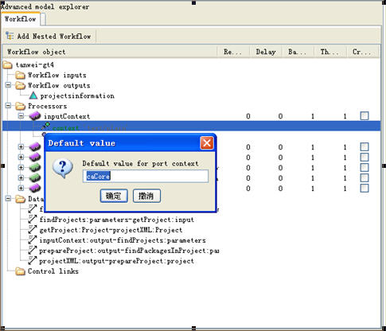

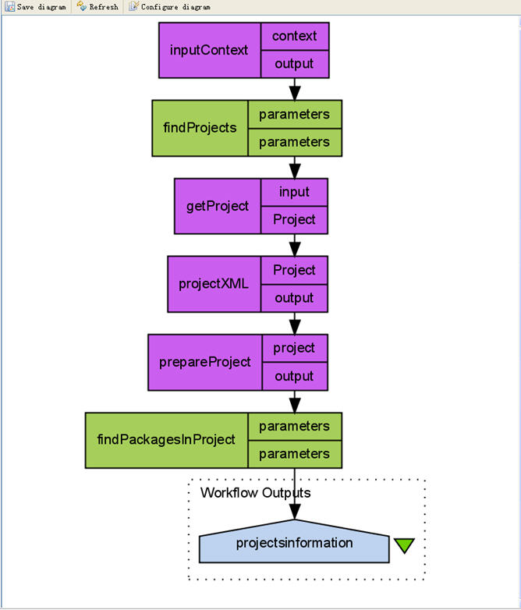

Step 4. Execute the workflow and get results.

From the menu, click "File"→"Run workflow…" to run a workflow in workbench.
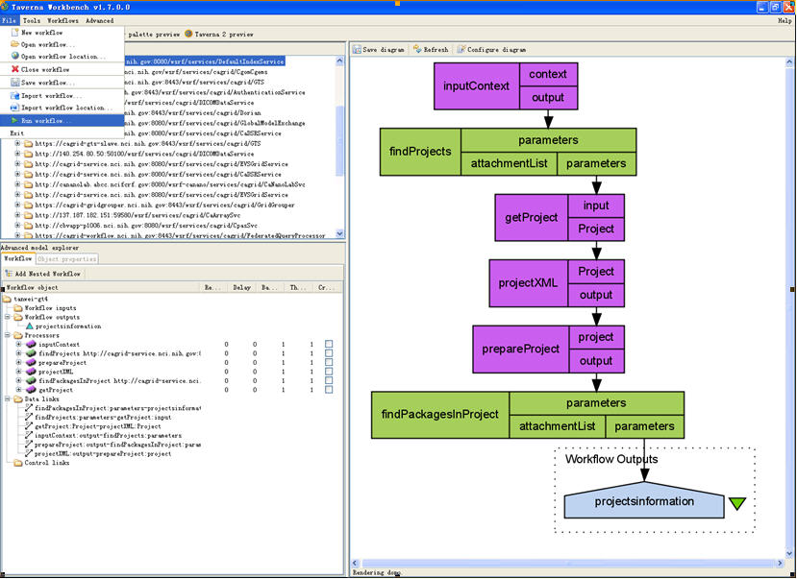

Then the workbench is switched to the Results perspective. The execution trace of the workflow, the status of each processor could be seen with text as well as graph.

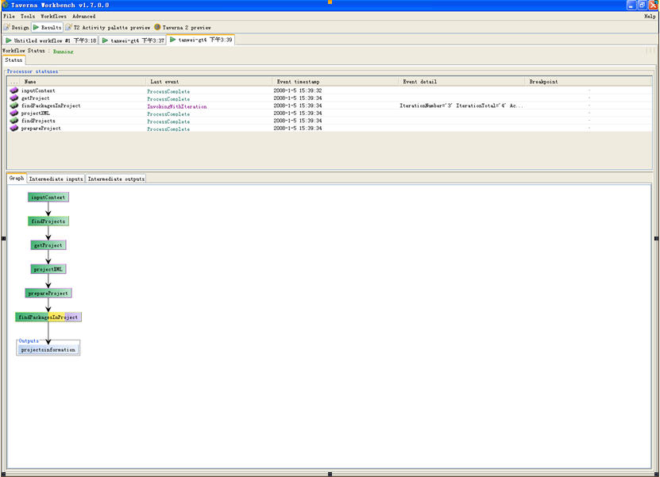

The intermediary output of processor findPackagesInProject:

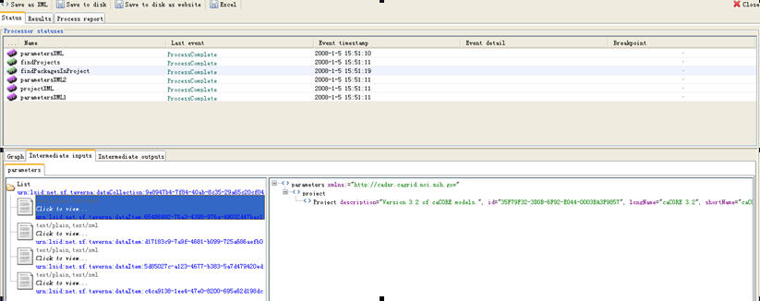

The result of this sample workflow:

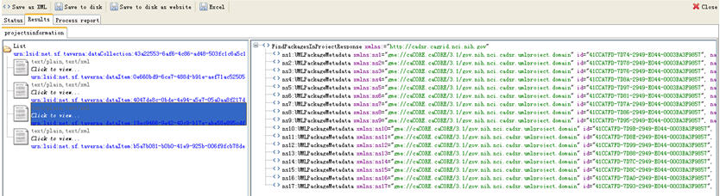
A More Complex Example
This workflow shows the coordinated use of two services in CaGrid, i.e., the caDSR (Cancer Data Standards Repository) and EVS (Enterprise Vocabulary Services) services. caDSR is to define a comprehensive set of standardized metadata descriptors for cancer research terminology used in information collection and analysis. EVS provides resources and services to meet NCI needs for controlled terminology, and to facilitate the standardization of terminology and information systems across the Institute and the larger biomedical community. This sample workflow is to find all the concepts related to a given context, for example, caCore. It is made up of four processors, several XML splitters between them, and a beanshell processor to do some XML transformation which can not be done by XML splitters (XML splitter cannot handle XML attributes). To accelerate the demo, we use two local java widgets, extract elements from a list, to filter out some intermediate results so that the workflow will complete quickly. This reduction does not influence the effect of the demo.
1. Use context information to invoke findProjects in caDSR, and get the project(s) information.
2. Use project information to invoke findClassesInProject in caDSR, to get the classes’ metadata.
3. Use project and classes metadata to invoke findSemanticMetadataForClass in caDSR, to get the semantic data for classes, including conceptName.
4. Use conceptName to invoke searchDescLogicConcept in EVS, to get detailed concept information.
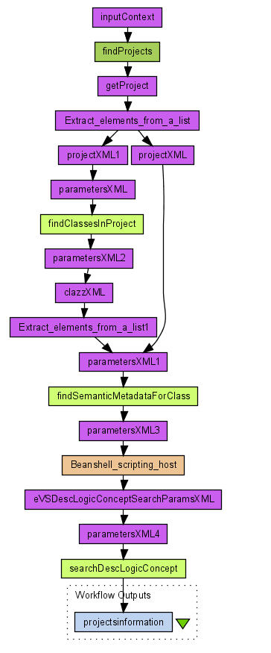
The execution trace.

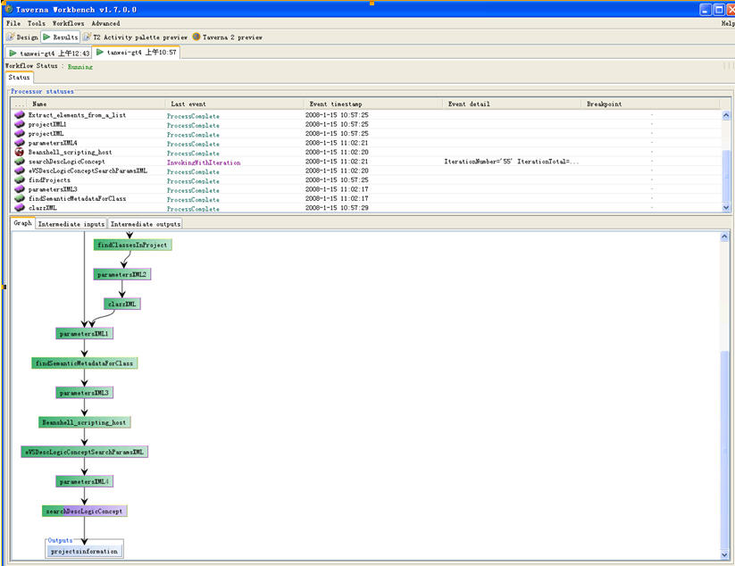

This completes the Taverna demo session. Feel free to continue to explore the program- this demo has only scratched the surface of what Taverna and caGrid services can do, but you now have the basic skills to discover more on your own.

