EUROPEAN REGIONAL EDUCATIONAL ACADEMY

FACULTY OF INFORMATION TECHNOLOGIES

PROJECT
Gold Miner Board Game with Python

Subject: | Python Introduction
Implementer: | Tigran Avetisyan
Supervisor: | Levon Berberyan

YEREVAN 2018

THE ASSIGNED TASK

The task assigned was to write Python code for a board game using the Python Tkinter GUI interface toolkit. The requirements for the code included:
- Logical separation of tasks into modules, classes, and methods as necessary.
- Avoidance of repetition and use of the DRY (Don’t Repeat Yourself) principle.
- Achieving as much code compactness as possible.
- Achieving as much flexibility for the user as possible.
In this game, the goal of the player is to find the specified number of golden coins, at the same time avoiding bombs.

Accomplishment of the assignment
The code has been separated into 3 modules:
- exec.py, which is responsible for the execution of the code.
- board_generator.py, which is responsible for the generation of the game board.
- GUI_generator.py, which is responsible for the generation of the entries that are meant to accept user input. It is also responsible for handling user input.
board_generator.py and GUI_generator.py modules both heavily rely on the use of classes. Classes have been used to minimize code repetition and also increase code readability.
board_generator.py contains the class GameBoard which controls the behavior of the game board. In particular, the methods of this class perform the following actions:
- Generate elements of the game board, i.e. placing bombs and coins.
- Generate buttons and associate them with each cell through their position on the board.
- Determine whether the clicked cell contains a bomb or a golden coin.
- Count the number of found coins, winning the game if the required number of coins has been found.
- Handle losses.
- Reset the game board.
GUI_generator.py contains the class GUI, which’s methods perform the following actions:
- Create labels and entry fields for player input.
- Check the player input and handle it differently depending on what has been entered.
As for the third module – exec.py – it is used to solely initiate the code.
The following Python modules and libraries have been used:
- Tkinter. Was used to create the user interface.
- Random. Its randint method was used to generate positions for the bombs randomly.
- Math. Its ceil method was used to ensure that the number of coins on the board is always greater than 0.

PROJECT DESCRIPTION

Upon launch, the following window opens:
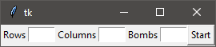
It contains three entry fields labeled Rows, Columns, and Bombs. The player is required to enter the desired number of each element on the game board.
The game has been programmed in a way to allow a maximum of 8 rows and 8 columns. This limit is solely a matter of screen space: otherwise, there are no limits on how many cells the game board can have. The maximum number of bombs is Rows*Columns-1, so that there is at least 1 cell on the game board that contains a coin.
Depending on what values the player enters, the game will respond differently. For example, if he doesn’t enter any values or leaves any field empty, the following error pops up:
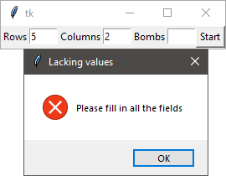
Alternatively, if the number of either the rows or the columns (or both) is greater than 8, the following window pops up:
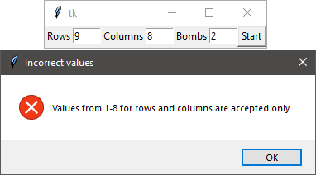
On the other hand, if the entered number of bombs is equal to or greater than Rows*Columns, no errors occur. Instead, the number of bombs is set to Rows*Columns-1 automatically.
Once the player enters the required numbers correctly, the game board is generated. For example, let’s view a 5x5 game board with 5 bombs in it:
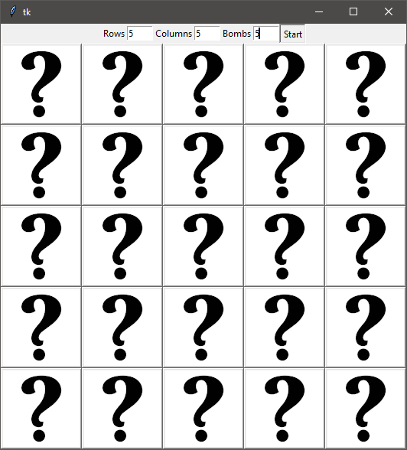
All the elements that haven’t been clicked display a question mark. Once the player clicks on any of the cells, its content is revealed:
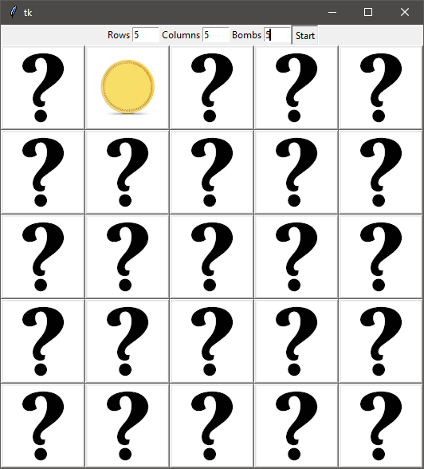
Depending on what is hidden in the cell, the question mark image will be replaced with the image of either a bomb or a golden coin. In this case, the player has found a coin.
When the player clicks on a cell with a bomb, the following happens:
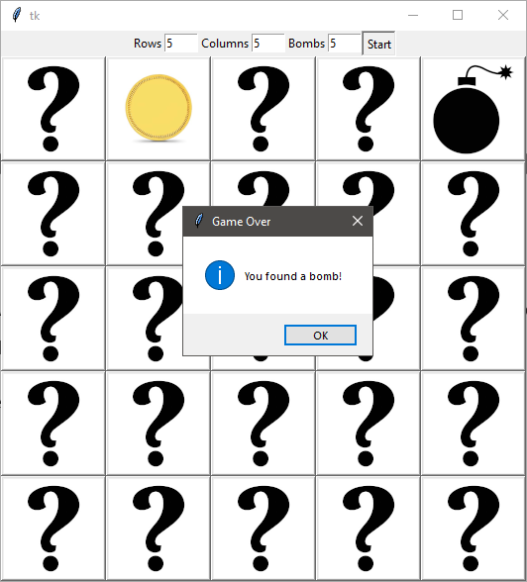
Clicking on a cell with a bomb leads to a loss, with a Game Over popup appearing.
After clicking the OK button in this popup, the buttons are disabled and visually grayed out so the player doesn’t continue clicking on the cells and playing the game:
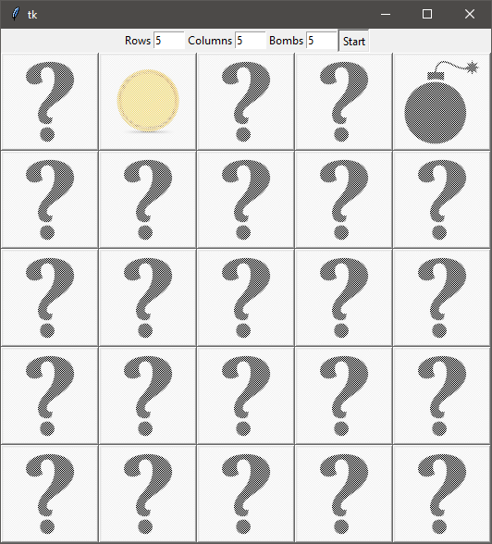
Thereafter, the player can either start the game over or close the application. If the player wishes to keep the board parameters unchanged, he just needs to click the Start button. Otherwise, he needs to enter the desired parameters and then start a game.
Now, let’s demonstrate what happens when the player wins the game on a 4x4 board with 4 bombs.
The game has been coded so that the player needs to find approximately the 1/3 of the golden coins hidden on the board. In the code, it is ensured that this number can never be a 0: otherwise, the game would be unwinnable due to the way it has been coded.
In case of a 4x4 board with 4 bombs, the player would need to find (4*4-4)/3 coins ((rows*columns-bombs)/3), or 4 coins.
After the player finds 4 coins, the following happens:
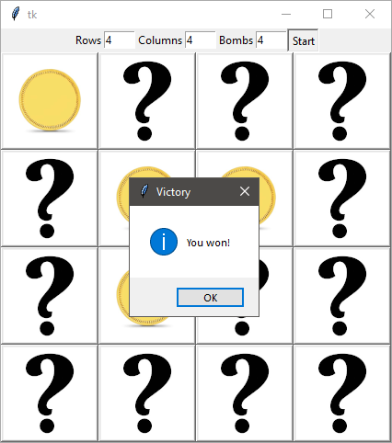
Like it was with the loss popup, the buttons are grayed out after the players clicks the OK button:
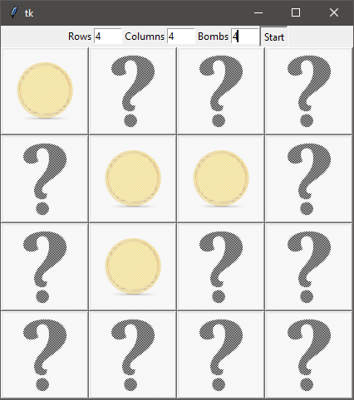
For simplicity, square game boards have been demonstrated. However, the code allows the creation of any rectangular board, as long as the number of either its rows or columns is no greater than 8.
In the end, this is a very simplistic game that allows some degree of flexibility and customizability for the player. Despite its simplicity, it could be made into a much more complex project that is more interesting from the perspective of both coding and player experience.

REFERENCES
- https://www.tutorialspoint.com/python/python_gui_programming.htm
- https://www.python-course.eu/python_tkinter.php
- http://effbot.org/tkinterbook/
- https://stackoverflow.com/questions/14349526/creating-a-game-board-with-python-and-tkinter
- https://docs.python.org/3/
- http://www.evolvefish.com/Question-Mark-Vinyl-Decal_p_563.html - question mark image.
- http://simpleicon.com/bomb.html - bomb image.
- https://mobile.caratlane.com/product/gold-coins/1gm-24kt-plain-gold-coin-gc00026-4y0000.html - gold coin image.

