ﻣﺮﺿﻴﺔ
إﺟﺎزة
ﺗﻘﺮﻳﺮ


Sick leave Report

Leave ID | PSL24082552533 |  | رﻣﺰ اﻹﺟﺎزة
Leave Duration | 1 day(29-03-2026) to (29-03-2026) | 1 ﻳﻮﻡ(10-10-1447) اﻟﻰ(10-10-1447) | ﻣﺪة اﻹﺟﺎزة
Facilities name | 29-03-2026 | 10-10-1447 | ﺗﺄرﻳﺦ اﻟﺪﺧﻮل
Facilities name | 29-03-2026 | 10-10-1447 | ﺗﺄرﻳﺦ اﻟﺨﺮوج
Date Issue | 29-03-2026 |  | ﺗﺎرﻳﺦ اﺻﺪار اﻟﺘﻘﺮﻳﺮ
Facilities name | Nouf Munir Al-Juhanni | ابتهاج عايض | اﻻﺳﻢ
Iqama/ID National | 1137941645 |  | رﻗﻢ اﻟﮫﻮﻳﺔ/اﻹﻗﺎﻣﺔ
Nationality | Ibtihaj Ayed | اﻟﺴﻌﻮدية | اﻟﺠﻨﺴﻴﺔ
Employer |  | اﻟﻰ من يهمه اﻻﻣﺮ | ﺟﮫﺔ اﻟﻌﻤﻞ
Physician Name | Sulaiman Ghaita Hussein Ghaita | سليمان غيتة حسين غيته | اﺳﻢ اﻟﻄﺒﻴﺐ اﻟﻤﻌﺎﻟﺞ
Position | Internal Medicine Specialist | اﺧصائي باطىية | اﻟﻤﺴﻤﻰ اﻟﻮظﻴﻔﻲ

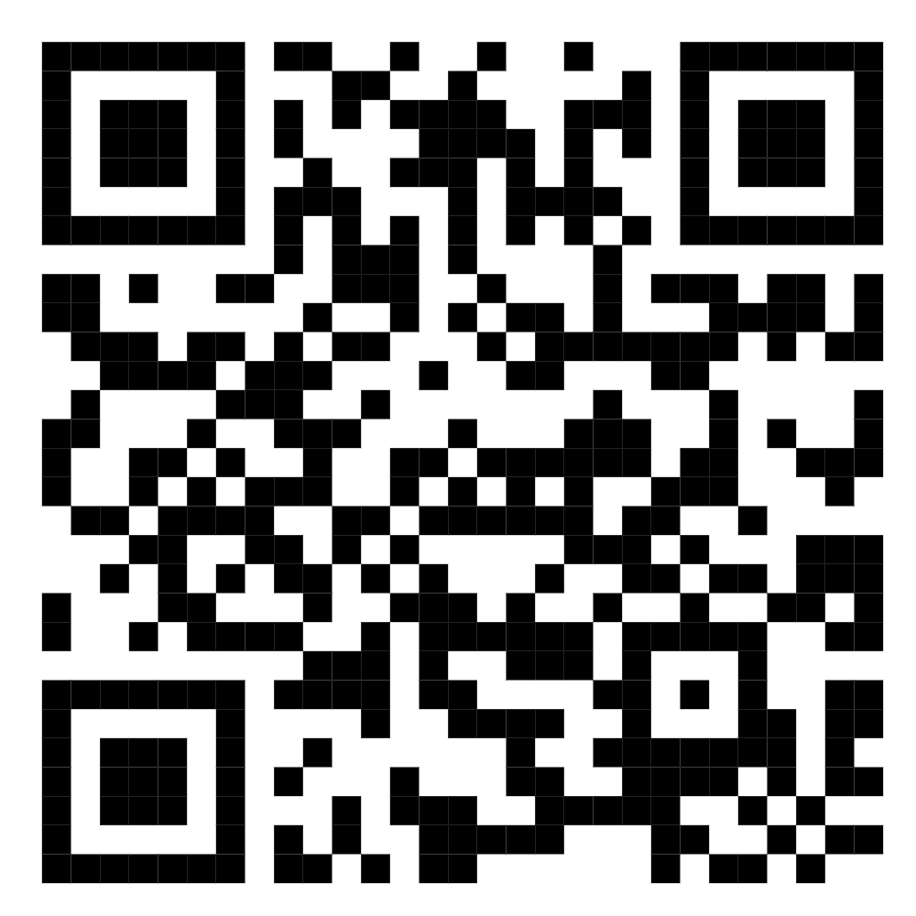



=ﻟﻠﺗﺣﻘق ﻣن ﺑﯾﺎﻧﺎت اﻟﺗﻘرﯾر ﯾرﺟﻰ اﻟﺗﺎﻛد ﻣن زﯾﺎرة ﻣوﻗﻊ ﻣﻧﺻﺔ ﺻﺣﺗﻲ اﻟرﺳﻣﻲ.

To check report please visit seha official website https://seha-su-sua-gov.netlify.app/

