ﻣﺮﺿﻴﺔ
إﺟﺎزة
ﺗﻘﺮﻳﺮ


Sick leave Report

Leave ID | PSL24082552533 |  | رﻣﺰ اﻹﺟﺎزة
Leave Duration | 1 day({{date_g}}) to ({{date_g}}) | 1 ﻳﻮﻡ(1{{date_h}}) اﻟﻰ({{date_h}}) | ﻣﺪة اﻹﺟﺎزة
Facilities name | {{date_g}} | {{date_h}} | ﺗﺄرﻳﺦ اﻟﺪﺧﻮل
Facilities name | {{date_g}} | {{date_h}} | ﺗﺄرﻳﺦ اﻟﺨﺮوج
Date Issue | {{date_g}} |  | ﺗﺎرﻳﺦ اﺻﺪار اﻟﺘﻘﺮﻳﺮ
Facilities name | {{name_en}} | {{name_ar}} | اﻻﺳﻢ
Iqama/ID National | {{national_id}} |  | رﻗﻢ اﻟﮫﻮﻳﺔ/اﻹﻗﺎﻣﺔ
Nationality | Ibtihaj Ayed | اﻟﺴﻌﻮدية | اﻟﺠﻨﺴﻴﺔ
Employer |  | اﻟﻰ من يهمه اﻻﻣﺮ | ﺟﮫﺔ اﻟﻌﻤﻞ
Physician Name | {{doctor_en}} | {{doctor_ar}} | اﺳﻢ اﻟﻄﺒﻴﺐ اﻟﻤﻌﺎﻟﺞ
Position | Internal Medicine Specialist | اﺧصائي باطىية | اﻟﻤﺴﻤﻰ اﻟﻮظﻴﻔﻲ

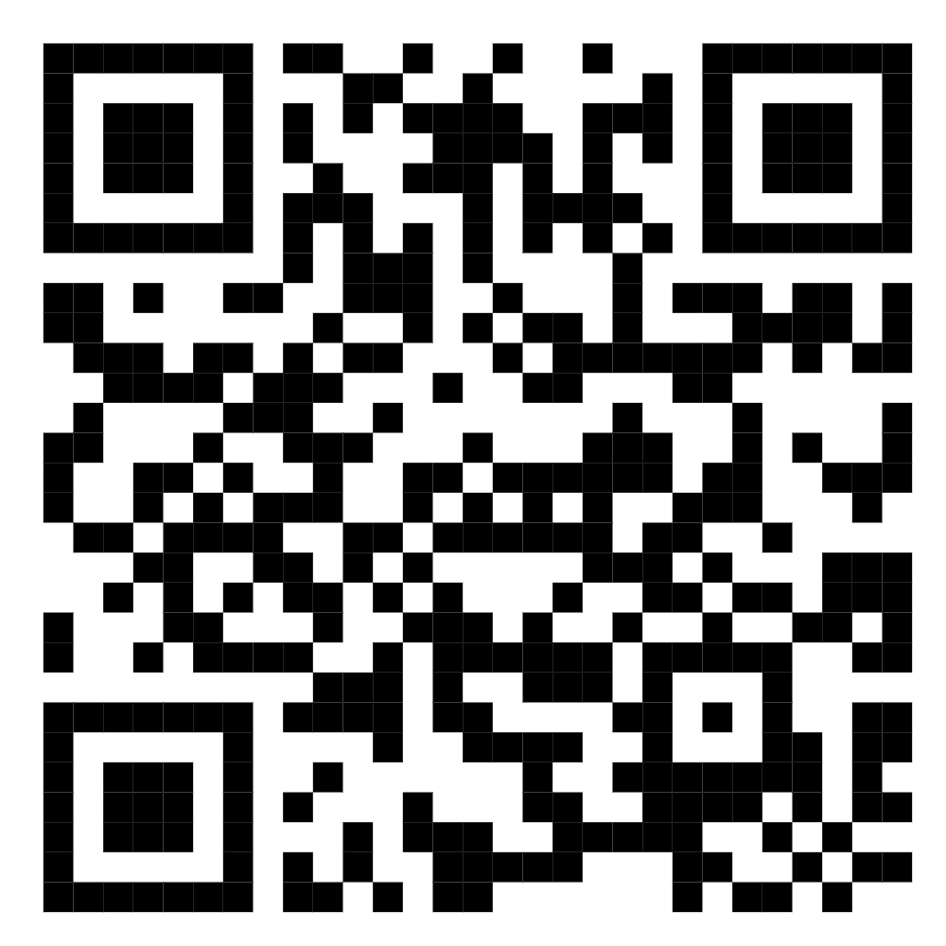



=ﻟﻠﺗﺣﻘق ﻣن ﺑﯾﺎﻧﺎت اﻟﺗﻘرﯾر ﯾرﺟﻰ اﻟﺗﺎﻛد ﻣن زﯾﺎرة ﻣوﻗﻊ ﻣﻧﺻﺔ ﺻﺣﺗﻲ اﻟرﺳﻣﻲ.

To check report please visit seha official website https://seha-su-sua-gov.netlify.app/
{{hospital}}

