**UML Diagram**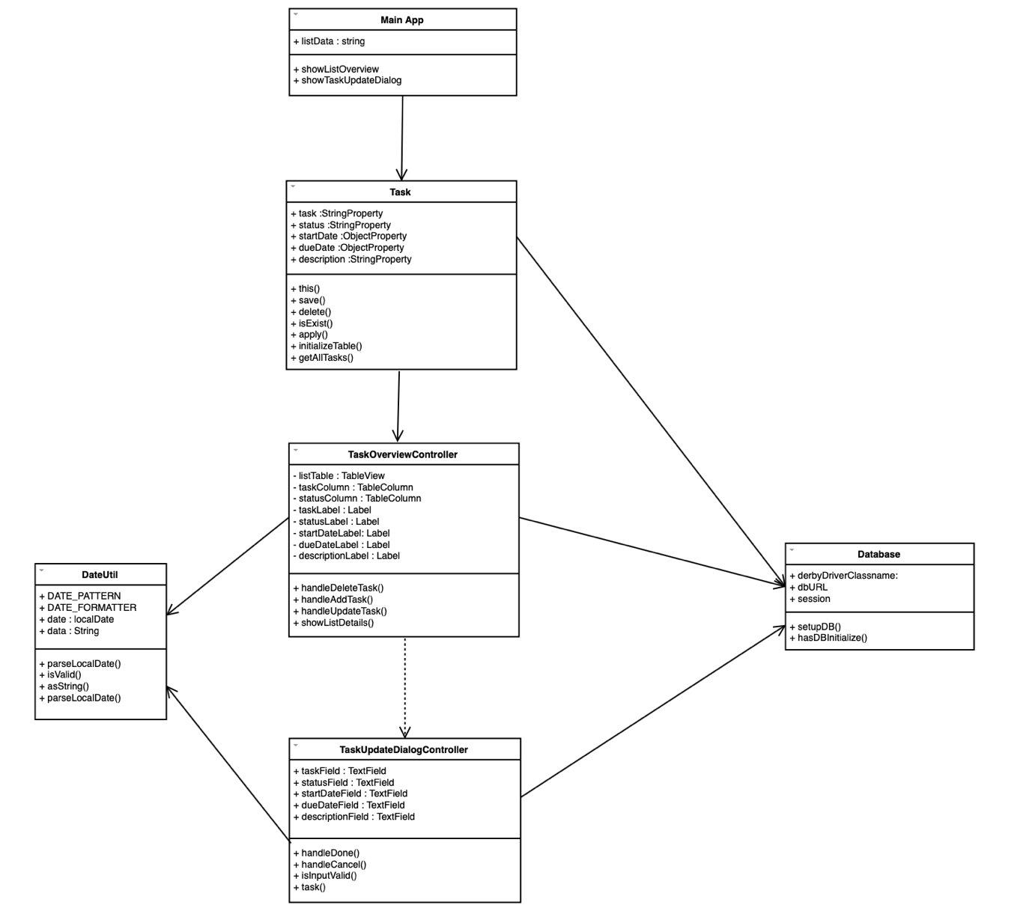

There are few use cases in this system, firstly the ***detail of task will show*** in the right-hand side of the main interface, like the following figure.

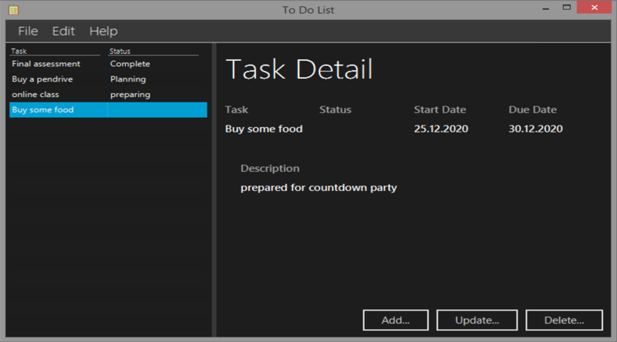

The next use case is ***Update***, is for user to update or edit any task in this system. The following figures are the example of update detail of the task.

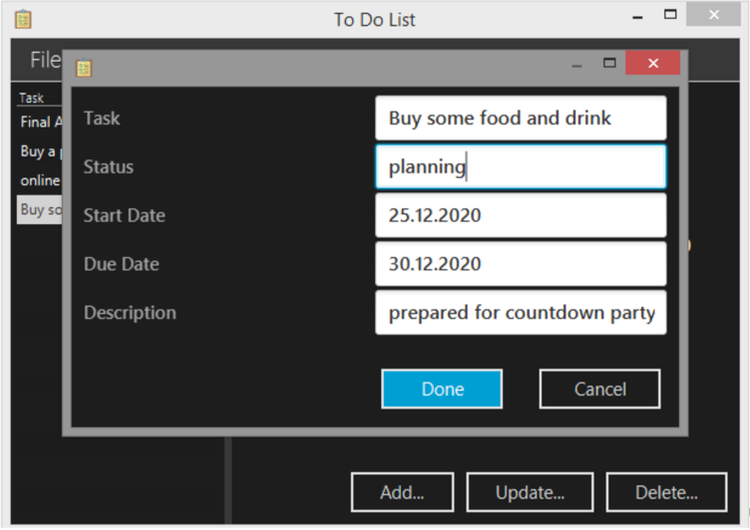

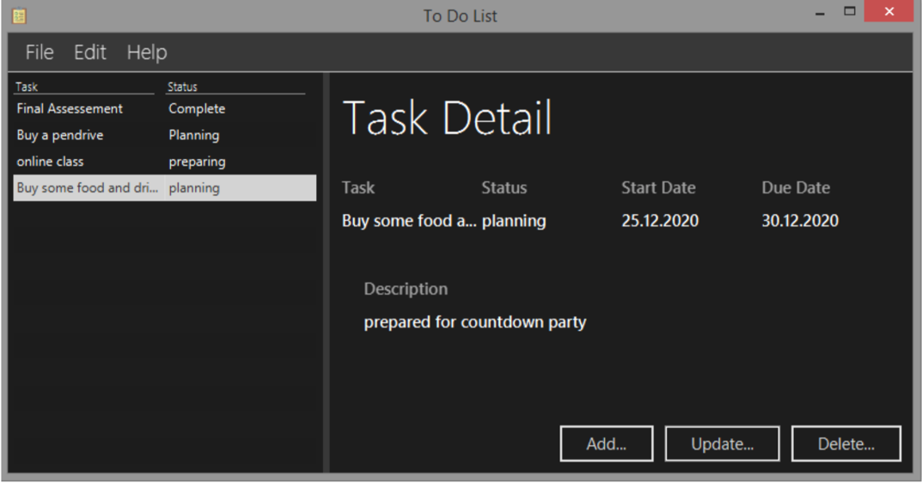

The following use case is ***Add*** a new task, in this use case user can add any validate task in the database, the validation in this use case is same as Update use case, user only need full up the correct format which in the task field and start date field.

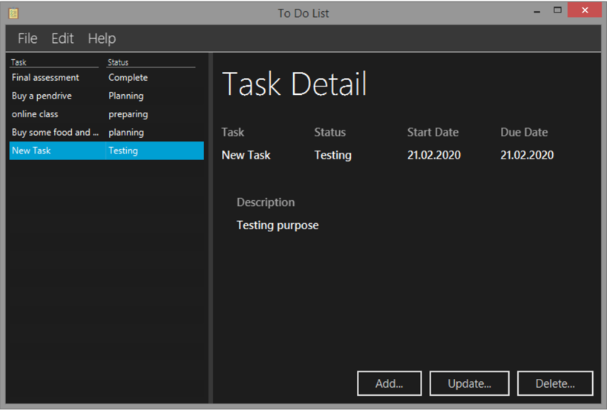

***Delete*** also is one of the use cases in this system, user can delete any task who are store in the database and display in this system.

***Before Delete***

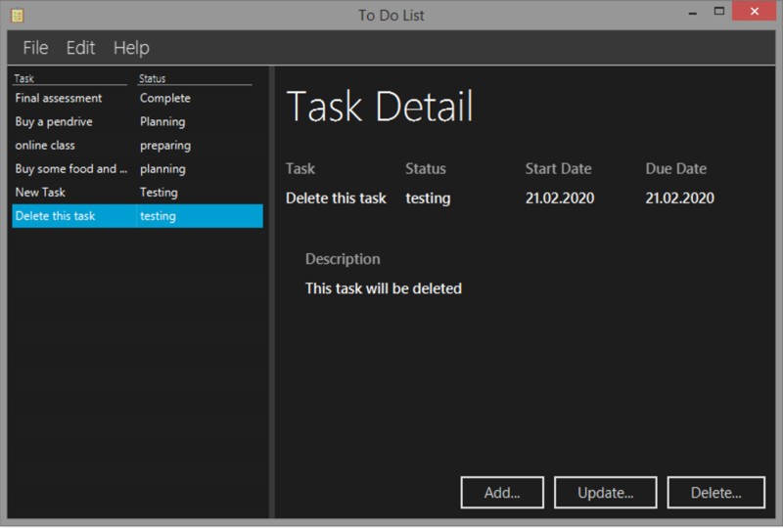

***After Delete***

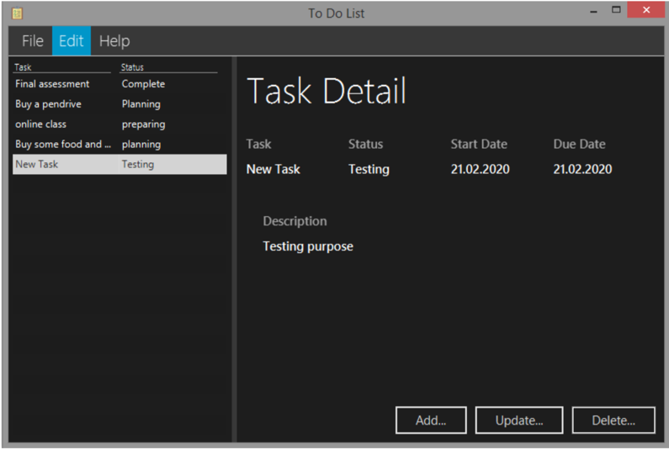

In this assignment the system that I code is called the To-Do List system, this system is for a user to list down or save the task that they need to do. Some people are more prefer to write on a piece of paper but when there is no paper or pen, this system is the most useful system for them to write down as a memory aid. In this To-Do List system, the user able to add a new task, view the details of the task, update a certain task and delete the task, although there is not much function these few functions are basic and important. Furthermore, in this system, all the tasks are saved in the database so that users can view the task at any time even shut down and run this system again.

Although this is a simple system, during doing this assignment I still encounter some issues, for example, the main issue is setup the database, my problem is when I run this system the first time there is nothing error but when I run in the second time, the terminal message shows me some error message. After I read through the whole code again, I found the problem which is to type the wrong name of the database.

The strengths of my system are users can easily add a new task with some validation only, users can easily understand what is the purpose of every single function, and users able to update their task’s detail from time to time. Besides the strengths of this system, the weakness of this system is a user not able to set in time format only able to set it in date format and the next feature I can improve is set a popup message to the user before the due date of the task.