TO-BE Summary
Customer Accounts and Profiles
As a first improvement, I implemented the ability of users to make personal profiles. For this, I created a new class called Customer Account containing the name, e-mail address, and password and implemented functions for creating, updating, or deleting a profile. It is very beneficial to implement this improvement because it saves a lot of time for the reoccurring customers because instead of having to put there contact info in every time, they purchased a comic. The account now saves that information. Moreover, it allows implementing more logical business flow because there are separate algorithms for members and guest clients. 2. Editable Shopping Carts
As a second improvement, I implemented the ability of customers to edit their shopping carts during the purchase process. It was achieved by adding new methods to the Shopping Cart class, which allow the user to change the number of comics in a particular variant or delete an entry from the shopping cart completely. The advantage of this improvement is obvious – it prevents a client from being frustrated when buying a comic because he will be able to check and correct his purchases during the process of purchasing comics.

As is
Functional Requirements
1. Manage Comic Inventory
- 1.1. Add new comics
  - 1.1.1. Select the "Add New Comic" function.
  - 1.1.2. Capture new comic details.
  - 1.1.3. Create and save the new comic record in the system.
- 1.2. Update existing comics
  - 1.2.1. Select a specific comic from the existing inventory list.
  - 1.2.2. Modify specific data fields.
  - 1.2.3. Save the updated comic record.
- 1.3. Remove comics
  - 1.3.1. Select a specific comic from the existing inventory list.
  - 1.3.2. Select the "Remove Comic" function.
  - 1.3.3. Delete the selected comic record entirely from the system database.
2. Browse and Shop Comics
- 2.1. Browse available catalog
  - 2.1.1. Display a comprehensive list of all comics currently tracked in the system.
  - 2.1.2. Display the Title, Issue Number, Variant, Publisher, Published Date, Genre, and Quantity for each listed comic.
- 2.2. Manage shopping cart
  - 2.2.1. Select an in-stock comic from the catalog.
  - 2.2.2. Add the selected comic to the virtual shopping cart.
  - 2.2.3. Prompt the customer with a choice to either proceed to checkout or continue browsing.
- 2.3. Handle out-of-stock items
  - 2.3.1. Identify if a selected comic currently has a stock quantity of 0.
  - 2.3.2. Generate an "Out of Stock" notification for the customer.
  - 2.3.3. Automatically query the system for an alternative, in-stock comic of the exact same genre.
  - 2.3.4. Display a prompt recommending the alternative comic.
  - 2.3.5. Add the recommended comic to the cart if the customer selects "Yes".
  - 2.3.6. Close the prompt and allow the customer to continue browsing if they select "No".
- 2.4. Initiate checkout
  - 3.1.1. Select the checkout option after adding items to the cart.
  - 3.1.2. Prompt the customer to confirm they are ready to check out.
- 2.5. Capture customer information
  - 3.2.1. Capture customer Name.
  - 3.2.2. Capture customer Email address.
- 2.6. Finalize order
  - 3.3.1. Generate a unique Order ID.
  - 3.3.2. Record the order in the system, tying the captured customer details to the selected cart items.
  - 3.3.3. Print the finalized order information so the store employee can physically retrieve the comics.
Use case Diagram
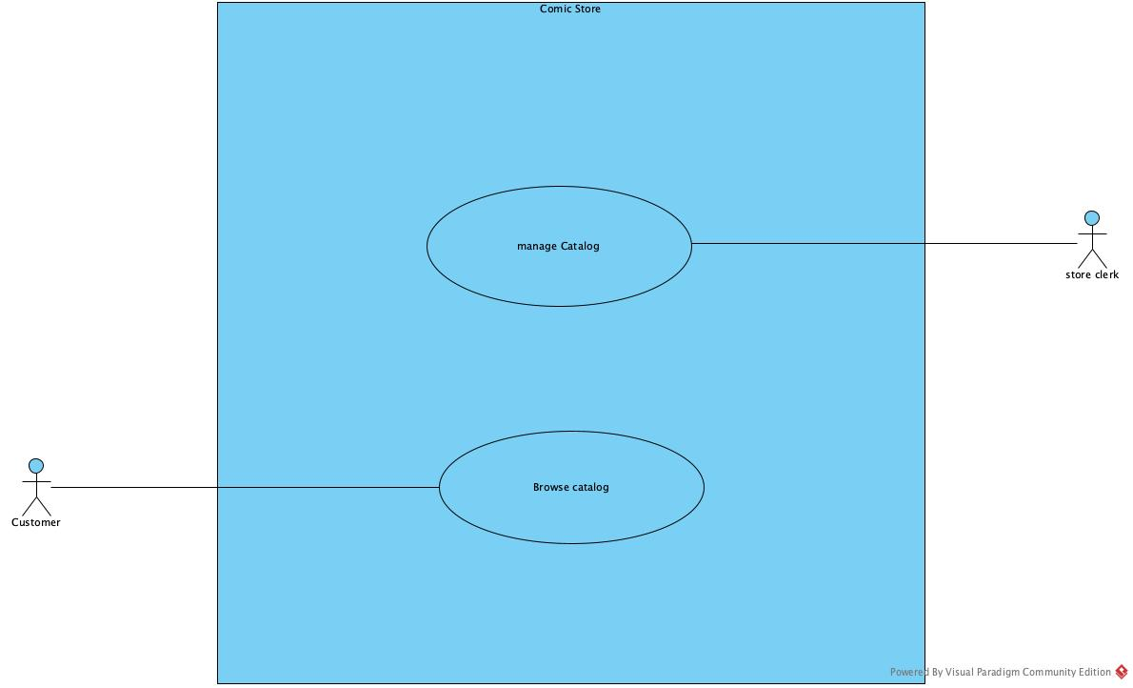

Activity Diagram
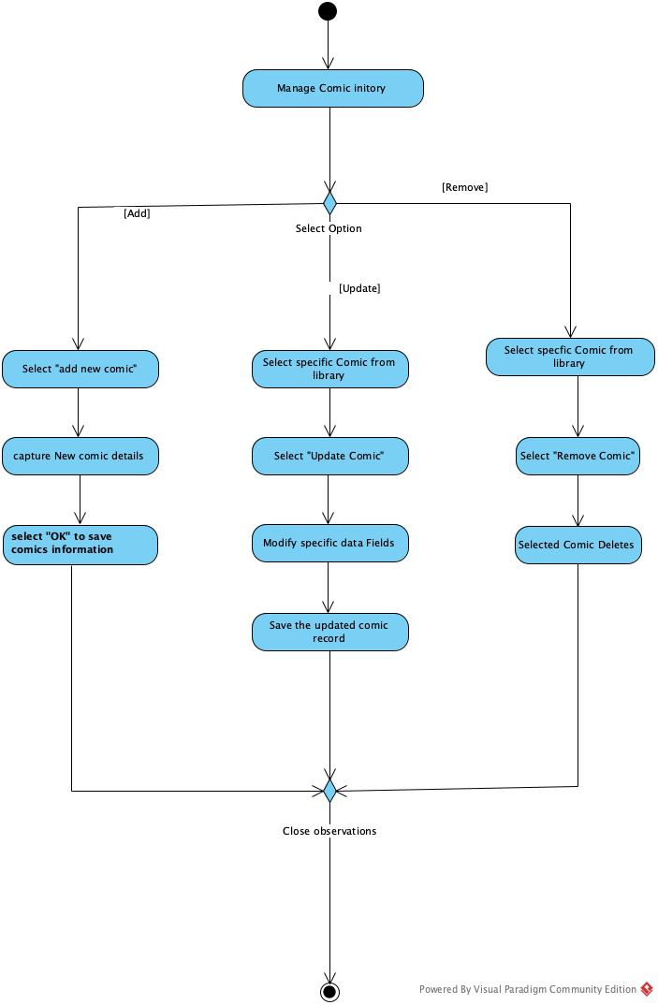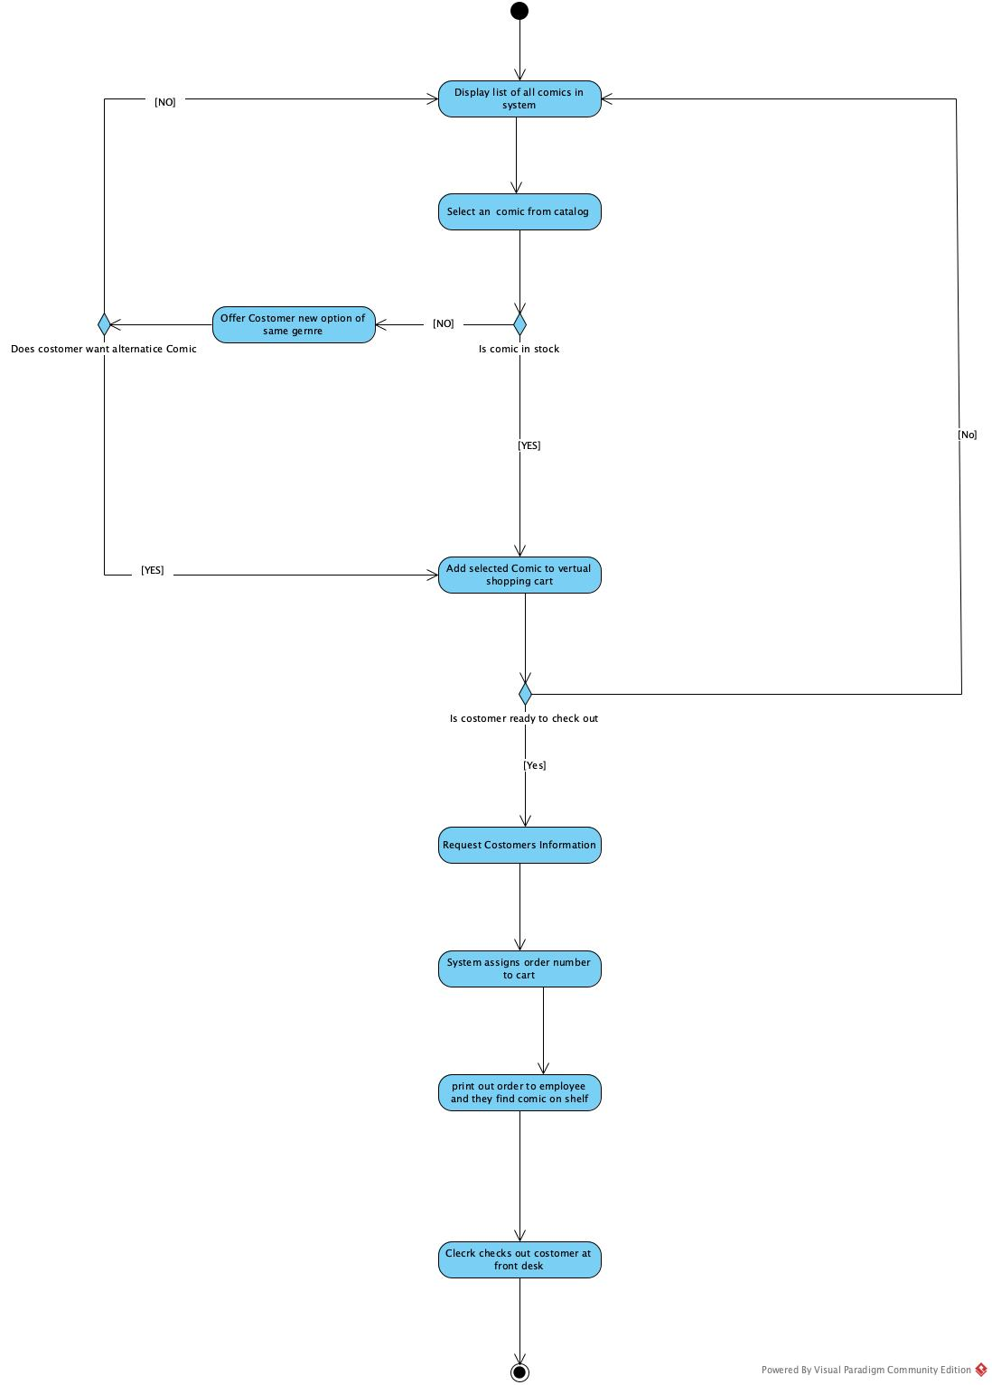

Use Case Descriptions

CRC Card

Class Name: Comic | ID: 1 |  | Type: Concrete, Domian
Description: Represents a comic book tracked within the store's inventory system. |  |  | Associated Use Cases: Add New Comic, Update Comic Data, Remove Comic, Browse Comics, Add to Cart, Recommend Alternative Comic
Responsibilities  Maintain comic metadata (title, publisher, etc.)  Update and track inventory quantity  Check stock availability |  | Collaborators  ShoppingCart  Order

Back:
Attributes:
Title, Issue Number, Variant ID, Publisher, Published Date, Genre, Quantity
Relationships:
Generalization (a-kind-of):

Aggregation (has-parts):

Other Associations:

Front:
Class Name: ShoppingCart | ID: 2 |  | Type: Concrete, Domain
Description: A temporary collection of comic books selected by a user during their session. |  |  | Associated Use Cases: Add to Cart, Checkout
Responsibilities  Add selected comic to cart  Maintain a list of selected items  Provide cart contents for Order creation |  | Collaborators  Comic  Order

Back:
Attributes:

Relationships:
Generalization (a-kind-of):

Aggregation (has-parts):

Other Associations:

Front:
Class Name: Order | ID: 3 |  | Type: Concrete, Domain
Description: A finalized purchase request containing the customer's details and the comics they intend to buy. |  |  | Associated Use Cases: Checkout, Complete Purchase
Responsibilities  Capture customer contact information  Generate a unique Order ID  Record the list of purchased comics |  | Collaborators  ShoppingCart  Comic

Back:
Attributes:
Order ID, Customer Name, Customer Email, Order Items (List of Comics)
Relationships:
Generalization (a-kind-of):

Aggregation (has-parts):

Other Associations:

Swimlanes diagram

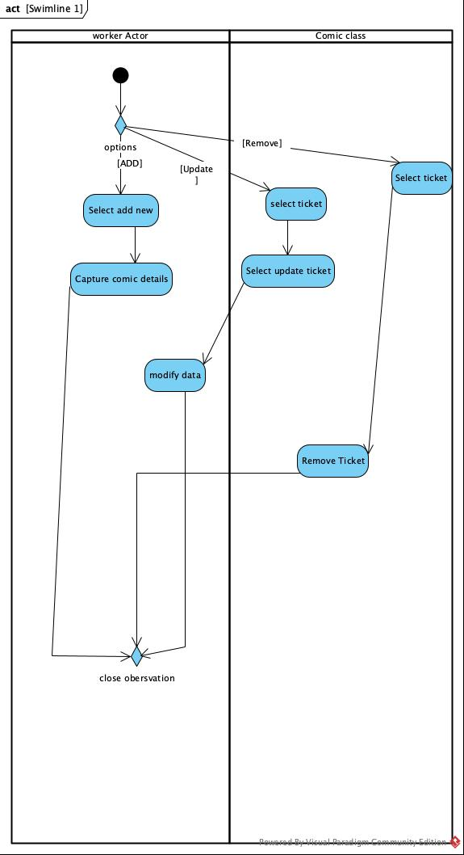

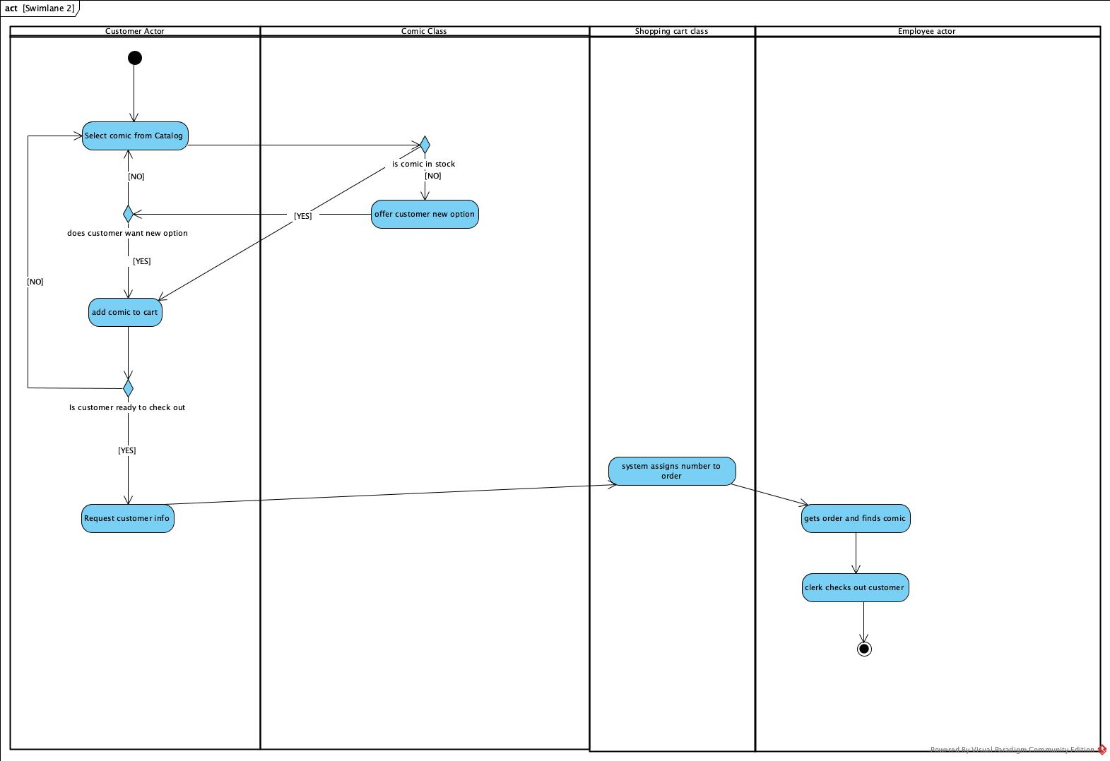

Class Diagram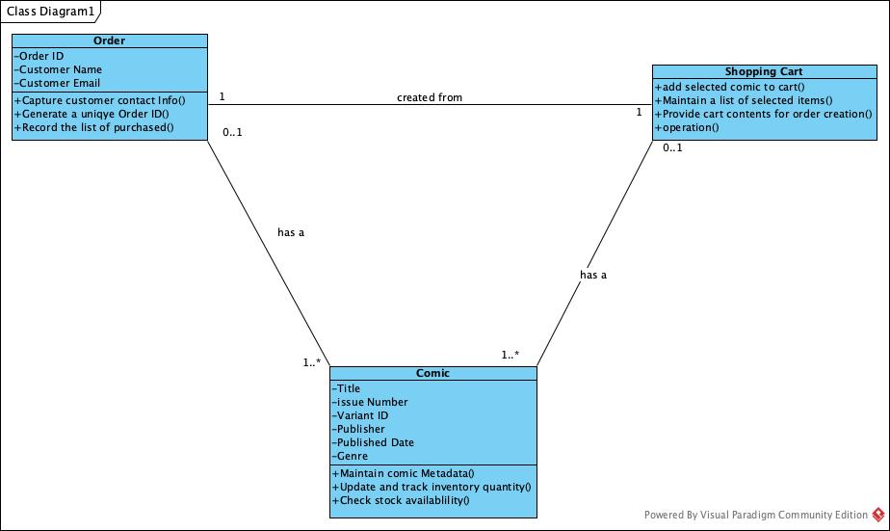

Sequence Diagram

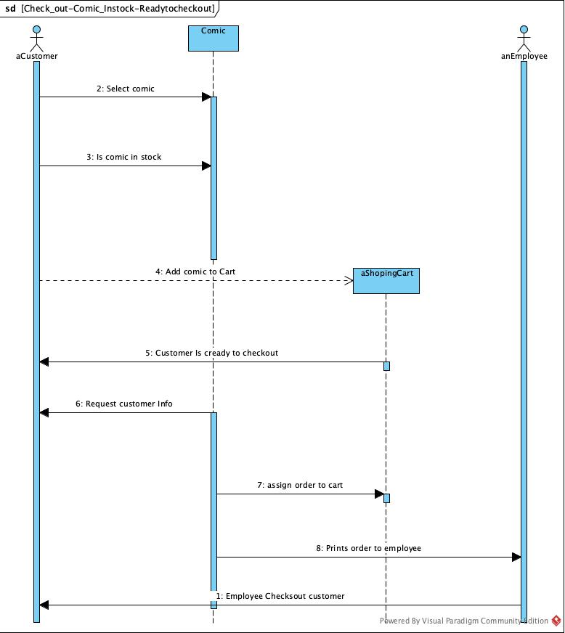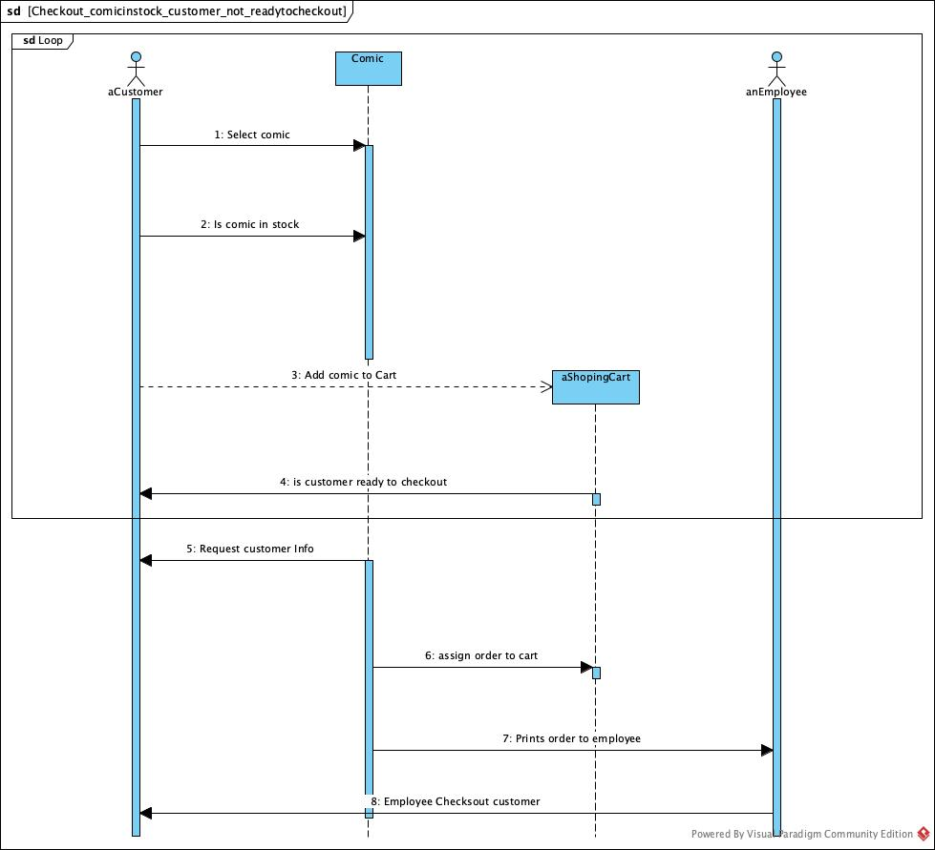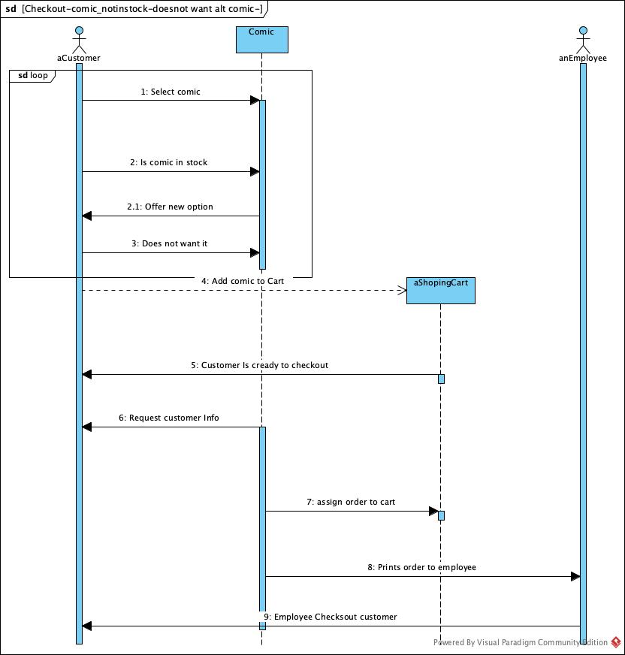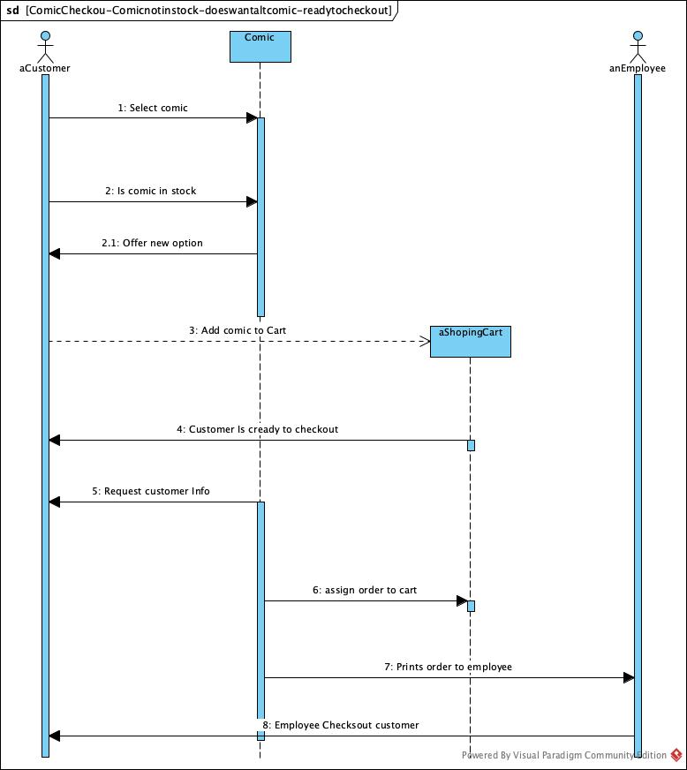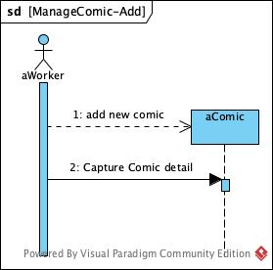

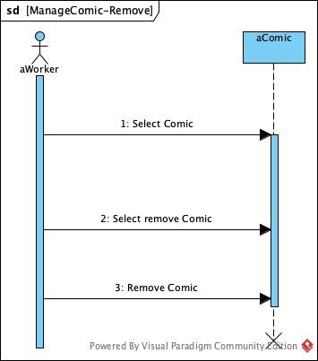

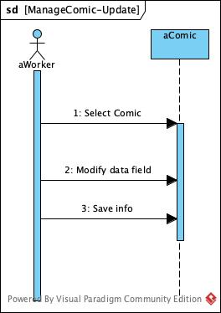

CRUDE Matrix
C-Create
R-Read, get, select
U-Update
D-Delete
E-Execute

 | Worker Actor | Comic Class | Customer Actor | Shopping Cart Class | Employee actor | Order Class
Worker Class |  | C,R,U,D
Comic Class |  |  | E | U,E
Customer Actor |  | R,E |  | C,R,U |  | C
Shopping Cart Class |  |  |  |  |  | C,E
Employee Actor |  | R |  | R |  | R,E
Order Class |  |  |  |  | E

Behavioral State Machines
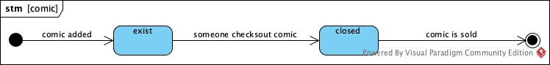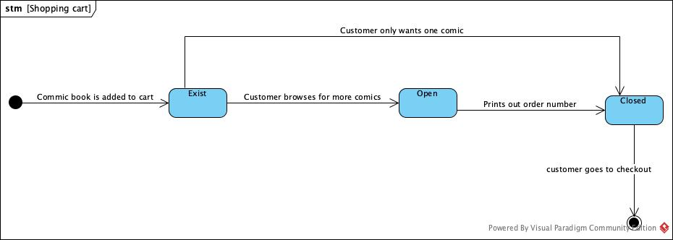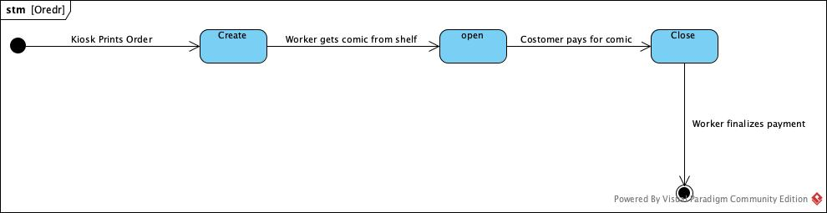
Package Diagram
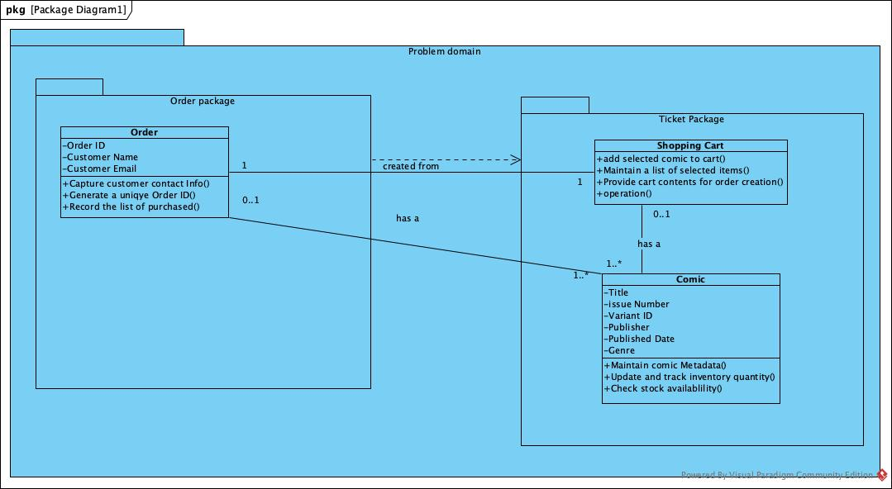

Contract

Method Name: Create | Class Name: Comic | ID: 1
Clients (Consumers):
Associated Use Cases: Add new comics
Description of Responsibilities: Create a new instance of the Comic Class.

Arguments Received: Title: String, IssueNumber: Integer, VariantID: String, Publisher: String, PublishedDate: Date, Genre: String, Quantity: Integer

Type of Value Returned: aComic: Comic
Pre-Conditions: Not Title = Null, Not Publisher = Null
Post-Conditions: None

Method Name: add selected comic to cart | Class Name: Shopping Cart | ID: 2
Clients (Consumers): Comic
Associated Use Cases: Browse and Shop Comics, Manage shopping cart
Description of Responsibilities: To associate a new comic with a Shopping Cart Object.

Arguments Received: aComic: Comic

Type of Value Returned: Boolean
Pre-Conditions: Not comicList.includes(aComic)
Post-Conditions: comicList = comicList@pre.including(aComic)

Method Name: Record the list of purchased | Class Name: Order | ID: 3
Clients (Consumers): Shopping Cart
Associated Use Cases: Finalize order
Description of Responsibilities: To associate a list of purchased comics with an Order Object.

Arguments Received: aShoppingCart: ShoppingCart

Type of Value Returned: Boolean
Pre-Conditions: Not orderItemsList.includes(aShoppingCart)
Post-Conditions: orderItemsList = orderItemsList@pre.including(aShoppingCart)
To be
Customer accounts or profiles
Editable shopping carts

Use case Diagram

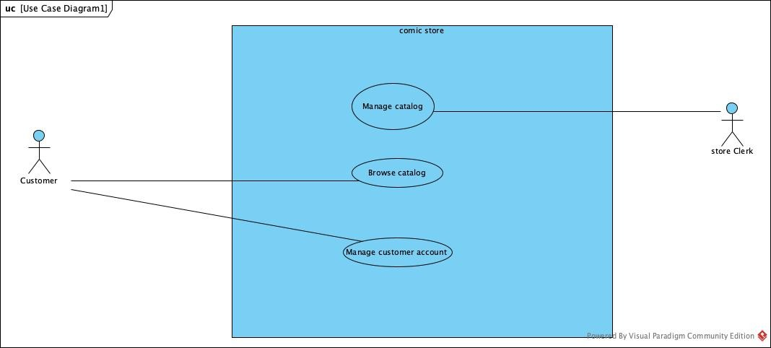

Activity Diagram
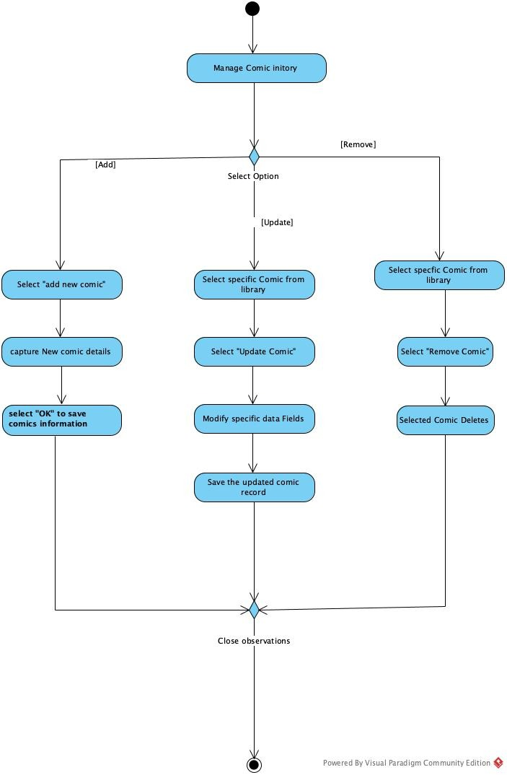
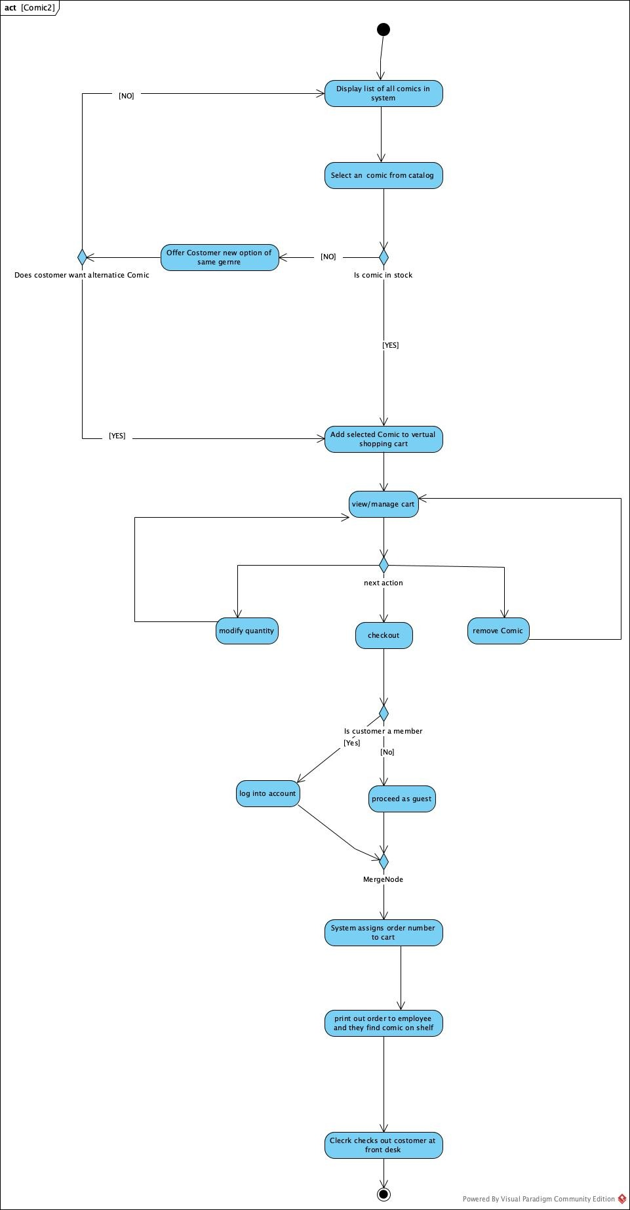
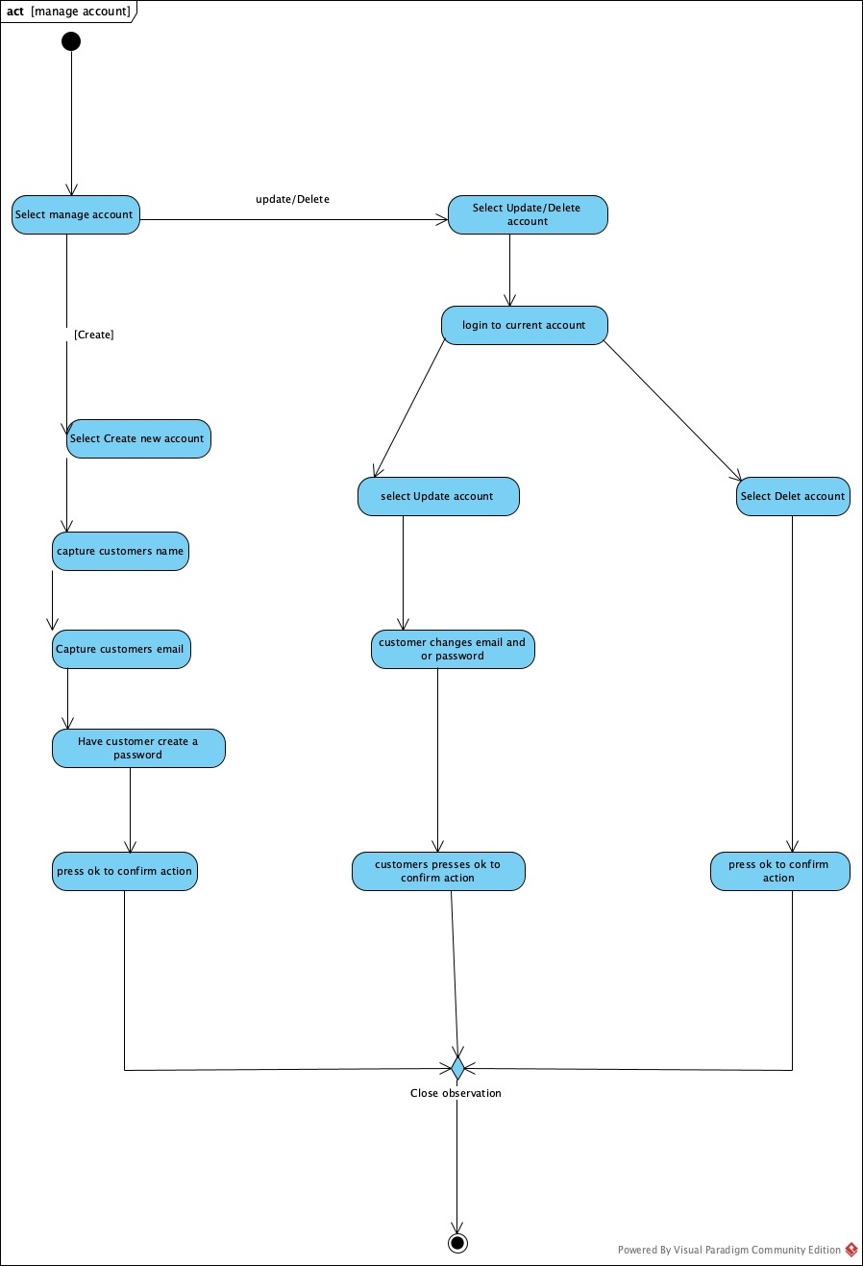
Swimlanes diagram
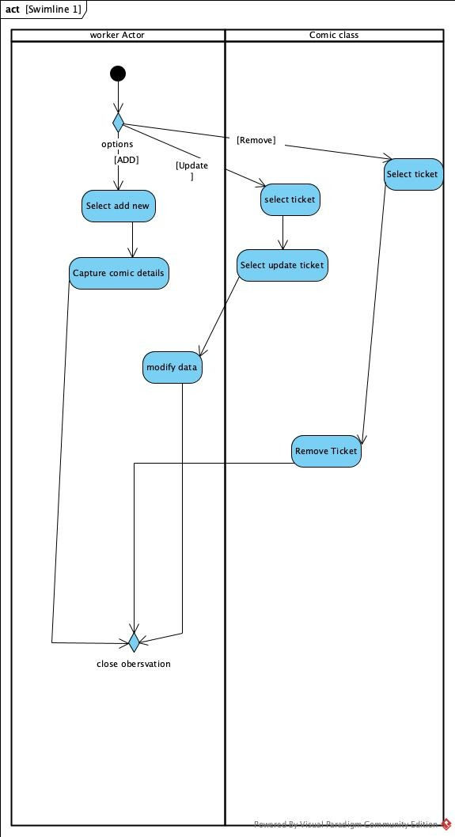
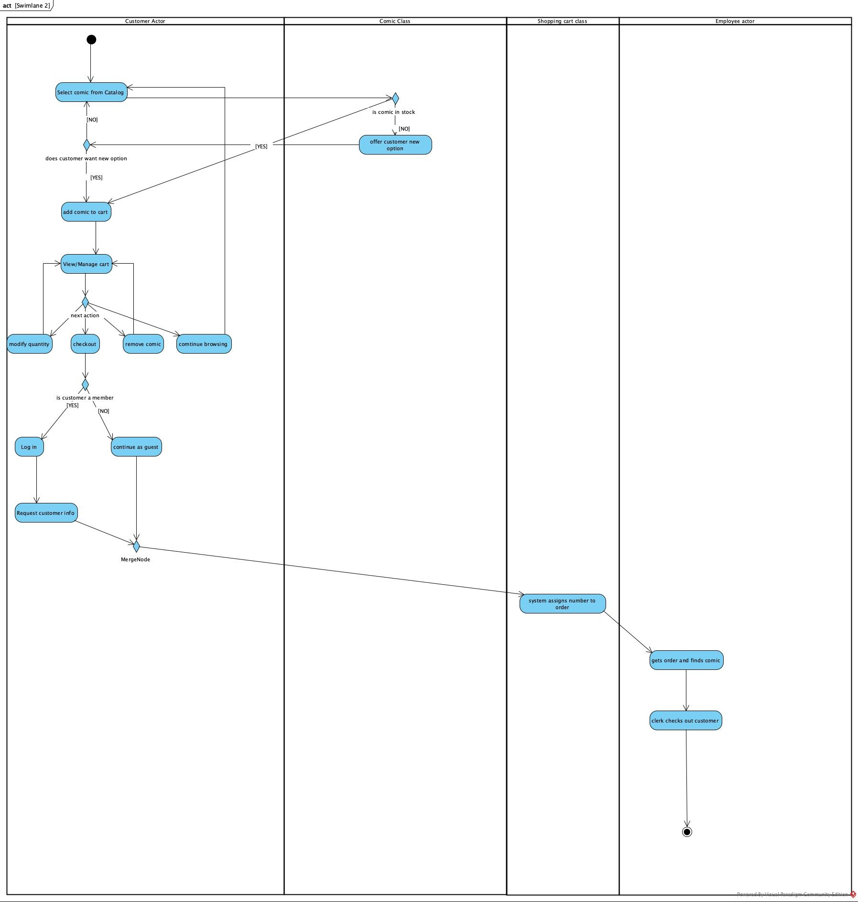

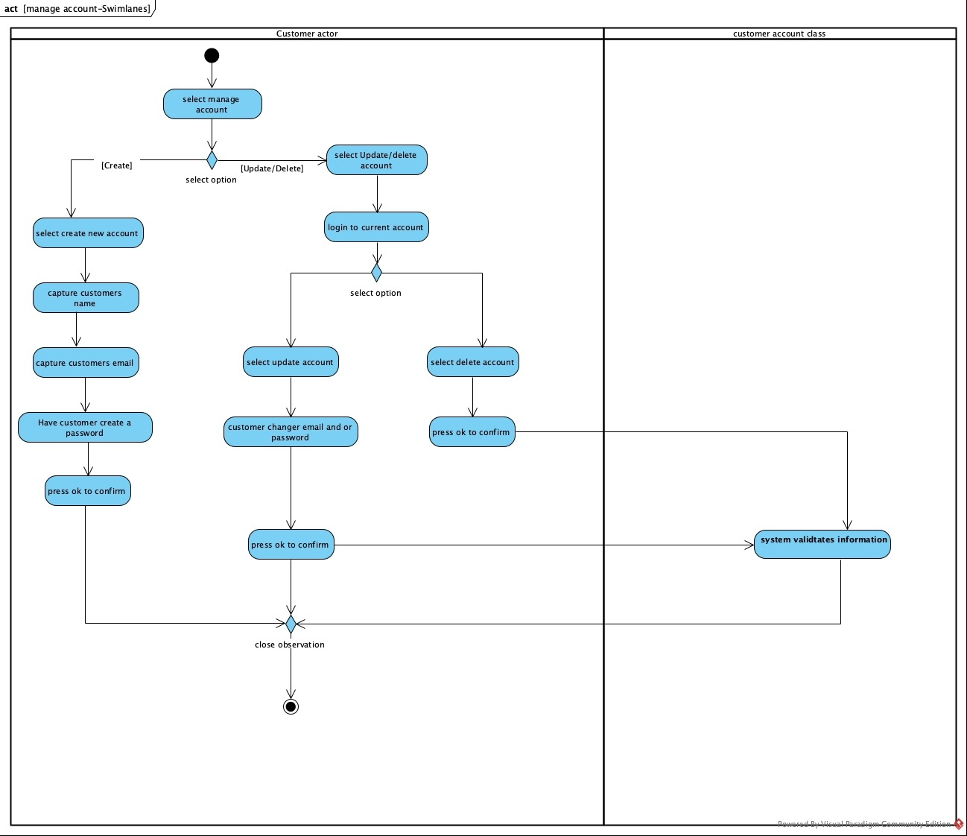

Class Diagram
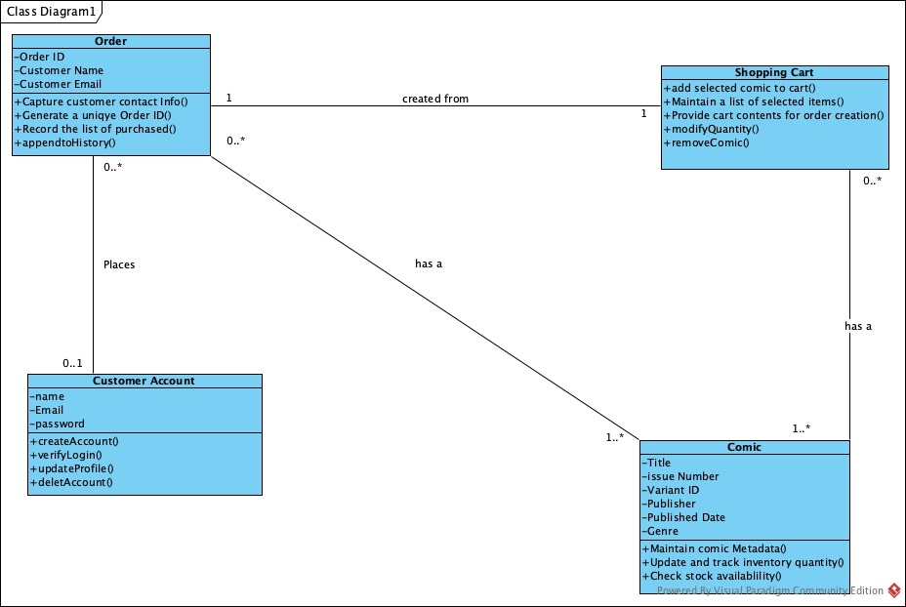

Sequence Diagram

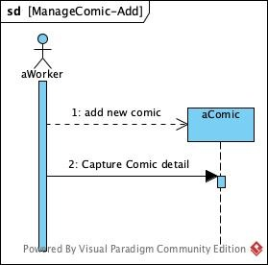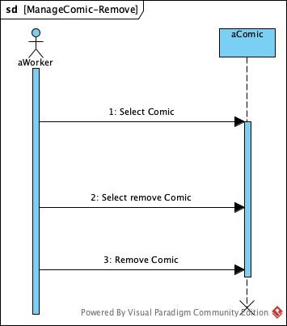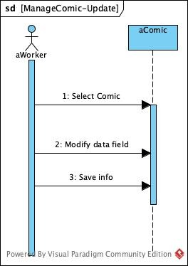

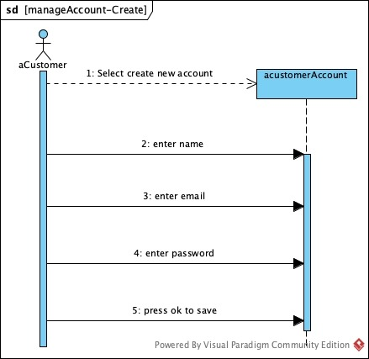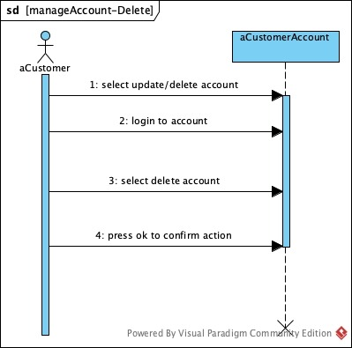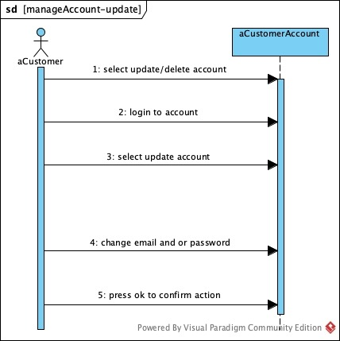

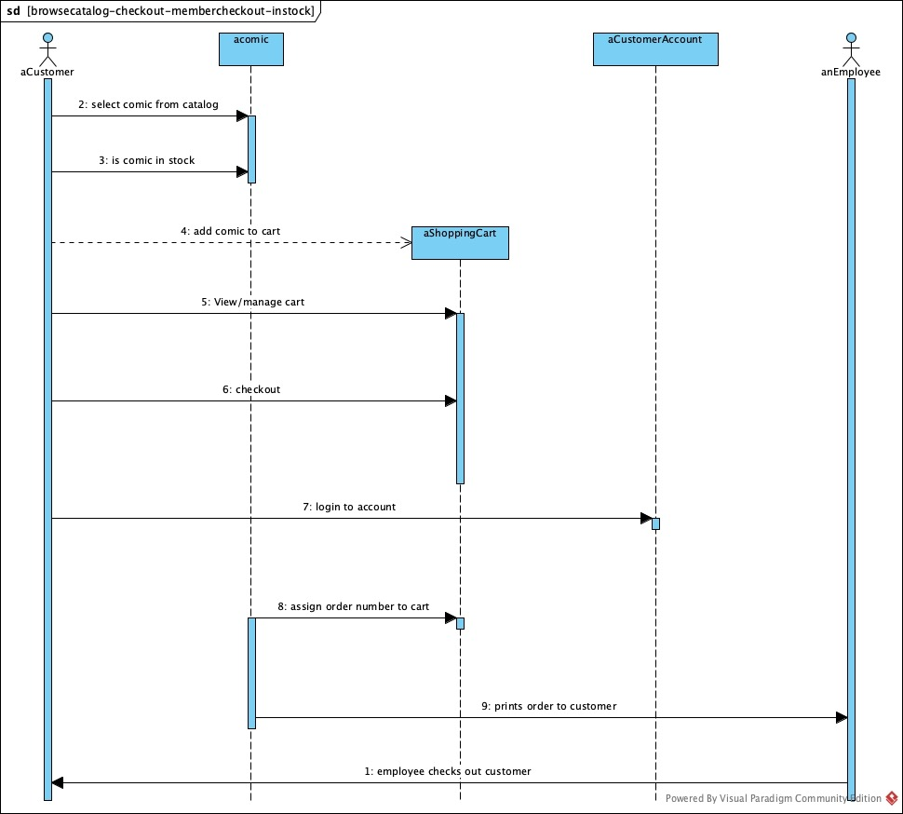
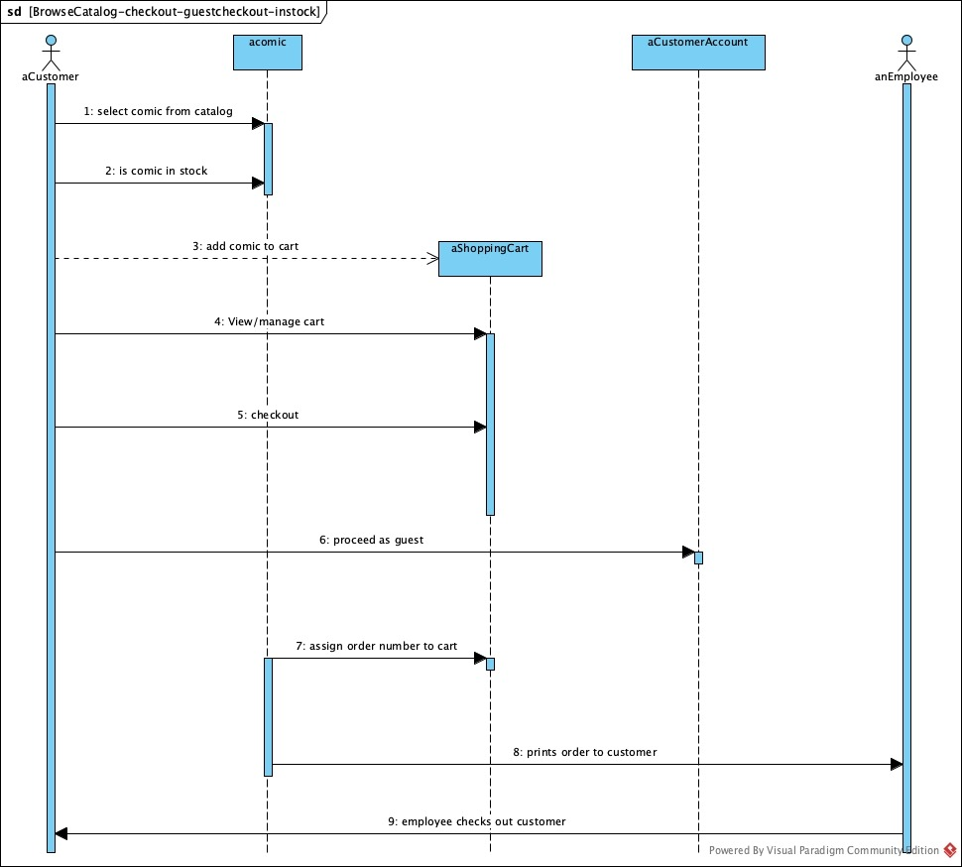


Behavioral State Machines
