Date: June 12th 2026 EOD Updates

1. Takeaway from Live Session:
Got an overall view of bootcamp project – Customer Churn prediction

2. Udemy/YouTube/Support Material Studied:
https://www.youtube.com/watch?v=EXIgjIBu4EU&pp=ygUNcGFuZGFzIHB5dGhvbg%3D%3D

3.Hands-on Practice:
Performed the Phase 1, data cleaning and pre-processing part.
https://colab.research.google.com/drive/1VtknlTSXMBSPyoNST4QPAy2Gqm7pb2Gp?usp=sharing
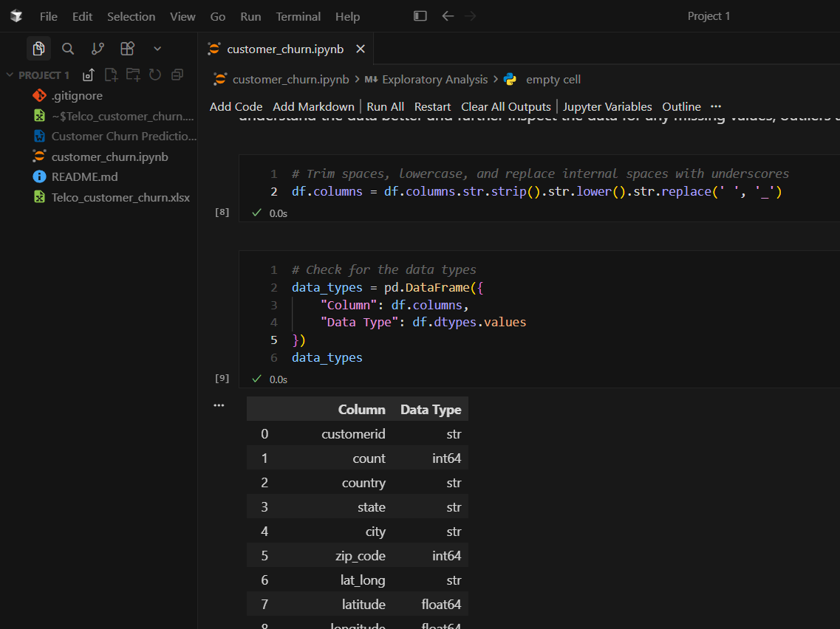

4. Progress in Self-Learning (Agile, Jira, & Confluence,):
[Update your daily progress on self-learning Python, and cover topics on Agile, Jira, and Confluence]
https://www.youtube.com/watch?v=ocMOZpuAMw4&pp=ygUaY3Vyc29yIGFpIGZvciBkYXRhIGFuYWx5c3Q%3D

5. Certification Preparation:
NA

