### INTEGRATED PROJECT REPORT

### ON

### TRAVEL AND TOURISM WEBSITE

Submitted in partial fulfilment of the

requirement for the Course Integrated Project

(CS 203) of

**COMPUTER SCIENCE AND ENGINEERING**

Batch-2019



**DEPARTMENT OF COMPUTER SCIENCE AND ENGINEERING**

# CHITKARA UNIVERSITY

**PUNJAB**

## Submitted By:

**1.RAKESH ROUT(1911981051)**

**2.MAHEK GARG(1910991150)**

**3.RIYA(1910990822)**

**4.VARNIKA SHARMA(1911981145)**

**5.MADHAV CHITTLANGIA(1910990401)**

**Introduction:**

The Tours and Travel Management System is a web based application. The main purpose of “Tours and travels management system ” is to provide a convenient way for a customer to book hotels, flight, train and bus for tour purposes. The objective of this project is to develop a system that automates the processes and activities of a travel agency. In this project, We will make an easier task of searching places and for booking train, flight or bus. . In the present system a customer has to approach various agencies to find details of places and to book tickets. This often requires a lot of time and effort. We provide approach skills to critically examine how a tourist visits and its ability to operate in an appropriate way when dealing with the consequences of tourism, locally, regionally, and nationally including visitor security and ecological influences. It is tedious for a customer to plan a particular journey and have it executed properly. The project ‘Tours and Travels Management System’ is developed to replace the currently existing system, which helps in keeping records of the customer details of destination as well as payment received.

About Page:

It tells regarding the services provided by the vendor, here the customer can see and know about the organisation and the services provided and also get to see some of reviews provided by the past customers.

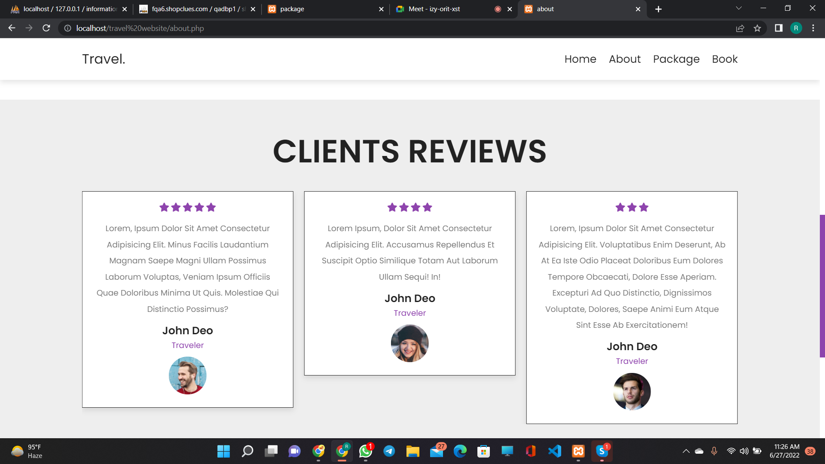

Home:

It's the landing page of our website where the user gets for the first time. Here the user can see the top recommendations sites and many more deals and see more services provided by the vendor such as Adventure, Tour guide, Trekking, camp-fire and many more such adventurous options.

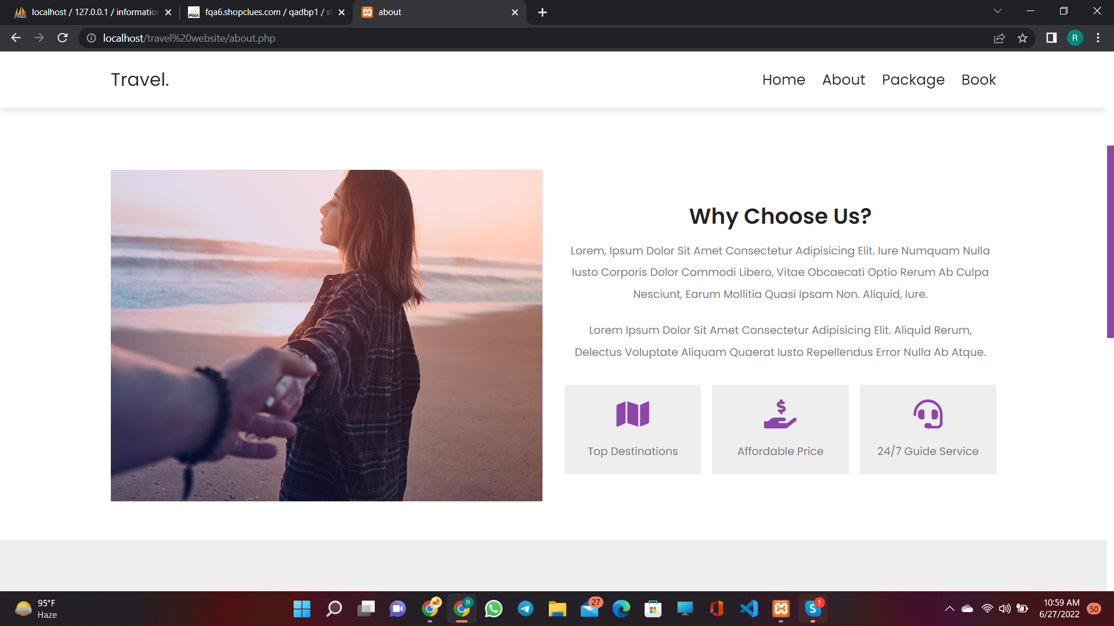

Packages:

The Packages provides the user a whole Package where the user can go and select packages as per his/her requirements and can get a glimpse of out top recommended destinations.

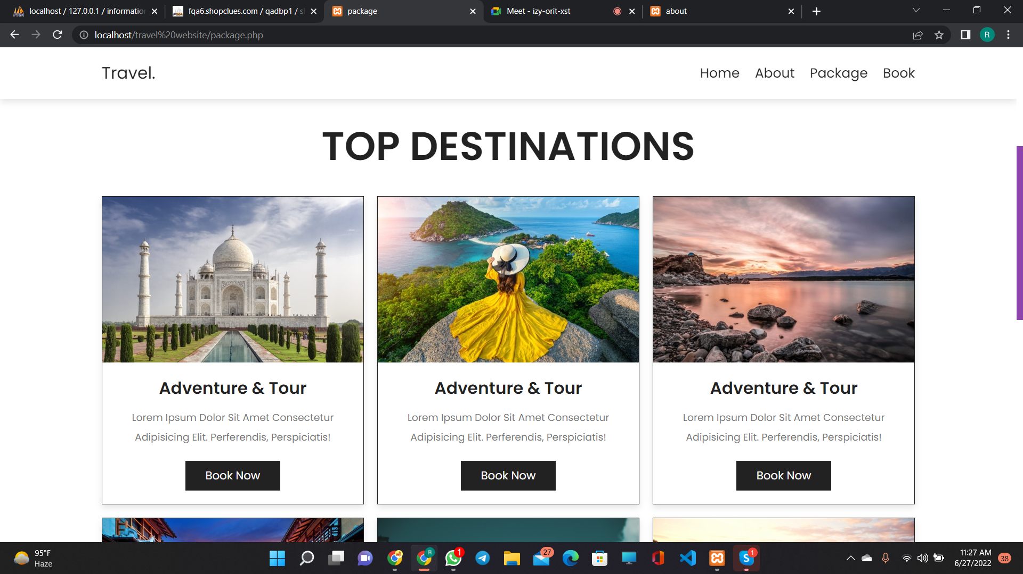

BOOKING:

This is the final page where the user finally book the packages they chose for themselves this and gets the trip book successfully.

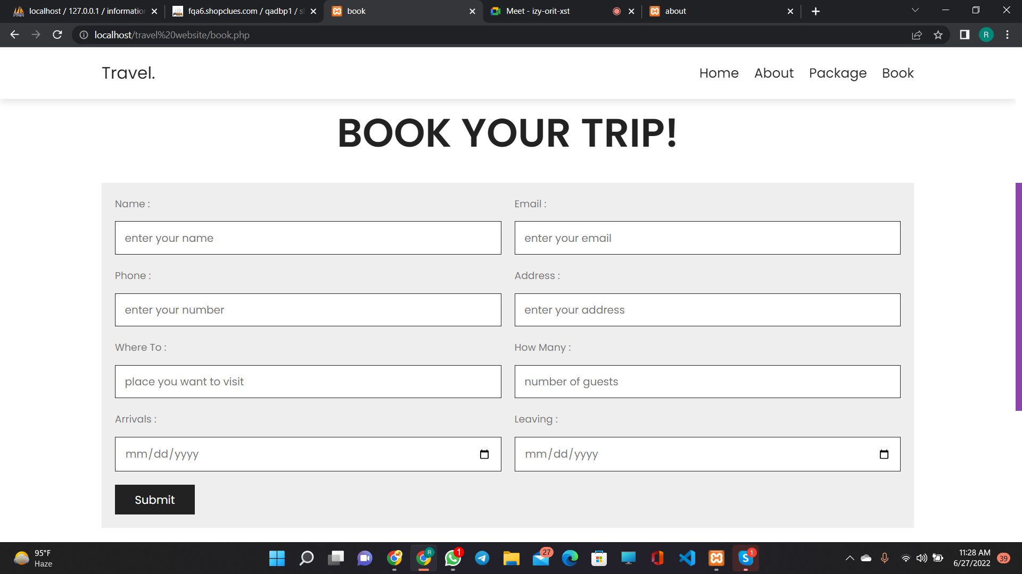

Miscellaneous:

In this project we are using HTML, CSS and JavaScript for front-end and PHP for our backend and is fully responsive.

**Objectives:**

This application is develop to provide best travelling services to the customers and travel agents. We have developed tours and travel management system to provide a search platform where a tourist can find their tour places according to their choices. This system also helps to promote responsible and interesting tourism so that people can enjoy their holidays at their favorable places. This system also helps to develop tourism with different cultures so that they enrich the tourism experience and build pride. We develop this system to create and promote forms of tourism that provide healthy interaction opportunities for tourists and locals and increase better understanding of different cultures, customs, lifestyles, traditional knowledge and believes. This system also provide a better way to connect with various events.

This system also gives tours related information like which places are tourist attractions, cities, and provinces. Tourist can also get the Map and navigation system and temperature and weather information. Tourist can also book tours through our tours and travels management system. This system also keeps a history of visited places of its users.

CONCLUSION:

This web application was successfully created and stored all the travel admin tourism packages booking, creation managing and tour details into the database using this application. The application was tested very well and the errors were properly debugged. Testing also concluded that the performance of the system is satisfactory. All the necessary output is generated. This system thus provides an easy way to automate all the functionalities of consumption. If this application is implemented in few consumption, it will be helpful. Further enhancements can be made to the project, so that the website functions in a very attractive and useful manner than the present one. It is concluded that the application works well and satisfy the needs. The application is tested very well and errors are properly debugged. It also acts as the sharing of files to the valuable resources.

REFERENCES:

1. www.msdn.microsoft.com

2. [www.phpcity.com](http://www.phpcity.com)

3. ww.phpgurukul.com

4. [www.myproject.com](http://www.myproject.com)

5. [www.way3html.com](http://www.way3html.com)

6. w3schools.com