### INTEGRATED PROJECT REPORT

**On**

# WEATHER APP

Submitted in partial fulfillment of the requirement for the Course Integrated Project (CS 203) of

**COMPUTER SCIENCE AND ENGINEERING**

### Batch-2019 in

**JUNE-2022**



**Under the Guidance of**

**Ms. Sakshi**

Chitkara University Research and Innovation Network (CURIN)

**Chitkara University** **(Punjab)**

## Submitted By:

**Kunal Chhabra**

**(1910991351)**

**Himanshu Mittal**

**(1911981151)**

**Rhythm Jaiswal**

**(1911981038)**

**DEPARTMENT OF COMPUTER SCIENCE AND ENGINEERING**

# CHITKARA UNIVERSITY

**PUNJAB**

### CERTIFICATE

This is to be certified that the project entitled “**WEATHER-APP**” has been submitted for the Bachelor of Computer Science Engineering at Chitkara University, Punjab during the academic semester January 2022- May-2022 is a bona fide piece of project work carried out by **Kunal Chhabra-1910991351 Himanshu Mittal-1911981151, Rhythm Jaiswal-1911981038** towards the partial fulfillment for the award of the course Integrated Project (CS 203) under the guidance of **Ms. Sakshi** and supervision.

**Ms. Sakshi**

Chitkara University Research and Innovation Network (CURIN)

**Chitkara University** **(Punjab)**

### CANDIDATE’S DECLARATION

We, **Kunal Chhabra-1910991351, Himanshu Mittal-1911981151, Rhythm Jaiswal-19118981038**, B.E.-2019 of the Chitkara University, Punjab hereby declare that the Integrated Project Report entitled “**WEATHER_APP**”is an original work and data provided in the study is authentic to the best of our knowledge. This report has not been submitted to any other Institute for the award of any other course.

**Kunal Chhabra**

**1910991351**

**Himanshu Mittal**

**1911981151**

**Rhythm Jaiswal**

**1911981038**

**Place: Chitkara University Date: 24th June 2022**

### ACKNOWLEDGEMENT

It is our pleasure to be indebted to various people, who directly or indirectly contributed in the development of this work and who influenced my thinking, behavior and acts during the course of study.

We express our sincere gratitude to all for providing me an opportunity to undergo Integrated Project as the part of the curriculum.

We are thankful to “**Ms. Sakshi** ” for her support, cooperation, and motivation provided to us during the training for constant inspiration, presence and blessings.

We also extend our sincere appreciation to **Ms. Sakshi** who provided his valuable Suggestions and precious time in accomplishing our Integrated project report.

Lastly, We would like to thank the almighty and our parents for their moral support and friends with whom we shared our day-to-day experience and received lots of suggestions that improve our quality of work.

**Kunal Chhabra**

**1910991351**

**Himanshu Mittal**

**1911981151**

**Rhythm Jaiswal**

**1911981038**

**KEYWORDS**

**HTML** : Hyper Text Markup Language

**CSS:** Cascading Style Sheets

**SPA:** Single Page Application

**JS:** Java Script

**API:** Application Programming Interface

**UI:** User Interface

## INTRODUCTION TO THE PROJECT

1. **Introduction**

Weather APP forecasting is the application of science and technology

to predict the conditions of the atmosphere for a given location

and time. Weather forecasts are made by collecting

quantitative data about the current state of the atmosphere at a

given place and using meteorology to project how the atmosphere

will change. The role of Technology has been remarkable in the

field of weather forecasting. Weather data is not only necessary

for researchers or scientists, ordinary people can be benefitted

from it as well. People nowadays are feeling the necessity of

weather data as well. There are a variety of weather mobile apps

in Google Play and the App store. Those apps have great

features and functionalities to satisfy users. However, only a few

of them have friendly user interface and human centered

interactions, which means that a lot of them might be difficult to be

navigated even though they provide enough functionalities. It is

not convenient for new users. Therefore, we would like to do

improvements on weather mobile apps. It is basically for Apple

smart phones and tablets.

**2.Purpose**

The best weather apps for Android are like pocket weather channels,

and they do not just tell anyone when the sun is going to shine and the

rain is going to fall, these apps tell us the wind speed, the UV level,

humidity levels, and even “feels like” temperature to account for the

dreaded wind chill.

**3.Problem Statement**

This project is to create a Weather Report application with a third party

server and users to enable the users to Forecast Weather.. The project

should be very easy to use enabling even a novice person to use it.

This application is also developed to make people’s life hustle free by

introducing some of the extraordinary features like Weather updates

which are going on all around the world and also getting the weather forecast before going out of the home. This project is to design an application which consists of all the basic features which the users can access all of them with a single Click.

**4.Literature Survey**

Weather report is the application of science and technology to predict

the conditions of the atmosphere for a given location and time. Human

beings have attempted to predict the weather informally for millennia

and formally since the 19th century. Weather forecasts are made by

collecting quantitative data about the current state of the atmosphere at a given place and using scientific understanding of atmospheric processes to project how the atmosphere will change. Once a human-only endeavour based mainly upon changes in barometric pressure, current weather conditions, and sky condition, weather forecasting now relies on computer-based models that take many atmospheric factors into account. Human input is still required to pick the best possible forecast model to base the forecast upon, which involves pattern recognition skills, teleconnections, knowledge of model performance, and knowledge of model biases. The inaccuracy of forecasting is due to the chaotic nature of the atmosphere, the massive computational power required to solve the equations that describe the

atmosphere, the error involved in measuring the initial conditions, and an incomplete understanding of atmospheric processes. Hence, forecasts become less accurate as the difference between current time and the time for which the forecast is being made (the range of the forecast) increases. The use of ensembles and model consensus help narrow the error and pick the most likely outcome. Over the past two decades, weather forecasting has experienced a paradigm shift towards probabilistic forecasts, which take the form of probability distributions over future weather quantities and events. Probabilistic forecasts allow for optimal decision making for many purposes, including air traffic control, ship routing, agriculture, electricity generation and weather-risk finance. In the history of weather forecasting, attempts have often been made to devise numerical and objective methods for producing the forecast. Thus Besson in 1904 and Taylor and Rolf in 1917 produced graphical devices for representing lag relationships between selected weather variables. These studies, in common with others made in later years , have attempted to provide an equation or a graphical device of some form which would be useful in applying a particular relationship or combination of relationships to the problem of making a forecast. The distinction between an objective forecasting procedure and a procedure which depends on subjective judgments and subjective experience has not been sharply defined, nor is it intended in this paper to advocate a rigid definition.

**5. Existing System**

The purpose of this project is to identify the effect that surface modifications have on the urban heat island phenomenon and related ozone problem in the metropolitan area of India. The basic hypothesis is that urban, summertime temperatures can be significantly lowered by increasing the vegetative

landscape cover and enhancing the solar reflectivity of paved and roofed surfaces within an urban area. It is proposed that in addition to a decrease in temperature, the modification of an urban surface to include more vegetative cover and lighter, lower albedo surfaces will also reduce energy consumption, ozone exceedances, and detrimental environmental and human health effects associated with high levels of ozone. The analysis is divided into three main parts. The first section of this report introduces the causes of ground level ozone and its effects in urban areas. It explains both the chemistry and transport associated with ozone exceedances. The second section is a compilation of the most viable mitigation strategies of urban heat islands: increasing vegetative cover and increasing proportions of light to dark surfaces. The effects, implementation strategies, and specific strengths and weaknesses associated with each approach are described, including a comparison of asphalt and concrete pavements systems using a life cycle analysis approach. The final section provides a case study of the Chicago area. This study entailed an examination of the land use, development of an urban fabric analysis in which total vegetative, paved, and roofed surfaces are investigated and quantified, and discussion on the effectiveness of possible mitigation strategies in the Chicago area. In general, the associated findings of my research are located within this final section.

**5.1 Issues in Existing System**

There are some existing systems available but they don’t give an accurate results and doesn’t provide any pictorial representation. They don’t provide information about weather conditions, humidity, pressure but just display the temperature. Some of the existing systems don’t provide the forecast weather which may not help the users to plan their works and may lead to futile results.

**6. Project Scope**

The scope of the project is the system on which the software is installed, i.e. the project is developed as a desktop application, and it will work for a particular institute or organization. But later on, the project can be modified to operate it online. The intention of developing weather app is to fetch the data in the need of taking information about weather worldwide. Another purpose for developing this software is to generate the report automatically

at the end of the session or in the between of the session or in the between of the session as they require. This project is basically a desktop application which means 3 self-contained software runs on which it has been installed under the user control

**7. Identification of Need**

System analysis is a process of gathering and interpreting facts, diagnosing problems and the information to recommend improvements on the system. It is a problem-solving activity that requires intensive communication between the system users and system developers. System analysis is or study is an important phase of any system development process. The system is studies to the minutest detail and analyzed. The system analyst plays the role of the interrogator and dwells deep into the working of the present system. The System is viewed as a whole and the input to the system are identified. The outputs from the organization are traced to the various processes. System analysis is concerned with becoming aware of the problem, identifying the relevant and Decisional variables, analysis

and synthesizing the various factors and determining an optimal or at least a satisfactory solution or program of action.

A detailed study of the process must be made by various techniques like interviews, questionnaires. The data collected by these sources must be scrutinized to arrive to a conclusion. The conclusion is an understanding of how the system functions. This system is called the existing system. Now the existing system is subjected to close study and problem area are identified. The designer now functions as a problem solver and tries to sort out the difficulties that the enterprise faces. The solutions are given as proposals. The proposal is then weighed with the existing system analytically and the best one is selected. The proposal is presented to the user for an endorsement by the user. The proposal is reviewed on user request and suitable changes are made. This is loop that ends as soon as the user is satisfied with proposal

## SOFTWARE REQUIREMENT SPECIFICATION

1. ***How This Application Works?***

All the information shown here will be collected with the help of the API link. The information will be collected first with the help of the JavaScript fetch method. Then with the help of inner HTML all that information has been arranged to be displayed on the web page.

**USER INTERFACE DIAGRAM**

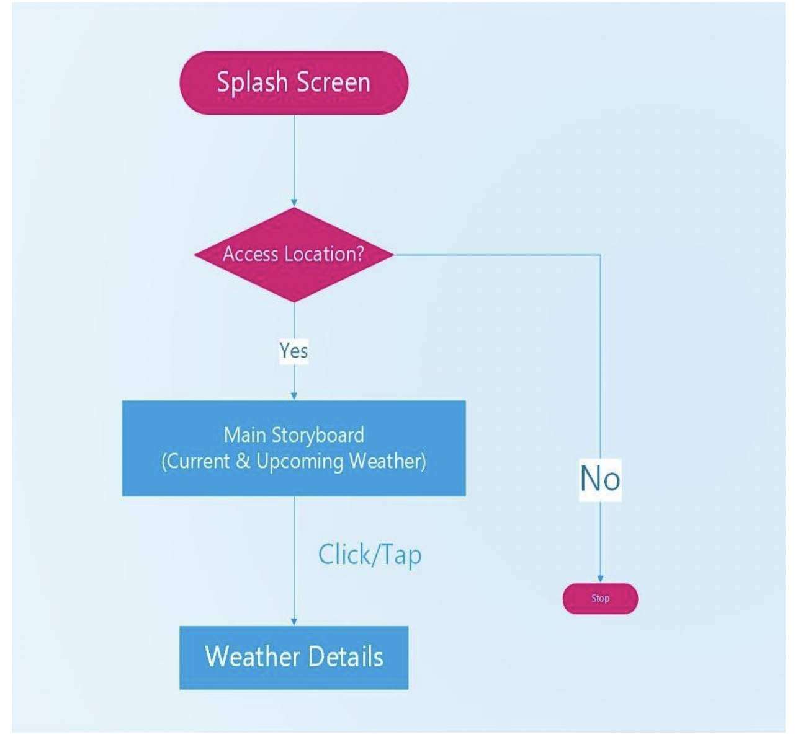

#### APPLICATION SCREENSHOT

**LIMITATIONS**

* Unpaid APIs provide incomplete services. Many details cannot be fetched
* Often, tuples of upcoming days remain empty once again due to free APIs
* The GMS API (Google Manual Search) is actually keyword based that might only provide data of few discrete locations. The data might not be precise and continuous.
* Language diversity could have been implemented. Multilingual apps make it easy for users worldwide

**UNIMPLEMENTED FEATURES**

* We intend to provide more detailed tips based on the age, gender, region and health conditions (Dust allergy, heatstroke tendency etc.) of the user.
* FAQ section based on detailed data might be quite handy. It will save the user’s efforts and make it more convenient.
* Using paid APIs to fetch more details might make the application more comprehensive and appealing. For example, wind speed, precipitation & sea level values can be used to provide more intellectual tips.
* Mobility of the traveler, their start & end points of the journey, their route of traveling (road, waterway, aerial) shall be strongly focused. The application needs to be an aid for traveling users.
* Recording User inputs to understand the user preferences and providing them necessary notifications needs to be kept in mind
* Maybe someday in the near future, we will use AIs for more precision and accuracy.

**PROGRAMMING/WORKING ENVIRONMENT**

* + **Frontend Framework:** Vanilla JS, CSS, HTML
  + **Development:** VS Code
  + **Web Browser:** Google Chrome
  + **API:** The OpenweatherMap Api

# CONCLUSION

**The project statement used multiple concepts to achieve the outcome.**

In summary, weather forecasts are increasingly accurate and useful, and their benefits extend widely across the economy. While much has been accomplished in improving weather forecasts, there remains much room for improvement. The forecasting community is working closely with multiple stakeholders to ensure that forecasts and warnings meet their specific needs. Simultaneously, they are developing new technologies and observational networks that can enhance forecaster skill and the value of their services to their users.

# FUTURE SCOPE

The current application is a small replica of the product/application which we are looking forward to building in future. Our future application will have advance features and complex database storage system. The advance features like :-

→ This application can be made to view forecast of multiple locations at once.

→ This application can also be customized for every individual user.

**BIBLIOGRAPHY/REFERENCES**

* [**https://stackoverflow.com/**](https://stackoverflow.com/)
* [**https://developer.mozilla.org/en-US/**](https://developer.mozilla.org/en-US/)
* [**https://openweathermap.org/**](https://openweathermap.org/)
* [**https://www.w3schools.com/**](https://www.w3schools.com/)
* [**https://www.postman.com/**](https://www.postman.com/)