

Group 30411 – Semigroup 1

Man Rareș-Ioan

Matei Octavian-Mihai

Rolling Average on 8-bit Data Stream

Table of contents

***I. Task 3***

*# Overview 3*

*## The Task 3*

***II. Block schemata 4***

***III. Detailed Block schemata 5***

*Data Generator 5*

*Filter 6*

***IV. Components, signals and implementation 7***

*Data Generator 7*

*Filter 8*

***V. Justification of the Chosen Solution 9***

***VI. Maintenance and user’s manual 10***

***VII. Possibilities for subsequent improvements 10***

***VIII. Conclusion 11***

# I. Task

## # Overview

- The Design Assignment will be to develop a simple signal processing system that will calculate the rolling average of a parallel 8-bit data stream as a systems design exercise.

- The design will be implemented on a self contained Xilinx/Digilent Spartan 3 XC3S200 FPGA board to allow demonstration of a working system.

- The system will be developed as a VHDL model using Xilinx ISE WebPack Version 6.3 that includes the use of the Modelsim simulation tools for design verification.

- Assessment will be based primarily on the records kept in individual logbooks supplemented by a short formal report of VHDL listings, system block diagrams and annotated simulation results.

## ## The Task

Within signal processing systems there is often the need to calculate the numerical average value for an input data stream. This implements a simple low pass filter - smoothing out rapid changes in value in the data stream but maintaining any overall trend. The greater the number of samples used to calculate the average the more smoothing will occur. The filter system will be required to run in "real time" and output the average value at the same rate as the original input data.

The task is to develop a VHDL based model for the "Digital Filter / Rolling Average" system combined with a data stream generator. Switches, Buttons and the Seven Segment Display located on the Diligent S3 board will need to be included to demonstrate correct operation.

# II. Block schemata

# III. Detailed Block schemata

## *Data Generator*

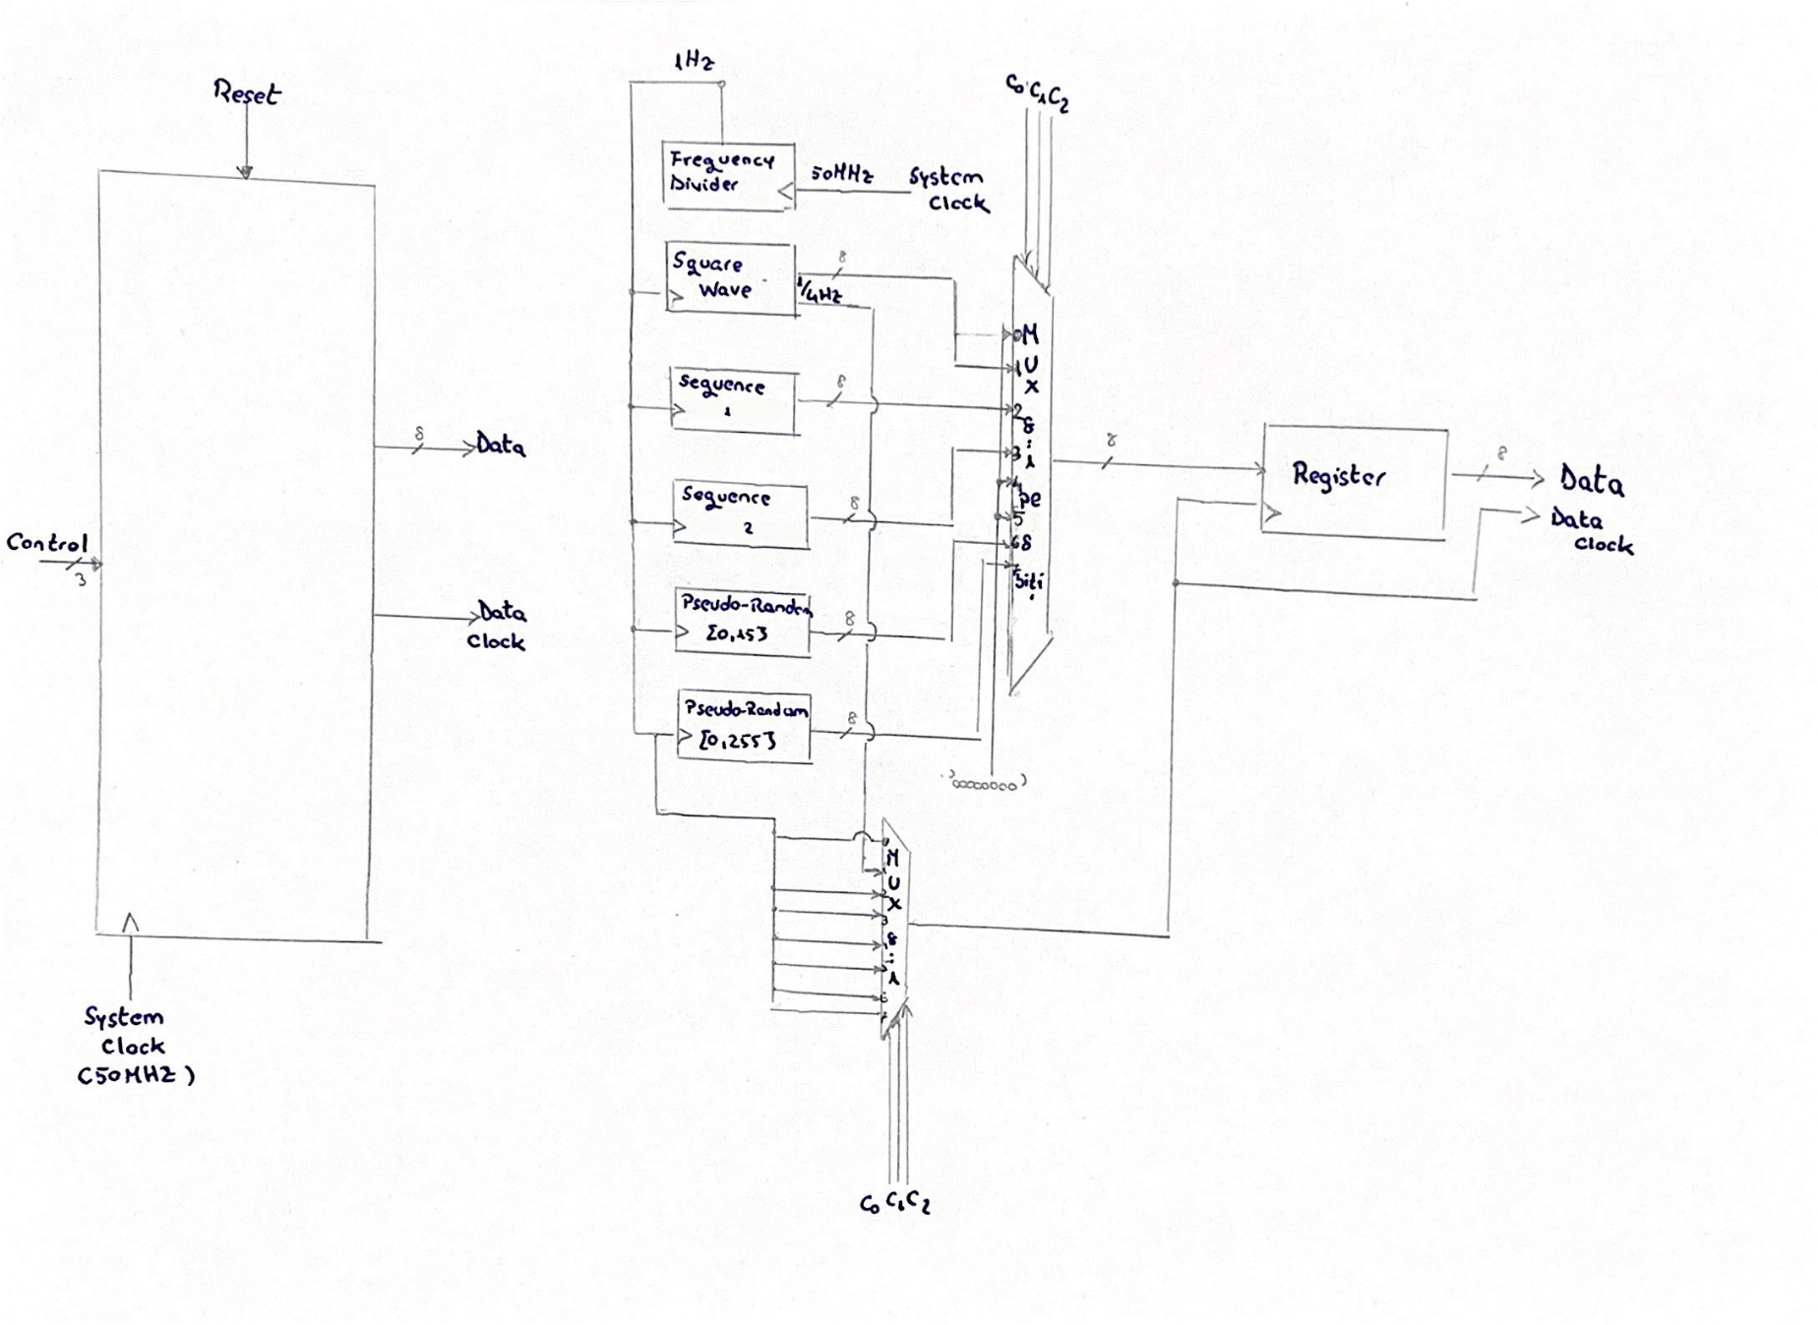

## *Filter*

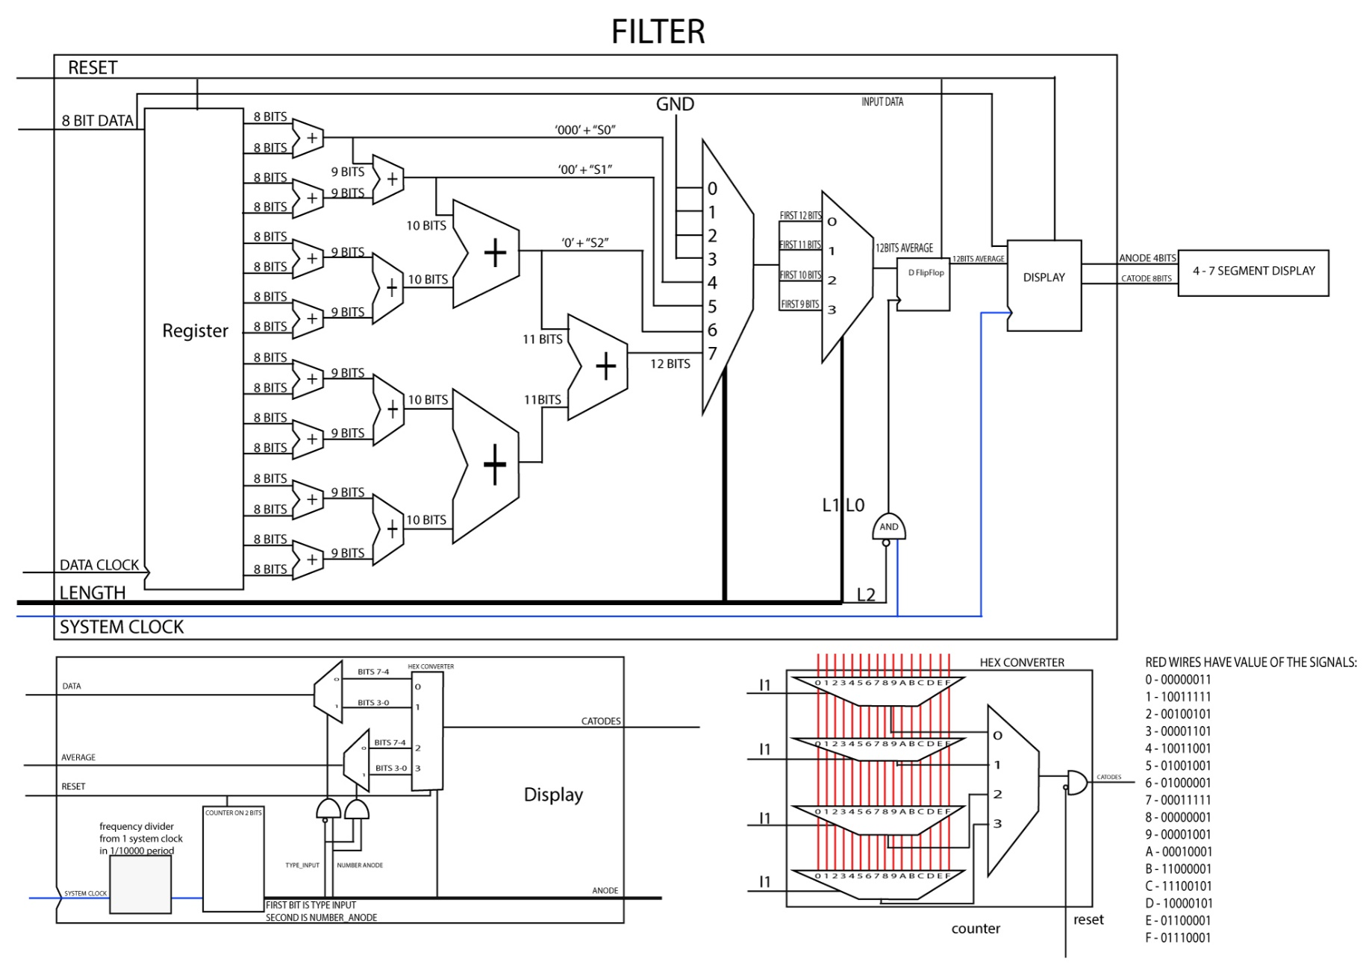

# IV. Components, signals and implementation

## *Data Generator*

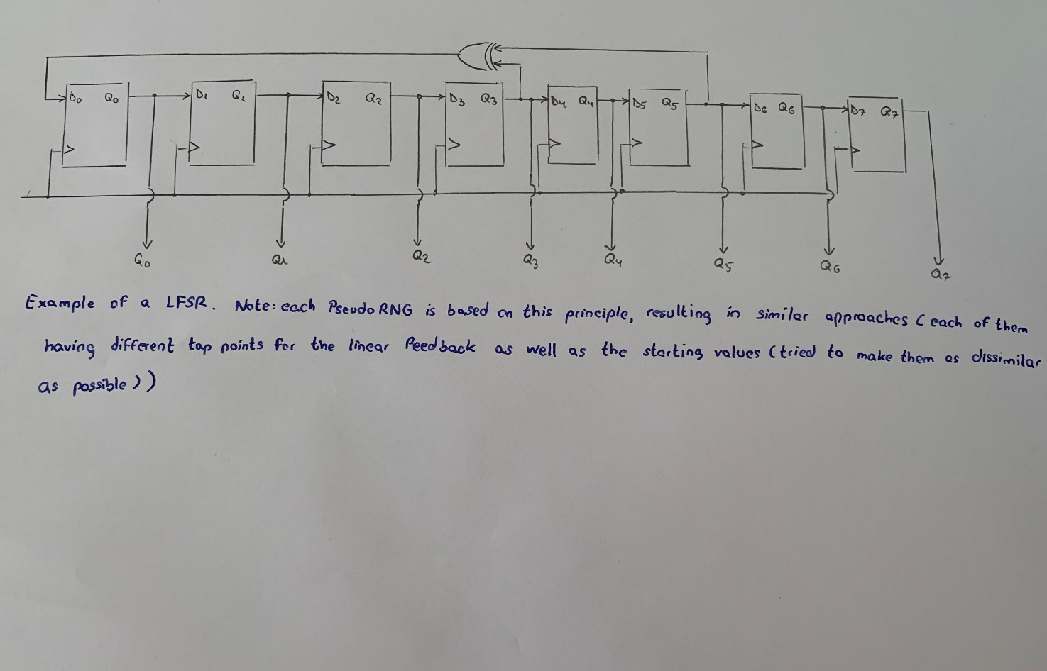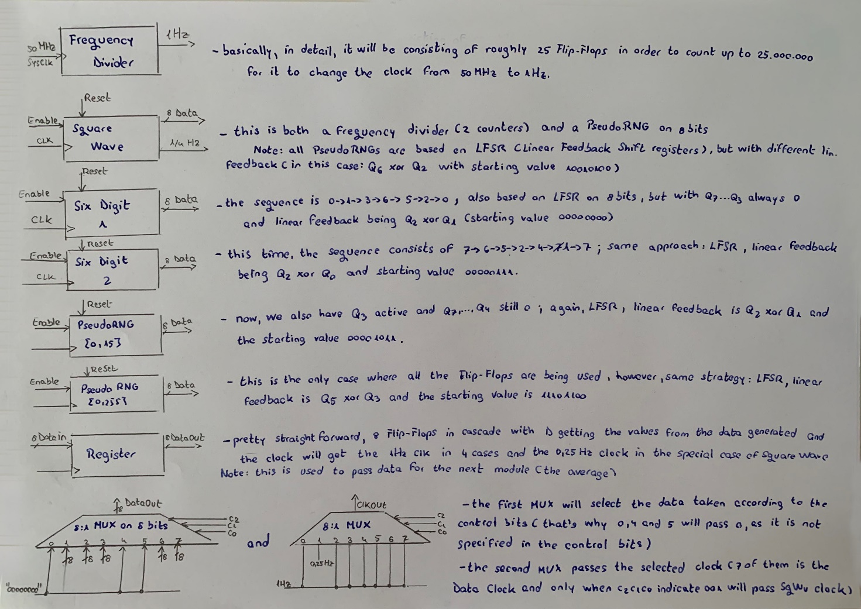

## *Filter*

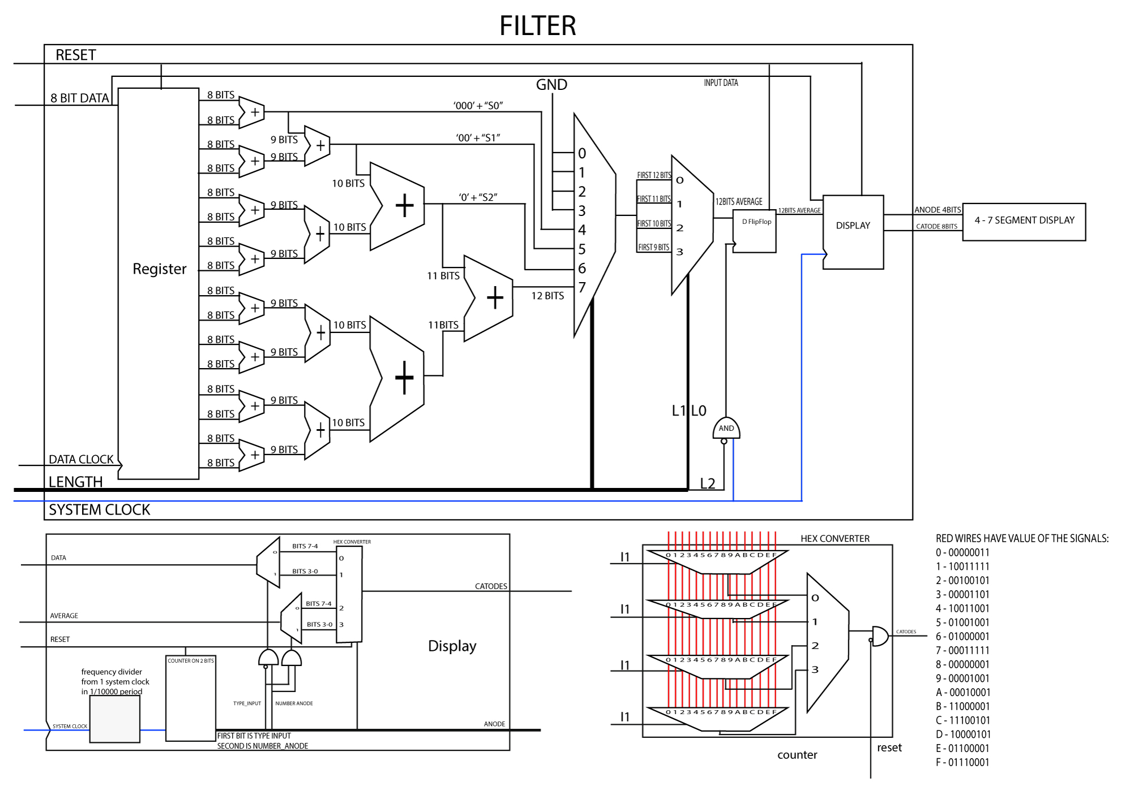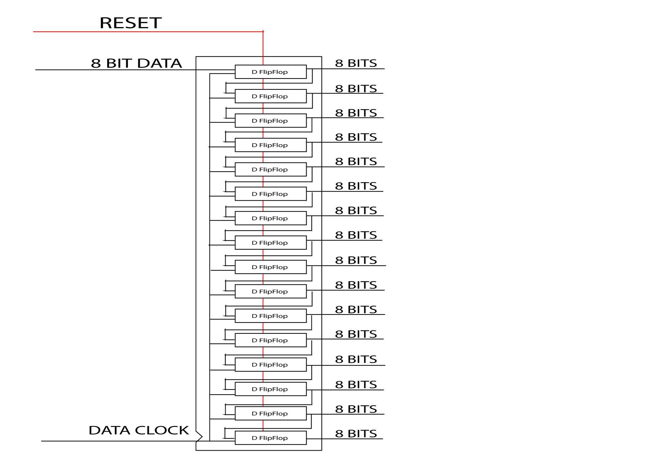

RED WIRES HAVE THE FOLLOWING VALUES:

0 – 00000011; 1 – 10011111; 2 – 00100101; 3 – 00001101; 4 – 10011001; 5 – 01001001; 6 – 01000001; 7 – 00011111; 8 – 00000001; 9 – 00001001; A – 00010001; B – 11000001; C – 11100101; D – 10000101; E – 01100001; F – 01110001;

# V. Justification of the Chosen Solution

Given the chosen solution, the interconnection of these components was done relatively easily which also makes it a lot easier for a less experimented user to understand the system’s functionality by taking a look at the block scheme or from the source code. In this solution that we chose, the processes and the sensitivity lists play a crucial role in defining the overall system.

The interconnection of all these compnents was done in the process of the Filter component. We chose this solution by pipelining in order to ensure a faster and better functionality of the system after the “dead” clock cycles (2-16 cycles). Nevertheless, the cost of doing such implementation is far greater than a more rudimentary approach, thus we believe that the end-user will acknowledge the performance increase.

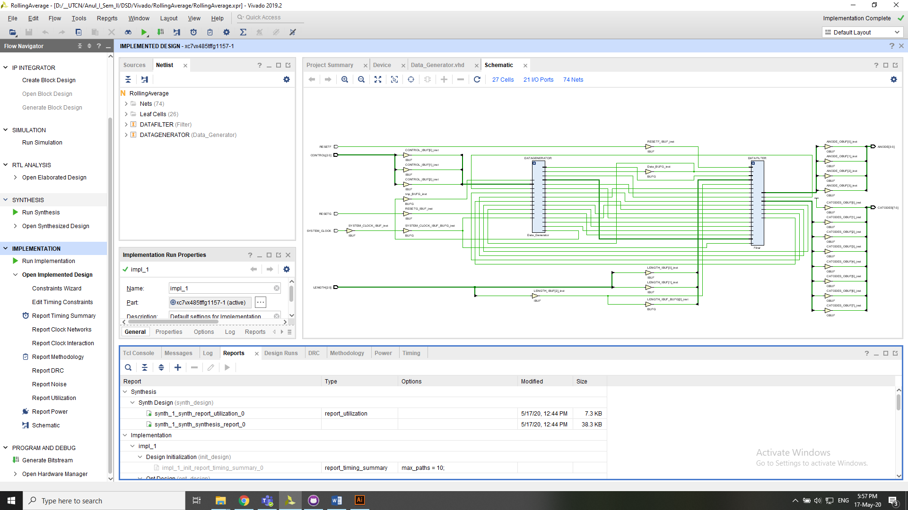The FPGA compatibility test was run in ISE VIVADO with the following result:

# VI. Maintenance and user’s manual

User’s Manual:

1. Power on the system;
2. Choose your desired configuration by moving the control and length switches;
3. Wait for the pipelining to occur;
4. Check the set of displays that show both the data that is generated and the average computed;
5. If the user wants to reset the whole system and compute another average, make sure that the reset is set on high voltage (logic ‘1’);
6. Repeat step 2.

Maintenance:

* Make sure that the FPGA is functional and runs properly;
* Ensure that the FPGA’s number of ports is greater or equal to the required minimum specification (7 switches and 4 anodes).

# VII. Possibilities for subsequent improvements

A first improvement which could be brought to this system could be a more exact approximation of the average value of the numbers by using floating point. However, this involves a rethinking and remapping of the system, as well as a much higher number of displays. In this way, the accuracy of the computed average will be higher.

Another improvement would be performance-wise: in spite of using a single pipeline, there is a possibility of acheiving a multi-level pipelining, thus speeding up the whole system after the mandatory initial clock cycles. Moreover, a performance gain would be given by reducing the computational power required to achieve the goal.

# VIII. Conclusion

All things considered, even though the task is rudimentary, it is of great impression by giving a look at how the work is done in VHDL using the ISE software family (Vivado) and a physical environment for testing solutions and maybe even publishing real hardware prototypes.