Tavi Tenari

2/28/2016

CSS337

Encryption Tool

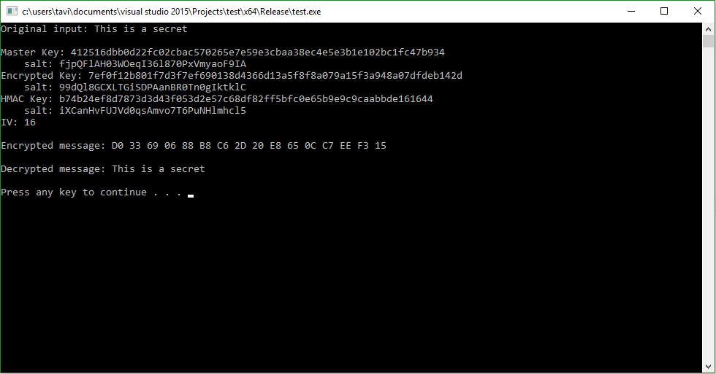

\*The salt beneath each key is the salt that was used for that specific key.

\*Encrypted message is displayed in hex.

Encryption functions were used from the OpenSSL library.

Additional code was found online, and referenced in comments in the code.