Tavi Tenari

Professor LeBlanc

2/7/2017

QOTD Server

Screenshot of Program Running:

TCP client/server (top 2 windows) and UDP client/server (bottom 2 windows) interacting:

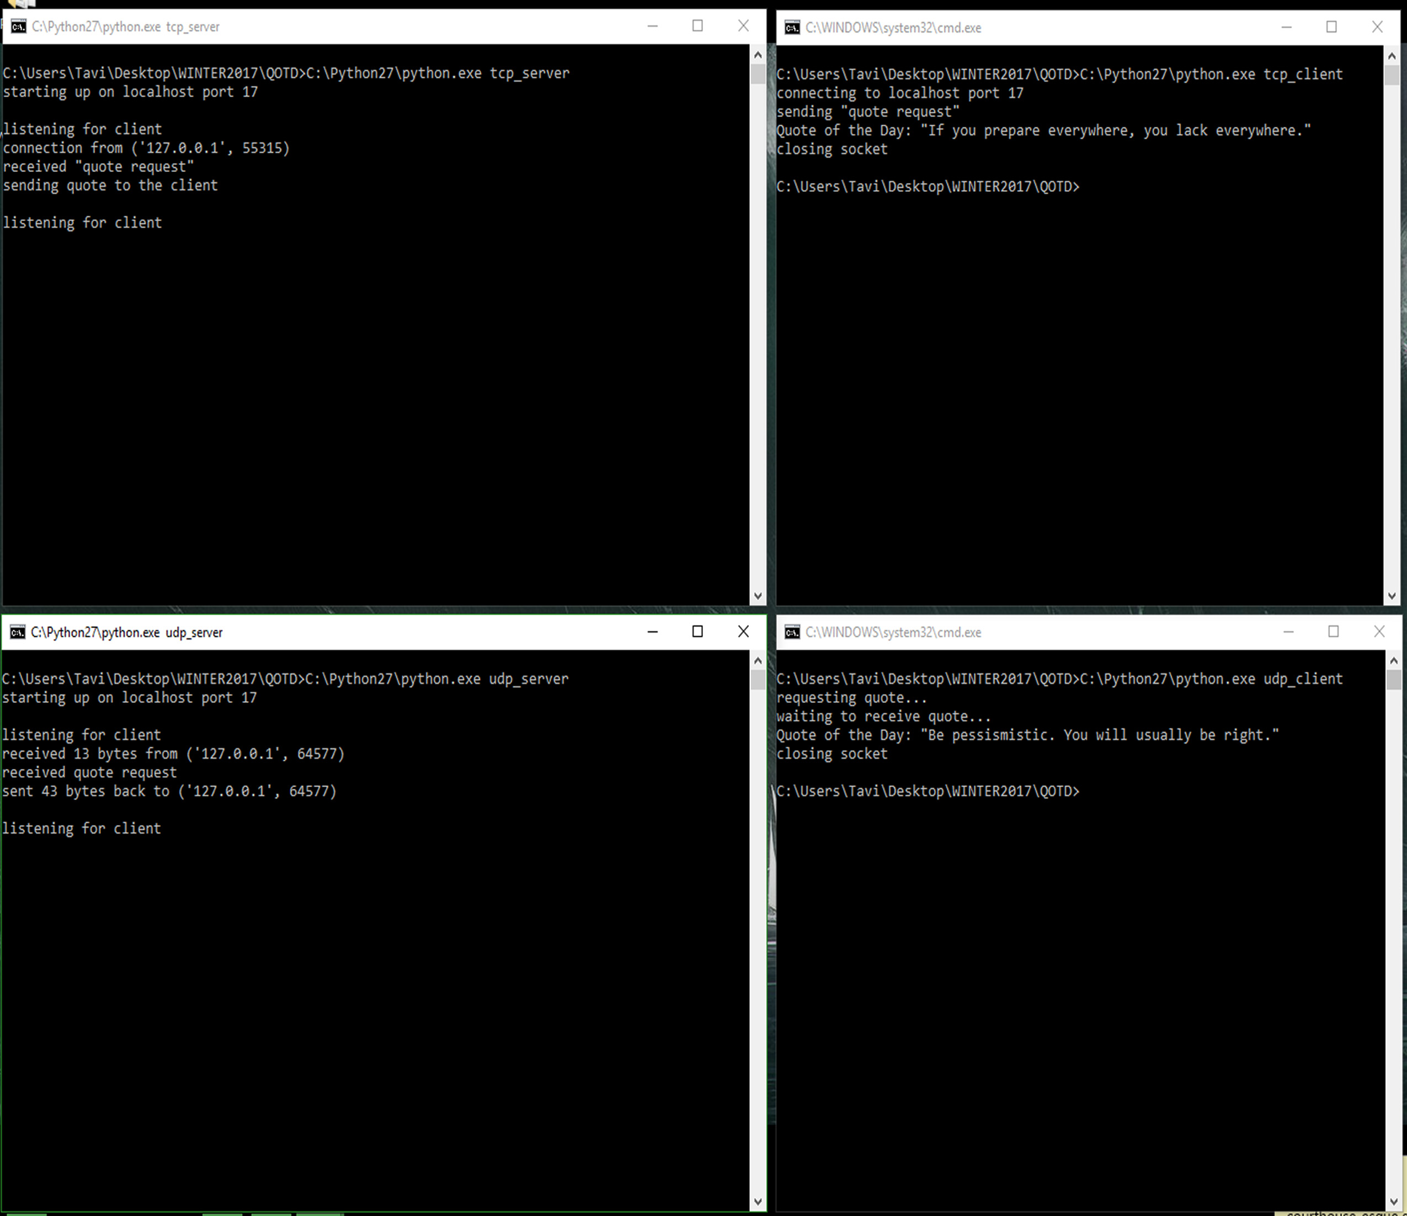

TCP packet capture (interaction between ports 17 and 55968)

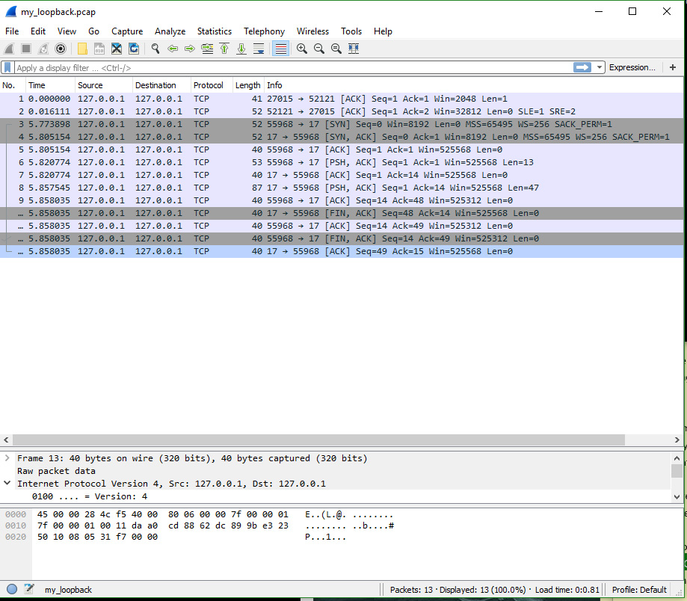

Potential Issues with TCP:

Besides flooding the server with TCP SYN packets, an attacker could attempt to impersonate the server during the TCP communication attempt. (If the attacker is only able to send packets to us, and not receive any of our TCP connection packets, they must guess the random SYN bit when we initiate the SYN, SYNACK, ACK handshake. TCP packets contain 32-bit initial sequence that match the response packets, so without eavesdropping, the attacker must guess this number.)

UDP packet capture (interaction between ports 17 and 58298)

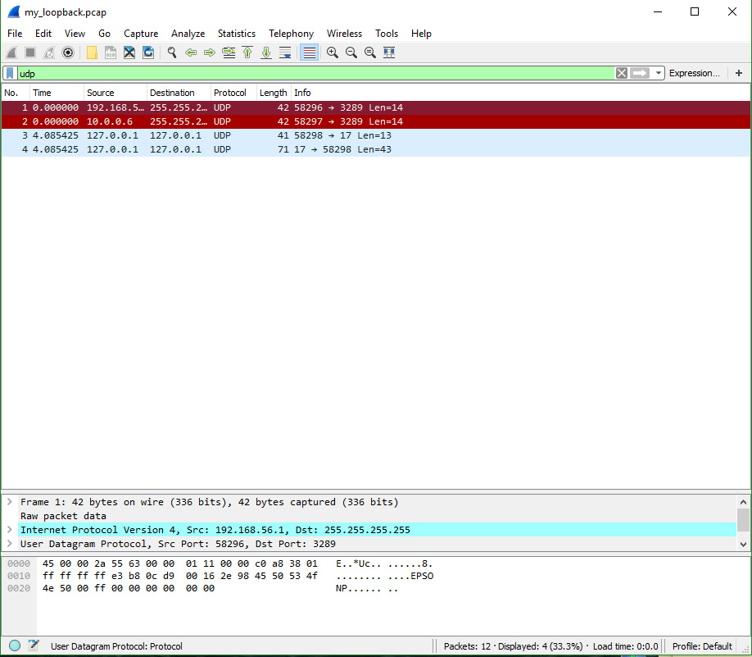

Potential Issues with UDP:

Like TCP, an attacker could flood the server with UDP requests. Also, an attacker could spoof the server much easier with UDP, since there are no SYN-ACK sequence numbers here.

# References

I wrote the code in Python since it seemed to be the simplest, and I used this website’s TCP and UDP server/client examples as a close guide: <https://pymotw.com/2/internet_protocols.html>.

It was very helpful since it was my first time using sockets.