Assignment 2:

TAVLEEN SINGH

8620702

Part 1: Basic queries with SELECT

1.Using the order_details table, find the revenue (price * quantity) earned on each order.

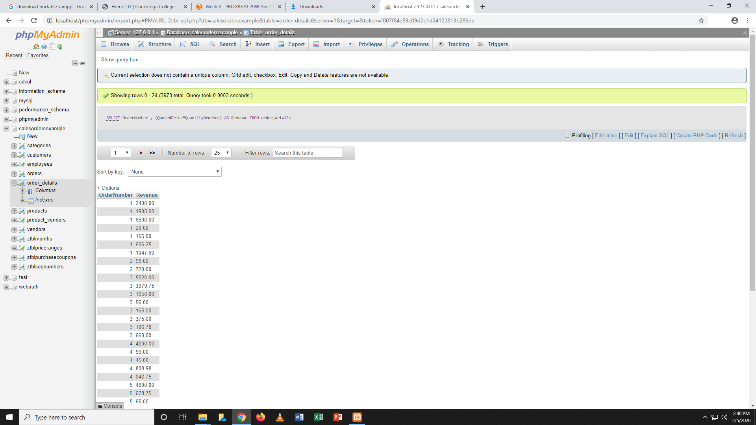

2. Using the employees table, find the age of each employee in years and order from youngest to oldest. NOTE: You do not have to account for leap years.

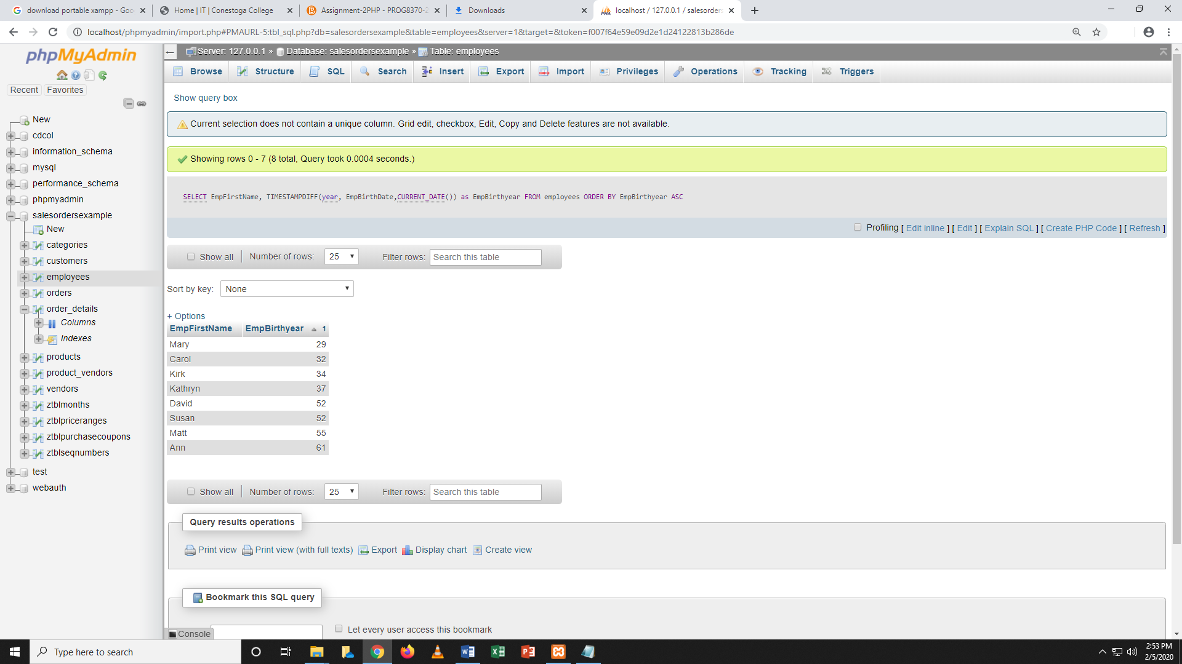

### Part 2: Conditional queries

1.Using the employees table, find all employees with a first name that contains an 'r' and a last name that does not contain a 'q'.

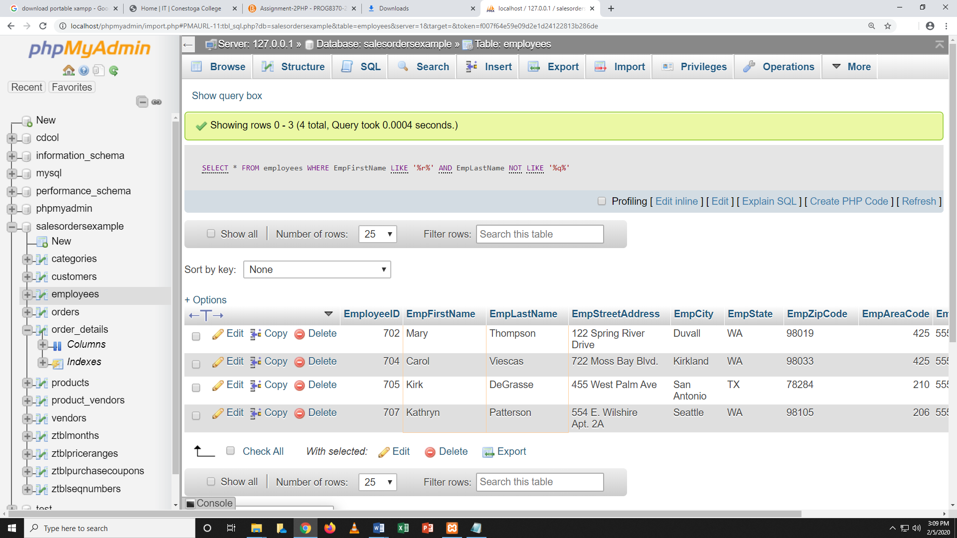

### Part 3: Database Design

Explain what is wrong with the following table and how you would fix it.

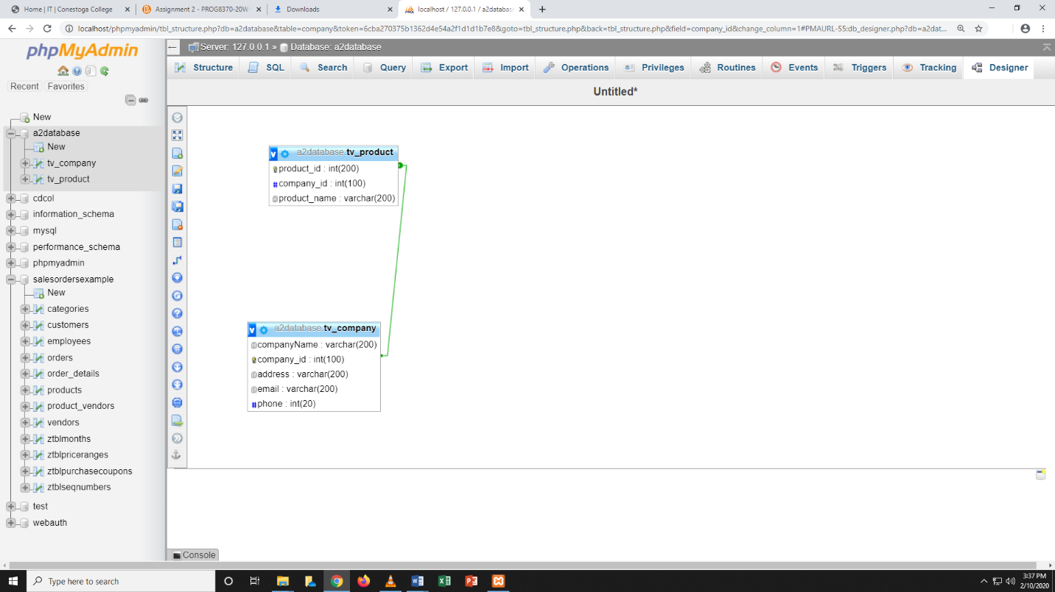

Part 4

1. Find the first name and phone number of all customers who have ever ordered a helmet. **HINT**: Use the keyword **DISTINCT.**

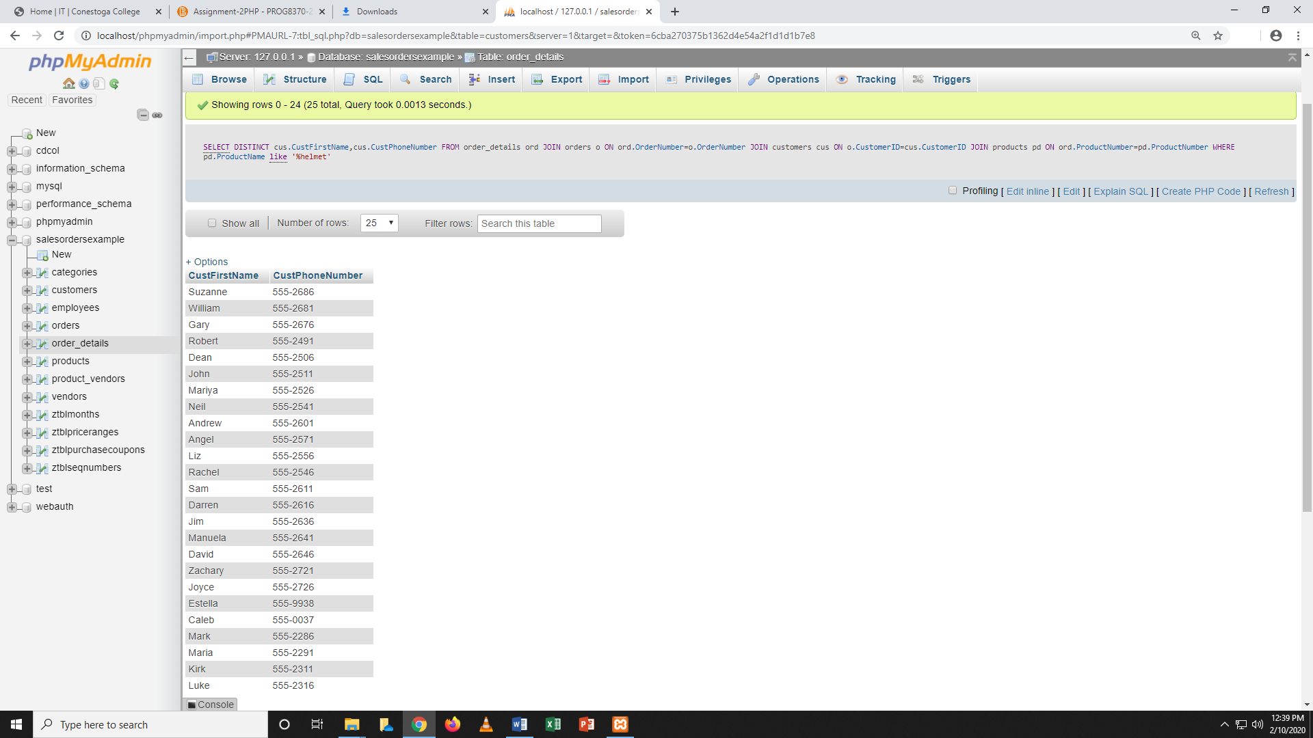

1. Display the first name of all customers who have the same first name as an employee.

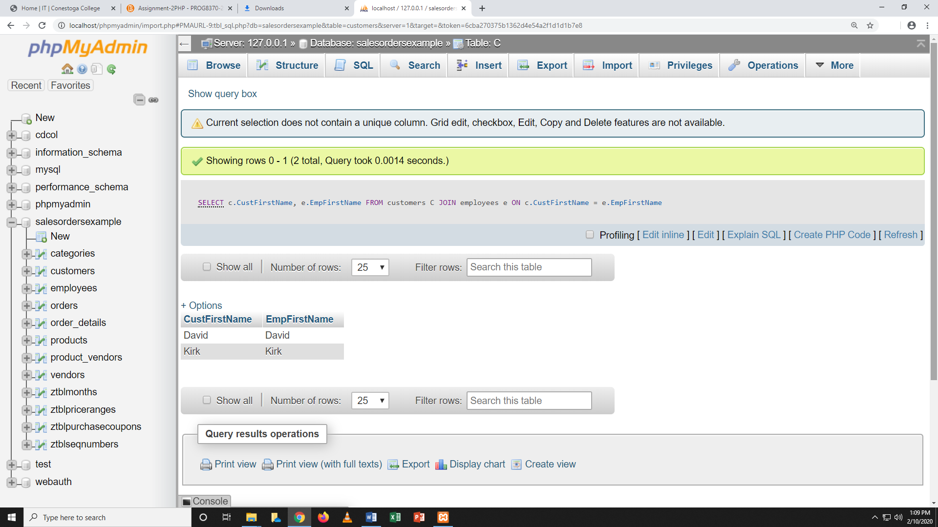

### Part 5: Aggregate Functions

### Find the combined total value (QuantityOrdered*QuotedPrice*2) of all orders made by customers from the state of 'OR'

