dry

- Steps
  - We’ll install a jump at the start of poll.
This jump redirects execution to our hook. Since poll writes to a global, the memory is writable, making this safe.
  - We’ll place our hook code in a new section at the end of the file.
This gives us space to write clean logic without interfering with existing code.
  - We’ll recreate the overwritten prologue of poll inside the hook.
This ensures the stack and control flow remain intact as if nothing changed.
  - We’ll write our custom interval value into the global variable.
This replaces the original behavior, letting us set any delay we want.
  - We’ll jump back into poll after its original memory write.
This skips the part where poll would have overwritten our value.
Key Points
- The memory is already writable.
- Our hook runs every time poll executes.
- We skip the original write to avoid being overwritten.
- No flags or assumptions are needed.
- We fully control where execution resumes.
- We assume the global write occurs before any return in poll.
- The return jump target must be chosen carefully by analyzing instruction boundaries.
The hook changes the polling interval reliably by injecting early and skipping over the original assignment.

- Steps
- Discover every call-target inside mine using symbol analysis or linear sweep. Each target must be treated as a separate entry point to hook, as shown in the "Hot Patching" technique.
- Overwrite the first 5–15 bytes at each entry with a relative jmp to a shared trampoline. The trampoline will include the original overwritten instructions to preserve execution flow.
- In the trampoline:
  - Save volatile registers and flags.
  - Locate the input parameter ([esp+4], ecx, or rcx/rdi depending on platform) and apply not.
  - Restore registers.
  - Jump back to the original function after the overwritten bytes.
- Use the end of mine (optional tail patch) if additional space is needed. The problem permits overwriting the single ret, allowing extra hook logic to be stored there.
- Ensure ASLR- and DEP-safety by resolving runtime addresses via GetModuleHandle and GetProcAddress. If no safe code caves are available, use VirtualAlloc to allocate executable memory, as done in DLL-injection setups.
Key Points
- Handles multiple entry points explicitly, avoiding reliance on a single prologue hook.
- Leaves the single return point untouched, preserving expected exit behavior.
- Does not attempt to restore x, as the goal is to compute f(~x) — reinversion is unnecessary and would corrupt the result.
- Assumes at least 5 writable and executable bytes at each hook location; fallback stubs may be needed if space is tight.
- Argument handling depends on the calling convention; support for fastcall and full 64-bit ABIs requires explicit extension.
- Not fully memory-free — although in-place hot patching is possible, external space allocation may be needed in constrained binaries.
- Steps
- Locate the IAT entry for sendf.
Use PE parsing to find the Import Address Table and identify the pointer for sendf.
- Replace the IAT entry with your hook function.
Use VirtualProtect to make the IAT writable, then patch the function pointer to redirect to your hook.
- Implement the hook function.
Accept the original arguments (socket, format string, and variadic args). Use va_list, va_start, and vsnprintf to format the message.
- Encrypt the formatted buffer.
Apply encryption to the resulting message.
- Call the original sendf using the same format string and arguments.
To preserve format fidelity, do not replace the format string with "%s"—instead, pass the original format and args to vsnprintf, then encrypt the output and send it as a raw message.
- Optionally wrap the original format call.
If reformatting is necessary, preserve argument count and types by parsing the format string and forwarding them accordingly.
- Manage memory and restoration.
Free buffers after use. If restoring the IAT is required, ensure thread safety using atomic or lock-free operations.

Key Points
- IAT hooks only affect external calls; internal/static calls to sendf are not intercepted.
- Replacing the format string with "%s" is lossy—maintain the original format and argument structure to avoid breaking downstream behavior.
- Ensure proper handling of variadic arguments to avoid stack or heap corruption, especially under cdecl.
- Consider fallback to hot patching if full control over all call sites is required.
- Thread safety must be explicitly handled when patching or restoring IAT entries.

- Steps
- Resolve Function Addresses
At runtime, use GetModuleHandle() and GetProcAddress() to determine the entry addresses of both parse and connect.
- Patch Each Function Prologue
For each of the two functions:
  - Read and save the first N bytes of the prologue (where N ≥ 5).
  - Use VirtualProtect() to enable writing to the function’s code page.
  - Overwrite the prologue with a relative jmp to a trampoline.
  - Restore the original memory protection.
- Implement a Shared Trampoline
In an RWX memory region (e.g., via VirtualAlloc()):
  - Save registers and flags (pushad / pushfd).
  - Execute the saved prologue bytes to preserve original logic.
  - Capture arguments into a struct and call CreateThread() with a worker that:
    - Receives the arguments,
    - Calls the rest of the original function (entry + N),
    - Exits via ExitThread().
  - Restore the original state (popfd / popad).
  - Jump back to entry + N, skipping the rest of the function body in the main thread.
- Thread Management
After both hooks execute:
  - Use WaitForMultipleObjects() if the original logic depends on the results of parse or connect.
  - Always CloseHandle() on thread handles to avoid resource leaks.
Key Points
- Each function receives its own patch via a single jmp at its prologue, avoiding complex control-flow hacks.
- Volatile registers and flags must be saved and restored to preserve correct behavior.
- We can Ensure each function’s prologue is at least 5 bytes long to accommodate a jmp instruction; otherwise, we can use a larger trampoline or adjust patching strategy.
- All addresses are resolved dynamically and patched memory is safely updated using VirtualProtect, making the solution ASLR- and DEP-safe.
- Argument data must be copied into a thread-safe structure before thread creation to avoid races with stack/register reuse.
- When using a shared trampoline, we can include logic to distinguish which function triggered it (e.g., by comparing the return address or thread-local identifiers).
- Store each thread handle in a global or thread-local array immediately after CreateThread() for proper cleanup and synchronization.
- We can use WaitForMultipleObjects() whenever subsequent code depends on the results of parse or connect—synchronization is mandatory in such cases to avoid data races.

- Steps
- Locate and validate calc
Use GetModuleHandle and GetProcAddress to find calc. Disassemble its prologue to ensure at least 5 bytes can be overwritten. If not, prepare a thunk and use a long jump.
- Set up infrastructure
Allocate an RWX trampoline, store original prologue bytes, and pre-build the jump back. Initialize a CRITICAL_SECTION for safe patch toggling. Set up a lock-free log buffer and a background flusher thread.
- Apply hot patch
Temporarily unprotect the code page, write a 5-byte jmp at the start of calc, and restore protection.
- Trampoline logic
Save volatile state, enter critical section, restore original prologue, call calc + N, reapply the hook, log return value, restore state, and return to caller.
- Handle integrity checks
If a watchdog might scan calc mid-call, delay its checks via a timer thread. If this fails, fallback to IAT hooking.
- Optional fallback
If calc is imported, patch its IAT entry instead of the prologue.
- Cleanup
On process exit, flush logs, close handles, and delete the critical section.
Key Points
- Only one jmp is written inside the target binary (at calc's entry).
- Thread safety is ensured via a critical section; recursion is not supported.
- The prologue is temporarily unhooked during execution, which may expose the patch.
- The IAT fallback applies only if calc is imported.
- If prologue is too short, use a thunk and long jump instead.

- Steps
- Verify patch feasibility
  - Disassemble the first instructions of solve; ensure at least 5 contiguous bytes can be overwritten.
  - Allocate an executable code cave for two trampolines (entry and tail).
- Entry hot-patch
  - Overwrite the prologue with one relative jmp to the entry-trampoline.
  - Store the original bytes for later restoration.
- Entry-trampoline actions
  - Save all volatile and non-volatile registers plus flags (x86 / x86-64).
  - Increment a thread-local recursion counter.
  - Restore the original prologue, then jump to solve+N so the real body executes intact.
- Discover and patch every exit (first execution only)
  - While control flows through the body, a lightweight disassembler records every ret/retn imm8.
  - Replace each recorded return with a short jump to a shared tail-trampoline.
- Tail-trampoline logic
  - On arrival from any return site, capture the value in EAX/RAX.
  - Decrement the thread-local counter.
  - Double the value always (case a) or only when the counter is zero (case b).
  - Place the adjusted value back into the return register.
  - Execute an exact copy of the original ret instruction to satisfy CFI/CET and return to the caller.
- Thread-safe patch management
  - Guard patch/un-patch operations with a CRITICAL_SECTION wrapped in SEH (__try / __except) so locks are released on unexpected faults.
- Integrity & security considerations
  - Because the body runs with its original code, most self-checksums pass; if tail bytes are covered by a checksum, delay that check with a timer until after the tail patch is restored.
  - Resolve all addresses at runtime and toggle page protections with VirtualProtect to remain ASLR/DEP compliant.
- Cleanup
  - On process detach, restore every patched return and the original prologue, free the trampolines, and delete the critical section.

Key Points
- Single if (depth==0) test in the tail-trampoline switches between “double every call” (case a) and “double only the outermost call” (case b).
- All exits captured – dynamic scan patches every return instruction, avoiding the “single-ret” assumption.
- One-jmp rule respected – only one detour at the prologue; exit patches remain inside the same function and do not add extra hooks elsewhere.
- Thread-local depth counter – prevents races in multi-threaded recursion; counter balance is guaranteed because the tail-trampoline runs on every exit path.
- CFI/CET safe – tail-trampoline ends with the exact original ret opcode, bypassing control-flow-integrity checks.
- SEH-protected critical section – avoids deadlocks if exceptions occur while the code is writable.
- Full register preservation – includes non-volatile registers (RBX, RBP, etc.) for 64-bit builds.
- Minor residual risks acknowledged
  - Disassembly overhead – initial exit-map construction adds one-time latency but is negligible for long-running processes.
  - Deep recursion – extremely deep call trees could overflow the thread-local counter; choose a wide integer type or add overflow checks if this is a concern.
  - Tail-byte checksums – if a security routine hashes the bytes around each ret, an additional stub may be required to spoof the expected hash.
  - Unusual calling conventions – if solve uses a non-standard convention (e.g., returning via EDX:EAX), adjust the tail-trampoline to handle multi-register returns.

Part 1
First im trying to run keygen.exe with input string:
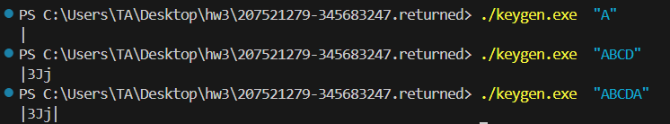
Tried opening in IDA to look for scanf function of some sort. Found ‘tolower’ function:
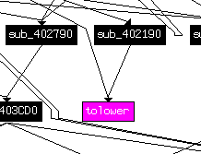
So maybe output is the same for lower/uppcase. 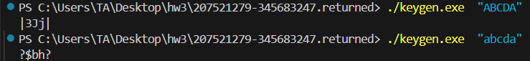
It seems like each character is mapped to a single output (ex. ‘A’ always maps to ‘|’).
We probably need to create a mapping for each character.(for loop in python file which saves output of each character after running keygen with the unique input.
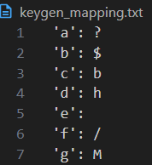
Noticed that ‘e’ and ‘I’ are mapped to essentially nothing so we tested to make sure:
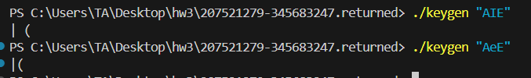
Seems like ‘I’ is space and ‘e’ is unclear, possibly maps to nothing.
We continue to make a reverse mapping for the .txt file to be able to get the input which gave us the output.
Creating the reverse mapper gave us the expected output:
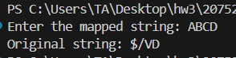
Trying to input randomly into tools the giant’s reversed password, not working.
They mention hw1’s passwords so we figured we need to use reverse keygen on one of those.
Tried with hw1 provided password:
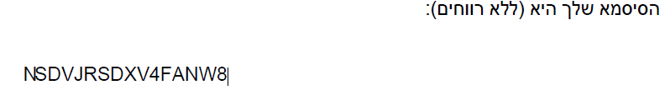
Didn’t work.
We realised we didn’t check mapping for numbers…
We also realised that we don’t have a mapping that leads to 8, which means we might have missed some characters.
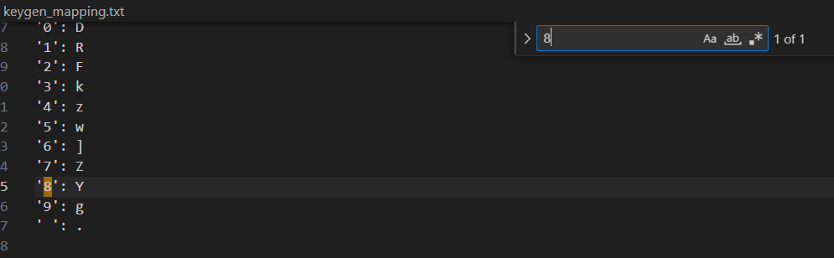
Searching for all possible inputs manually to try and find which one gives 8 as output we found out that ‘*’ gives 8x where x is a printable character.
Searching for values we found that *I(which we previously found out is space of some sort) gives us 8 as output:
So we run the reverse mapper and get:
And in stead of 8 we will try and input: *I as mentioned above. Which didn’t work. So we tried many inputs with * and we have noticed that all of them have 8 at the beginning so we tried to get into tools using the password we got and a * at the end of the string and we got in:

Which means that we need to change the mapping file to fit the exercise requirement and make a special mapping for 8 specifically.
Ascii for 8 is 56, ascii for * is 42 so we added to our table: {56,42}.
Which gives us the correct mapping:
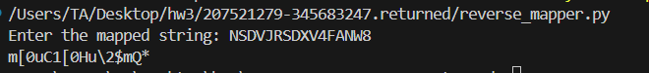

Part 2
Running client.exe:
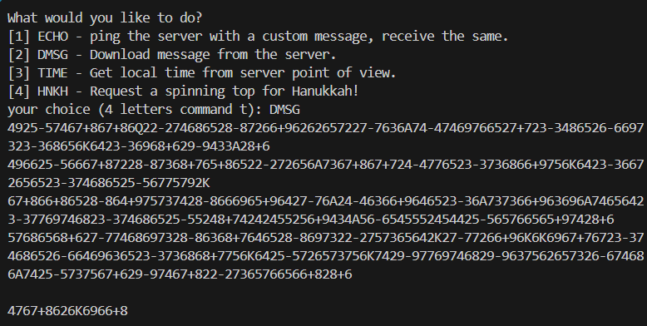
Trying to run secure_pipe:
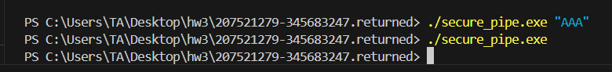
Opening secure_pipe on IDA.
We find some randomizing calls in sub_401410:
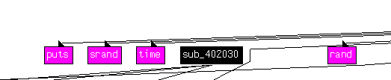
Which reminds us of hw1 function calls(and also function address is similar. And the usage of srand gives a hint of high likelyhood of some encryption). This leads us to believe that some input might be randomized.
After asking on discord we have been told to statically analyze the file so we do.
(sub 401410: )
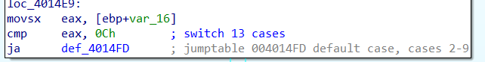
We have to figure out which are the 13 cases
Based off of the data preperation stage we figured out there is an upper nibble and lower nibble which’s values are being compared in a 13 case switch.
We’ll mark a random number generated by rand function call (which is between 2 and 9) in ‘rand’:
Value (decimal) | buffer
0 | ‘rand’+ ‘-‘ + ‘rand’
1 | A
10 | J
11 | Q
12 | K
2-9 | ‘rand_1’ + ’+’ + ’rand_2’
Else: ‘x’ | x+48

First lets create the function reverse the actions made in sub401410 to figure out how to revert the string. After making a small parser we got:
Search for the function that prints the string in client.exe:
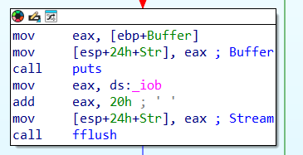
We probably to replace puts function using injector.
In the injector template we will change the args (dll path to our dll, application to the client.exe to inject our new dll, and the comand line input DMSG to automatically run the command):
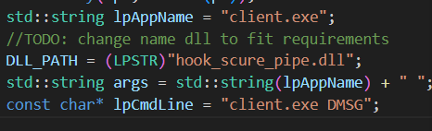
We will use the workshop file to mimic IAT hooking:
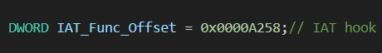
Address was chosen based on the distance to puts relatively to base(400000):
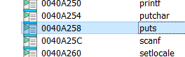
Now after creating the dll and the injector we got our injector.exe and we get the output:
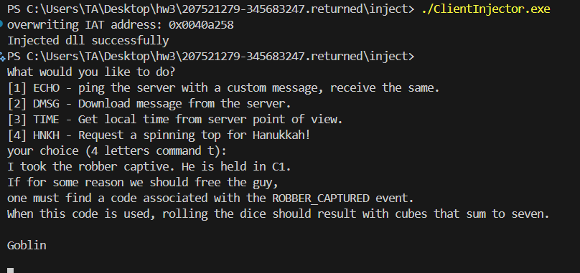
Which means we successfully injected the new dll and hooked puts properly.
Part 3
Tried downloading files that are hinted at in the goblin’s message from the last part(dice.exe and code.exe):
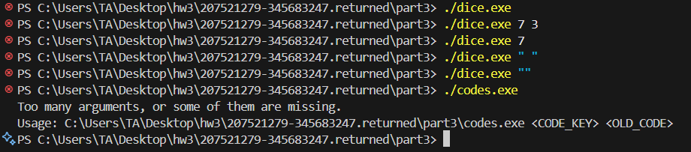
Opening codes on ida and looking for an event called “ROBBER_CAPTURED”
Found:
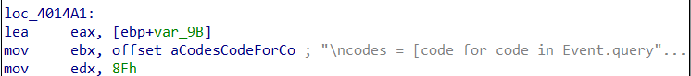
So we probably need to search around the codes.exe file.
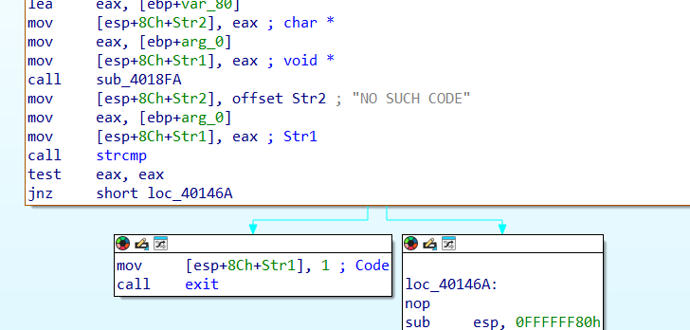
When debugging with input ‘1 1’ we pass this strcmp and don’t exit. However:
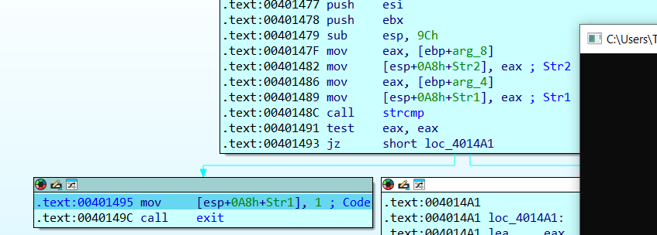
in sub401473 we fail the strcmp.
we find out that the first function uses old_code to search for an old event code and compares it to “no such code”.
then in another function it uses strcmp which we fail. So if we bypass the strcmp check with our own implementation we could find the event required.
We will use IAT hook again with the delta address 9294, basically using the same file as in part 2 but changing minor details..:

Since we passed the first strcmp we could just check the 2nd str inputted and if the event name(str2 input) is “ROBBER CAPTURED” (as we were instructed to look for in part 2)
then we could make sure the strcmp return value in EAX would be 0 (to pass the JZ condition).
After debugging with prints we found out that the first input is the event name, so we played with the order of the arguments until we got a good hook which enters the “robber captured” event, however we still got a traceback:
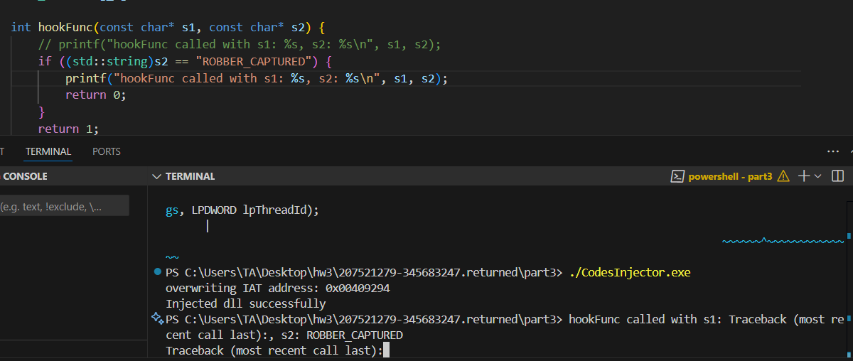
We assume we get the traceback because it needs to run on the server.

It appears that toolfix.exe is being run so we probably want to rename the inejctor to toolfix.exe.
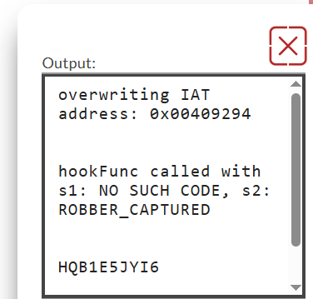
it seems like our code is: HQB1E5JYI6.
We input the code with the ‘C1’ from part2 and we get halperted out of our minds:
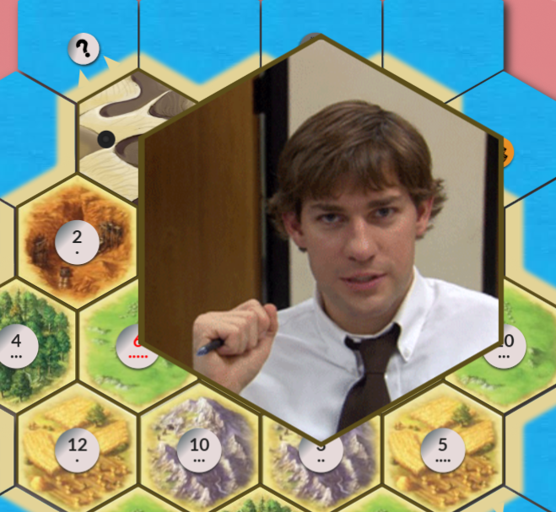
Which is clearly not a robber…
We realize that we need to hook the function sub_401410 with new code that disables the 7 comparison for our specific code.
So we open dice.exe in CFF explorer and add a 200byte space at the end of the code.
Using the code we used in the workshop as reference we manually change the bytes in 1410 to match the jump opcode:
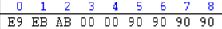
We calculated the distance to the end of the old code:
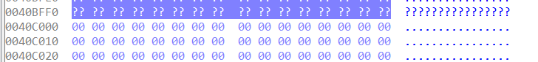
Where the section we added in CFF starts in C000 so we got:
$$C000-1410-5=ABEB$$
Where the 5 is added for the eip after execution as we have seen in workshop.

Now all that is left is to add our function to that piece of empty space at the end of the file. We create our code in visual studio and then copy the bytes from the exe created in cff explorer:
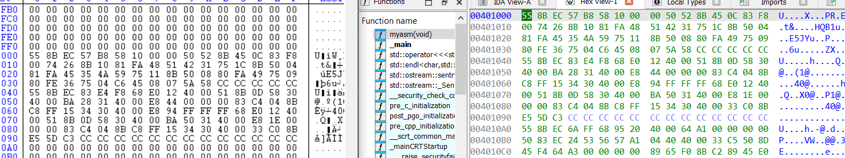
Which gives us the new function, where we just had to adjust the return address for the jmp command( E9 XX XX XX XX):
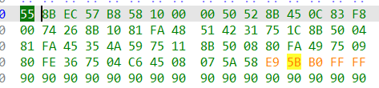
Which copies instructions from the old code and checks for our specific dice code. Then returns to normal execution.
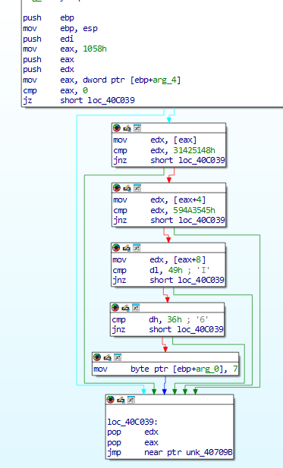
And we got our robber:
