dry

Part 1
First im trying to run keygen.exe with input string:
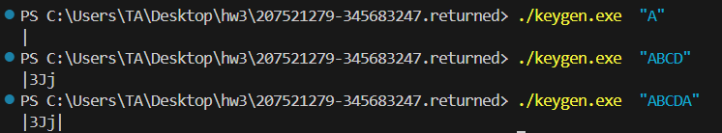
Tried opening in IDA to look for scanf function of some sort. Found ‘tolower’ function:
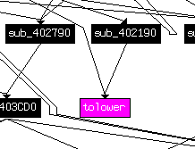
So maybe output is the same for lower/uppcase. 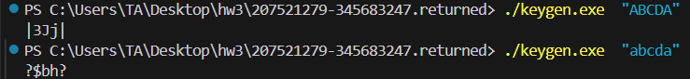
It seems like each character is mapped to a single output (ex. ‘A’ always maps to ‘|’).
We probably need to create a mapping for each character.(for loop in python file which saves output of each character after running keygen with the unique input.
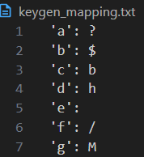
Noticed that ‘e’ and ‘I’ are mapped to essentially nothing so we tested to make sure:
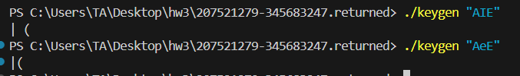
Seems like ‘I’ is space and ‘e’ is unclear, possibly maps to nothing.
We continue to make a reverse mapping for the .txt file to be able to get the input which gave us the output.
Creating the reverse mapper gave us the expected output:
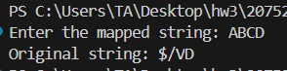
Trying to input randomly into tools the giant’s reversed password, not working.
They mention hw1’s passwords so we figured we need to use reverse keygen on one of those.
Tried with hw1 provided password:
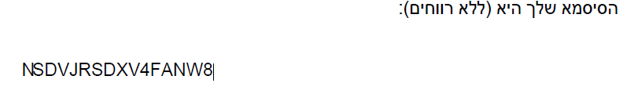
Didn’t work.
We realised we didn’t check mapping for numbers…
We also realised that we don’t have a mapping that leads to 8, which means we might have missed some characters.
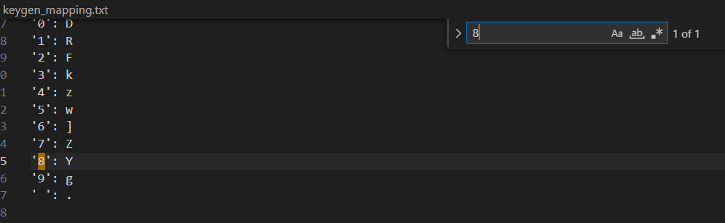
Searching for all possible inputs manually to try and find which one gives 8 as output we found out that ‘*’ gives 8x where x is a printable character.
Searching for values we found that *I(which we previously found out is space of some sort) gives us 8 as output:
So we run the reverse mapper and get:
And in stead of 8 we will try and input: *I as mentioned above. Which didn’t work. So we tried many inputs with * and we have noticed that all of them have 8 at the beginning so we tried to get into tools using the password we got and a * at the end of the string and we got in:

Which means that we need to change the mapping file to fit the exercise requirement and make a special mapping for 8 specifically.
Ascii for 8 is 56, ascii for * is 42 so we added to our table: {56,42}.
Which gives us the correct mapping:
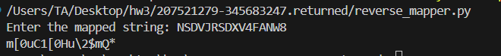

Part 2
Running client.exe:
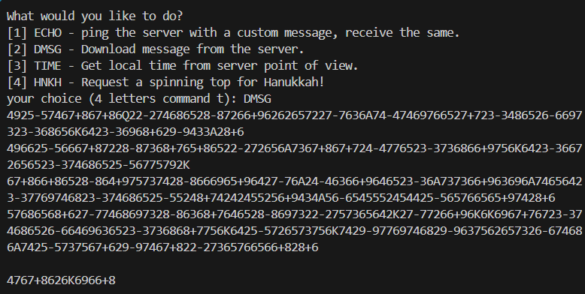
Trying to run secure_pipe:
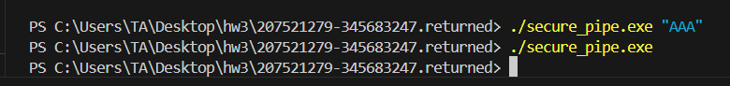
Opening secure_pipe on IDA.
We find some randomizing calls in sub_401410:
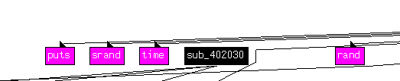
Which reminds us of hw1 function calls(and also function address is similar. And the usage of srand gives a hint of high likelyhood of some encryption). This leads us to believe that some input might be randomized.
After asking on discord we have been told to statically analyze the file so we do.
(sub 401410: )
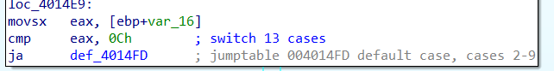
We have to figure out which are the 13 cases
Based off of the data preperation stage we figured out there is an upper nibble and lower nibble which’s values are being compared in a 13 case switch.
We’ll mark a random number generated by rand function call (which is between 2 and 9) in ‘rand’:
Value (decimal) | buffer
0 | ‘rand’+ ‘-‘ + ‘rand’
1 | A
10 | J
11 | Q
12 | K
2-9 | ‘rand_1’ + ’+’ + ’rand_2’
Else: ‘x’ | x+48

First lets create the function reverse the actions made in sub401410 to figure out how to revert the string. After making a small parser we got:
Search for the function that prints the string in client.exe:
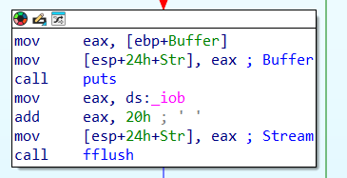
We probably to replace puts function using injector.
In the injector template we will change the args (dll path to our dll, application to the client.exe to inject our new dll, and the comand line input DMSG to automatically run the command):
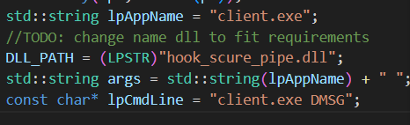
We will use the workshop file to mimic IAT hooking:
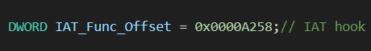
Address was chosen based on the distance to puts relatively to base(400000):
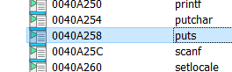
Now after creating the dll and the injector we got our injector.exe and we get the output:
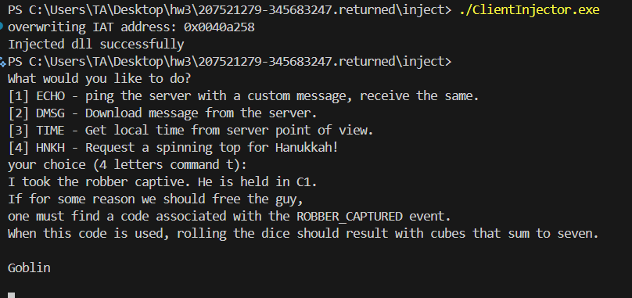
Which means we successfully injected the new dll and hooked puts properly.
Part 3
Tried downloading files that are hinted at in the goblin’s message from the last part(dice.exe and code.exe):
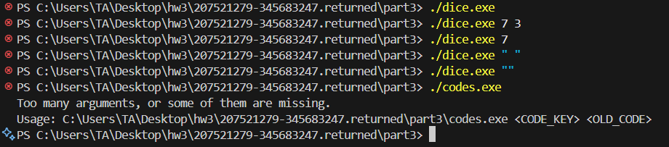
Opening codes on ida and looking for an event called “ROBBER_CAPTURED”
Found:
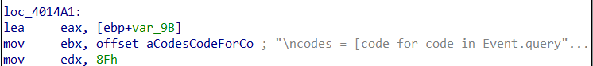
So we probably need to search around the codes.exe file.
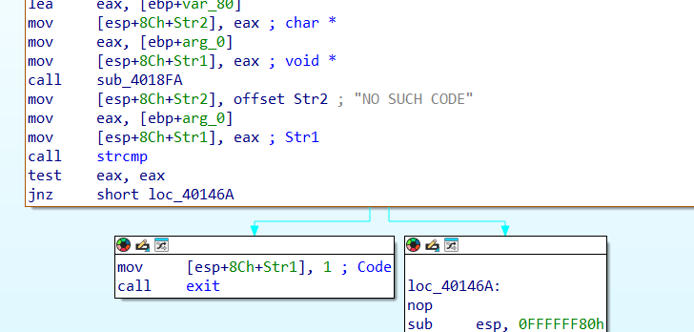
When debugging with input ‘1 1’ we pass this strcmp and don’t exit. However:
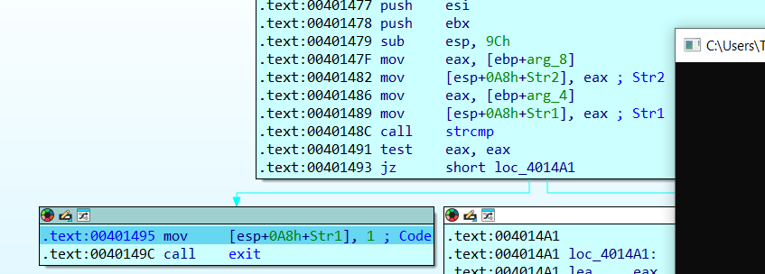
in sub401473 we fail the strcmp.
we find out that the first function uses old_code to search for an old event code and compares it to “no such code”.
then in another function it uses strcmp which we fail. So if we bypass the strcmp check with our own implementation we could find the event required.
We will use IAT hook again with the delta address 9294, basically using the same file as in part 2 but changing minor details..:

Since we passed the first strcmp we could just check the 2nd str inputted and if the event name(str2 input) is “ROBBER CAPTURED” (as we were instructed to look for in part 2)
then we could make sure the strcmp return value in EAX would be 0 (to pass the JZ condition).
After debugging with prints we found out that the first input is the event name, so we played with the order of the arguments until we got a good hook which enters the “robber captured” event, however we still got a traceback:
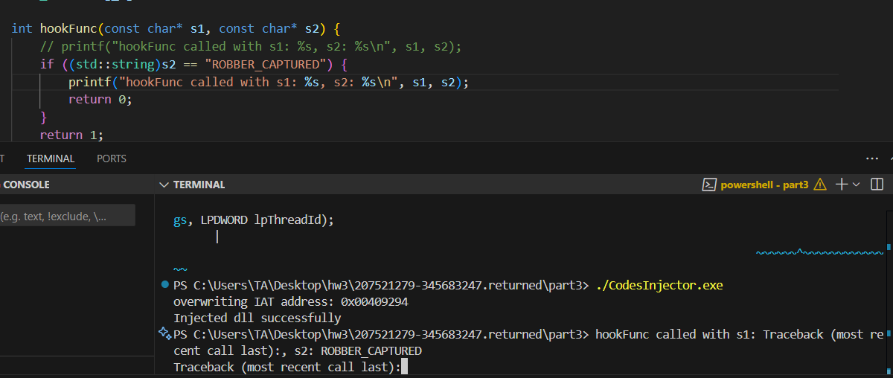
We assume we get the traceback because it needs to run on the server.
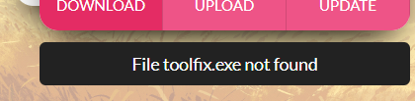
It appears that toolfix.exe is being run so we probably want to rename the inejctor to toolfix.exe.
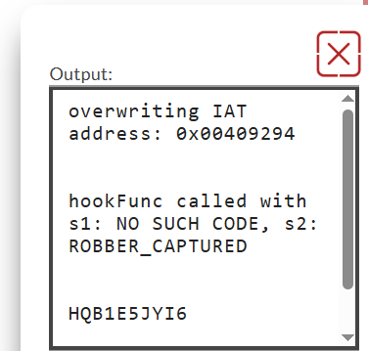
it seems like our code is: HQB1E5JYI6.
We input the code with the ‘C1’ from part2 and we get halperted out of our minds:

Which is clearly not a robber…
We realize that we need to hook the function sub_401410 with new code that disables the 7 comparison for our specific code.
So we open dice.exe in CFF explorer and add a 200byte space at the end of the code.
Using the code we used in the workshop as reference we manually change the bytes in 1410 to match the jump opcode:
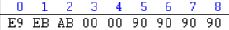
We calculated the distance to the end of the old code:
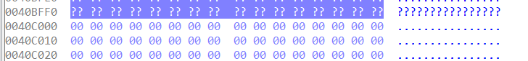
Where the section we added in CFF starts in C000 so we got:
$$C000-1410-5=ABEB$$
Where the 5 is added for the eip after execution as we have seen in workshop.

Now all that is left is to add our function to that piece of empty space at the end of the file. We create our code in visual studio and then copy the bytes from the exe created in cff explorer:
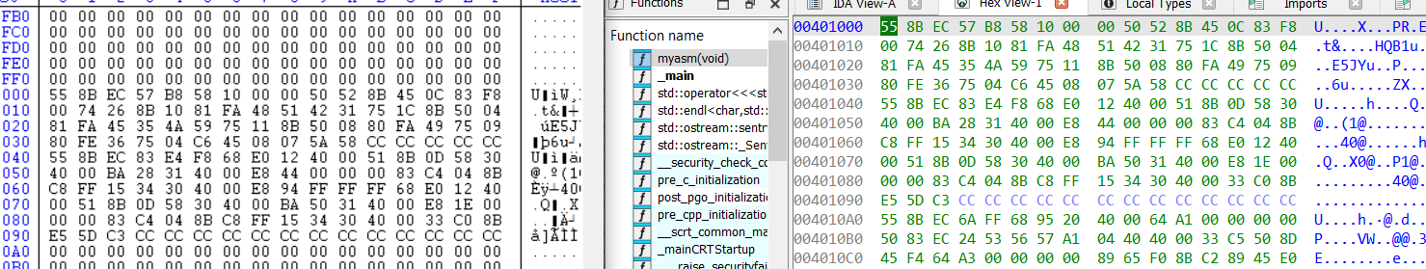
Which gives us the new function, where we just had to adjust the return address for the jmp command( E9 XX XX XX XX):
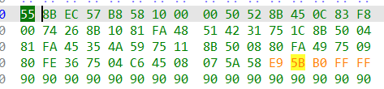
Which copies instructions from the old code and checks for our specific dice code. Then returns to normal execution.
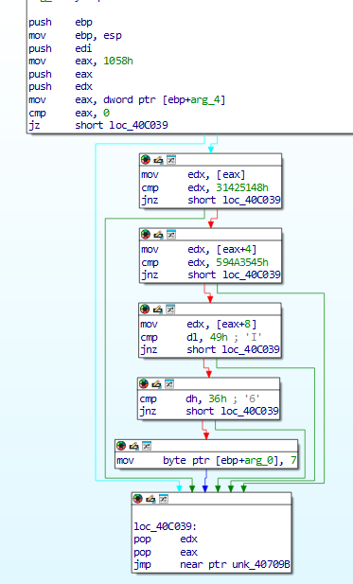
And we got our robber:
