**PYTHON LESSON 1**

1. **State differences between Python 2 and Python 3 version.**

|  |  |  |
| --- | --- | --- |
| Python 2 | | Python 3 |
| -Old version | -Newest version | |
| -Not much updated or supported | -Currently being updated, mantained, and supported. | |
| -It has been longer, so more libraries and codes. | -Less libraries and codes. | |
| -String are ASCII by default. | -Strings are Unicode by default. | |
| -Rounds calculation by default. | -Does not round calculation by default. | |

**2. Write a python program for the following:**

**Take the user first name and last name and print it in reversed form**

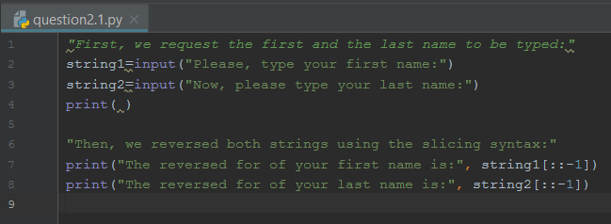

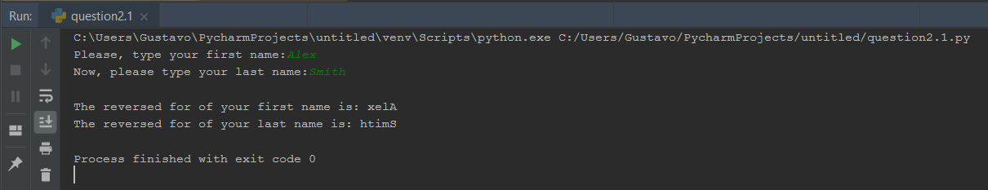

**Take two numbers from user and perform arithmetic operations on them.**

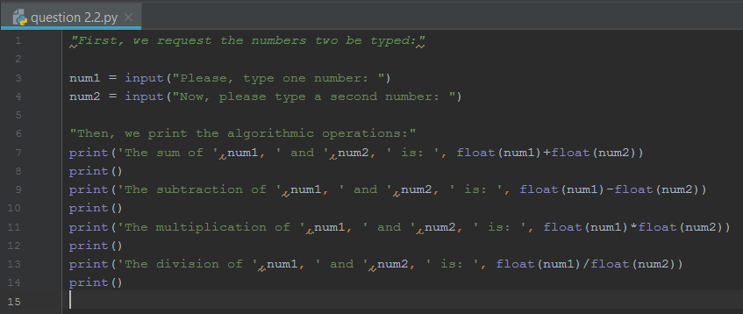

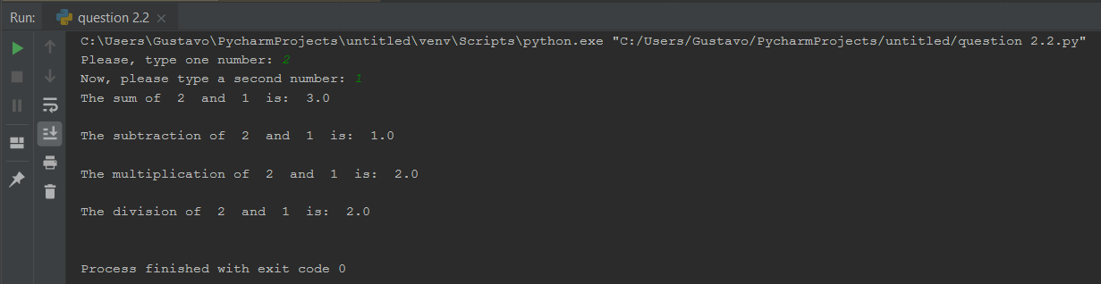

**3. Write a program that accepts a sentence and prints the number of letters and digits in**

**Sentence.**

