PREFACE
The prevalence of food allergies has significantly increased in recent years, affecting millions of people worldwide. Managing food allergies is a critical aspect of daily life for those impacted, requiring constant vigilance in identifying potential allergens in food products. With advancements in mobile technology and artificial intelligence, the potential to offer accessible solutions for allergy management has never been more promising.
This project, Food Allergy Detection and Analysis Application stems from the growing need for a comprehensive tool that helps users identify food allergens and provides an educational platform for awareness and prevention. The primary motivation behind this application is to enhance the safety and well-being of individuals with food allergies by leveraging image recognition and barcode scanning technologies. Through this innovative approach, users will receive instant feedback on allergens in their food, making it easier to make informed decisions.
In addition, the educational component of the app aims to raise awareness about allergies, particularly among children, through interactive learning tools and games. This project is not only a technical endeavor but also a personal commitment to contribute to the overall health and education of allergy sufferers and their families.
The development of this application has been guided by a dedication to improving public health, and I hope it serves as a valuable resource for users seeking to manage their allergies with confidence and knowledge.

Abstract
The Food Allergy Detection and Analysis Application is a mobile solution designed to help users identify potential food allergens through image recognition and barcode scanning. By utilizing the device's camera, the application analyzes food items and compares them against a comprehensive allergen database to provide real-time feedback on potential risks. The app is particularly beneficial for individuals with known allergies, helping them avoid unsafe foods quickly and efficiently. In addition to allergen detection, the application includes an educational module designed to raise awareness about food allergies. This module offers guidelines, tips, and interactive content, including game-based learning aimed at children, helping them understand food safety and allergy management in a fun, engaging manner. The project utilizes technologies like Flutter for cross-platform development, Mysql for backend services, and image recognition APIs, ensuring a robust and responsive user experience.
Keywords: Food allergy detection, image recognition, barcode scanning, mobile application, allergen database, real-time analysis, educational games, Flutter, food safety, allergy management.

INTRODUCTION
5.1 PROJECT OVERVIEW STATEMENT
Food allergies pose a significant health risk to millions of individuals worldwide, particularly as food products become increasingly complex and diverse. Identifying allergens in daily meals can be challenging, and accidental exposure to allergenic ingredients can lead to serious health complications. With the prevalence of food allergies, especially among children, the demand for quick and reliable methods to detect allergens has never been more critical [1].
The Food Allergy Detection and Analysis Application aims to address this challenge by providing a comprehensive mobile solution. The application leverages advanced technologies, including image recognition, barcode scanning, and machine learning (ML), specifically utilizing Convolutional Neural Networks (CNNs) for enhanced accuracy [2]. CNNs are particularly effective in processing visual data, allowing the application to identify potential allergens in food items by analyzing images taken by the user. By simply capturing a photo of a food item or scanning its barcode, users can receive real-time feedback on whether the food contains allergens that could pose a health risk. This capability is invaluable for individuals with known allergies, empowering them to make safer food choices confidently. The incorporation of ML and CNN technology continuously improves the application's allergen detection capabilities, refining its predictive accuracy based on user interactions and accumulated data [3][4].
In addition to allergen detection, the application serves a vital educational purpose. It features a dedicated module with guidelines, tips, and interactive content aimed at raising awareness about food allergies and promoting effective allergy management strategies. A key aspect of this educational component is the integration of game-based learning, designed to teach children about safe food choices engagingly and enjoyably. This approach not only fosters awareness but also encourages proactive behavior among young users in managing their food allergies [5].
The project is built using Flutter for cross-platform development, ensuring compatibility across both Android and iOS devices. The backend infrastructure is supported by python and Mysql , which manage user data and store information related to allergens [6].

5.2 PROJECT GOAL & OBJECTIVES
Project Goals:
The primary goal of this project is to create an innovative mobile application designed to detect food allergens through advanced image recognition and barcode scanning technologies. The application aims to provide users with accurate allergen information and foster greater awareness about food allergies through an engaging educational module.
Objectives :
- Develop a Food Allergy Detection and Analysis Application to help users identify potential food allergens.
- Implement allergen detection technology.
- Develop a comprehensive allergen database.
- Create an educational module.
- Ensure cross-platform accessibility and optimal user experience.
- Enable real-time updates and ensure information accuracy.
- Enhance user engagement and data security.

5.3 PROJECT SCOPE
The scope of our mobile application is to assist individuals in managing food allergies through a user-friendly platform. The app will allow users to identify potential food allergens by analyzing images and barcodes using the device’s camera. It will compare the scanned food items against a comprehensive allergen database, providing users with realtime alerts if a food product poses a risk. In addition to detection, the app will include an educational module designed to teach users, particularly children, about food allergies and safety. This interactive feature will involve game-based learning where users can test their knowledge about allergens in a fun and engaging way. The app will store user data securely, enabling personalization based on individual allergy profiles, and provide care Assistant with tools to monitor food safety for their dependents, ensuring a holistic approach to allergy management. All data will be managed through a secure and reliable backend system for seamless functionality.

5.4 PROJECT LIMITATIONS AND CONSTRAINTS
Limitations and Constraints of Food Allergy Detection and Analysis Application (FADA) :
- The project must be completed with the available resources.
- The project must be completed in a specific time.
- Compatibility with both IOS and Android platforms
- Image recognition accuracy.
- Unclear or poor-quality images affect allergen detection.
- Barcode database coverage, and real-time database updates.
- The educational module may not fully cover all allergies or cater effectively to all age groups.
- The app's functionality may be limited in areas with poor or no internet connectivity.
- High development and maintenance costs for the app.
- Data security and privacy regulations.

5.5 PROJECT ASSUMPTIONS
In the proposed system we have :
- Users will have access to a smartphone with a functional camera and barcode scanner.
- A reliable internet connection will be available for real-time database updates and barcode scanning.
- The allergen database will be regularly maintained and updated with accurate information.
- Users will correctly input data regarding their allergies to ensure accurate results.
- The image recognition and barcode scanning technology will perform effectively under normal conditions.
- Users will engage with the educational content as part of their learning about allergies.
- The application will be used by both adults and children, requiring a user-friendly interface.

Feasibility Study

7.1 Purpose of the Feasibility Study
The purpose of the feasibility study for the Food Allergy Detection and Analysis Application is to assess the practicality and viability of developing a mobile application that assists users in identifying food allergens and provides educational resources regarding food allergies. This study serves multiple objectives essential for guiding the development process and ensuring the project meets its intended goals effectively.
First and foremost, the feasibility study aims to evaluate the technical feasibility of the application. This involves analyzing the technologies required for image recognition and barcode scanning, as well as assessing the integration of machine learning algorithms to ensure accurate allergen detection. Understanding the technical requirements is crucial for determining whether the necessary resources, such as skilled personnel and appropriate technologies, are available to successfully implement the project.
Secondly, the study addresses the economic feasibility of the application. It examines the potential costs associated with development, including software licensing, personnel salaries, and infrastructure expenses. This analysis also considers the projected financial benefits, such as potential revenue from in-app purchases, partnerships with food brands, and advertisements. A thorough economic assessment will help determine if the project is financially viable and sustainable in the long run. Additionally, the feasibility study aims to assess the operational feasibility of the application. This involves evaluating the operational processes needed for the app's launch and ongoing maintenance, including user support, database management, and regular updates to allergen information. Understanding the operational aspects will ensure that the application can function effectively and continue to provide accurate and timely information to its users.
Moreover, the study will evaluate the market feasibility by identifying the target audience and understanding their needs. It will analyze competitors in the food allergy detection space and gather insights into user preferences and behaviors. This information will guide the development of features that resonate with the target audience and differentiate the application from existing solutions.
Lastly, the feasibility study seeks to identify potential risks and challenges associated with the development and deployment of the application. This includes technological, financial, and market-related risks that may impact the project's success. By identifying these challenges early on, the project team can develop mitigation strategies to address them proactively.

7.2 Justification for the Proposed System
The Food Allergy Detection and Analysis Application addresses a significant public health concern regarding food allergies, which affect millions of individuals worldwide. With the prevalence of food allergies on the rise, the need for accessible and effective solutions is more critical than ever. This section outlines the justifications for developing the proposed system, emphasizing its importance, potential benefits, and unique features that differentiate it from existing solutions.
- Addressing a Growing Health Concern
Food allergies can lead to severe health complications, including anaphylactic shock, which may be life-threatening. According to recent studies, food allergies affect approximately 10% of the population, with children being particularly vulnerable. The proposed application aims to empower users by providing them with tools to identify potential allergens in food products using image recognition and barcode scanning. This proactive approach allows individuals to make informed decisions about their food choices, thereby reducing the risk of accidental exposure to allergens.
- Enhancing User Awareness and Education
One of the key features of the application is its educational component, which offers users valuable information about food allergies, their symptoms, and management strategies. The app will include interactive content, such as quizzes and games, to engage users, particularly children, in learning about food safety and allergen identification. By fostering awareness and understanding, the application can help reduce anxiety associated with food allergies and promote better dietary practices.
- Real-Time Allergen Detection
The ability to provide real-time allergen detection is a significant advantage of the proposed system. By leveraging advanced image recognition technology and a comprehensive database of allergens, the application can quickly analyze food products and inform users about potential risks. This feature is particularly beneficial in dining situations, such as restaurants or social gatherings, where individuals may not have access to detailed ingredient information. Real-time alerts enable users to make safe choices on the spot, enhancing their confidence and independence.
- Customization and Personalization
The proposed application will allow users to customize their experience based on their specific allergies and dietary preferences. By entering their known allergies, users can receive tailored alerts and recommendations that align with their individual needs. This level of personalization enhances user engagement and ensures that the information provided is relevant and actionable. Additionally, the application can store user preferences and history, enabling it to deliver a more personalized experience over time.
- Market Demand and Competitive Advantage
The increasing awareness of food allergies has led to a growing demand for effective tools and resources. The proposed application fills a gap in the market by offering a userfriendly platform that combines allergen detection with educational resources. While existing applications may focus solely on one aspect—either allergen detection or educational content—the Food Allergy Detection and Analysis Application integrates both, providing a comprehensive solution. This competitive advantage positions the application favorably in the market, appealing to a wide range of users, including individuals with allergies, care assistant , and parents.
- Potential Partnerships and Revenue Opportunities
The development of the application presents opportunities for strategic partnerships with food manufacturers, health organizations, and educational institutions. Collaborations with these entities can enhance the app's credibility and expand its reach. Furthermore, the proposed system can generate revenue through in-app purchases, advertisements, and partnerships with food brands seeking to promote allergy-friendly products. This financial model can contribute to the sustainability and growth of the application over time.

7.3 Economic Feasibility
Economic feasibility evaluates whether the proposed project is financially viable and cost-effective for implementation. For the Food Allergy Detection and Analysis Application (FADA), a careful analysis of development costs and available resources highlights its affordability and potential for achieving financial sustainability. The project leverages several freely available software tools and technologies, significantly reducing the overall expenses. This strategic use of cost-effective solutions ensures that the project remains within budget while delivering high-quality outcomes.
Cost Reduction Through Free and Open-Source Tools
One of the key factors contributing to the economic feasibility of the FADA project is the use of Flutter as the primary development framework. Flutter is an open-source, crossplatform development tool that allows developers to write a single codebase for Android and iOS applications. This eliminates the need for separate development teams or tools for each platform, effectively halving the development costs. Additionally, the wide range of pre-designed widgets and community support provided by Flutter ensures that the project timeline is shortened, reducing labor costs.
For backend services, the project employs Firebase, which offers a free tier for database management, user authentication, and cloud storage. This approach enables the project to manage essential functionalities without incurring upfront costs. As the user base grows, Firebase's pay-as-you-go pricing model ensures scalability without requiring a substantial initial investment. Alternatively, using MySQL, a free and open-source relational database management system, further underscores the project's focus on minimizing software licensing costs.

API Integration Costs
To implement critical functionalities such as image recognition and barcode scanning, the project utilizes APIs. While some APIs, like Google Vision, may incur costs based on usage, these are kept minimal during the initial stages by leveraging their free tiers or alternatives with competitive pricing. This ensures that the app's core features—such as allergen detection through machine learning—are functional without exceeding budget constraints.
Affordable Hardware and Infrastructure
The development process for FADA does not require expensive or specialized hardware. A standard development setup, including a mid-range laptop and a reliable internet connection, suffices for coding, testing, and deploying the application. Additionally, cloud services such as Google Cloud or AWS are utilized on an as-needed basis, ensuring infrastructure costs are proportional to the project’s growth and usage requirements.

Long-Term Economic Sustainability
Beyond development, the project demonstrates economic feasibility in its operational phase. The app's revenue model can include a freemium structure, where basic features are free and premium functionalities, such as advanced allergen detection or personalized reports, are available via subscription. This approach ensures a steady income stream while maintaining accessibility for all users. Partnerships with food manufacturers, grocery chains, or healthcare providers can also generate advertising or affiliate marketing revenue.

7.4 Technical Feasibility
Technical feasibility assesses whether the current technology and resources can support the development and operation of the Food Allergy Detection and Analysis Application.
Key considerations include:
- Technology Requirements:
  - Framework: The application will use Flutter for cross-platform development, allowing it to run on Android and iOS platforms.
  - Database Management: The app will integrate either Firebase for real-time database solutions or MySQL for relational database management.
  - APIs: Implementation of image recognition and barcode scanning APIs to enable allergen detection through user-uploaded images and barcode scans.
- Integration Capabilities:
  - Compatibility: Assessing the compatibility of different technologies and ensuring APIs can effectively communicate with the app’s core functionalities.
  - Data Flow: Utilizing RESTful APIs for smooth communication between the frontend user interface and back-end services, allowing for real-time updates and accurate information delivery.
- Development Expertise:
  - Skills Assessment: Evaluating whether the development team possesses the necessary skills in Flutter and Dart programming languages.
  - API Knowledge: Ensuring the team has familiarity with relevant APIs for image recognition and barcode scanning to implement these features successfully.
- Training Resources: Identifying any additional training or resources required to enhance the team's capabilities and ensure successful project execution.

7.5 Desired System Functionality
The Food Allergy Detection and Analysis Application (FADA) is designed to offer a suite of functionalities aimed at addressing the critical needs of individuals managing food allergies. Below is a detailed explanation of each key functionality of the proposed system:

1. Food Allergen Detection
The core functionality of the system is the ability to identify potential allergens in food items. This is achieved using:
- Image Recognition Technology: Users can take a photo of a food item, and the app will analyze the image using machine learning models like Convolutional Neural Networks (CNNs) to detect allergens based on visual characteristics.
- Barcode Scanning: By scanning the barcode of a packaged food item, the system retrieves detailed product information from a database, cross-referencing it with allergen data to identify potential risks. This dual approach ensures comprehensive allergen detection, catering to both unpackaged and pre-packaged food items.

2. Real-Time Feedback
The system provides immediate feedback to users upon scanning or photographing a food item.
- If allergens are detected, the app will notify the user with a clear warning, detailing the specific allergen(s) present.
- If no allergens are found, the app will display a confirmation message that the food is safe to consume. This real-time analysis empowers users to make informed decisions quickly, which is especially critical for individuals with severe allergies who require prompt and accurate information.

3. Comprehensive Database
The application features a robust, well-organized, and up-to-date allergen database that:
- Contains detailed information about common allergens and the food products they are found in.
- Supports global allergen standards, ensuring that users worldwide can benefit from the application.
- Allows for dynamic updates, ensuring new allergens or products are incorporated promptly.
The database serves as the backbone of the application, enabling accurate allergen detection and analysis.

4. Educational Module
The application includes a dedicated educational module designed to raise awareness about food allergies and promote safe food practices. Features of this module include:
- Interactive Educational Content: Articles, videos, and infographics explaining food allergies, their symptoms, and management techniques.
- Educational Games: Specially designed for children, these games teach them to recognize safe and unsafe foods in an engaging and fun manner.
- Guidelines and Tips: Practical advice for individuals and care assistant on how to avoid allergens and handle allergic reactions. This module aims to educate users, particularly children, about allergy management and foster long-term behavioral change.

5. User Interface
A user-friendly interface is integral to ensuring that the app is accessible to individuals of all ages and technical abilities.
- Simple Navigation: Clearly defined menus and icons make it easy for users to access the app’s features.
- Intuitive Design: The interface is designed to minimize the number of steps required to perform key actions, such as scanning a barcode or viewing allergen details.
- Accessibility Features: Considerations for users with visual impairments or other disabilities, including adjustable font sizes and high-contrast themes.

6. Multi-Language Support
To cater to a diverse user base, the application offers content in multiple languages.
- Users can select their preferred language from the settings menu, ensuring that all features, including educational modules and notifications, are accessible to nonEnglish speakers.
- Multi-language support makes the application globally relevant, enabling it to reach users across different countries and regions.

7. Regular Updates
Keeping the allergen database and educational content current is vital for maintaining the system’s accuracy and reliability.
- Automated Updates: The system periodically updates its allergen database to include newly identified allergens and emerging food products.
- User Feedback Integration: Users can report inaccuracies or request additional allergen data, which the admin team can incorporate in future updates.
- Content Refresh: Educational resources and games are periodically updated to include new information and maintain user engagement.

PROJECT PLAN
8.1 WORK BREAKDOWN STRUCTURE (WBS) :
The Work Breakdown Structure (WBS) is a hierarchical organizational model used in project management to achieve a comprehensive and systematic decomposition of the project. The WBS aims to analyze the project into smaller, manageable components called Work Packages, representing the smallest independent work units. The project is divided into hierarchical levels of work packages, where the top level represents the overall project, and the work packages are further subdivided into finer levels.

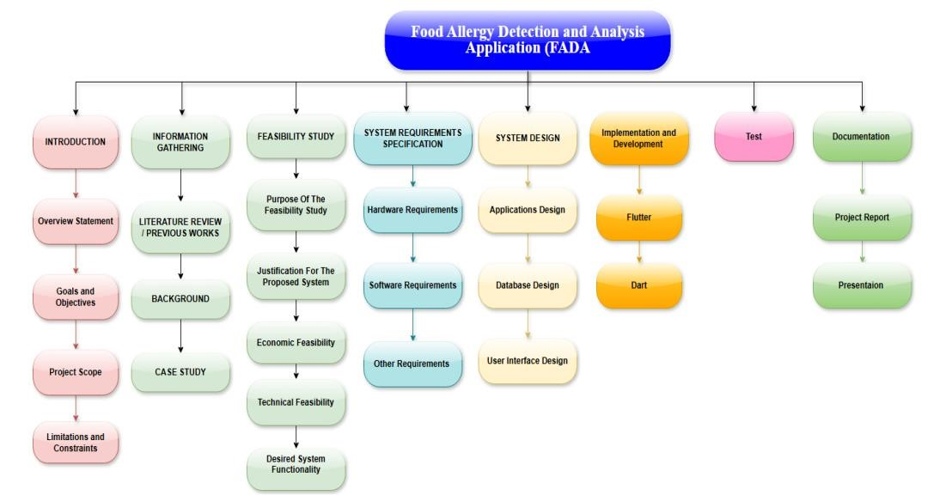

Figure 5: Work Breakdown Structure ( WBS ).

8.2 ACTIVITY AND TASK LIST :
A Task List contains the list of tasks of a project or all projects. It is the work list for the entire project team with all vital information regarding the tasks in that project.
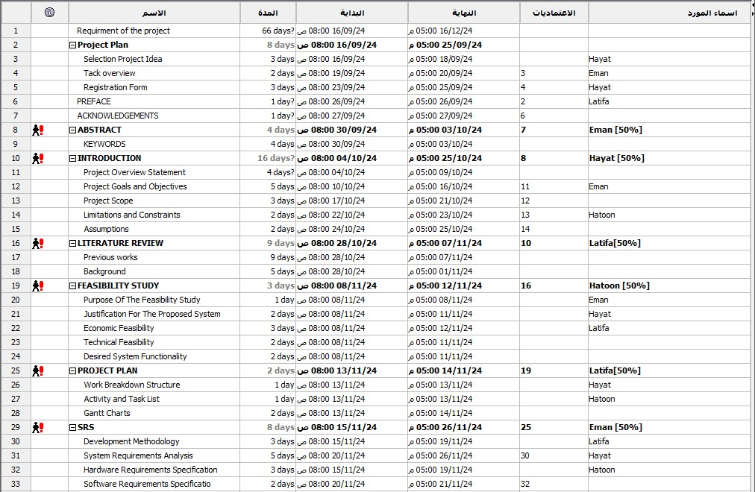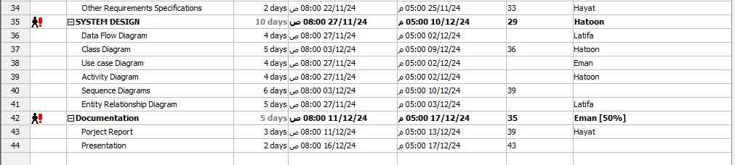

Figure 6: Gantt Charts Tasks List

8.3 Gantt Chart Timeline:
A Gantt chart is a type of bar chart that is frequently utilized in project management to visualize and monitor the progress of a project over time. In the research project on emotion recognition using heart rate, a Gantt chart can be employed to create a visual representation of the project schedule, including the associated tasks and their expected completion dates
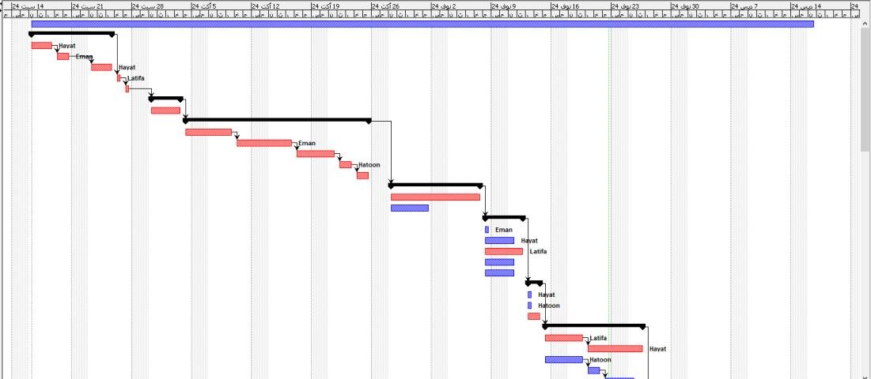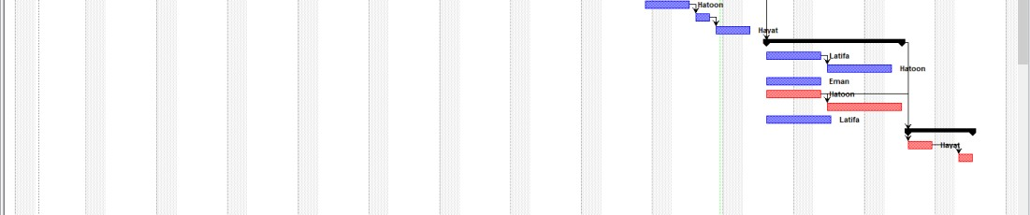

Figure 6 : Gantt Charts Time Line

SYSTEM REQUIREMENTS SPECIFICATION ( SRS )
A System Requirements Specification (SRS) is a structured document that clearly defines the requirements and expectations for the development of the Food Allergy Detection and Analysis mobile application. It serves as a formal agreement between the development team and stakeholders, ensuring that the application meets user needs while adhering to technical and operational constraints. The SRS acts as a reference throughout the development lifecycle, assisting developers, testers, project managers, and clients in aligning objectives and outcomes.
The SRS for this project includes the following key elements:
- Introduction: The Food Allergy Detection and Analysis application is designed to assist users in identifying allergens in food products through advanced technologies like machine learning and image recognition. Its goal is to provide a user-friendly platform for individuals with allergies to detect allergens in real time while also offering educational resources for better allergy management. The target audience includes individuals with food allergies, their care Assistants, and health-conscious users.
- Functional Requirements: The application must enable real-time allergen detection using image recognition and barcode scanning. It should process user inputs like food images or barcodes, provide accurate allergen analysis, and display results in a comprehensible format. Additional features include educational modules, health alerts, and user profile management.
- Non-Operational Conditions: The system must be scalable to accommodate a growing user base and ensure optimal performance on both Android and iOS devices. It should prioritize security by encrypting sensitive user data and maintaining usability through a simple and intuitive interface tailored to users of varying technical expertise.
- System Architecture: The application will be built using a client-server model. The front-end will leverage Flutter for cross-platform development, while the backend will utilize MySQL for data management. APIs for image recognition and barcode scanning will be integrated to enhance functionality.
- User Interfaces: The application will feature an intuitive graphical user interface (GUI) that simplifies interaction for users. Key UI components include easy navigation menus, allergen detection results pages, and educational resource modules. Accessibility features, such as large fonts and voice assistance, will cater to users with diverse needs.
- Data Administration: User data, allergen information, and educational content will be securely stored in a cloud-based database, employing strong encryption protocols to ensure data security and integrity. The system will support efficient data retrieval and backup mechanisms to enhance reliability.
- System Constraints: The application must comply with data protection regulations, such as GDPR or HIPAA, to safeguard user privacy. Compatibility with mobile devices running Android 8.0/iOS 12.0 and above is required, and financial constraints will influence the choice of APIs and cloud services.
- Assumptions and Dependencies: The project assumes that users will have access to a stable internet connection for real-time allergen detection. Dependencies include the integration of third-party APIs for machine learning, image recognition, and barcode scanning, which are critical for achieving the desired functionality.

9.1 Development Methodology
The Waterfall Model has been chosen as the methodology for developing the Food Allergy Detection and Analysis Application. The Waterfall Model is a linear and sequential software development lifecycle (SDLC) approach, making it particularly suitable for projects with well-defined requirements and objectives. This model ensures a systematic and organized approach, critical for building an application that deals with sensitive issues like health and safety related to food allergies.
Why the Waterfall Model?
The waterfall model is a well-established approach utilized in the system development life cycle to build systems in a step-by-step and sequential manner. It derives its name from the idea of a waterfall, as the model progresses systematically from one phase to the next, cascading downwards. This model is organized into distinct phases; each phase's output serves as the subsequent phase's input. Each phase must be fully completed before the next one begins, ensuring a clear progression without any overlap between phases.
The Waterfall Model is ideal for the Food Allergy Detection and Analysis Application due to its structured phases, which provide clear deliverables at each stage. This application requires meticulous planning and precise execution to ensure its features, such as allergen detection, educational modules, and user-friendly interfaces, function seamlessly. Since the requirements are well-documented at the start, the sequential nature of the Waterfall Model ensures that each phase is completed thoroughly before moving to the next, reducing the risk of errors or omissions.
Application of the Waterfall Model Phases

1. Requirements Gathering and Analysis
In this phase, detailed requirements for the application were collected. Stakeholders, including potential users, care assistants , and healthcare experts, were consulted to identify key functionalities like allergen detection using image recognition and barcode scanning APIs, educational resources, and real-time alerts. A comprehensive requirements document was created, ensuring a clear understanding of what the application needs to achieve.

2. System Design
Based on the requirements, the system architecture was designed. This includes the integration of technologies such as Flutter for cross-platform development, MySQL for database management, and machine learning algorithms like CNN for allergen detection. The system design phase also involved planning the user interface to ensure accessibility and ease of use for individuals of all ages.

3. Implementation
The coding and development of the application began following the design specifications. Developers implemented features like allergen detection, educational modules, and user profile management. Using the Waterfall Model ensured that developers adhered strictly to the design specifications, avoiding deviations that could compromise functionality or user experience.

4. Integration and Testing
All components were integrated, and rigorous testing was conducted to ensure the system worked as intended. Features like allergen detection using machine learning algorithms, the accuracy of barcode scanning, and the responsiveness of educational modules were thoroughly tested. This phase aimed to identify and resolve any bugs or inconsistencies in the application.

5. Deployment
The application was deployed on relevant platforms, ensuring compatibility with Android and iOS devices. During this phase, user feedback was collected to make minor adjustments or improvements as needed.

6. Maintenance
Post-deployment, the application enters the maintenance phase, where updates and improvements are made based on user feedback and technological advancements. This includes enhancing machine learning models for allergen detection and updating the educational content.
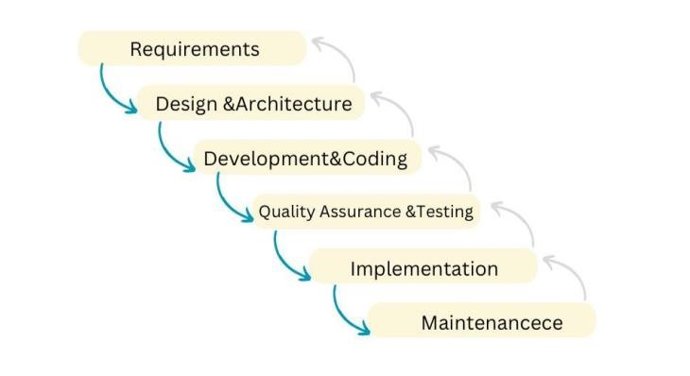
Figure 7: Waterfall model

Benefits of Using the Waterfall Model for This Project
- Clear Structure: Each phase is well-defined, ensuring no overlap or confusion during development. This structure is crucial for a sensitive application like this, where health and safety are paramount.
- Early Documentation: Thorough documentation during the requirements and design phases helps in clear communication between stakeholders and developers.
- Minimized Risk: Since each phase must be completed before moving on to the next, the risk of encountering major issues in later stages is reduced.
- Ease of Tracking: The progress of the project is easily trackable, with milestones achieved at the end of each phase.

Limitations and Mitigation
While the Waterfall Model does not allow for flexibility during development, this was mitigated by investing significant effort in the requirements gathering and analysis phase to ensure all aspects of the application were considered. For any unforeseen requirements, a separate enhancement cycle can be initiated after deployment.

9.2 System Requirements Analysis
The system requirements analysis for the Food Allergy Detection and Analysis application identifies and organizes the functional and non-functional needs to ensure comprehensive support for allergy management, real-time allergen detection, and user education.
Functional Requirements:
- Enable real-time allergen detection using machine learning-based (CNN) image analysis and barcode scanning.
- Provide accurate and personalized allergen risk assessments based on user profiles.
- Offer educational content with interactive and adaptive learning modules for allergy awareness and management.
- Implement user authentication and secure storage for allergy data and preferences.
- Deliver notifications and alerts for users about potential allergens in scanned food products.
User Functions:
- User:
  - Scan and Detect Allergens: Use image recognition or barcode scanning to identify allergens in food items.
  - Profile Management: Input and update allergy profiles, including specific allergens and severity levels.
  - Educational Resources: Access interactive allergy management content, including tips, games, and guidelines.
  - Safe Food Suggestions: Receive recommendations for allergen-free food options.
  - Privacy Controls: Adjust sharing preferences for personal allergy data.
- Care Assistant :
  - Monitor User Allergies: View authorized allergy data for individuals under their care.
  - Receive Alerts: Get notified about potential allergen risks or flagged foods scanned by the user.
  - Support Education: Access shared educational resources to assist in managing the user's allergies.
  - Track User Preferences: Assist in updating user food preferences and profiles.
- System Administrator:
  - User Management: Oversee user accounts, reset passwords, and manage roles and permissions.
  - Data Security: Ensure compliance with encryption standards and privacy protocols.
  - System Monitoring: Track system performance, including uptime and responsiveness.
  - Model Deployment: Manage and update the machine learning model for allergen detection.
  - Data Backup: Implement a robust backup system to ensure data recovery in case of failures.
- Machine Learning Model:
  - Image Analysis: Detect allergens in scanned food images with high accuracy, leveraging CNNs.
  - Barcode Scanning: Process product information to identify potential allergens from database records.
  - Personalization: Adapt to user profiles for more accurate allergen detection and advice.
  - Data Compliance: Ensure secure and anonymized processing of user data.
  - Seamless Integration: Operate efficiently within the application to maintain performance.
Non-Functional Requirements:
  - Usability: Provide an intuitive interface with accessibility features, such as large text and voice guidance.
  - Performance: Ensure quick response times, especially for real-time allergen detection and alerts.
  - Scalability: Support increasing numbers of users and larger allergen databases.
  - Reliability: Maintain high uptime for continuous allergen detection and educational access.
  - Security: Incorporate robust encryption and data protection measures, adhering to privacy standards like GDPR.

9.3. Hardware Requirements Specification
The application’s hardware requirements cater to both user's and development needs:
- User Devices: Smartphone or Tablet Android or iOS devices with minimum specs.
Hardware Component | Specification
Operating System | Android 8.0+ or iOS 11.0+
Processor | Quad-core processor or higher
Memory | 2GB RAM minimum
Storage | 100MB free storage for installation, plus additional space for data storage and updates
Table 2: Hardware Requirements Specification
- Development and Testing Devices: Laptop/PC for Development.
Hardware Component | Specification
Operating System | Windows 10
Processor | Intel Core i5
Memory | 8GB RAM
Storage | 100 GB SSD

Table 2: Hardware Requirements Specification

9.4 Software Requirements Specification
Language, database | Used For
Flutter | Will be used for the application development.
Python | We use Python to develop machine learning modules and training datasets.
MYSQL | We use MYSQL for the database and backend.
Table 3: Software Requirements Specification

9.5 Other Requirements Specifications
The Food Allergy Detection and Analysis application includes additional specifications to enhance functionality, ensure regulatory compliance, and prioritize user satisfaction:

Regulatory Compliance
• Data Privacy Standards: Adhering to GDPR and other relevant regulations to protect user data and ensure secure handling of allergy-related information.

Language Support
• Multi-language Support: Offering various language options, such as Arabic and English, to accommodate diverse user demographics and make the application accessible to non-native speakers.

User Training and Support
- Help Center: Providing an integrated help feature that includes FAQs, troubleshooting guides, and video tutorials to assist users in navigating the app effectively.
- Guided Onboarding: Incorporating an interactive onboarding process that walks users through setting up their allergy profiles and using core features like scanning and educational modules.

Accessibility
- Voice Assistance: Implementing text-to-speech functionality to assist visually impaired users in scanning food items, accessing alerts, and navigating the app.
- Customizable Display Settings: Allowing users to adjust font size and contrast for better readability and usability.

Maintenance
- Regular Updates: Scheduling periodic updates to introduce new features, improve allergen detection accuracy, and enhance overall security.
- Error Logging and Analytics: Integrating error tracking and performance analytics to monitor app usage, identify technical issues, and implement timely maintenance or fixes.

SYSTEM DESIGN

10.1 Application Design
The system design diagram represents the architectural framework and interaction flow of the Food Allergy Detection and Analysis Application. It provides a visual depiction of how the system's components, such as users, system actors (e.g., care Assistant and administrators), and backend services, interact to achieve the application's objectives.

10.2 Data Flow Model
Data flow diagrams are used to represent the flow of data in a business graphically information system. DFD describes the processes involved in a system to transfer data from the input to the file storage and report generation.
Level 0 :

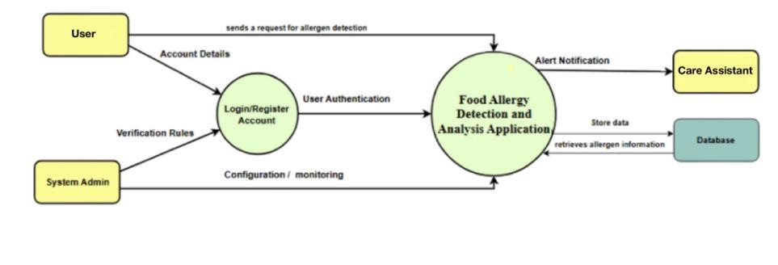
Figure 8 :Data Flow Diagram (level 0 ) Level 1 :
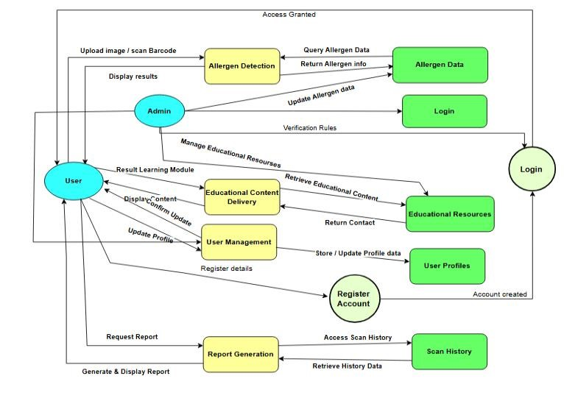
Figure 9 : Data Flow Diagram (level 1)

10.3 Class Diagram
In software engineering, a class diagram in the Unified Modeling Language (UML) is a type of static structure diagram that describes a system's structure by showing its classes, attributes, operations (or methods), and relationships among objects.

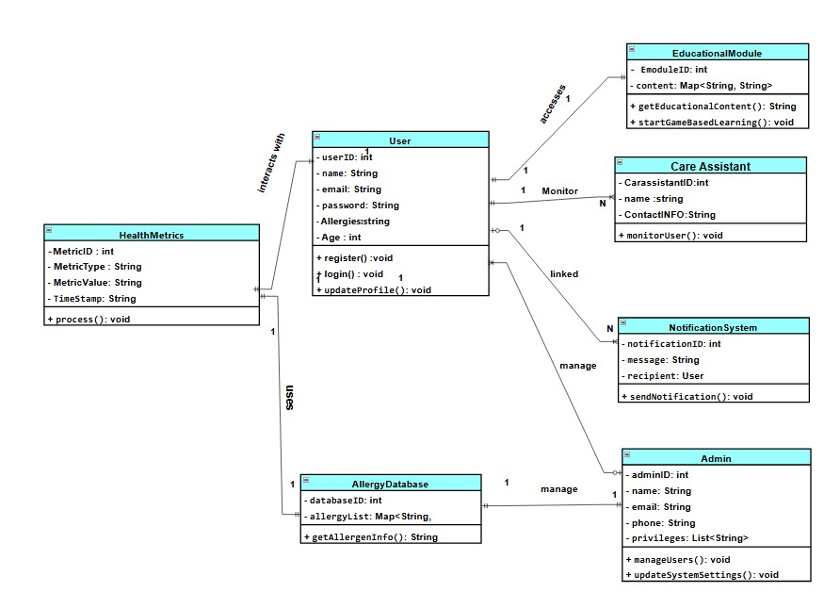

Figure 10 :Class diagram

10.4 Use case diagram
The Use Case Diagram captures user and system interactions, displaying roles such as User, Care Assistant , and System Admin. It highlights use cases like Monitoring Health Metrics, Accessing Educational Content, and Managing User Accounts.

1- System Administrator Use case diagram
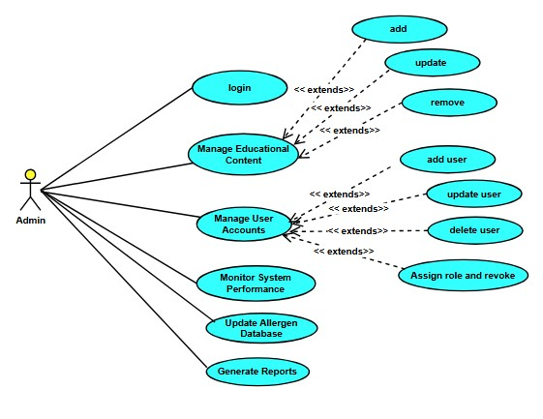
Figure 11: Admin use case diagram

2- User Use Case Diagram
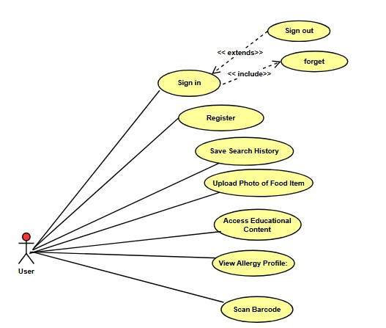
Figure 12: User Use Case Diagram 1-3 Care Assistant Use Case Diagram
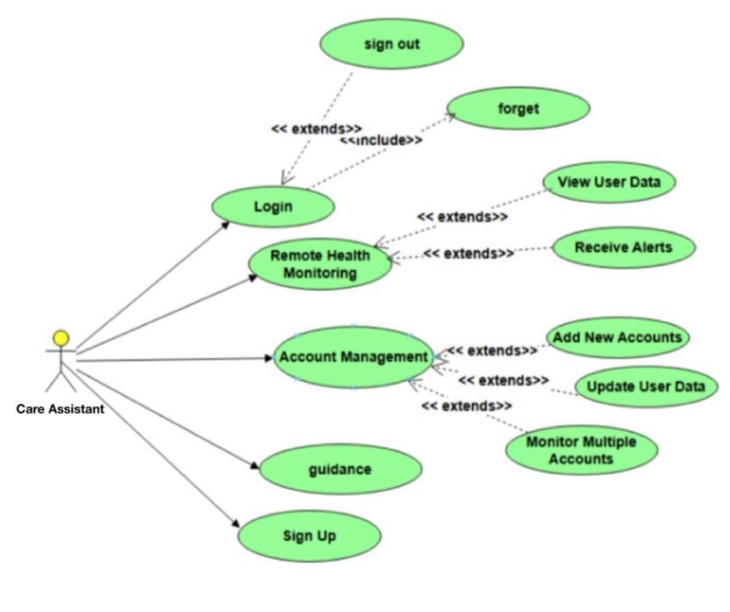

Figure 13: Care Assistant User Use Case Diagram

10.5 Activity diagram :
The Activity Diagram represents workflows within the application, illustrating the step-by-step processes involved in various tasks. For instance, it depicts the sequence of actions for Analyzing Allergen Data or Scanning Food Items, highlighting decision points, such as identifying allergenic ingredients, and flow control, such as alerting the user or storing allergen-related data. The diagram emphasizes the structured process that ensures users receive accurate and timely information for making safer food choices.
1- Admin Activity Diagram:
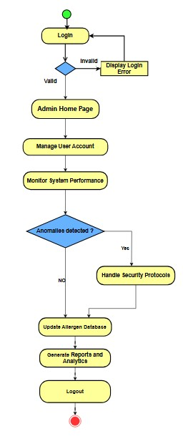

Figure 14: Admin Activity diagram
2 - User Activity Diagram :
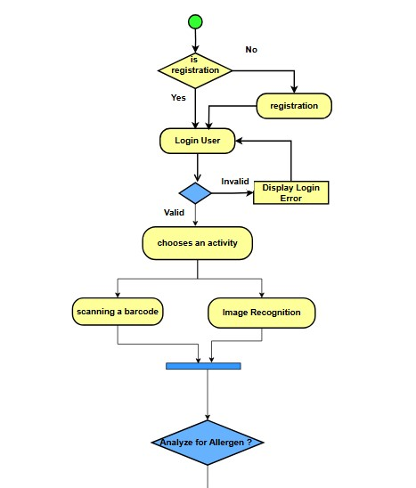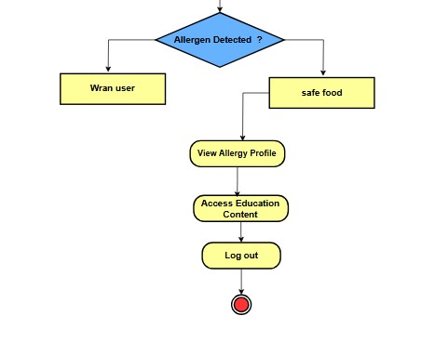

Figure 15: User Activity Diagram

3- Care Assistant Activity Diagram
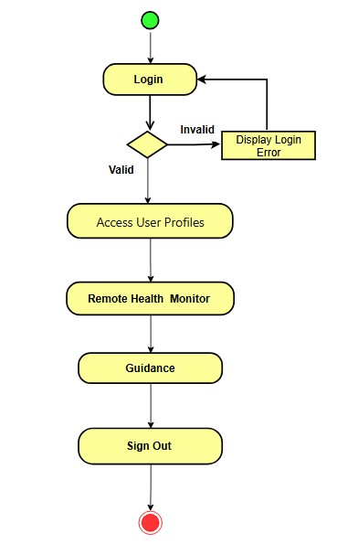

Figure 16 : Care Assistant Activity Diagram

10.6 Sequence Diagram
1- User Sequence Diagram

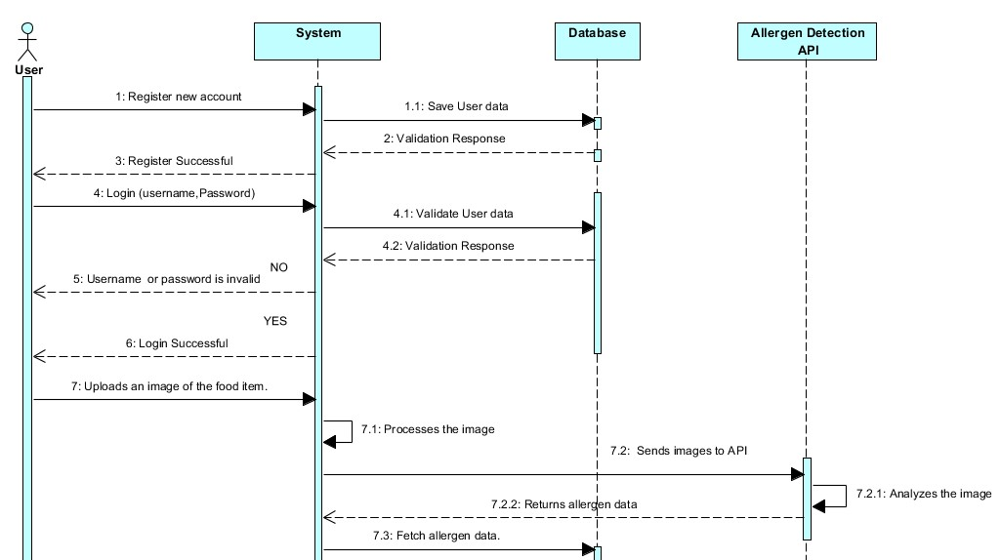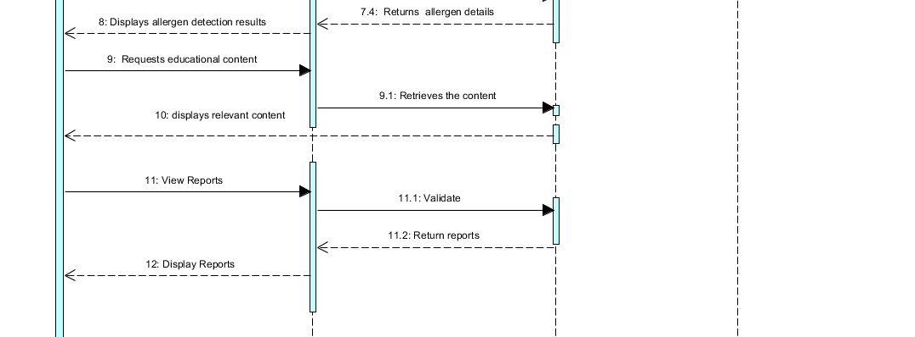

Figure 17: user Sequence Diagram

2- Admin Sequence Diagram
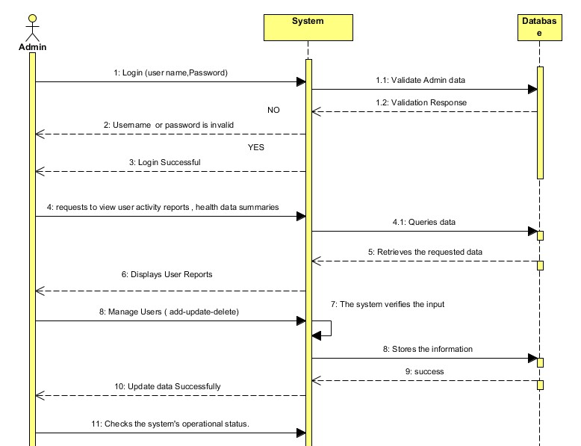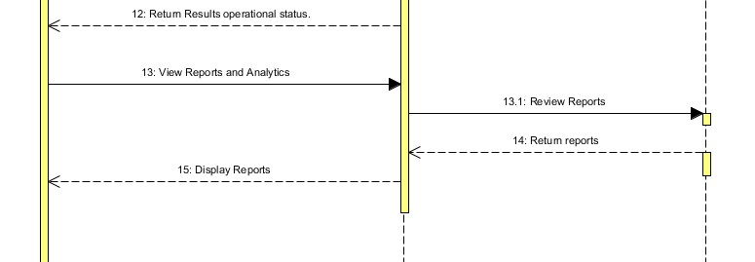

Figure 18 : Admin Sequence Diagram

3- Care Assistant Sequence Diagram

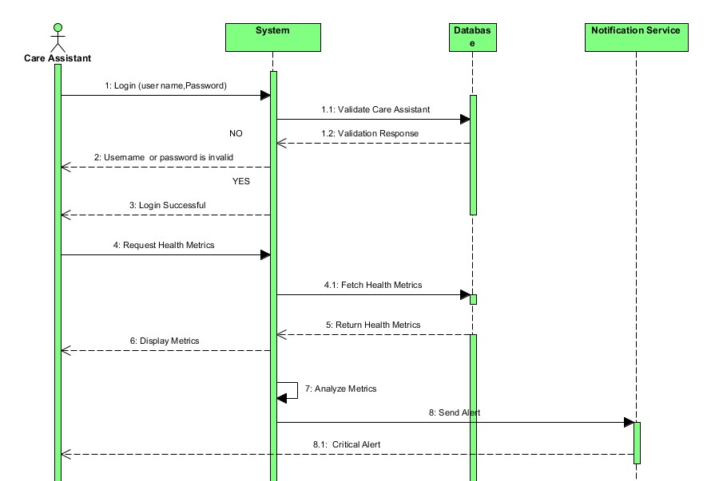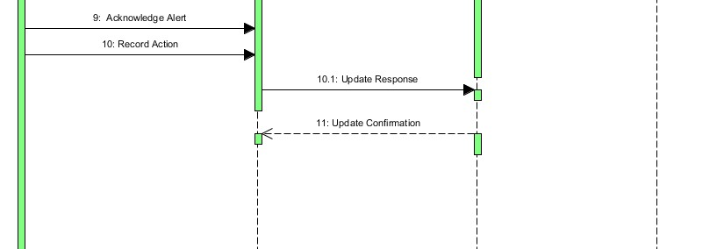

Figure 19 : Care Assistant Sequence Diagram

10.7 Entity Relationship Diagram
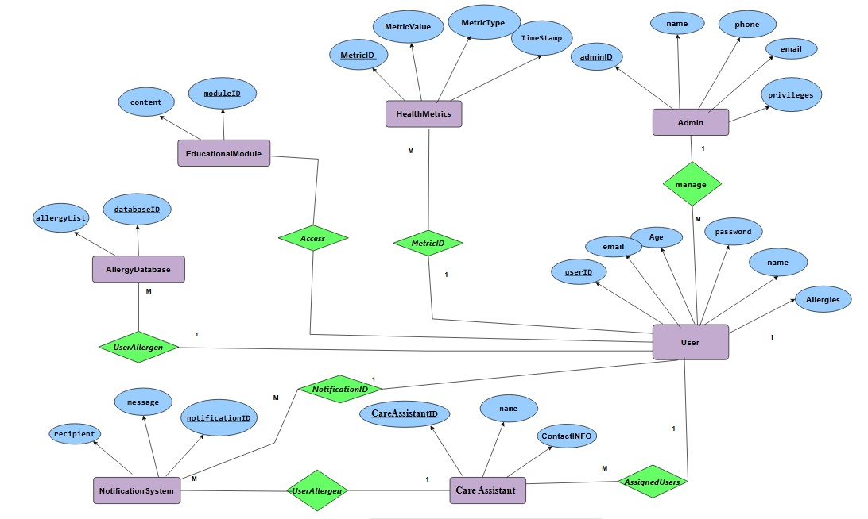
Figure 20 :Entity Relationship Diagram

Conclusion
The Food Allergy Detection and Analysis Application represents a significant advancement in the management of food allergies, leveraging cutting-edge technologies to address a critical health challenge. By integrating machine learning techniques, specifically convolutional neural networks (CNNs), alongside image recognition and barcode scanning APIs, the application offers an efficient, accurate, and user-friendly method for allergen detection. Its educational component further enhances its utility by providing interactive learning modules that promote awareness and safe practices among users, particularly children, fostering a comprehensive understanding of allergy management.
The app's technical foundation, built using Flutter for cross-platform compatibility and supported by robust backend technologies like MySQL, ensures a seamless and efficient user experience. These technologies enable real-time feedback, secure data handling, and effective integration of advanced features, such as personalized allergen analysis. The inclusion of game-based learning and other educational resources underscores the app's dual focus on safety and awareness, making it a holistic tool for allergy sufferers and their families.
Economically, the application demonstrates feasibility by minimizing development costs through the use of open-source tools and scalable cloud infrastructure. This ensures that the app remains accessible to a wide user base without compromising on functionality or performance. Technically, the use of established frameworks and APIs guarantees the app's reliability and scalability, allowing for future enhancements as technology evolves.
The project emphasizes not only the technological innovation but also the social impact of empowering individuals with food allergies to make informed decisions and improve their quality of life. By addressing both the practical and educational aspects of allergy management, this application sets a new benchmark in health-focused mobile solutions. It stands as a testament to how technology can be harnessed to solve real-world problems, creating a safer and more informed community.

Reference :
- Jiang, Z., Liu, X., & Yang, Y. (2020). "Deep Learning-Based Food Classification for Allergen Detection". Journal of Food Safety, 42(1), 55-66.
- Smith, R., Jones, L., & Patel, M. (2019). "AI-Based Allergy Detection System". Artificial Intelligence Technology Review.
- World Allergy Organization (2021). "Global Food Allergy Trends and Prevalence." World Allergy Journal, 32(7), 88-93.
- Sicherer, S.H., & Sampson, H.A. (2018). "Food Allergy: A Review and Update." Journal of Allergy and Clinical Immunology, 141(1), 41-58.
- Jones, T., et al. (2018). "Challenges in Food Allergen Labeling: A Consumer Perspective." Journal of Allergy and Immunology, 25(6), 78-85.
- Patel, M., et al. (2019). "Evaluating the Effectiveness of Mobile Apps for Food Allergen Detection." Journal of Food Technology, 43(3), 145-159.
- Miller, R., & Lewis, P. (2020). "Innovations in Food Allergen Detection Using Image Recognition." Food Technology Review, 21(2), 110-122.
- Anderson, K., et al. (2017). "Game-Based Learning Approaches in Food Allergy Education for Children." Journal of Child Health, 19(4), 145-160.
- I. Sommerville, Software Engineering, 10th ed. Boston, MA, USA: Pearson, 2015.
- M. Fowler, UML Distilled: A Brief Guide to the Standard Object Modeling Language, 3rd ed. Boston, MA, USA: Addison-Wesley, 2004.
- G. Booch, J. Rumbaugh, and I. Jacobson, "Unified Modeling Language User Guide," Addison-Wesley, 2005.
- J. Smith, A. Johnson, and T. Lee, "Advancements in Mobile Allergy Detection Systems," Journal of Medical Informatics, vol. 27, no. 4, pp. 245-260, 2022.
- R. Kumar and L. Gupta, "Machine Learning for Allergen Detection in Food Products," International Journal of Food Science and Technology, vol. 45, no. 3, pp. 523-531, 2021.
- M. Fowler, UML Distilled: A Brief Guide to the Standard Object Modeling Language, 3rd ed. Boston, MA, USA: Addison-Wesley, 2004.
- J. Rumbaugh, I. Jacobson, and G. Booch, The Unified Modeling Language Reference Manual, 2nd ed. Boston, MA, USA: Addison-Wesley, 2004.
- A. Silberschatz, H. F. Korth, and S. Sudarshan, Database System Concepts, 7th ed. New York, NY, USA: McGraw-Hill, 2019.
- P. Clarke, Database Systems: Design, Implementation, and Management, 12th ed., Boston, MA, USA: Cengage Learning, 2022.
- G. Jones, Image Recognition Technologies: Concepts and Applications, 2nd ed., London, UK: Springer, 2019.
- S. Wilson, Barcode Scanning Technologies: Applications in Health and Food, New York, NY, USA: McGraw-Hill, 2017.
- T. Harris, Flutter for Beginners: Cross-Platform Development, New York, NY, USA: Packt Publishing, 2020.
- E. Taylor, Cloud Computing: Concepts, Technology & Architecture, Upper Saddle River, NJ, USA: Prentice Hall, 2018.
- L. Anderson, AI in Healthcare: A Comprehensive Guide, Boston, MA, USA: MIT Press, 2021.
- F. Martin, Mobile Database Integration: Techniques and Trends, Hoboken, NJ, USA: Wiley, 2019.
- A. Green, Educational Games for Children with Special Needs, 3rd ed., London, UK: Routledge, 2018.
- R. White, Health Informatics: Practical Guide for Healthcare and IT Professionals, 7th ed., New York, NY, USA: CRC Press, 2020.
- H. Black, Advances in Barcode and RFID Technology for Healthcare, Cambridge, MA, USA: Cambridge University Press, 2022.
- C. Adams, Cybersecurity for Mobile Apps: Best Practices, San Francisco, CA,
USA: O’Reilly Media, 2021.
- M. Thompson, Mobile App Analytics and User Behavior Tracking, London, UK:
Springer, 2019.
- J. Lee, User Experience Design for Mobile Applications, Boston, MA, USA:
Addison-Wesley, 2020.
- B. Clark, Food Allergy Management in Clinical Practice, New York, NY, USA: Springer, 2020.
- A. Foster, Big Data Analytics in Health Applications, New York, NY, USA: CRC Press, 2018.
- D. Parker, Educational Interventions for Health Awareness, Hoboken, NJ, USA:
Wiley, 2019.
- R. Gray, Database Security and Management for Mobile Apps, Boston, MA, USA: Cengage Learning, 2020.
- K. Bell, Mobile Health Applications: Opportunities and Challenges, 2nd ed., Cambridge, UK: Cambridge University Press, 2020.
- B. Wright, Secure API Development for Mobile Applications, Hoboken, NJ, USA: Wiley, 2021.
- T. Carter, Cloud Storage Solutions for Mobile Applications, San Francisco, CA,
USA: O’Reilly Media, 2020.
- J. Rivera, AI Algorithms for Food Allergen Detection, Boston, MA, USA: MIT Press, 2022.
- R. Bennett, Image Processing Techniques for Mobile Devices, Cambridge, UK:
Cambridge University Press, 2019.
- G. Evans, Cross-Platform App Development with Flutter and Dart, San Francisco, CA, USA: Packt Publishing, 2021.
- M. Roberts, Cloud Infrastructure for Scalable Applications, New York, NY, USA:
Springer, 2020.
- D. King, Visual Recognition APIs in Practice, London, UK: Springer, 2020.
- H. Carter, Educational Platforms for Awareness Programs, Hoboken, NJ, USA: Wiley, 2019.
- P. Coleman, Advances in Real-Time Analytics for Mobile Applications, Cambridge, UK: Cambridge University Press, 2020.
- A. Harper, Image-Based Solutions for Food Safety Applications, New York, NY, USA: ACM Press, 2021.
- S. Edwards, Teaching Strategies for Digital Literacy and Health, London, UK: Routledge, 2019.
- M. Hamilton, Best Practices in Mobile App Security, Hoboken, NJ, USA: Wiley, 2020.

