Project Plan

WORK BREAKDOWN STRUCTURE (WBS) :
The Work Breakdown Structure (WBS) is a hierarchical organizational model used in project management to achieve a comprehensive and systematic decomposition of the project. The WBS aims to analyze the project into smaller, manageable components called Work Packages, representing the smallest independent work units. The project is divided into hierarchical levels of work packages, where the top level represents the overall project, and the work packages are further subdivided into finer levels.
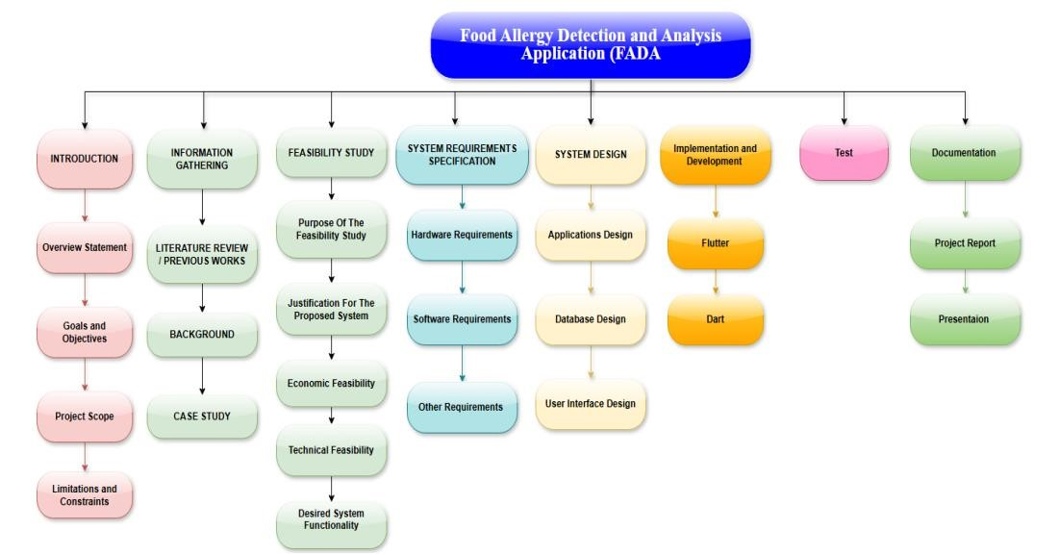

ACTIVITY AND TASK LIST :
A Task List contains the list of tasks of a project or all projects. It is the work list for the entire project team with all vital information regarding the tasks in that project.
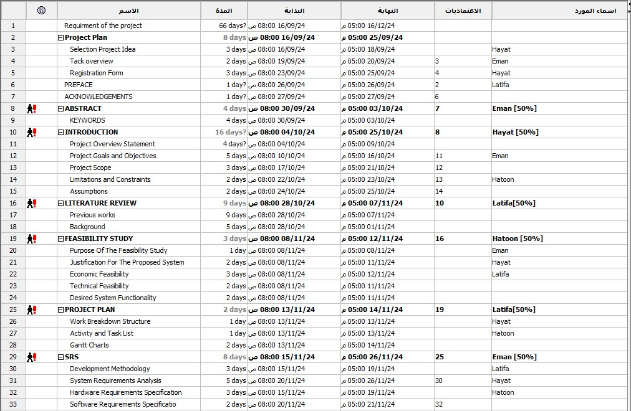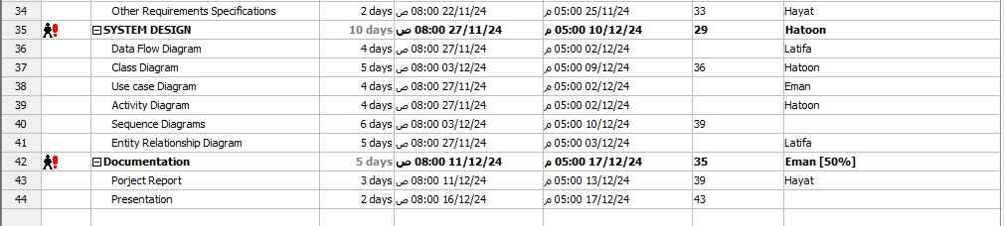

Gantt Chart Timeline:
A Gantt chart is a type of bar chart that is frequently utilized in project management to visualize and monitor the progress of a project over time. In the research project on emotion recognition using heart rate, a Gantt chart can be employed to create a visual representation of the project schedule, including the associated tasks and their expected completion dates
