TOTAL CUSTOMER=8000
TOTAL SPEND=92303537.83
AVERAGE SPEND=11537.94223
TOTAL ORDERS=55654
TOP 10 CUSTOMER BY TOTAL SPEAND
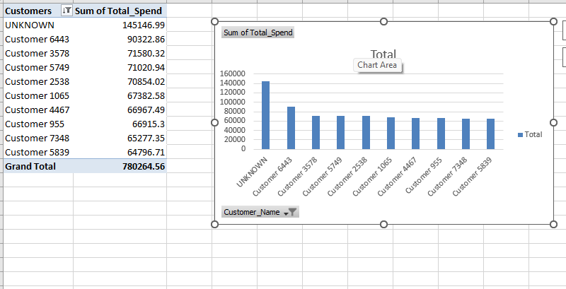

AVERAGE SPEND BY CUSTOMER SEGEMENT
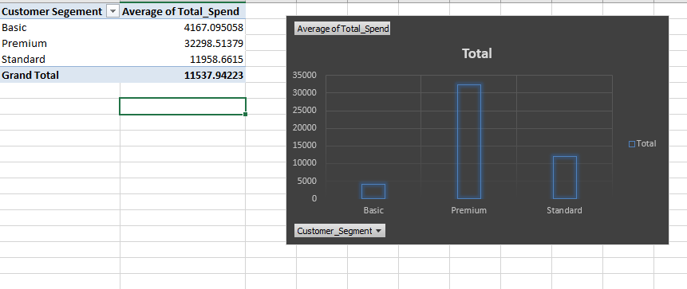

CUSTOMER COUNT BY SUBSCRIPTION PLAN
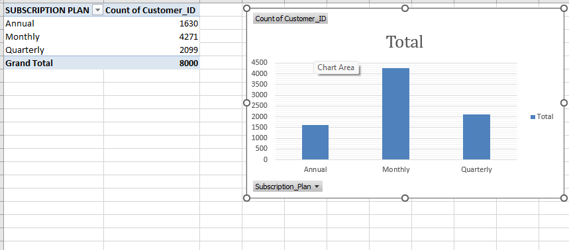
HOW MANY CUSTOMERS ARE CHURNED CUSTOMERS, ACTIVE CUSTOMERS AND AT RISK CUSTOMERS
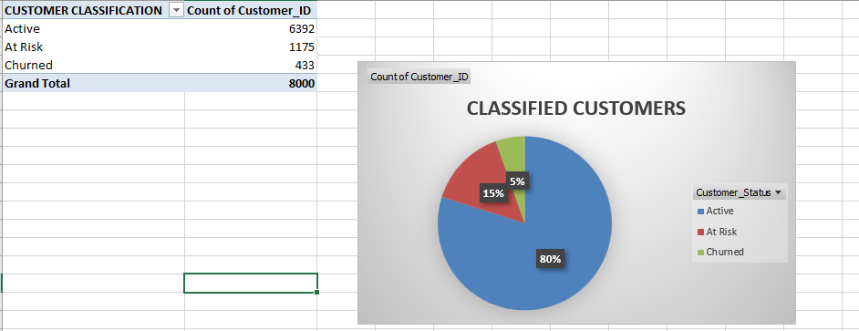

Churn Rate by Customer Segment.
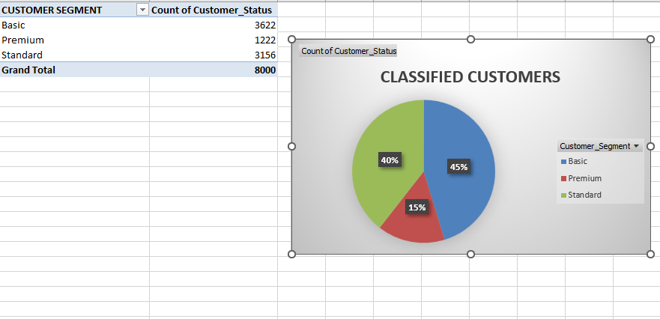
Churn Rate by Subscription Plan.
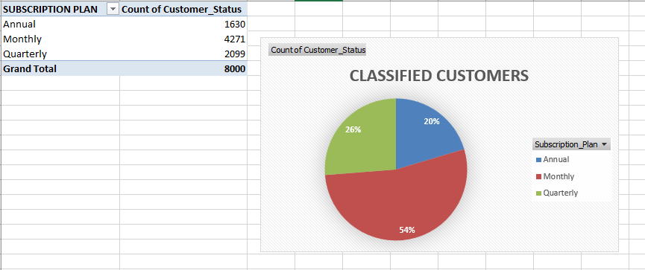

AVERAGE SPEND BY CUSTOMER STATUS
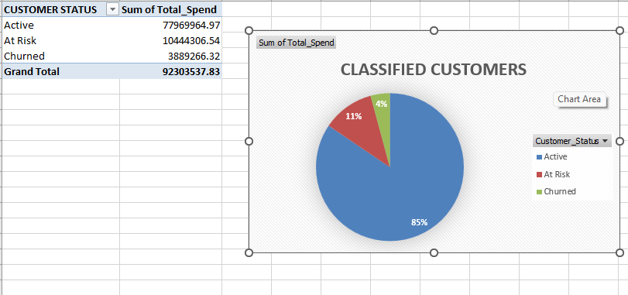
AVERAGE LOGIN BY CUSTOMER STATUS
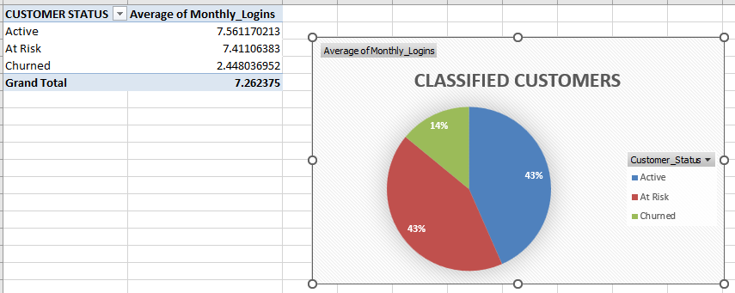
#POWER PIVOT
Churn Rate by Customer Segment.
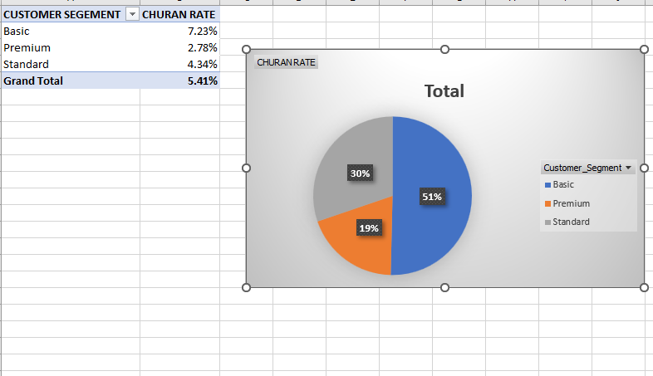

Churn Rate by Subscription Plan.
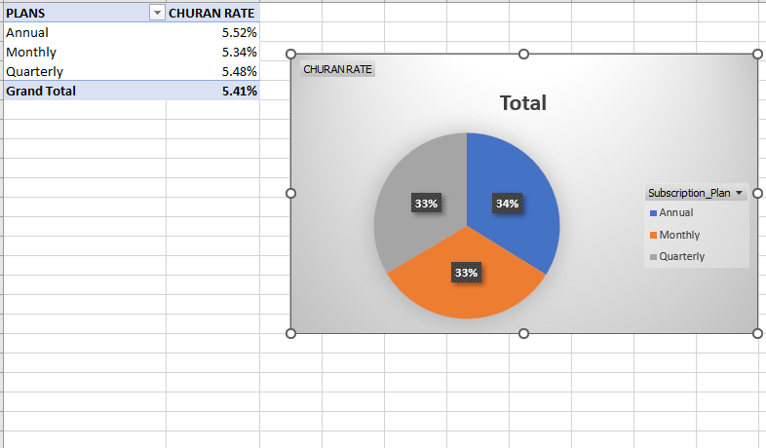

Churn Rate by Acquisition Channel.
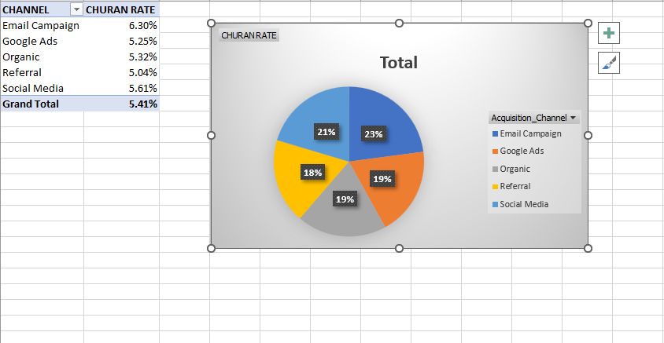
TOP 10 CUSTOMER CONTRIBUTION
