**جامعة المنوفية**

**كلية الحاسبات والمعلومات**

**Menofyia University**

**System Analysis Project**

**second year**



|  |  |
| --- | --- |
| Name | Section |
| توفيق اشرف شلش | 4 |
| ثناء عادل عبد العزيز الشامي | 4 |
| صفا محمود طلعت | 6 |
| سندس سعد مجاهد | 5 |
|  |  |

Restaurant book system

**Planning (Project Plan)**

**Project Identification**

Project Name:

Restaurant book system

Short Description about project:

The restaurant in hotel has a problem that people should go to restaurant to book a table and some people don’t won’t to wait to mush until the meal prepared. So, the restaurant manager needs to make a system that help the people in booking and the restaurant in preparing the meal. The site will enable you book your own table with simple steps or touches if you use a smartphone.

**System Request**

Project sponsor:

The restaurant manager.

Business needs:

1. Make it easy to book tickets throw internet.
2. Increase the income.
3. Make it faster to prepare the food.
4. Increase the number of free tables.
5. Improve customer service.

Business requirements

1. Designer
2. Analysis.
3. database developer
4. web developer
5. business development

Business value

1. 5% increase in sales.
2. 8% increase in the number of free tables

3-4% improve in the hotel system

4-2% services

Special Issues or Constraints

1. Deadline in 2 February.
2. Good security with data.
3. Easy to access the booking form.

4-reservation dates from 6am to 8pm

5-Commitment the rules (no-smoking - be calm)

**Feasibility Analysis**

Technical Feasibility

1. Html, CSS, java Script, php.
2. QR code.
3. Vs code.
4. Dell latitude e6530.

Economic Feasibility

1. We will have a budget 40%.
2. Software will cost 8% of the budget.
3. Web designer will take 5% of the profit for 2years.

Organizational Feasibility

1. Reduce the meal prepare time for people they need to go fast.
2. Increase the restaurant profit because of the QR code in each room in the hotel will make booking easy and people will prefer to use it.
3. If the customers want to come again it will be easy to book by make the site in favorite in his browser.
4. Make it easy for the restaurant to manage the tables.

**Time estimation**

|  |  |  |  |  |
| --- | --- | --- | --- | --- |
|  | **Planning** | **Analysis** | **Design** | **Implementation** |
| Standard percentages | 15% | 20% | 35% | 30% |
| **Estimated** time based on planning time | Actual:  12hours | 16hours | 28hours | 24hours |

**Task Identification (At least six tasks must be identified)**

|  |  |
| --- | --- |
| System request | Name of Task |
| 2-11-2020 | Start Date |
| 2-11-2020 | End Date |
| Tawfik Ashraf Shalash | Person assigned to task |
| High | Priority |
| Microsoft word | Resources Needed |
| 1 day | Estimated Time |
| 5hours | Actual Time |

|  |  |
| --- | --- |
| Feasibility study | Name of Task |
| 8-11-2020 | Start Date |
| 10-11-2020 | End Date |
| Tawfik Ashraf Shalash | Person assigned to task |
| Medium | Priority |
|  | Resources Needed |
| 10hours | Estimated Time |
| 2days | Actual Time |

|  |  |
| --- | --- |
| Project plan | Name of Task |
| 2020-11-11 | Start Date |
| 17-11-2020 | End Date |
| Tawfik Ashraf Shalash | Person assigned to task |
| high | Priority |
| MS project | Resources Needed |
| 7 days | Estimated Time |
| 7days | Actual Time |

|  |  |
| --- | --- |
| Interview | Name of Task |
| 20-11-2020 | Start Date |
| 22-11-2020 | End Date |
| Sana Elshamy, Tawfik Shalash, Sondos megahd,safa Mahmoud. | Person assigned to task |
| medium | Priority |
| Notepad | Resources Needed |
| 2 day | Estimated Time |
| 1day | Actual Time |

|  |  |
| --- | --- |
| jAD session | Name of Task |
| 23-11-2020 | Start Date |
| 24-11-2020 | End Date |
| Sondos megahd | Person assigned to task |
| Medium | Priority |
| Record | Resources Needed |
| 1day | Estimated Time |
| 4hours | Actual Time |

|  |  |
| --- | --- |
| questionnaire | Name of Task |
| 2020-11-25 | Start Date |
| 27-11-2020 | End Date |
| Safe Mahmoud Talat | Person assigned to task |
| Medium | Priority |
| Google form | Resources Needed |
| 2 days | Estimated Time |
| 1 days | Actual Time |

|  |  |
| --- | --- |
| Data flow diagram | Name of Task |
| 2020-11-29 | Start Date |
| 12-5-2020 | End Date |
| Safe Mahmoud Talat, Sana Adel | Person assigned to task |
| High | Priority |
| E documents online tool | Resources Needed |
| 7days | Estimated Time |
| 5 days | Actual Time |

|  |  |
| --- | --- |
| Data dictionary | Name of Task |
| 2-71-2020 | Start Date |
| 12-9-2020 | End Date |
| Sondos saad megahed | Person assigned to task |
| Medium | Priority |
| Dfd program for drawing | Resources Needed |
| 2 days | Estimated Time |
| 1 days | Actual Time |

|  |  |
| --- | --- |
| ERD | Name of Task |
| 2-131-2020 | Start Date |
| 16-21-2020 | End Date |
| Sanaa adel | Person assigned to task |
| Medium | Priority |
| none | Resources Needed |
| 3days | Estimated Time |
| 2days | Actual Time |

|  |  |
| --- | --- |
| Normalization | Name of Task |
| 2020-12-25 | Start Date |
| 2020-12-28 | End Date |
| Sanaa adel | Person assigned to task |
| Medium | Priority |
| erd | Resources Needed |
| 3days | Estimated Time |
| 3days | Actual Time |

**Pert Chart**

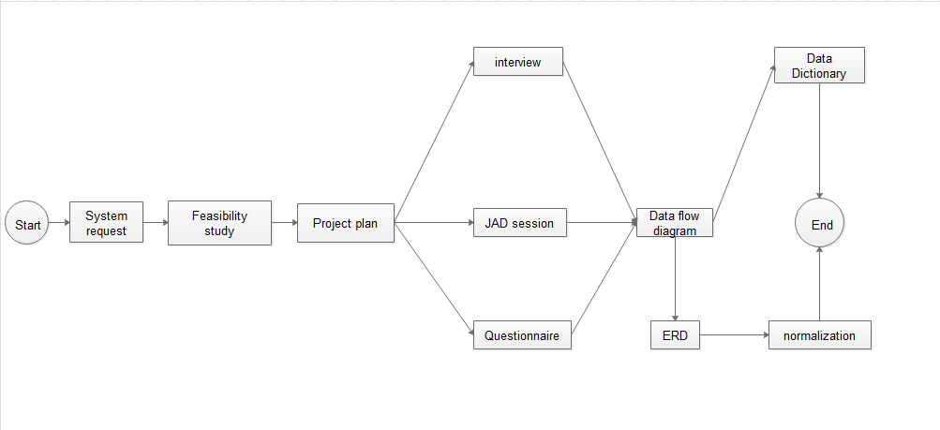

**Gantt chart**

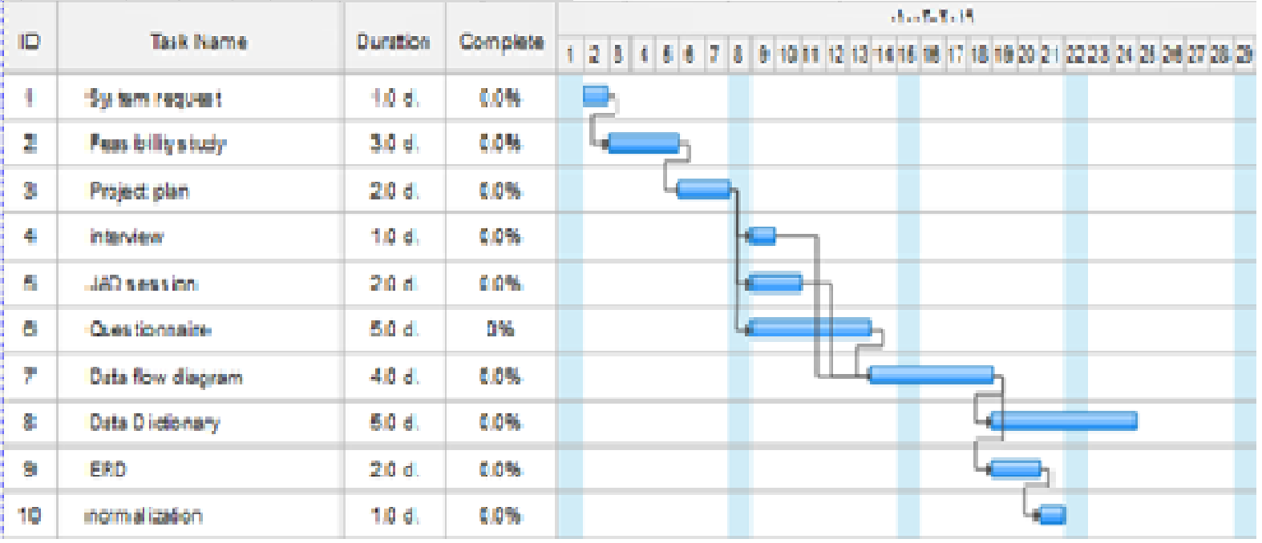

**Analysis (Project Proposal)**

**Interview**

**We will ask these questions in the interview.**

1. **are people come to the restaurant is from the hotel or not?**

**A: yes, some of them from the hotel.**

1. **What data you need from guest to book a table from the internet?**

**A: his room address and what kind of food he will eat and where he will eat the food and if he needs it to prepare fast and if he will wait someone or not.**

1. **What the time the guest takes to book a table?**

**A: about 60 seconds.**

1. **What is the capacity of the place?**

**A: The capacity is 30 tables**

1. **The meal takes long time to be prepared or not?**

**Sometimes it takes a long time it depends on what is the customer ask for.**

1. **Are guests come again or not?**

**A: yes, many of them come again.**

1. **Have you got Additional services?**

**And we will close the interview with a question**

**“do you want to add anything?”**

**close interview then checks hands…….**

**Interview Report**

|  |
| --- |
| **Interview Report** |
| **Person Interviewed:**  **Interviewer:**  **Purpose of Interview:**  **1.collect data about system requirements.**  **2.collect data about interviewee opinions and feelings**  **3.current state of the system to update it**  **Summary of Interview:**   * **People come to restaurant from the hotel so we will make it easy to book a table for the hotel visitors using Tec like QRCODE.** * **People will fill a form to book a table in the restaurant.** * **People will take less time to book a table in the restaurant** * **The capacity of the place is 30 tables** * **Some meals take a long time** * **Many of people come again to the restaurant.** * **They have some additional services like take food to rooms in the hotel. And book all tables in the restaurant for a party and some birthdays offers.**   **Detailed Notes:** See attached transcript. |

**Questionnaire**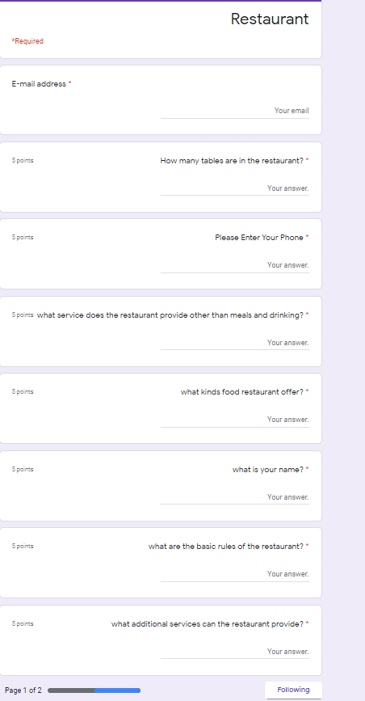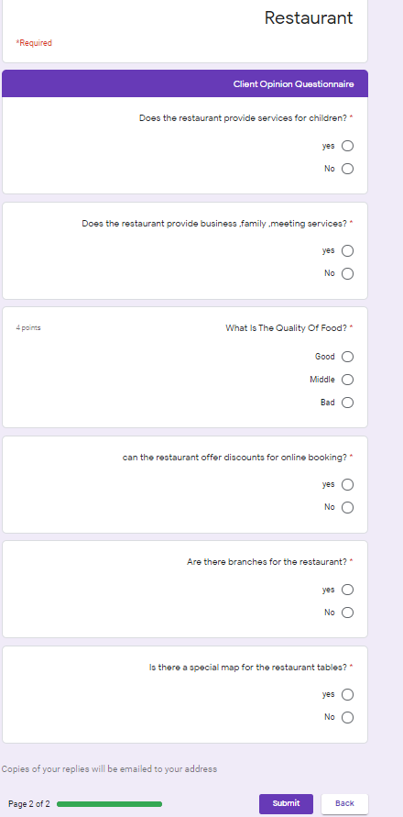

**Questionnaire feed back**

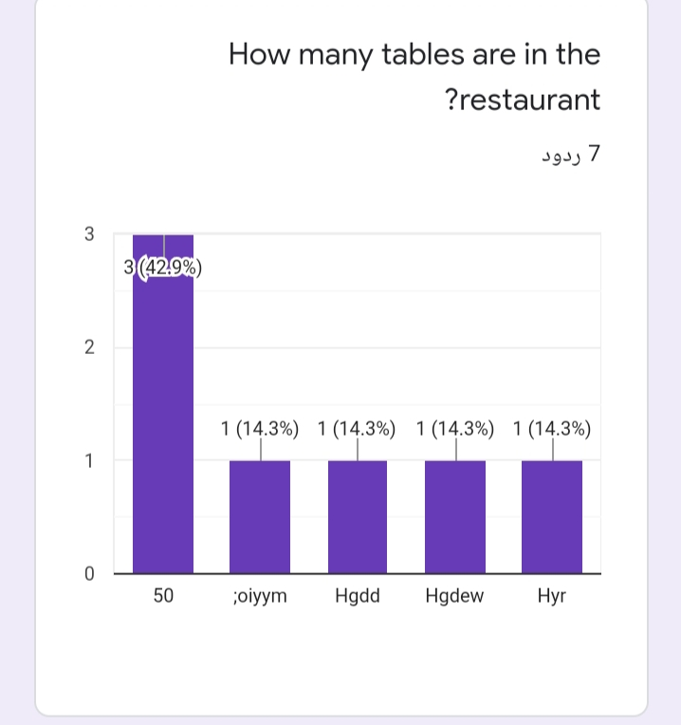

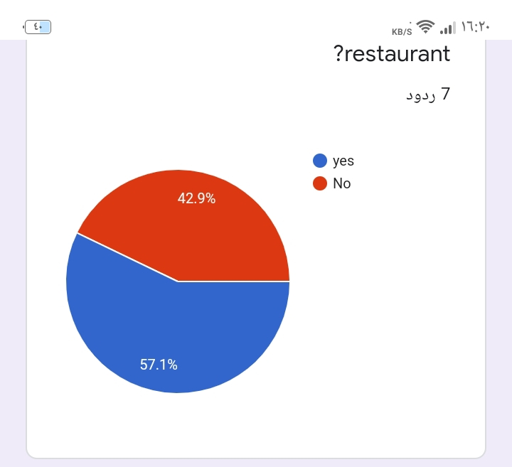

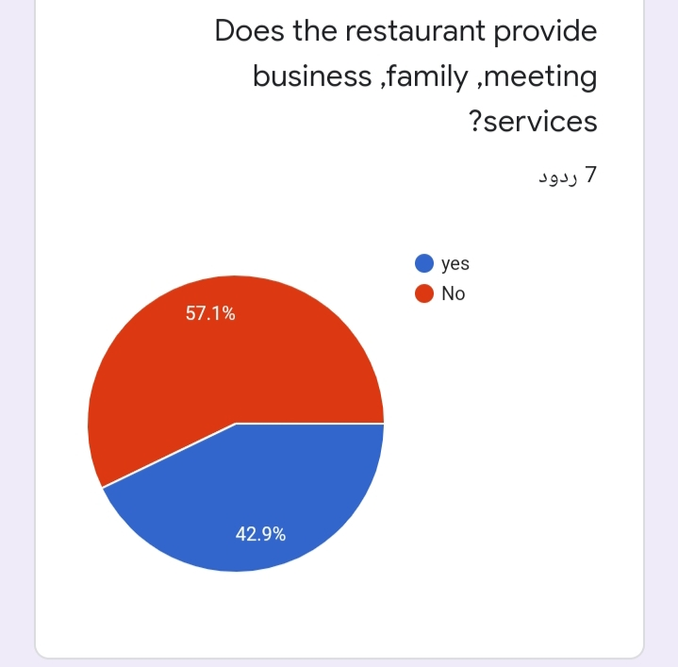

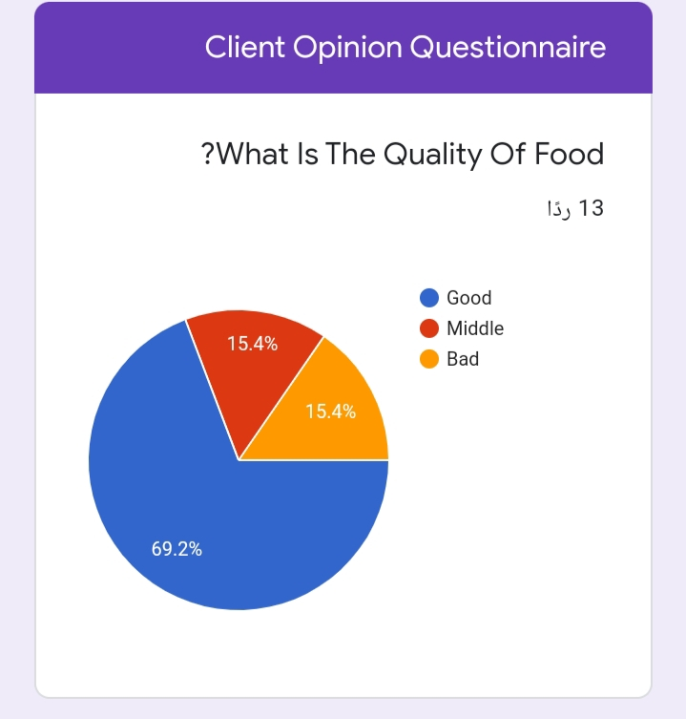

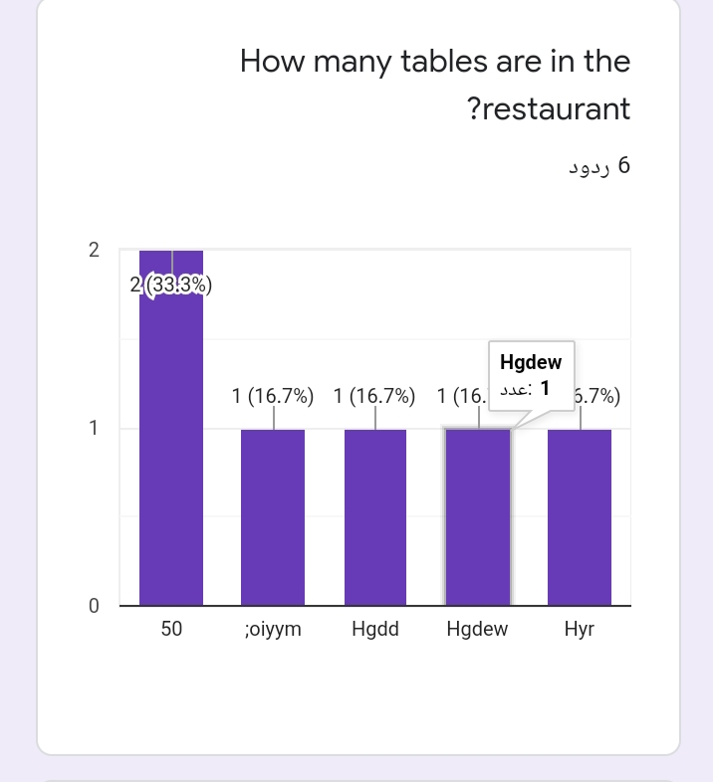

**Context Diagram – Data Flow Diagram**

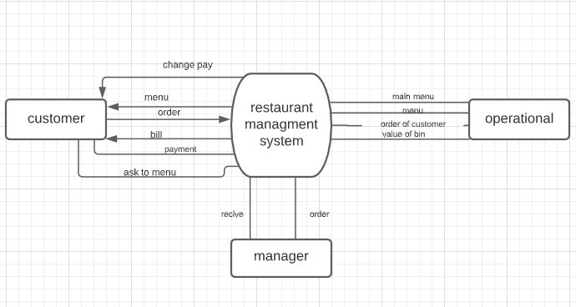

**Diagram 0 – Data Flow Diagram**

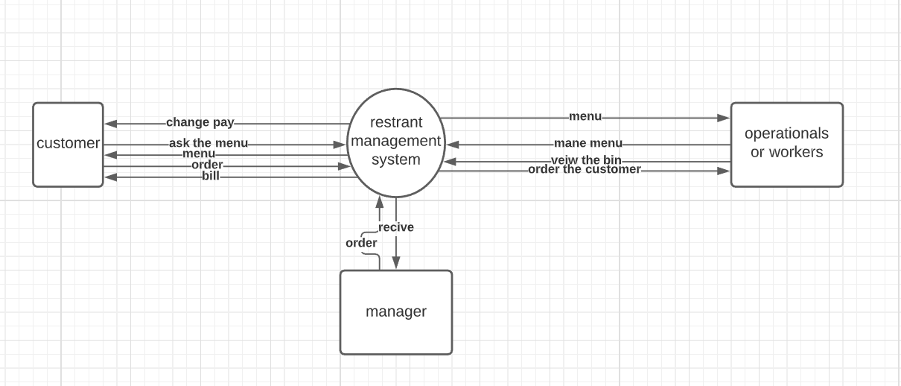

Figure 1 diagram 1 Data flow Diagram

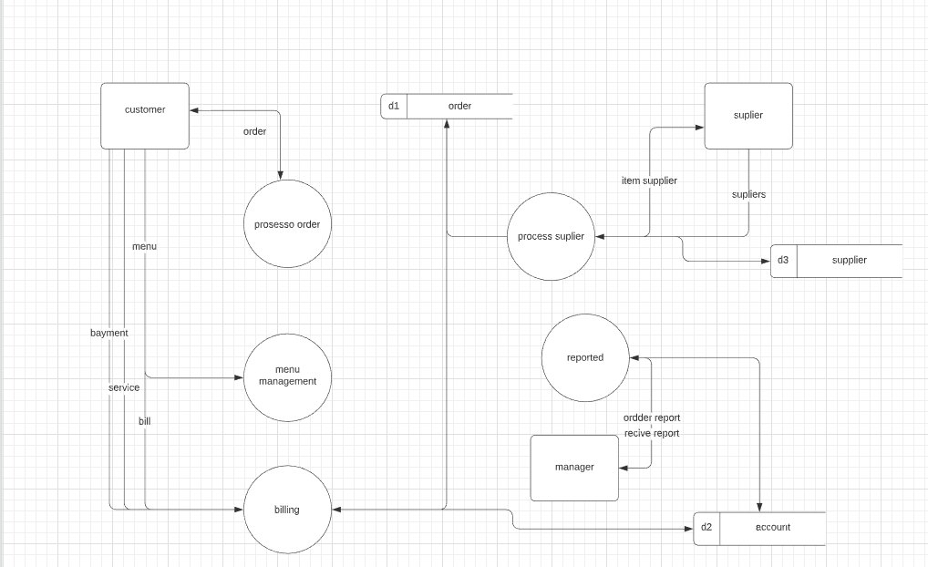

Figure 2 child Diagram-Data Flow Diagram

**Child Diagram – Data Flow Diagram**

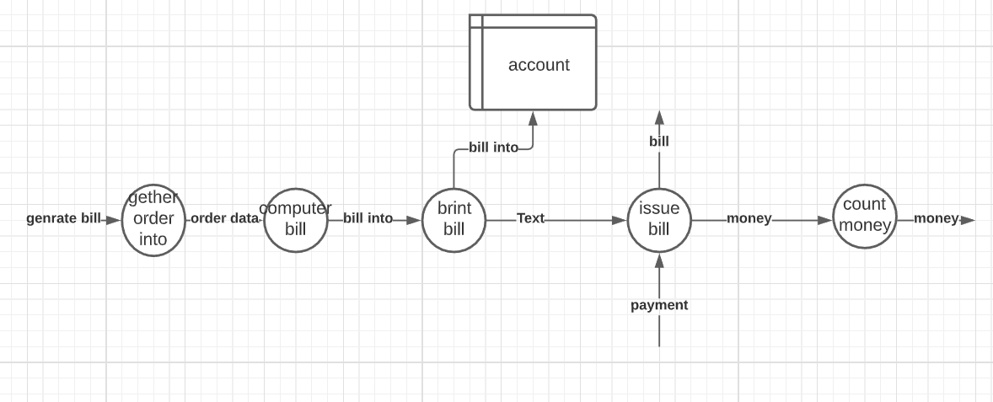

**Data Dictionary**

**Data Flow (At least three Data Flows needed)**

**1**

|  |  |
| --- | --- |
| 1 | ID |
| Menu | Label |
| contain kinds of food ,drinks and price | Description |
| external entity-customer | Source |
| process-menu management | Destination |
| Screen | Type |
| menu structure | Data Structure |
| 500/month | Volume/Time |
| this menu for one customer only | Comments |

**Data structure**

1-menu={kinds of food}+{kinds of drinks}+price

**structural record**

1-kinds of food=sefod+pizza+pasta+sweets+pets

2-kinds of drinks={cold drinks}+{hot drinks}+juice

**Data Element**

|  |  |
| --- | --- |
| 1 | ID |
| Menu | Name |
| list of food and drinks | Alias |
| contain kinds of food ,drinks and price | Description |
| 2500 | Length |
| x&9(2500) | Input Format |
| x&9(2500) | Output Format |
| - | Default Value |
| Continuous | Continuous / Discrete |
| alphabetic and number | Type |
| Base | Base / Derived |
| - | Upper Limit |
| - | Lower Limit |
| - | Discrete |
| this menu for one customer only | Comments |

**2**

|  |  |
| --- | --- |
| 2 | ID |
| Payment | Label |
| contain money that the customer will pay to the restaurant | Description |
| external entity-customer | Source |
| process-billing | Destination |
| Screen | Type |
| payment structure | Data Structure |
| 300/month | Volume/Time |
| payment has many method | Comments |

**Data structure**

payment=money+{payment method}

**structural record**

payment method=[cash payment]+[online payment]+[payment by visa]

**Data Elemnt**

|  |  |
| --- | --- |
| 2 | ID |
| Payment | Name |
| Payment | Alias |
| contain money that the customer will pay to the restaurant | Description |
| 4 | Length |
| 9(4) | Input Format |
| 9(4) | Output Format |
| - | Default Value |
| Continuous | Continuous / Discrete |
| Number | Type |
| Base | Base / Derived |
| 9999 | Upper Limit |
| 0000 | Lower Limit |
| - | Discrete |
| this payment for one customer only | Comments |

|  |  |
| --- | --- |
| 1 | ID |
| Menu | Label |
| contain kinds of food ,drinks and price | Description |
| external entity-customer | Source |
| process-menu management | Destination |
| Screen | Type |
| menu structure | Data Structure |
| 500/month | Volume/Time |
| this menu for one customer only | Comments |

**Data structure**

1-menu={kinds of food}+{kinds of drinks}+price

**structural record**

1-kinds of food=sefod+pizza+pasta+sweets+pets

2-kinds of drinks={cold drinks}+{hot drinks}+juice

**Data Element**

|  |  |
| --- | --- |
| 1 | ID |
| Menu | Name |
| list of food and drinks | Alias |
| contain kinds of food ,drinks and price | Description |
| 2500 | Length |
| x&9(2500) | Input Format |
| x&9(2500) | Output Format |
| - | Default Value |
| Continuous | Continuous / Discrete |
| alphabetic and number | Type |
| Base | Base / Derived |
| - | Upper Limit |
| - | Lower Limit |
| - | Discrete |
| this menu for one customer only | Comments |

**3**

|  |  |
| --- | --- |
| 3 | ID |
| order report | Label |
| contain any thing that the restaurant doing | Description |
| process- reported | Source |
| external entity-manager | Destination |
| File | Type |
| order report structure | Data Structure |
| 600/month | Volume/Time |
| this report must have any thing abut the restaurant | Comments |

**Data structure**

order report={restaurant buisness}

**Data Elemnt**

|  |  |
| --- | --- |
| 3 | ID |
| order report | Name |
| order report | Alias |
| contain any thing that the restaurant doing | Description |
| 3000 | Length |
| x&9(3000) | Input Format |
| x&9(3000) | Output Format |
| - | Default Value |
| Discrete | Continuous / Discrete |
| number and alphabetic | Type |
| Derived | Base / Derived |
|  | Upper Limit |
|  | Lower Limit |
| - | Discrete |
|  | Comments |

**Data Element (For Each Element in Structural Record)**

|  |  |
| --- | --- |
|  | ID |
| kinds os food | Name |
| food kinds | Alias |
| contain all food in the menu | Description |
| 1000 | Length |
| x(1000) | Input Format |
| x(1000) | Output Format |
|  | Default Value |
| Continuous | Continuous / Discrete |
| Alphabetic | Type |
| Base | Base / Derived |
|  | Upper Limit |
|  | Lower Limit |
|  | Discrete |
| food have many kinds | Comments |

|  |  |
| --- | --- |
|  | ID |
| kinds os drinks | Name |
| drinks kinds | Alias |
| contain all drinks in the menu | Description |
| 1000 | Length |
| x(1000) | Input Format |
| x(1000) | Output Format |
|  | Default Value |
| Continuous | Continuous / Discrete |
| Alphabetic | Type |
| Base | Base / Derived |
|  | Upper Limit |
|  | Lower Limit |
|  | Discrete |
| drinks have many kinds | Comments |

|  |  |
| --- | --- |
|  | ID |
| payment method | Name |
|  | Alias |
| contain all drinks in the menu | Description |
| 1000 | Length |
| x(1000) | Input Format |
| x(1000) | Output Format |
|  | Default Value |
| Continuous | Continuous / Discrete |
| Alphabetic | Type |
| Base | Base / Derived |
|  | Upper Limit |
|  | Lower Limit |
|  | Discrete |
| drinks have many kinds | Comments |

**Data Store (For All Data Stores)**

|  |  |
| --- | --- |
| d1 | ID |
| Order | Name |
| Order | Alias |
| this file will store the orders that the customer orderd | Description |
| Computer | File Type |
| Database | File Format |
| 300 | Record Size |
| 45000 | Maximum Records |
| 41000 | Average Records |
| 6% | Growth per Year |
| Order | Data Set |
| order structure | Data Structure |
| customer phone | Primary Key |
| customer name | Secondary Key |
| the file will update as the customer order again | Comments |

|  |  |
| --- | --- |
| d2 | ID |
| Account | Name |
| Account | Alias |
| this file store the payment of all customer | Description |
| Computer | File Type |
| Database | File Format |
| 500 | Record Size |
| 50000 | Maximum Records |
| 40000 | Average Records |
| 20% | Growth per Year |
| Account | Data Set |
| account structure | Data Structure |
| customer's payment | Primary Key |
|  | Secondary Key |
| the file will update as the customer pay again | Comments |

|  |  |
| --- | --- |
| d3 | ID |
| Supplier | Name |
| Supplier | Alias |
| this file will store the order that the restaurant will order from the supplier | Description |
| Manual | File Type |
| Database | File Format |
| 400 | Record Size |
| 7000 | Maximum Records |
| 6500 | Average Records |
| 5% | Growth per Year |
| Supplier | Data Set |
| suplier structure | Data Structure |
| suplier id | Primary Key |
| suplier name | Secondary Key |
| the file will update as the restaurant will order any thing from supplier | Comments |

**Process Specification (at least two processes)**

|  |
| --- |
| **Process Specification**  **Number**:1-0  **Name:** menu mangement  **Description:**determine that the customer order menu or not |
| **Input Data Flowm:**menufrom external entity-customer |
| **Output Data Flow:-** |
| **Type of Process :**online  **Online Batch Manual** |
| **Process Logic:** |
| **Structured English Decision Table Decision Tree** |
| **Unresolved Issues:** no |

|  |
| --- |
| **Process Specification**  **Number**:5-0  **Name:** reporter  **Description:**this process order all information about the restaurant to sent it to the manger |
| **Input Data Flowm:**1-data store from account |
| **Output Data Flow:-**order report to external entity to manager |
| **Type of Process :**online  **Online Batch Manual** |
| **Process Logic:**structured english  do while accounts store the payment os the customer  reported it |
| **Structured English Decision Table Decision Tree** |
| **Unresolved Issues:** no |

|  |
| --- |
| **Process Specification**  **Number**  **Name:** process suplier  **Description:**this process order the requirement that thec restaurant need from suplier |
| **Input Data Flowm:**1-supliers from external entity-suplier  2- data store-suplier |
| **Output Data Flow:1-**item suplier to suplier  2-data store-suplier  3-data store-order |
| **Type of Process :**online  **Online Batch Manual** |
| **Process Logic:** |
| **Structured English Decision Table Decision Tree** |
| **Unresolved Issues:** no |

**Entity Relationship Diagram**

**Normalization**

**Normal Tables**

**Tables after 1NF**

**Tables after 2NF**

**Tables after 3NF**

