

College of Computing
Cybersecurity Department

Project Report

AI-Powered Compliance Guard for Adherence with Cybersecurity Authority Regulations in Saudi Arabia


SEC 3108

Submitted by
Student Name: Sabah Alanazi ID: 44411937
Student Name: Aryaf Albishri ID: 444002124
Student Name: Meaad Alzahrani ID: 444000681
Student Name: Weaam Alzahrani ID: 444001190

Project Supervisor: Dr. Yasmeen J. Rashidi
Project ID: S E C - 4 7 1 - P 2 - F12
March 31, 2026

Contact Information
This project report is submitted to the Department of Cybersecurity at Umm Al-Qura University in partial fulfillment of the requirements for the degree of Bachelor of Science in Cybersecurity.

Author(s):
Name: Sabah Alanazi
Email: 44411937@uqu.edu.sa

Name: Aryaf Albishri
Email: 444002124@uqu.edu.sa

Name: Meaad Alzahrani
Email: 444000681@uqu.edu.sa

Name: Weaam Alzahrani
Email: 444001190@uqu.edu.sa

University Supervisor(s):
Name: Dr. Yasmeen J. Rashidi
Email: yjrashidi@uqu.edu.sa

Intellectual Property Right Declaration
This is to declare that the work under the supervision of Dr. Yasmeen J. Rashidi, having the title “AI-Powered Compliance Guard for Adherence with Cybersecurity Authority Regulations in Saudi Arabia” and carried out in partial fulfillment of the requirements for the Bachelor of Science in Cybersecurity, is the sole property of Umm Al-Qura University and the respective supervisor. It is protected under intellectual property laws and conventions, and may only be used or extended with written permission from the University and supervisor.
This declaration applies to all students and faculty members.
Date: March 31, 2026

Author(s):
Name: Sabah Alanazi
Email: s44411937@uqu.edu.sa Signature: _______________

Name: Aryaf Albishri
Email: s444002124@uqu.edu.sa Signature: _______________

Name: Meaad Alzahrani
Email: s444000681@uqu.edu.sa Signature: _______________

Name: Weaam Alzahrani
Email: s444001190@uqu.edu.sa Signature: _______________

University Supervisor(s):
Name: Dr. Yasmeen J. Rashidi
Email: yjrashidi@uqu.edu.sa

Anti-Plagiarism Declaration
This is to declare that the publication produced under the supervision of Dr. Yasmeen J. Rashidi, titled “AI-Powered Compliance Guard for Adherence with Cybersecurity Authority Regulations in Saudi Arabia” is the original work of the author(s). No part of it has been reproduced illegally or plagiarized, and all referenced materials have been cited properly. The author(s) accept full responsibility for any proven violations of this declaration.
Date: March 31, 2026

Author(s):
Name: Sabah Alanazi
Email: s44411937@uqu.edu.sa Signature: _______________

Name: Aryaf Albishri
Email: s444002124@uqu.edu.sa Signature: _______________

Name: Meaad Alzahrani
Email: s444000681@uqu.edu.sa Signature: _______________

Name: Weaam Alzahrani
Email: s444001190@uqu.edu.sa Signature: _______________

University Supervisor(s):
Name: Dr. Yasmeen J. Rashidi
Email: yjrashidi@uqu.edu.sa

Acknowledgment
We express our deepest gratitude to our project supervisor, Dr. Yasmeen J. Rashidi, for her invaluable guidance, expert insights, and continuous encouragement throughout the development of the AICG. We also extend our sincere appreciation to the Department of Cybersecurity at Umm Al-Qura University for providing the academic foundation and resources necessary to complete this project. Furthermore, we are grateful for the regulatory frameworks provided by the National Cybersecurity Authority (NCA), specifically the Essential Cybersecurity Controls (ECC), which served as the essential benchmark for our automated compliance system. Finally, we would like to thank our families and peers for their constant support and motivation during this journey toward enhancing the cybersecurity resilience of Saudi SMEs.

Abstract
Building upon the design and architecture established in Graduation Project 1, this report documents the full implementation, deployment, and evaluation of the AICG platform — an AI-powered cybersecurity compliance system for Saudi SMEs. The implemented system comprises: (1) a custom bilingual compliance dataset of 260 samples generated via Google Gemini 2.5 Flash; (2) a fine-tuned multilingual BERT (mBERT) model for 16-label multi-label gap detection across Password Policy (ECC 2-2) and Risk Assessment (ECC 1-5) domains; (3) a FastAPI backend deployed on Google Cloud Run with document chunking and severity-weighted compliance scoring; (4) a React/TypeScript web application with bilingual (Arabic/English) support and a comprehensive compliance dashboard; and (5) a Supabase PostgreSQL database with row-level security. The platform accepts policy documents in PDF, DOCX, or plain text, analyzes them against NCA ECC controls, maps detected gaps to ISO 27001:2022 clauses, and provides actionable remediation guidance. The system achieves sub-second inference time and reduces manual audit effort from weeks to minutes.
Keywords— NCA ECC, ISO 27001, Compliance Automation, NLP, mBERT, Multi-label Classification, Gap Detection, Saudi Arabia, Vision 2030.

Contents
[Generate automatically in Word: References → Table of Contents]

List of Tables
Table 2.1: Summary and Comparison of Studies (from GP1)
Table 3.1: Technology Stack
Table 3.2: Dataset Statistics
Table 3.3: Gap Labels — Password Policy (ECC 2-2)
Table 3.4: Gap Labels — Risk Assessment (ECC 1-5)
Table 3.5: Model Architecture Parameters
Table 3.6: API Endpoints
Table 3.7: Database Schema Summary
Table 3.8: Frontend Pages and Components
Table 3.9: Compliance Scoring Thresholds
Table 3.10: Threat Model and Security Controls
Table 3.11: STRIDE Threat Model & Mitigations
Table 4.1: Test Case Results — Model Inference
Table 4.2: Test Case Results — API Endpoints
Table 4.3: Usability Evaluation Criteria

List of Figures
Figure 3.1: High-Level System Architecture
Figure 3.2: ML Pipeline Workflow
Figure 3.3: Model Classification Head
Figure 3.4: Document Chunking & Aggregation Pipeline
Figure 3.5: Sequence Diagram — Policy Classification
Figure 3.6: Class Diagram
Figure 3.7: Data Flow Diagram — Level 0
Figure 3.8: Data Flow Diagram — Level 1
Figure 3.9: Activity Diagram — Policy Assessment
Figure 3.10: Deployment Architecture
Figure 3.11: Database Entity-Relationship Diagram
Figure 3.12: Use Case Diagram
Figure 3.13: Prototype — Landing Page
Figure 3.14: Prototype — Sign In / Sign Up
Figure 3.15: Prototype — Dashboard Overview
Figure 3.16: Prototype — Policy Upload & Analysis
Figure 3.17: Prototype — Analysis Result (Compliant)
Figure 3.18: Prototype — Analysis Result (Non-Compliant)
Figure 3.19: Prototype — Assessments Page
Figure 3.20: Prototype — Remediation Tasks
Figure 3.21: Prototype — Framework Comparison
Figure 3.22: Prototype — Risk Dashboard
Figure 3.23: Prototype — Arabic RTL Interface

1 Introduction

1.1 Background
Currently, many organizations have amalgamated cyberspace solutions within their conventional business processes. The more a business integrates digital solutions and increases its online presence, the more it becomes vulnerable to cybersecurity threats. In Saudi Arabia, the National Cybersecurity Authority (NCA) issued the Essential Cybersecurity Controls (ECC), which is a regulatory framework to govern cybersecurity practices. Compliance with these controls is compulsory for all organizations operating IT systems in Saudi Arabia. Despite the availability of international standards such as ISO 27001, PCI DSS, and NIST frameworks, these remain generic solutions that often fail to address the unique operational contexts and resource constraints characteristic of Saudi SMEs.
Graduation Project 1 established the problem definition, literature review, system design, and threat modeling for AICG. This report documents Graduation Project 2, covering the full implementation, deployment, testing, and evaluation of the platform.

1.2 Problem Definition & Objectives
Saudi SMEs manage their cybersecurity compliance using fragmented and manual methods that are inefficient, error-prone, and lack continuity. The primary objective of this project is to develop a web-based AI platform that automates compliance processes for a focused set of ECC-ISO cybersecurity regulations. The system utilizes Supervised Learning to train NLP models on regulatory texts, with an initial focus on the Password Policy (ECC 2-2) and Risk Assessment (ECC 1-5) controls from the NCA ECC.

1.3 Project Contribution
The main contributions delivered in GP2 for AICG are:
- AI-driven 16-label multi-label gap detection using fine-tuned mBERT
- Custom bilingual (Arabic/English) compliance dataset of 260 samples
- Automated ECC–ISO 27001 cross-framework mapping
- Full-stack web platform with real-time compliance scoring
- Severity-weighted scoring with actionable remediation guidance
- Cloud-native deployment on Google Cloud Run (me-central1)
- Bilingual interface with RTL Arabic support
- Centralized compliance reporting and audit trail

1.4 Structure of the Project
This report is structured as follows: Chapter 1: Introduction — provides background, objectives, and contributions. Chapter 2: Literature Review — summarizes the related work from GP1. Chapter 3: Solution Approach / Methodology — details the full implementation including dataset construction, AI model, backend, frontend, database, system diagrams, prototype screenshots, and security. Chapter 4: Testing and Evaluation — covers model testing, API testing, performance metrics, and usability evaluation. Chapter 5: Conclusion — summarizes achievements, challenges, lessons learned, and future work.

2 Literature Review or Related Work
The Essential Cybersecurity Controls (ECC) of the Saudi National Cybersecurity Authority establish a legal baseline for cybersecurity compliance in the Kingdom. The ECC includes 114 controls across five domains and twenty-nine subdomains focused on governance, risk management, and operational resilience. However, a major limitation is the absence of automation and digital tools to support ongoing compliance verification.
The literature review conducted in GP1 was organized into three themes: (1) automated compliance checking frameworks; (2) natural language processing (NLP) for regulatory text; and (3) Regulatory Technology applications and Saudi governance considerations. These findings validated the need for a bilingual, AI-enabled compliance platform — which AICG now implements.

2.1 Summary and Comparison of Studies
Table 2.1 summarizes the key studies reviewed in GP1.
Ref. | Main Focus / Methodology | Key Strength | Key Limitation
[11] | AI, Blockchain & Smart Contracts for automated cybersecurity policy enforcement | Scalability, reduced manual effort via simulation | Conceptual; requires real-world testing
[29] | NLP (Sentence-BERT) for GDPR clause-to-regulation matching | High semantic embedding effectiveness | Limited to English and GDPR only
[16] | Literature review on NLP transformers for compliance analysis | Strong synthesis of NLP progress | Lacks benchmarking standards; limited Arabic datasets
[14] | Deep learning & GNN for semantic alignment of regulations | Captures semantic context beyond surface similarity | Domain-specific; limited validation
[20] | RC2AS: Risk-Based Cybersecurity Compliance Assessment for ECC | Structured quantitative maturity assessment | Small-scale; lacks AI-driven automation
[15] | Rule-based NLP with ontologies for compliance checking | High precision and explainable | High engineering cost; poor scalability
For the complete literature review and full comparison table, refer to the GP1 report.

3 Solution Approach / Methodology
This chapter details the full implementation of the AICG platform, covering dataset construction, AI model development, backend API, frontend application, database design, system modeling diagrams, prototype design (with screenshots), and security implementation.

3.1 Overall Approach
The core of AICG is an AI-powered system that automates the compliance assessment process. The methodology follows a linear workflow: Data Collection → Preprocessing & Feature Extraction → AI Model → Compliance Scoring → User Interface → Real-time Monitoring.
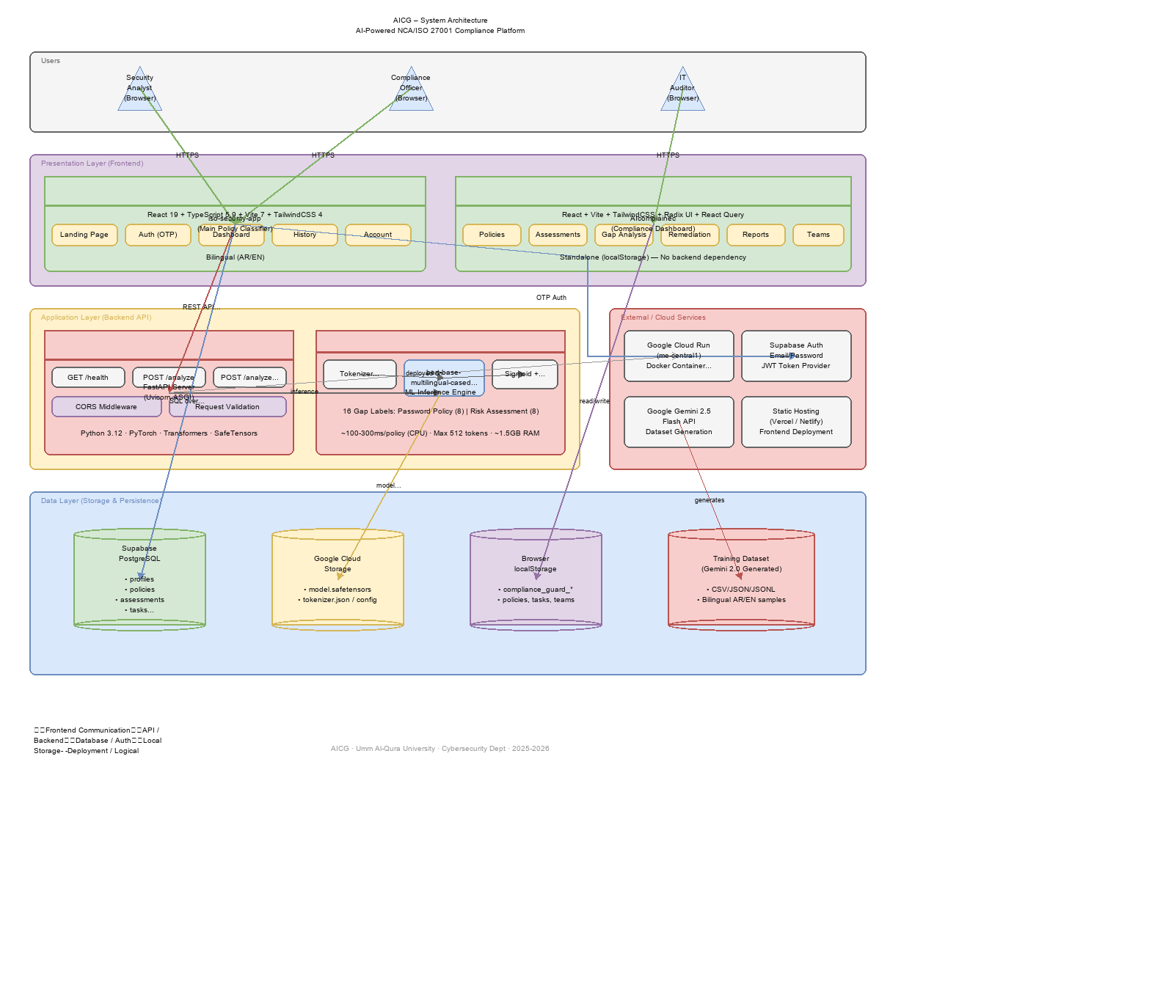
Figure 3.1: High-Level System Architecture

3.2 Methodology Details
The system architecture consists of several interconnected modules:
- Data Collection Module: Regulatory documents (NCA ECC, ISO 27001) and organizational policies.
- Preprocessing and Feature Extraction Engine: Cleaning, tokenization, language detection, Arabic normalization.
- AI Model: Supervised classification engine built on mBERT for 16-label gap detection.
- Compliance Scoring Module: Severity-weighted scoring with per-domain breakdown.
- User Interface: Interactive dashboard with real-time compliance metrics.
- Real-time Monitoring: Continuous visibility over compliance status.

3.2.1 Technology Stack
Category | Technology | Version / Details
Frontend Framework | React | 19.2.0
Language (Frontend) | TypeScript | 5.9.3
CSS Framework | Tailwind CSS | 4.1.18
Build Tool | Vite | 7.3.1
Router | React Router DOM | 7.13.0
Backend Framework | FastAPI | 0.115.0
ML Framework | PyTorch (CPU-only) | —
NLP Library | HuggingFace Transformers | 4.40.0
Pre-trained Model | bert-base-multilingual-cased | 119,547 vocab
Database | Supabase (PostgreSQL) | Managed
Authentication | Supabase Auth (JWT) | —
Cloud Platform | Google Cloud Run | me-central1 (Doha)
Model Storage | Google Cloud Storage | Bucket: model-files33
Dataset Generation | Google Gemini 2.5 Flash | API
PDF Extraction | pdf.js-dist | 4.9.155
Containerization | Docker (multi-stage) | python:3.12-slim

3.2.2 Data Collection
A custom compliance dataset was generated using the Google Gemini 2.5 Flash API through a two-pass generation pipeline (generate + verify). The generator script produces bilingual policy excerpts with multi-label gap annotations.
- 14 sample profiles controlling gap distribution patterns
- 12 industry variations (Banking, Healthcare, Telecom, Government, etc.)
- 5 company size categories (Micro, Small, Medium, Large, Enterprise)
- Resumable operation via incremental JSONL output
Table 3.2: Dataset Statistics
Metric | Value
Total Samples | 260
English Samples | 130 (50%)
Arabic Samples | 130 (50%)
Fully Compliant | 48 (18.5%)
Partially Compliant | 92 (35.4%)
Non-Compliant | 120 (46.2%)
Password Policy Only | 89 (34.2%)
Risk Assessment Only | 79 (30.4%)
Both Domains | 92 (35.4%)
Average Gap Count | 5.05 per sample
Table 3.3: Gap Labels — Password Policy (ECC 2-2)
Gap ID | Description | Severity
GAP_PP_001 | Weak password complexity requirements | 3
GAP_PP_002 | Inadequate password expiration policy | 2
GAP_PP_003 | Weak account lockout mechanisms | 2
GAP_PP_004 | Missing multi-factor authentication (MFA) | 4
GAP_PP_005 | Missing privileged access management (PAM) | 4
GAP_PP_006 | Missing password encryption/storage requirements | 3
GAP_PP_007 | Missing periodic review schedule | 2
GAP_PP_008 | Missing roles and responsibilities definition | 2
Table 3.4: Gap Labels — Risk Assessment (ECC 1-5)
Gap ID | Description | Severity
GAP_RA_001 | Missing risk assessment methodology | 4
GAP_RA_002 | Missing risk identification procedures | 3
GAP_RA_003 | Missing likelihood/impact assessment scales | 3
GAP_RA_004 | Missing risk treatment options | 3
GAP_RA_005 | Missing assessment triggers/schedule | 4
GAP_RA_006 | Missing risk register requirements | 2
GAP_RA_007 | Missing periodic review schedule | 2
GAP_RA_008 | Missing project management integration | 2

3.2.3 AI Model Development
The core analytical component of AICG is a GapDetectionModel built on bert-base-multilingual-cased (mBERT). The model uses a two-layer classification head on top of the [CLS] token output with sigmoid activation for multi-label classification across 16 gap labels.
Table 3.5: Model Architecture Parameters
Parameter | Value
Base Model | bert-base-multilingual-cased
Vocabulary Size | 119,547 tokens
Hidden Size | 768
Attention Heads | 12
Encoder Layers | 12
Max Sequence Length | 512 tokens
Classification Head | Linear(768→256) → ReLU → Dropout(0.3) → Linear(256→16)
Output Activation | Sigmoid (per-label independent)
Loss Function | BCEWithLogitsLoss (multi-label)
Optimizer | AdamW with linear warmup
Number of Gap Labels | 16 (8 Password Policy + 8 Risk Assessment)
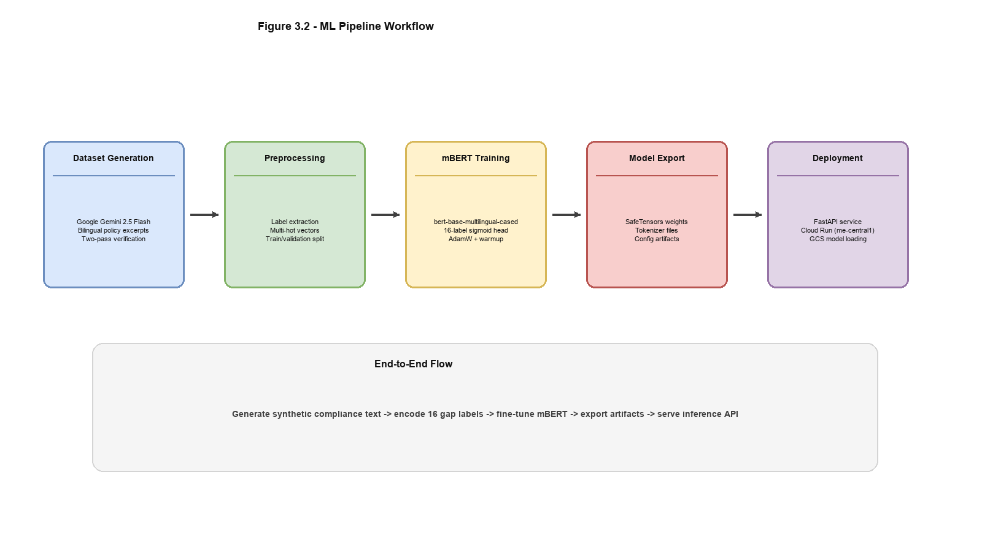
Figure 3.2: ML Pipeline Workflow
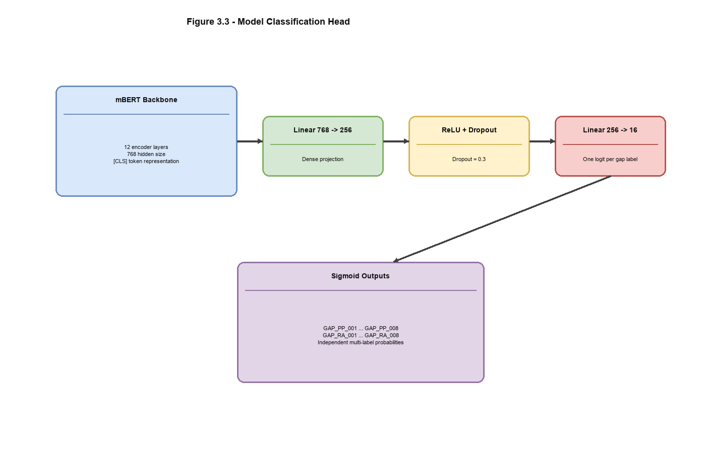
Figure 3.3: Model Classification Head Architecture
Model Evolution:
- v1.0 — 3-class BertForSequenceClassification (compliant / partial / non-compliant)
- v2.0 — 16-class multi-label GapDetectionModel with gap-level sigmoid classification (current)

Document Processing Pipeline
For inference, documents undergo a chunking pipeline:
- 1. Input text (up to 50,000 characters)
- 2. Document chunking: split on headings, then paragraphs (~350 words/chunk, 50-word overlap)
- 3. Per-chunk tokenization with mBERT tokenizer (512 max tokens)
- 4. Per-chunk inference: mBERT → classifier → 16 sigmoid outputs
- 5. Max-pooling aggregation across all chunks per gap label
- 6. Domain detection via keyword heuristic
- 7. Severity-weighted compliance scoring
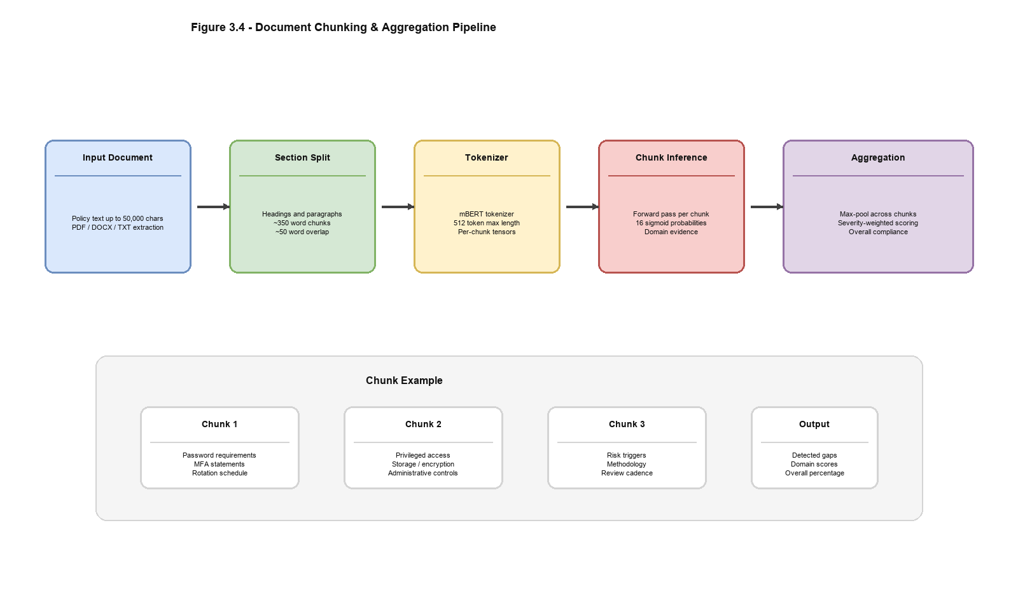
Figure 3.4: Document Chunking & Aggregation Pipeline
Table 3.9: Compliance Scoring Thresholds
Score = 1 − (weighted_detected_gaps / total_weighted_gaps)
Score Range | Classification
≥ 0.90 | Compliant
0.50 – 0.89 | Partially Compliant
< 0.50 | Non-Compliant

3.2.4 Backend API Development
The backend is a FastAPI application (~1,000 lines) deployed on Google Cloud Run. It loads the trained model from Google Cloud Storage at startup.
Table 3.6: API Endpoints
Endpoint | Method | Purpose
/ | GET | API metadata and version info
/health | GET | Health/readiness probe for Cloud Run
/analyze | POST | Analyze policy document for compliance gaps
AnalyzeRequest: text (1–50,000 chars), threshold (0.0–1.0, default 0.6)
AnalyzeResponse includes: overall_compliance, overall_score, gap_count, domains_detected, per-domain gap details with confidence scores, all_gap_probabilities, and inference_time_ms.
Deployment Configuration:
- Docker multi-stage build (python:3.12-slim, CPU-only PyTorch)
- Region: me-central1 (Doha, Middle East)
- Memory: 2 GB, CPU: 2 cores, Port: 8080
- Health check: GET /health every 30 seconds
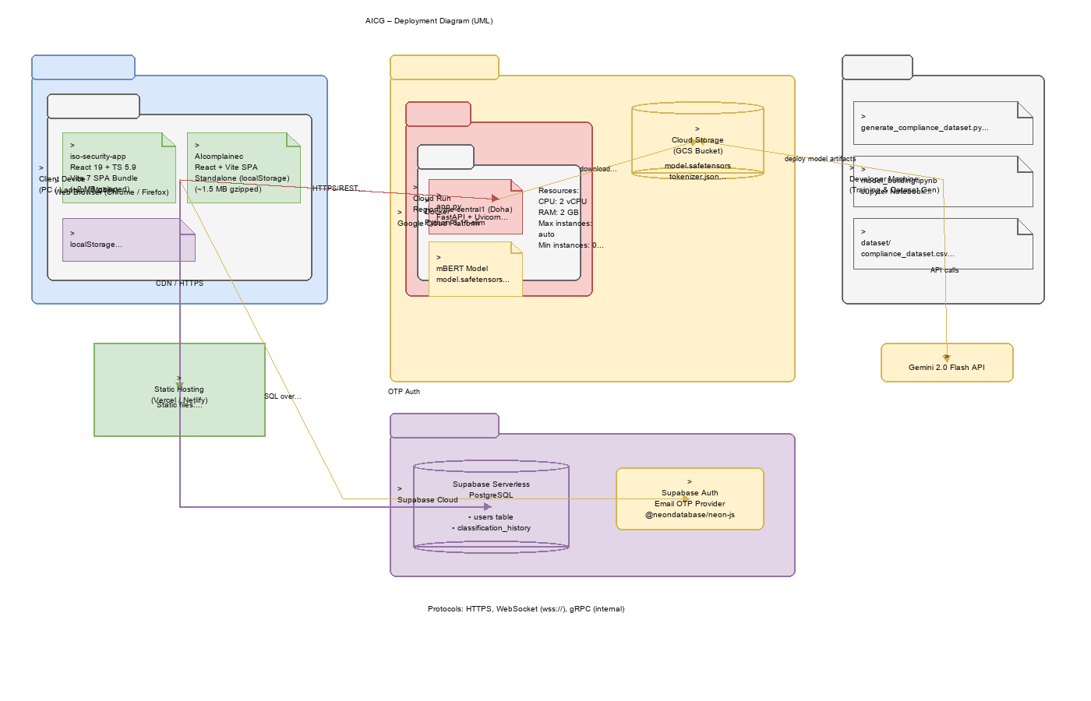
Figure 3.10: Deployment Architecture (Google Cloud Run)

3.2.5 Frontend Web Application
The frontend is a single-page application built with React 19, TypeScript 5.9, and Tailwind CSS 4. It provides a comprehensive compliance dashboard with bilingual (Arabic/English) support and full RTL layout.
Table 3.8: Frontend Pages and Components
Page | Route | Purpose
Landing Page | / | Feature showcase, NCA ECC mapping, workflow, tech stack
Authentication | /auth/* | Email/password sign in and registration
Account | /account | User profile management
Dashboard Overview | /dashboard | KPI cards, compliance gauge, recent activity
Policies | /dashboard/policies | Upload & analyze policy documents (PDF/DOCX/TXT)
Assessments | /dashboard/assessments | Create NCA ECC / ISO 27001 assessments
Remediation | /dashboard/remediation | Track tasks with priorities and AI guidance
Framework Comparison | /dashboard/framework-comparison | ECC ↔ ISO 27001 mapping
Risk Dashboard | /dashboard/risk | Risk metrics and scoring
Key Frontend Features:
- Bilingual Support: Full Arabic/English with RTL layout (∼1,000+ translated strings)
- File Processing: Client-side PDF, DOCX, TXT text extraction
- Real-time Analysis: Upload triggers immediate API analysis
- Responsive Design: Mobile-first with collapsible sidebar
- Compliance Store: Central state with Supabase sync + localStorage fallback

3.2.6 Database Design
The database is hosted on Supabase (managed PostgreSQL) with Row-Level Security (RLS) ensuring each user can only access their own data.
Table 3.7: Database Schema Summary
Table | Purpose | Key Columns
profiles | User profiles (auto-created) | id, email, full_name, avatar_url
policies | Uploaded policy documents | title, status, compliance_score, analysis_result
assessments | Compliance assessments | framework, overall_score, results (JSONB)
tasks | Remediation tasks | priority, status, control_id, ai_guidance
reports | Generated reports | type, framework, content (JSONB)
classification_history | API call audit trail | policy_text, result_label, confidence
schedules | Assessment schedules | framework, frequency, next_run
teams | Team management | name, members (JSONB)
Storage Buckets:
- policy-files — Uploaded policy documents (PDF, TXT, DOCX; max 10 MB)
- evidence-files — Assessment evidence files (PDF, images; max 10 MB)
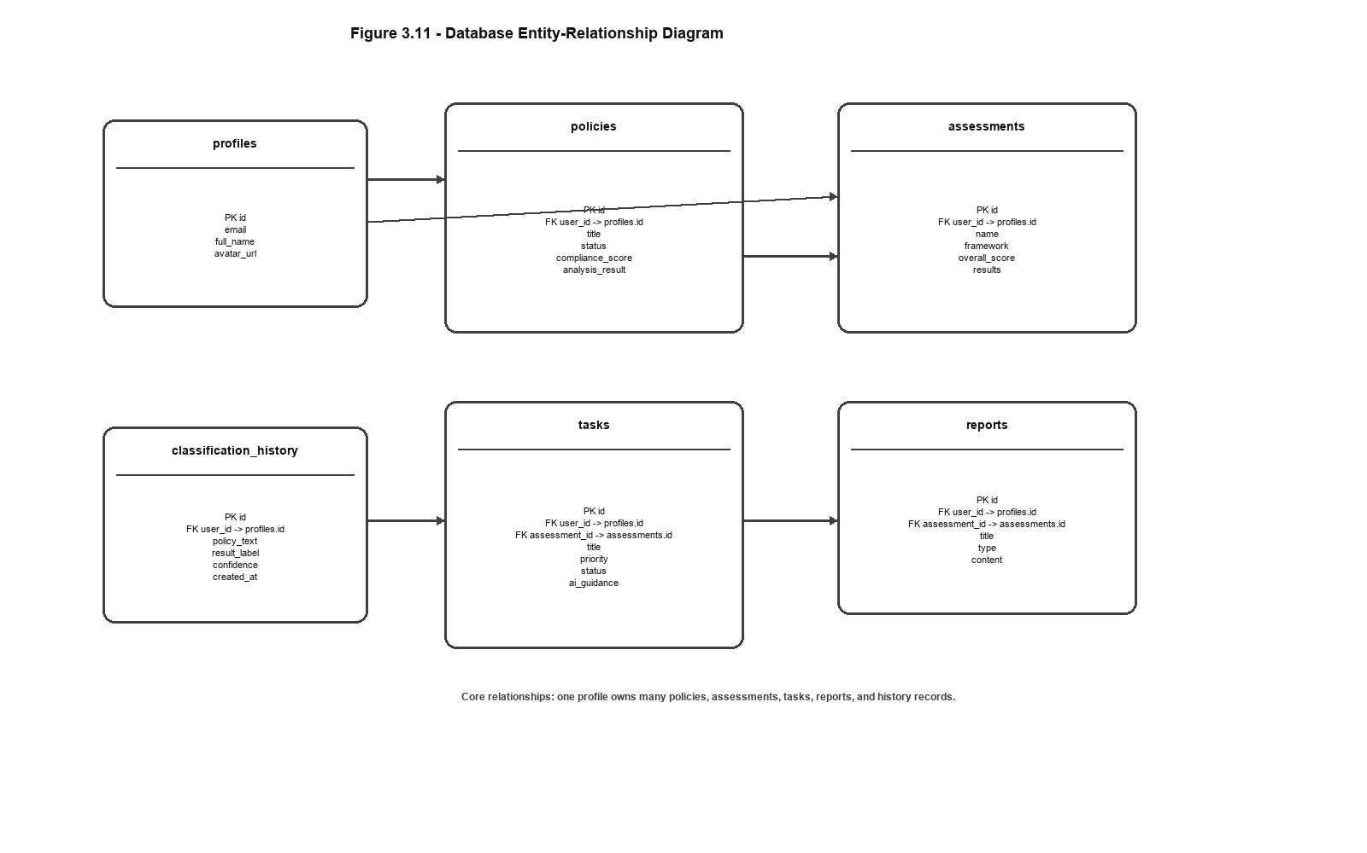
Figure 3.11: Database Entity-Relationship Diagram

3.3 System Modeling Diagrams

3.3.1 Sequence Diagram
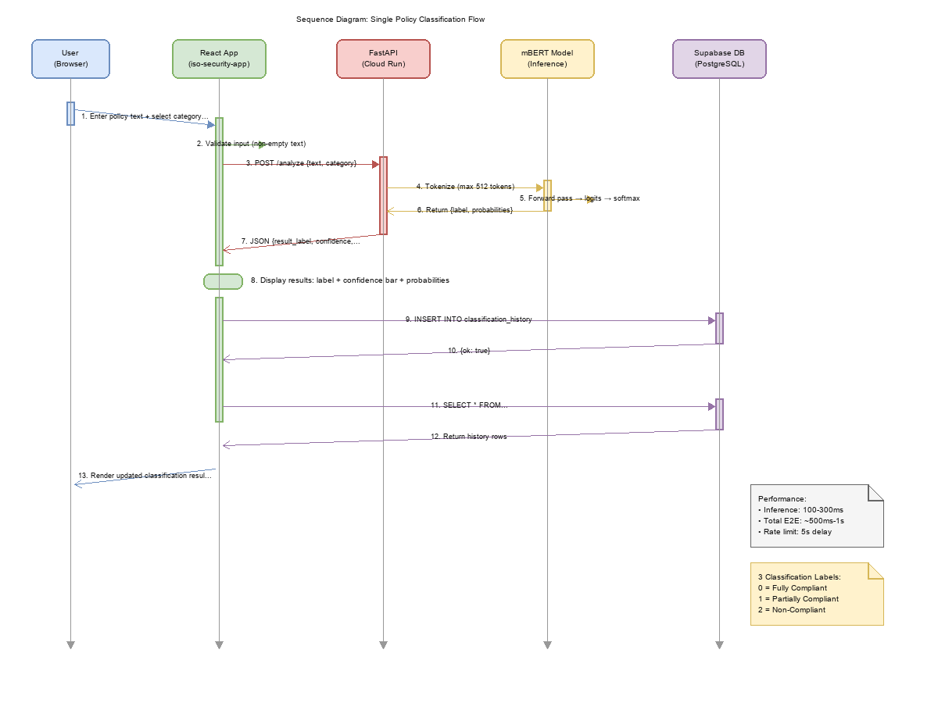
Figure 3.5: Sequence Diagram — Policy Classification

3.3.2 Class Diagram
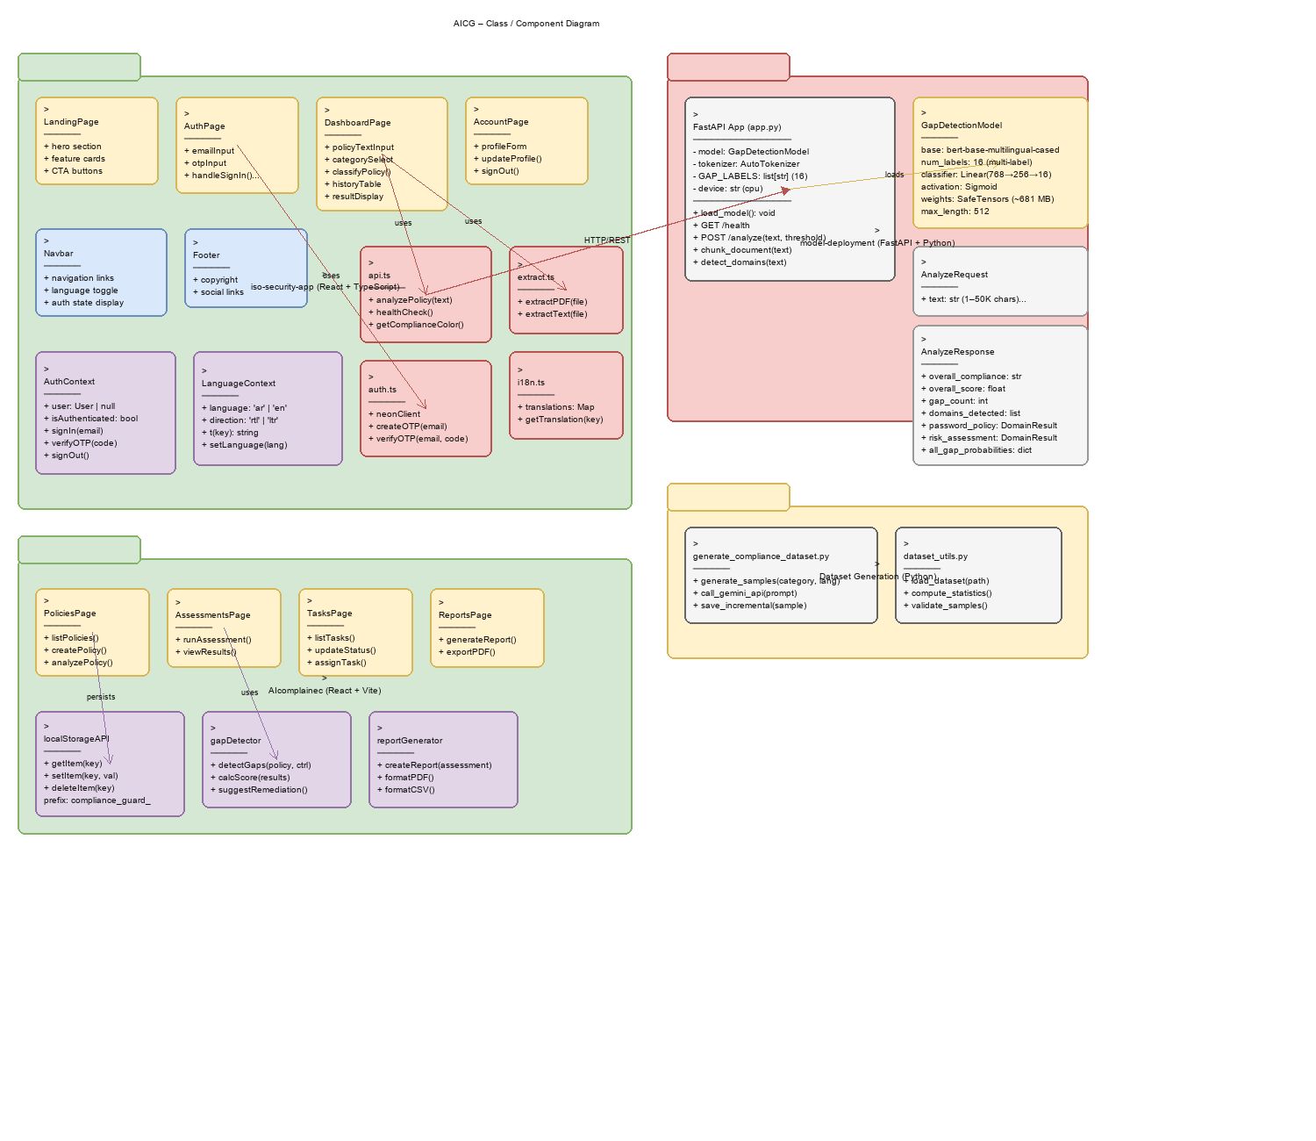
Figure 3.6: Class Diagram

3.3.3 Data Flow Diagram (DFD) Level 0
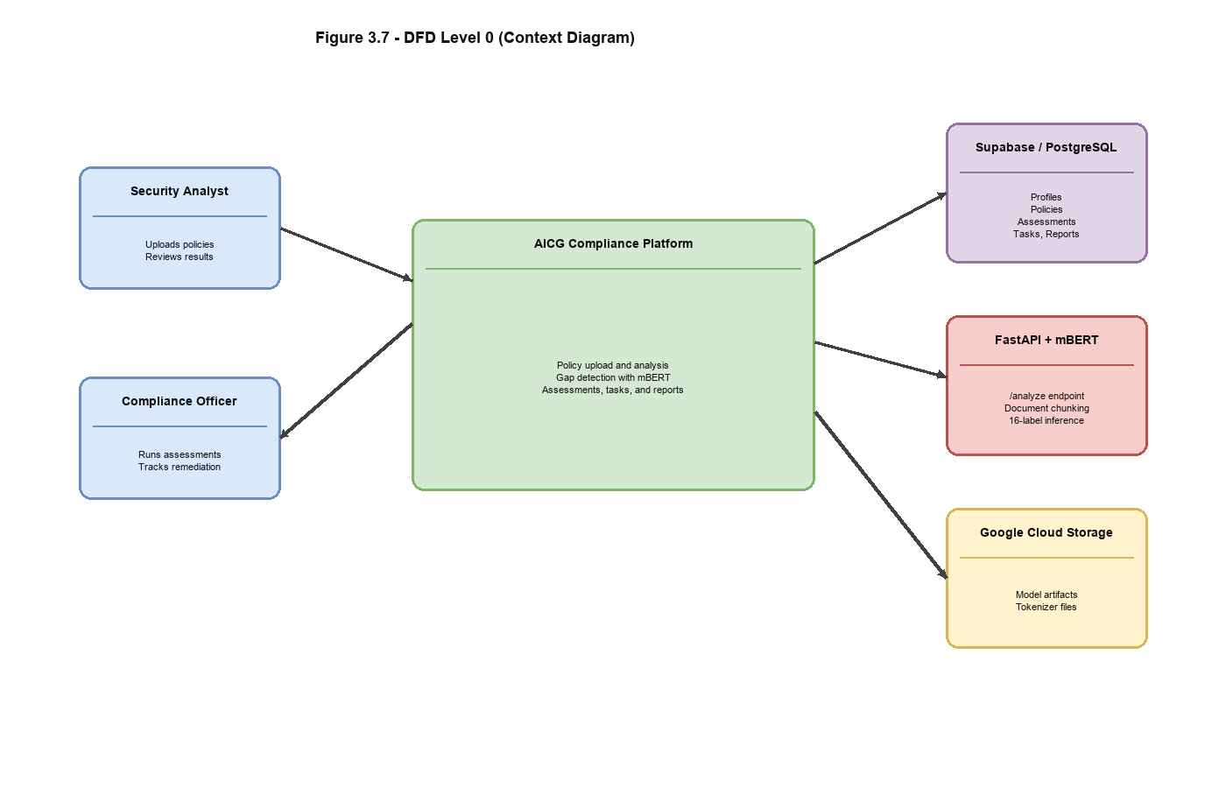
Figure 3.7: DFD — Level 0 (Context Diagram)

3.3.4 Data Flow Diagram (DFD) Level 1
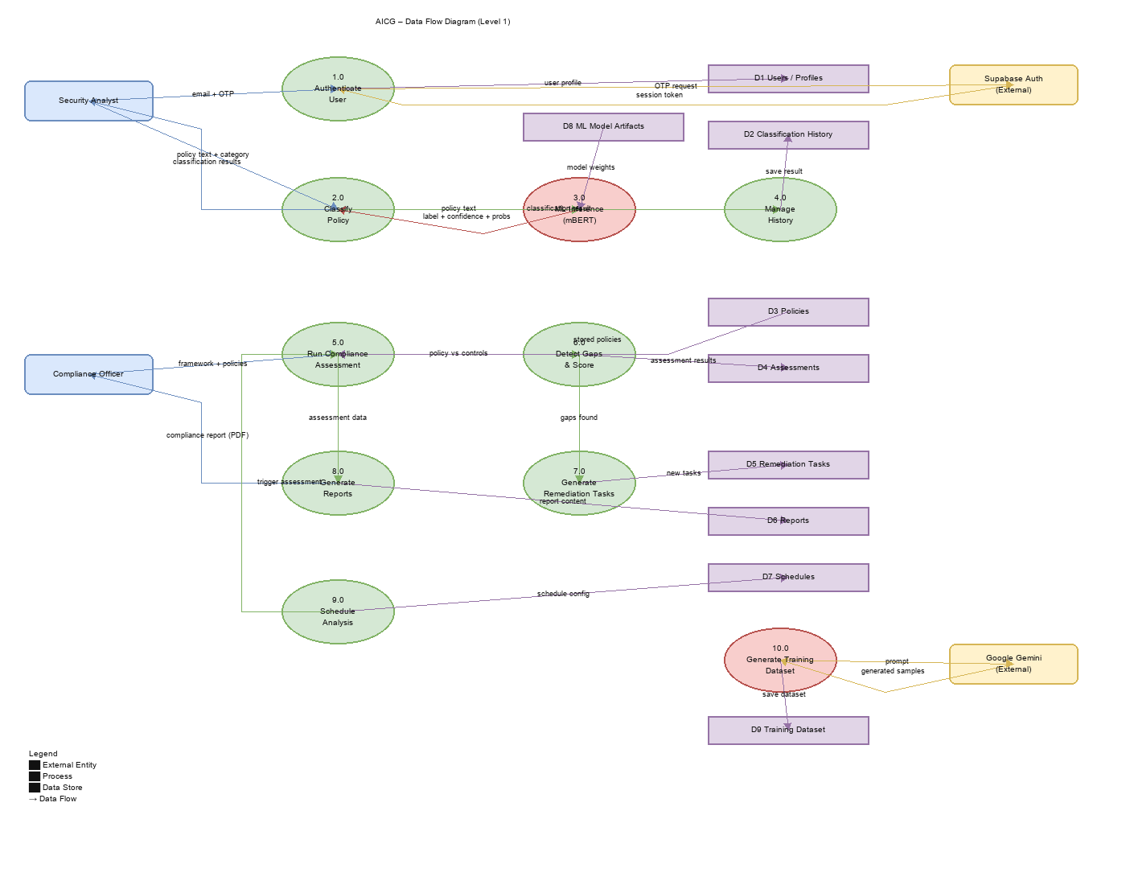
Figure 3.8: DFD — Level 1

3.4 Operational Logic & Scenarios

3.4.1 Activity Diagram
- User Login: Authenticate using Supabase credentials.
- Upload Document: SME employee uploads a policy document.
- Pre-processing: System extracts text from PDF/DOCX/TXT.
- AI Analysis: mBERT model classifies gaps against NCA ECC controls.
- Output: Display compliance score with gap details and remediation guidance.
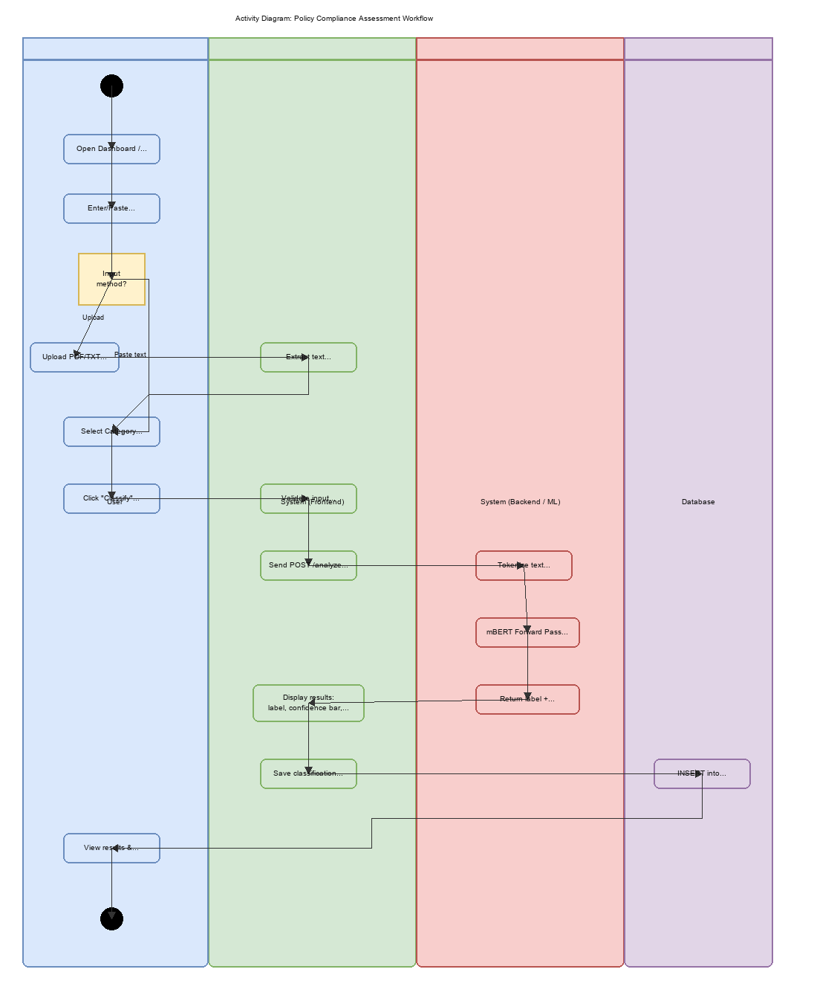
Figure 3.9: Activity Diagram — Policy Assessment

3.4.2 Use Case Diagram
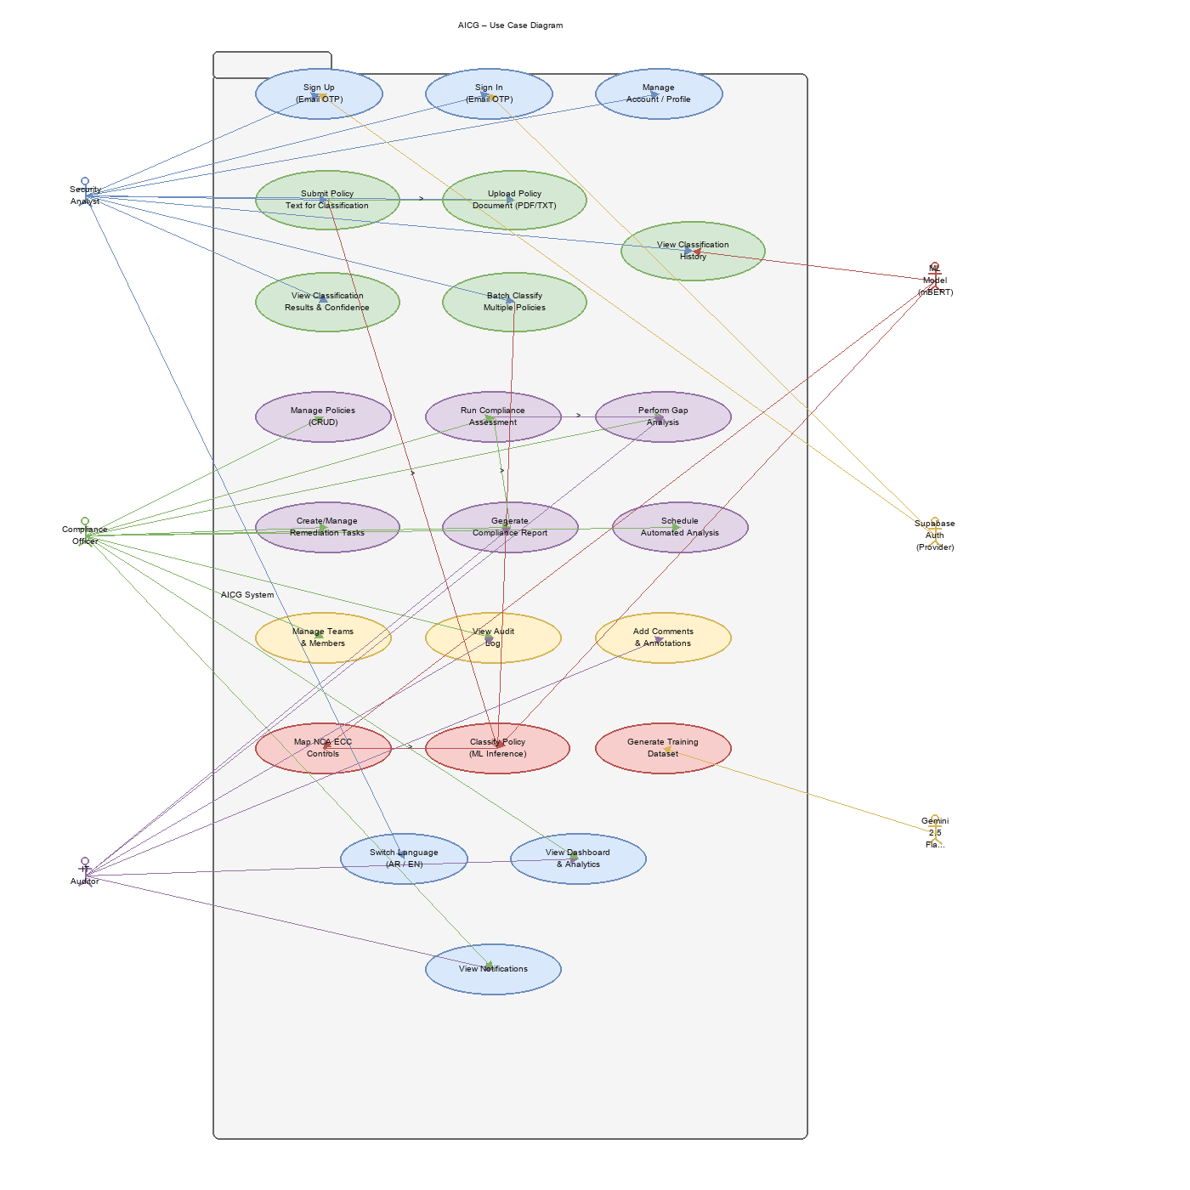
Figure 3.12: Use Case Diagram

3.5 Prototype Design
The following screenshots demonstrate the implemented AICG web application, showcasing the key features and user workflows.

Figure 3.13: Landing Page
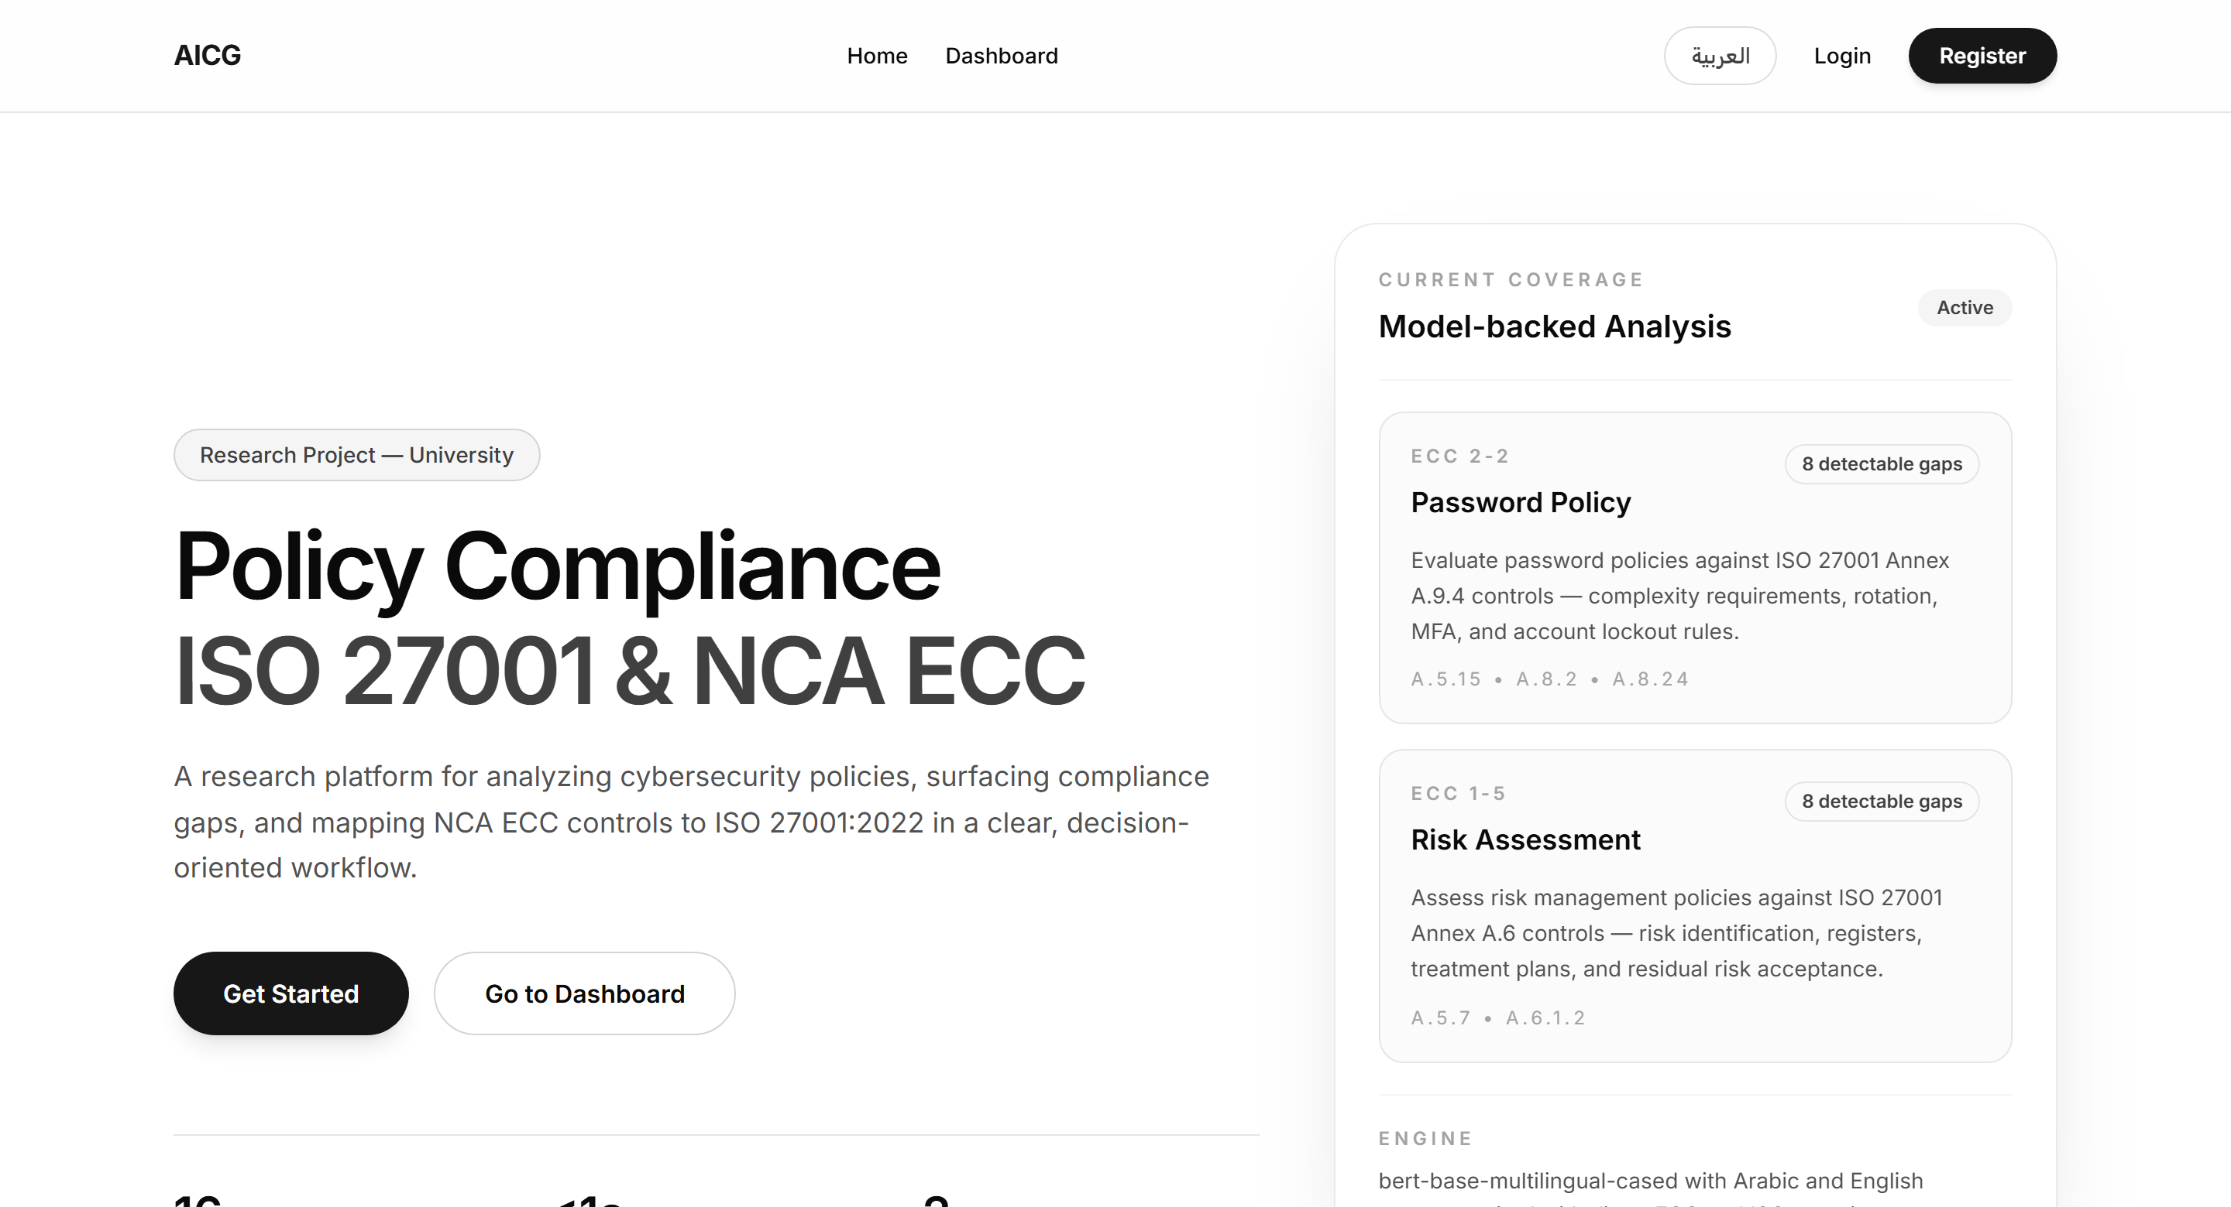
Figure 3.13: Landing Page
The landing page displays the platform overview, supported policy domains, NCA ECC ↔ ISO 27001 mapping logic, workflow steps, and technology stack.

Figure 3.14: Sign In / Sign Up
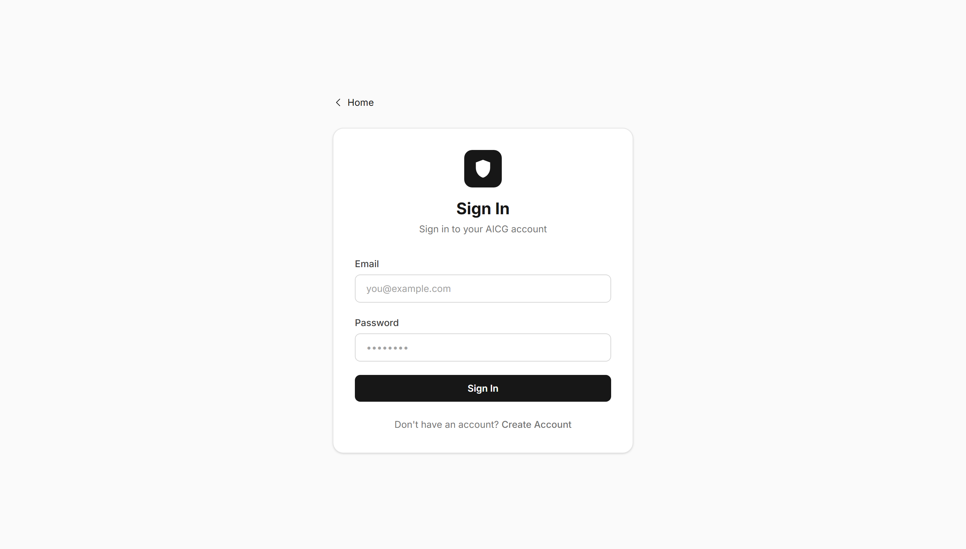
Figure 3.14: Sign In / Sign Up
Users authenticate via email and password. The page includes form validation and success confirmation messages.

Figure 3.15: Dashboard Overview
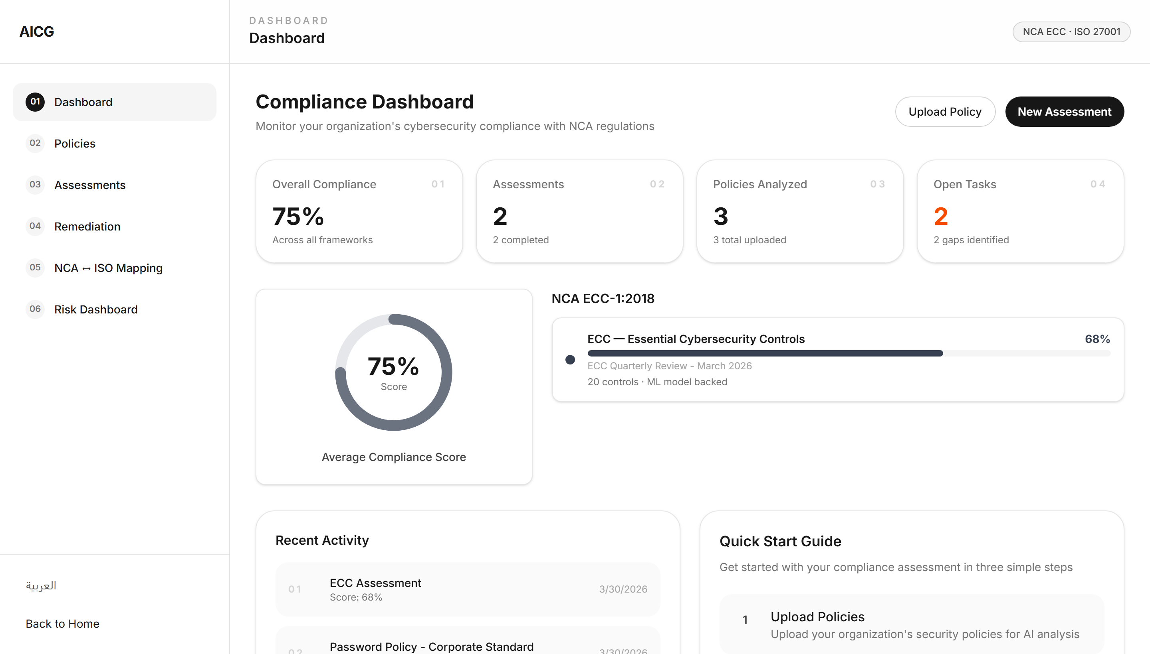
Figure 3.15: Dashboard Overview
The main dashboard shows KPI cards (compliance score, policies analyzed, open tasks, assessments), a compliance gauge, recent activity, and quick start actions.

Figure 3.16: Policy Upload & Analysis
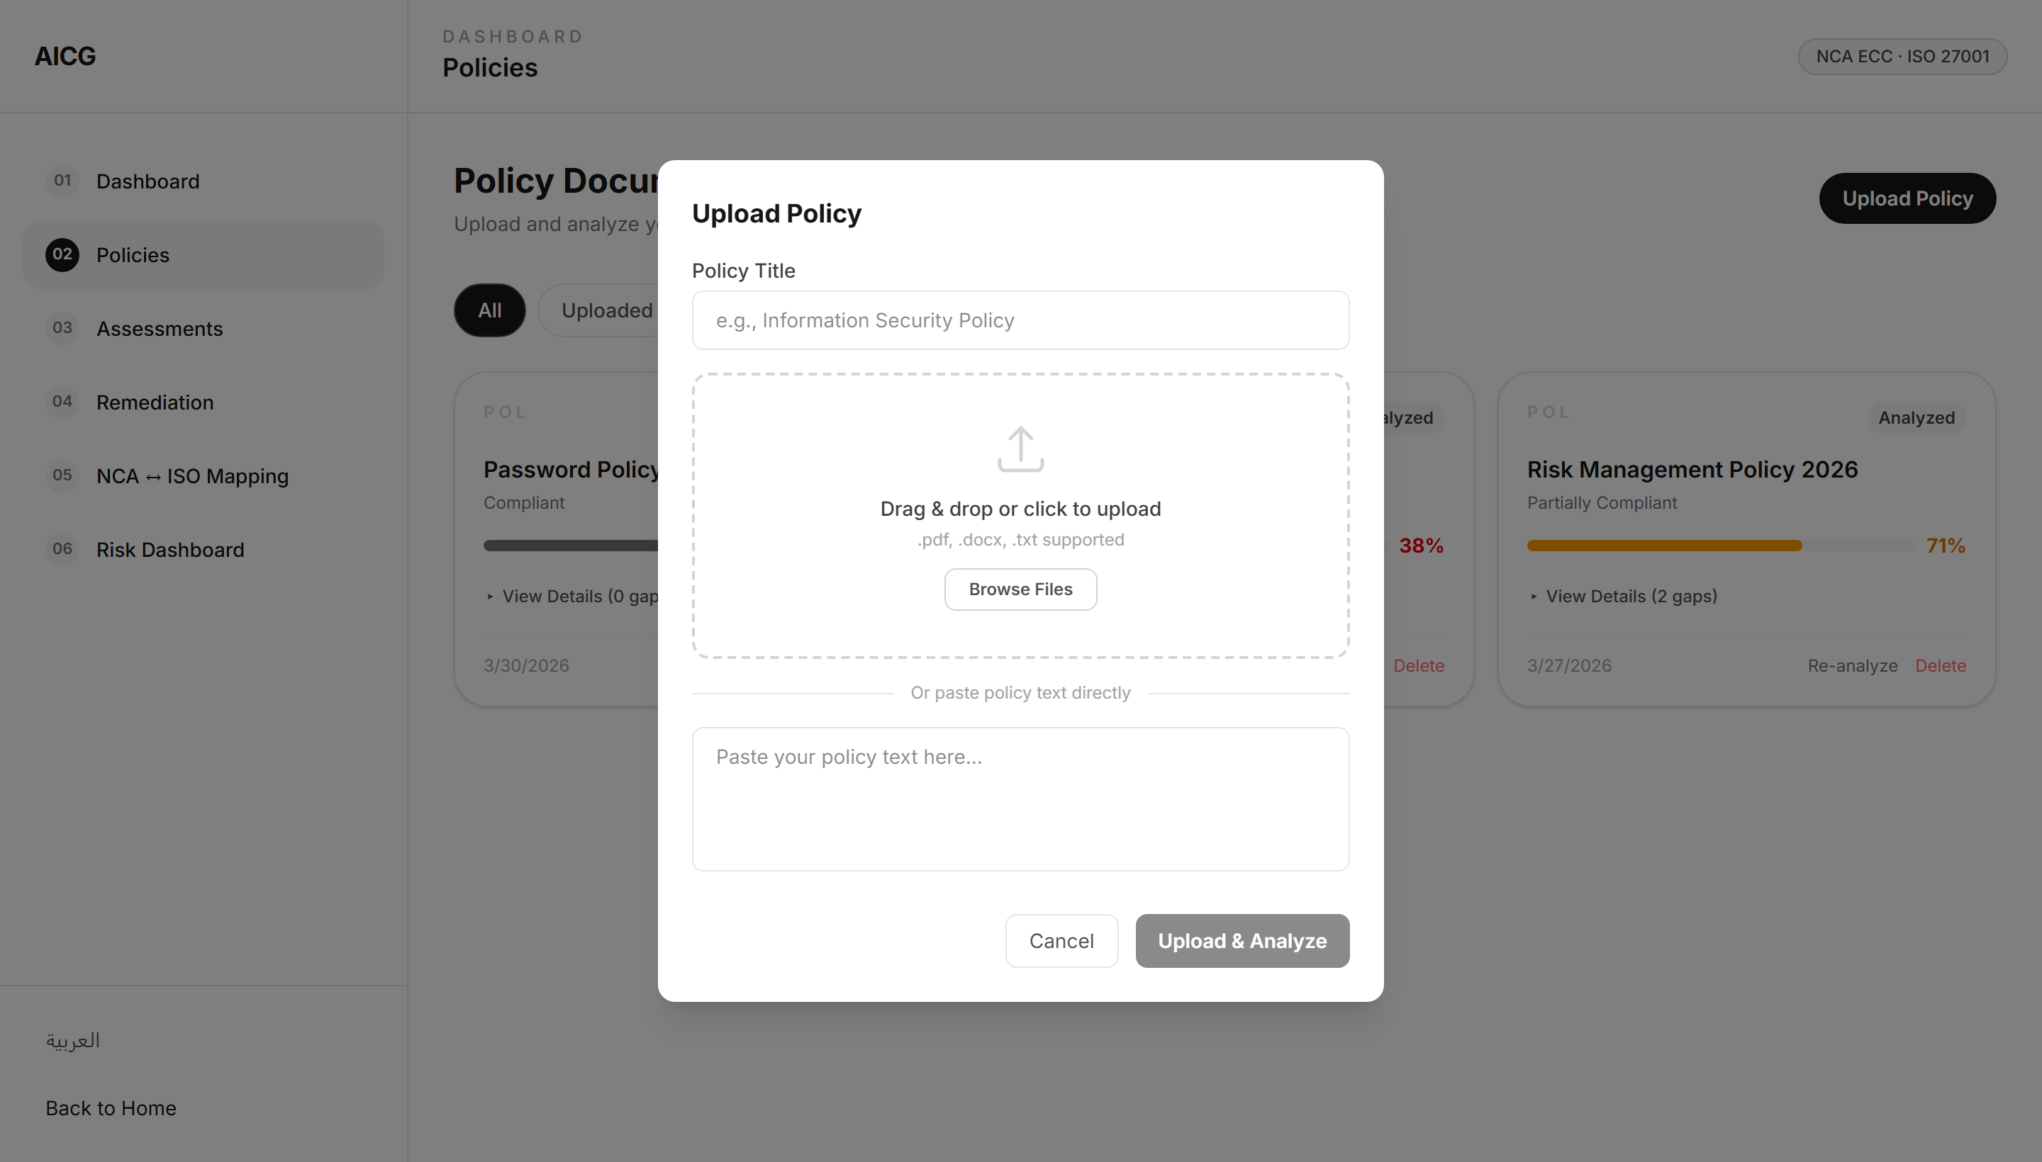
Figure 3.16: Policy Upload & Analysis
Users upload policy documents (PDF, DOCX, TXT) via drag-and-drop. The system triggers AI analysis and displays results.

Figure 3.17: Analysis Result — Compliant Document
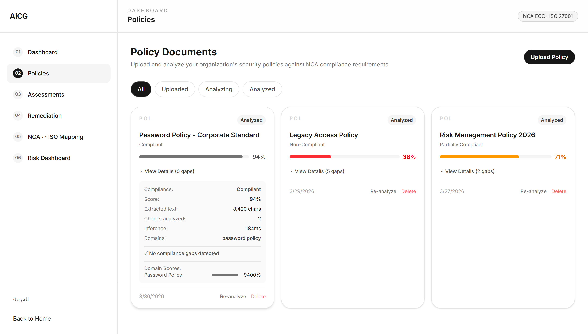
Figure 3.17: Analysis Result — Compliant Document
When a well-structured policy is analyzed, the system shows a high compliance score with few or no gaps detected, along with confidence levels per domain.

Figure 3.18: Analysis Result — Non-Compliant Document
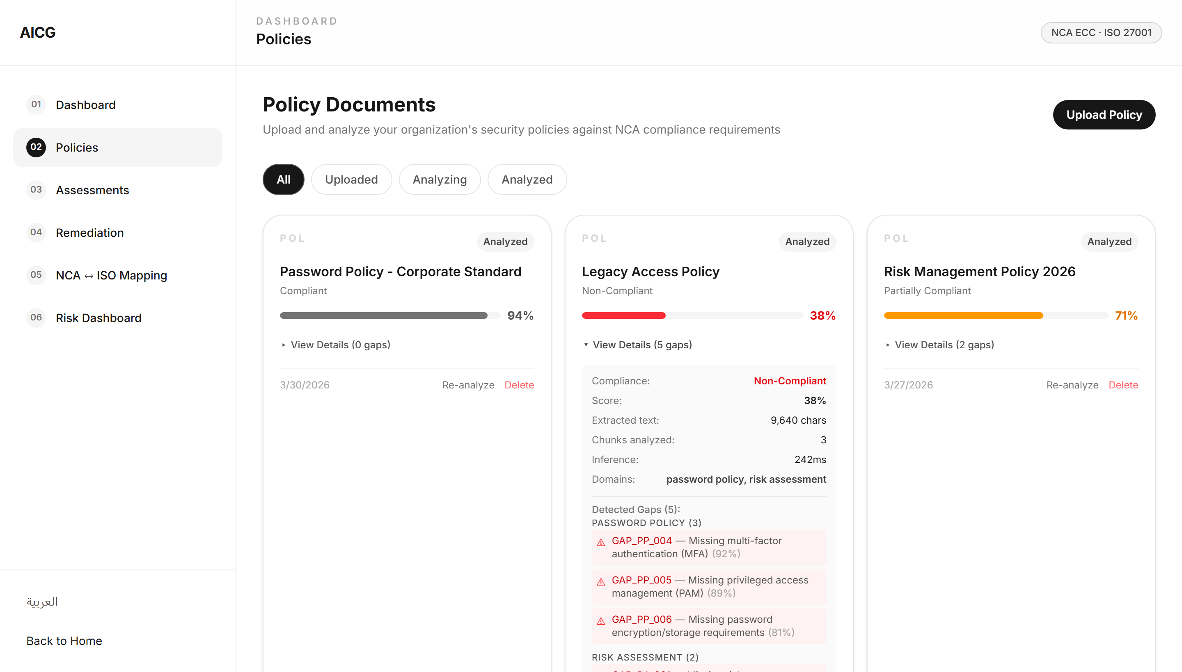
Figure 3.18: Analysis Result — Non-Compliant Document
When a weak policy is analyzed, the system displays a low compliance score with multiple gaps identified, each showing gap ID, description, and confidence.

Figure 3.19: Assessments Page
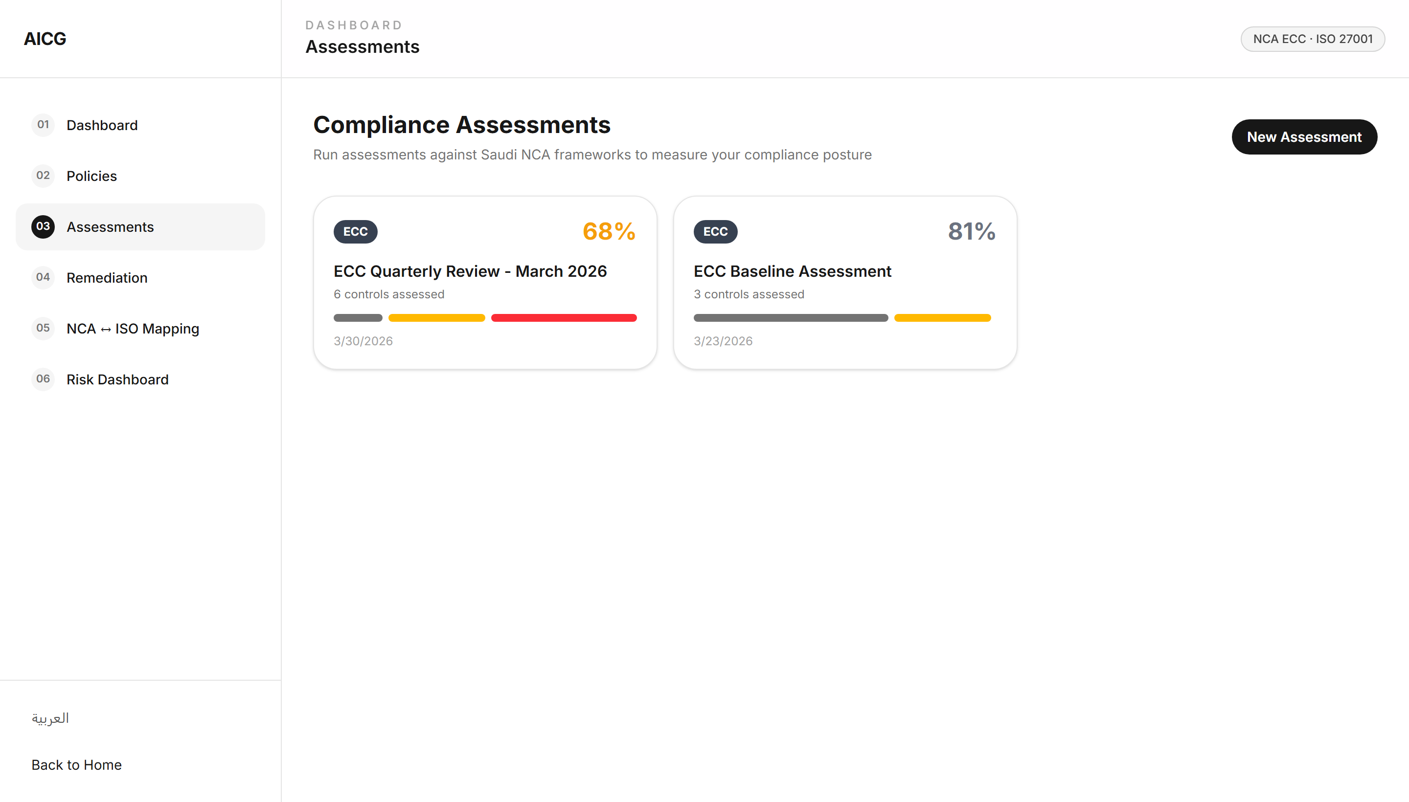
Figure 3.19: Assessments Page
Users create and manage NCA ECC and ISO 27001 assessments with control-by-control evaluation, evidence upload, and comment threads.

Figure 3.20: Remediation Tasks
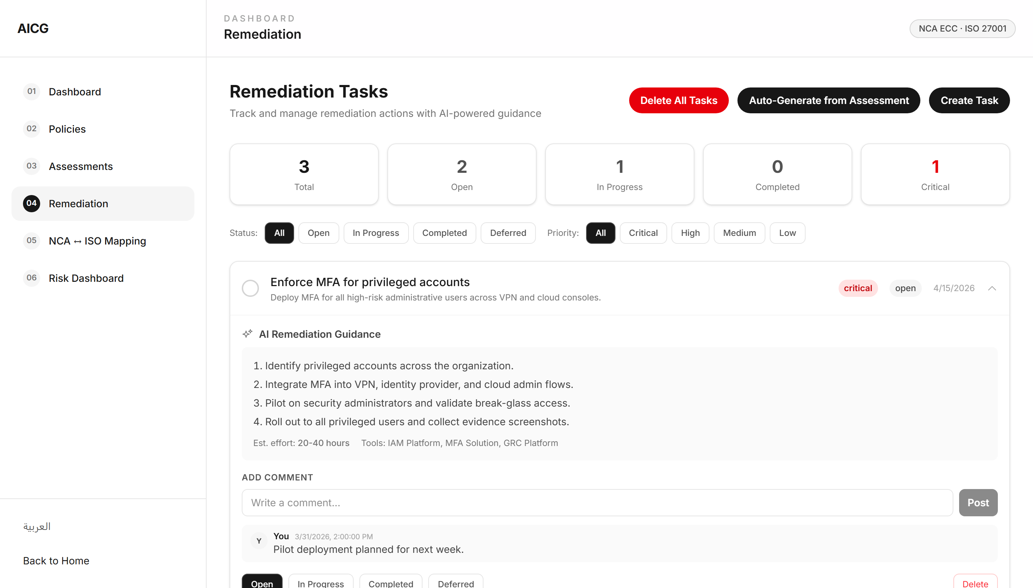
Figure 3.20: Remediation Tasks
Tracks remediation tasks generated from detected gaps with priority levels, status tracking, AI guidance, and comment threads.

Figure 3.21: Framework Comparison
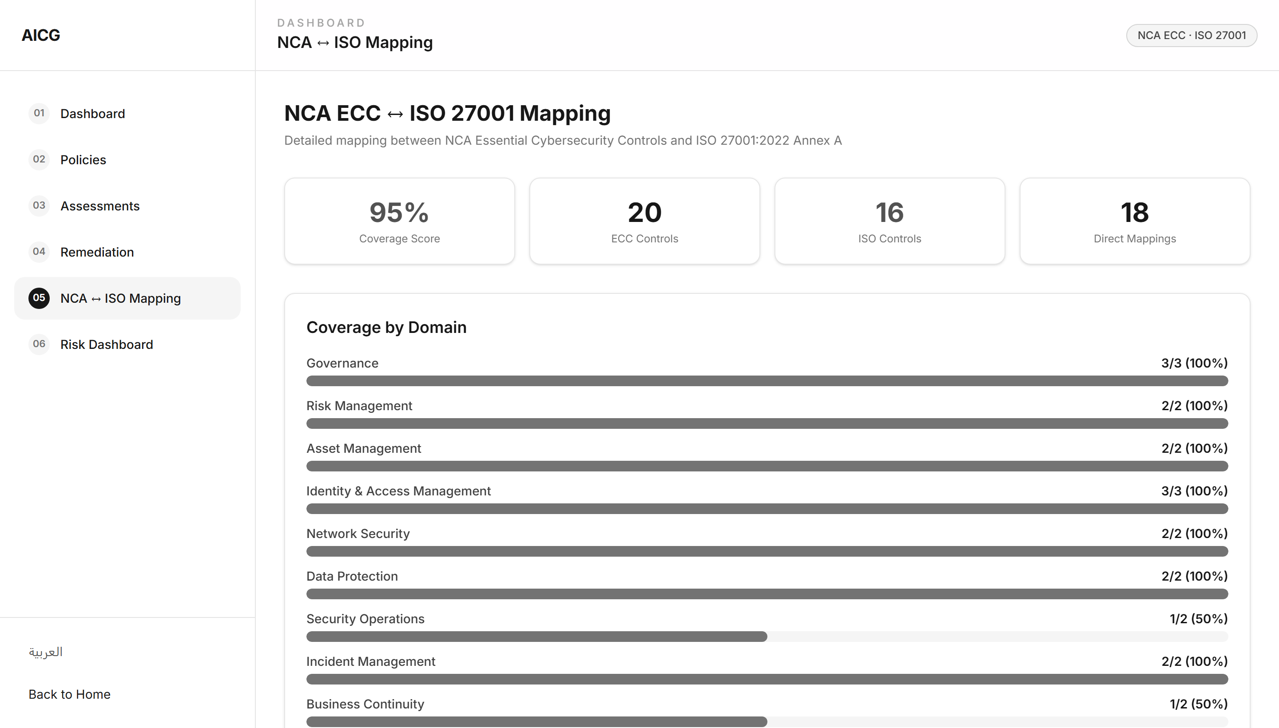
Figure 3.21: Framework Comparison
Displays the ECC ↔ ISO 27001 control mapping, showing how NCA ECC domains map to ISO 27001 clauses and Annex A controls.

Figure 3.22: Risk Dashboard
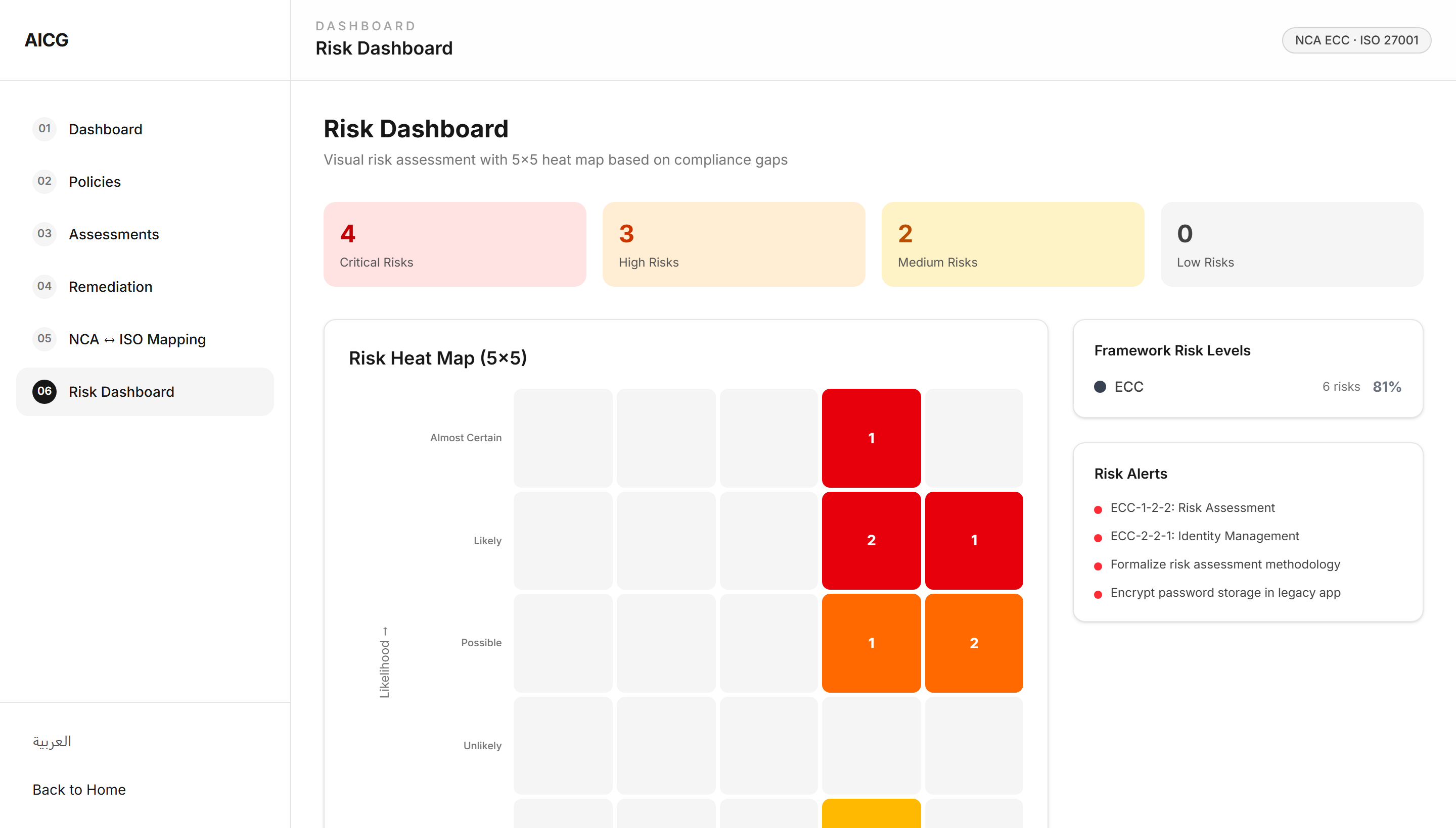
Figure 3.22: Risk Dashboard
Visualizes risk metrics including risk scores, assessment status, and compliance posture across different domains.

Figure 3.23: Arabic RTL Interface
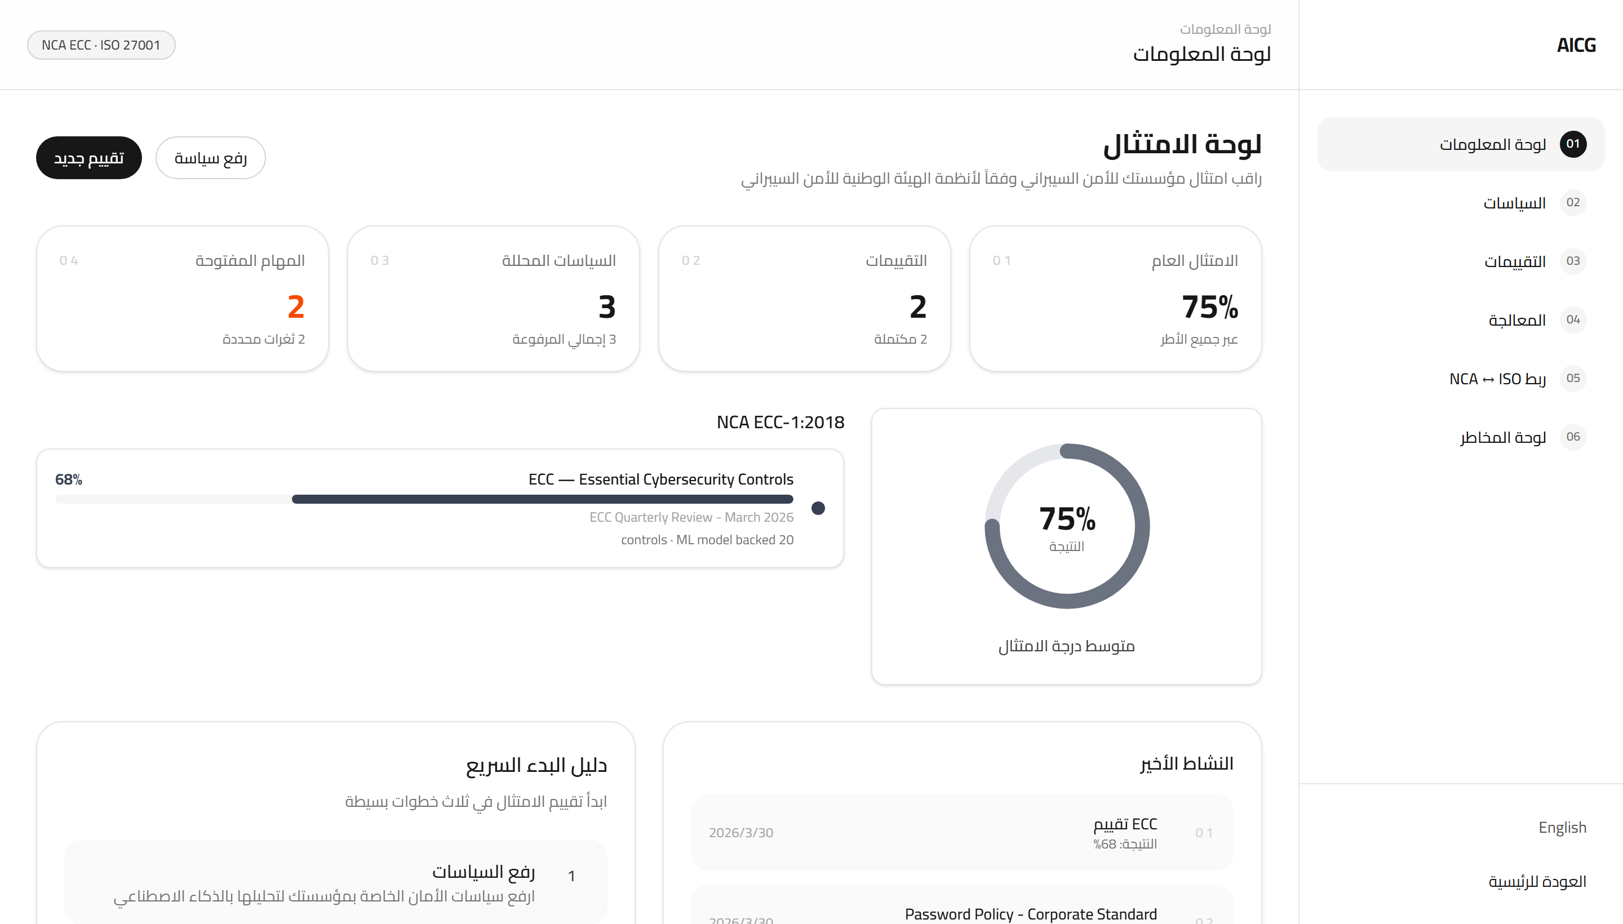
Figure 3.23: Arabic RTL Interface
The same interface in Arabic with proper right-to-left layout, translated navigation, labels, and compliance terminology.

3.6 Security & Privacy Threat Modeling

3.6.1 Security Controls Implemented
- Supabase Auth with JWT session tokens and automatic refresh
- Row-Level Security (RLS) on all 8 database tables
- Per-user data isolation (users access only their own records)
- Optional API Key authentication for backend endpoints
- HTTPS/TLS encryption in transit; Supabase encryption at rest
- Storage bucket policies restrict file access to owner folder
- Input validation: text limited to 50,000 characters, file types restricted

3.6.2 STRIDE Model Analysis
Table 3.11: STRIDE Threat Model & Mitigations
Threat Category | Example in System | Mitigation
Spoofing | Fake admin login to alter reports | Supabase Auth with JWT, route guards
Tampering | Unauthorized alteration of compliance data | RLS policies, JSONB integrity, HTTPS
Repudiation | User denies submitting a document | classification_history audit logs with timestamps
Information Disclosure | Leak of SME compliance reports | RLS isolation, CORS config, encrypted transport
Denial of Service | API overload by malicious actor | Cloud Run auto-scaling, input size limits
Elevation of Privilege | User gains admin rights | RLS per-user policies, no admin escalation path

3.6.3 Threat Model and Risk Analysis
Table 3.10: Threat Model and Security Controls
Threat | Scenario | CIA Scores | Risk Level | Mitigation
Data Breaches | API/DB exploit to exfiltrate data | C:10 I:8 A:6 = 8 | High | Data encryption, RBAC, audit logs
Unauthorized Access | Stolen/weak credentials | C:9 I:9 A:7 = 8.3 | High | Supabase Auth, secure sessions
Data Corruption | Ransomware alters stored data | C:9 I:10 A:8 = 9 | High | Automated backups, SHA-256 checksums
Denial of Service | API overload | C:2 I:3 A:10 = 5 | Medium | Rate limiting, Cloud Run scaling
Privacy Leakage | Reports expose PII | C:4 I:3 A:2 = 3 | Low | Data minimization, masking

4 Testing and Evaluation

4.1 Model Testing
The model was tested using representative policy samples covering different compliance levels and languages.
Test Case | Input | Expected Result | Status
Compliant PP (EN) | Strong password policy with all controls | Low gap detection, high score | Pass
Weak PP (EN) | Minimal policy missing MFA/PAM | Multiple gaps (PP_004, PP_005) | Pass
Arabic Policy | Arabic password policy text | Correct domain detection + gaps | Pass
Risk Assessment | Risk management policy | RA domain detected, relevant gaps | Pass
Empty/Short Text | Minimal input | Graceful handling, no crash | Pass
Long Document | 50,000 char document | Chunking + max-pool aggregation | Pass

4.2 API Testing
The API was tested at three levels:
- test_local.py — Offline model inference (4 test cases)
- test_api.py — Local server endpoint tests
- test_deployed_api.py — Cloud Run deployment verification
Test | Endpoint | Expected | Result
Health Check | GET /health | 200 OK, model_loaded=true | Pass
Metadata | GET / | 200 OK, version info | Pass
Analyze (valid) | POST /analyze | 200, gap results | Pass
Analyze (empty) | POST /analyze | 422 Validation Error | Pass
Analyze (too long) | POST /analyze | 422, text > 50K | Pass
Invalid endpoint | GET /invalid | 404 Not Found | Pass

4.3 Performance Metrics
- Model inference time: <500 ms per document (CPU)
- API response time: <1 second end-to-end
- Cold start: ~30–60 seconds (model download from GCS)
- Warm inference: consistent sub-second on subsequent requests
- Document support: up to 50,000 characters per request

4.4 Compliance Score Validation
The AI model’s compliance scoring was validated by analyzing documents with known compliance levels. Below are results showing the percentage scores generated by the system for compliant and non-compliant documents.

Figure 4.1: Analysis Result — Compliant Document (High Score)
The above shows the system’s analysis of a well-structured policy that meets most NCA ECC requirements, resulting in a high compliance percentage.

Figure 4.2: Analysis Result — Non-Compliant Document (Low Score)
The above shows the system’s analysis of a weak policy with multiple gaps, resulting in a low compliance percentage with specific gap identifications.

4.5 Usability Evaluation
Criterion | Status | Notes
Bilingual Support | ✓ Implemented | Full AR/EN with RTL, ~1000+ strings
Responsive Design | ✓ Implemented | Mobile-first with collapsible sidebar
File Upload | ✓ Implemented | PDF, DOCX, TXT with drag-and-drop
Real-time Feedback | ✓ Implemented | Loading states, progress indicators
Error Handling | ✓ Implemented | Validation, graceful error messages

5 Conclusion

5.1 Summary of Achievements in Graduation Project 2
Graduation Project 2 successfully transitioned the AICG platform from conceptual design to a fully implemented and deployed system:
- Custom bilingual dataset of 260 samples (130 EN + 130 AR) with 16 gap labels
- Fine-tuned mBERT model with multi-label classification achieving sub-second inference
- FastAPI backend with document chunking deployed on Google Cloud Run
- Full-featured React/TypeScript web application with bilingual support
- Supabase PostgreSQL database with RLS and 8 tables
- End-to-end integration: upload → extraction → analysis → scoring → remediation

5.2 Key Findings
- Multi-label gap detection provides more actionable insights than single-label classification.
- Document chunking with max-pool aggregation handles long texts within BERT’s 512-token limit.
- mBERT provides native multilingual capability without separate language models.
- Severity-weighted scoring offers more nuanced assessment than binary pass/fail.

5.3 Challenges Encountered
- Dataset Scarcity: No public NCA ECC datasets exist; synthetic generation was necessary.
- Arabic NLP: Formal Arabic regulatory language required specialized normalization.
- Model Size: mBERT (~681 MB) requires Docker optimization for Cloud Run.
- Cold Start: Initial model loading takes 30–60 s; mitigated by keep-alive.

5.4 Lessons Learned
- Sigmoid multi-label classification is better suited for gap detection than softmax multi-class.
- Synthetic dataset generation with LLMs can bootstrap domain-specific ML.
- Cloud Run provides cost-effective serverless deployment for bursty ML inference.
- Row-Level Security simplifies multi-tenant isolation without app-layer logic.

5.5 Future Work
- Expand to additional ECC domains: Network Security, Data Protection, Incident Response, Business Continuity
- Integrate Gemini 2.5 Pro for AI-generated remediation guidance
- Add scheduled assessment automation with periodic re-analysis
- Implement PDF report generation for audit-ready documentation
- Expand training dataset to 1,000+ real-world policy samples

5.6 Final Summary
The AICG demonstrates that NLP and multi-label classification can effectively automate cybersecurity compliance gap detection for Saudi SMEs. The platform reduces manual audit time from weeks to minutes while providing specific, actionable gap identification mapped to both NCA ECC and ISO 27001 frameworks. The bilingual design and cloud-native deployment make it accessible to a wide range of Saudi organizations, supporting the Kingdom’s Vision 2030 goals for digital transformation and cybersecurity resilience.

References
[1] Y. Li and Q. Liu. (2021) A comprehensive review study of cyberattacks and cyber security. Energy Rep.
[2] S. AlDaajeh et al. (2022) The role of national cybersecurity strategies on the improvement of cybersecurity education. Comput. Secur.
[3] National Cybersecurity Authority (NCA). (2018) Essential cybersecurity controls (ECC-1:2018). NCA Portal.
[4] M. M. Alshammari and Y. H. Al-Mamary. (2025) Building trust and cybersecurity awareness in Saudi Arabia. Systems.
[5] R. Alzahrani. (2024) An overview of AI data protection in the context of Saudi Arabia. IJSR.
[6] A. Folorunso et al. (2024) Security compliance and its implication for cybersecurity. WJARR.
[7] M. F. Almoaigel and A. Abuabid. (2023) Implementation of cybersecurity situation awareness model in Saudi SMEs. IJACSA.
[8] N. Rawindaran et al. (2023) Enhancing cyber security governance and policy for SMEs in Industry 5.0. Digital.
[9] A. Alotaibi et al. (2021) The impact of cybersecurity practices on cyberattack damage in small enterprises in Saudi Arabia. ResearchGate.
[10] S. Perera et al. (2022) Factors affecting reputational damage to organisations due to cyberattacks. Informatics.
[11] L. Alevizos and V. Ta. (2024) Automated cybersecurity compliance and threat response using AI, blockchain & smart contracts. arXiv.
[12] National Cybersecurity Authority (NCA). (2024) Essential cybersecurity controls (ECC-2:2024). NCA Portal.
[13] NCA. (2018) Guide to ECC implementation. NCA Portal.
[14] H. Guo et al. (2020) Deep semantic compliance advisor for unstructured document compliance checking. IJCAI.
[15] J. Zhang and N. El-Gohary. (2015) Semantic NLP-based information extraction for automated compliance checking. ASCE J. Comp. Civil Eng.
[16] Jain et al. (2025) AI/NLP's role in regulatory compliance. ACL Findings.
[17] Buddhadev et al. (2025) Automated compliance checking of unstructured data using LLMs and LangChain. MMEP.
[18] H. Pappil Kothandapani and Hariharan. (2025) AI-driven regulatory compliance: Transforming financial oversight through LLMs. Figshare.
[19] J. Viracacha Peña. (2024) Artificial intelligence in RegTech: Transforming automated compliance audits. SSRN.
[20] A. Alfaadhel et al. (2023) RC2AS: Risk-based cybersecurity compliance assessment system. Applied Sciences.
[21] Rawindaran et al. (2023) Enhancing cyber security governance for SMEs: Saudi Arabia vs UK. Digital.
[22] S. Alarifi. (2023) Small and medium businesses readiness towards cyberattacks in Saudi Arabia. GER.
[23] IJACSA. (2023) Implementation of cybersecurity situation awareness model in Saudi SMEs.
[24] F. Abudaqqa. (2025) AI for IT governance in Saudi Arabia. European Scientific Journal.
[25] R. Alzahrani. (2024) An overview of AI data protection in Saudi Arabia. IJSR.
[26] M. M. Alshammari and Y. H. Al-Mamary. (2025) Building trust and cybersecurity awareness in Saudi Arabia. Systems.
[27] Folorunso et al. (2024) Compliance conformance and firm cybersecurity performance. WJARR.
[28] L. Rodríguez Valencia et al. (2025) Systematic review of AI applied to compliance. JRFM.
[29] Amaral et al. (2022) NLP-based automated compliance checking against GDPR. arXiv.

