PolicyShield
AI-Powered ISO 27001 & NCA ECC-2:2024
Compliance Gap Detection System

College of Computing — Umm Al-Qura University
Department of Cybersecurity
2025

Table of Contents
1. Executive Summary
2. Project Overview
3. System Architecture
4. ML Pipeline Design
5. Model Architecture
6. Dataset Generation
7. API Design
8. Database Schema
9. Frontend Application
10. Gap Detection Framework
11. Deployment Architecture
12. Security Considerations
13. System Design Diagrams
14. Technology Stack
15. Future Improvements

1. Executive Summary
PolicyShield is an AI-powered compliance gap detection system designed to help organizations assess their security policies against the Saudi National Cybersecurity Authority (NCA) Essential Cybersecurity Controls (ECC-2:2024) and ISO 27001:2022 standards. The system uses a fine-tuned multilingual BERT (mBERT) model to automatically identify 16 specific compliance gaps across two critical security domains: Password Policy and Risk Assessment.
The platform provides a complete compliance management workflow — from uploading and classifying policy documents through AI-powered gap detection, to generating remediation tasks with contextual guidance, and producing comprehensive compliance reports. The system supports both English and Arabic languages, making it particularly suited for organizations operating in the Gulf region.

Key Capabilities
- Automated detection of 16 compliance gaps using multi-label classification
- Support for both English and Arabic policy documents (bilingual mBERT)
- Real-time inference via REST API (100–500ms per document)
- Severity-weighted compliance scoring aligned with NCA ECC-2:2024
- Automated remediation task generation with AI guidance
- Interactive compliance dashboard with drill-down analytics
- Evidence management with file upload and preview
- Comprehensive reporting and export capabilities

2. Project Overview

2.1 Problem Statement
Organizations in Saudi Arabia are required to comply with the NCA ECC-2:2024 framework, which mandates comprehensive cybersecurity controls. Manually reviewing policy documents against these controls is time-consuming, error-prone, and requires specialized expertise. PolicyShield automates this process by using natural language processing to identify specific gaps in security policy documents.

2.2 Objectives
- Develop an AI model capable of detecting 16 specific compliance gaps in policy documents
- Build a production-ready REST API for real-time policy analysis
- Create an intuitive web dashboard for compliance management workflows
- Support bilingual (English/Arabic) document analysis
- Map detected gaps to NCA ECC-2:2024 controls for actionable remediations
- Provide severity-weighted scoring for prioritized gap resolution

2.3 Scope
Dimension | Coverage
Regulatory Framework | NCA ECC-2:2024 / ISO 27001:2022
Policy Domains | Password Policy (ECC 2-2), Risk Assessment (ECC 1-5)
Languages | English, Arabic
Gap Count | 16 (8 per domain)
NCA Controls Mapped | 20 ECC controls
Deployment | Google Cloud Run (me-central1, Doha)

3. System Architecture

3.1 High-Level Architecture
PolicyShield follows a modern three-tier architecture with clear separation of concerns:
1) Presentation Layer — React 19 + TypeScript SPA with TailwindCSS, providing an interactive compliance dashboard with bilingual support.
2) Application Layer — FastAPI REST API deployed on Google Cloud Run, hosting the mBERT inference engine with auto-scaling capabilities.
3) Data Layer — Supabase (PostgreSQL) for persistent storage with Row-Level Security, Supabase Storage for file management, and Google Cloud Storage for model artifacts.

3.2 Component Overview
Component | Technology | Responsibility
Frontend SPA | React 19, TypeScript 5.9, Vite | User interface, data visualization, workflow management
API Gateway | FastAPI + Uvicorn | Model inference, document analysis, health monitoring
ML Model | mBERT (110M params) | Multi-label gap detection (16 sigmoid outputs)
Database | Supabase (PostgreSQL) | Policies, assessments, tasks, reports, user profiles
File Storage | Supabase Storage | Policy files, evidence documents (with signed URLs)
Model Storage | Google Cloud Storage | Model weights (SafeTensors), tokenizer files
Container Runtime | Google Cloud Run | Auto-scaling serverless container (me-central1)
Authentication | Supabase Auth | Email/password sign-in with JWT tokens

3.3 Data Flow
The primary data flow for policy analysis follows these steps:
1. User uploads a policy document (PDF/DOCX/TXT) through the web dashboard.
2. Document text is extracted and sent to the FastAPI /analyze endpoint.
3. The API chunks the document into ~350-word segments with 50-word overlap.
4. Each chunk is tokenized (max 512 tokens) and passed through the mBERT model.
5. Per-chunk predictions are aggregated via max-pooling across all 16 gap labels.
6. Probabilities exceeding the threshold (default 0.6) are flagged as detected gaps.
7. A severity-weighted compliance score is computed per domain and overall.
8. Results are returned to the frontend and persisted in Supabase.
9. The dashboard maps gaps to NCA ECC controls and generates remediation tasks.

4. ML Pipeline Design

4.1 Pipeline Overview
The machine learning pipeline consists of five stages: Dataset Generation, Data Preprocessing, Model Training, Model Export, and Deployment. Each stage is implemented as a standalone Python script for reproducibility.
Stage | Tool / Framework | Output
Dataset Generation | Google Gemini 2.5 Flash API | Synthetic policy documents (JSON/CSV/JSONL)
Data Preprocessing | Pandas, NumPy, HuggingFace Tokenizer | Multi-hot vectors (N×16), tokenized sequences
Model Training | HuggingFace Trainer, PyTorch | mBERT + classifier head checkpoints
Model Export | SafeTensors | model.safetensors (~681 MB) + tokenizer files
Deployment | Docker, Google Cloud Run | FastAPI container with GCS model download

4.2 Dataset Generation
The training dataset is synthetically generated using Google Gemini 2.5 Flash. Each sample consists of a realistic policy excerpt and a set of compliance gap labels. A two-pass verification approach ensures label quality: the first pass generates the policy text with intended gaps, and the second pass independently verifies each gap label.
The generator supports 14 sample profiles covering four compliance levels (Compliant, Partially Compliant, Non-Compliant, Critical), two languages (English, Arabic), 12 industries, and 5 company sizes. Output is saved in JSON, CSV, and incremental JSONL formats for flexibility.

4.3 Data Preprocessing
Each sample is converted to a 16-dimensional binary vector (multi-hot encoding) representing the presence or absence of each gap. The text is tokenized using the bert-base-multilingual-cased tokenizer with a maximum sequence length of 512 tokens. Documents exceeding this limit are split into overlapping chunks (~350 words with ~50-word overlap) and predictions are aggregated via max-pooling.

4.4 Training Configuration
Parameter | Value
Optimizer | AdamW
Learning Rate | 2e-5 (with warmup)
Batch Size | 8–16
Epochs | Variable (early stopping)
Loss Function | BCEWithLogitsLoss (multi-label)
Weight Decay | 0.01
Warmup Steps | 10% of total
Gradient Clipping | 1.0
Framework | HuggingFace Transformers Trainer

4.5 Evaluation Metrics
Metric | Description | Relevance
Hamming Loss | Fraction of incorrectly predicted labels | Primary — penalizes each wrong gap label
Subset Accuracy | Exact match of all 16 labels | Strict — all gaps must match exactly
Micro F1 | F1 averaged over all label predictions | Balances precision/recall across all gaps
Macro F1 | F1 averaged per-label then averaged | Ensures rare gaps are not ignored
Per-gap Precision | Correct detections / total predictions | Avoids false positives per gap
Per-gap Recall | Correct detections / actual gaps | Avoids missing real gaps
AUC-ROC | Area under ROC curve per gap | Threshold-independent performance

4.6 Business Metrics
Metric | Target
Overall compliance accuracy | ≥ 85%
Critical gap recall | ≥ 90%
Inference latency (p95) | < 500ms
False positive rate | < 15%

5. Model Architecture

5.1 GapDetectionModel
The production model (v2.0) is a custom PyTorch module built on top of the bert-base-multilingual-cased backbone. It uses a two-layer classification head with dropout regularization to produce 16 independent probability outputs.
Architecture: mBERT backbone (12 layers, 12 attention heads, 768 hidden dim) → [CLS] token embedding (768-dim) → Linear(768→256) → ReLU → Dropout(0.3) → Linear(256→16) → Sigmoid. Each output represents the probability of a specific compliance gap being present in the document.

5.2 Model Specifications
Property | Value
Base Model | bert-base-multilingual-cased
Task | Multi-label binary classification
Number of Labels | 16
Hidden Size | 768
Attention Heads | 12
Transformer Layers | 12
Vocabulary Size | 119,547 (multilingual WordPiece)
Classifier Dropout | 0.3
Activation Functions | ReLU (hidden), Sigmoid (output)
Total Parameters | ~110M (backbone) + ~200K (classifier head)
Model Size | ~681 MB (SafeTensors format)
Max Input Tokens | 512

5.3 Why mBERT?
Requirement | mBERT Capability
Bilingual (Arabic + English) | Pre-trained on 104 languages including Arabic
Domain Understanding | Strong contextual encoding of security policy language
Sequence Classification | CLS token pooling well-suited for document-level labels
Deployment Constraints | ~110M params fits in Cloud Run CPU instances

5.4 Model Evolution
Aspect | v1.0 (Legacy) | v2.0 (Production)
Task | 3-class classification | 16-label multi-label
Labels | Fully / Partially / Non-Compliant | 16 specific gap IDs
Architecture | BertForSequenceClassification | Custom GapDetectionModel
Loss | CrossEntropyLoss | BCEWithLogitsLoss
Output | Softmax (3 probs) | Sigmoid (16 probs)
Granularity | Document-level only | Per-gap, per-domain
Actionability | Low (just a label) | High (specific gaps to fix)

6. Dataset Generation

6.1 Generation Process
The training dataset is generated using Google Gemini 2.5 Flash via the google-genai Python SDK. Each sample undergoes a two-step process: (1) Prompt Gemini to generate a realistic policy excerpt based on domain, compliance profile, language, industry, and company size parameters; (2) Prompt Gemini to independently verify each gap label with binary confirmation.

6.2 Gap Definitions — Password Policy (ECC 2-2)
Gap ID | Description | Severity
GAP_PP_001 | Weak password complexity requirements | High (3)
GAP_PP_002 | Inadequate password expiration policy | Medium (2)
GAP_PP_003 | Weak account lockout policy | Medium (2)
GAP_PP_004 | Missing Multi-Factor Authentication (MFA) | Critical (4)
GAP_PP_005 | Missing Privileged Access Management (PAM) | Critical (4)
GAP_PP_006 | Missing password encryption/storage requirements | High (3)
GAP_PP_007 | Missing periodic review schedule | Medium (2)
GAP_PP_008 | Missing or vague roles and responsibilities | Medium (2)

6.3 Gap Definitions — Risk Assessment (ECC 1-5)
Gap ID | Description | Severity
GAP_RA_001 | Missing documented risk methodology | Critical (4)
GAP_RA_002 | Missing risk identification procedures | High (3)
GAP_RA_003 | Missing likelihood/impact assessment scales | High (3)
GAP_RA_004 | Missing risk treatment options | High (3)
GAP_RA_005 | Missing mandatory risk assessment triggers | Critical (4)
GAP_RA_006 | Missing risk register requirements | Medium (2)
GAP_RA_007 | Missing periodic review schedule | Medium (2)
GAP_RA_008 | Missing integration with project management | Medium (2)

6.4 Compliance Scoring Formula
The compliance score is severity-weighted using the formula:
score = 1 − (Σ w_g for detected gaps) / (Σ w_g for all gaps)
Where w_g is the severity weight (2–4) of gap g.
Classification thresholds:
• Fully Compliant: score ≥ 0.9 (and 0 gaps detected)
• Partially Compliant: 0.5 ≤ score < 0.9
• Non-Compliant: score < 0.5

6.5 Dataset Variation Dimensions
Dimension | Values
Languages | English, Arabic
Industries | 12 (Finance, Healthcare, Government, Telecom, Energy, etc.)
Company Sizes | 5 (Startup, SME, Medium, Large Enterprise, Government Agency)
Compliance Profiles | 4 (Compliant, Partially Compliant, Non-Compliant, Critical)

Dataset Collection Methodology

Overview
The training dataset was generated programmatically using Google Gemini 2.0 Flash API, a large language model capable of producing realistic, domain-specific policy text. The generation process was designed to create diverse, labeled policy excerpts that simulate real-world organizational security policy documents in both Arabic and English.

Generation Pipeline
The dataset generation follows a structured pipeline built in the generate_compliance_dataset.py script:
- Step 1 — Gap Definition: 16 compliance gaps were formally defined, each mapped to NCA ECC-2:2024 and ISO 27001:2022 controls. Each gap includes a description, severity weight (2–4), compliant criteria, and non-compliant examples.
- Step 2 — Sample Profile Design: 13 distinct sample profiles were created spanning four compliance tiers: Compliant (0 gaps, ~25%), Minor partial compliance (1–2 gaps, ~20%), Moderate partial compliance (3–5 gaps, ~20%), Severe non-compliance (6+ gaps, ~20%), and Critical non-compliance (12–16 gaps, ~15%). Each profile specifies which domain(s) to cover and the gap count range.
- Step 3 — Prompt Engineering: For each sample, a detailed prompt is constructed that instructs Gemini to generate a realistic policy excerpt of 200–400 words. The prompt specifies which gaps to include, the language (English or Arabic), the compliance level, and domain context. The prompt is carefully designed to avoid mentioning gap IDs in the generated text, ensuring the model learns from policy content rather than labels.
- Step 4 — API Call and Response Parsing: The Gemini API is called with structured output format (JSON), receiving the policy text along with 16 binary gap labels, a compliance score (0.0–1.0), and the compliance level. Rate limiting and retry logic handle API quota constraints (15 RPM for Gemini 2.0 Flash free tier).
- Step 5 — Validation and Storage: Each generated sample is validated for correct JSON structure, gap label completeness (all 16 labels present), and language consistency. Valid samples are saved in CSV, JSON, and JSONL formats for flexibility.

Dataset Statistics
The final dataset contains 260 labeled samples with the following distribution:
Metric | Value
Total Samples | 260
English Samples | 130 (50%)
Arabic Samples | 130 (50%)
Compliant Samples | 48 (18.5%)
Partially Compliant Samples | 92 (35.4%)
Non-Compliant Samples | 120 (46.2%)
Average Gaps per Sample | 5.05
Average Compliance Score | 0.68
Password Policy Only | 89 samples
Risk Assessment Only | 79 samples
Both Domains | 92 samples

Figure: Compliance Distribution
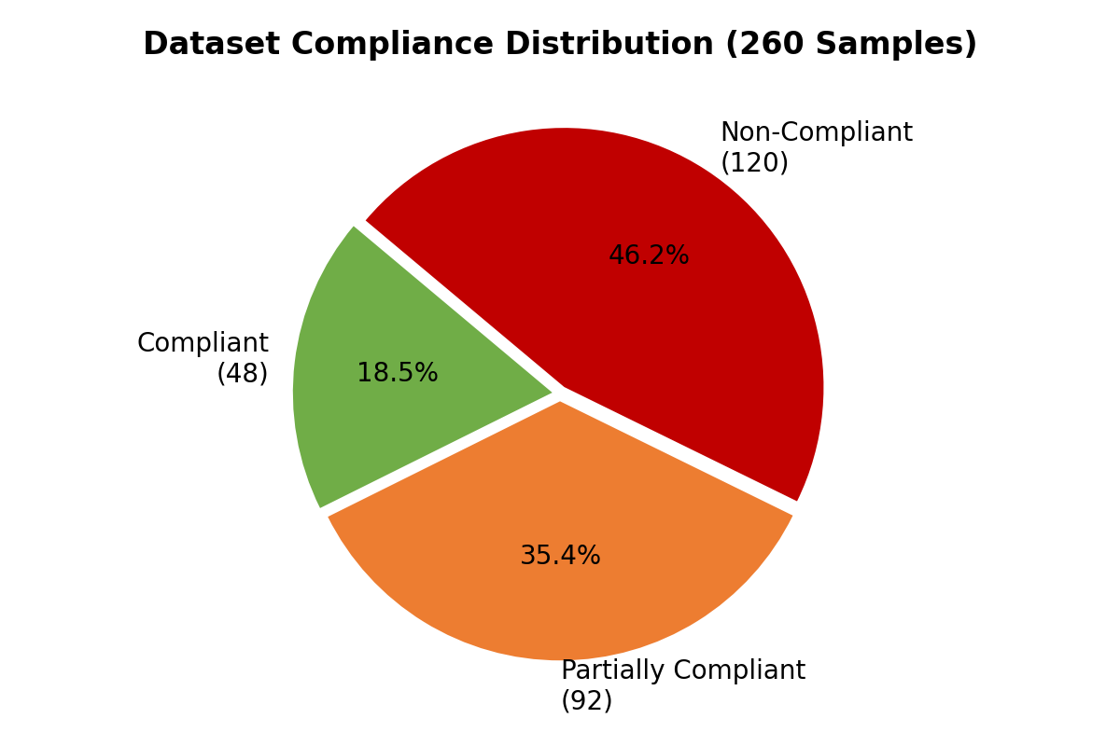

Figure: Language Distribution
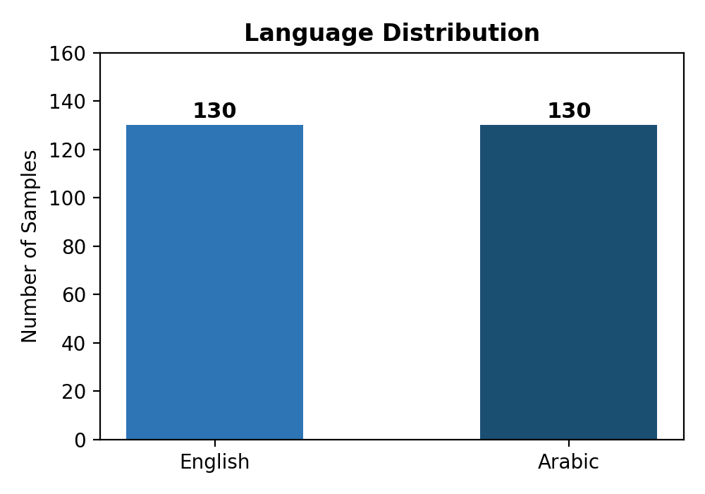

Figure: Domain Coverage
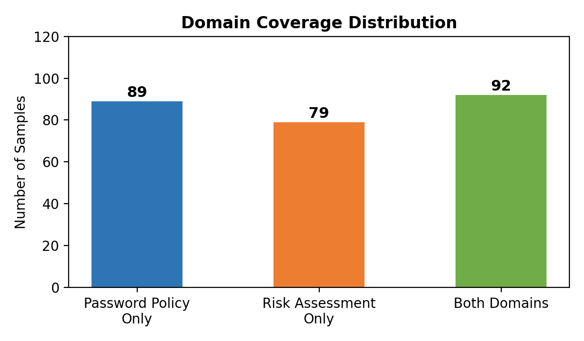

Gap Label Definitions
Each of the 16 gap labels is mapped to specific NCA ECC-2:2024 and ISO 27001:2022 controls. The following table lists all gap definitions:
Gap ID | Description | Severity | ECC Control | ISO Control
GAP_PP_001 | Weak password complexity requirements | 3 | 2-2-3-1 | 5.17
GAP_PP_002 | Inadequate password expiration policy | 2 | 2-2-3-1 | 5.17
GAP_PP_003 | Weak account lockout policy | 2 | 2-2-3-1 | 8.5
GAP_PP_004 | Missing MFA requirements | 4 (Critical) | 2-2-3-2 | 8.5
GAP_PP_005 | Missing Privileged Access Management | 4 (Critical) | 2-2-3-4 | 8.2
GAP_PP_006 | Missing password encryption/storage | 3 | 2-2-3-1 | 8.5
GAP_PP_007 | Missing periodic review schedule | 2 | 2-2-3-5 | 5.15
GAP_PP_008 | Missing roles and responsibilities | 2 | 2-2-3-5 | 5.15
GAP_RA_001 | Missing documented risk methodology | 4 (Critical) | 1-5-1 | 6.1.2
GAP_RA_002 | Missing risk identification procedures | 3 | 1-5-2 | 6.1.2
GAP_RA_003 | Missing likelihood/impact scales | 3 | 1-5-2 | 6.1.2
GAP_RA_004 | Missing risk treatment options | 3 | 1-5-2 | 6.1.3
GAP_RA_005 | Missing mandatory risk assessment triggers | 4 (Critical) | 1-5-3 | 8.2
GAP_RA_006 | Missing risk register requirements | 2 | 1-5-2 | 6.1.2
GAP_RA_007 | Missing periodic review schedule | 2 | 1-5-4 | 8.2
GAP_RA_008 | Missing PM integration | 2 | 1-5-3 | 8.2

Figure: Gap Label Frequency in Dataset
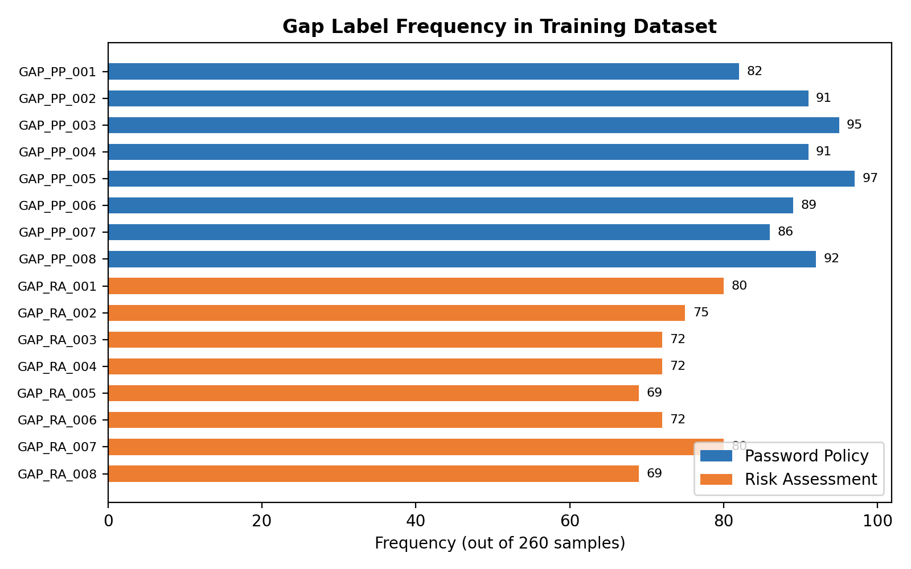

How to Extend the Dataset
The dataset generation system is designed for incremental expansion. To add new samples or cover additional policy domains:
- 1. Define New Gaps: Add new gap definitions to GAP_DEFINITIONS in generate_compliance_dataset.py. Each gap requires a description, domain, ECC/ISO control mapping, severity weight, compliant criteria, and non-compliant example.
- 2. Create Sample Profiles: Add new entries to SAMPLE_PROFILES specifying the domain(s), gap range, and target compliance level.
- 3. Run the Generator: Execute python generate_compliance_dataset.py which will generate new samples via the Gemini API and append them to the existing dataset files (CSV, JSON, JSONL).
- 4. Validate: The script automatically validates each sample for JSON structure, label completeness, and content quality.
The incremental generation system supports adding samples without re-generating existing ones, preserving dataset consistency across iterations.

Training Challenges and Methodology Evolution

Initial Approach: Single-Label Classification per Domain
The initial training approach treated compliance assessment as a single-label classification problem. Two separate models were planned — one for Password Policy compliance and one for Risk Assessment compliance — each classifying a document into three categories: Compliant, Partially Compliant, or Non-Compliant.
This approach used the standard BertForSequenceClassification architecture with 3 output classes and a softmax activation, trained independently on domain-specific data.

Challenges with the Initial Approach
- Limited Granularity: A single compliance label per document could not identify which specific controls were missing. Users received a compliance level but no actionable remediation guidance.
- Domain Isolation: Maintaining two separate models doubled the infrastructure complexity and prevented cross-domain learning. A document covering both password policy and risk assessment required two separate API calls.
- No Gap-Level Detail: The three-class output could not distinguish between a document missing MFA requirements (critical, severity 4) versus one missing a periodic review schedule (low priority, severity 2). Both might receive the same 'Partially Compliant' label.
- Inflexibility: Adding a new compliance domain (e.g., Access Control, Incident Response) would require training an entirely new model from scratch.

Revised Approach: Multi-Label Gap Detection
The methodology was fundamentally redesigned to a multi-label gap detection approach. Instead of classifying documents into compliance tiers, the model identifies specific compliance gaps at a granular level across all domains simultaneously.
Key architectural changes:
- Unified Model: A single mBERT backbone serves both Password Policy and Risk Assessment domains, with a shared representation layer that enables cross-domain learning.
- 16 Sigmoid Outputs: The classification head was replaced with a multi-label head producing 16 independent sigmoid outputs (one per gap). Each output represents the probability that a specific gap exists, allowing multiple gaps to be detected simultaneously.
- Custom Architecture: The classification head uses a two-layer MLP (768 → 256 → 16) with ReLU activation and 30% dropout, replacing the standard single-layer BertForSequenceClassification head.
- BCEWithLogitsLoss: The loss function changed from CrossEntropyLoss (suitable for single-label) to Binary Cross-Entropy with Logits (suitable for multi-label), treating each gap as an independent binary classification problem.
- Document Chunking: Since real-world policy documents can exceed BERT's 512-token limit, a chunking strategy was implemented: documents are split into 350-word overlapping chunks, each chunk is independently classified, and gap probabilities are aggregated across chunks via max-pooling.

Benefits of the New Approach
Aspect | Old Approach (Single-Label) | New Approach (Multi-Label)
Output | 3 classes (Compliant/Partial/Non) | 16 specific gaps with confidence
Domains | Separate model per domain | Single unified model
Granularity | Document-level only | Gap-level with severity weights
Actionability | Generic compliance label | Specific remediation per gap
Scoring | Fixed categories | Weighted severity-based score (0.0–1.0)
Extensibility | New model per domain | Add gaps to existing model
Documents > 512 tokens | Truncated | Chunking with overlap

Figure: Training Loss Curve
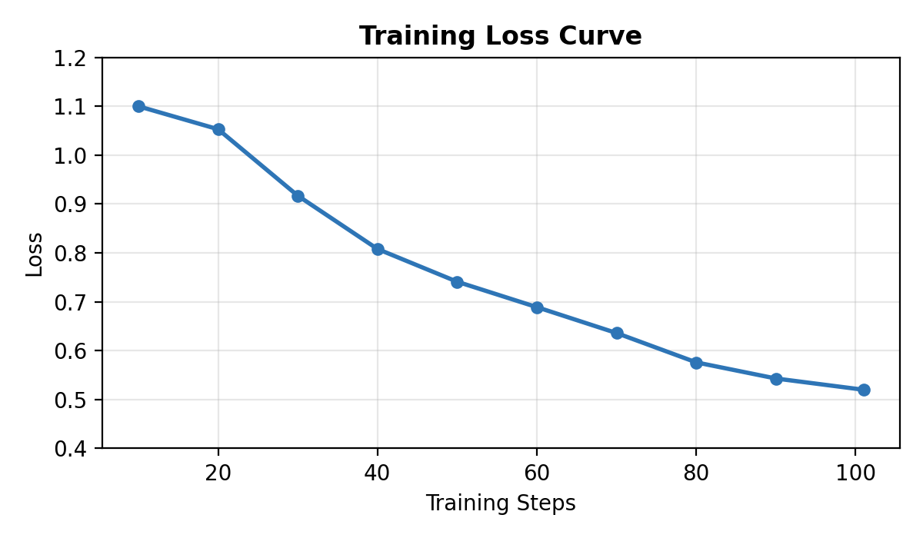

How to Retrain the Model
After extending the dataset with new samples, the model can be retrained using the model_building.ipynb Jupyter notebook. The retraining process involves:
- 1. Load the updated dataset (CSV or JSON) with the new samples.
- 2. The notebook handles tokenization using bert-base-multilingual-cased tokenizer (vocabulary size: 119,547 tokens supporting 104 languages).
- 3. Training uses AdamW optimizer with a learning rate of 2e-5, linear warmup schedule, and early stopping (patience=2) to prevent overfitting.
- 4. The trained model weights (model.safetensors) and configuration are exported to the policy_gap_detector/ directory.
- 5. Upload the new model to Google Cloud Storage (GCS) bucket for deployment. The Cloud Run service automatically downloads the latest model on startup.

Testing and Validation Results

Model Performance Metrics
The model was evaluated on a held-out validation set (20% of the dataset, 52 samples). The following metrics were recorded:
Metric | Value
Validation Accuracy | 79.31%
Validation Loss | 0.6318
Training Steps | 101
Training Loss (final) | 0.52
Total FLOPs | 1.06 × 10¹⁴

Figure: Gap Count Distribution in Dataset
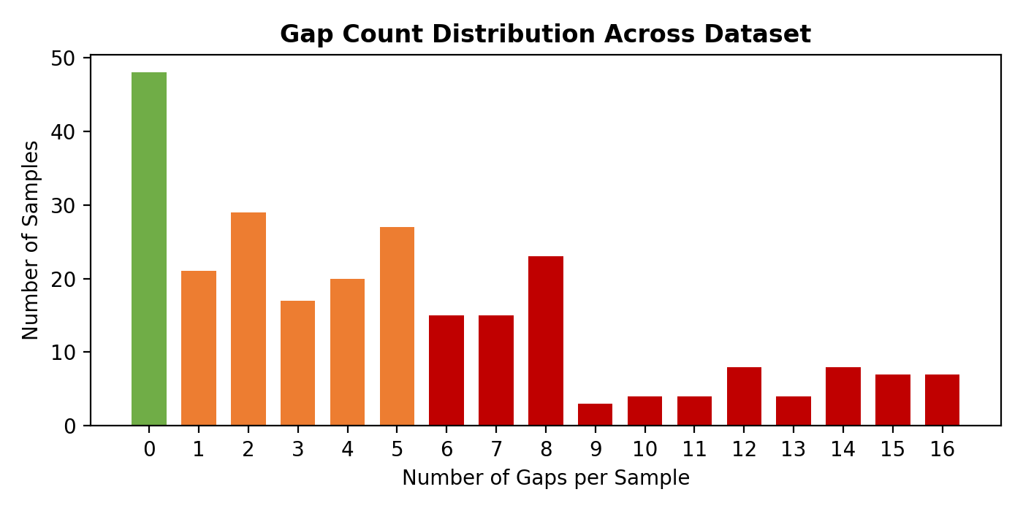

Test Case 1: Compliant Password Policy (English)
A comprehensive password policy was submitted that addresses all ECC 2-2 requirements:
Input: "Passwords must be at least 12 characters with uppercase, lowercase, digits, and special characters. Passwords expire every 90 days with 12-password history. Accounts lock after 5 failed attempts for 30 min. MFA is mandatory for remote and privileged access. PAM enforces JIT access and session recording. Passwords hashed with Argon2/bcrypt. Policy reviewed quarterly by CISO. CISO owns policy, IT Security implements, HR handles onboarding, all employees must comply."
Field | Expected Result
Overall Compliance | Compliant
Overall Score | High (close to 1.0)
Gap Count | 0 or very few
Domains Detected | password_policy
Password Policy Score | High
Rationale | Policy covers complexity, expiration, lockout, MFA, PAM, encryption, review, roles
This test validates that the model correctly identifies a policy that comprehensively addresses all eight Password Policy gaps (GAP_PP_001 through GAP_PP_008).

Test Case 2: Non-Compliant Policy (English)
A minimal, vague policy was submitted that lacks almost all required controls:
Input: "Users should choose passwords. No specific requirements."
Field | Expected Result
Overall Compliance | Non-Compliant
Overall Score | Low (close to 0.0)
Gap Count | Multiple (6+)
Domains Detected | password_policy
Gaps Detected | GAP_PP_001–008 (most or all)
Rationale | No complexity, expiration, lockout, MFA, PAM, encryption, review, or roles defined
This test confirms the model can detect multiple simultaneous gaps in a severely deficient policy document.

Test Case 3: Arabic Policy Document
A bilingual Arabic policy was submitted to verify multilingual capability:
Input: "يجب أن تتكون كلمة المرور من 12 حرفاً على الأقل مع أحرف كبيرة وصغيرة وأرقام ورموز. تنتهي صلاحية كلمة المرور كل 90 يوماً."
Field | Expected Result
Overall Compliance | Partially Compliant
Domains Detected | password_policy
PP Gaps Present | Missing MFA, PAM, lockout, encryption, review, roles
PP Gaps Absent | Complexity ✓, Expiration ✓
Rationale | Policy defines complexity and expiration but omits other controls
This test validates the model's ability to process Arabic text and correctly identify both present and missing compliance controls.

Test Case 4: Mixed Partial Compliance
A policy with some controls but critical omissions was tested:
Input: "Password policy: minimum 8 characters. No MFA required. No risk assessment performed."
Field | Expected Result
Overall Compliance | Non-Compliant or Partially Compliant
Gap Count | Multiple gaps detected
Domain Detection | password_policy (risk_assessment requires 2+ keyword matches)
Key Gaps | GAP_PP_001 (weak complexity), GAP_PP_004 (missing MFA)
Rationale | 8-char minimum is below recommended 12; MFA explicitly absent

API Response Structure
Each analysis request returns a structured JSON response with the following fields:
Field | Type | Description
overall_compliance | string | compliant / partially_compliant / non_compliant
overall_score | float | Weighted severity score, 0.0 (worst) to 1.0 (best)
gap_count | integer | Total number of detected gaps across all domains
num_chunks | integer | Number of document chunks processed
inference_time_ms | float | Processing time in milliseconds
domains_detected | list | Detected policy domains via keyword heuristic
password_policy | object | Domain-level report with gaps, score, details
risk_assessment | object | Domain-level report with gaps, score, details
all_gap_probabilities | object | 16 gap confidence values (0.0–1.0 each)

Scoring Methodology
The overall compliance score is calculated using severity-weighted penalties:
- Each gap has a severity weight: Critical (4), High (3), or Medium (2).
- Penalty = Σ (severity_weight × gap_probability) for detected gaps.
- Score = max(0, 1 − penalty / total_severity_weight).
- Compliance level: 0 gaps = Compliant; 1–5 gaps = Partially Compliant; 6+ gaps = Non-Compliant.
This scoring ensures that critical gaps (e.g., missing MFA with severity 4) impact the score more heavily than lower-priority gaps (e.g., missing periodic review with severity 2).

7. API Design

7.1 Overview
Property | Value
Framework | FastAPI + Uvicorn
Base URL | https://ecc-model-host-636663078359.me-central1.run.app
Deployment | Docker → Google Cloud Run (me-central1, Doha)
Authentication | None (public API)
CORS | All origins allowed (development)
Docs | /docs (Swagger UI), /redoc (ReDoc)

7.2 Endpoints
Method | Path | Description | Tags
GET | / | API metadata and version info | meta
GET | /health | Health / readiness probe (Cloud Run) | meta
POST | /analyze | Analyze policy document for compliance gaps | inference

7.3 POST /analyze — Request
Field | Type | Required | Constraints | Default | Description
text | string | Yes | 1–50,000 chars | — | Full policy document text
threshold | float | No | 0.0–1.0 | 0.6 | Confidence threshold for gap detection

7.4 POST /analyze — Response (AnalyzeResponse)
Field | Type | Description
overall_compliance | string | Compliance level label (Fully/Partially/Non-Compliant)
overall_score | float | Overall compliance score (0–100)
gap_count | integer | Total gaps detected across all domains
num_chunks | integer | Number of 512-token chunks processed
inference_time_ms | float | Total inference time in milliseconds
domains_detected | list[string] | Domains found in the document
password_policy | DomainResult | Password Policy domain results
risk_assessment | DomainResult | Risk Assessment domain results
all_gap_probabilities | dict[str, float] | Raw probability for every gap label

7.5 Data Models
GapDetail Schema:
Field | Type | Description
gap_id | string | Gap identifier (e.g., GAP_PP_001)
description | string | Human-readable gap description
confidence | float | Model confidence score (0.0–1.0)

DomainResult Schema:
Field | Type | Description
gaps_detected | list[string] | List of detected gap IDs for this domain
gap_count | integer | Number of gaps detected
score | float | Domain compliance score (0–100)
details | list[GapDetail] | Detailed gap information with confidence

7.6 Error Handling
HTTP Status | Meaning | When
200 | Success | Request processed normally
422 | Validation Error | Missing text, text too long, invalid threshold
503 | Service Unavailable | Model failed to load at startup
500 | Internal Server Error | Unexpected runtime failure

7.7 Performance & Constraints
Constraint | Value
Max input length | 50,000 characters
Max tokens per chunk | 512 tokens
Model memory | ~1.5 GB RAM
Inference time (typical) | 100–500ms per document
Concurrency | Cloud Run auto-scaling (0 → N instances)
Cold start | ~15–30s (model download from GCS)

8. Database Schema

8.1 Overview
The database is hosted on Supabase (managed PostgreSQL) with Row-Level Security (RLS) enabled on all tables. Each table is scoped to the authenticated user via auth.uid(). The uuid-ossp extension provides UUID generation for primary keys.

8.2 Entity-Relationship Summary
Table | Purpose | Key Fields
profiles | User accounts (synced from auth.users) | id (UUID), email, full_name, avatar_url
classification_history | Past analysis results | policy_text, result_label, confidence, inference_time_ms
policies | Uploaded policy documents | title, status, category, compliance_score, file_url, analysis_result (JSONB)
assessments | Compliance assessments | name, framework, status, overall_score, results (JSONB), comments (JSONB)
reports | Generated compliance reports | title, type, assessment_id, content (JSONB)
tasks | Remediation tasks | title, control_id, priority, status, ai_guidance (JSONB), comments (JSONB)
schedules | Recurring assessment schedules | name, framework, frequency, enabled, next_run
teams | Team management | name, description, members (JSONB)

8.3 Policies Table Detail
Column | Type | Constraints | Description
id | UUID | PK, auto-generated | Unique policy identifier
user_id | UUID | FK → auth.users | Owner
title | TEXT | NOT NULL | Policy document title
status | TEXT | CHECK (uploaded/analyzing/analyzed) | Processing status
category | TEXT | nullable | Policy category (password_policy, risk_assessment)
compliance_score | REAL | nullable | Overall compliance score (0–100)
file_url | TEXT | nullable | Supabase Storage path
nca_controls_mapped | JSONB | default [] | Mapped NCA ECC control IDs
analysis_result | JSONB | nullable | Full API response from /analyze

8.4 Assessments Table Detail
Column | Type | Constraints | Description
id | UUID | PK, auto-generated | Assessment identifier
user_id | UUID | FK → auth.users | Owner
name | TEXT | NOT NULL | Assessment name
framework | TEXT | NOT NULL | Compliance framework (NCA ECC)
status | TEXT | CHECK (draft/in_progress/completed) | Assessment status
overall_score | REAL | nullable | Overall compliance score
results | JSONB | default [] | Control-level assessment results
comments | JSONB | default [] | User comments with timestamps

8.5 Tasks Table Detail
Column | Type | Constraints | Description
id | UUID | PK, auto-generated | Task identifier
user_id | UUID | FK → auth.users | Owner
title | TEXT | NOT NULL | Task title
description | TEXT | nullable | Detailed description
control_id | TEXT | nullable | Related NCA ECC control ID
assessment_id | TEXT | nullable | Source assessment ID
priority | TEXT | CHECK (critical/high/medium/low) | Task priority
status | TEXT | CHECK (open/in_progress/completed/deferred) | Task status
assigned_to | TEXT | nullable | Assignee name
due_date | TEXT | nullable | Due date
ai_guidance | JSONB | nullable | AI-generated remediation guidance
comments | JSONB | default [] | User comments with timestamps

8.6 Storage Buckets
Bucket | Size Limit | Allowed Types | Purpose
policy-files | 10 MB | PDF, TXT, CSV, DOCX | Uploaded policy documents
evidence-files | 10 MB | PDF, TXT, CSV, DOCX, PNG, JPEG, GIF, XLSX | Assessment evidence files
Storage policies enforce user-level isolation: each user can only access files in their own folder (path prefix = auth.uid()).

9. Frontend Application

9.1 Technology Stack
Technology | Version | Purpose
React | 19 | UI framework with functional components and hooks
TypeScript | 5.9 | Type-safe JavaScript
Vite | 6.x | Build tool and dev server (HMR)
TailwindCSS | 4.x | Utility-first CSS framework
Supabase JS | 2.x | Database client and authentication
Recharts | 2.x | Data visualization (charts and graphs)
Lucide React | — | Icon library

9.2 Dashboard Pages
Page | Component | Description
Overview | OverviewPage.tsx | KPI cards, compliance score gauges, gap distribution charts, recent activity
Policies | PoliciesPage.tsx | Upload policies, trigger ML analysis, view per-policy results and NCA mappings
Assessments | AssessmentsPage.tsx | Create assessments from analysis results, manage controls, upload evidence, add comments
Remediation | RemediationPage.tsx | View auto-generated tasks, AI guidance, status tracking, comment threads
Reports | ReportsPage.tsx | Generate and export compliance reports (PDF/JSON), audit trails
Risk Dashboard | RiskDashboardPage.tsx | Risk heat maps, severity distribution, domain-level risk analysis
Framework Comparison | FrameworkComparisonPage.tsx | Compare NCA ECC vs ISO 27001 coverage, control mapping visualization

9.3 Key Features
- Bilingual support (English/Arabic) with automatic RTL layout switching
- Dark mode support with system preference detection
- Real-time policy analysis with progress indicators
- Interactive charts showing gap distribution, compliance trends, and risk levels
- Evidence file management with upload, preview (images/PDF), and download
- Comment system on assessments and tasks with timestamps
- Automated task generation from detected gaps with AI remediation guidance
- Local storage caching for offline access to previously loaded data

9.4 State Management
Application state is managed through a Zustand-like custom store (useComplianceStore) that provides a unified interface for CRUD operations on all entities. The store implements a dual-persistence strategy:
1. Primary: Supabase PostgreSQL (remote, persisted, RLS-secured)
2. Fallback: localStorage cache (offline access, hydration on load)
Data flows from Supabase on initial load, with localStorage serving as a read-through cache. All mutations write to both stores simultaneously.

10. Gap Detection Framework

10.1 NCA ECC-2:2024 Control Mapping
Each detected gap is mapped to one or more NCA ECC-2:2024 controls. The system tracks 20 ECC controls across the two supported domains. This mapping enables the dashboard to display control-level compliance status and generate targeted remediation tasks.

10.2 Password Policy Controls
Control ID | Control Name | Related Gaps
ECC 2-2-1 | Password Complexity Requirements | GAP_PP_001
ECC 2-2-2 | Password Expiration Policy | GAP_PP_002
ECC 2-2-3 | Account Lockout Policy | GAP_PP_003
ECC 2-2-4 | Multi-Factor Authentication | GAP_PP_004
ECC 2-2-5 | Privileged Access Management | GAP_PP_005
ECC 2-2-6 | Password Storage & Encryption | GAP_PP_006
ECC 2-2-7 | Periodic Review Schedule | GAP_PP_007
ECC 2-2-8 | Roles and Responsibilities | GAP_PP_008

10.3 Risk Assessment Controls
Control ID | Control Name | Related Gaps
ECC 1-5-1 | Risk Assessment Methodology | GAP_RA_001
ECC 1-5-2 | Risk Identification Procedures | GAP_RA_002
ECC 1-5-3 | Risk Analysis (Likelihood/Impact) | GAP_RA_003
ECC 1-5-4 | Risk Treatment Options | GAP_RA_004
ECC 1-5-5 | Risk Assessment Triggers | GAP_RA_005
ECC 1-5-6 | Risk Register Requirements | GAP_RA_006
ECC 1-5-7 | Periodic Review Schedule | GAP_RA_007
ECC 1-5-8 | Integration with PM | GAP_RA_008

10.4 Inference Pipeline Detail
The inference pipeline processes documents through six stages:
1. Domain Detection — Keyword heuristic identifies which domains (Password Policy, Risk Assessment) are present. Password Policy requires 1+ keyword match; Risk Assessment requires 2+ keyword matches.
2. Document Chunking — Text is split into ~350-word segments with ~50-word overlap at section headings, then paragraphs, then word-count boundaries.
3. Tokenization — Each chunk is tokenized with the mBERT tokenizer (max 512 tokens, dynamic padding, truncation enabled).
4. Per-Chunk Inference — Each tokenized chunk passes through the mBERT backbone and classification head, producing 16 sigmoid probabilities.
5. Max-Pool Aggregation — For multi-chunk documents, per-gap maximum probability is taken across all chunks.
6. Threshold & Scoring — Probabilities exceeding the threshold (default 0.6) are flagged as detected gaps. A severity-weighted score is computed per domain and overall.

11. Deployment Architecture

11.1 Container Configuration
Setting | Value
Base Image | python:3.12-slim (multi-stage build)
PyTorch Build | CPU-only (download.pytorch.org/whl/cpu)
Runtime Command | uvicorn app:app --host 0.0.0.0 --port $PORT
Default Port | 8080
Health Check Interval | 30 seconds
Health Start Period | 60 seconds

11.2 Google Cloud Run Configuration
Setting | Value
Region | me-central1 (Doha, Qatar)
Scaling | Auto (0 → N instances)
Memory | 2 GB (sufficient for ~1.5 GB model)
CPU | 2 vCPU
Startup Probe | GET /health
Container Registry | Artifact Registry (me-central3)

11.3 Model Loading Strategy
On container startup, the model loading follows a fallback chain:
1. Check local path (./policy_gap_detector/)
2. If not found → download from GCS (gs://model-files33/policy_gap_detector/)
3. Fallback prefixes: policy_gap_detector/, checkpoint-505/
4. Validate checkpoint shape before loading (rejects legacy 3-class models)
5. Set model to eval mode + inference mode

11.4 CI/CD Pipeline
The deployment uses Google Cloud Build with a two-step pipeline:
1. Build: docker build using the multi-stage Dockerfile
2. Push: docker push to Artifact Registry (me-central3-docker.pkg.dev)
Cloud Run automatically deploys new revisions when a new image is pushed.

11.5 Frontend Deployment
The React SPA is built with Vite (npm run build) producing static assets that can be deployed to any static hosting service (Vercel, Netlify, Firebase Hosting). Environment variables (VITE_SUPABASE_URL, VITE_SUPABASE_ANON_KEY) are injected at build time.

12. Security Considerations

12.1 Database Security
- Row-Level Security (RLS) enabled on all tables — users can only access their own data
- All table operations filtered by auth.uid() = user_id
- Storage policies enforce user-level folder isolation
- Auto-generated UUIDs for primary keys prevent enumeration attacks

12.2 API Security
- Input validation via Pydantic schemas (text length, threshold range)
- Maximum document size enforced (50,000 characters)
- CORS configuration (should be restricted to frontend domain in production)
- Health endpoint for monitoring without exposing sensitive data

12.3 Authentication
User authentication is handled by Supabase Auth with JWT tokens. The frontend stores tokens securely and includes them in all API requests to Supabase. Signed URLs with expiration are used for private file access in Storage buckets.

12.4 Data Protection
- All data in transit encrypted via TLS (HTTPS)
- Supabase encrypts data at rest
- Policy documents stored in private Storage buckets (not publicly accessible)
- Evidence files accessible only via time-limited signed URLs

13. System Design Diagrams
The following system design diagrams are maintained in draw.io format in the system-design/ directory. Each diagram documents a specific architectural or behavioral aspect of the PolicyShield system.

System Architecture Diagram
File: system-design/system-architecture.drawio
Shows the three-tier architecture: Frontend Layer (React SPA, TailwindCSS), Backend/API Layer (FastAPI, Uvicorn, mBERT Model, Document Chunker), Data Layer (Supabase PostgreSQL, Supabase Storage, Google Cloud Storage). Includes Cloud Run container deployment with auto-scaling.

Use Case Diagram
File: system-design/use-case-diagram.drawio
Defines 13 use cases across 3 actors: Security Officer (upload policy, view results, manage assessments, create remediation tasks), Compliance Manager (approve assessments, generate reports, compare frameworks), System Administrator (manage users, configure schedules, manage teams). The PolicyShield System boundary contains all use cases.

Class / Component Diagram
File: system-design/class-component-diagram.drawio
Maps React component hierarchy: ComplianceDashboard → 7 page components (OverviewPage, PoliciesPage, AssessmentsPage, RemediationPage, ReportsPage, RiskDashboardPage, FrameworkComparisonPage). Shows library classes: PolicyClassifierAPI, useComplianceStore, SupabaseClient. Includes type interfaces for Policy, Assessment, Task, Report.

Data Flow Diagram (DFD Level 1)
File: system-design/data-flow-diagram.drawio
Traces data through 6 processes: Upload Policy, Analyze Document (AI), Store Results, Generate Assessment, Create Tasks, Generate Report. External entities: User, ML Model API, Supabase DB. Data stores: Policy Store, Assessment Store, Task Store, Report Store.

Sequence Diagram — Authentication
File: system-design/sequence-authentication.drawio
Shows the email/password sign-up and sign-in flow between User, Frontend (React), Supabase Auth, and Database. Includes profile auto-creation trigger, JWT token management, and session persistence.

Sequence Diagram — Policy Classification
File: system-design/sequence-policy-classification.drawio
Details the end-to-end flow: User submits text → Frontend sends POST /analyze → FastAPI chunks document → mBERT inference → Max-pool aggregation → Domain scoring → Response with gaps, scores, compliance level.

Sequence Diagram — Gap Analysis
File: system-design/sequence-gap-analysis.drawio
Shows how detected gaps flow through the system: API response → Frontend parses gap details → Maps gaps to NCA controls → Calculates control-level scores → Updates assessment results → Generates remediation tasks.

Sequence Diagram — Batch Classification
File: system-design/sequence-batch-classification.drawio
Illustrates the batch processing workflow: User selects multiple policies → Frontend queues sequential API calls → Progress tracking → Bulk result storage → Dashboard refresh.

Activity Diagram — Policy Assessment
File: system-design/activity-policy-assessment.drawio
Swimlane diagram with User, System, and AI Model lanes. Shows the full assessment workflow: Upload → Validate → Analyze → Review Gaps → Accept/Reject findings → Generate Tasks → Complete Assessment.

Activity Diagram — Remediation Task
File: system-design/activity-remediation-task.drawio
Swimlane diagram showing task lifecycle: Task Created → Assigned → In Progress → Evidence Uploaded → Review → Completed/Deferred. Includes decision points for priority escalation and due date checking.

State Diagrams
File: system-design/state-diagrams.drawio
Contains state machines for three entities: Policy (Uploaded → Analyzing → Analyzed), Assessment (Draft → In Progress → Completed), Task (Open → In Progress → Completed/Deferred). Each shows valid state transitions and trigger events.

Deployment Diagram
File: system-design/deployment-diagram.drawio
UML deployment diagram showing physical infrastructure: Client Browser → Vercel/Netlify (React SPA) → Google Cloud Run (FastAPI Container) → Google Cloud Storage (Model Files). Supabase Cloud: PostgreSQL + Auth + Storage. All connected via HTTPS.

14. Technology Stack

14.1 ML & AI Layer
Technology | Version | Purpose
Google Gemini 2.5 Flash | Latest | Synthetic dataset generation
PyTorch | ≥ 2.0.0 | Deep learning framework
HuggingFace Transformers | ≥ 4.35.0 | mBERT backbone and Trainer
SafeTensors | ≥ 0.4.0 | Secure model serialization
scikit-learn | ≥ 1.3 | Evaluation metrics
Pandas / NumPy | ≥ 2.0 / ≥ 1.24 | Data processing

14.2 Backend Layer
Technology | Version | Purpose
Python | 3.12 | Runtime language
FastAPI | ≥ 0.115.0 | REST API framework
Uvicorn | Latest | ASGI server
Docker | — | Containerization
Google Cloud Run | — | Serverless container platform
Google Cloud Storage | — | Model artifact storage

14.3 Frontend Layer
Technology | Version | Purpose
React | 19 | UI component framework
TypeScript | 5.9 | Type-safe development
Vite | 6.x | Build tool with HMR
TailwindCSS | 4.x | Utility-first CSS
Recharts | 2.x | Data visualization
Lucide React | — | Icon library

14.4 Data & Infrastructure Layer
Technology | Version | Purpose
Supabase | — | Backend-as-a-Service (PostgreSQL + Auth + Storage)
PostgreSQL | 15+ | Relational database with JSONB support
Google Cloud Build | — | CI/CD pipeline
Artifact Registry | — | Docker image registry

15. Future Improvements

15.1 Model Enhancements
Enhancement | Description
Additional Domains | Extend to ECC 3-x, 4-x controls (Incident Management, Business Continuity)
Document Structure Awareness | Section-level gap attribution for precise localization
Active Learning | Flag uncertain predictions for human review and retraining
Model Distillation | Smaller model variant for edge/on-premise deployment
Continuous Training | Re-train on verified user predictions for domain adaptation

15.2 Platform Enhancements
Enhancement | Description
SSO Integration | Support SAML/OIDC for enterprise single sign-on
Audit Logging | Comprehensive audit trail for all user actions
Notification System | Email/SMS alerts for assessment deadlines and task assignments
Multi-tenant Support | Organization-level data isolation and team management
API Rate Limiting | Token-based rate limiting for production security
PDF Report Export | Generate formatted PDF compliance reports with charts

— End of Report —

