# Remaining lifetime of degrading systems continuously monitored by degrading sensors: Report.

*Step 1: Data simulation for the degradation process*

The authors consider a degrading system being continuously monitored by a degrading sensor, where the degradation processes of the system and the sensor that follow a Wiener process are assumed to be independent of each other. The following equations represent the degradation process of system and sensor.

𝑋(𝑡) = 𝛼𝑡 + 𝜎𝐵1(𝑡) ----- (1)

𝑆(𝑡) = 𝛽𝑡 + 𝜂𝐵2(𝑡) -------(2)

Here, 𝛼, 𝛽 are drift parameters and 𝜎, 𝜂 are diffusion parameters. B1 and B2 are standard Brownian motion representing the stochastic dynamics of the degradation process. The observed degradation data which we get from the sensor contains the sum of the sensor degradation and the system degradation. Hence, at a time 𝑡 the resultant degradation measurement 𝑌 (𝑡) obtained from the degrading (monitoring) sensor can be written as:

𝑌 (𝑡) = 𝑋(𝑡) + 𝑆(𝑡) + 𝜖 ------(3)

where 𝜖 is the measurement noise, following a Gaussian distribution with 𝑁 (0, 𝜎2𝜖).

Figure 1 shows the simulated X(t), S(t) and Y(t). We first presented the figure from paper and then presented the graph we have produced.

**Figure 1: System and sensor degradation and resultant observation including measurement error, using 𝛼 = 10, 𝜎 = 5, 𝛽 = 5, 𝜂 = 3, 𝜎𝜖 = 0.45.**

***According to paper***

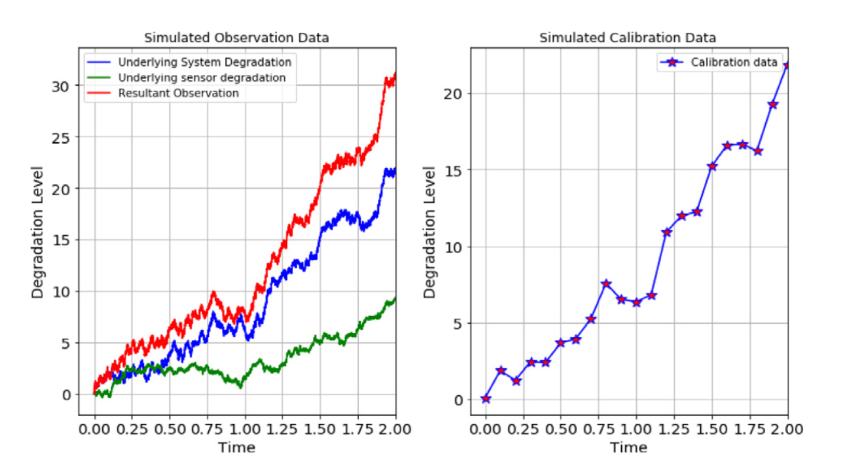

***Our implementation***

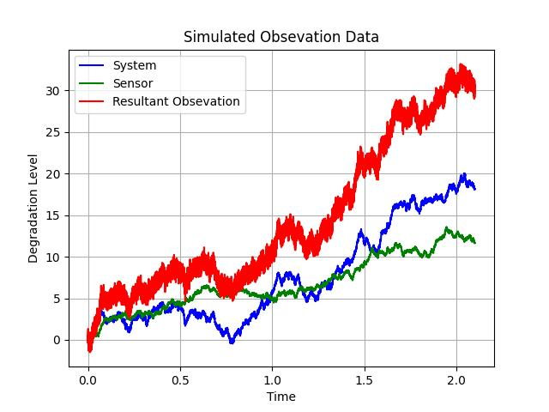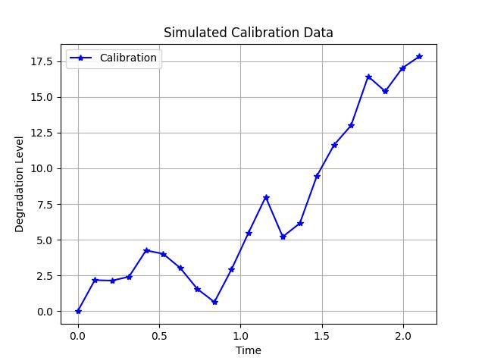

Regarding calibration data, the authors assume there are 21 calibration points with the first one being at time 0 and with the interval 𝛥𝜏 = 0.1, which gives 21 data points from the simulated underlying system degradation at every 1000 measurement points.

*Step 2: Parameter estimation of the degradation process.*

The parameters to be estimated are 𝛼, 𝛽, 𝜎, 𝜂, and 𝜎𝜖. The author employs the MAP estimation to estimate the system degradation parameters 𝛼 and 𝜎 based on the calibration data, and the MLE is used to estimate the remaining parameters.

Table 1 shows the effectiveness of the proposed estimation approach for system degradation parameters. Here we have presented true value, the author’s estimated value and the value estimated from our implementation. Our value is very close to the true value which shows successful implementation of the paper.

Table 1: True values vs. estimated values for system degradation parameters

|  |  |  |  |
| --- | --- | --- | --- |
| Parameter Name | True Value | Estimated Value (According to Paper) | Estimated Value (Our Implementation) |
| α | 10 | 9.98 | 9.9 |
| σ | 5 | 4.3 | 4.9 |

Fig. 2 depicts the estimated values of 𝛼 + 𝛽 between 10 000th and 11 000th monitoring point or 10th and 11th calibration point. Like before, we first presented the figure from paper and then presented the graph we have produced.

**Figure 2: Estimated 𝜔 = 𝛼 + 𝛽 vs the number of data points between 10 000 and 11 000 monitoring points (here 0 in the X axis corresponds to the 10 000th monitoring point).**

***According to paper***

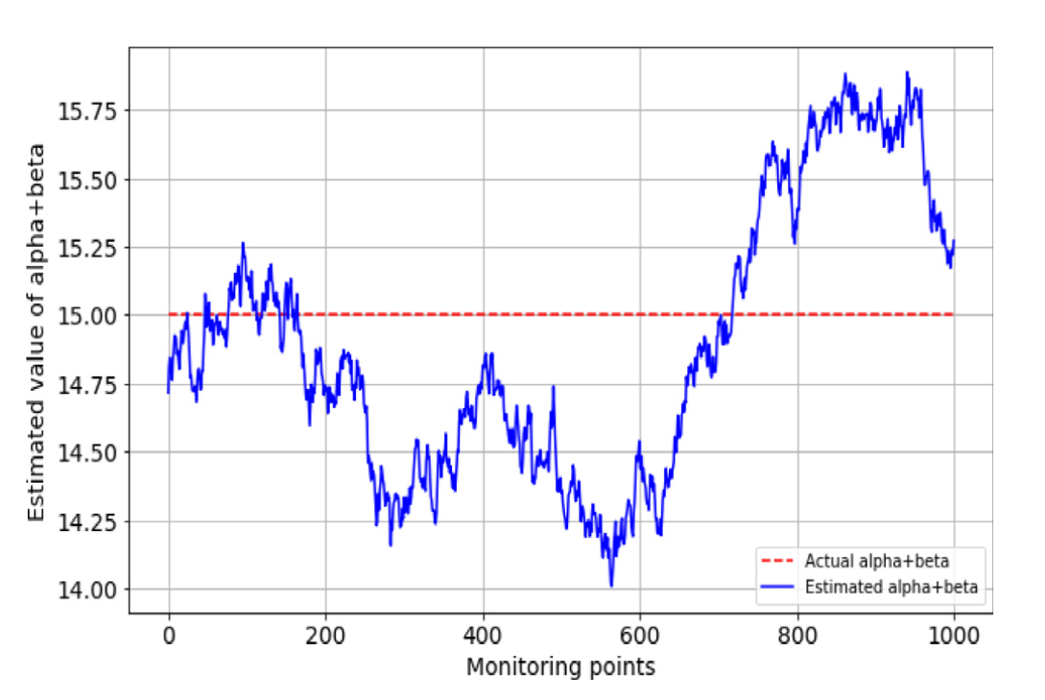

***Our implementation***

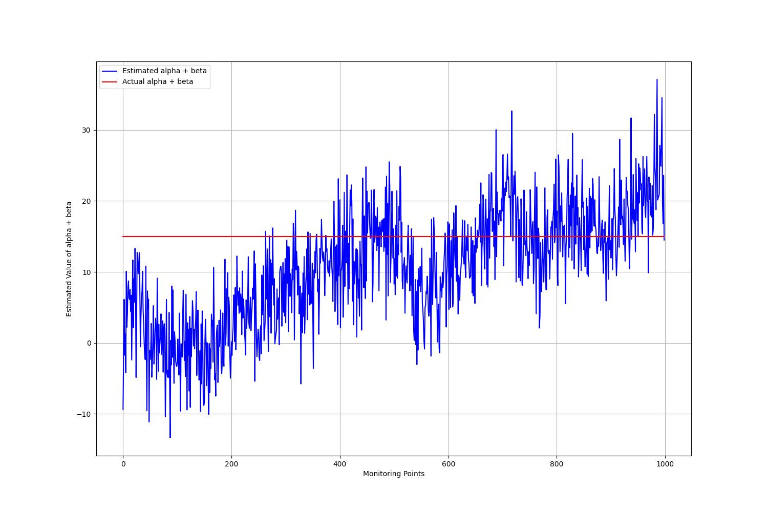

The true value, estimated value for sensor degradation parameters, that are estimated using MLE are presented in Table 2. In our case, value of η is a little off, which we assumed is caused by the randomness of Brownian motion.

Table 2: True values vs. estimated values for the sensor degradation parameters

|  |  |  |  |
| --- | --- | --- | --- |
| Parameter Name | True Value | Estimated Value (According to Paper) | Estimated Value (Our Implementation) |
| β | 5 | 5.28 | 4.59 |
| η | 3 | 3 | **5.85** |
| σϵ | 0.45 | 0.3 | 0.46 |

*Step 3: State estimation and RUL evaluation*

This section demonstrates the numerical example of the system state estimation using Kalman filter. Fig. 3 compares the degradation obtained from simulated data and the state estimation using the Kalman filter. The first figure is from the paper and the second one is the graph we have produced.

**Figure 3: Comparison of state estimation using Kalman filter and actual degradation.**

***According to Paper***

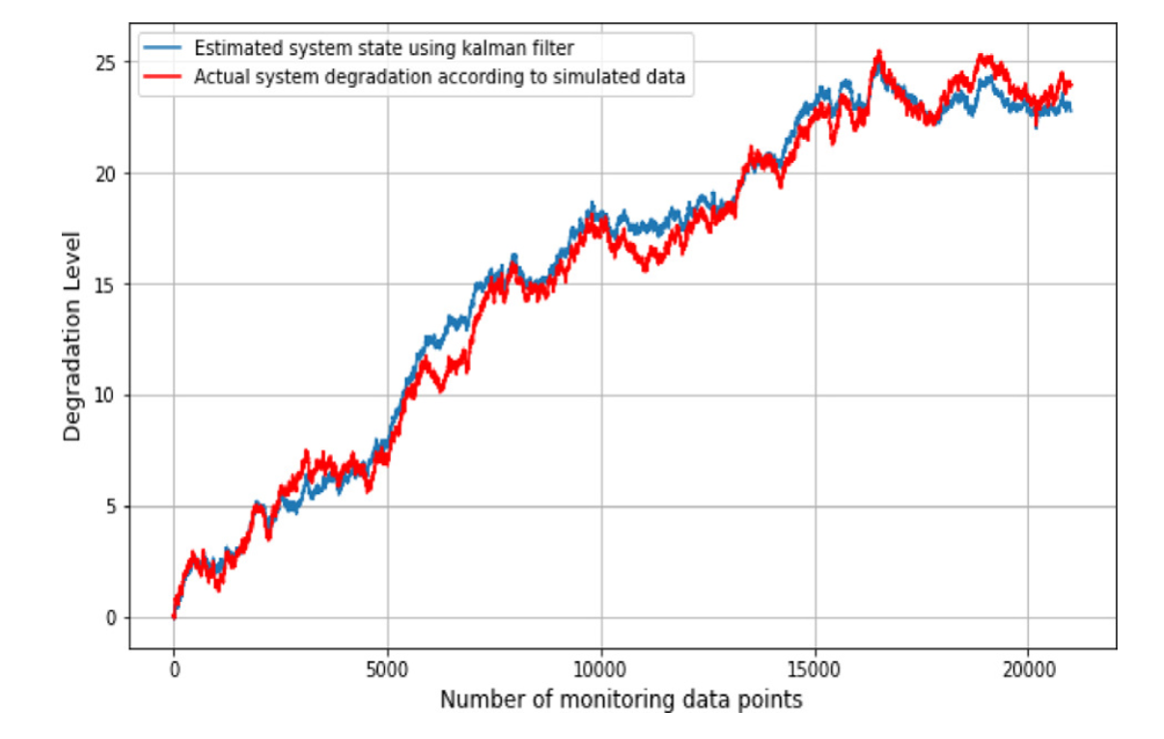

***Our implementation***

