**Requirement Specification Document**

**Database System for Bradford WW1 Group**

**1. Introduction**

The WW1 Bradford Group is looking to develop a comprehensive database system aimed at cataloguing and preserving the names of Bradford citizens who served in World War I. The data will be stored in a database, with the goal of making the information accessible to users in an easily searchable format. The system will be operated by the WW1 Bradford Group members and other interested parties, including researchers and historians, and will be referred to as the WW1 Bradford Database. The data will include names of individuals who served in military or war-related occupations, as well as those memorialised or buried in Bradford. The system will be accessed through a user-friendly web interface and will allow both guest and admin access with varying levels of permissions.

**2. Functional and non-functional requirements**

**2.1. Actors**

The WW1 Database System will have two types of users (actors):

*2.1.1. Admin*: Has full access to the system, including the ability to add, edit, delete, import, export, and manage user privileges.

*2.1.2. Guest*: Can only view the data and perform searches. Cannot add, edit, delete, download, or copy data.

**2.2. Functional Requirements**

*2.2.1. User Authentication*: The user can log into the database using their username and password. After validating the login credentials, the system will either assign Admin permissions or Guest permissions.

*2.2.2. Interface:* Upon startup, the user will see the welcome page containing information about Bradford WW1 Group and a button that will take them to the login page. After logging in, the user will be presented with a dashboard, providing access to the 5 databases namely, 1 – Bradford and surrounding townships, 2 - Names recorded on Bradford Memorials, 3 – Buried in Bradford, 4 – Newspaper references, 5 – Biographies. The dashboard will provide a visual interface for selecting and accessing each database.

*2.2.3. Data Management:* If a user logs into the database as an Admin, they can add, edit or delete records as well as import to and export from the database. The system will ensure data integrity by validating inputs while adding or editing records.

*2.2.4. Search Functionality:* The system will allow users to search across the database using surname, forename, military service detail, burial location etc. The search results will be displayed in a user-friendly format.

*2.2.5. Forms and User Interface:* The system will provide the user with forms for data entry and editing that cover the entire screen. Only the Admin will be able to view the administrative tools. It will be ensured that all forms and interfaces are visually intuitive and easy to use.

*2.2.6. Password Security:* The system will require password authentication for both Admin and Guest access. The passwords will be encrypted before storing in the database to ensure security. Admin users will have the privilege to manage Guest user accounts

**2.3. Non-Functional Requirements**

* + The system shall ensure data security by restricting access based on user roles.
  + The system shall encrypt sensitive data, such as passwords and user information.
  + The system shall prevent unauthorized access to the database through password protection and role-based access control.
  + The system shall handle large datasets efficiently, ensuring quick search and retrieval times.
  + The system shall provide a user-friendly interface with clear navigation and intuitive design.
  + The system shall ensure all forms and dashboards are visually consistent and easy to understand.
  + The system shall be hosted locally on a laptop, ensuring it can be used offline.
  + The system shall ensure data integrity by preventing corruption during import/export operations.
  + The system shall be designed with facility to allow for easy updates and maintenance.

**2.4. Additional Features**

* + The system shall allow Admin users to upload and manage biography information, including text and media files (e.g., images, documents).
  + The system shall display biography information in a readable format for users.
  + The system shall allow Admin users to add and manage links to published newspaper articles.
  + The system shall provide a clickable link to access external newspaper references.
  + The system shall allow Admin users to export search results or entire databases to external files (e.g., CSV, Excel).

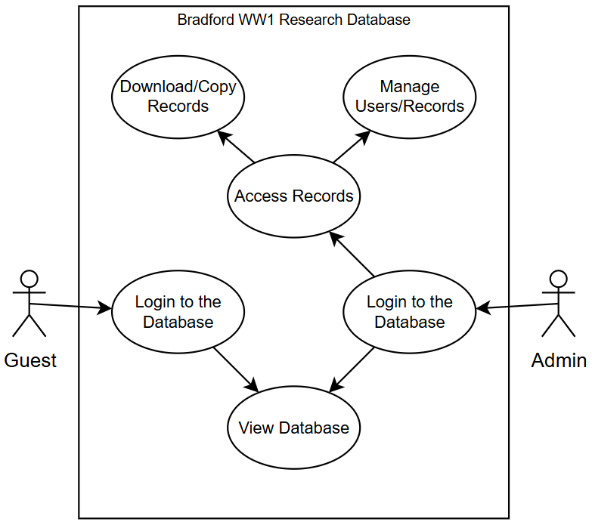

Fig: UML Use Case Diagram

**3. Data Description**

Data Handled by the program –

Guest– Normal User’s username and password required for logging in and accessing webpage.

* username – Unique string between 5-25 characters
* password – string between 8-25 characters

Admin – Admin username and password required for logging in and accessing all functionalities and other users.

* username – Unique string between 5-25 characters
* password – string between 8-25 characters

Databases – 5 databases containing all records which will be accessible for the user and admin, as well as modifiable for the admin only.

* “Bradford and surrounding townships Great War Roll of Honour” - 22 fields
* “Bradford Memorials” – 7 fields
* “Those Buried in Bradford” – 11 fields
* “Newspaper references” – 11 fields
* “Biography Information” – 5 fields

Information Docs – Some search results will provide a link to a Doc file with information which the users will be able to view

* filename – The unique name of the stored Doc file

**4. Interface**

Welcome page:

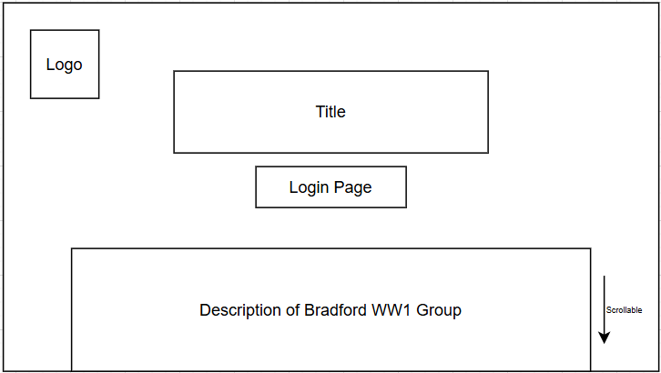

* Upon entering the website, users will be greeted with a welcome page for a brief introduction to the site. A login and signup button is in the middle under the big title to illustrate that you must register and sign in to continue. In the bottom left, there will be a brief description about what the website is about and general information.

Login page:

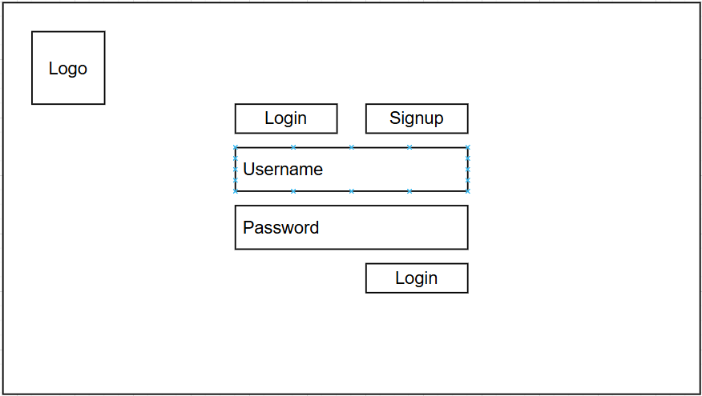

* Users are greeted with the login page first, where they must input their username and password. A simple layout for the login page is used as it is much more accessible for all users and if they do not have a account then they can click on the sign-up button the top and it will transition to the registration section.

Sign-up:

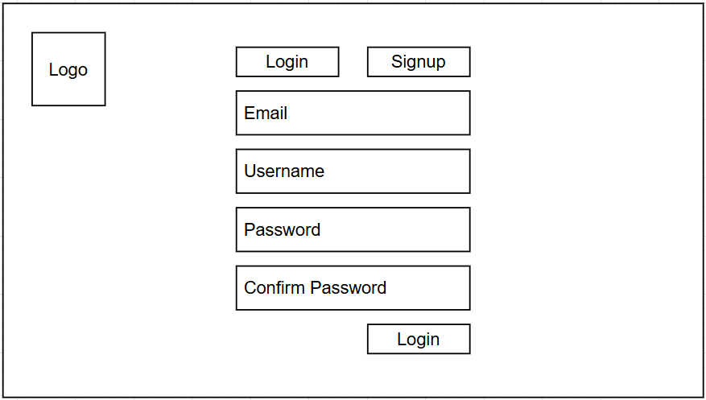

* The sign-up page will require an email address, username and password. An email address is required so that the admin can easily verify each user and efficiently manage each user. It also negates the possibility that a user may register and use the site for illicit purposes as an email address will be associated with each user.

Sections Page (User):

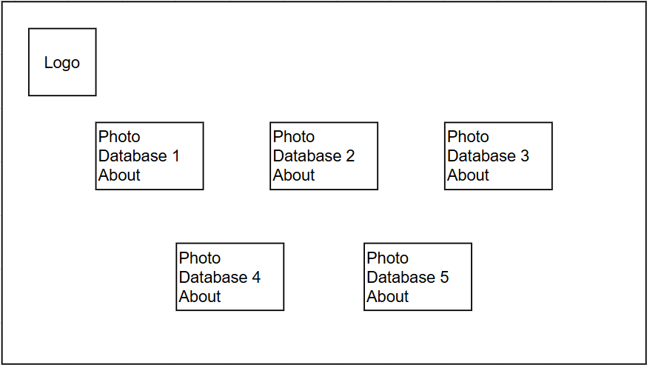

* After registering and logging in, there will be two paths. For the user, you will be directed to the sections page where you have an overview of all 5 sections(databases), with a photo and a brief about section. Both the photo and the name of the database will be clickable and once clicked, the user will be redirected to that specific database webpage.
* It is much better to have two paths and keep the user and admin redirected to different webpages because the admin will have more tools available to manipulate the database which requires no interference from the user side. Once the admin has made changes to the database, it will be updated to the user side as well.

Sections page (Admin):

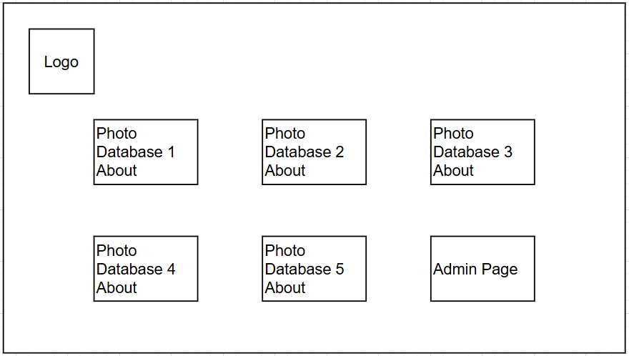

* If the administrator logs in then he will be directed to the admin sections page, where just like the user, can access and view all 5 database webpages but there is a 6th section to click and be redirected to the admin page.

Records Display:

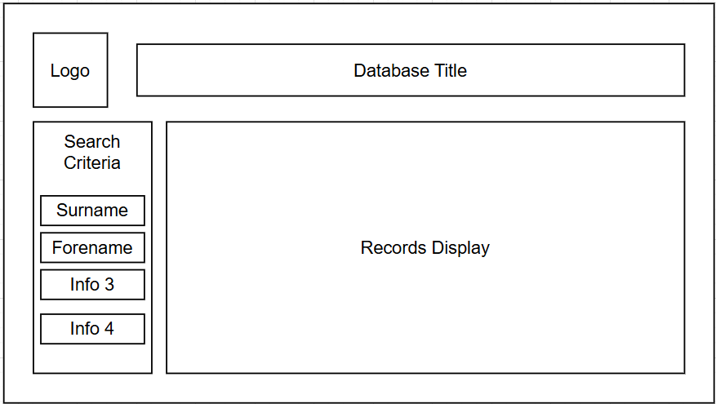

* After the user has clicked one of the sections, they will be redirected to the database webpage where they can access the records. there will be a search criteria on the left side to create a form and refine the search. This layout ensures that the user can easily view all records on the page and if they want to fill a form (refine the search) then they can search from the left of the page.

Admin Page:

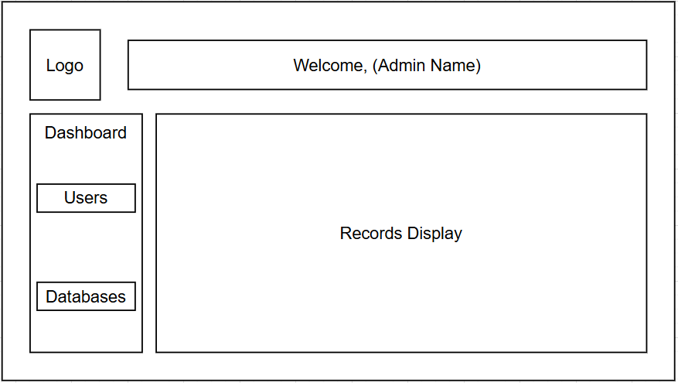

* The admin page will have two sections where you can access the user’s database – view all user data and delete users as well. The other section will be accessing the databases and making changes to each database. – creating new records, deleting existing records and batch removing and adding data. This layout is also kept simple yet will be fully functional to minimize any errors when making changes and overall easy navigation for the admin.

Configure Database Section:

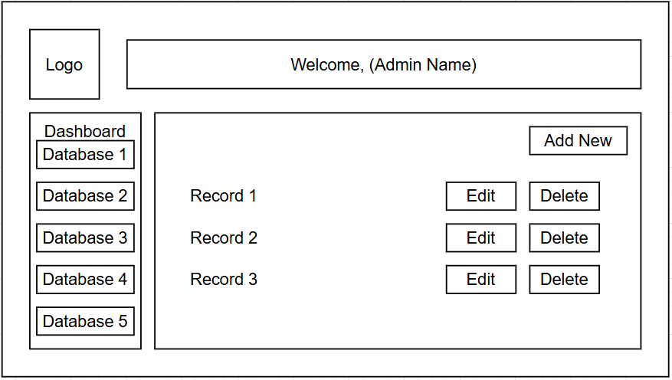

* For the admin database section, there will be a side dashboard to access each database and in the middle of the webpage will be where the admin can see each record and its associated columns (D.o.B, Regiment, Memorial location…) depending on which database they want to make changes on. The admin will be able to edit each record to correct any errors and be able to delete each record as well. Additionally, there will be a button to add new records where under each field, data is entered and stored as a new record after clicking save.
* the user section will be the same as this except it will show each user, their associated email address and password encrypted. – the admin will be able to delete any user from the database and also be able to add a new user directly from the admin page.

**5. LSEPI and Risk Assessment**

Legal Issues:

1. Access Control:

Ensuring that only authorised users, such as the admin role, can access, modify or delete records of the database, this is crucial to prevent unauthorised data manipulation.

1. Copyright and Intellectual Property:

Research data that has been included in this project, maybe copyrighted materials and personal contributions from the Bradford WW1 research group. Therefore, to ensure that this data is secure, proper attribution and permission must be managed.

1. Data Protection Laws:

The database stores and contains research records that include personal and sensitive information. Use of sensitive information, it must be compliant with data protection regulations, to ensure lawful data handling.

Social Issues:

1. Public Interest:

This project is preserving WW1 research, therefore historical research that benefits the community and academic circles. Making this information accessible is essential to other researcher, historians and to educate the public.

1. Digital Inclusion:

The web interface and database should be easy for the user to use, as it must be able to cater to users of different levels of technical expertise.

1. Historical Sensitivity:

These historical records include sensitive content; therefore, considerations must be considered when it is used ethically.

Ethical Issues:

1. Accuracy and Integrity:

The information and data that is gathered by the research group and going to be used in the database must be accurate, no misinformation to maintain historical credibility.

1. Privacy and Content:

Sensitive, personal information is being included, so it is necessary that consent has been given before the data is used.

1. Bias and Representation:

These records are to be shown neutrally without any bias or misrepresentation from a historical perspective.

Professional Issues:

1. Reliability:

The systems that are being made are to be robust, to prevent crashes, data loss or security breaches.

1. Usability Standards:

The web interface should be able to adhere to the standard usability practices to ensure ease of use.

1. Documentation and Support:

A user manual will be provided along with the web interface and database to ensure non-technical users can educate themselves on using the system.

Security Aspects:

Authentication and Authorisation:

* User roles such as admin and guest, must be assigned the correct permission for the right data privileges.

Encryption:

* User login credentials should be encrypted otherwise in transit and at rest (or when being stored) ensuring safety of the data.

Logging and Monitoring:

* The system’s activity should be tracked and logged when data is modified through authorised and unauthorised access, maintaining security in the system.

Risk Assessment and Mitigation:

|  |  |  |
| --- | --- | --- |
| Risk | Potential Impact | Mitigation Solution |
| Data Breach | Unauthorised access to sensitive records | Implement encryption of data and authorisation control measure over the database |
| System Downtime | Loss of access to research data | Regular system backups |
| Data Corruption | Loss or modification of data and records | Implement data validation and integrity checks of the data and records contained |
| User Error | Accidental Data deletion and modification | Implement user roles with correct privileges with audit logging for example to the correct user roles. |

**6. Work Plan**

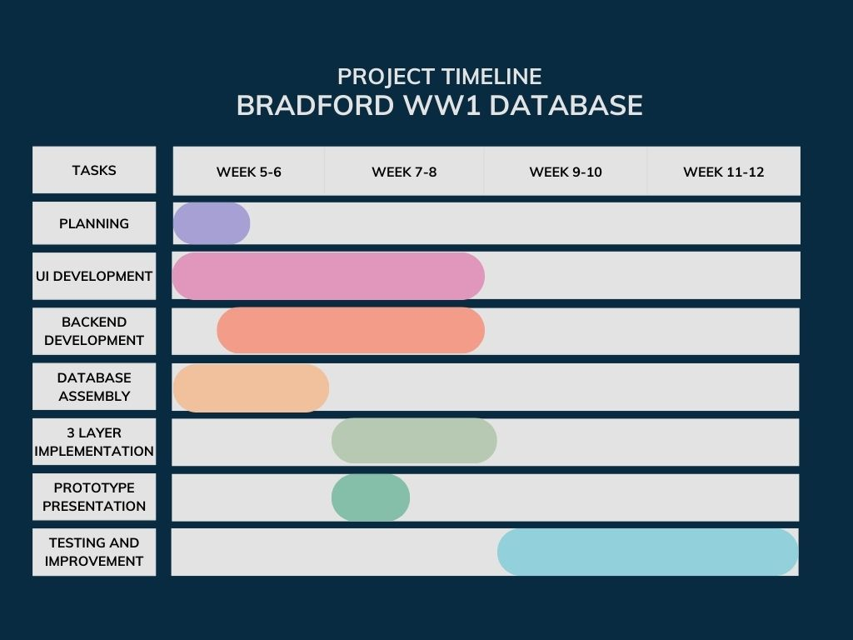

**7. GitHub Link**

**8. Peer Review**