Internet Technologies

Development of a Dynamic Website

Tawseef Abdullah

UB: 22071169

**Purpose of the website**

The purpose of this website is to demonstrate my learning of and ability to use HTML, CSS, Javascript, PHP and SQL. The website store user and product information as well as display products to the user.

I chose Arcane Emporium, a fantasy ecommerce website, to make sure I can stay focused and motivated while working on the website. Because of this, it was easier for me to choose the colour theme, fonts, background images and the general layout of the website.

Here are the sketches of my webpages.

**Main Page**

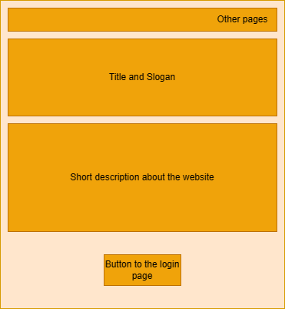

**Login/Signup Page**

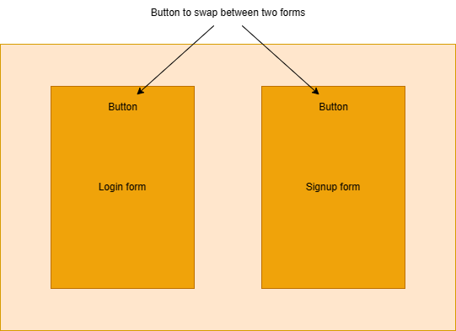

**Admin Panel Page**

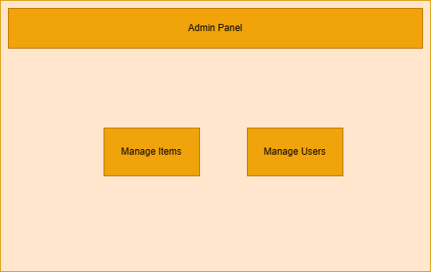

**Admin Manage Items/Users**

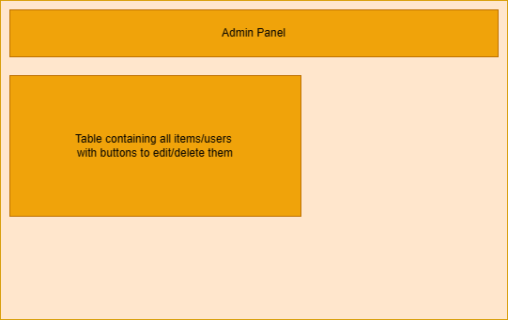

**Shop Page**

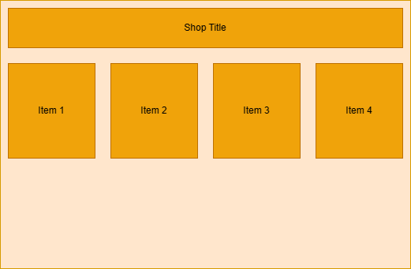

References:

<https://youtu.be/L5WWrGMsnpw?si=FhRnxtn43NMQTFrr>

<https://youtu.be/bOqTCDfc7Tk?si=yI67iQ7zK7uUa-Vf>

<https://youtu.be/5L9UhOnuos0?si=GDuVCoaZDO00pKMs>

<https://youtu.be/NqP0-UkIQS4?si=8-CHCXvxVU7w6FVa>

<https://youtu.be/1bUc4tMX7i4?si=gsbIgnS2HZovYkJ_>