E‑Commerce Single Store
Client Documentation (Features, Admin Guide, Setup & Operations)
Generated on: 2026-05-09

1. Overview
This project is a single‑store e‑commerce system consisting of a customer website, an admin dashboard, and a backend API.
- Storefront: product browsing, cart, checkout, order tracking, user account features.
- Admin panel: manage products, categories, banners, orders, shipping zones, payment methods, coupons, reports, and website settings.
- Backend: Node.js/Express API with MongoDB persistence and optional integrations (email, courier, analytics).
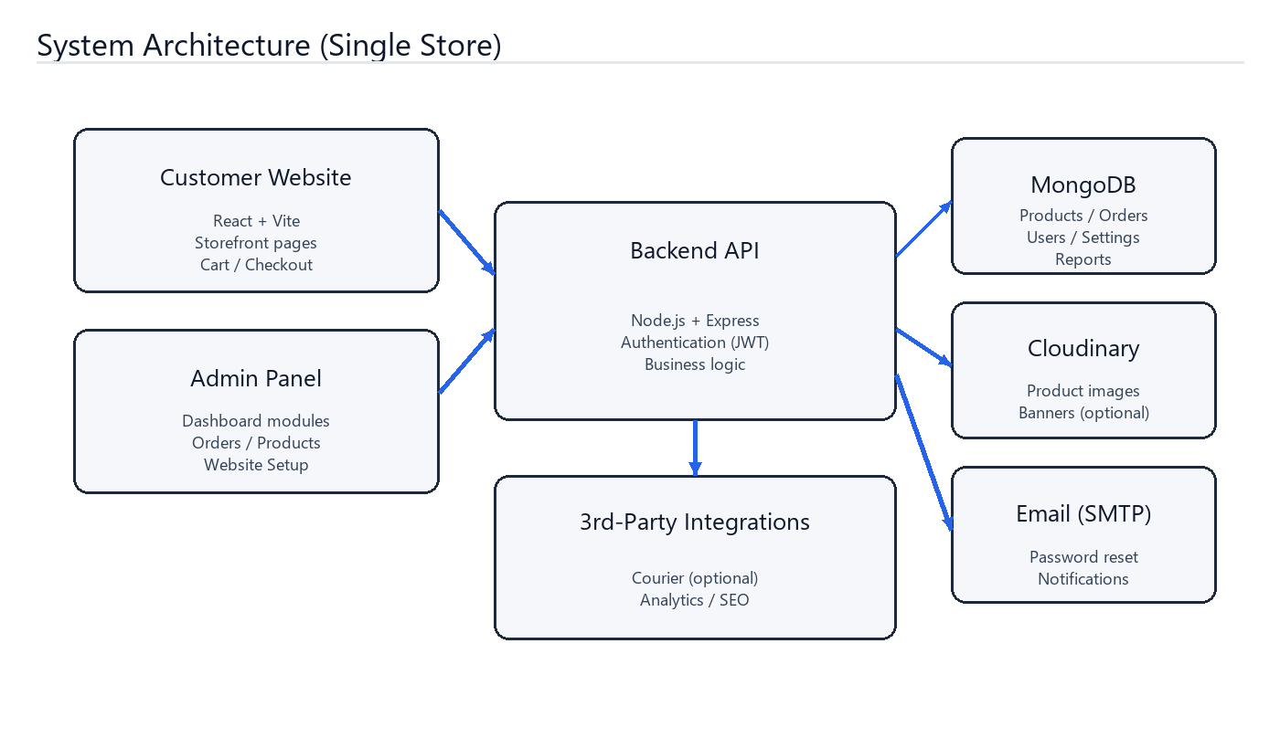
Figure 1 — System Architecture (Single Store).

2. Customer‑Facing Features (Storefront)
- Product catalog: browse products, categories, and brands.
- Product details: images, descriptions, and reviews (where enabled).
- Cart & checkout: add to cart, update quantities, and place orders.
- Shipping calculation: shipping costs are controlled by admin‑configured shipping zones.
- Coupons/discounts: customers can apply coupon codes at checkout (if configured).
- Order tracking: track an order from the public tracking page.
- Customer account: registration/login, saved addresses, order history, wishlist.
- Pages: about, contact, FAQs, policy pages, and marketing landing pages by slug.

3. Admin Panel (Dashboard) — What You Can Manage
Admins access the dashboard at `/dashboard` after logging in.
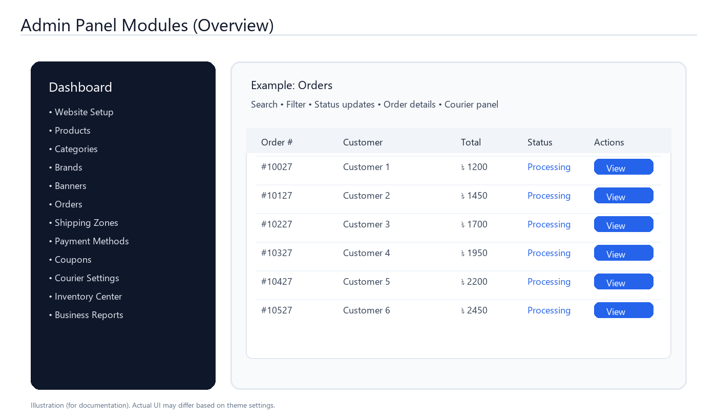
Figure 2 — Admin Panel Modules (Illustration).

3.1 Main Admin Modules
- Website Setup: store branding, theme settings, pages, landing pages, and policies.
- Catalog: products, categories, brands, and homepage banners.
- Orders: view/update orders, add manual orders, and (optionally) courier/consignment tools.
- Commerce: shipping zones, payment methods, coupons.
- Operations: inventory center, abandoned orders, customer risk controls, support tickets.
- Insights: business reports, SEO & analytics dashboards.
- Security: admin users, roles/permissions (super admin can control restricted modules).

4. Order Lifecycle (How Orders Flow)
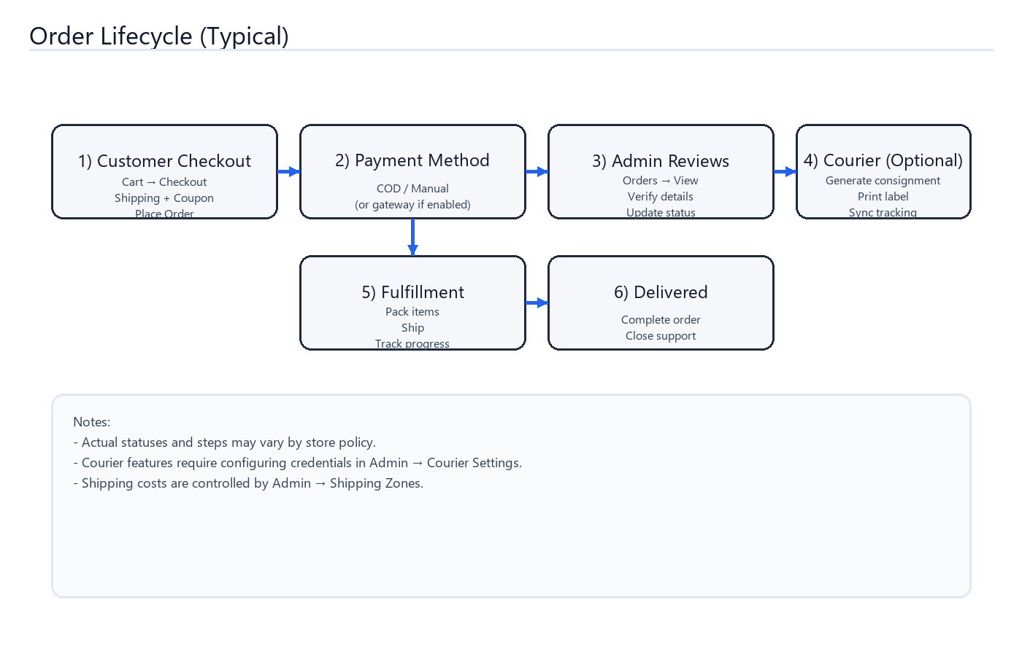
Figure 3 — Typical Order Lifecycle.

5. Environment & Prerequisites
- Node.js (backend + frontend).
- MongoDB (database).
- Cloudinary account (recommended for image hosting).
- SMTP email account (recommended for password reset and store emails).

6. Quick Start (Local Development)

6.1 Backend setup
From the repository root:
cd backend
copy .env.example .env (Windows PowerShell: Copy-Item .env.example .env)
npm install
npm run dev
Backend default port: `5000` (configurable via `backend/.env`).

6.2 Frontend setup
cd frontend
copy .env.example .env (Windows PowerShell: Copy-Item .env.example .env)
npm install
npm run dev
Frontend default dev URL: `http://localhost:5173`.

6.3 MongoDB setup
- Install MongoDB locally or use a managed MongoDB cluster.
- Set `MONGODB_URI` in `backend/.env` (example: `mongodb://localhost:27017/ecommerce_office`).

7. Production Notes (Deployment Checklist)
- Set strong `JWT_SECRET` in production.
- Set `NODE_ENV=production` on the backend.
- Update `FRONTEND_URL` in `backend/.env` to your deployed frontend URL.
- Update `VITE_API_URL` in `frontend/.env` to your deployed backend API URL (ending with `/api`).
- Ensure MongoDB backups are configured.
- Ensure uploads/media are persisted (Cloudinary recommended).

8. First‑Time Admin Setup (Required)
Important: the first user registered in a fresh database becomes the primary Admin (and Super Admin).
- Start backend + frontend with an empty MongoDB database.
- Open the website and register your first account (name/email/phone/password).
- Log in and open `/dashboard` to access Admin modules.
- Immediately update environment secrets and keep admin credentials private.

9. Operating the Store (Admin How‑To)
This section explains the recommended day‑to‑day workflows inside the Admin Panel. Exact labels can differ slightly depending on your theme and enabled modules.

9.1 Website setup
- Set store name, contact details, and theme/branding settings.
- Configure homepage banners and highlight content.
- Create landing pages for marketing campaigns (URL: `/lp/<slug>`).
- Maintain policy pages (URL: `/policy/<policyType>`).
Recommended first steps (in order): set branding → add banners → add policies → create landing pages.

9.2 Catalog management
- Create categories and brands first, then add products.
- For each product: title, price/sale price, stock, images, category, and description.
- Optional: add SKU, low-stock threshold, and product variations (if used by your store).
- Use the modify product module for editing, disabling, or removing items from sale.
- Suggested workflow: Categories → Brands → Products → Review the storefront product page.
- Tip: keep product titles consistent and use clear photos for better conversion.

9.3 Shipping zones
- Create shipping zones to control delivery costs by region.
- Review shipping prices periodically and update based on courier rates.
If shipping looks incorrect during checkout, re-check shipping zones first.

9.4 Payment methods
- Enable and configure available payment methods (e.g., Cash on Delivery, manual bank/bKash instructions).
- Confirm checkout and order confirmation behavior using a test order.
Payments are customer-facing: always place at least one test order after changes.

9.5 Orders (daily workflow)
- Open Orders and review new orders.
- Confirm customer information, address, and items.
- Update order status as you process (processing → shipped → delivered, depending on policy).
- Use the Add Order module to place an order manually when needed (phone/in‑store orders).
- Recommended daily routine: check new orders → confirm stock → pack → dispatch → sync tracking → close tickets.
- If a customer asks for changes, update the order before shipping and keep an internal note (if supported).

9.6 Courier integration (optional)
If courier integration is enabled and configured, the admin can generate consignments, print labels, and sync tracking updates from the order details view.
- Open Admin → Courier Settings and enter courier credentials.
- Open an order, generate a courier consignment, then print/download label (if supported).
- Use “Sync Status” to pull the latest tracking state into the order record.

9.7 Reports, SEO & analytics
- Use Business Reports for sales trends, order summaries, and performance snapshots.
- Use SEO & Analytics to monitor page performance and marketing impact.
- Follow the Google Analytics setup guide if you want GA tracking enabled.

9.8 Support & customer risk
- Support Tickets: track customer issues and close them after resolution.
- Customer Risk: review suspicious customers, blacklist abusive buyers if needed.
- Abandoned Orders: review incomplete checkouts and follow up (process-based).

9.9 Admin users & permissions
The first registered user in a new database becomes Admin and also Super Admin. Super Admin can control restricted modules and permissions.
- Create separate admin accounts for staff (do not share one password).
- Grant only the modules each staff member needs (least privilege).
- Remove access promptly when staff roles change.

10. Security, Backup & Maintenance

10.1 Security essentials
- Use a long, unique `JWT_SECRET` in production.
- Use strong admin passwords (8+ characters minimum; longer recommended).
- Keep server access (SSH / hosting panel) limited to trusted operators.
- Prefer Cloudinary (or durable object storage) for images to avoid losing uploads on redeploy.

10.2 Backups
- MongoDB: schedule automated backups (daily recommended).
- Media: ensure Cloudinary account access is secured; export critical assets if required by policy.
- Config: keep `.env` values in a secure password manager (never commit secrets).

10.3 Routine maintenance
- Review order/report dashboards weekly to spot issues early.
- Check email deliverability monthly (password resets, notifications).
- Keep Node.js and dependencies updated during scheduled maintenance windows.

11. Troubleshooting (Common Issues)

11.1 API not reachable from the website
- Check `frontend/.env` → `VITE_API_URL` points to the backend `/api` base URL.
- Check backend CORS: `backend/.env` → `FRONTEND_URL` matches the deployed frontend URL.
- Confirm backend is running and reachable on its port (default 5000).

11.2 Emails not sending
- Verify SMTP credentials in `backend/.env` (`EMAIL_HOST`, `EMAIL_PORT`, `EMAIL_USER`, `EMAIL_PASS`).
- If using Gmail, use an App Password (not your normal Gmail password).
- Check server logs for SMTP authentication errors.

11.3 Image upload issues
- Confirm Cloudinary keys are set in `backend/.env`.
- If using local uploads, ensure the backend `uploads/` directory is writable and persisted.

11.4 Courier integration issues (optional)
- Re-check courier credentials and provider settings in Admin → Courier Settings.
- Use the courier troubleshooting FAQ documents for provider-specific error codes.

12. Appendix: Key Configuration Variables
Backend (`backend/.env`) highlights:
PORT=5000
NODE_ENV=development
MONGODB_URI=mongodb://localhost:27017/ecommerce_office
JWT_SECRET=replace-with-secure-secret
FRONTEND_URL=http://localhost:5173
CLOUDINARY_CLOUD_NAME=...
CLOUDINARY_API_KEY=...
CLOUDINARY_API_SECRET=...
EMAIL_HOST=smtp.gmail.com
EMAIL_PORT=587
EMAIL_USER=...
EMAIL_PASS=... (Gmail App Password recommended)
Frontend (`frontend/.env`) highlights:
VITE_API_URL=http://localhost:5000/api

13. Additional Project Guides
- Courier integration: `COURIER_QUICK_SETUP.md`, `COURIER_INTEGRATION_GUIDE.md`, `COURIER_TROUBLESHOOTING_FAQ.md`
- Google Analytics: `GOOGLE_ANALYTICS_SETUP.md`

