**Comprehensive Vulnerability Analysis and Remediation on Metasploitable**

Tawsif Chowdhury  
Information Systems Security  
Concordia University   
Montreal, QC, Canada  
tawsifulhye@gmail.com

**Executive Summary**

This report documents the results of a vulnerability assessment conducted on a Metasploitable2 machine using OpenVAS and Nikto. The objective was to identify high-risk vulnerabilities and propose actionable remediation steps. The scan revealed several critical security flaws, including remote code execution vulnerabilities, backdoors, and misconfigurations in web services. Immediate remediation is recommended to prevent exploitation.

**Test Environment**: Kali Linux 2025.1(Scanner Host), Metasploitable2(Target Host).

**Tools Used**: Nmap, OpenVAS, Nikto.

**Network Reconnaissance**

At first, we need to find out the network of the scanner host connected.

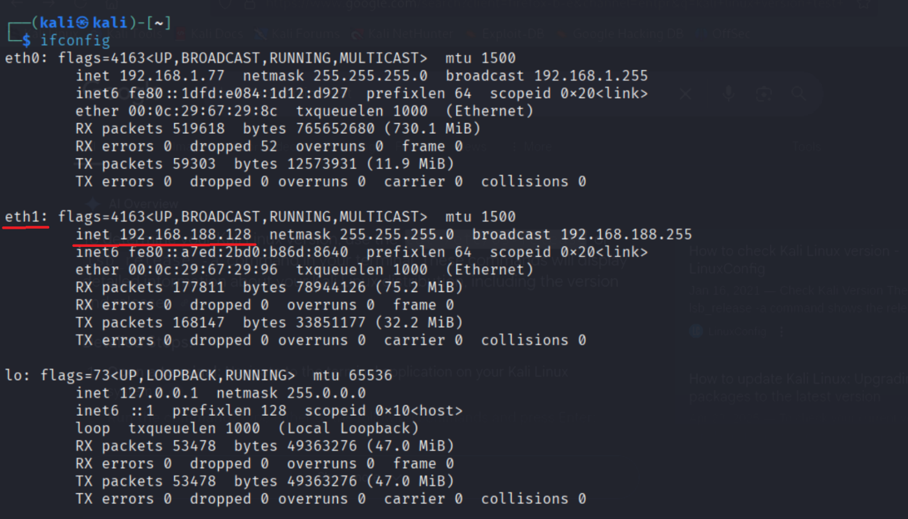

Use Nmap to discover open ports and services.

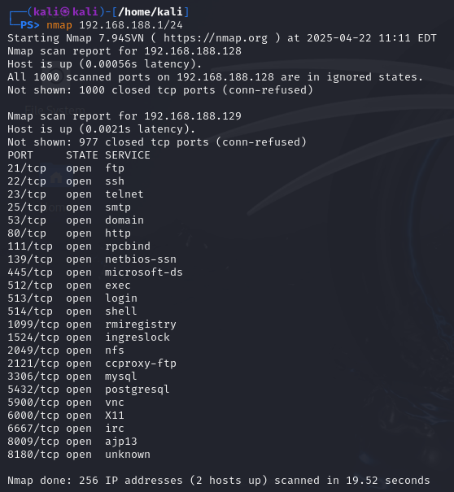

From the scan, it can be found that Metasploitable has the IP address **192.168.188.129.** Now let’s run another command to scan for versions of the open ports.

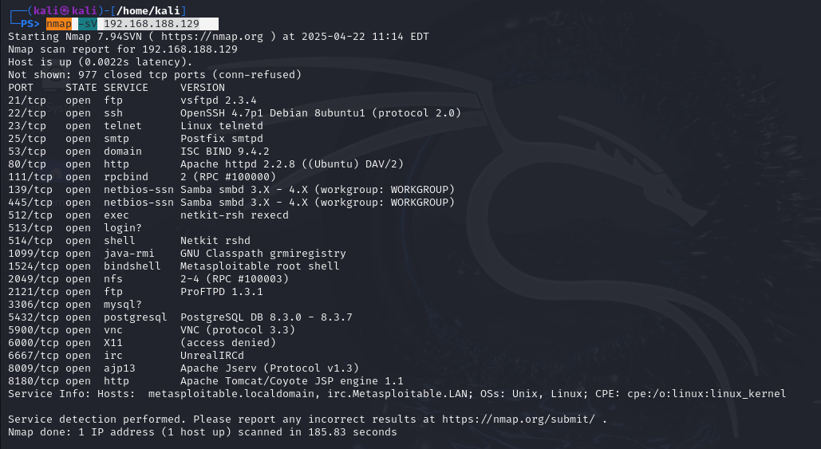

So from the output of the scan, it can be seen that the target system is vulnerable with several open ports. To get detailed overview

**OpenVAS Scan Workflow**

OpenVAS (Open Vulnerability Assessment System) is a powerful, free, and open-source framework used for scanning and assessing network vulnerabilities. It is part of the Greenbone Vulnerability Management (GVM) platform, which provides comprehensive solutions for identifying, classifying, and managing vulnerabilities in IT systems.

Before starting with OpenVAS, it is necessary to update the feed to. To update use the following command *sudo greenbone-feed-sync,* it takes time to update, by this time OpenVAS scan cannot be run. Run *sudo gvm-start* to start the OpenVAS in browser. To check update go to *Feed Status* under *Administration.* You can see all the status are current.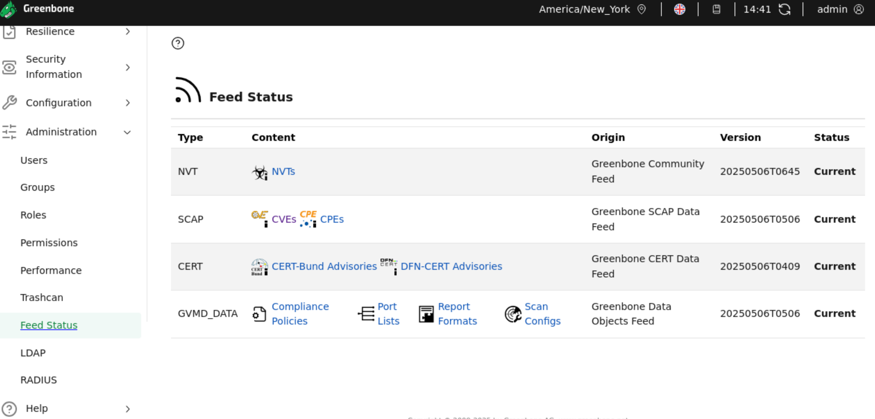

Now let’s run the scan. First, we have to create a task following the attached workflow.

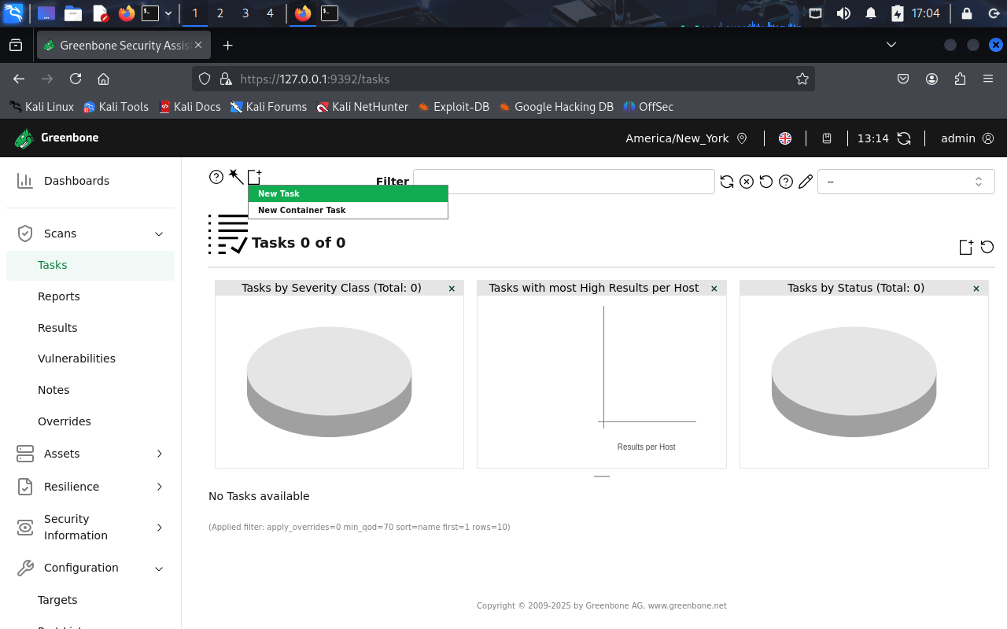

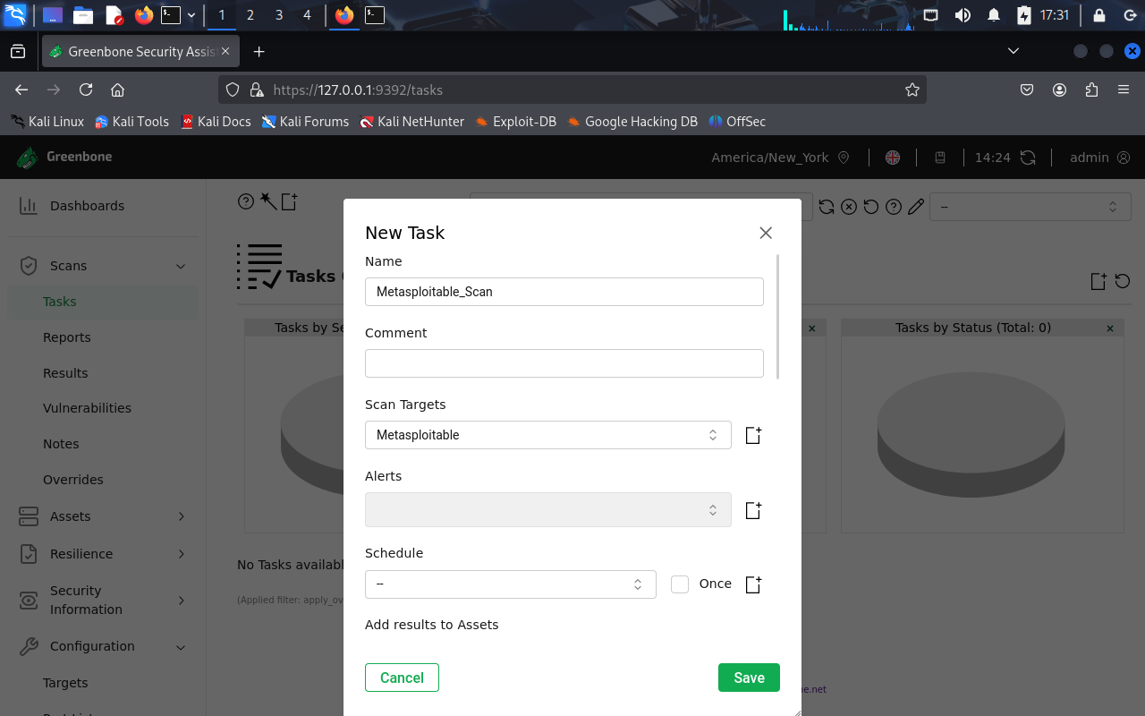

After adding the required configuration click on ‘Save’ to create a task. Click ‘Start’ button to start the scan.

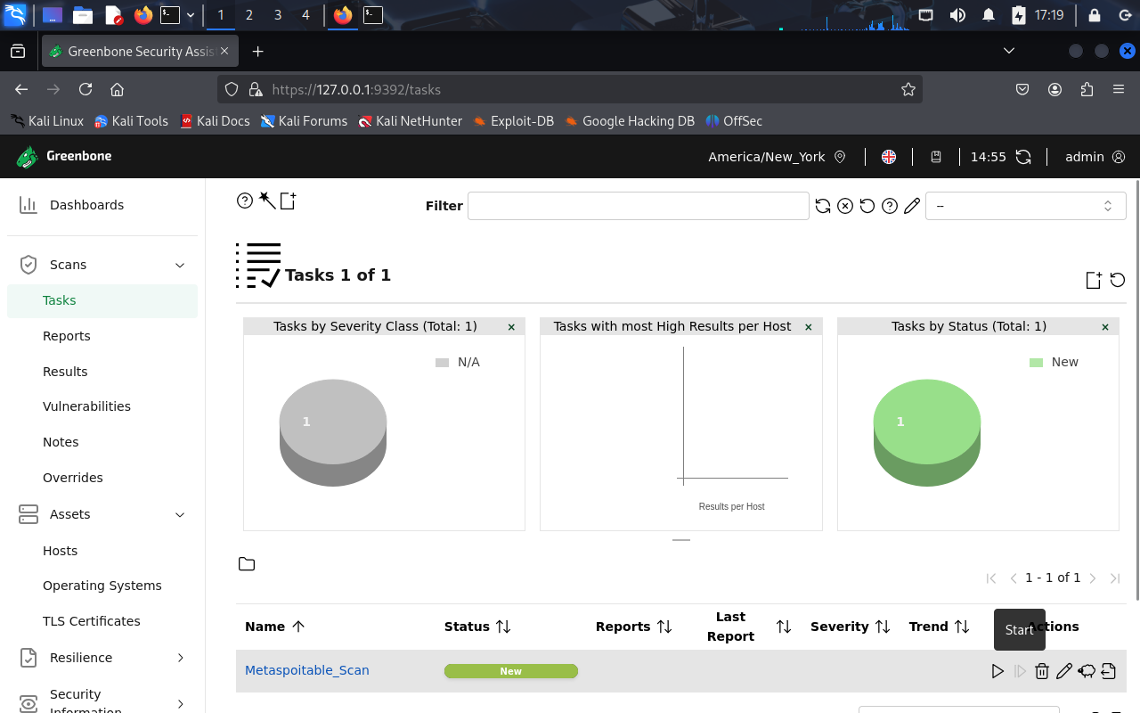

After the scan is over the report shows the vulnerability found.

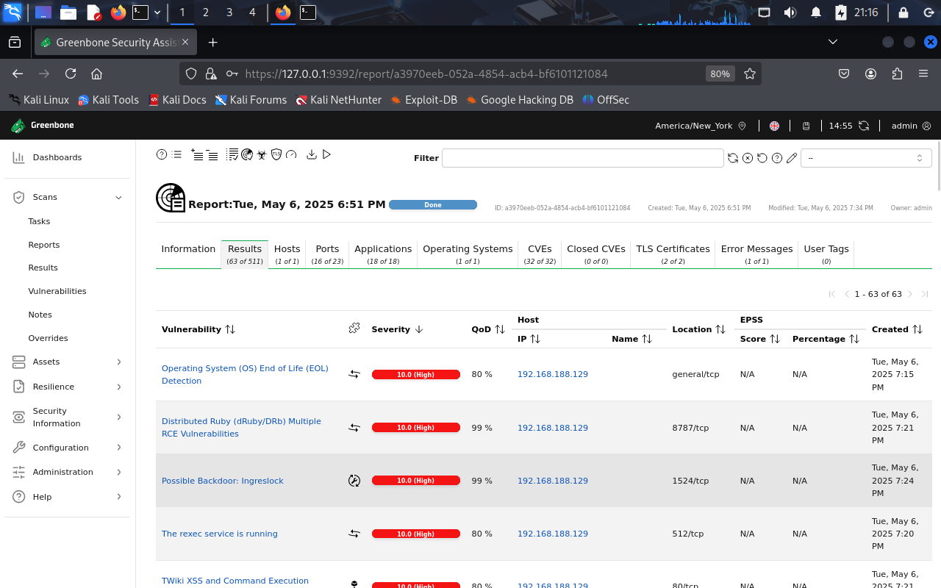

From the OpenVAS report, five high-severity vulnerabilities have been selected for analysis.

1. **vsftpd Compromised Source Packages Backdoor Vulnerability (CVE-2011-2523)**

* **Severity:** High (CVSS 9.8).
* **Description:** vsftpd 2.3.4 downloaded between 20110630 and 20110703 contains a backdoor which opens a shell on port 6200/tcp.
* **Detection Tool:** OpenVAS (Scan Date: May 6, 2025).
* **Evidence:** vsFTPd FTP Server Detection. OID: .3.6.1.4.1.25623.1.0.103185.
* **Impact:** Attackers can exploit this issue to execute arbitrary commands in the context of the application. Successful attacks will compromise the affected application.
* **Remediation:** 
  + Type: VendorFix.
  + The repaired package can be downloaded from the referenced vendor homepage. Please validate the package with its signature.

1. **DistCC RCE Vulnerability (CVE-2004-2687)**

* **Severity:** High (CVSS 9.3)
* **Description:** distcc 2.x, as used in XCode 1.5 and others, when not configured to restrict access to the server port, allows remote attackers to execute arbitrary commands via compilation jobs, which are executed by the server without authorization checks.
* **Detection Tool:** OpenVAS (Scan Date: May 6, 2025)
* **Evidence:** Version used: 2022-07-07T10:16:06Z.
* **Impact:** DistCC by default trusts its clients completely that in turn could allow a malicious client to
* execute arbitrary commands on the server.
* **Remediation:** 
  + Type: VendorFix.
  + Restrict network access.
  + Configure distcc for greater security.

1. **Apache Tomcat AJP RCE Vulnerability (Ghostcat) (CVE-2020-1938)**

* **Severity:** High (CVSS 9.5)
* **Description:** Apache Tomcat is prone to a remote code execution (RCE) vulnerability (dubbed 'Ghostcat') in the AJP connector. Apache Tomcat server has a file containing vulnerability, which can be used by an attacker to read or include any files in all webapp directories on Tomcat, such as webapp configuration files or source code.
* **Detection Tool:** OpenVAS (Scan Date: May 6, 2025)
* **Evidence:** It was possible to read the file "/WEB-INF/web.xml" through the AJP connector.
* **Impact:** Apache Tomcat server has a file containing vulnerability, which can be used by an attacker to read or include any files in all webapp directories on Tomcat, such as webapp configuration files or source code.
* **Remediation:** 
  + Type: VendorFix.
  + Update Apache Tomcat to version 7.0.100, 8.5.51, 9.0.31 or later.

1. **Java RMI Server Insecure Default Configuration RCE Vulnerability - Active Check (CVE-2011-3556)**

* **Severity:** High (CVSS 7.5)
* **Description:** Multiple Java products that implement the RMI Server contain a vulnerability that could allow an unauthenticated, remote attacker to execute arbitrary code (remote code execution/RCE) on a targeted system with elevated privileges.
* **Detection Tool:** OpenVAS (Scan Date: May 6, 2025)
* **Evidence:** By doing an RMI request it was possible to trigger the vulnerability and make th e remote host sending a request back to the scanner host
* **Impact:** An unauthenticated, remote attacker could exploit the vulnerability by transmitting crafted packets to the affected software. When the packets are processed, the attacker could execute arbitrary code on the system with elevated privileges.
* **Remediation:** 
  + Type: Workaround.
  + Disable class-loading.

1. **NVT: UnrealIRCd Authentication Spoofing Vulnerability (CVE-2016-7144)**

* **Severity:** High (CVSS 8.1)
* **Description:** UnrealIRCd is prone to authentication spoofing vulnerability.
* **Detection Tool:** OpenVAS (Scan Date: May 6, 2025)
* **Evidence:** The flaw exists due to an error in the 'm_authenticate' function in 'modules/m_sasl.c' script.
* **Impact:** Successful exploitation of this vulnerability will allow remote attackers to spoof certificate fingerprints and consequently log in as another use.
* **Remediation:** 
  + Type: VendorFix.
  + Upgrade to UnrealIRCd 3.2.10.7, or 4.0.6, or later.

**Web Server Scanning Using Nikto**

Nikto is a free, open-source web server scanner that identifies vulnerabilities and misconfigurations on web servers. It's used to assess the security of websites and web applications by checking for dangerous files, outdated software, and other security risks.

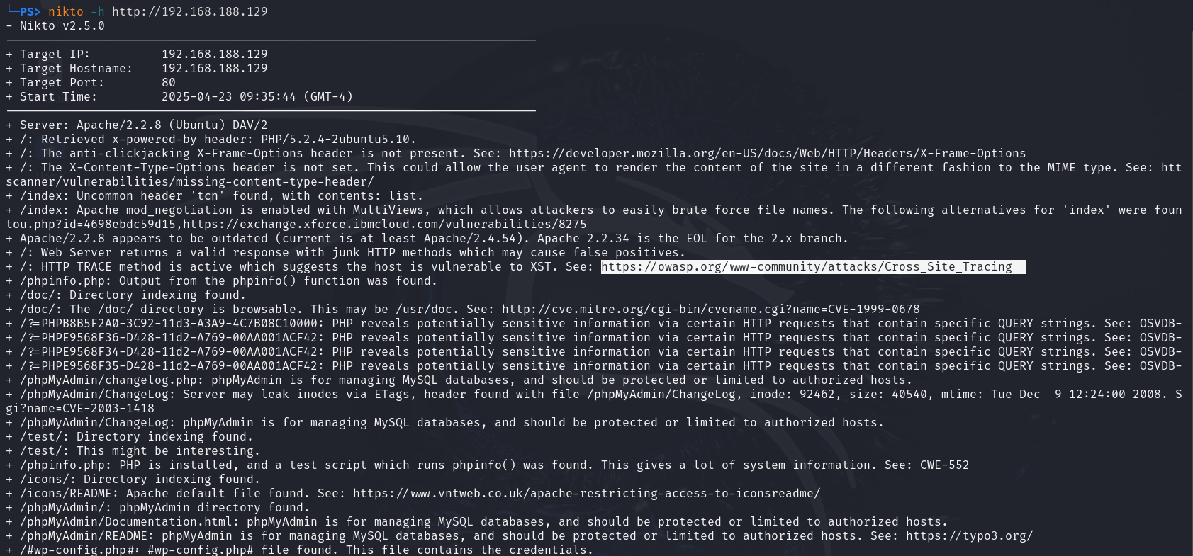

Based on the Nikto scan results from your screenshot (http://192.168.188.129), here are the key findings:

|  |  |  |  |
| --- | --- | --- | --- |
| **Issue** | **Description** | **CVE/Reference** | **Risk** |
| Outdated Apache | Apache/2.2.8 is outdated | - | High |
| Missing Headers | Lacks X-Frame-Options, X-Content-Type-Options | OWASP | Medium |
| TRACE Method Enabled | Allows XST attacks | OWASP | Medium |
| Directory Indexing | /usr/doc exposed | CVE-1999-0678 | Medium |
| phpinfo.php | Full system disclosure | OSVDB-12184 | High |
| phpMyAdmin Directory | Accessible without auth | CVE-2003-1418 | High |

**Recommendations**

1. **Apply all vendor-released patches** to close known CVEs.
2. **Restrict network services** such as FTP, RMI, and DistCC to internal, authenticated users.
3. **Harden Apache web server configuration**:

* Disable TRACE.
* Remove sensitive scripts (e.g., phpinfo.php).
* Enforce security headers.

1. **Limit access to administrative directories** such as /phpMyAdmin/.

**Conclusion**

This vulnerability assessment of the Metasploitable2 virtual machine demonstrates the importance of continuous security evaluation and prompt remediation. Utilizing tools such as OpenVAS and Nikto, several critical and high-severity vulnerabilities were uncovered, including remote code execution backdoors, misconfigured services, and web server weaknesses. If these vulnerabilities existed in a production environment, they would pose a significant threat to the confidentiality, integrity, and availability of systems and data.

To mitigate these risks, organizations should enforce strict network access controls, regularly update software, harden service configurations, and adopt a defense-in-depth approach. Timely patch management, combined with consistent vulnerability assessments, is essential to maintaining a strong security posture.