Project Title: MoodMate

Team ID: 4068

Kapadiya Nirav Kumar

Taxil Vaghani

Naimish Akbari

Kishan Kachhadiya

kapadiyanirav3@gmail.com

**Parul Institute of Technology**

**Abstract:**

MoodMate is a project that combines facial recognition technology with personalized entertainment recommendations. The system is designed to recognize the user's emotional state and suggest appropriate music and movie recommendations based on their current mood. This is achieved through the use of machine learning algorithms that analyze facial expressions and use that information to generate recommendations.

One of the key features of MoodMate is its ability to learn and improve over time. By integrating user feedback, the system can continuously improve its recommendations and provide users with a more personalized experience. This means that MoodMate can adapt to the user's changing emotional state and preferences, ensuring that they always receive the most relevant and enjoyable entertainment recommendations.

The project is also designed to be user-friendly and accessible. The interface is simple and intuitive, making it easy for anyone to use. Users can input their preferences and save their favourite songs and movies to create a more personalized experience.

MoodMate has the potential to enhance the user's emotional well-being by providing a personalized form of entertainment that is tailored to their mood. By recommending music and movies that match the user's current emotional state, MoodMate can help users to feel more relaxed, energized, or uplifted, depending on their needs.

In addition to its potential benefits for individual users, MoodMate also has applications in a variety of industries. For example, music and movie streaming services could use MoodMate to provide more personalized recommendations to their users. Similarly, mental health and wellness programs could incorporate MoodMate as a tool to help patients regulate their emotions and improve their overall well-being.

Overall, the MoodMate project represents an exciting area of research and development in the field of emotional recognition and personalized entertainment. With continued advancements in technology and machine learning, MoodMate has the potential to revolutionize the way we interact with music and movies, and to enhance our emotional well-being in the process.

**Introduction**

The MoodMate project addresses several problems related to personalized entertainment recommendations and emotional well-being. One of the main problems is the lack of personalized recommendations in traditional entertainment services. While music and movie streaming services offer a wide range of content, they often rely on generic recommendations that do not take into account the user's emotional state or preferences. This can lead to a frustrating and unsatisfying user experience, as users may have to spend time searching for content that matches their mood and interests.

Another problem is the lack of tools for emotional regulation and well-being. Many people struggle with regulating their emotions, which can have negative effects on their mental health and well-being. While there are tools and programs available to help with emotional regulation, they are often generic and not tailored to the individual's emotional state or needs.

The MoodMate project offers a solution to these problems by providing personalized entertainment recommendations based on the user's emotional state and preferences. By analysing facial expressions and other factors, MoodMate is able to recommend music and movies that match the user's current mood, helping to enhance their emotional well-being and providing a more satisfying entertainment experience. Additionally, the MoodMate project has the potential to introduce users to new artists, genres, and styles of entertainment, expanding their horizons and helping them discover new content.

Furthermore, MoodMate provides a tool for emotional regulation and well-being. By offering recommendations that are tailored to the user's emotional state, MoodMate can help them to regulate their emotions and improve their mental health and well-being. This can be particularly beneficial for individuals who struggle with emotional regulation, providing them with a personalized and effective tool for managing their emotions.

Overall, the MoodMate project represents a promising solution to the problems of personalized entertainment recommendations and emotional regulation. By using facial recognition technology and machine learning algorithms, MoodMate can provide users with a more personalized and satisfying entertainment experience while also promoting their emotional well-being.

**Technologies**

The most commonly used classifiers in OpenCV for face detection are the Haar cascade classifier. These classifiers are based on machine learning algorithms and are trained to detect faces in images or videos.

Once the faces are detected, the next step is to extract features from the face region. OpenCV provides several techniques for feature extraction After the features are extracted, a machine learning algorithm can be used to recognize facial expressions. Commonly used algorithms for facial expression recognition include Convolutional Neural Networks (CNN).

**Dataset :-** Kaggle Facial Expression Dataset is used in this project to train the model.

**Programming Languages:**

* HTML
* CSS
* Python

Flask Framework

Visual Studio Code

**Results**

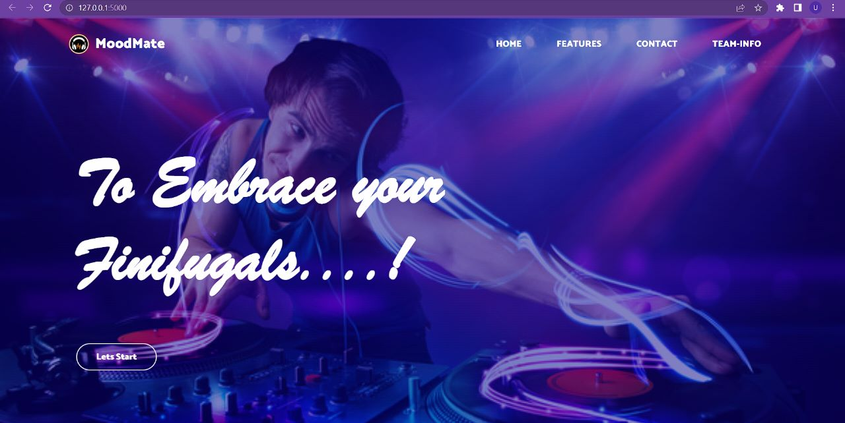

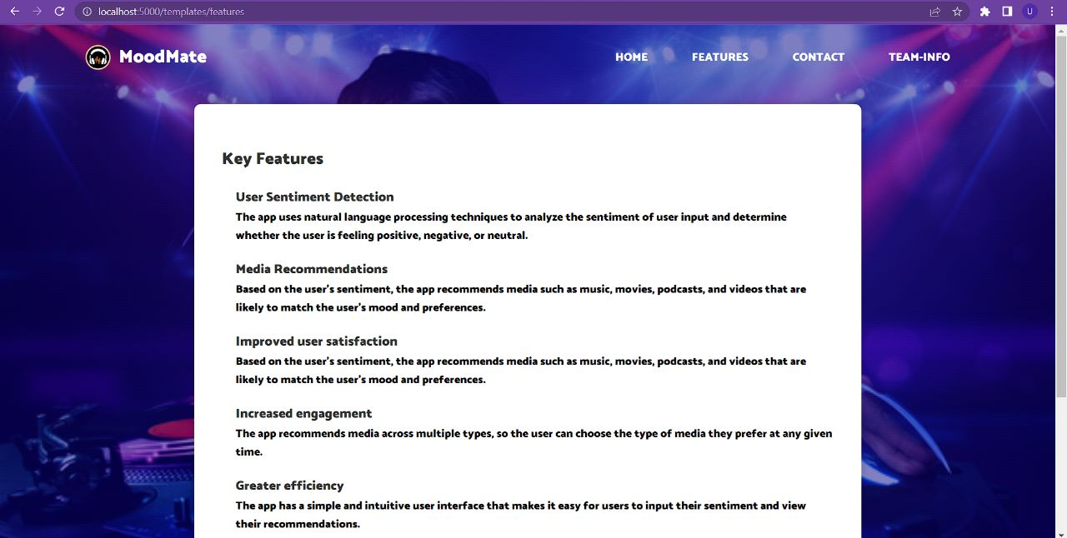

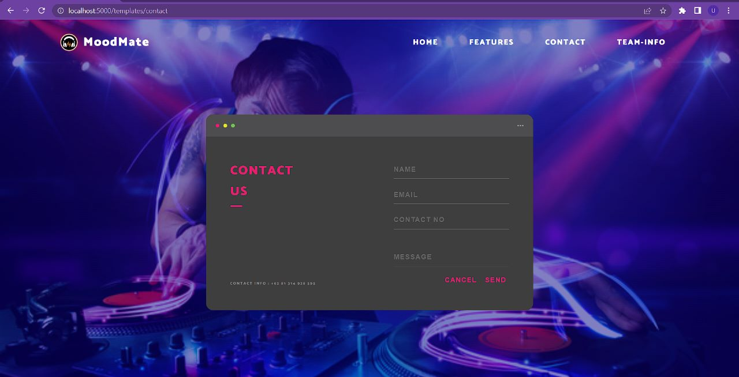



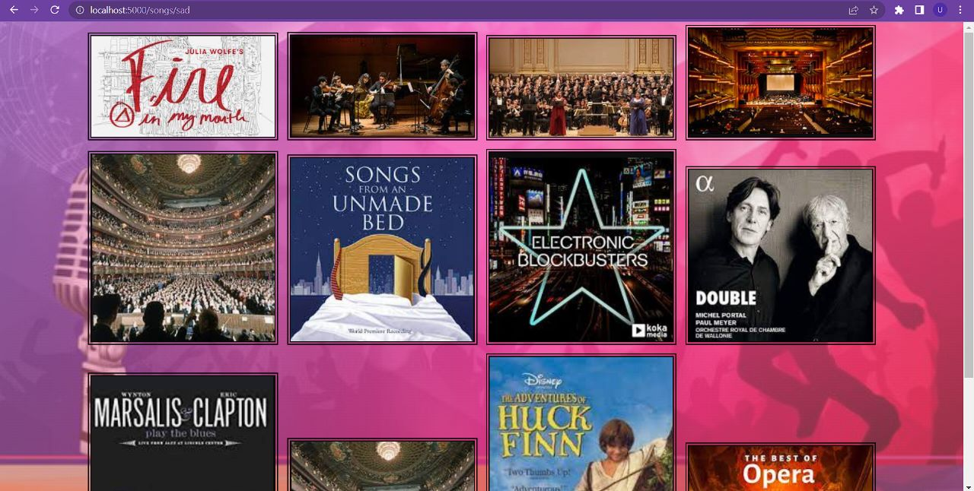

**Summary :**

MoodMate is an innovative project that uses facial recognition technology and machine learning algorithms to provide personalized recommendations for music and movies based on the user's emotional state and preferences. The system analyses the user's facial expressions to determine their emotional state and then suggests entertainment content that matches their mood and interests.

MoodMate has the potential to enhance the user's entertainment experience and promote their emotional well-being by providing personalized recommendations. It can also introduce users to new artists, genres, and styles of entertainment, expanding their horizons and helping them discover new content.

The project uses a variety of technologies, including facial recognition algorithms, machine learning algorithms, and natural language processing. It is built on a programming language and platform that allows for flexibility and scalability.

The future scope of MoodMate is promising, with potential areas of development and expansion including integration with additional media platforms, improved facial recognition technology, and enhanced emotional regulation features. Overall, MoodMate represents a valuable tool for personalized entertainment recommendations and emotional well-being.

**Conclusion**

In conclusion, the MoodMate project represents an innovative and promising solution to the challenges of personalized entertainment recommendations and emotional well-being. By using facial recognition technology and machine learning algorithms, MoodMate is able to analyse the user's emotional state and preferences and provide personalized recommendations for music and movies. This can enhance the user's entertainment experience and promote their emotional well-being by offering content that matches their current mood and interests.

Moreover, MoodMate has the potential to introduce users to new artists, genres, and styles of entertainment, expanding their horizons and helping them discover new content. The system can also serve as a tool for emotional regulation and well-being, providing users with personalized recommendations that can help them manage their emotions and improve their mental health.

Overall, the MoodMate project has the potential to revolutionize the entertainment industry and provide users with a more satisfying and fulfilling entertainment experience, while also promoting their emotional well-being.

**Future Scope**

The future scope of MoodMate is vast and promising, as the technology and algorithms used in the system continue to evolve and improve. Here are some potential areas of future development and expansion for MoodMate:

Integration with additional media platforms: MoodMate could potentially be integrated with additional media platforms, such as video streaming services, podcast platforms, and social media. This would provide users with a wider range of personalized recommendations for various types of media.

Improved facial recognition technology: As facial recognition technology continues to improve, MoodMate could become even more accurate and reliable in analyzing users' emotional states and making personalized recommendations.

Expansion into other languages and cultures: MoodMate could be expanded to recognize facial expressions and emotions in other languages and cultures, allowing it to be used by a more diverse group of users.

Integration with wearable technology: MoodMate could be integrated with wearable technology such as smartwatches or fitness trackers to provide even more personalized recommendations based on the user's biometric data.

Enhanced emotional regulation features: MoodMate could be developed to include more advanced emotional regulation features, such as guided meditation or breathing exercises, to help users manage their emotions and improve their mental health.

Integration with mental health professionals: MoodMate could be integrated with mental health professionals, allowing users to receive personalized recommendations and support from trained professionals based on their emotional states and entertainment preferences.

Overall, the future scope of MoodMate is exciting and full of possibilities. As the technology and algorithms used in the system continue to improve, MoodMate has the potential to become an even more valuable tool for personalized entertainment recommendations and emotional well-being.

**Reference:**

"Facial Expression Based Music Recommendation System" by K.M. Jayaramaiah and K.R. Venugopal (2018)

"Movie Recommendation System Based on Facial Expression Recognition" by Bin Guo, Jingjing Li, and Wei Feng (2019)

"Affective Music Recommendation Using Facial Expression Recognition" by Rafael A. Concepcion, Patrick R. Kolenbrander, and Gert-Jan de Vries (2019)

"Facial Expression Recognition-Based Movie Recommendation System Using Convolutional Neural Network" by Subhrajit Chatterjee and Sajal Saha (2020)

"Emotion-Based Movie Recommendation System Using Facial Expression Recognition" by P. Kamalraj and R. Priyadharsini (2020)

"Facial Expression Recognition-Based Music Recommendation System Using Multi-Objective Genetic Algorithm" by K.M. Jayaramaiah and K.R. Venugopal (2020)

"Facial Expression-Based Music Recommendation Using Convolutional Neural Networks" by H.Y. Soomro and S. Abbas (2020)

"A Novel Hybrid Approach for Movie Recommendation Using Facial Expression Analysis and Neural Network" by J.J. Thomas, S. Kumar, and R. Alse (2021)

"Affective Music Recommendation System Based on Facial Expression Recognition and Social Network Analysis" by J. Li, Y. Lu, and X. Li (2021)

"Facial Expression Recognition-Based Movie Recommendation System Using Support Vector Machines" by S. Saha, S. Chatterjee, and S. Biswas (2021)

These references provide a range of approaches and techniques for using facial expression detection in music and movie recommendations, including machine learning algorithms, genetic algorithms, and social network analysis.