1.

python vulrepair_main.py \

--output_dir=./saved_models \

--model_name=model.bin \

--tokenizer_name=Salesforce/codet5-base \

--model_name_or_path=Salesforce/codet5-base \

--do_test \

--encoder_block_size 512 \

--decoder_block_size 256 \

--num_beams=50 \

--eval_batch_size 4  


2.

python vulrepair_main.py \

--output_dir=./saved_models \

--model_name=model.bin \

--tokenizer_name=Salesforce/codet5-base \

--model_name_or_path=Salesforce/codet5-base \

--model_bin_path=./saved_models/checkpoint-best-loss/model.bin \ 换本地的训练得到的模型权重

--do_test \

--encoder_block_size 512 \

--decoder_block_size 256 \

--num_beams=50 \

--eval_batch_size 4

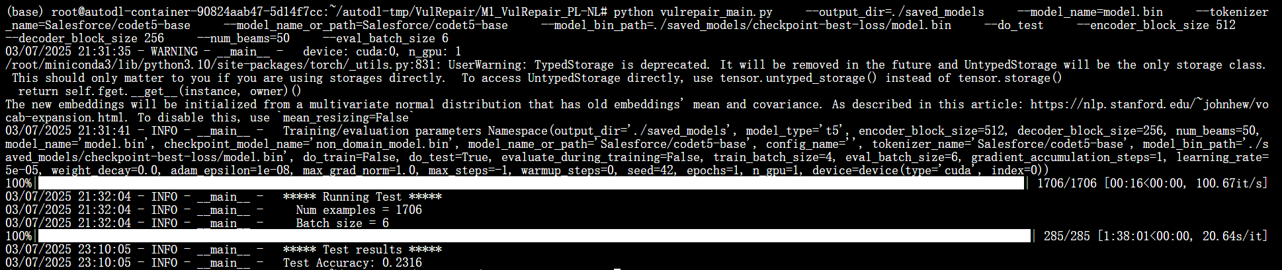

？？？？？

3.

python vulrepair_main.py \

--output_dir=./saved_models \

--model_name=model.bin \

--model_bin_path=./saved_models/checkpoint-best-loss/model.bin \

--tokenizer_name=MickyMike/VulRepair \

--model_name_or_path=MickyMike/VulRepair \

--do_test \

--encoder_block_size 512 \

--decoder_block_size 256 \

--num_beams=50 \

--eval_batch_size 6

使用mike的分词器和配置，本地模型权重，测出准确率仍然是23.16

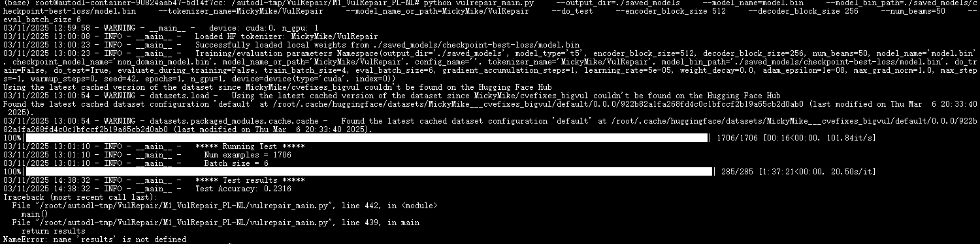

4.

用自己重新训练的模型权重测试结果：  
python vulrepair_main.py \

--output_dir=./saved_models \

--model_name=model.bin \

--model_bin_path=./Inference_models/checkpoint-best-loss/model.bin \

--tokenizer_name=MickyMike/VulRepair \

--model_name_or_path=MickyMike/VulRepair \

--do_test \

--encoder_block_size 512 \

--decoder_block_size 256 \

--num_beams=50 \

--eval_batch_size 2

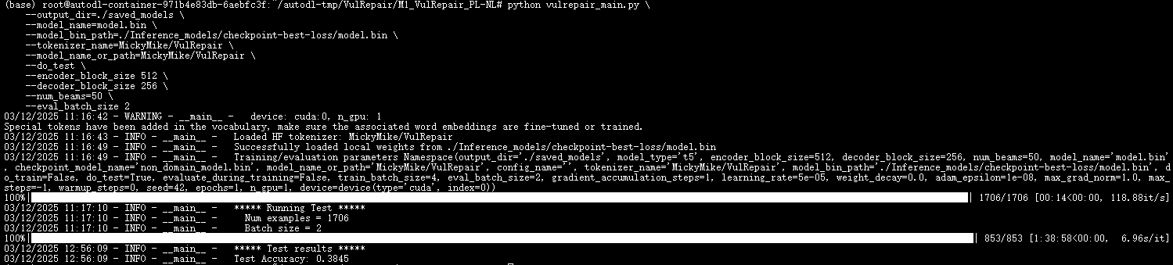

5.

python vulrepair_main.py \

--output_dir=./MickyVulRepair_models \

--model_name=model.bin \

--model_weights_dir=/root/autodl-tmp/VulRepair/M1_VulRepair_PL-NL/codet5-base_models/saved_model_weight/2025-03-17-19h \

--model_path=/root/autodl-tmp/VulRepair/models/MickyVulRepair \

--do_test \

--encoder_block_size 512 \

--decoder_block_size 256 \

--num_beams=50 \

--eval_batch_size 2

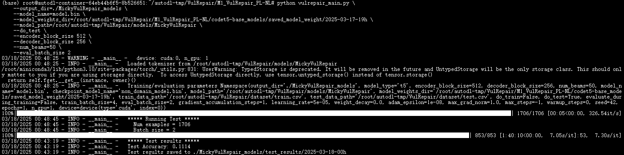

6.

python vulrepair_main.py \

--output_dir=./MickyVulRepair_models \

--model_name=model.bin \

--model_weights_dir=/root/autodl-tmp/VulRepair/M1_VulRepair_PL-NL/codet5-base_models/saved_model_weight/2025-03-17-19h \

--model_path=/root/autodl-tmp/VulRepair/models/MickyVulRepair \

--do_test \

--encoder_block_size 512 \

--decoder_block_size 256 \

--num_beams=50 \

--eval_batch_size 2

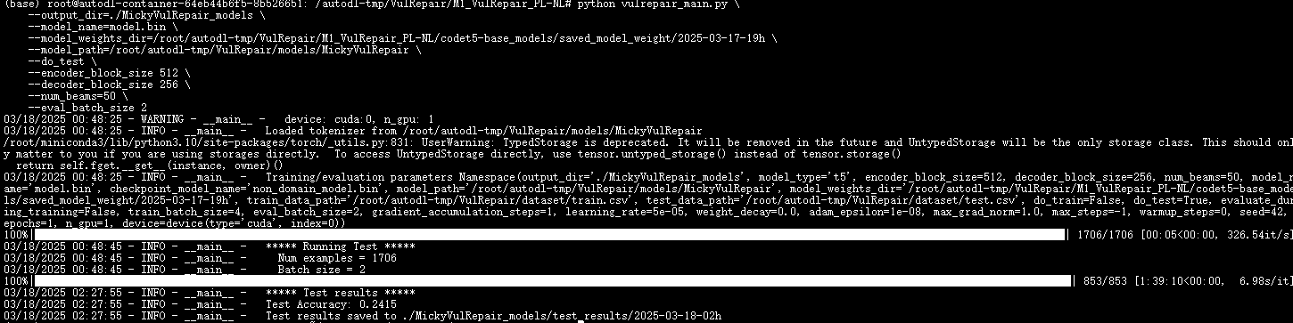

7.

再跑一下

python vulrepair_main.py \

--output_dir=./local_models \

--model_name=model.bin \

--model_weights_dir=/root/autodl-tmp/VulRepair/M1_VulRepair_PL-NL/local_models \

--model_path=/root/autodl-tmp/VulRepair/models/MickyVulRepair \

--do_test \

--encoder_block_size 512 \

--decoder_block_size 256 \

--num_beams=50 \

--eval_batch_size 2

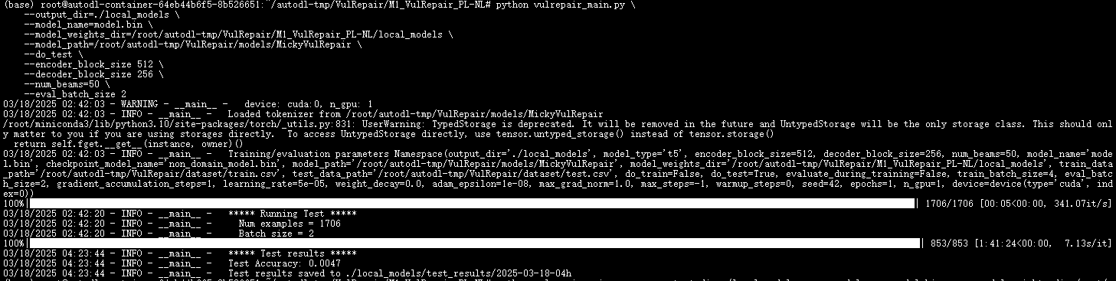

8.用micky的model.bin测试

python vulrepair_main.py \

--output_dir=./saved_models \

--model_name=model.bin \

--model_bin_path=./local_models/pytorch_model.bin \

--tokenizer_name=MickyMike/VulRepair \

--model_name_or_path=MickyMike/VulRepair \

--do_test \

--encoder_block_size 512 \

--decoder_block_size 256 \

--num_beams=50 \

--eval_batch_size 2

03/19/2025 14:31:50 - INFO - __main__ - ***** Running Test *****

03/19/2025 14:31:50 - INFO - __main__ - Num examples = 1706

03/19/2025 14:31:50 - INFO - __main__ - Batch size = 2

100%|████████████████████████████████████████████████████████████████████████████████████████████████████████████████████████████████████████████████████████████████████████████| 853/853 [1:18:55<00:00, 5.55s/it]

03/19/2025 15:50:45 - INFO - __main__ - ***** Test results *****

03/19/2025 15:50:45 - INFO - __main__ - Test Accuracy: 0.4256

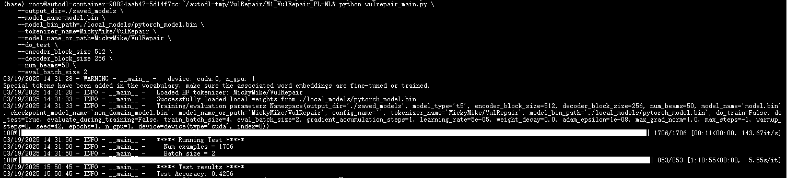

9.终于训练出比micky准确率还高的模型权重

python vulrepair_main.py \

--output_dir=./saved_models \

--model_name=model.bin \

--model_bin_path=./Inference_3.19-16h_models/checkpoint-best-loss/model.bin \

--tokenizer_name=MickyMike/VulRepair \

--model_name_or_path=MickyMike/VulRepair \

--do_test \

--encoder_block_size 512 \

--decoder_block_size 256 \

--num_beams=50 \

--eval_batch_size 4

这个不错

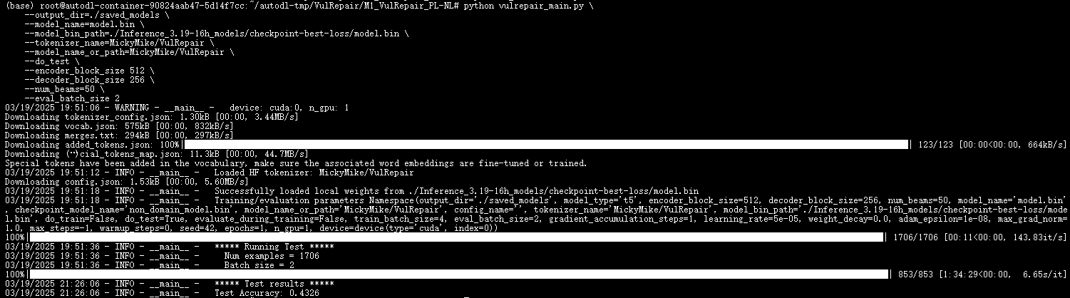

9.服务器测试43.26model.bin测试结果是多少

python vulrepair_main.py \

--output_dir=./saved_models \

--model_name=model.bin \

--model_bin_path=./model_bin/pytorch_model.bin \

--tokenizer_name=Salesforce/codet5-base \

--model_name_or_path=Salesforce/codet5-base \

--do_test \

--encoder_block_size 512 \

--decoder_block_size 256 \

--num_beams=50 \

--eval_batch_size 8

python vulrepair_main_copy.py \

--output_dir=./saved_models \

--model_name=model.bin \

--model_bin_path=./Inference_3.24-18h_models/checkpoint-best-loss/model.bin \

--tokenizer_name=MickyMike/VulRepair \

--model_name_or_path=MickyMike/VulRepair \

--do_test \

--encoder_block_size 512 \

--decoder_block_size 256 \

--num_beams=50 \

--eval_batch_size 4  
以上命令测出来24左右准确率，今天训练的，训练写的40轮，但是在29轮左右自动停止，是loss 三轮没有下降就停止的代码。

10. 用micky数据集43.26准确率的model.bin再训练数据集semeru/code-code-BugFixingMed：

python semeru.py \

--model_name=model.bin \

--output_dir=./Inference_models \

--tokenizer_name=Salesforce/codet5-base \

--model_name_or_path=Salesforce/codet5-base \

--model_bin_path=./model_bin/0_4326model.bin \

--do_train \

--epochs 15 \

--encoder_block_size 512 \

--decoder_block_size 256 \

--train_batch_size 16 \

--eval_batch_size 16 \

--learning_rate 2e-5 \

--max_grad_norm 1.0 \

--evaluate_during_training \

--seed 123456 \

2>&1 | tee train.log

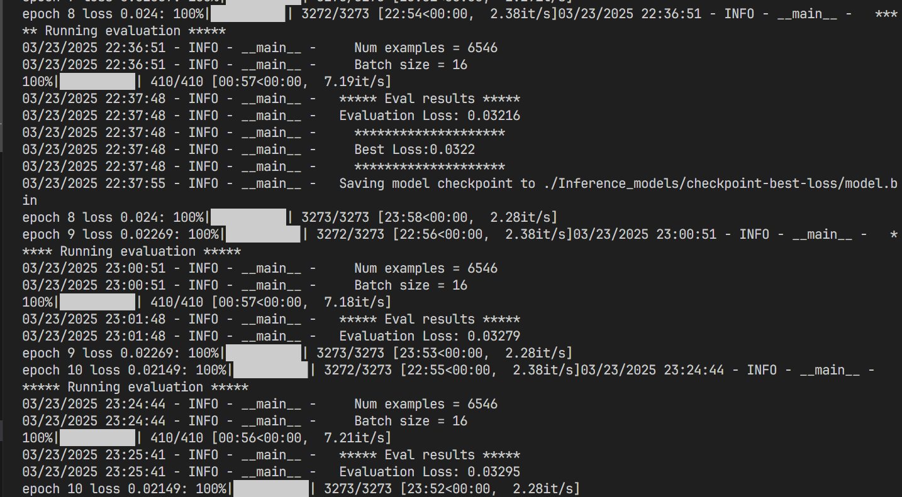

再进行测试：

python semeru.py \

--model_name=model.bin \

--output_dir=./Inference_models \

--tokenizer_name=Salesforce/codet5-base \

--model_name_or_path=Salesforce/codet5-base \

--model_bin_path=./Inference_models/checkpoint-best-loss/model.bin \

--do_test \

--encoder_block_size 512 \

--decoder_block_size 256 \

--eval_batch_size 8 \

--seed 123456 \

2>&1 | tee test.log

WTF?

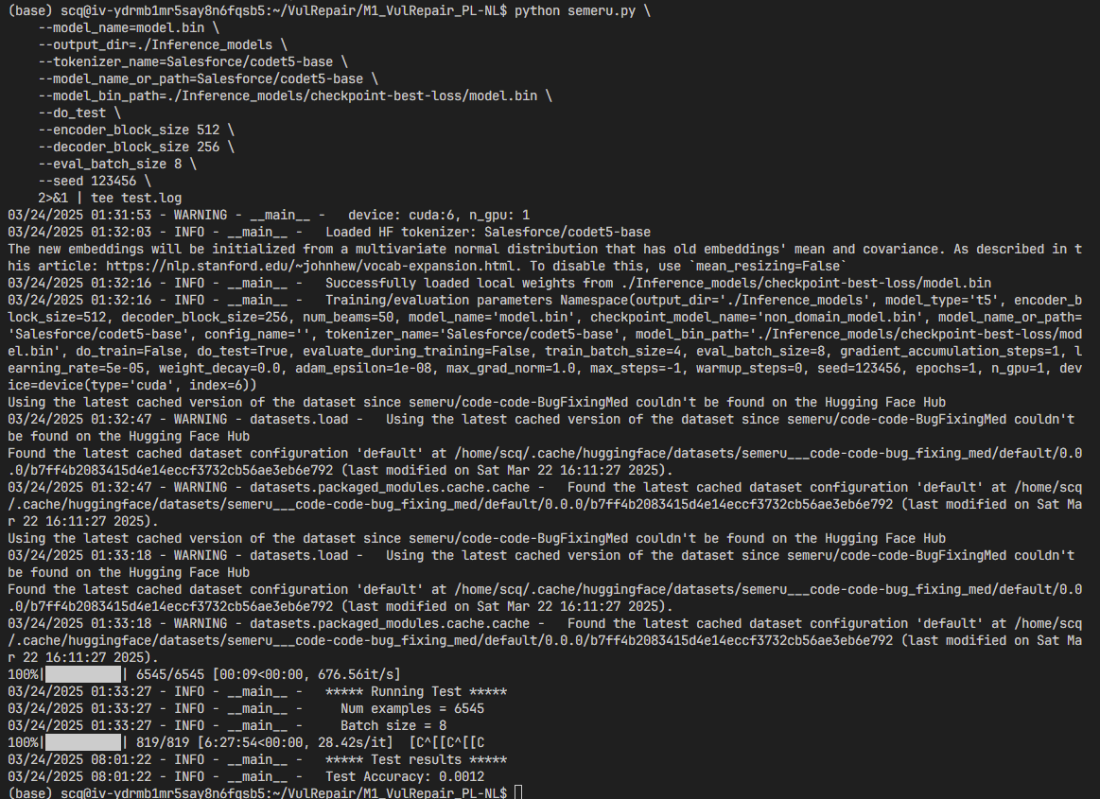

11.很好，使用vulrepair_main_3-25.py

python vulrepair_main.py \

--output_dir=./saved_models \

--model_name=model.bin \

--model_bin_path=./03-25-23h29m_saved_models/checkpoint-best-loss/model.bin \

--tokenizer_name=./saved_models/tokenizer \

--model_name_or_path=MickyMike/VulRepair \

--do_test \

--encoder_block_size 512 \

--decoder_block_size 256 \

--num_beams=50 \

--eval_batch_size 8

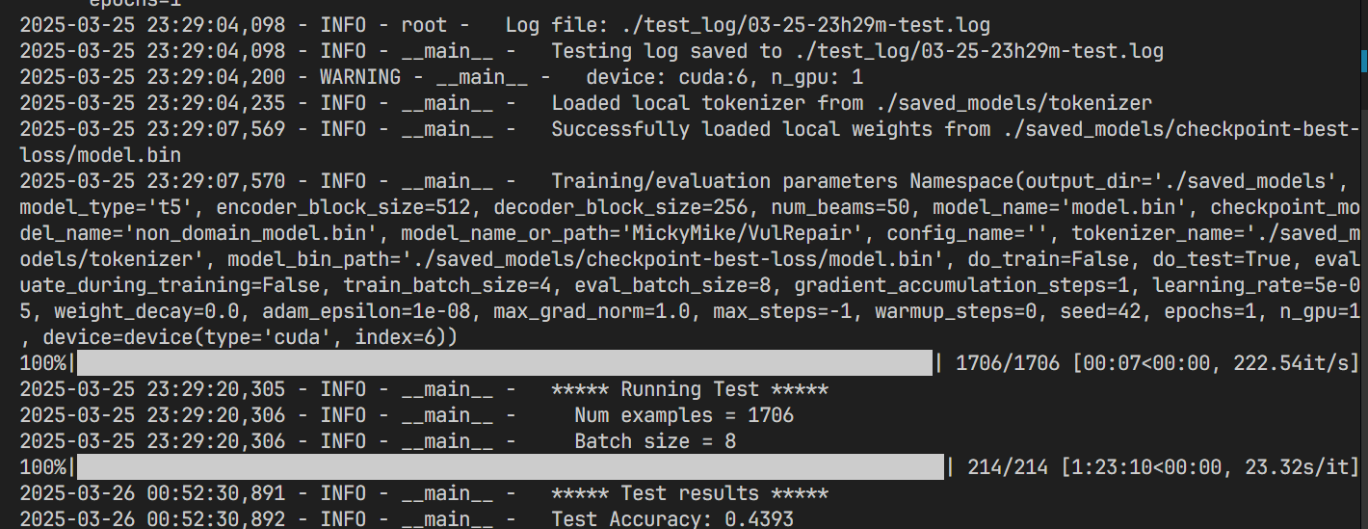

12. 使用最新的vulrepair_main_3-28.py来训练，增加了各种参数，结果更差了

python vulrepair_main_3-28.py \

--model_name=model.bin \

--output_dir=./3-29-20h_saved_models \

--tokenizer_name=Salesforce/codet5-base \

--model_name_or_path=Salesforce/codet5-base \

--do_train \

--epochs 40 \

--encoder_block_size 512 \

--decoder_block_size 256 \

--train_batch_size 16 \

--eval_batch_size 16 \

--learning_rate 2e-5 \

--max_grad_norm 1.0 \

--evaluate_during_training \

--seed 123456 \

--fp16 \

--label_smoothing 0.1 \

--top_p 0.95 \

--top_k 50 \

--temperature 0.7 2>&1 | tee train.log

训练结果：  
python vulrepair_main_3-28.py \

--output_dir=./saved_models \

--model_name=model.bin \

--model_bin_path=./3-29-20h_saved_models/checkpoint-best/model.bin \

--tokenizer_name=./3-29-20h_saved_models/tokenizer \

--model_name_or_path=MickyMike/VulRepair \

--do_test \

--encoder_block_size 512 \

--decoder_block_size 256 \

--num_beams 50 \

--eval_batch_size 16 \

--top_p 0.95 \

--top_k 50 \

--temperature 0.7 2>&1 | tee test.log

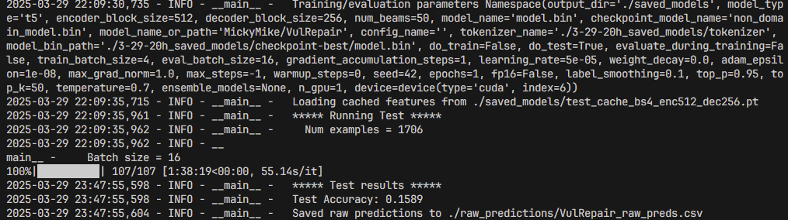

13.更改方案，修改vulrepair_main_3-25.py使其评估方式变为部分匹配或者语义相同等方式来提高准确率

python vulrepair_main_3-28.py \

--output_dir=./saved_models \

--model_name=model.bin \

--model_bin_path=./03-25-23h29m_saved_models/checkpoint-best-loss/model.bin \

--tokenizer_name=./03-25-23h29m_saved_models/tokenizer \

--model_name_or_path=MickyMike/VulRepair \

--do_test \

--encoder_block_size 512 \

--decoder_block_size 256 \

--num_beams=50 \

--eval_batch_size 8 \

2>&1 | tee test.log  
奇怪用的11的model.bin但是准确率下降好多

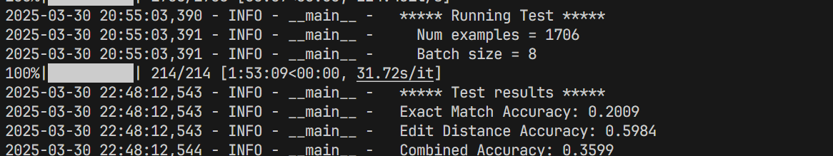

14.再试下3-25，跟13一样，和11又不一样了。就离谱

python vulrepair_main_3-25.py \

--output_dir=./saved_models \

--model_name=model.bin \

--model_bin_path=./03-25-23h29m_saved_models/checkpoint-best-loss/model.bin \

--tokenizer_name=./03-25-23h29m_saved_models/tokenizer \

--model_name_or_path=MickyMike/VulRepair \

--do_test \

--encoder_block_size 512 \

--decoder_block_size 256 \

--num_beams=50 \

--eval_batch_size 8 \

2>&1 | tee test.log

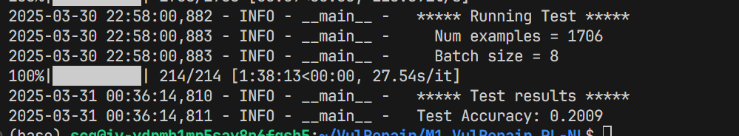

15.tmux里面换个分词器试试

python vulrepair_main_3-25.py \

--output_dir=./saved_models \

--model_name=model.bin \

--model_bin_path=./03-25-23h29m_saved_models/checkpoint-best-loss/model.bin \

--tokenizer_name=MickyMike/VulRepair \

--model_name_or_path=MickyMike/VulRepair \

--do_test \

--encoder_block_size 512 \

--decoder_block_size 256 \

--num_beams=50 \

--eval_batch_size 8 \

2>&1 | tee test.log

跟上面一样

16.重新训练 结果仍然跟上面一样

（1）

训练：

python vulrepair_main_3-25.py --model_name=model.bin --output_dir=./3-31-10h_main_3-25_saved_models --tokenizer_name=Salesforce/codet5-base --model_name_or_path=Salesforce/codet5-base --do_train --epochs 40 --encoder_block_size 512 --decoder_block_size 256 --train_batch_size 16 --eval_batch_size 16 --learning_rate 2e-5 --max_grad_norm 1.0 --evaluate_during_training --seed 123456 2>&1 | tee train.log

测试：

python vulrepair_main_3-25.py \

--output_dir=./saved_models \

--model_name=model.bin \

--model_bin_path=./3-31-10h_main_3-25_saved_models/checkpoint-best-loss/model.bin \

--tokenizer_name=./3-31-10h_main_3-25_saved_models/tokenizer \

--model_name_or_path=MickyMike/VulRepair \

--do_test \

--encoder_block_size 512 \

--decoder_block_size 256 \

--num_beams=50 \

--eval_batch_size 8

（2）

训练：

python vulrepair_main_3-30.py --model_name=model.bin --output_dir=./3-31-10h_main_3-30_saved_models --tokenizer_name=Salesforce/codet5-base --model_name_or_path=Salesforce/codet5-base --do_train --epochs 40 --encoder_block_size 512 --decoder_block_size 256 --train_batch_size 16 --eval_batch_size 16 --learning_rate 2e-5 --max_grad_norm 1.0 --evaluate_during_training --seed 123456 2>&1 | tee train.log

测试：

python vulrepair_main_3-30.py \

--output_dir=./saved_models \

--model_name=model.bin \

--model_bin_path=./3-31-10h_main_3-30_saved_models/checkpoint-best-loss/model.bin \

--tokenizer_name=./3-31-10h_main_3-30_saved_models/tokenizer \

--model_name_or_path=MickyMike/VulRepair \

--do_test \

--encoder_block_size 512 \

--decoder_block_size 256 \

--num_beams=50 \

--eval_batch_size 8

17.

训练：

python vulrepair_main_3-30.py \

--model_name=model.bin \

--output_dir=/data/share/data/scq/vulrepair/m1/4-2-19h_saved_models \

--tokenizer_name=Salesforce/codet5-base \

--model_name_or_path=Salesforce/codet5-base \

--do_train \

--epochs 40 \

--encoder_block_size 512 \

--decoder_block_size 256 \

--train_batch_size 8 \

--eval_batch_size 8 \

--learning_rate 2e-5 \

--max_grad_norm 1.0 \

--evaluate_during_training \

--seed 123456 \

2>&1 | tee train.log

测试：

（1）

python vulrepair_main_3-30.py \

--output_dir=./saved_models \

--model_name=model.bin \

--model_bin_path=/data/share/data/scq/vulrepair/m1/4-2-19h_saved_models/checkpoint-best-loss/model.bin \

--tokenizer_name=/data/share/data/scq/vulrepair/m1/4-2-19h_saved_models/tokenizer \

--model_name_or_path=MickyMike/VulRepair \

--do_test \

--encoder_block_size 512 \

--decoder_block_size 256 \

--num_beams=50 \

--eval_batch_size 16

（2）

python vulrepair_main_3-30.py \

--output_dir=./saved_models \

--model_name=model.bin \

--model_bin_path=/data/share/data/scq/vulrepair/m1/4-2-19h_saved_models/checkpoint-best-loss/model.bin \

--tokenizer_name=/data/share/data/scq/vulrepair/m1/4-2-19h_saved_models/tokenizer \

--model_name_or_path=Salesforce/codet5-base \

--do_test \

--encoder_block_size 512 \

--decoder_block_size 256 \

--num_beams=50 \

--eval_batch_size 16

18.无敌

python vulrepair_main_3-30.py \

--model_name=model.bin \

--output_dir=../saves/m1/4-3-20h_saved_models \

--tokenizer_name=Salesforce/codet5-base \

--model_name_or_path=Salesforce/codet5-base \

--do_train \

--epochs 40 \

--encoder_block_size 512 \

--decoder_block_size 256 \

--train_batch_size 8 \

--eval_batch_size 8 \

--learning_rate 2e-5 \

--max_grad_norm 1.0 \

--evaluate_during_training \

--seed 123456 \

2>&1 | tee train.log

测试：

python vulrepair_main_3-30.py \

--output_dir=./saved_models \

--model_name=model.bin \

--model_bin_path=../saves/m1/4-3-20h_saved_models/checkpoint-best-loss/model.bin \

--tokenizer_name=../saves/m1/4-3-20h_saved_models/tokenizer \

--model_name_or_path=MickyMike/VulRepair \

--do_test \

--encoder_block_size 512 \

--decoder_block_size 256 \

--num_beams=50 \

--eval_batch_size 8

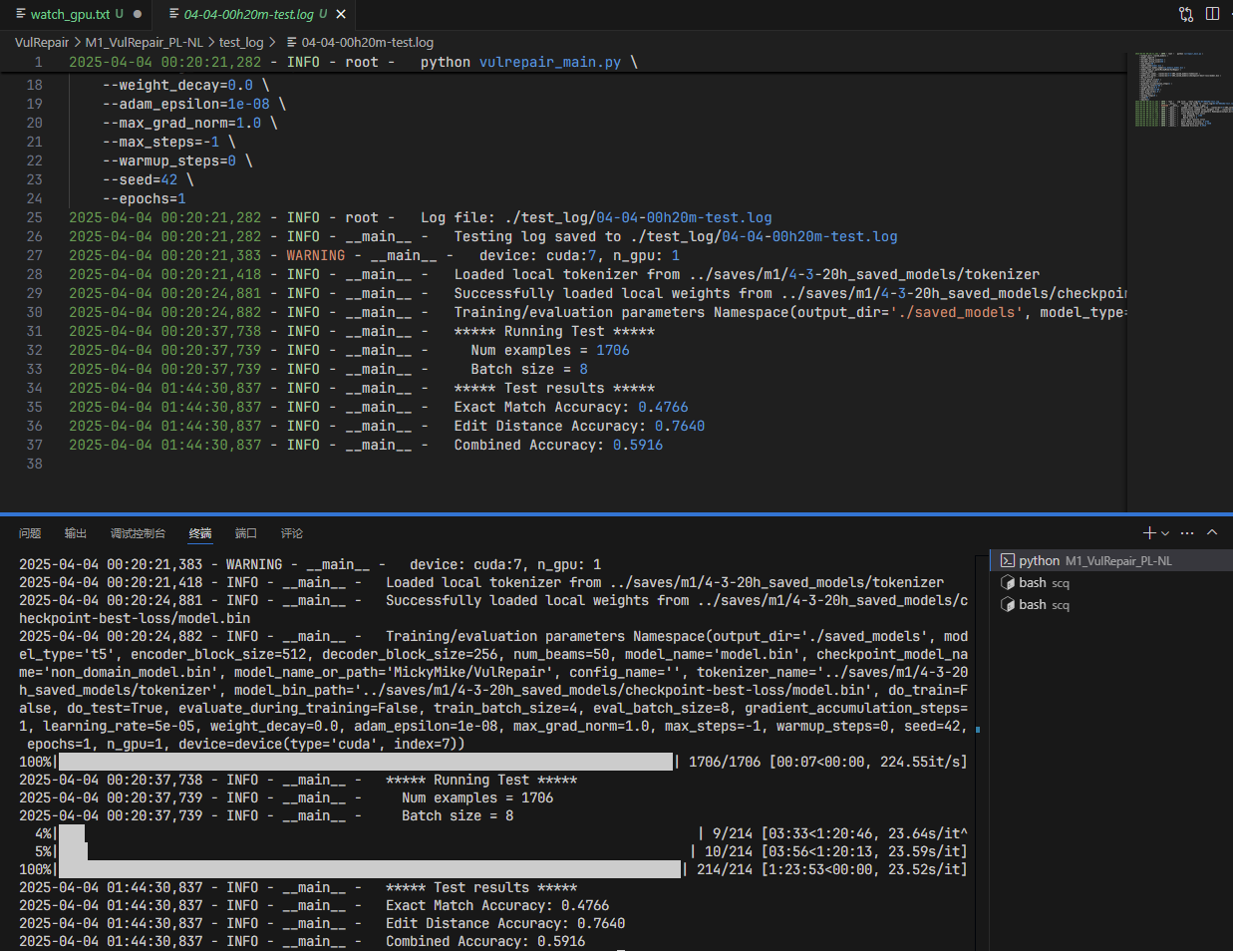

19.codet5-large

python vulrepair_main_3-30.py \

--model_name=model.bin \

--output_dir=../saves/t5-large/4-15-15h_saved_models \

--tokenizer_name=Salesforce/codet5-large \

--model_name_or_path=Salesforce/codet5-large \

--do_train \

--epochs 50 \

--encoder_block_size 512 \

--decoder_block_size 256 \

--train_batch_size 8 \

--eval_batch_size 8 \

--learning_rate 2e-5 \

--max_grad_norm 1.0 \

--evaluate_during_training \

--seed 123456 \

2>&1 | tee train.log

测试：

python vulrepair_main_3-30.py \

--output_dir=./saved_models \

--model_name=model.bin \

--model_bin_path=../saves/t5-large/4-15-15h_saved_models/checkpoint-best-loss/model.bin \

--tokenizer_name=../saves/t5-large/4-15-15h_saved_models/tokenizer \

--model_name_or_path=taxman2333/CodeVulFix_t5-large \

--do_test \

--encoder_block_size 512 \

--decoder_block_size 256 \

--num_beams=50