

TABLE OF CONTENTS

Table of Contents
ABSTRACT 3
1. INTRODUCTION 3
1.1 Context and Motivation 3
1.2 Problem Statement 4
1.3 Project Objectives 4
1.4 Contributions 4
2. LITERATURE REVIEW 4
2.1 Logistic Regression as an Interpretable Baseline 4
2.2 Decision Trees and Random Forests 4
2.3 Gradient Boosting and XGBoost 4
2.4 Leakage-Safe Pipelines 5
3. DATASET DESCRIPTION 5
3.1 Dataset Source and Granularity 5
3.2 Core Feature Groups 5
3.3 Target Distribution 6
4. METHODOLOGY 7
4.1 End-to-End Workflow 7
4.2 Data Cleaning 7
4.3 Crash-Level Reconstruction 7
4.4 Leakage Prevention 8
4.5 Feature Engineering 8
4.6 Preprocessing 8
4.7 Train–Test Split and Cross-Validation 9
5. EXPLORATORY DATA ANALYSIS 9
6. MODEL ARCHITECTURE AND TRAINING 18
6.1 Candidate Models 18
6.2 Final XGBoost Configuration 19
6.3 Hyperparameter Search 19
6.4 Training Curves 20
7. RESULTS AND EVALUATION 21
7.1 Comparative Model Performance 21
7.2 Improvement Calculations 21
7.3 Class-Level Evaluation 21
7.4 Inference Speed 22
8. COMPARATIVE ANALYSIS 23
8.1 What the Results Suggest 23
8.2 Why Macro-F1 Matters 23
8.3 Statistical Significance 23
9. INNOVATIONS AND UNIQUE CONTRIBUTIONS 23
10. ETHICAL CONSIDERATIONS AND BIAS ANALYSIS 23
10.1 Potential Bias Sources 23
10.2 Responsible Use Controls 23
11. LIMITATIONS AND MITIGATION STRATEGIES 24
12. REPRODUCIBILITY STATEMENT 24
12.1 Run Instructions 25
13. CONCLUSION 25
14. FUTURE WORK 25
15. REFERENCES 26
16. GLOSSARY OF TERMS 26
APPENDIX A. SYSTEM ARCHITECTURE AND DATA FLOW 27
APPENDIX B. DASHBOARD ARCHITECTURE AND USER WORKFLOW 27
APPENDIX C. KEY NOTEBOOK EVIDENCE 28
APPENDIX D. COMPLETE NOTEBOOK CODE 28
APPENDIX E. PROJECT README-DERIVED APPLICATION NOTES 74

Note: The TOC is a native Word field. In Microsoft Word, use References → Update Table to refresh page numbers and heading entries.

ABSTRACT
Road accident severity prediction is a multi-class classification problem in which model quality depends not only on the algorithm but also on how the underlying records are represented. This project develops an end-to-end machine-learning pipeline for predicting crash severity from an occupant-level Indian road-accident dataset. The supplied dataset contains 131,404 occupant records associated with 20,000 unique crashes. Because several occupants may belong to the same crash, the workflow reconstructs a single crash-level observation by grouping records with `crash_ref_id` and aggregating meaningful occupant characteristics. Data cleaning standardizes column names and categorical values, validates numerical ranges, removes exact duplicates, and checks crash-level consistency. Feature engineering adds cyclical time variables, speed-related indicators, safety non-compliance measures, and interaction terms. To reduce target leakage, post-crash outcomes such as injury outcome, hospitalization, fatality flags, survival, emergency response time, and related variables are excluded from the primary prediction feature set. Four models are evaluated: Logistic Regression, Decision Tree, Random Forest, and XGBoost. Preprocessing is embedded inside model pipelines using median imputation, standardization for numerical variables where appropriate, and one-hot encoding for categorical variables. Model selection uses stratified five-fold cross-validation and macro-F1 as the primary metric because the severity classes are imbalanced. On the held-out 4,000-crash test set, XGBoost achieved an accuracy of 0.9528, macro precision of 0.9413, macro recall of 0.9433, macro-F1 of 0.9423, weighted F1 of 0.9528, and weighted one-vs-rest ROC-AUC of 0.9946. The class-level evaluation produced recall values of 0.93 for fatal, 0.92 for major, and 0.97 for minor crashes. These results demonstrate that a carefully constructed crash-level representation and leakage-aware preprocessing can support strong severity classification while remaining suitable for deployment in a lightweight Streamlit application.
Project result at a glance
Final XGBoost: 95.28% test accuracy and 0.9423 macro-F1 on 4,000 held-out crashes.

1. INTRODUCTION

1.1 Context and Motivation
The supplied data is occupant-level, meaning multiple rows can refer to the same crash. Treating each row as an independent example would give crashes with more occupants greater influence and could allow records from the same crash to appear in both training and test sets. Crash reconstruction is therefore a central modeling decision.
The prediction setup is also defined by information availability. Variables that become known only after the outcome—such as injury outcome, hospitalization, survival, fatality flags, and emergency-response measurements—are excluded from the primary model. This makes the task closer to incident-time decision support and reduces artificial performance caused by target leakage.

1.2 Problem Statement
The objective is to predict one of three crash-severity classes—fatal, major, or minor—using crash context and occupant-derived characteristics available at or near the time of the incident. The model is intended as analytical decision support rather than an autonomous emergency or liability decision-maker.

1.3 Project Objectives
- Load and inspect the updated occupant-level dataset.
- Clean and standardize raw records.
- Reconstruct one crash-level record for each `crash_ref_id`.
- Engineer temporal, speed, safety, traffic, and occupant-aggregation features.
- Prevent target leakage by excluding post-crash outcome variables.
- Compare Logistic Regression, Decision Tree, Random Forest, and XGBoost.
- Select the final model using macro-F1 with supporting recall and ROC-AUC.
- Produce confusion-matrix and feature-importance outputs.
- Export the complete preprocessing-and-model bundle for Streamlit deployment.

1.4 Contributions
- Crash-level reconstruction from 131,404 occupant records into 20,000 modeling records.
- Leakage-safe feature selection based on prediction timing.
- Hybrid numerical/categorical preprocessing inside model pipelines.
- Resource-conscious hyperparameter tuning suitable for a 4 GB environment.
- Severity-focused evaluation using macro-F1.
- Deployment consistency through a saved preprocessing-and-model bundle.

2. LITERATURE REVIEW
The supplied notebook does not contain a formal literature survey. This section therefore provides a concise methodological review to contextualize the algorithms used; it is not a systematic review of road-safety research.

2.1 Logistic Regression as an Interpretable Baseline
Logistic Regression provides a strong reference model for multi-class classification and gives comparatively direct coefficient-based interpretation after preprocessing.

2.2 Decision Trees and Random Forests
Decision Trees represent nonlinear decision rules. Random Forests combine many randomized tree predictors to reduce sensitivity to individual tree structure and improve generalization. Breiman's 2001 paper is a foundational reference for the method.

2.3 Gradient Boosting and XGBoost
XGBoost is a scalable gradient-boosted tree system. The original XGBoost work describes sparse-data handling, approximate tree learning, and systems-level efficiency improvements. In this project it is the final candidate model.

2.4 Leakage-Safe Pipelines
The project uses a pipeline design in which imputation, scaling, one-hot encoding, and model fitting are connected into one estimator. This prevents preprocessing statistics from being learned from the held-out test set.
Methodological relevance
The main contribution is the disciplined construction of a crash-level, leakage-aware learning problem rather than a novel classifier.

3. DATASET DESCRIPTION

3.1 Dataset Source and Granularity
The notebook identifies the dataset as a user-provided updated project dataset and does not assume external provenance. The raw file contains 131,404 occupant-level records and 50 columns representing occupants nested within 20,000 unique crashes.
Table 1. Dataset and experimental configuration
Property | Value
Raw records | 131,404 occupant-level rows
Raw columns | 50
Unique crashes | 20,000
Crash-level records | 20,000
Modeling records | 20,000
Target | crash_severity_first
Target classes | fatal, major, minor
Train/test | 80% / 20%
Random state | 42

3.2 Core Feature Groups

Table 2. Feature groups used in the crash-level representation
Feature group | Representative variables | Role
Location | city_name, state_name, lat_coord, lon_coord | Crash context
Time | incident_year, incident_month, hour_of_day, weekday_name | Temporal context
Road / traffic | route_category, lane_count, congestion_level, road_surface_condition | Road environment
Weather | weather_condition, visibility_level, temp_celsius | Environmental context
Cause / hazard | primary_cause, alcohol_suspected_flag, road_hazard_flag | Risk context
Vehicles / occupants | vehicle_count, dominant_vehicle_type, occupants_per_vehicle | Crash composition
Speed | mean/max/min impact speed, speed standard deviation | Physical context
Safety | helmet_seatbelt_usage_rate, airbag_deployed_flag_mean, license ratios | Safety behavior
Target | crash_severity_first | Three-class target

3.3 Target Distribution
Table 3. Crash-level target distribution
Severity | Count | Share
Minor | 11,025 | 55.13%
Major | 5,988 | 29.94%
Fatal | 2,987 | 14.94%
The class distribution is imbalanced. Minor crashes form more than half of the crash-level data, while fatal crashes are the smallest class. This directly motivates macro-F1 as the primary selection metric.

4. METHODOLOGY

4.1 End-to-End Workflow
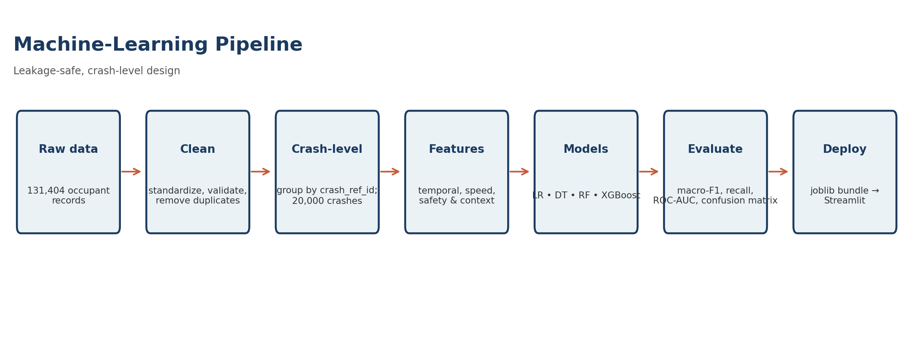
Figure 1. End-to-end machine-learning workflow
The workflow keeps the unit of analysis aligned with the target. Raw occupant rows are cleaned, aggregated by `crash_ref_id`, engineered into model-ready features, split at crash level, tuned, evaluated, and exported for Streamlit.

4.2 Data Cleaning
- Standardize column names to lowercase machine-friendly names.
- Convert blank and placeholder strings to missing values.
- Normalize categorical text and common binary values.
- Coerce numeric candidates with `pd.to_numeric(..., errors='coerce')`.
- Remove exact duplicates and records missing essential keys.
- Report domain-range anomalies without blindly deleting rare observations.
Data-quality decision
Potentially invalid physical values are reported rather than automatically removed. This avoids treating rare but plausible accident conditions as errors without a documented domain rule.

4.3 Crash-Level Reconstruction
The raw data is grouped by `crash_ref_id`. Crash-context fields are retained once, while occupant-level fields become aggregates such as age statistics, gender ratios, seat-position ratios, helmet/seatbelt usage rate, airbag deployment rate, license-status ratios, and occupant-record count.

Table 4. Record flow through the pipeline
Stage | Records | Purpose
Raw dataset | 131,404 | Occupant-level observations
Unique crash keys | 20,000 | Prediction unit
Crash-level data | 20,000 | One row per crash
Training | 16,000 | Fitting + CV
Test | 4,000 | Final evaluation

4.4 Leakage Prevention
Table 5. Primary feature exclusions
Excluded variable | Reason
injury_outcome | Post-outcome information
hospitalized_flag | Post-outcome information
estimated_recovery_days | Known after outcome
fatality_flag | Directly encodes outcome
Survived | Directly encodes outcome
ambulance_called_flag | Post-incident response
emergency_response_time_min | Post-incident measurement
computed_risk_score | Unknown provenance; may encode severity
total_casualties_reported | May be known only after incident
Identifiers | Not predictive features

4.5 Feature Engineering
- Cyclical hour and month encodings using sine/cosine.
- Speed-per-lane ratio and high-speed flag at ≥80 km/h mean impact speed.
- Safety non-compliance rate = 1 − helmet/seatbelt usage rate.
- Night-time × weekend interaction.
- Road-hazard × night-time interaction.

4.6 Preprocessing
Table 6. Preprocessing strategy
Data type | Transformation
Numerical | Median imputation; standardization where appropriate
Categorical | Most-frequent imputation; one-hot encoding
Unknown categories | Ignored
Integration | Transformations inside each model Pipeline

4.7 Train–Test Split and Cross-Validation
An 80/20 stratified crash-level split produces 16,000 training crashes and 4,000 held-out test crashes. Five-fold StratifiedKFold cross-validation is used for tuning.
Table 7. Experimental split
Set | Percentage | Count | Purpose
Training | 80% | 16,000 | Fitting and CV
Testing | 20% | 4,000 | Final evaluation
CV | 5 folds | Training set | Hyperparameter selection

5. EXPLORATORY DATA ANALYSIS
EDA is performed on the crash-level dataset so that crashes with many occupants do not receive disproportionate descriptive weight.
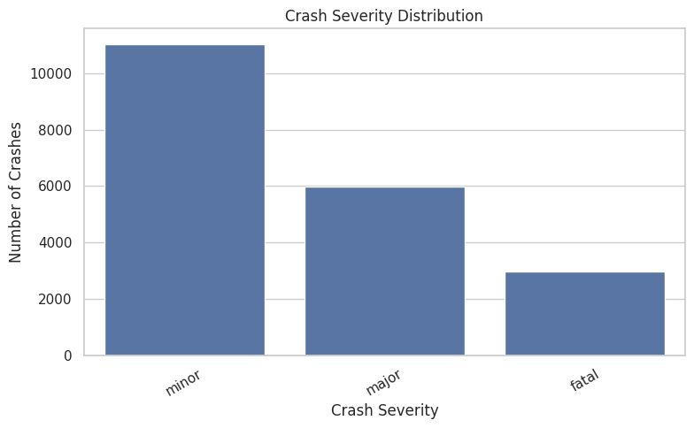
Figure 1. Crash Severity Distribution
Analytical insight: Minor crashes dominate, followed by major and fatal. This imbalance supports macro-F1 as the primary metric.
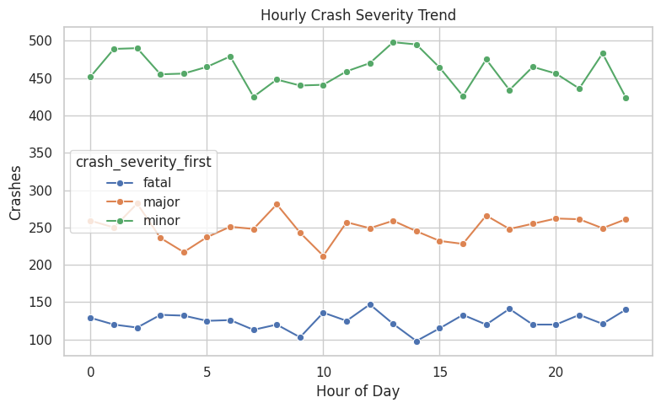
Figure 2. Hourly Crash Severity Trend
Analytical insight: The daily curves vary by hour while preserving the class ordering, supporting the use of hour-of-day and cyclic time features.
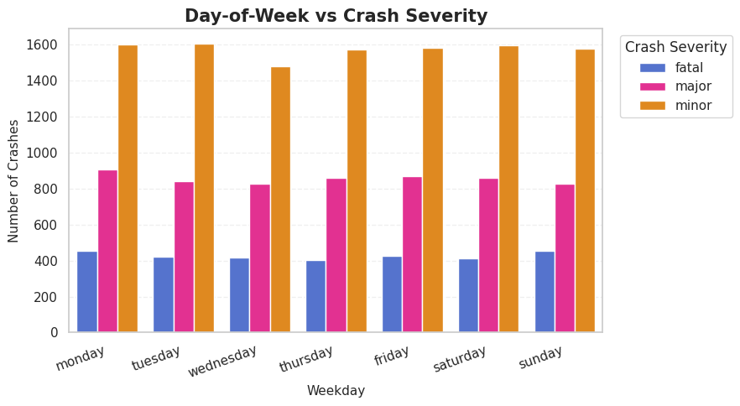
Figure 3. Day-of-Week versus Crash Severity
Analytical insight: Minor crashes dominate across every weekday; weekday provides context but should not be interpreted alone as a causal driver.
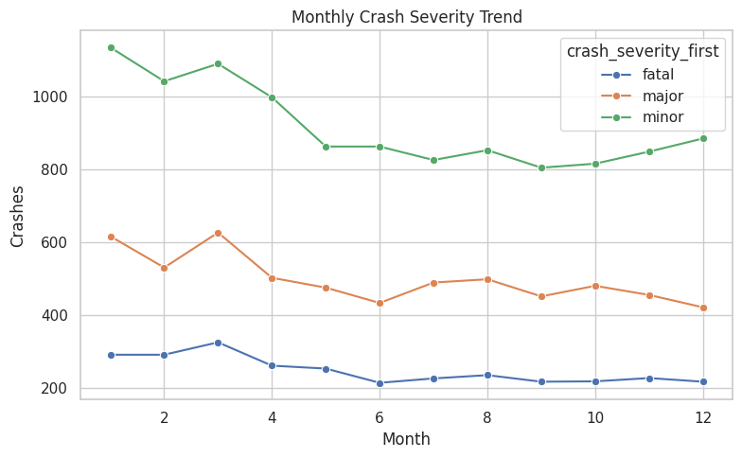
Figure 4. Monthly Crash Severity Trend
Analytical insight: Monthly counts vary while the class ordering remains stable, supporting retention of month information.
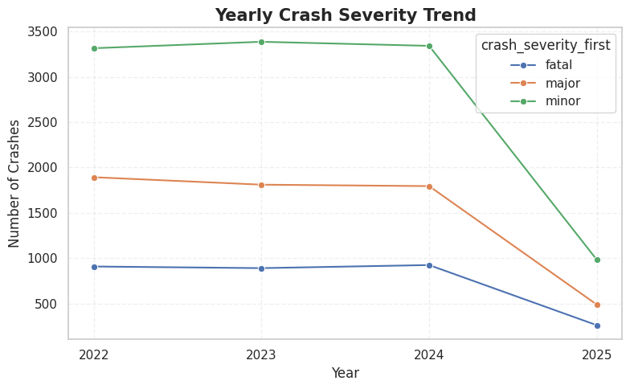
Figure 5. Yearly Crash Severity Trend
Analytical insight: 2022–2024 are comparatively stable, while 2025 is much lower across all classes; this should be checked for observation-window or coverage effects.
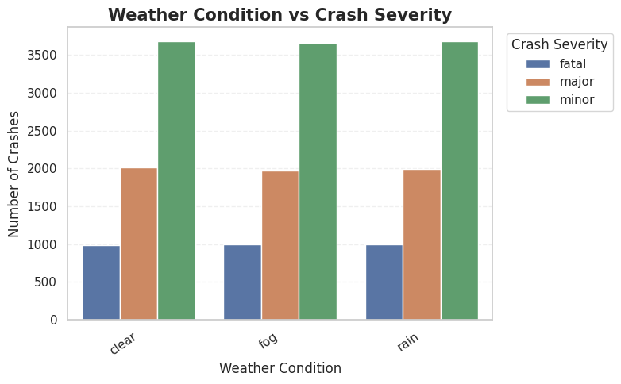
Figure 6. Weather Condition versus Crash Severity
Analytical insight: Clear, fog, and rain show the same broad class ordering; raw counts should not be interpreted as risk rates without exposure normalization.
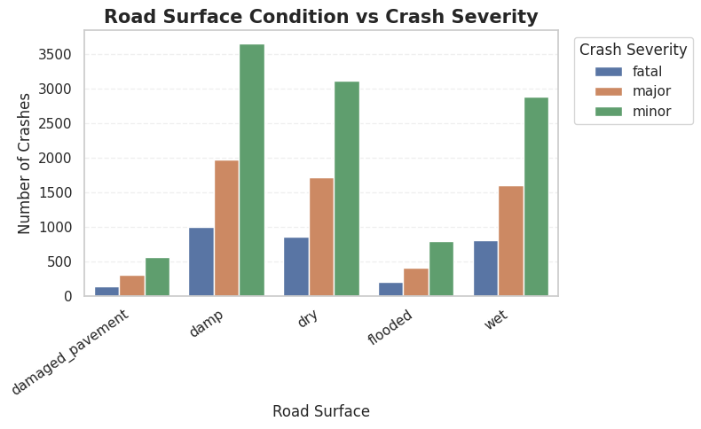
Figure 7. Road Surface Condition versus Crash Severity
Analytical insight: Surface categories differ in frequency and composition. Raw counts should be read alongside category frequency.
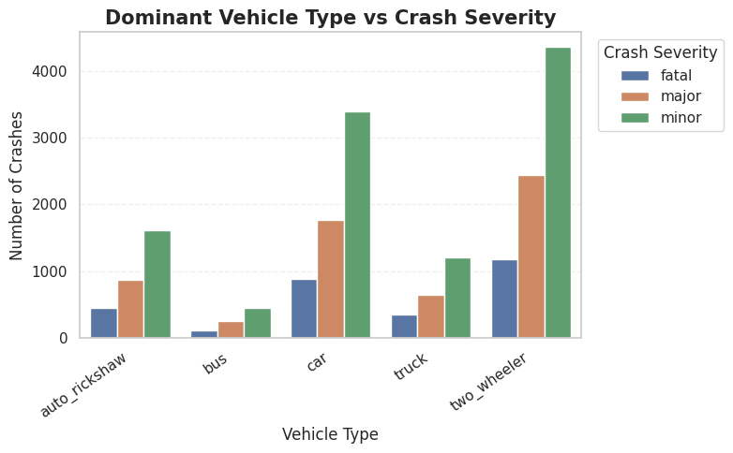
Figure 8. Dominant Vehicle Type versus Crash Severity
Analytical insight: Two-wheelers and cars contribute many observations; class composition provides potential predictive signal but category size affects raw counts.
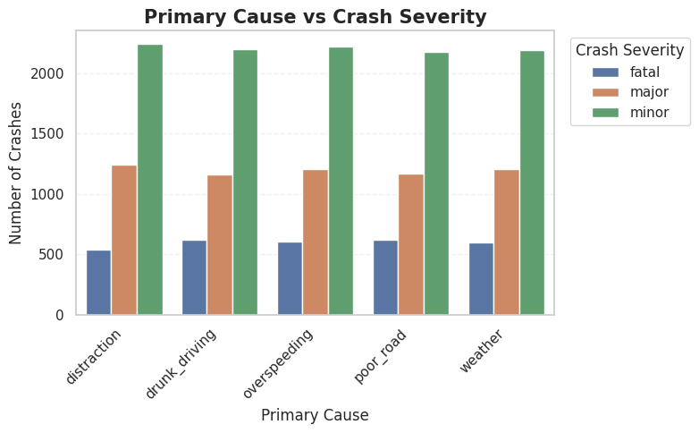
Figure 9. Primary Cause versus Crash Severity
Analytical insight: Minor crashes dominate across cause groups, so causes should be interpreted as combined predictive context rather than isolated causal effects.
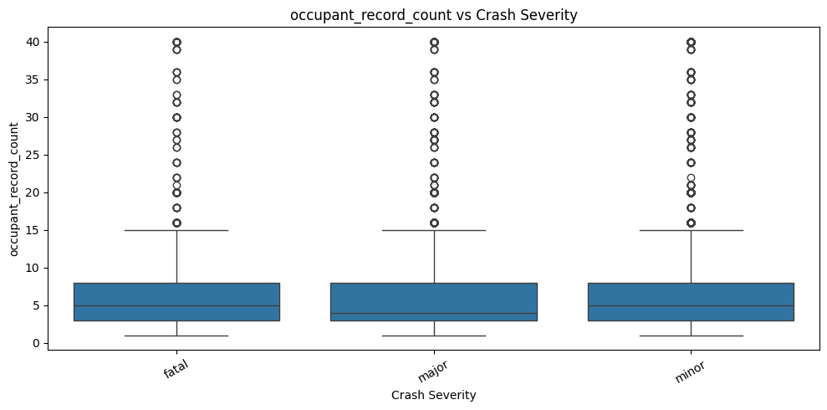
Figure 10. Occupant Record Count versus Crash Severity
Analytical insight: Central ranges are concentrated but many high-value outliers exist; large crashes can legitimately have many occupants.
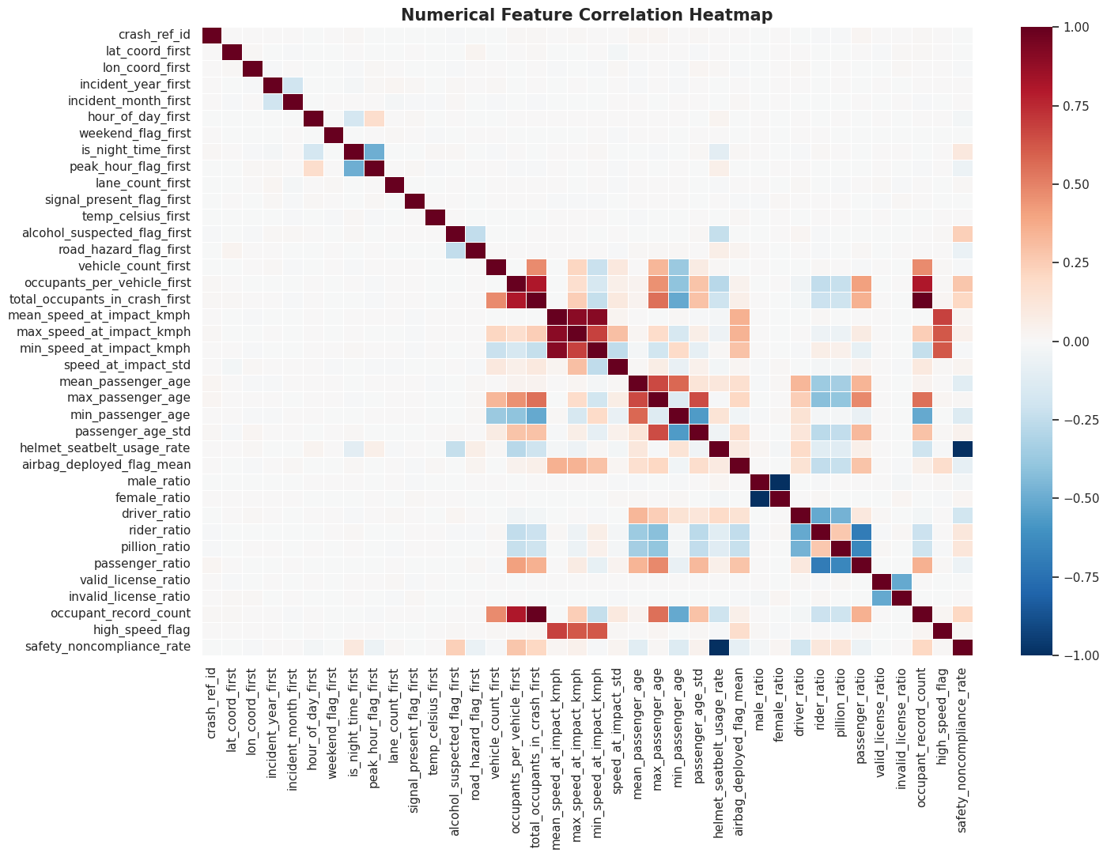
Figure 11. Numerical Feature Correlation Heatmap
Analytical insight: Related speed and occupant variables form correlation clusters, showing that several features capture overlapping information.
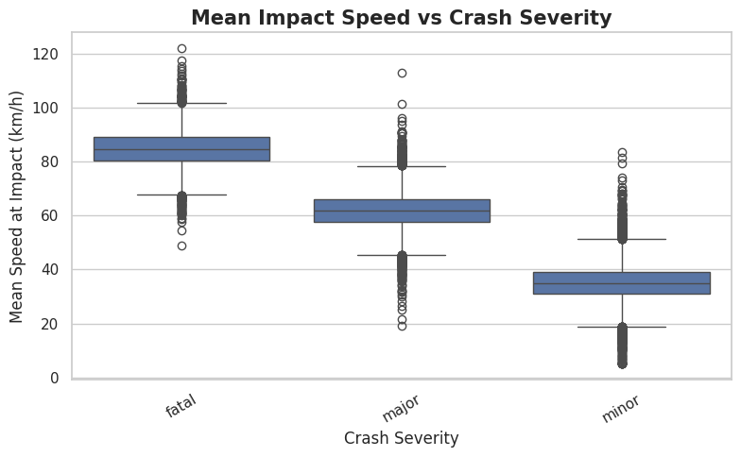
Figure 12. Mean Impact Speed versus Crash Severity
Analytical insight: Impact speed shows strong visual separation across severity classes, matching the later feature-importance result.
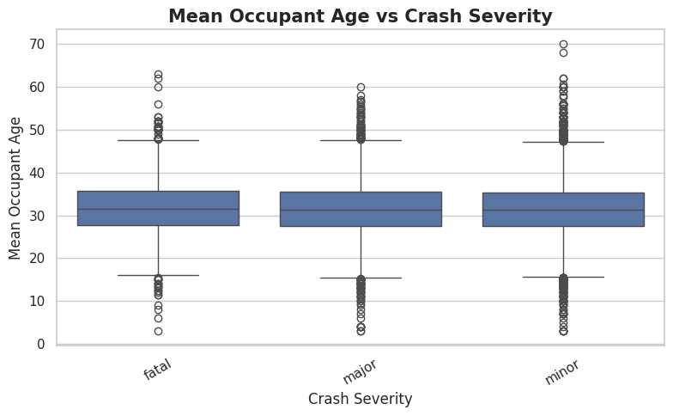
Figure 13. Mean Occupant Age versus Crash Severity
Analytical insight: Age distributions overlap heavily, suggesting limited standalone separation but possible weak contextual contribution.
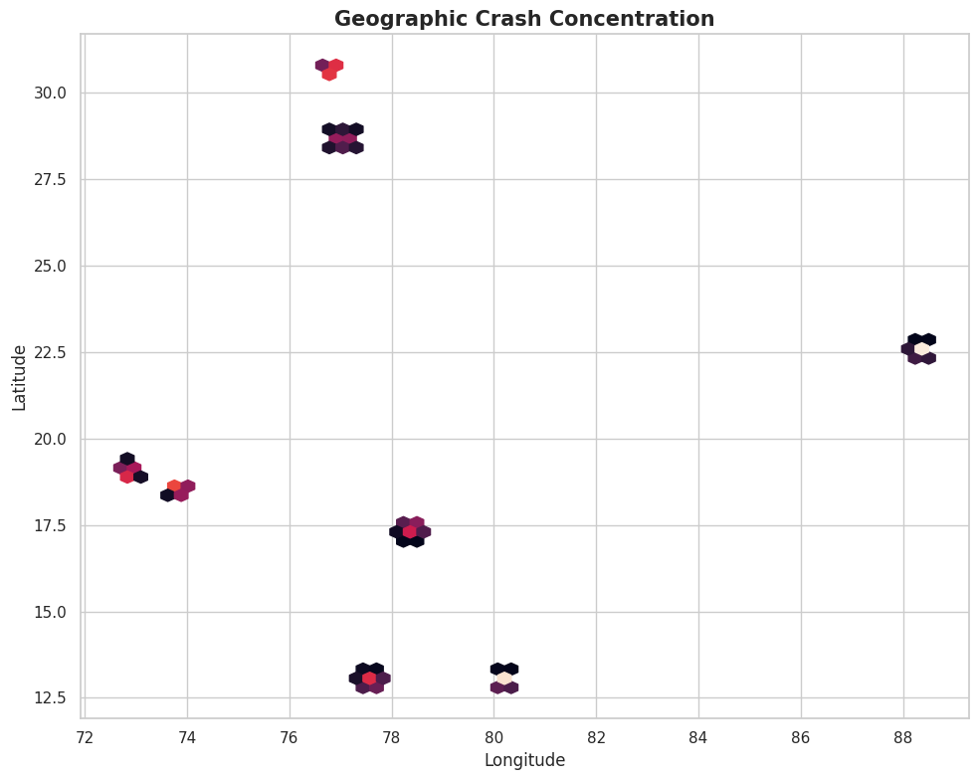
Figure 14. Geographic Crash Concentration
Analytical insight: Several coordinate clusters are visible; this is a concentration plot, not an exposure-normalized risk map.
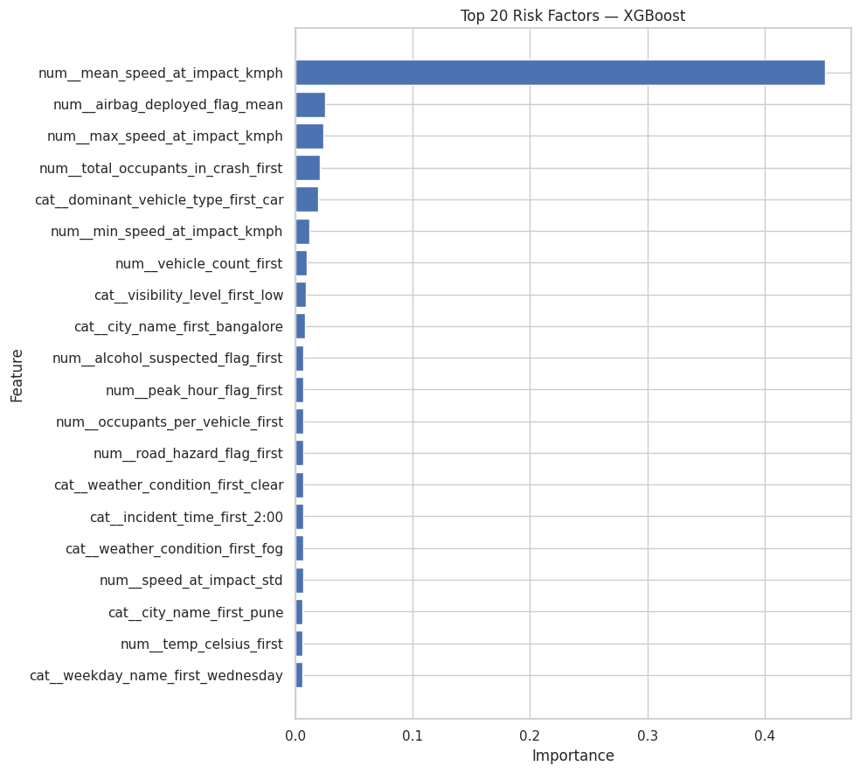
Figure 15. Top 20 Global Risk Factors from the Final Model
Analytical insight: Mean impact speed has the dominant global importance (~0.451), far above the next variables. Importance is model-specific and not causal.
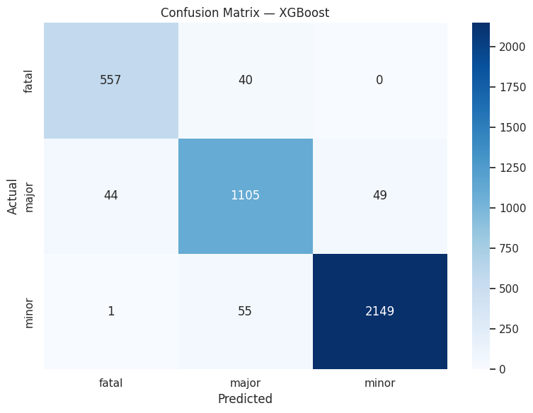
Figure 16. Confusion Matrix for the Final XGBoost Model
Analytical insight: The matrix shows 557/597 fatal, 1,105/1,198 major, and 2,149/2,205 minor crashes correctly classified; errors concentrate mainly between adjacent severity levels.

6. MODEL ARCHITECTURE AND TRAINING

6.1 Candidate Models
Table 8. Models evaluated
Model | Role | Characteristics
Logistic Regression | Interpretable baseline | Scaled numeric; class-balanced
Decision Tree | Nonlinear baseline | Unscaled numeric; class-balanced
Random Forest | Bagged tree ensemble | Balanced classes; constrained complexity
XGBoost | Gradient-boosted candidate | Small randomized search; resource-aware

6.2 Final XGBoost Configuration
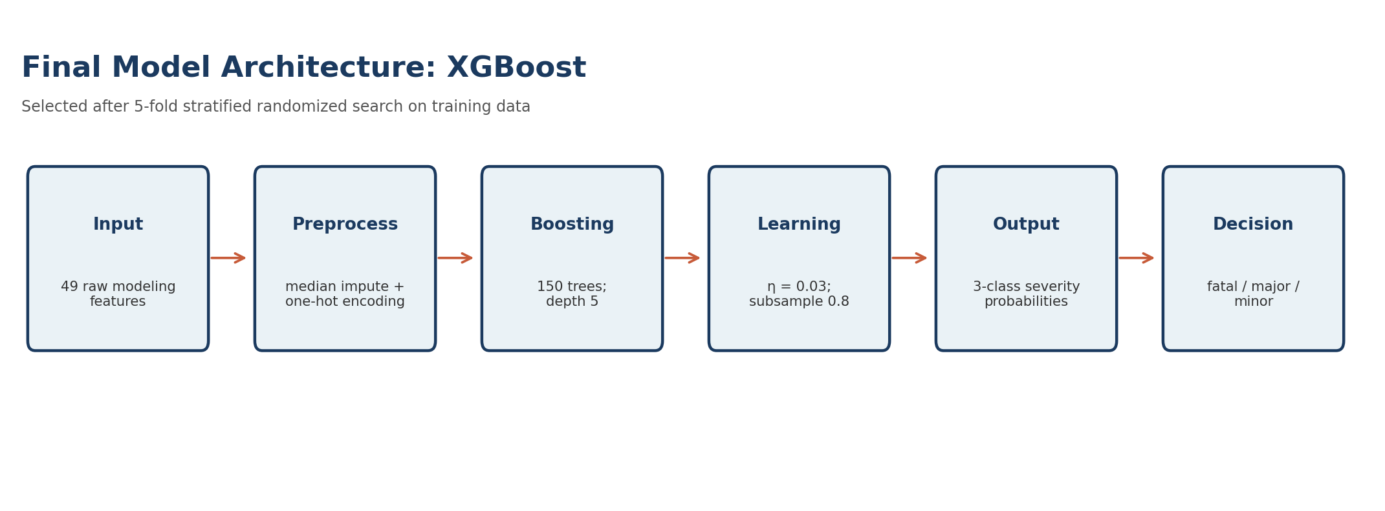
Figure 17. Conceptual architecture of the final XGBoost pipeline
Table 9. Best XGBoost configuration
Hyperparameter | Value
n_estimators | 150
max_depth | 5
learning_rate | 0.03
subsample | 0.8
colsample_bytree | 1.0
min_child_weight | 1
CV | 5-fold StratifiedKFold
Scoring | macro-F1
n_jobs | 1
random_state | 42

6.3 Hyperparameter Search
RandomizedSearchCV is used with macro-F1 scoring. Search size is intentionally limited for the 4 GB environment.

Table 10. Hyperparameter search summary
Model | Possible | Evaluated | Best CV macro-F1 | Search time
Logistic Regression | 5 | 5 | 0.9298 | 1.49 min
Decision Tree | 45 | 10 | 0.9288 | 0.60 min
Random Forest | 48 | 10 | 0.9315 | 3.05 min
XGBoost | 144 | 10 | 0.9352 | 2.69 min
Note. Times are tuning/search times, not isolated single-fit training times.

6.4 Training Curves
Applicability note
Epoch-by-epoch loss/accuracy curves are not applicable because the supplied final models are linear/tree/boosting models rather than epoch-trained neural networks. The notebook therefore does not generate training-curve figures.

7. RESULTS AND EVALUATION

7.1 Comparative Model Performance
Table 11. Held-out test-set model comparison
Rank | Model | Accuracy | Macro Precision | Macro Recall | Macro-F1 | Weighted F1 | ROC-AUC
1 | XGBoost | 0.9528 | 0.9413 | 0.9433 | 0.9423 | 0.9528 | 0.9946
2 | Random Forest | 0.9465 | 0.9319 | 0.9413 | 0.9365 | 0.9468 | 0.9927
3 | Logistic Regression | 0.9448 | 0.9261 | 0.9406 | 0.9330 | 0.9451 | 0.9898
4 | Decision Tree | 0.9415 | 0.9211 | 0.9400 | 0.9299 | 0.9419 | 0.9833
Note. Rank is ordered by macro-F1. No statistical significance test was computed.

7.2 Improvement Calculations
Table 12. Relative improvement of selected model
Comparison | Metric | Absolute | Relative
XGBoost vs Random Forest | Macro-F1 | 0.0058 | 0.62%
XGBoost vs Logistic Regression | Macro-F1 | 0.0093 | 1.00%
XGBoost vs Decision Tree | Macro-F1 | 0.0124 | 1.33%
XGBoost vs Decision Tree | Accuracy | 0.0113 | 1.20%
The differences justify selecting XGBoost under the notebook's macro-F1 criterion, but they are not evidence of statistical significance because no repeated-test or formal significance analysis was performed.

7.3 Class-Level Evaluation
Table 13. Classification report for XGBoost
Class | Precision | Recall | F1 | Support
Fatal | 0.93 | 0.93 | 0.93 | 597
Major | 0.92 | 0.92 | 0.92 | 1,198
Minor | 0.98 | 0.97 | 0.98 | 2,205
Macro average | 0.94 | 0.94 | 0.94 | 4,000
Weighted average | 0.95 | 0.95 | 0.95 | 4,000

7.4 Inference Speed
Measurement gap
Inference latency/throughput was not measured in the notebook, so no speed figure is invented. A production benchmark should record median and p95 latency on target hardware.

8. COMPARATIVE ANALYSIS

8.1 What the Results Suggest
All four models achieve strong held-out performance. Logistic Regression is competitive, showing that the engineered feature representation contains substantial class-separating information. Decision Tree performs slightly lower, Random Forest improves on the single-tree and linear baselines, and XGBoost provides the highest macro-F1, accuracy, and weighted ROC-AUC in the supplied test evaluation.

8.2 Why Macro-F1 Matters
Macro-F1 averages class-level F1 without weighting by frequency. In an imbalanced safety dataset, this prevents the majority class from dominating model selection and makes performance on the smaller fatal class more visible.

8.3 Statistical Significance
The notebook does not report confidence intervals, paired resampling tests, McNemar tests, bootstrap comparisons, or repeated cross-validation distributions. The comparison is therefore an empirical held-out benchmark, not a statistical significance claim.

9. INNOVATIONS AND UNIQUE CONTRIBUTIONS
- Crash-level reconstruction from occupant rows.
- Leakage-safe prediction timing.
- Occupant aggregation into interpretable crash-level ratios/statistics.
- Cyclical temporal feature engineering.
- Resource-aware randomized tuning on a 4 GB environment.
- Deployment-consistent saving of preprocessing and model together.

10. ETHICAL CONSIDERATIONS AND BIAS ANALYSIS
Accident-severity prediction is safety-relevant. Model output should be treated as analytical decision support rather than an autonomous determination of emergency priority, liability, or individual fault.

10.1 Potential Bias Sources
- Class imbalance may reduce reliability on fatal crashes.
- Geographic concentration may limit generalization.
- Vehicle-type frequency differences can distort raw count comparisons.
- Historical recording practices may introduce measurement bias.
- Location, vehicle type, or demographic aggregates may act as proxies for broader factors.

10.2 Responsible Use Controls
- Monitor class-specific recall, not accuracy alone.
- Evaluate on geographically or temporally separated data.
- Do not interpret feature importance as causal evidence.
- Keep post-outcome variables out of incident-time prediction.
- Require human review for high-impact decisions.
- Document provenance, coverage, missingness, and known limitations.
Important interpretation rule
Feature importance identifies variables used by the fitted model; it does not prove that changing a feature would cause severity to change.

11. LIMITATIONS AND MITIGATION STRATEGIES
Table 14. Limitations and mitigation strategies
Limitation | Potential effect | Mitigation
Dataset provenance is not independently documented | Limits external validity | Document source, collection period, sampling and data dictionary
2025 is lower in the yearly plot | Possible partial-coverage effect | Verify observation window
No external validation set | Generalization uncertain | Use geographic/temporal holdout
Inference speed not measured | Deployment performance unknown | Benchmark median/p95 latency
No significance testing | Model differences uncertain | Repeated CV/bootstrap/paired tests
Feature importance is model-specific | May be mistaken for causality | Use SHAP/permutation + domain review
Geographic plot not exposure-normalized | Concentration ≠ risk | Normalize by exposure when possible
Categorical imbalance | Rare categories may be unstable | Robust validation and category handling

12. REPRODUCIBILITY STATEMENT
The notebook uses a fixed random state and a defined directory structure. The saved model bundle contains the fitted pipeline, label encoder, feature columns, target, model name, and class labels.
Table 15. Reproducibility configuration
Item | Specification
Random seed | 42
Python requirement in README | Python 3.9 or above
Core libraries | pandas, NumPy, Matplotlib, Seaborn, scikit-learn, XGBoost, joblib
Deployment/EDA libraries | Streamlit, Plotly, Folium, openpyxl
Model artifact | models/best_model_bundle.joblib
Metrics artifact | outputs/metrics/model_comparison.csv
Risk-factor artifact | outputs/risk_factor_importance.csv
Processed dataset | data/processed/crash_level_accidents.csv
EDA artifacts | eda_plots/*.png

12.1 Run Instructions
The supplied README recommends Python 3.9 or above, a virtual environment, installation from `requirements.txt`, and launching with `streamlit run app.py`. The dashboard supports CSV/Excel upload, data inspection, interactive visualizations, filtering, and downloadable filtered data.
Deployment consistency
The Streamlit application should load the saved pipeline bundle and use the same feature columns as training. Post-outcome variables should not be exposed as prediction inputs.

13. CONCLUSION
This project demonstrates an end-to-end road-accident severity pipeline in which data representation is treated as a central modeling decision. Starting from 131,404 occupant-level observations, the workflow reconstructs 20,000 crash-level records, performs leakage-aware feature engineering, and evaluates four supervised learning models under a common preprocessing framework.
XGBoost provides the strongest held-out performance in the supplied experiment: 0.9423 macro-F1, 0.9528 accuracy, and 0.9946 weighted one-vs-rest ROC-AUC. Class-level recall is 0.93 for fatal, 0.92 for major, and 0.97 for minor crashes. Mean impact speed is the dominant global feature-importance signal.
The principal value of the project is the combination of crash-level reconstruction, leakage prevention, class-aware evaluation, resource-conscious tuning, and deployment consistency. Further independent validation is required before operational safety use.

14. FUTURE WORK
- Validate on an independently sourced or geographically separated dataset.
- Add probability calibration analysis.
- Measure inference latency and memory use on target hardware.
- Use SHAP or permutation importance alongside tree importance.
- Perform subgroup evaluation by state, road type, vehicle type, and time period.
- Use temporal holdout validation for future robustness.
- Normalize geographic hotspots by traffic exposure where possible.
- Add confidence intervals and repeated validation.
- Extend the Streamlit dashboard with probabilities, explanations, and monitoring.

15. REFERENCES
[1] T. Chen and C. Guestrin, “XGBoost: A Scalable Tree Boosting System,” Proceedings of the 22nd ACM SIGKDD International Conference on Knowledge Discovery and Data Mining, pp. 785–794, 2016. doi: 10.1145/2939672.2939785.
[2] L. Breiman, “Random Forests,” Machine Learning, vol. 45, pp. 5–32, 2001. doi: 10.1023/A:1010933404324.
[3] Scikit-learn Developers, “Getting Started: Transformers, ColumnTransformer, and Pipelines,” scikit-learn documentation.
[4] XGBoost Developers, “Python API Reference — XGBClassifier,” XGBoost documentation.
[5] Supplied project notebook, “Indian Road Accident Severity Prediction,” 2026.
[6] Supplied project README, “Indian Road Accident Severity Dashboard,” 2026.

16. GLOSSARY OF TERMS
Table 16. Technical glossary
Term | Definition
Accuracy | Fraction of test observations classified correctly.
Macro-F1 | Unweighted mean of class-level F1-scores.
Precision | Correct fraction among observations predicted as a class.
Recall | Correct fraction among observations belonging to a class.
ROC-AUC | Area under ROC; notebook reports weighted one-vs-rest multiclass ROC-AUC.
Target leakage | Use of information unavailable at prediction time or derived from the target.
One-hot encoding | Binary indicator representation for categorical values.
Imputation | Replacement of missing values using a defined rule.
Cross-validation | Repeated train/validation partitioning for model selection.
XGBoost | Gradient-boosted decision-tree learning system.
Crash-level record | One row representing one crash rather than one occupant.
Feature importance | Model-specific measure of feature contribution; not causal.
Stratification | Split procedure preserving class proportions.

APPENDIX A. SYSTEM ARCHITECTURE AND DATA FLOW
The supporting README describes a Streamlit frontend connected to a Python backend. Uploaded CSV/Excel files are read with pandas, validated, filtered, aggregated, and rendered through Plotly/Matplotlib or Streamlit tables. If no file is uploaded, the dashboard can generate a 500-row sample dataset for structural demonstration.
Figure 17. Machine-learning implementation flow used in the report
Analytical insight: The pipeline connects the notebook's analytical workflow to the intended Streamlit deployment path.

APPENDIX B. DASHBOARD ARCHITECTURE AND USER WORKFLOW
The README specifies system architecture, data flow, and user workflow: browser → Streamlit widgets → Python backend → pandas processing → charts/tables → user-facing output. Users can upload data, inspect it, choose visualizations, apply filters, and download filtered CSV output.
Table 17. README-described dashboard functions
Dashboard page | Function
Home and Overview | KPI cards and summary charts
Upload and Explore | File upload, column information, dtypes, missing-value counts
Visualizations | Interactive charts by road type, weather, vehicle type, time of day, etc.
Filter and Analyze | State, severity, road type, speed-limit filters and CSV download
About | Project and tool information

APPENDIX C. KEY NOTEBOOK EVIDENCE
Table 18. Key notebook outputs
Evidence item | Value
Raw shape | 131,404 × 50
Exact duplicate rows | 0
Unique crashes | 20,000
Crash-level shape | 20,000 × 49 before feature engineering
Modeling shape | 20,000 × 49
Numeric features | 37
Categorical features | 12
Train/test | 16,000 / 4,000
Final model | XGBoost
Test macro-F1 | 0.9423
Test accuracy | 0.9528
Weighted ROC-AUC | 0.9946

APPENDIX D. COMPLETE NOTEBOOK CODE
The following appendix preserves the executable code cells from the supplied notebook in monospaced form. Markdown-only explanatory cells are omitted because their methodology is already incorporated into the main report.
Notebook Code Cell 4
# Cell 1 — Install dependencies if required
# Run this cell once in a fresh environment.

%pip install -q pandas numpy matplotlib seaborn scikit-learn xgboost joblib folium openpyxl
Notebook Code Cell 5
# Cell 2 — Imports and configuration

from pathlib import Path
import warnings
warnings.filterwarnings("ignore")

import numpy as np
import pandas as pd
import matplotlib.pyplot as plt
import seaborn as sns
import joblib

from sklearn.model_selection import train_test_split, StratifiedKFold, RandomizedSearchCV
from sklearn.compose import ColumnTransformer
from sklearn.pipeline import Pipeline
from sklearn.impute import SimpleImputer
from sklearn.preprocessing import OneHotEncoder, StandardScaler, LabelEncoder
from sklearn.linear_model import LogisticRegression
from sklearn.tree import DecisionTreeClassifier
from sklearn.ensemble import RandomForestClassifier
from sklearn.metrics import (
accuracy_score,
precision_score,
recall_score,
f1_score,
classification_report,
confusion_matrix,
roc_auc_score
)
from sklearn.inspection import permutation_importance

from xgboost import XGBClassifier

RANDOM_STATE = 42

# Project directories
PROJECT_DIR = Path(".")
DATA_DIR = PROJECT_DIR / "data"
RAW_DIR = DATA_DIR / "raw"
PROCESSED_DIR = DATA_DIR / "processed"
EDA_DIR = PROJECT_DIR / "eda_plots"
OUTPUT_DIR = PROJECT_DIR / "outputs"
METRICS_DIR = OUTPUT_DIR / "metrics"
MODEL_DIR = PROJECT_DIR / "models"

for folder in [RAW_DIR, PROCESSED_DIR, EDA_DIR, METRICS_DIR, MODEL_DIR]:
folder.mkdir(parents=True, exist_ok=True)

# Change this filename if your CSV has a different name.
DATA_PATH = RAW_DIR / "indian_road_accidents_passenger_level.csv"

print("Project directories ready.")
print("Expected data file:", DATA_PATH)
Notebook Code Cell 6
# Cell 3 — Load data

if not DATA_PATH.exists():
raise FileNotFoundError(
f"Dataset not found at {DATA_PATH}. "
"Place your CSV inside data/raw/ or update DATA_PATH."
)

df = pd.read_csv(DATA_PATH)

print("Raw shape:", df.shape)
print("Raw memory usage:", round(df.memory_usage(deep=True).sum() / 1024**2, 2), "MB")
display(df.head())
Notebook Code Cell 7
# Cell 4 — Initial structural inspection

print("Rows:", len(df))
print("Columns:", len(df.columns))
print("\nColumn names:")
print(df.columns.tolist())

print("\nData types:")
display(df.dtypes.to_frame("dtype"))

print("\nMissing values:")
display(df.isna().sum().sort_values(ascending=False).to_frame("missing_count"))

print("\nExact duplicate rows:", df.duplicated().sum())

if "crash_ref_id" in df.columns:
print("Unique crashes:", df["crash_ref_id"].nunique(dropna=True))

if "crash_severity" in df.columns:
print("\nTarget distribution:")
display(df["crash_severity"].value_counts(dropna=False).to_frame("count"))
Notebook Code Cell 9
# Cell 5 — Standardize columns and blank values

df.columns = (
df.columns
.str.strip()
.str.lower()
.str.replace(r"[^a-z0-9]+", "_", regex=True)
.str.strip("_")
)

# Convert blank/whitespace-only strings to missing values
object_cols = df.select_dtypes(include=["object", "string"]).columns

for col in object_cols:
df[col] = df[col].astype("string").str.strip()
df[col] = df[col].replace({
"": pd.NA,
"nan": pd.NA,
"none": pd.NA,
"null": pd.NA
})

print("Standardized columns:", len(df.columns))
Notebook Code Cell 10
# Cell 6 — Normalize categorical values

categorical_candidates = [
"city_name", "state_name", "weekday_name", "festival_name",
"route_category", "weather_condition", "visibility_level",
"congestion_level", "road_surface_condition", "primary_cause",
"dominant_vehicle_type", "passenger_gender", "seat_position",
"helmet_or_seatbelt_used", "license_status", "injury_outcome",
"crash_severity"
]

for col in categorical_candidates:
if col in df.columns:
df[col] = (
df[col].astype("string")
.str.strip()
.str.lower()
.str.replace(r"\s+", "_", regex=True)
)

# Standardize common yes/no values to lowercase strings.
binary_candidates = [
"weekend_flag", "is_night_time", "peak_hour_flag",
"signal_present_flag", "alcohol_suspected_flag", "road_hazard_flag",
"helmet_or_seatbelt_used", "airbag_deployed_flag",
"ambulance_called_flag", "hospitalized_flag", "fatality_flag",
"survived"
]

for col in binary_candidates:
if col in df.columns and df[col].dtype == "object":
df[col] = df[col].astype("string").str.lower().str.strip()

print("Categorical normalization complete.")
Notebook Code Cell 11
# Cell 7 — Numeric coercion

numeric_candidates = [
"lat_coord", "lon_coord", "incident_year", "incident_month",
"hour_of_day", "weekend_flag", "is_night_time", "peak_hour_flag",
"lane_count", "signal_present_flag", "temp_celsius",
"alcohol_suspected_flag", "road_hazard_flag", "vehicle_count",
"occupants_per_vehicle", "total_occupants_in_crash",
"speed_at_impact_kmph", "computed_risk_score",
"passenger_age_years", "airbag_deployed_flag",
"ambulance_called_flag", "emergency_response_time_min",
"distance_to_hospital_km", "total_casualties_reported",
"hospitalized_flag", "estimated_recovery_days",
"fatality_flag", "survived"
]

for col in numeric_candidates:
if col in df.columns:
df[col] = pd.to_numeric(df[col], errors="coerce")

print("Numeric conversion complete.")
display(df[numeric_candidates].dtypes.to_frame("dtype"))
Notebook Code Cell 12
# Cell 8 — Remove exact duplicates and records without essential keys

before = len(df)

df = df.drop_duplicates().copy()

if "crash_ref_id" in df.columns:
df = df[df["crash_ref_id"].notna()].copy()

if "crash_severity" in df.columns:
df = df[df["crash_severity"].notna()].copy()

print("Rows before:", before)
print("Rows after :", len(df))
print("Rows removed:", before - len(df))
Notebook Code Cell 13
# Cell 9 — Domain validation

def report_invalid_range(data, col, low=None, high=None):
if col not in data.columns:
return
s = data[col]
mask = s.notna()
if low is not None:
mask &= s < low
if high is not None:
mask |= s > high
print(f"{col}: {int(mask.sum())} potentially invalid values")

report_invalid_range(df, "lat_coord", 6, 37)
report_invalid_range(df, "lon_coord", 68, 98)
report_invalid_range(df, "incident_month", 1, 12)
report_invalid_range(df, "hour_of_day", 0, 23)
report_invalid_range(df, "lane_count", 1, None)
report_invalid_range(df, "passenger_age_years", 0, 120)
report_invalid_range(df, "speed_at_impact_kmph", 0, None)
report_invalid_range(df, "temp_celsius", -30, 60)
report_invalid_range(df, "vehicle_count", 1, None)
report_invalid_range(df, "total_occupants_in_crash", 1, None)
Notebook Code Cell 16
# Cell 10 — Check crash-level consistency

crash_level_candidates = [
"city_name", "state_name", "lat_coord", "lon_coord",
"incident_year", "incident_month", "incident_time", "hour_of_day",
"weekday_name", "weekend_flag", "is_night_time", "peak_hour_flag",
"festival_name", "route_category", "lane_count",
"signal_present_flag", "weather_condition", "visibility_level",
"temp_celsius", "congestion_level", "road_surface_condition",
"primary_cause", "alcohol_suspected_flag", "road_hazard_flag",
"vehicle_count", "dominant_vehicle_type",
"occupants_per_vehicle", "total_occupants_in_crash",
"total_casualties_reported", "crash_severity"
]

consistency_rows = []

for col in crash_level_candidates:
if col in df.columns:
nunique = df.groupby("crash_ref_id")[col].nunique(dropna=True)
inconsistent = int((nunique > 1).sum())
consistency_rows.append({
"column": col,
"crashes_with_multiple_values": inconsistent
})

consistency_df = pd.DataFrame(consistency_rows).sort_values(
"crashes_with_multiple_values", ascending=False
)

display(consistency_df)
Notebook Code Cell 17
# Cell 11 — Remove crashes with conflicting target labels

severity_counts = (
df.groupby("crash_ref_id")["crash_severity"]
.nunique(dropna=True)
)

conflicting_crashes = severity_counts[severity_counts > 1].index

print("Crashes with conflicting crash_severity labels:", len(conflicting_crashes))

if len(conflicting_crashes) > 0:
df = df[~df["crash_ref_id"].isin(conflicting_crashes)].copy()

print("Remaining raw rows:", len(df))
print("Remaining unique crashes:", df["crash_ref_id"].nunique())
Notebook Code Cell 18
# Cell 12 — Helper functions for occupant aggregation

def normalized_string(s):
return s.astype("string").str.strip().str.lower()

def yes_rate(s):
x = normalized_string(s)
return x.isin(["yes", "1", "true", "y"]).mean()

def value_rate(s, values):
x = normalized_string(s)
return x.isin(values).mean()

def category_ratio(s, keywords):
x = normalized_string(s)
return x.str.contains("|".join(map(str, keywords)), regex=True, na=False).mean()

def safe_std(s):
return s.std(ddof=0)

def safe_mode(s):
s = s.dropna()
if len(s) == 0:
return np.nan
m = s.mode()
return m.iloc[0] if len(m) else np.nan
Notebook Code Cell 19
# Cell 13 — Build one row per crash

# Fields that represent the crash context and can safely be retained once
crash_first = [
"city_name", "state_name", "lat_coord", "lon_coord",
"incident_year", "incident_month", "incident_time", "hour_of_day",
"weekday_name", "weekend_flag", "is_night_time", "peak_hour_flag",
"festival_name", "route_category", "lane_count",
"signal_present_flag", "weather_condition", "visibility_level",
"temp_celsius", "congestion_level", "road_surface_condition",
"primary_cause", "alcohol_suspected_flag", "road_hazard_flag",
"vehicle_count", "dominant_vehicle_type",
"occupants_per_vehicle", "total_occupants_in_crash",
"crash_severity"
]

crash_first = [c for c in crash_first if c in df.columns]

agg_dict = {c: "first" for c in crash_first}

# Numeric occupant/crash characteristics
if "speed_at_impact_kmph" in df.columns:
agg_dict["speed_at_impact_kmph"] = ["mean", "max", "min", "std"]

if "passenger_age_years" in df.columns:
agg_dict["passenger_age_years"] = ["mean", "max", "min", "std"]

# Occupant safety and demographic summaries
if "helmet_or_seatbelt_used" in df.columns:
agg_dict["helmet_or_seatbelt_used"] = yes_rate

if "airbag_deployed_flag" in df.columns:
agg_dict["airbag_deployed_flag"] = "mean"

if "passenger_gender" in df.columns:
agg_dict["passenger_gender"] = [
lambda s: value_rate(s, ["male", "m"]),
lambda s: value_rate(s, ["female", "f"])
]

if "seat_position" in df.columns:
agg_dict["seat_position"] = [
lambda s: category_ratio(s, ["driver"]),
lambda s: category_ratio(s, ["rider"]),
lambda s: category_ratio(s, ["pillion"]),
lambda s: category_ratio(s, ["passenger", "co_passenger", "copassenger"])
]

if "license_status" in df.columns:
agg_dict["license_status"] = [
lambda s: value_rate(s, ["valid"]),
lambda s: value_rate(s, ["expired", "invalid", "suspended"])
]

crash_df = df.groupby("crash_ref_id", sort=False).agg(agg_dict)

# Flatten MultiIndex columns
flat_columns = []
for col in crash_df.columns:
if isinstance(col, tuple):
base, func = col
if callable(func):
name = "custom"
else:
name = str(func)
flat_columns.append(f"{base}_{name}")
else:
flat_columns.append(str(col))

crash_df.columns = flat_columns
crash_df = crash_df.reset_index()

# Rename generated columns to meaningful names
rename_map = {
"speed_at_impact_kmph_mean": "mean_speed_at_impact_kmph",
"speed_at_impact_kmph_max": "max_speed_at_impact_kmph",
"speed_at_impact_kmph_min": "min_speed_at_impact_kmph",
"speed_at_impact_kmph_std": "speed_at_impact_std",
"passenger_age_years_mean": "mean_passenger_age",
"passenger_age_years_max": "max_passenger_age",
"passenger_age_years_min": "min_passenger_age",
"passenger_age_years_std": "passenger_age_std",
}

crash_df = crash_df.rename(columns=rename_map)

# Because lambda names may be generic, identify them by source prefix and position.
gender_custom = [c for c in crash_df.columns if c.startswith("passenger_gender_")]
seat_custom = [c for c in crash_df.columns if c.startswith("seat_position_")]
license_custom = [c for c in crash_df.columns if c.startswith("license_status_")]

if len(gender_custom) >= 2:
crash_df = crash_df.rename(columns={
gender_custom[0]: "male_ratio",
gender_custom[1]: "female_ratio"
})

if len(seat_custom) >= 4:
crash_df = crash_df.rename(columns={
seat_custom[0]: "driver_ratio",
seat_custom[1]: "rider_ratio",
seat_custom[2]: "pillion_ratio",
seat_custom[3]: "passenger_ratio"
})

if len(license_custom) >= 2:
crash_df = crash_df.rename(columns={
license_custom[0]: "valid_license_ratio",
license_custom[1]: "invalid_license_ratio"
})

# Rename safety-rate function column
helmet_custom = [c for c in crash_df.columns if c.startswith("helmet_or_seatbelt_used_")]
if helmet_custom:
crash_df = crash_df.rename(columns={helmet_custom[0]: "helmet_seatbelt_usage_rate"})

# Number of occupant records represented by each crash
occupant_counts = df.groupby("crash_ref_id").size().rename("occupant_record_count")
crash_df = crash_df.merge(occupant_counts, on="crash_ref_id", how="left")

print("Crash-level shape:", crash_df.shape)
display(crash_df.head())
Notebook Code Cell 20
print("Raw occupant records:", len(df))
print("Unique crashes:", df["crash_ref_id"].nunique())
print("Crash-level records:", len(crash_df))

print("\nCrash-level target distribution:")
display(crash_df["crash_severity_first"].value_counts(dropna=False).to_frame("count"))

print("\nCrash-level missing values:")
display(
crash_df.isna().sum()
.sort_values(ascending=False)
.to_frame("missing_count")
.head(20)
)

crash_df.to_csv(PROCESSED_DIR / "crash_level_accidents.csv", index=False)
print("\nSaved:", PROCESSED_DIR / "crash_level_accidents.csv")
Notebook Code Cell 22
# Cell 15 — Feature engineering

def add_features(data):
data = data.copy()

# Cyclical time features
if "hour_of_day" in data.columns:
hour = pd.to_numeric(data["hour_of_day"], errors="coerce")
data["hour_sin"] = np.sin(2 * np.pi * hour / 24)
data["hour_cos"] = np.cos(2 * np.pi * hour / 24)

if "incident_month" in data.columns:
month = pd.to_numeric(data["incident_month"], errors="coerce")
data["month_sin"] = np.sin(2 * np.pi * (month - 1) / 12)
data["month_cos"] = np.cos(2 * np.pi * (month - 1) / 12)

# Speed/road structure
if {"mean_speed_at_impact_kmph", "lane_count"}.issubset(data.columns):
lanes = data["lane_count"].replace(0, np.nan)
data["speed_per_lane"] = data["mean_speed_at_impact_kmph"] / lanes

if "mean_speed_at_impact_kmph" in data.columns:
data["high_speed_flag"] = (
data["mean_speed_at_impact_kmph"] >= 80
).astype(float)

# Safety non-compliance
if "helmet_seatbelt_usage_rate" in data.columns:
data["safety_noncompliance_rate"] = (
1 - data["helmet_seatbelt_usage_rate"]
)

# Interactions
if {"is_night_time", "weekend_flag"}.issubset(data.columns):
data["night_weekend_interaction"] = (
pd.to_numeric(data["is_night_time"], errors="coerce") *
pd.to_numeric(data["weekend_flag"], errors="coerce")
)

if {"road_hazard_flag", "is_night_time"}.issubset(data.columns):
data["night_hazard_interaction"] = (
pd.to_numeric(data["road_hazard_flag"], errors="coerce") *
pd.to_numeric(data["is_night_time"], errors="coerce")
)

return data

crash_df = add_features(crash_df)

print("Feature engineering complete.")
display(crash_df.head())
Notebook Code Cell 24
# Cell 16 — EDA helper

def save_fig(filename, dpi=150):
path = EDA_DIR / filename
plt.tight_layout()
plt.savefig(path, dpi=dpi, bbox_inches="tight")
plt.show()
plt.close()
print("Saved:", path)
Notebook Code Cell 25
plt.figure(figsize=(8, 5))
order = crash_df["crash_severity_first"].value_counts().index
sns.countplot(data=crash_df, x="crash_severity_first", order=order)
plt.title("Crash Severity Distribution")
plt.xlabel("Crash Severity")
plt.ylabel("Number of Crashes")
plt.xticks(rotation=30)
save_fig("01_severity_distribution.png")
Notebook Code Cell 26
# Cell 18 — 2. Hourly severity trend

hour_severity = (
crash_df.groupby(["hour_of_day_first", "crash_severity_first"])
.size()
.reset_index(name="crashes")
)

plt.figure(figsize=(8, 5))
sns.lineplot(
data=hour_severity,
x="hour_of_day_first",
y="crashes",
hue="crash_severity_first",
marker="o"
)
plt.title("Hourly Crash Severity Trend")
plt.xlabel("Hour of Day")
plt.ylabel("Crashes")
save_fig("02_hourly_severity_trend.png")
Notebook Code Cell 27
# Cell 19A — Day-of-week severity plot

weekday_order = [
"monday",
"tuesday",
"wednesday",
"thursday",
"friday",
"saturday",
"sunday"
]

plot_df = crash_df[
["weekday_name_first", "crash_severity_first"]
].dropna().copy()

plot_df["weekday_name_first"] = (
plot_df["weekday_name_first"]
.astype(str)
.str.strip()
.str.lower()
)

plot_df["crash_severity_first"] = (
plot_df["crash_severity_first"]
.astype(str)
.str.strip()
.str.lower()
)

plot_df = plot_df[
plot_df["weekday_name_first"].isin(weekday_order)
]

tmp = (
plot_df
.groupby(
["weekday_name_first", "crash_severity_first"],
observed=True
)
.size()
.reset_index(name="crashes")
)

available_days = [
day for day in weekday_order
if day in plot_df["weekday_name_first"].unique()
]

severity_colors = {
"minor": "darkorange",
"moderate": "seagreen",
"serious": "crimson",
"severe": "darkviolet",
"critical": "teal",
"fatal": "royalblue",
"major": "deeppink",
"low": "goldenrod",
"medium": "slateblue"
}

plt.figure(figsize=(9, 5))

sns.barplot(
data=tmp,
x="weekday_name_first",
y="crashes",
hue="crash_severity_first",
order=available_days,
palette=severity_colors,
errorbar=None
)

plt.title(
"Day-of-Week vs Crash Severity",
fontsize=15,
fontweight="bold"
)

plt.xlabel("Weekday", fontsize=11)
plt.ylabel("Number of Crashes", fontsize=11)

plt.xticks(rotation=20, ha="right")

plt.legend(
title="Crash Severity",
bbox_to_anchor=(1.02, 1),
loc="upper left"
)

plt.grid(
axis="y",
linestyle="--",
alpha=0.3
)

save_fig("03_weekday_severity.png")

plt.show()
Notebook Code Cell 28
# Cell 19B — Day-of-week severity data

display(
tmp[
[
"weekday_name_first",
"crash_severity_first",
"crashes"
]
]
)
Notebook Code Cell 29
# Cell 20 — 4. Monthly trend

monthly = (
crash_df.groupby(["incident_month_first", "crash_severity_first"])
.size()
.reset_index(name="crashes")
)

plt.figure(figsize=(8, 5))
sns.lineplot(
data=monthly,
x="incident_month_first",
y="crashes",
hue="crash_severity_first",
marker="o"
)
plt.title("Monthly Crash Severity Trend")
plt.xlabel("Month")
plt.ylabel("Crashes")
save_fig("04_monthly_severity_trend.png")
Notebook Code Cell 30
# Cell 21A — 5. Yearly trend plot

yearly = (
crash_df
.dropna(subset=["incident_year_first", "crash_severity_first"])
.groupby(["incident_year_first", "crash_severity_first"], observed=True)
.size()
.reset_index(name="crashes")
.sort_values("incident_year_first")
)

plt.figure(figsize=(8, 5))

sns.lineplot(
data=yearly,
x="incident_year_first",
y="crashes",
hue="crash_severity_first",
marker="o"
)

plt.title(
"Yearly Crash Severity Trend",
fontsize=15,
fontweight="bold"
)

plt.xlabel("Year")
plt.ylabel("Number of Crashes")

plt.xticks(
sorted(yearly["incident_year_first"].unique())
)

plt.grid(
True,
linestyle="--",
alpha=0.3
)

save_fig("05_yearly_severity_trend.png")

plt.show()
Notebook Code Cell 31
# Cell 22A — 6. Weather condition vs crash severity plot

weather = (
crash_df
.dropna(subset=["weather_condition_first", "crash_severity_first"])
.groupby(
["weather_condition_first", "crash_severity_first"],
observed=True
)
.size()
.reset_index(name="crashes")
)

plt.figure(figsize=(8, 5))

sns.barplot(
data=weather,
x="weather_condition_first",
y="crashes",
hue="crash_severity_first",
errorbar=None
)

plt.title(
"Weather Condition vs Crash Severity",
fontsize=15,
fontweight="bold"
)

plt.xlabel("Weather Condition")
plt.ylabel("Number of Crashes")

plt.xticks(
rotation=35,
ha="right"
)

plt.legend(
title="Crash Severity",
bbox_to_anchor=(1.02, 1),
loc="upper left"
)

plt.grid(
axis="y",
linestyle="--",
alpha=0.3
)

save_fig("06_weather_severity.png")

plt.show()
Notebook Code Cell 32
# Cell 23A — 7. Road surface vs severity plot

surface = (
crash_df
.dropna(
subset=[
"road_surface_condition_first",
"crash_severity_first"
]
)
.groupby(
[
"road_surface_condition_first",
"crash_severity_first"
],
observed=True
)
.size()
.reset_index(name="crashes")
)

plt.figure(figsize=(8, 5))

sns.barplot(
data=surface,
x="road_surface_condition_first",
y="crashes",
hue="crash_severity_first",
errorbar=None
)

plt.title(
"Road Surface Condition vs Crash Severity",
fontsize=15,
fontweight="bold"
)

plt.xlabel("Road Surface")
plt.ylabel("Number of Crashes")

plt.xticks(
rotation=35,
ha="right"
)

plt.legend(
title="Crash Severity",
bbox_to_anchor=(1.02, 1),
loc="upper left"
)

plt.grid(
axis="y",
linestyle="--",
alpha=0.3
)

save_fig("07_road_surface_severity.png")

plt.show()
Notebook Code Cell 33
# Cell 24A — 8. Vehicle type vs severity plot

vehicle = (
crash_df
.dropna(
subset=[
"dominant_vehicle_type_first",
"crash_severity_first"
]
)
.groupby(
[
"dominant_vehicle_type_first",
"crash_severity_first"
],
observed=True
)
.size()
.reset_index(name="crashes")
)

plt.figure(figsize=(8, 5))

sns.barplot(
data=vehicle,
x="dominant_vehicle_type_first",
y="crashes",
hue="crash_severity_first",
errorbar=None
)

plt.title(
"Dominant Vehicle Type vs Crash Severity",
fontsize=15,
fontweight="bold"
)

plt.xlabel("Vehicle Type")
plt.ylabel("Number of Crashes")

plt.xticks(
rotation=35,
ha="right"
)

plt.legend(
title="Crash Severity",
bbox_to_anchor=(1.02, 1),
loc="upper left"
)

plt.grid(
axis="y",
linestyle="--",
alpha=0.3
)

save_fig("08_vehicle_type_severity.png")

plt.show()
Notebook Code Cell 34
# Cell 25A — 9. Primary cause vs severity plot

cause = (
crash_df
.dropna(
subset=[
"primary_cause_first",
"crash_severity_first"
]
)
.groupby(
[
"primary_cause_first",
"crash_severity_first"
],
observed=True
)
.size()
.reset_index(name="crashes")
)

plt.figure(figsize=(8, 5))

sns.barplot(
data=cause,
x="primary_cause_first",
y="crashes",
hue="crash_severity_first",
errorbar=None
)

plt.title(
"Primary Cause vs Crash Severity",
fontsize=15,
fontweight="bold"
)

plt.xlabel("Primary Cause")
plt.ylabel("Number of Crashes")

plt.xticks(
rotation=45,
ha="right"
)

plt.legend(
title="Crash Severity",
bbox_to_anchor=(1.02, 1),
loc="upper left"
)

plt.grid(
axis="y",
linestyle="--",
alpha=0.3
)

save_fig("09_primary_cause_severity.png")

plt.show()
Notebook Code Cell 35
# Cell 26 — 10. Occupant/casualty distribution

numeric_plot_col = (
"total_casualties_reported"
if "total_casualties_reported" in crash_df.columns
else "occupant_record_count"
)

if numeric_plot_col in crash_df.columns:
plt.figure(figsize=(10, 5))
sns.boxplot(
data=crash_df,
x="crash_severity_first",
y=numeric_plot_col
)
plt.title(f"{numeric_plot_col} vs Crash Severity")
plt.xlabel("Crash Severity")
plt.ylabel(numeric_plot_col)
plt.xticks(rotation=30)
save_fig("10_occupant_casualty_distribution.png")
Notebook Code Cell 36
# Cell 27 — 11. Numerical correlation heatmap

numeric_cols = crash_df.select_dtypes(include=np.number).columns.tolist()

# Exclude IDs and target-coded fields from correlation visualization where appropriate
corr_df = crash_df[numeric_cols].copy()

if len(corr_df.columns) > 1:
corr = corr_df.corr(numeric_only=True)

plt.figure(figsize=(15, 11))

sns.heatmap(
corr,
cmap="RdBu_r",
center=0,
square=False,
annot=False,
linewidths=0.5
)

plt.title(
"Numerical Feature Correlation Heatmap",
fontsize=15,
fontweight="bold"
)

plt.tight_layout()

save_fig("11_numeric_correlation_heatmap.png")

plt.show()
Notebook Code Cell 37
# Cell 28 — 12. Speed vs Severity

if "mean_speed_at_impact_kmph" in crash_df.columns and "crash_severity_first" in crash_df.columns:

plot_df = crash_df[
["crash_severity_first", "mean_speed_at_impact_kmph"]
].dropna().copy()

plot_df["crash_severity_first"] = (
plot_df["crash_severity_first"]
.astype(str)
.str.strip()
.str.lower()
)

plt.figure(figsize=(8, 5))

sns.boxplot(
data=plot_df,
x="crash_severity_first",
y="mean_speed_at_impact_kmph"
)

plt.title(
"Mean Impact Speed vs Crash Severity",
fontsize=15,
fontweight="bold"
)
plt.xlabel("Crash Severity")
plt.ylabel("Mean Speed at Impact (km/h)")
plt.xticks(rotation=30)

plt.tight_layout()

save_fig("12_speed_vs_severity.png")

plt.show()
Notebook Code Cell 38
# Cell 29 — 13. Age vs Severity

if "mean_passenger_age" in crash_df.columns and "crash_severity_first" in crash_df.columns:

plot_df = crash_df[
["crash_severity_first", "mean_passenger_age"]
].dropna().copy()

plot_df["crash_severity_first"] = (
plot_df["crash_severity_first"]
.astype(str)
.str.strip()
.str.lower()
)

plt.figure(figsize=(8, 5))

sns.boxplot(
data=plot_df,
x="crash_severity_first",
y="mean_passenger_age"
)

plt.title(
"Mean Occupant Age vs Crash Severity",
fontsize=15,
fontweight="bold"
)
plt.xlabel("Crash Severity")
plt.ylabel("Mean Occupant Age")
plt.xticks(rotation=30)

plt.tight_layout()

save_fig("13_age_vs_severity.png")

plt.show()
Notebook Code Cell 39
# Cell 30 — 14. Geographic Hotspot Visualization

if {
"lat_coord_first",
"lon_coord_first",
"crash_severity_first"
}.issubset(crash_df.columns):

geo = crash_df[
[
"lat_coord_first",
"lon_coord_first",
"crash_severity_first"
]
].dropna().copy()

# Sample large point sets to protect memory and plotting performance.
if len(geo) > 20000:
geo = geo.sample(20000, random_state=RANDOM_STATE)

plt.figure(figsize=(10, 8))

plt.hexbin(
geo["lon_coord_first"],
geo["lat_coord_first"],
gridsize=60,
mincnt=1
)

plt.xlabel("Longitude")
plt.ylabel("Latitude")
plt.title(
"Geographic Crash Concentration",
fontsize=15,
fontweight="bold"
)

plt.tight_layout()

save_fig("14_geographic_hotspots.png")

plt.show()
Notebook Code Cell 41
# Cell 31 — Define target and leakage-safe feature set

TARGET = "crash_severity_first"

DROP_FEATURES = [
"record_id",
"occupant_unique_id",
"crash_ref_id",
"occupant_seq_no",
"computed_risk_score",
"ambulance_called_flag",
"emergency_response_time_min",
"distance_to_hospital_km",
"injury_outcome",
"hospitalized_flag",
"estimated_recovery_days",
"fatality_flag",
"survived",
"total_casualties_reported",
TARGET
]

# Drop only columns that actually exist in crash_df
DROP_FEATURES = [
c for c in DROP_FEATURES
if c in crash_df.columns
]

X = crash_df.drop(columns=DROP_FEATURES).copy()

y_raw = (
crash_df[TARGET]
.astype(str)
.str.strip()
.str.lower()
)

# Remove accidental string representations of missing target values
valid_target = ~y_raw.isin(["nan", "none", ""])

X = X.loc[valid_target].copy()
y_raw = y_raw.loc[valid_target].copy()

print("Modeling X shape:", X.shape)
print("Target classes:", sorted(y_raw.unique()))

display(
y_raw.value_counts()
.to_frame("count")
)
Notebook Code Cell 42
# Cell 32 — Encode target

label_encoder = LabelEncoder()
y = label_encoder.fit_transform(y_raw)

print("Encoded classes:")
for idx, label in enumerate(label_encoder.classes_):
print(idx, "->", label)
Notebook Code Cell 43
# Cell 33 — Train/test split

# Stratification preserves the severity distribution.
X_train, X_test, y_train, y_test = train_test_split(
X,
y,
test_size=0.20,
random_state=RANDOM_STATE,
stratify=y
)

print("Train:", X_train.shape)
print("Test :", X_test.shape)

print("\nTraining target distribution:")
display(pd.Series(y_train).value_counts().sort_index().to_frame("count"))

print("\nTesting target distribution:")
display(pd.Series(y_test).value_counts().sort_index().to_frame("count"))
Notebook Code Cell 44
# Cell 34 — Identify numeric and categorical columns

numeric_features = X_train.select_dtypes(include=np.number).columns.tolist()
categorical_features = X_train.select_dtypes(
include=["object", "string", "category"]
).columns.tolist()

print("Numeric features:", len(numeric_features))
print(numeric_features)

print("\nCategorical features:", len(categorical_features))
print(categorical_features)
Notebook Code Cell 46
# Cell 35 — Preprocessing pipeline factory

def make_preprocessor(scale_numeric=True):
if scale_numeric:
numeric_pipe = Pipeline([
("imputer", SimpleImputer(strategy="median")),
("scaler", StandardScaler())
])
else:
numeric_pipe = Pipeline([
("imputer", SimpleImputer(strategy="median"))
])

categorical_pipe = Pipeline([
("imputer", SimpleImputer(strategy="most_frequent")),
("onehot", OneHotEncoder(
handle_unknown="ignore",
sparse_output=True
))
])

return ColumnTransformer([
("num", numeric_pipe, numeric_features),
("cat", categorical_pipe, categorical_features)
])
Notebook Code Cell 48
# Cell 36 — Cross-validation

min_class_count = pd.Series(y_train).value_counts().min()

if min_class_count >= 5:
n_splits = 5
elif min_class_count >= 3:
n_splits = 3
else:
n_splits = 2

cv = StratifiedKFold(
n_splits=n_splits,
shuffle=True,
random_state=RANDOM_STATE
)

print("CV folds:", n_splits)
Notebook Code Cell 49
# Cell 37 — Model definitions and parameter spaces (Refined)

n_classes = len(label_encoder.classes_)

models_and_params = {}

# 1. Logistic Regression
logistic_pipe = Pipeline([
("preprocessor", make_preprocessor(scale_numeric=True)),
("model", LogisticRegression(
solver="lbfgs",
max_iter=2000,
class_weight="balanced",
random_state=RANDOM_STATE
))
])

models_and_params["Logistic Regression"] = (
logistic_pipe,
{
"model__C": [0.01, 0.1, 1.0, 5.0, 10.0]
}
)

# 2. Decision Tree
tree_pipe = Pipeline([
("preprocessor", make_preprocessor(scale_numeric=False)),
("model", DecisionTreeClassifier(
class_weight="balanced",
random_state=RANDOM_STATE
))
])

models_and_params["Decision Tree"] = (
tree_pipe,
{
"model__max_depth": [3, 5, 8, 12, 16],
"model__min_samples_split": [5, 10, 20],
"model__min_samples_leaf": [2, 5, 10]
}
)

# 3. Random Forest (trimmed n_estimators to protect memory and runtime)
rf_pipe = Pipeline([
("preprocessor", make_preprocessor(scale_numeric=False)),
("model", RandomForestClassifier(
class_weight="balanced",
random_state=RANDOM_STATE,
n_jobs=1
))
])

models_and_params["Random Forest"] = (
rf_pipe,
{
"model__n_estimators": [100, 150],
"model__max_depth": [8, 15, 20],
"model__min_samples_split": [5, 10],
"model__min_samples_leaf": [2, 5],
"model__max_features": ["sqrt", "log2"]
}
)

# 4. XGBoost
if n_classes == 2:
xgb_model = XGBClassifier(
objective="binary:logistic",
eval_metric="logloss",
tree_method="hist",
random_state=RANDOM_STATE,
n_jobs=1
)
else:
xgb_model = XGBClassifier(
objective="multi:softprob",
eval_metric="mlogloss",
tree_method="hist",
random_state=RANDOM_STATE,
n_jobs=1
)

xgb_pipe = Pipeline([
("preprocessor", make_preprocessor(scale_numeric=False)),
("model", xgb_model)
])

models_and_params["XGBoost"] = (
xgb_pipe,
{
"model__n_estimators": [100, 150],
"model__max_depth": [3, 5, 7],
"model__learning_rate": [0.03, 0.08, 0.15],
"model__subsample": [0.8, 1.0],
"model__colsample_bytree": [0.8, 1.0],
"model__min_child_weight": [1, 5]
}
)

print("Models prepared:", list(models_and_params.keys()))
Notebook Code Cell 50
# Insert directly before running Cell 38 to wipe any pd.NA objects

import numpy as np

for col in categorical_features:
if col in X_train.columns:
X_train[col] = X_train[col].astype(object).replace({pd.NA: np.nan})
if col in X_test.columns:
X_test[col] = X_test[col].astype(object).replace({pd.NA: np.nan})

for col in numeric_features:
if col in X_train.columns:
X_train[col] = pd.to_numeric(X_train[col], errors="coerce")
if col in X_test.columns:
X_test[col] = pd.to_numeric(X_test[col], errors="coerce")
Notebook Code Cell 51
# Cell 38 — Tune all models (Refined)

import time
import gc
from sklearn.model_selection import ParameterGrid

search_results = {}
best_estimators = {}

for model_name, (pipeline, param_grid) in models_and_params.items():
print("\n" + "=" * 70)
print(f"Tuning: {model_name}")
print("=" * 70)

# Prevent warning when candidate combinations are fewer than 10
total_combos = len(ParameterGrid(param_grid))
effective_n_iter = min(10, total_combos)
print(f"Testing {effective_n_iter} out of {total_combos} possible parameter settings...")

start_time = time.time()

search = RandomizedSearchCV(
estimator=pipeline,
param_distributions=param_grid,
n_iter=effective_n_iter,
scoring="f1_macro",
cv=cv,
random_state=RANDOM_STATE,
n_jobs=1,
verbose=1,
refit=True,
error_score=np.nan
)

search.fit(X_train, y_train)

elapsed_min = (time.time() - start_time) / 60.0

search_results[model_name] = search
best_estimators[model_name] = search.best_estimator_

print(f"Completed in: {elapsed_min:.2f} minutes")
print("Best CV macro-F1:", round(search.best_score_, 4))
print("Best parameters:", search.best_params_)

# Free memory between large model iterations
gc.collect()
Notebook Code Cell 52
# Cell 39 — Compare tuned models on the held-out test set

def calculate_metrics(model, X_eval, y_eval):
pred = model.predict(X_eval)

metrics = {
"accuracy": accuracy_score(y_eval, pred),
"precision_macro": precision_score(
y_eval, pred, average="macro", zero_division=0
),
"recall_macro": recall_score(
y_eval, pred, average="macro", zero_division=0
),
"f1_macro": f1_score(
y_eval, pred, average="macro", zero_division=0
),
"f1_weighted": f1_score(
y_eval, pred, average="weighted", zero_division=0
)
}

if hasattr(model, "predict_proba"):
try:
proba = model.predict_proba(X_eval)
metrics["roc_auc_ovr_weighted"] = roc_auc_score(
y_eval,
proba,
multi_class="ovr",
average="weighted"
)
except ValueError:
metrics["roc_auc_ovr_weighted"] = np.nan

return metrics

comparison = []

for name, model in best_estimators.items():
metrics = calculate_metrics(model, X_test, y_test)
metrics["model"] = name
comparison.append(metrics)

comparison_df = pd.DataFrame(comparison).set_index("model")
comparison_df = comparison_df.sort_values("f1_macro", ascending=False)

display(comparison_df.round(4))

comparison_df.to_csv(METRICS_DIR / "model_comparison.csv")
print("Saved:", METRICS_DIR / "model_comparison.csv")
Notebook Code Cell 53
# Cell 40 — Select final model by macro-F1

best_model_name = comparison_df.index[0]
best_model = best_estimators[best_model_name]

print("Selected model:", best_model_name)
print("Test macro-F1:", round(comparison_df.loc[best_model_name, "f1_macro"], 4))
Notebook Code Cell 54
# Cell 41 — Detailed final evaluation

y_pred = best_model.predict(X_test)

print("Classification Report")
print(
classification_report(
y_test,
y_pred,
target_names=label_encoder.classes_,
zero_division=0
)
)

cm = confusion_matrix(y_test, y_pred)

plt.figure(figsize=(8, 6))
sns.heatmap(
cm,
annot=True,
fmt="d",
cmap="Blues",
xticklabels=label_encoder.classes_,
yticklabels=label_encoder.classes_
)
plt.title(f"Confusion Matrix — {best_model_name}")
plt.xlabel("Predicted")
plt.ylabel("Actual")
plt.tight_layout()

cm_path = OUTPUT_DIR / "confusion_matrix_best_model.png"
plt.savefig(cm_path, dpi=150, bbox_inches="tight")
plt.show()
plt.close()

print("Saved:", cm_path)
Notebook Code Cell 56
# Cell 42 — Extract transformed feature importance

preprocessor = best_model.named_steps["preprocessor"]
estimator = best_model.named_steps["model"]

feature_names = preprocessor.get_feature_names_out()

if hasattr(estimator, "feature_importances_"):
importance_values = estimator.feature_importances_
elif hasattr(estimator, "coef_"):
coef = estimator.coef_
importance_values = np.mean(np.abs(coef), axis=0)
else:
importance_values = None

if importance_values is not None:
importance_df = pd.DataFrame({
"feature": feature_names,
"importance": importance_values
}).sort_values("importance", ascending=False)

display(importance_df.head(30))

importance_df.to_csv(
OUTPUT_DIR / "risk_factor_importance.csv",
index=False
)

plt.figure(figsize=(10, 9))
top = importance_df.head(20).sort_values("importance")
plt.barh(top["feature"], top["importance"])
plt.title(f"Top 20 Risk Factors — {best_model_name}")
plt.xlabel("Importance")
plt.ylabel("Feature")
save_fig("15_top_risk_factors.png")
else:
importance_df = pd.DataFrame()
print("Feature importance is not directly available for this estimator.")
Notebook Code Cell 58
# Cell 43 — City-level risk summary

if {"city_name", "crash_severity"}.issubset(crash_df.columns):
city_summary = (
crash_df.groupby("city_name")
.agg(
crashes=("crash_severity", "size"),
severe_rate=("crash_severity", lambda s: (
s.astype(str).str.lower()
.str.contains("fatal|severe|major", regex=True)
.mean()
))
)
.reset_index()
)

# Minimum sample size avoids ranking tiny locations as hotspots.
city_summary = city_summary[city_summary["crashes"] >= 30].copy()
city_summary = city_summary.sort_values(
["severe_rate", "crashes"],
ascending=[False, False]
)

display(city_summary.head(20))

city_summary.to_csv(
OUTPUT_DIR / "high_risk_cities.csv",
index=False
)
Notebook Code Cell 60
# Cell 44 — Save an interactive geographic heatmap

try:
import folium
from folium.plugins import HeatMap

if {"lat_coord", "lon_coord"}.issubset(crash_df.columns):
points = crash_df[["lat_coord", "lon_coord"]].dropna().copy()

# Keep map generation lightweight.
if len(points) > 15000:
points = points.sample(15000, random_state=RANDOM_STATE)

center = [
points["lat_coord"].mean(),
points["lon_coord"].mean()
]

fmap = folium.Map(location=center, zoom_start=6)

HeatMap(
points[["lat_coord", "lon_coord"]].values.tolist(),
radius=8,
blur=12
).add_to(fmap)

hotspot_path = OUTPUT_DIR / "hotspot_map.html"
fmap.save(hotspot_path)

print("Saved:", hotspot_path)

except ImportError:
print("Folium is not installed. Run: %pip install folium")
except Exception as e:
print("Heatmap generation skipped:", e)
Notebook Code Cell 62
# Cell 45 — Save model bundle

model_bundle = {
"pipeline": best_model,
"label_encoder": label_encoder,
"feature_columns": X.columns.tolist(),
"target": TARGET,
"model_name": best_model_name,
"classes": label_encoder.classes_.tolist()
}

MODEL_PATH = MODEL_DIR / "best_model_bundle.joblib"

joblib.dump(model_bundle, MODEL_PATH)

print("Saved model bundle:", MODEL_PATH)
Notebook Code Cell 63
# Cell 46 — Final output summary

print("=" * 70)
print("PROJECT COMPLETE")
print("=" * 70)

print("Raw occupant records:", len(df))
print("Unique crashes:", df["crash_ref_id"].nunique())
print("Crash-level modeling records:", len(crash_df))
print("Target classes:", list(label_encoder.classes_))
print("Best model:", best_model_name)
print("Test macro-F1:", round(comparison_df.loc[best_model_name, "f1_macro"], 4))

print("\nGenerated directories:")
print("EDA plots :", EDA_DIR)
print("Processed data :", PROCESSED_DIR)
print("Metrics :", METRICS_DIR)
print("Model :", MODEL_DIR)
print("Outputs :", OUTPUT_DIR)

APPENDIX E. PROJECT README-DERIVED APPLICATION NOTES
The supplied README identifies the application as an Indian Road Accident Severity Dashboard. It states that users can upload CSV/Excel files, inspect columns and missing values, explore breakdowns by state, severity, road type, weather, vehicle type, and time of day, filter records, and download filtered CSV output.

Source integrity note
The report distinguishes notebook-derived results from project documentation and does not invent missing measurements such as inference latency or statistical significance.

