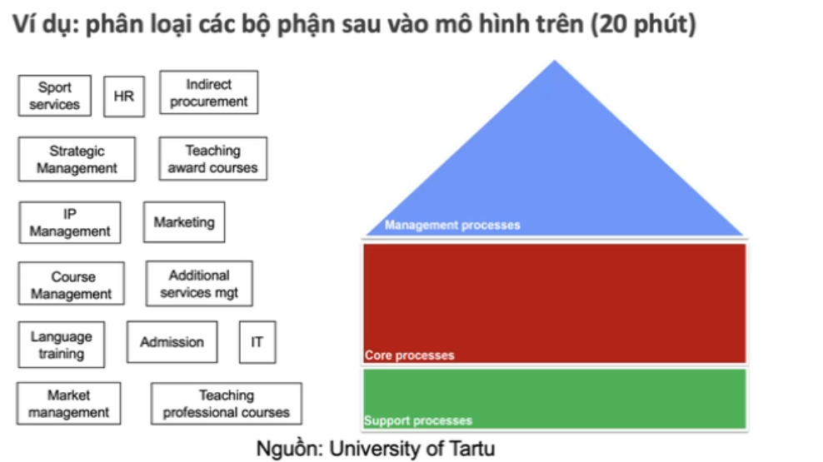
Management processes:
Strategic Management, Corporate Development, Market Development, Investor Relations.
Core processes:

Support processes:

