Taylor Woodington

02/10/2024

**The “Most Important” Aspects of Travel**

Traveling is done by every person at some capacity within their life. Even if it is just a drive to see family or a flight to another country. Around 2.29 billion Americans take domestic trips each year while 93 million travels internationally each year, and 79.6 million international visitors travel to the United States each year (Adrian, 2023). That is a lot of traveling done each year and there are a lot of different things to consider when going to a specific destination. What are the most important aspects of travel, destination and/or transportation of getting there? For example, do people choose to travel to places more for the natural elements or social aspects like city life? Is traveling by plane convenient enough for the price of a flight to get to the desired destination? Do people often choose traveling by plane over driving a car? Are places traveled to more often for being well known and popular? Do people prefer convenience over wonder?

Looking into natural elements versus city life, there are little trend searches, but multiple articles stating how they have their pros and cons. It really ties in more factors than just what is “liked” more, because one must consider how sometimes cities are easier to travel to get to the natural area and individuals could be traveling to cities for both the city itself and the natural elements around them as well (Czepkiewicz1 et al., 2018). However, some studies have shown that while sun and beach destinations were popular, urban destinations are becoming more popular for tourists with a 52% growth rate (Paula, 2023). When researching if flight prices have deterred travelers from traveling, I found no large indicators that there could be a relevant relationship between the two currently. When looking at Figure 1.0 below the interest over time in flight prices, has increased but in Figure 2.0 the interest in travel has stayed steady showing no large increase or decrease for a price change that could have indicated being affected by flight prices positively or negatively. Studies and articles from the University of California, Berkley state that people want to balance convenience and price, they want a flight that is convenient enough for the price that it is. Raising prices for less convenience will cause consumers to go to other airlines which will keep the prices fair, reasonable, and affordable (Walsh, 2023).

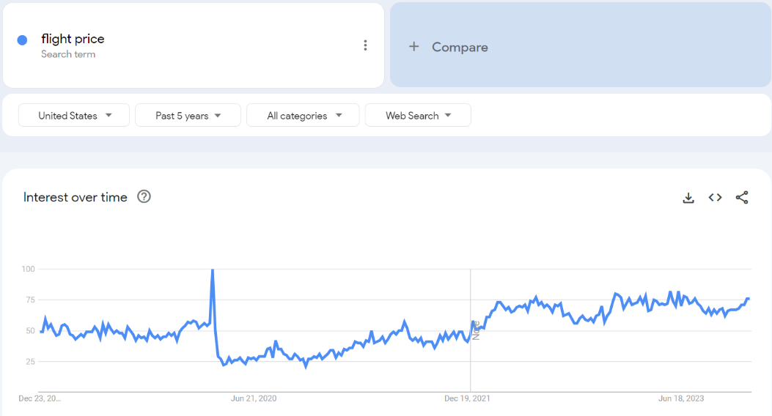

**Figure 1.0 Interest in Flight Prices**

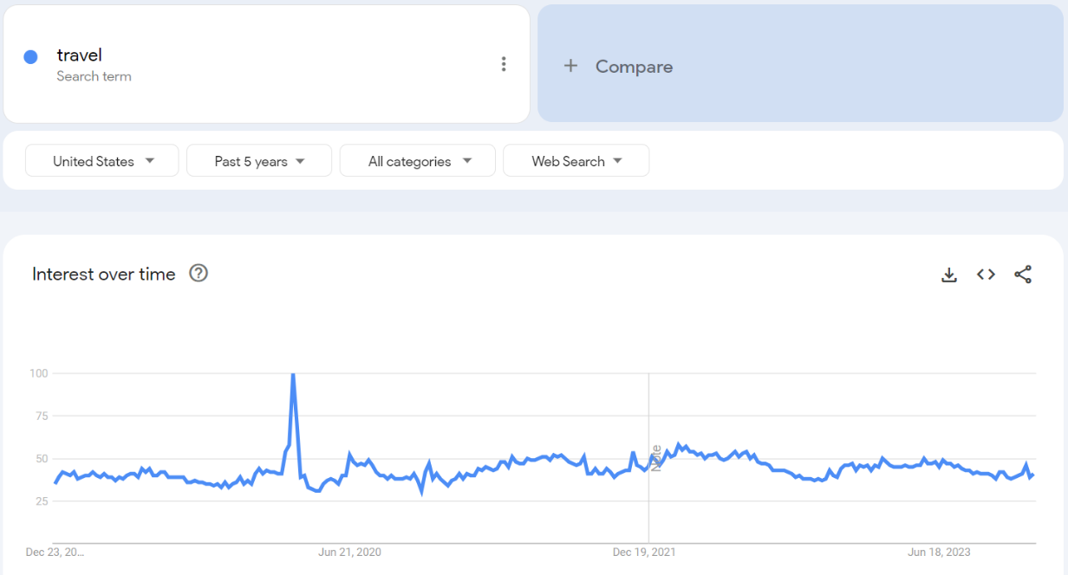

**Figure 2.0 Interest in Travel**

From there, checking if flight travel or road trips were preferred, you can see in Figure 3.0 below that flight travel had a significantly large interest in comparison to road tripping. A lot of the locations that people seem to show interest in required flying and cannot just be traveled to by car, so it takes the option out completely. In addition, recent studies have been showing individuals to have an increase care in climate impact and how their own actions can influence it. Studies from Yale have shown a pattern of decrease in environmental impact from planes, showing that “the average energy intensity of driving is about twice that of flying” (Wihbey, 2020), whereas the University of Michigan states “the energy intensity of car transportation is on average 57% higher than air transports” (Sivak, 2015). Overall, planes have shown to have less of a negative impact on the environment and 74% of travelers are willing to pay for sustainable travel options (AAA Travel).

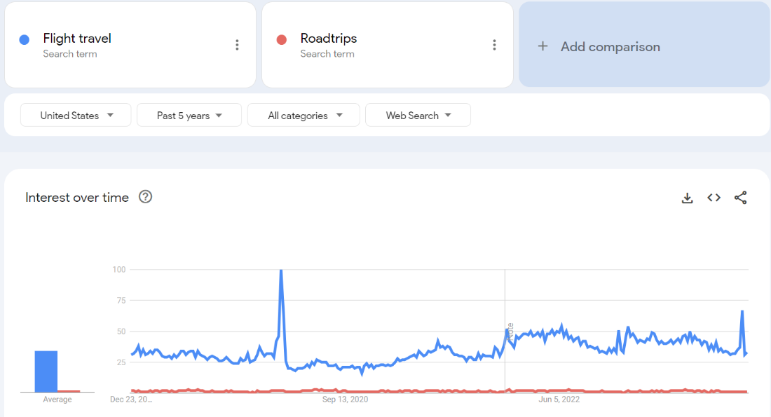

**Figure 3.0 Flight Travel interest versus Road trip Interest**

Lastly, with areas outside of the U.S. being promoted more through social media or television shows, etc. those destinations may outweigh the wonders of domestic travel. Below (Figure 4.0) you can see that many individuals are inspired by social media and shows for the places they choose to travel to, and in Figure 5.0 it shows some of the most searched experiences in some of the most well-known areas people would like to travel in. There are articles such as CN Traveler stating that beloved places are struggling with overtourism (Editors C, 2018), and research showing that 36.5% of travelers use social media to find travel ideas (Vianna, 2023). In more recent years 60% of Gen Z and 40% of millennials were reported to have used social media for their traveling purposes (Vianna, 2023). Popularity and promotion of an area seems to be a big aspect of how certain destinations are picked to travel to. Most of these places as shown in Figure 5.0 Are outside of the U.S., which is inconvenient for traveling and can be costly, showing that convenience may not outweigh the wonder of a destination.

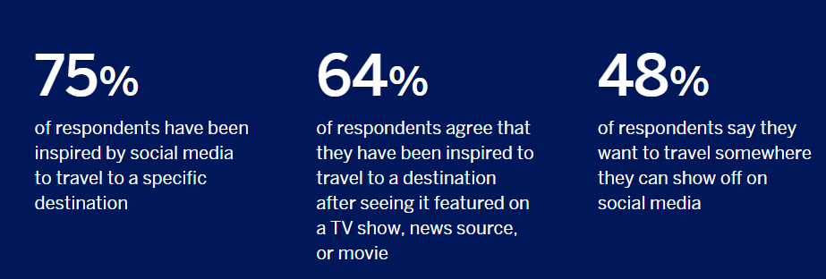

**Figure 4.0 Media Influencing Travel (Person, 2020)**

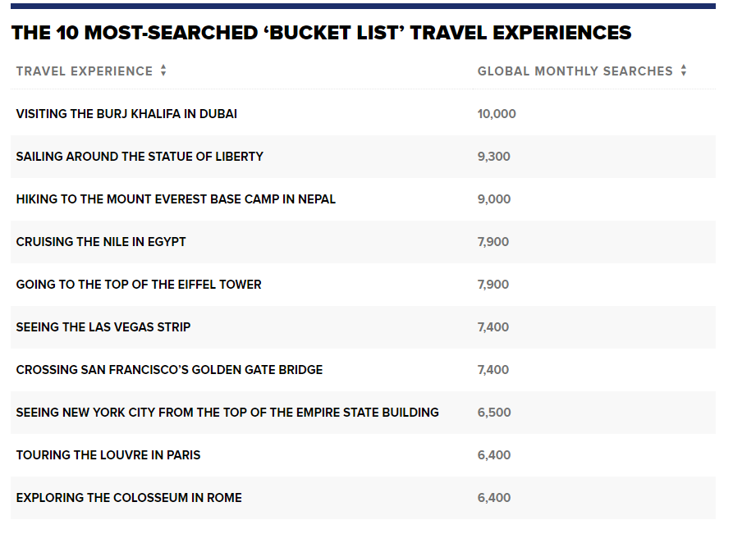

**Figure 5.0 Most Searched ‘Bucket List’ Travel Experiences (Pitrelli, 2021)**

With all the above research regarding the important aspects of travel, patterns and statistics have shown that people would prefer to travel to urban areas, use planes as their mode of transportation, and travel to popular destinations using social media suggestions. While planes are quicker than road travel and better for the environment, more research could be done between cars and planes. When looking at the Bureau of Transportation Statistics, most of the surveys found were on daily travel compared to personal vehicles to public transportation. Comparing the two of those things to air transportation and maybe even watercraft transportation would be interesting to see and could show more patterns in choices of transportation. While this would be interesting to compare, it must be considered that there are different purposes of use and distances that each mode of transportation is used for so it may be difficult to compare them at similar capacities when discussing travel use. In addition, more and more data are being collected on the environmental impacts of transportation, that could alter the decisions of the public once they have more knowledge of it. It would be interesting to see how social media will affect the dispersal of this information. Right now, so much is accessible through the internet. The public can see different flight patterns and which specific planes are on those routes as well as buses and more. While we can see what routes they are on and how full they are we are unable to see who occupies each seat. However, those companies can see this data and disperse statistics out to the public for analysis. Even with the information currently released to the public, we see a relationship with social media that impacts the places selected to travel to.

Moving forward, it will be interesting to see what relationships or patterns we can find while social media grows collecting data even more than it does now. I am interested to see how the popularity of different destinations will change, possibly showing phases of locations and time of year being hotspots for tourism, or if some of these places are popular due to their old lore and “iconic” status. Maybe enough data can be collected through social media to cluster different characteristics of travel destinations to see what makes those destinations more desirable for travel. I expect to see a lot more social media platforms continuing to promote specific areas to travel to along with recommendations and full profiles that post planned trips for those to follow. However, some challenges that follow this could be that not everyone who travels, has the same access to internet or uses the internet in the same way, skewing the data that we are consuming afterward. Things like this would need to be accounted for when analyzing the data for which areas are the most popular and sought out in travel. When social media is being considered as a form of influence a question comes up of if it should be compared to the newspaper as a form of media and travel books, as well as different social media platforms. It would be interesting to compare different media platforms such as TikTok, Instagram, and Facebook to each other, and then to compare those types of social media platforms to the travel channels on television, travel blogs, and/or travel sites. While I think there is a large relationship between traveling and the media, I believe there is a lot more to be explored.

**References**

*98 statistics on travel: AAA*. Travel. (n.d.). <https://travel.aaa.com/statistics-on-travel#chapter-02>

Adrian. (2023, October 3). *U.S. Travel & Tourism Statistics 2020-2021*. TourismAcademy_Horizontal_black. <https://blog.tourismacademy.org/us-tourism-travel-statistics-2020-2021#:~:text=US%20Citizen%20domestic%20tourism%3A%20Americans,international%20visitors%20to%20the%20US>

Czepkiewicz1, M., Heinonen1, J., Ottelin2, J., & <https://orcid.org/0000-0001-7079-1723>, M. C. (2018, June 21). *IOPscience*. Environmental Research Letters. <https://iopscience.iop.org/article/10.1088/1748-9326/aac9d2>

Editors, C. (2018, October 24). *15 beloved places struggling with overtourism*. Condé Nast Traveler. <https://www.cntraveler.com/galleries/2015-06-19/barcelona-bhutan-places-that-limit-tourist-numbers>

Google. (n.d.). Google trends. <https://trends.google.as/trends/?geo=US&hl=en-US>

Paula. (2023, November 24). *Global Travel trends 2023*. ForwardKeys. <https://forwardkeys.com/global-travel-trends-2023/>

Person. (2020, January 1). *2023 Global Travel Trends Report*. American Express Credit Cards, Rewards & Banking. <https://www.americanexpress.com/en-us/travel/discover/get-inspired/Global-Travel-Trends>

Pitrelli, M. (2021, July 8). *These are the most-searched “bucket list” travel experiences in the world*. CNBC. <https://www.cnbc.com/2021/07/06/-the-most-popular-bucket-list-travel-experiences-in-the-world-.html>

Sivak, M. (2015, April). Energy Intensities of Flying and Driving. <https://deepblue.lib.umich.edu/bitstream/handle/2027.42/111894/103194.pdf>

*Topic: Travel and tourism in the U.S.* Statista. (n.d.). <https://www.statista.com/topics/1987/travel-and-tourism-industry-in-the-us/#topicOverview>

Walsh, D. (2023, October 20). *Research shows how airline pricing really works: Haas News: Berkeley Haas*. Haas News | Berkeley Haas. <https://newsroom.haas.berkeley.edu/research/why-the-hunt-for-the-cheapest-plane-ticket-is-a-waste-of-your-time/>

Wihbey, J. (2020, October 16). *Evolving climate math of flying vs. driving " Yale climate connections*. Yale Climate Connections. <https://yaleclimateconnections.org/2015/09/evolving-climate-math-of-flying-vs-driving/>

Vianna, C. (2023, October 24). *How social media has changed the travel industry*. Xola. <https://www.xola.com/articles/how-social-media-has-permanently-changed-the-travel-industry/>