Taylor Woodington

DSC680 Project 2

Manatee Population Trends: White Paper

1. Business Problem

This project, “Manatee Population Trends”, aims to analyze manatee observation surveys in hopes to identify population trends which can inform conservation groups on strategies to move forward with assisting their population. Manatees have been a part of a human and wildlife conflict of the eastern coast of the United States where they are inhabiting areas that people partake in using boats for recreation. This alters their environment as well as their wellbeing, with them being at risk for propellor accidents and oil spills. All of this mentioned could affect their population status. This project's goal is to address the need for better understanding of the manatee population dynamics and distribution patterns.

1. Background/History

The dataset being used to address the problem described above is from the Florida Fish and Wildlife Conservation Commission. The dataset includes columns for the survey and location ID’s, observation dates, adult counts, calf counts, total counts, the county and state of identification, and more. Any information necessary for field observations could provide valuable insight to manatee populations. We could see the trends in observations over time, as well as observations by location, and more.

1. Data Preparation

When preparing the data, I first looked at the initial statistics and information of the dataset and checked the way the data was structured. Moving forward I began cleaning up the data by converting the date to a datetime format and dropping missing values. Dropping the missing values will limit the bias that may be present with taking the average of the values, limiting the possible skew. Before going into deep analysis, I did a basic statistical pull, seeing the total number of observations made in the dataset were 103,824 as well as the counts for each year in the dataset to get a good look at what the data consists of.

1. Methods and Analysis

To do further data analysis I decided to investigate the average manatee observations my month throughout the years, the average count of adults versus calves throughout the years, total manatee observations by county, and finally with an analysis of manatee observations by county and year through a heatmap. Looking at image A.1 we can see how the total manatee observations over time change drastically up and down before the year of 2005 and then begin to gradually increase again throughout the years in a little bit more of a stable format. The year with the highest count of manatees was in 2003 with 8,986 observations coming from 1,758 in the previous year and then going back down to 2,505 in 2004. This shows instability in the population or observation methods. I decided to dive further and look at the average number of adults observed in a year versus the average number of calves observed in the year across all the years of the dataset. Upon running this and looking at the graphics, I can see a general increase in average adults throughout the years except for a small amount of time around 2011, however, the average number of calves barely increased. A possible reason for this could be because calves are not being born during most of the times that observations have taken place. So, an analysis has been done to show when the busiest time of year is for observations. The chart made, as shown in A.3, shows that the average number of manatees observed per month was between 4 and 6 for the observing months. However, there were only three observing months, January, February, and March. This could be due to the inland waters of the counties being warmer water and safer for them during the colder months of Florida.

When looking by county we can see in A.4 that Brevard, Lee, and Citrus County have the highest count in observations overall. To see how this compares over the years, a heatmap was done to show the manatee observations by county for each year. Consistently, those three counties and Broward have the most counts over the years showing a pattern for manatee behavior. The manatees are choosing the same places to be year after year.

1. Limitations and Challenges

While the data discussed above gives really great general information about manatee observations. A lot of the data does not show enough of other data. For example, we do not have the weather temperatures of any of the counties observed, within this dataset to be able to run an analysis on number of manatees versus temperature. It becomes a little difficult when looking at the dataset to come to massive conclusions.

1. Future Uses and Recommendations

In the future I would recommend adding additional data from a reliable source to get more information on factors which could affect these behavioral observation counts. For example, collecting weather information as well as how populated the area in which observations were made was could be useful. I would not expect manatees to be close to land when the weather and water temperature is of a good range and when there are many people within the area.

1. Implementation Plan

This data prompts the future analysis of why manatees are seen in these counties during those specific times of the year every single year. Moving forward, collection on alternative factors is important in understanding the patterns of observation count of manatees. Once information such as weather, water temperature, and more are collected. A series of analysis can be run through a multi-linear regression to see which factors affect the observation count the most to understand the manatee behaviors to protect the habitats in which they use most. Protection could be implemented by managing areas to have warm water refuge spots which are no boat zones to limit the risk of strikes and reduce high traffic areas, allowing for boats to still pass through but also give protected space for marine life.

1. Ethical Assessment

Some ethical concerns to consider would include ensuring that the data is accurate in order to avoid misrepresentation of their population. There may be missing values, filling these gaps inaccurately could lead to misrepresentation. In addition, sensitive information such as location should be displayed in a way which does not encourage human interference with the manatee's homes. To make sure that this is done correctly, location may not fully be shared to the public with the habitat preservation of protected spaces or permits will be acquired for a protected space. Overall, with the trends shown in the data, the weather must be kept in mind. There are external factors, such as the weather, that will affect the population by staying in certain locations and this must be noted.

1. Audience Questions and Answers
2. What are the three lowest years of observation counts overall?
   1. The three lowest years of observation counts overall were the years 1992 at 1,844 manatees, 1998 at 2,018, and 2002 at 1,758 manatees.
3. What is the highest and lowest count for calves seeing that there is not a large increase or decrease in the count over the years?
   1. The lowest number of calves observed would be 0 calves and the highest number of calves observed would be 52.
4. Are the counties with the higher number of observations on the same side of Florida or near each other?
   1. Not all the counties are on the same side as each other. Brevard is on the east coast of the state whereas Lee, Citrus, and others are on the west coast. A possible reason for them being on the west coast is because it is in the Gulf where the water may be warmer.
5. Was there a relationship between a higher number in adults and a higher number of calves in a year?
   1. A correlation was run between adult manatee count and calf count throughout the years and there was a strong correlation with a score of 0.86 showing that as adult count increases, so does the calf count.
6. Is the data valuable before the year 2005 with the inconsistency mentioned?
   1. Yes, this data is still valuable because it can open questions to investigate why the population or count of manatees were so inconsistent to see if there were difficulties in sustaining the population.
7. Why aren't there observations throughout the whole year every year, and just a few months of the year?
   1. The months of the year that we see a high number of observations are the coldest months of the year, so the water closest to the coast will be the warmer spaces for the manatees to reside in which increases the chance of seeing them.
8. Why would manatees have less children during the observation months?
   1. The manatees may have less children during the observation months because the observation months are cooler months which would be extremely difficult to rear and care for calves.
9. Are there any other factors that could be affecting the counts that are made during the actual time and location of observations? Meaning a single observation time on a single day.
   1. Yes, many things could be at play here and should be taken into consideration. For example, the amount of people observing during observation time. If more eyes are looking out there are more individuals to confirm the population and identification of the mammals. In addition, observing during busy hours for recreation on the beach may alter the actions of the animals and spaces they are inhabiting may change based on human action.
10. What do you think the effects are on the manatee count in an area of a high manatee ecotourism are?
    1. In areas with high ecotourism, I would expect the count to start out high because that is where the tours are taking place, however, I would think the number would consistently decrease due to the high traffic of people in the area creating less space for the manatees to be. Of course more data would be necessary to see if there is really a relationship there.
11. What are the expected behaviors between cold and hot weather for manatees in local waterways?
    1. For Florida waterways it is expected by most to see manatees. Scientifically, manatees are tropical marine mammals and will migrate during the colder times of the year to warmer waters which Florida does have. (...) So I would expect local water ways to be more populated during the colde+r months.
12. References

*Habitat*. Florida Fish And Wildlife Conservation Commission. (n.d.). <https://myfwc.com/wildlifehabitats/wildlife/manatee/habitat/>

*Manatee Synoptic Survey Observation Locations*. Florida Fish and Wildlife Conservation Commission. (n.d.). <https://geodata.myfwc.com/datasets/manatee-synoptic-survey-observation-locations/explore?location=27.834871%2C-82.273454%2C6.44&showTable=true>

1. Appendix A

A.1: Total Manatee Observations from 1991 through 2019

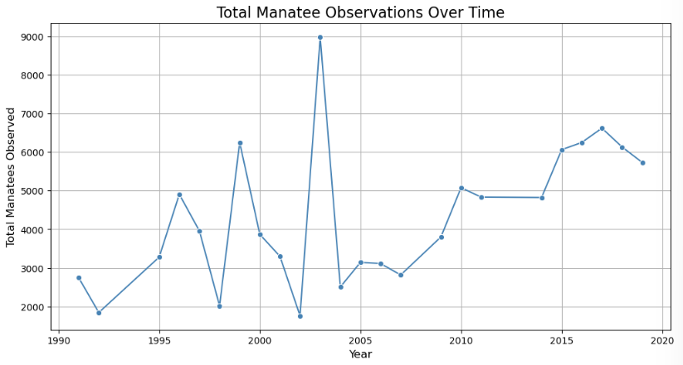

A.2: Average Adults versus Average Calves observed over the Years.

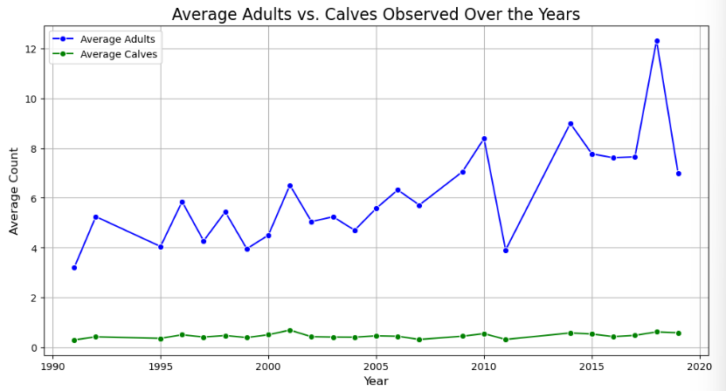

A.3: Average Manatee Observation by Month

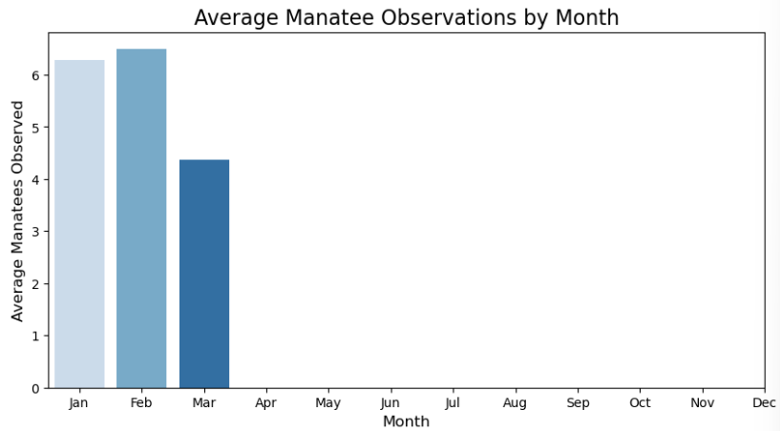

A.4: Total Manatee Observations by County

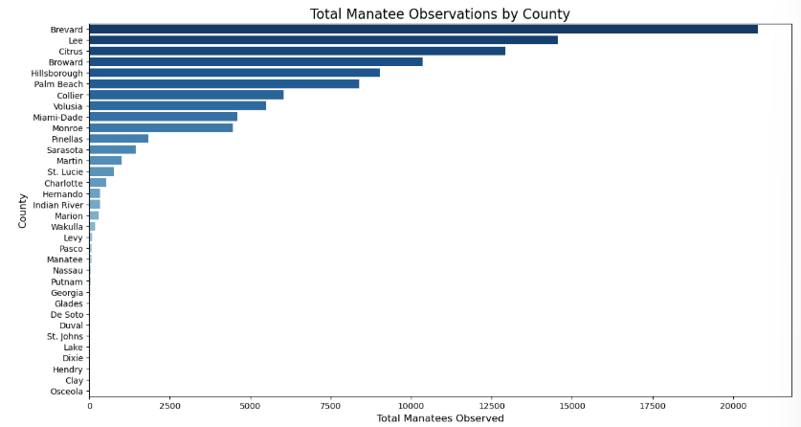A.5: Heatmap of Manatee Observations by County and Year

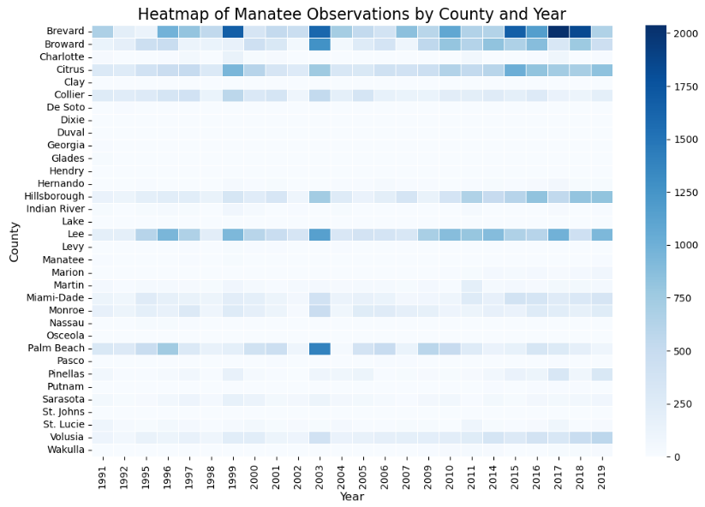

A.6: Top 3 Months by Average Manatee Observations

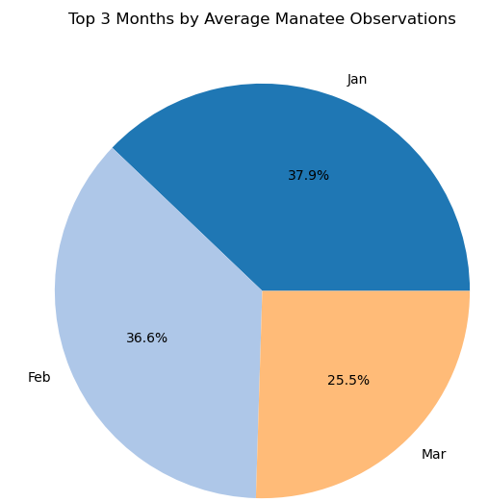

A.7: Correlation Graph of the Relationship Between Adult and Calf Counts

