**Single Moms of U.S. Need for Childcare and Employment**

Families across the United States need a daycare to watch their children for them to have an income. This can become very expensive, especially when there are multiple children that need to be watched. This becomes even more difficult when the children are younger and need more attention, it is more difficult finding places for them to be such as extracurriculars while they are at work. While most families in the United States with children under 6 years of age have two working parents, the second majority household type is single working mothers providing for their children. This paper plans to show the investigation of childcare prices and employment and earnings of women compared to men or the prices of childcare.

**Investigation**

nding that the most expensive states for childcare were Massachusetts, Connecticut, and Rhode Island. While the least expensive states were West Virginia, Kansas, and Mississippi. For all these states mentioned, the men of the population had higher earnings compared to females. This prompted a closer look into the female labor force participation rate with those who have children under six and the female median earnings.

**Analysis and Findings**

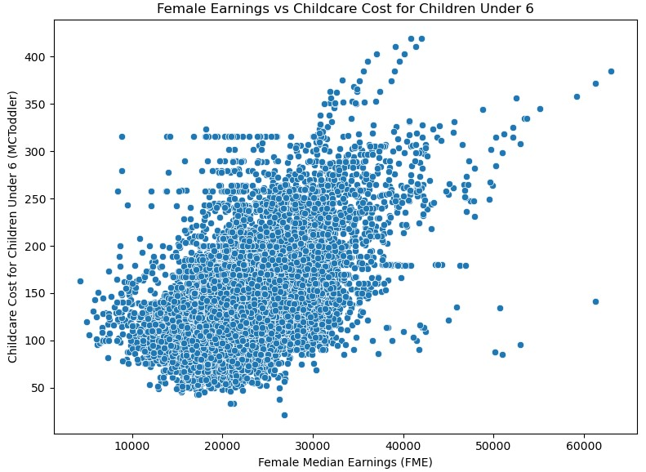When analyzing the labor force participation in hand with the female median earnings, it was found that majority of women earn less than $35,000 annually even when childcare becomes more expensive. The small percentage that has a higher earnings rate are able and do pay for more expensive childcare. However, majority of the women are earning less even when paying more. Overall, with women earnings compared to men, women are earning less so single mothers are at a larger disadvantage when compared to men when it comes to raising their children alone.

This prompted a further look into the different job sectors and where women's opportunities were compared to men. From this it was shown that women are more dominant in the fields for manufacturing, service, and sales, whereas males were significantly more dominant in the natural resources and professional world. This shows that wom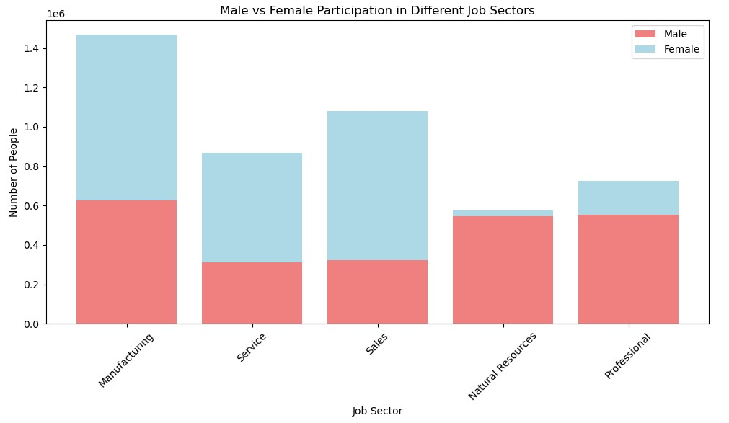en are receiving opportunities but maybe not the right opportunities for advancement in their careers to earn more and afford childcare for their children.

**Recommendations**

To summarize the investigations and findings above we can see multiple facts, the first being that overall women are earning less than men and many women are single mothers providing for their family with children under six years old. When analyzing the opportunities in different fields we can see that woman, when compared to men, do not have many opportunities in the professional workforce. This could be an opportunity for you as daycare owners, to solve multiple problems being presented. Daycares could find business improvement in helping single mothers develop for a professional career while receiving childcare. While this may seem unconventional at first it could create a great program which would put ease on the hiring process when needing employees for the daycares. This plan could begin by marketing available jobs with networking/resume building opportunities for single mothers with an additional benefit of receiving free childcare for working at these facilities. This will create great opportunities for mothers to advance their professional career while saving money from childcare expenses. The question then seems to be how this helps the Daycare business. Well, this provides a steady inflow of reliable and caring individuals to become employees. It narrows down the competition of lazy or uncaring applicants to the role and minimizes the bargaining. Those applying to the role would be individuals that need the job for its benefits and care to improve and do well as an employee in the workforce. These businesses would not have to increase pay to make the role more desirable for individuals to apply, it will be desirable with its multiple life and professional development benefits. In addition to this, the companies would gain a better reputation publicly by assisting single mothers in need. With this reputation increase, more people would be likely to enroll their children in that daycare. Overall, this would benefit single mothers with young children who need childcare and professional development as well as daycares to have a steady way of employing good workers and increasing positive reputation.