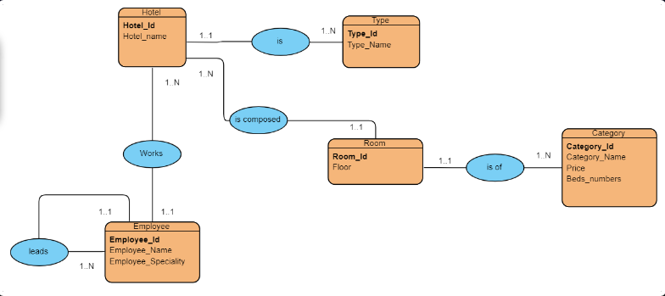

Hotel (**Hotel_id** , Hotel_name, **#Type_id** )

Type (**Type_id**, Type_Name)

Employee (**Employee_id** , Employee_Name , Employee_Speciality**,#Hotel_id,#id_Employee**)

Room (**Room_id** , Floor , **#Hotel_id , #Category_id**)

Catagory (**Category_id ,** Category_Name , Price , Bedis_numbers)