Remake of Barbarian Game in Unity 3D
Reference Images:
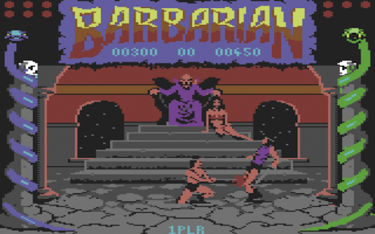
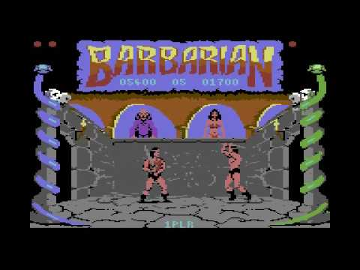
Longplay video link:
https://www.youtube.com/watch?v=14ORMf6SjTc

