Assignment: Module 3 Narrative

Taylor R. Jones
CS499 Capstone Course
SNHU
Dr. Philomena Ogoh
11/16/2025

1. Briefly describe the artifact. What is it? When was it created?
The artifact I selected for this enhancement is the RESTful dashboard application that I originally developed during my CS340 course. That project was a Python-based web service focused on enabling basic CRUD operations over animal shelter data. While functional, the original artifact lacked a formal architecture, robust routing, layered design, and modern software engineering practices. For this milestone, I chose to rebuild and significantly enhance that artifact using Java and the Spring Boot framework. This new version of the application was created during the current term as part of CS499, and it represents a more professional, scalable approach that aligns with industry expectations for backend API development.
2. Justify the inclusion of the artifact in your ePortfolio. Why did you select this item? What specific components of the artifact showcase your skills and abilities in software development? How was the artifact improved?
I chose this artifact because it demonstrates my growth from building simple scripts in a couple of files from earlier courses to designing a well-structured, scalable backend system in Spring Boot. This enhancement showcases my abilities in software design, API development, layered architecture, and version control.
While researching how to approach this enhancement, I learned how essential annotations are in Spring applications. This project has helped me understand how annotations such as @RestController, @Service, @Repository, and the various HTTP mapping annotations worked. Through documentation, videos, and experimentation, I learned that annotations act like “sticky notes” that tell the framework how to behave and how different layers interact. This is reflected in the improved structure and clarity of the enhanced artifact.
To improve the artifact, I implemented a complete layered architecture consisting of controller, service, repository, model, DTO, and exception packages. The controller now exposes fully functional and tested REST endpoints using HTTP verbs such as GET, POST, PUT, and DELETE. I added Data Transfer Objects (DTOs) to separate internal model structures from external-facing API contracts, which helps protect sensitive fields and keeps data structures clean. I also implemented full CRUD functionality, temporary in-memory data storage, dependency injection, and meaningful route definitions. The new artifact includes central error handling, standardized naming conventions (using PascalCase for classes), and improved maintainability. These enhancements also reflect industry-standard development practices, including the use of Git branches, pull requests, and version control workflows.
Overall, the artifact has evolved from a basic academic exercise into a professionally structured backend service that demonstrates my competency in backend development, software engineering principles, and modern REST API design.
3. Did you meet the course outcomes you planned to meet with this enhancement in Module One? Do you have any updates to your outcome-coverage plans?
I successfully met the course outcomes I targeted in my Module One enhancement plan. My goal for Milestone Two was to show improvement in software design and engineering by modernizing an existing artifact and implementing best practices for backend architecture. By rebuilding the project using Spring Boot, incorporating architectural layers, and implementing full CRUD operations with proper routing, I met my planned outcome of demonstrating professional-quality backend development skills.
This enhancement also sets a strong foundation for the next two milestones. The current structure allows me to easily incorporate algorithmic improvements in Milestone Three and database persistence in Milestone Four without restructuring the entire project. Therefore, no updates are needed to my outcome-coverage plans currently.
4. Reflect on the process of enhancing and modifying the artifact. What did you learn as you were creating it and improving it? What challenges did you face?
Throughout this enhancement, I learned how critical proper project setup and architectural design are in larger software applications. One of the first challenges I encountered was deciding which dependencies and project structure to use. I initially started the enhancement with a different setup but ultimately chose to restart the project with a cleaner dependency configuration after researching common Spring Boot patterns.
I also deepened my understanding of Java annotations and how the Spring framework uses them to create routes, register components, inject services, and build REST endpoints. Although I had seen annotations such as @Override in previous courses, I had never fully understood the role they played. This enhancement required me to explore annotations more thoroughly, which improved both my knowledge and confidence.
While implementing the CRUD functionality, I gained experience with routing, serialization, DTO creation, and in-memory data management. As I worked through these features, I realized this is an area I want to continue strengthening as I further develop the project beyond the capstone. I intend for this project to be one of the things I include on my resume and in my ePortfolio to show potential employers that I can build full stack projects.
Another significant area of learning was working with Git in a more professional capacity. I created a GitHub repository, linked my project, worked within a feature branch, and merged my enhancements using a pull request to follow an industry-standard workflow. Working on this project made me really appreciate the foundation I gained in CS465 (Full Stack Development) as I already had experience setting up a fresh repositing, linking files to it with Git, and versioning best practices.
One challenge I faced was ensuring that my classes followed Java’s naming conventions. Initially, I used camelCase for files, but I corrected this after revisiting best practice guidelines. I also had to refactor some of my code to ensure clean separation of concerns between layers. These challenges helped reinforce good design habits and made the final version of the artifact more maintainable and readable.
Overall, this enhancement strengthened my understanding of backend development, improved my ability to design clean and scalable APIs, and prepared me for the next milestones where algorithms and database integration will further extend this evolving project.

Images from this week’s development:

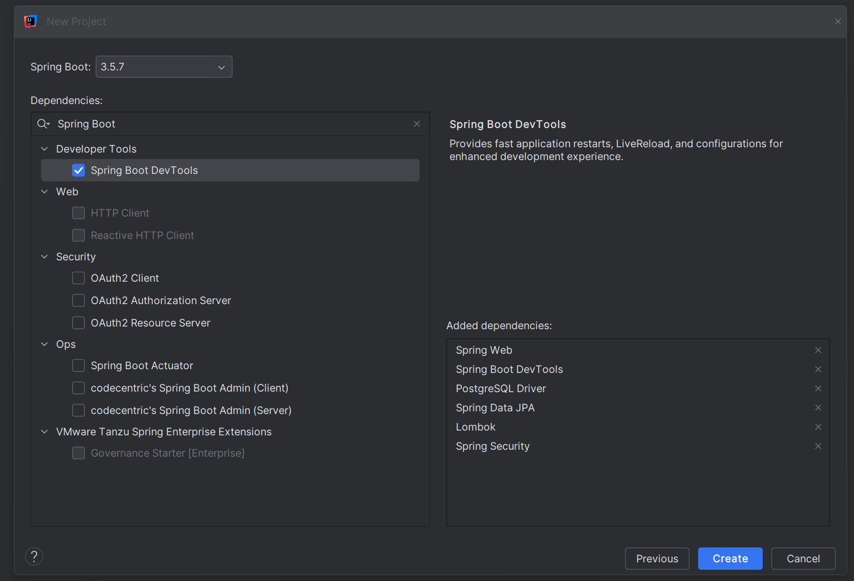
Figure 1. Initial Dependency Setup

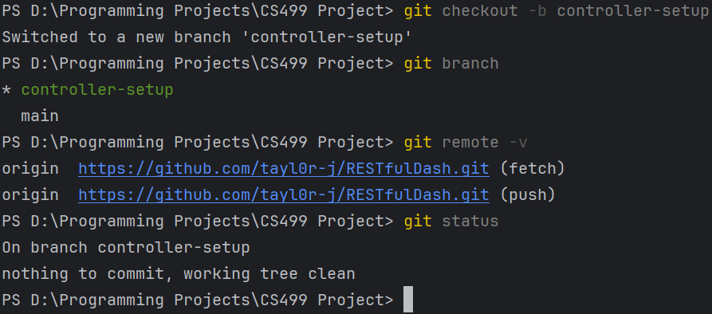
Figure 2. Initial Dependency Setup

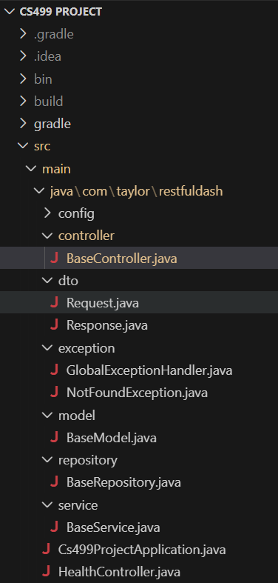
Figure 3. Project folder structure

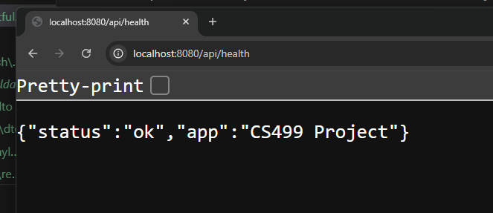
Figure 4. Initial API check

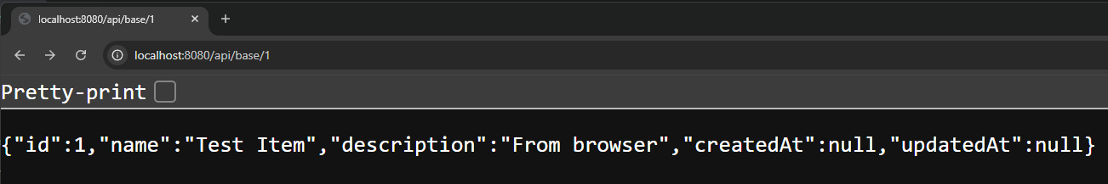
Figure 5. GET endpoint verification
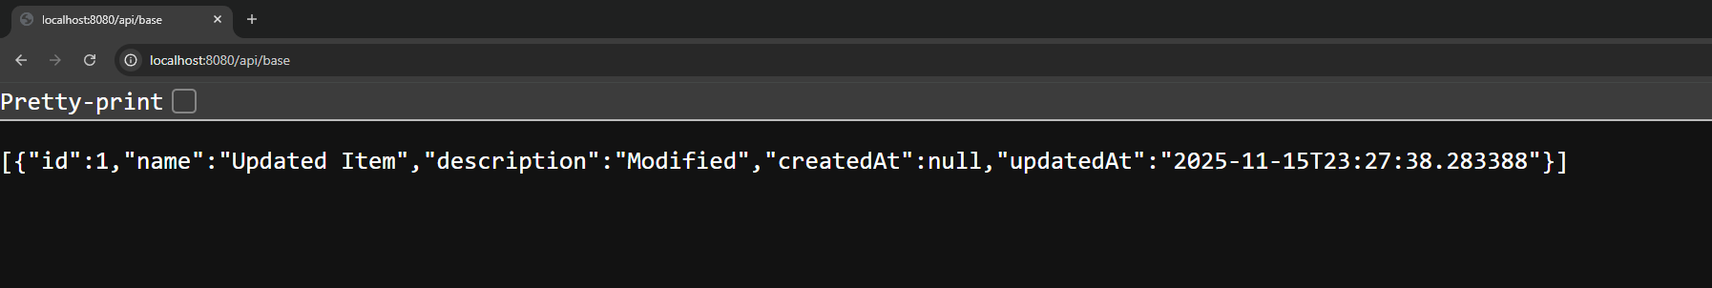
Figure 6. POST endpoint verification

