Assignment: Module 4 Narrative

Taylor R. Jones
CS499
SNHU
Dr. Ogoh
11/23/2025

1. Briefly describe the artifact. What is it? When was it created?
For this enhancement, I chose to pivot away from my original CS 340 artifact, which was a MongoDB-based animal shelter dashboard. While that project was useful for learning basic CRUD operations and filtering, it didn’t reflect the kind of software I actually want to build or the areas of computer science that I’ve become most interested in during the later parts of the program. Because of that, I rebuilt the artifact from the ground up into something much more relevant to both my career goals and my actual engineering interests: a raid-team management system for MMORPG players. This new version uses a professional backend structure with Spring Boot, controllers, services, repositories, models, and DTOs. It also includes data structures and algorithms that weren’t part of the original artifact at all.
The core idea remains the same: take structured data, organize it, and expose it through a functional system only now it's implemented in a way that demonstrates real backend engineering skills. The updated artifact was created during this milestone and has already grown into a more realistic and maintainable foundation than the original artifact I selected.
2. Justify the inclusion of the artifact in your ePortfolio. Why did you select this item? What specific components of the artifact showcase your skills and abilities in software development? How was the artifact improved?
I selected this artifact because it demonstrates my ability to build a complete backend system using professional industry practices and then extend that system with algorithmic logic that meaningfully improves functionality, performance, and maintainability. Enhancing this artifact with a data structure focused feature allowed me to showcase both my understanding of backend architecture and my ability to design algorithms that solve practical, real-world problems. In its current form, the project illustrates my capacity to apply data structures and algorithms directly to application functionality, such as sorting and role prioritization. It also highlights my ability to design clean, layered architectures using controllers, services, repositories, and utility classes.
The artifact further demonstrates my ability to encode domain-specific concepts using enums, which helps maintain clear state management and predictable behavior across the application. Separating concerns between domain models and API outputs using DTOs preserves consistency in the project. Version control practices using branches and pull requests reflect an understanding of collaborative, industry-aligned workflows, and my testing process through Postman endpoints shows that I can validate and iterate on backend logic effectively. Finally, the improvement made during this milestone—refactoring the sorting algorithm into its own reusable utility class—illustrates my commitment to maintainable software design and reinforces my ability to organize complex logic in a way that supports future development.
3. Did you meet the course outcomes related to this enhancement? Do you have updates to your outcome-coverage plans?
Yes, the work I completed for this enhancement meaningfully aligns with the outcomes for algorithms and data structures and expands my ability to apply those concepts within a real backend system. The main enhancements were creating a sorting algorithm, implementing role-based organization, refactoring logic for maintainability, and building a clean service-layer structure directly support the outcome of designing and applying algorithmic solutions to solve software problems.
This milestone also strengthened my understanding of how to evaluate trade-offs while designing logic for performance, readability, and extensibility. Initially, my sorting and grouping logic was embedded directly in the service layer, but as I iterated, I refactored the algorithm into its own utility class, demonstrating my ability to identify structural improvements and implement them. These decisions not only improved performance but also created cleaner boundaries within the system.
As a result, I have updated my outcome-coverage plan to reflect deeper competency in algorithm development, data organization, software maintainability, and object-oriented design practices. The enhanced artifact now serves as a stronger example of my ability to integrate algorithms into real systems instead of isolated practice problems.
4. Reflect on the process. What did you learn? What challenges did you face?
Working on this enhancement helped me deepen my understanding of how data structures and algorithms support real features, not just theoretical exercises. Implementing custom sorting and role-based organization exposed me to real-world constraints such as maintainability, serialization issues, circular dependencies, and the need for refactoring as complexity grows. For example, I encountered challenges with JSON recursion between teams and members, handled through annotations like @JsonIgnoreProperties, and discovered that placing sorting logic directly inside a service made the code harder to test and extend. The more I work on this project, the more I realize how important planning out architecture is. These challenges pushed me toward cleaner architectural choices and reinforced the importance of writing code that can scale alongside future features.
I also learned how critical it is to validate behavior through hands-on testing. Using Postman repeatedly, examining JSON output, and adjusting the model and service classes helped me understand how backend logic behaves in practice.
Perhaps the biggest shift was learning to structure logic in a way that supports future development. Moving the algorithm to a dedicated utility class, introducing DTOs, organizing enums, and cleaning up the service layer all contributed to a more professional and maintainable artifact. Overall, this milestone helped me understand not just how to write an algorithm, but how to integrate it responsibly into a wider system.

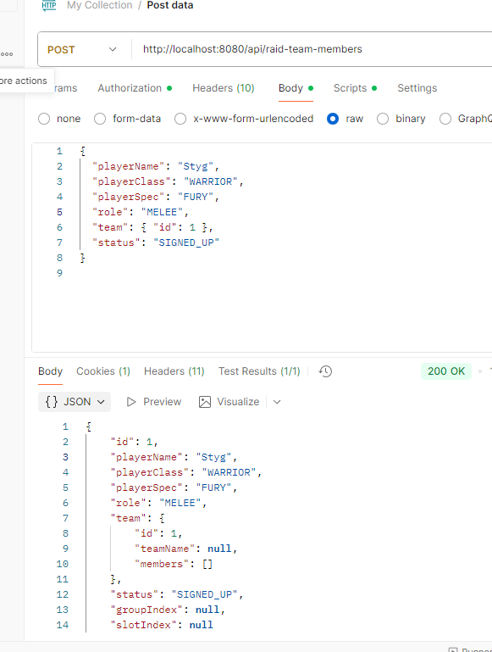
Testing POST endpoint
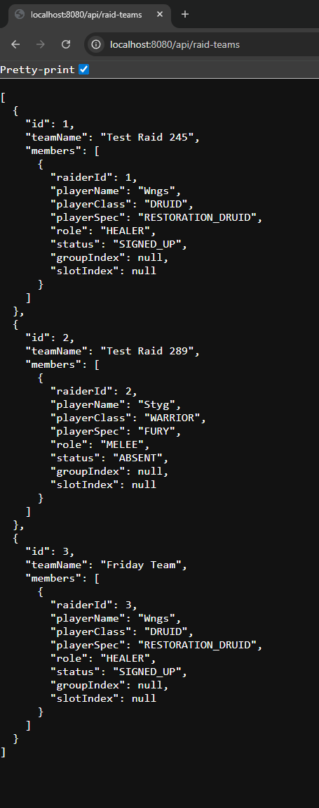
Raid Teams GET endpoint

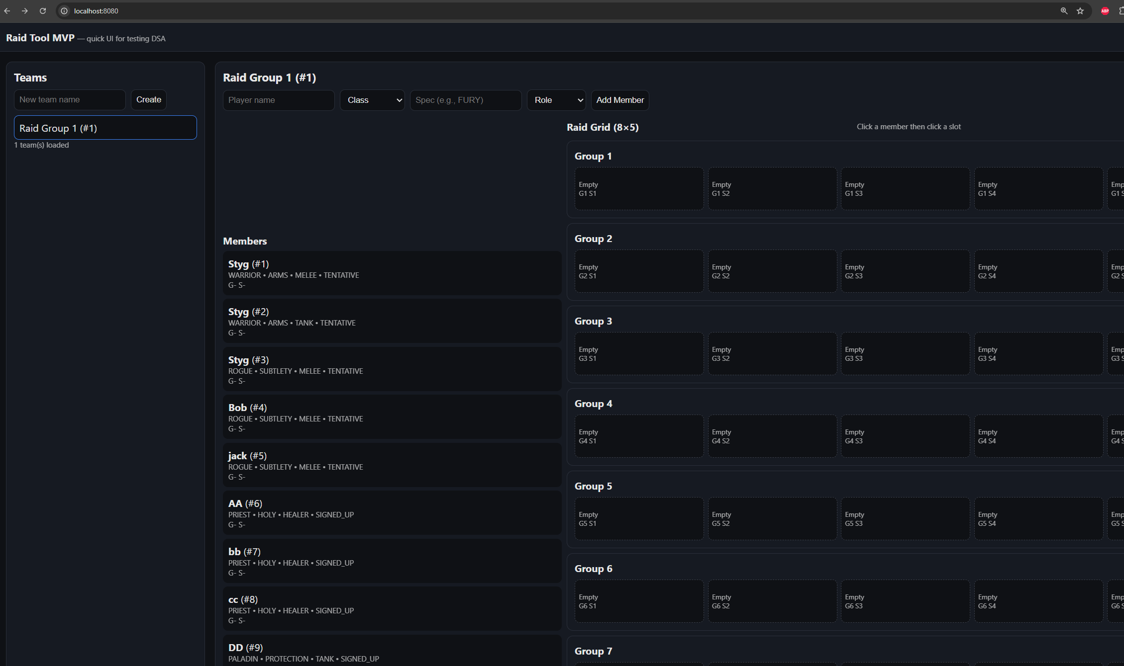
Early Dashboard Testing
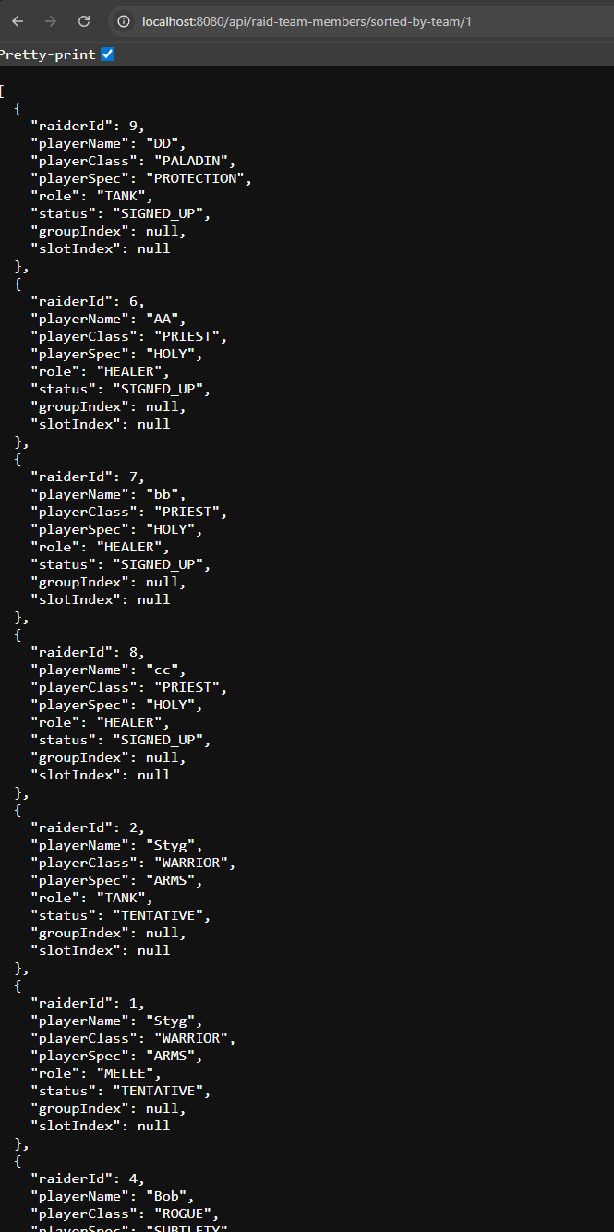
Testing the sorting algorithm. Players are organized by signup status, then role, then class.

