Enhancement Three:
Databases

Taylor R. Jones
CS499
SNHU
Dr. Ogoh
11/30/2025

Database Enhancement
The artifact I selected for this milestone is the data layer of my Raid Tool application, specifically the RaidTeam and RaidTeamMember entities, their relational mapping, the PostgreSQL backed repository layer, and the new sorted endpoint that retrieves raid members in an organized format. This artifact was originally created during my earlier work in Spring Boot, but it was expanded and restructured in CS499 to support a full relational database environment. It represents the foundation of the application’s ability to store raid team information, persist team compositions, and serve data accurately to future user interfaces. Since the application is centered around managing players in organized raid groups, this artifact captures the core functionality necessary for the system to work.
I chose this artifact for my ePortfolio because it demonstrates my ability to design and implement a real database backed solution that supports a meaningful use case. Integrating PostgreSQL required updating the entities, restructuring the relationships to support persistence, and building repositories that interact cleanly with the database. The enhancements I completed strengthened data integrity, improved query performance, and added features such as sorted retrieval of raid members to support usability on the front end. These changes showed my ability to work with relational schemas, object relational mapping, service logic, and structured responses through DTOs. As a result, the artifact now offers a much more complete demonstration of my skills in back-end engineering and database integration.
My enhancement plan for Module Five focused on meeting Outcome Three by improving the data layer of my application and ensuring that persistence with a real relational database was reliable and predictable. I updated the entity relationships so that they accurately reflected the structure needed for PostgreSQL. I cleaned up the service layer to support sorted retrieval of team members, created improved DTOs for cleaner API responses, and updated endpoints to test persistence across the full create, read, update, and delete workflow. These updates align directly with the outcome, since they required me to evaluate database design decisions, apply algorithmic logic for sorting, and ensure stable communication between the application and PostgreSQL. The enhancements meet the expectations I set, and they strengthen the usability and reliability of the artifact.
Enhancing this artifact taught me how important clarity, structure, and data consistency are when building real applications. Integrating PostgreSQL pushed me to think more carefully about my entity relationships, the service logic that interacts with them, and the format of the responses that a future user interface will need. Implementing sorted endpoints and improving the DTO layer helped me understand how to design endpoints that return predictable results and support a better user experience. Updating the UI for functional testing also showed me how tied together the front end and database logic are. One of the challenges I faced was ensuring that changes in one part of the application did not unintentionally break another area, especially when dealing with persistence. Working through this reinforced my understanding of relational models, query behavior, and practical back-end development. It also left me more confident in my ability to build and maintain database driven applications at a professional level.

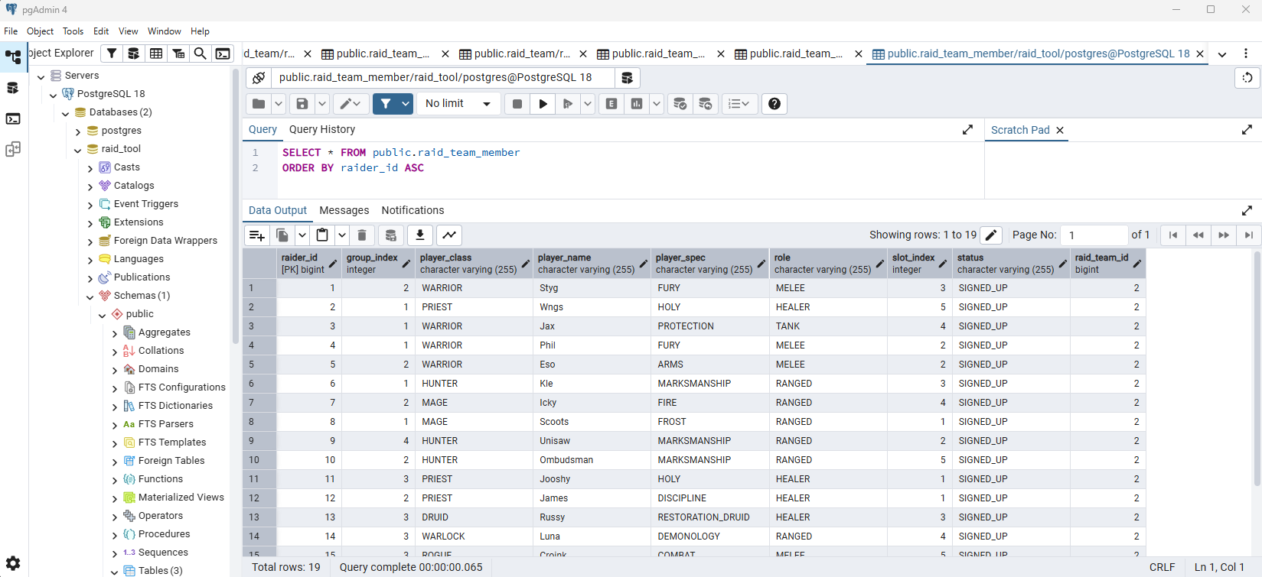
PostgreSQL Database

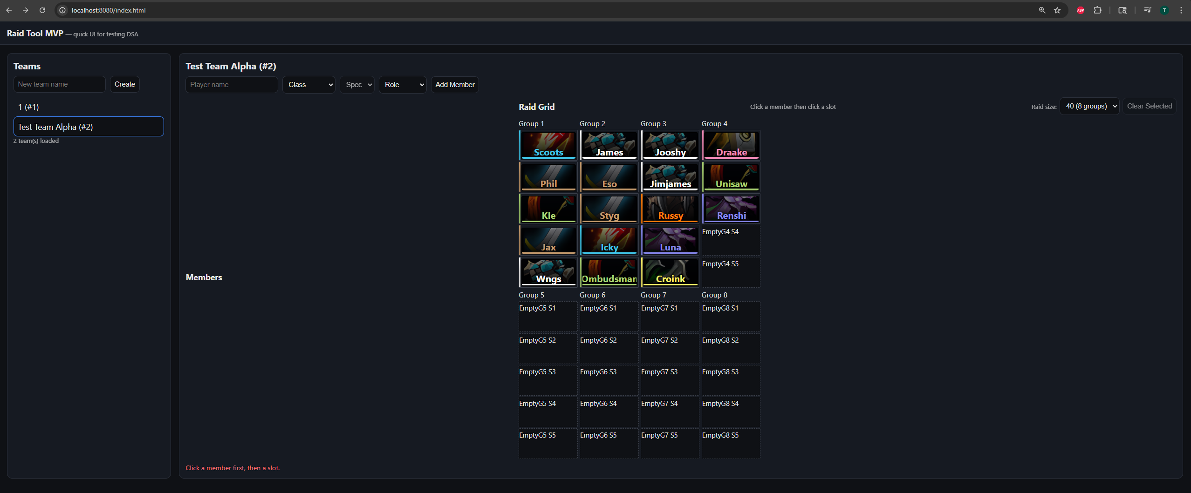
Raid Grid Screen

