**Q.1)**

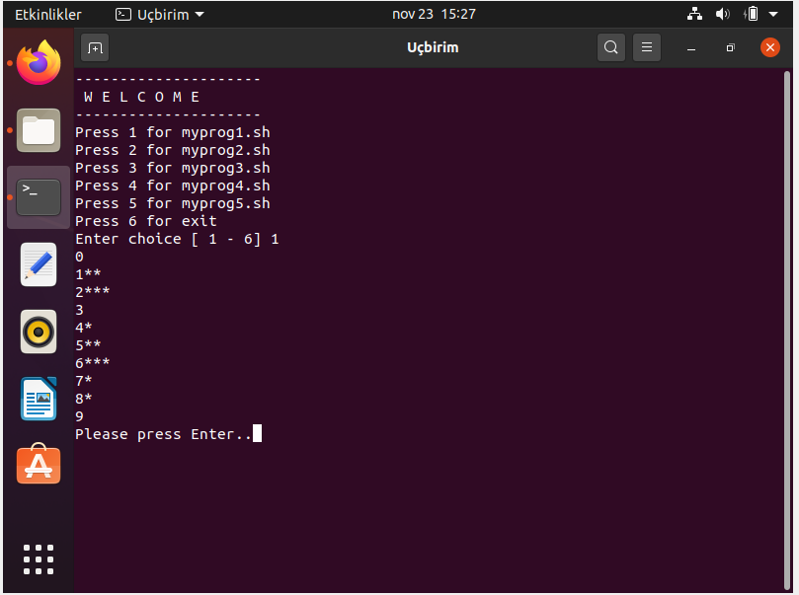

First of all we check that number in the file are smaller than 10 (0,1,2,3….9) And if our first argument and then compare with each other, if they are equal, then we incerement count by 1. Addition to this, we put if clause that checks whether there is a specific number in file or not (For instance if there is no 3, we put space next to 7 and continue.) Finally in the last if clause, we put stars(*) equivalant to the count.

**Q.2)**

metin içeren bir resim

Açıklama otomatik olarak oluşturuldu

ekran görüntüsü, elektronik eşyalar, ekran, telefon içeren bir resim

Açıklama otomatik olarak oluşturuldu

We take 2 inputs from user. One of them is string and other one is a number. If number length is not equal 1 or string’s length, then it gives us an error message.

If the number length is 1;

If the entered number’s length is 1, we replace the letters in the Word by incrementing the value of number in the alphabet. For instance if string is aaa and the number is 3, then output will be ddd.

If the number length equals to string’s length;

We replace all the letters one by one respectively to the input number’s value. For instance if string is aaa and the number is 123, then output will be bcd.

**Q.3)**

metin içeren bir resim

Açıklama otomatik olarak oluşturuldu

metin içeren bir resim

Açıklama otomatik olarak oluşturuldu

Basically what we are doing here is taking the path of our current directory and calculate how many files in there. Then we find oldest file of the current directory and delete.

**Q.4)**

metin içeren bir resim

Açıklama otomatik olarak oluşturuldu

Firstly we create array, and then ask from user the txt file name that contains a text. After that, we read our input file’s name and transfer it’s content into the array that we created. Then we used special command in order to convert numbers to their’s string equivalant.

For instance:

‘s/0/zero/g’ converts all “0”s in input file to the “zero”s.

**Q.5)**

**ekran görüntüsü, ekran, bilgisayar, oturma içeren bir resim

Açıklama otomatik olarak oluşturuldu**

**ekran görüntüsü, ekran, bilgisayar içeren bir resim

Açıklama otomatik olarak oluşturuldu**

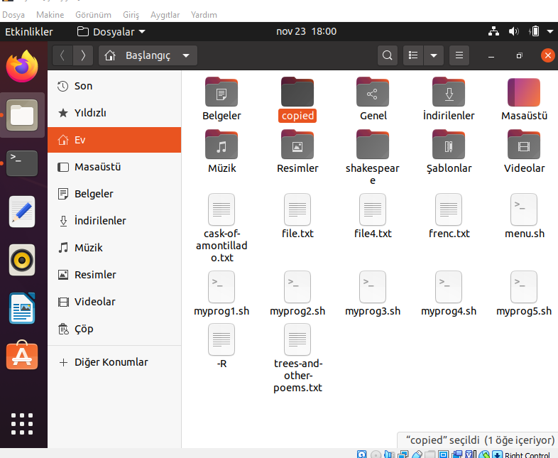

**metin içeren bir resim

Açıklama otomatik olarak oluşturuldu**

**metin içeren bir resim

Açıklama otomatik olarak oluşturuldu**

Despite the these errors when we ask 2nd iteration, our program creates copy files exactly same way as homework requires us as can be seen below:

**metin içeren bir resim

Açıklama otomatik olarak oluşturuldu**

**ekran görüntüsü, ekran, bilgisayar, uzaktan içeren bir resim

Açıklama otomatik olarak oluşturuldu**

First of all, we create wildCard in order to take wildcard like “*.txt” from user to search just for txt files for instance. Then with mkdir function we copied files in “copied” directory that we have just created.

Fort he second part, we create an array and put all folders&files in current directory. But when user writes “-R” to tell us it has to be recursive copying, then our wildCard’s argument number changes. So we updated our wildCard as $2. Then we scan our array and we check whether there is subdirectory or not, if there is, we get into them and create “copied” directory again and copy files inside of it.

**Important Notes:**

Unfortunately, we could not manage to integrate our 5th question to the menu. So it can be checked seperately in terminal.

Our 3th question’s first part fits with menu but 2nd(with the argument) does not. It can be checked seperately in terminal.

Note that path in question and menu codes has to be changed according to pc owner in order to work without error.