Network+ Study Guide Taylan Unal 9/7/16-Present

**2.1 Twisted Pair**

Crosstalk is when wires emit signals onto other nearby wires. The twisted pair wiring standard allows copper wires to deliver data uncorrupted.

Some advantages of Twisted Pair wiring include its cost, physical flexibility, easy to work with, and new protocols are being developed and used with Twisted Pair cables. However, TP also has some disadvantages including EMI interference and eavesdropping potential.

UTP (unshielded twisted pair) includes cables from CAT3, CAT5, CAT5e, CAT6, CAT6a; each is backwards compatible with one another.

RJ45 and RJ11 connectors can both be used in Ethernet networks; however RJ11 is generally used in phone

**2.2 Coaxial**

Advantages of coaxial cables include its fair resistance to EMI, resistance to physical damage. Its disadvantages include its cost to implement, its thickness/lack of flexibility, and the lack of support from modern high speed networking standards.

Common types of coaxial cables include RG58 used in older Ethernet networks; RG59 is used for cable TV distribution (Not backwards compatible). RG6 is used for satellite TV systems and connecting cable modems to TV providers. (RG6 is backwards compatible with RG59)

BNC and F-Type cables connectors are both used in broadband cable; however, F-Type is not generally used in Ethernet deployments.

**2.3 Fiber Optic**

Instead of electrical signals, fiber optic cables transmit bits over light signals. Generally have plastic or glass cores that readily transmit light signals. Some advantages include its high transfer rates and transfer distance. Its disadvantages include its cost, lack of flexibility, as well as its difficulty in maintenance. In general, the faster the desired transfer speed, the shorter the potential cable runs.

ST, SC, LC, and MTRJ connectors can be used in both single and multimode application, while FC connectors can only be used in single mode applications. All fiber optic cables are immune to eavesdropping and support much faster transfer speeds than UTP cabling. Fiber optic cables, both single and multimode can be converted to UTP signals.

**2.4 Wiring Implementation**

Twisted pair cable construction: RJ45 has 8 pins and 8 cables, straight through cables have pins that contact one another linearly, whereas crossover cables connect proper TX and RX pins. Crossover switches can be used between switches in order to daisy chain the connections. This is only necessary of switch doesn’t have a dedicated uplink port available.

T568A is one standard for twisted pair wires: (GW, G, OW, B, BW, O, BrW, Br)

T568B is another standard for twisted pair wires: (OW, O, GW, B, BW, G, BrW, Br)

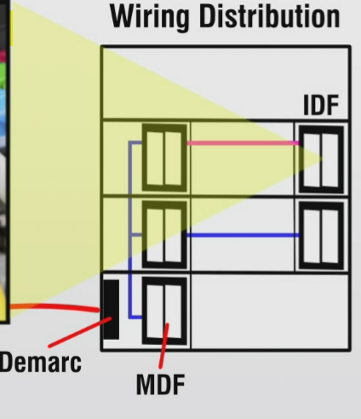Though technically these color coding schemes are not absolutely necessary, as long as the same wires are used on the proper ends on both sides, these standards allow for future technicians to diagnose and address issues.

The demarcation point is where network administrators take over responsibility for the network management. Before the demarc point, ISPs are responsible for the network’s function.

The MDF is called the main distribution frame; using vertical cross connects to connect different IDFs on floors of a business or building. The IDF allows floors of building to have its own data connection. IDFs on the same floor are connected using horizontal cross connects. To protect sensitive data, a demarc extension can be used to create a unique MDF point on your own floor.

Punch down blocks allows admins to connect individual pairs of wires together. Patch panels include large punch down blocks with RJ45 connections coming out of the panel, easing management.

**2.5 Troubleshooting**

Interference is a foreign electrical signal on a wire, and using STP or Fiber can help reduce or remove the effects of EMI. Crosstalk is when wires act as both antennas and receivers, and when cables are too close to one another, each cable’s data may become corrupted. Attenuation is a loss of signal strength due to distance. Longer cables generally result in more attenuation. Impedance mismatch is when resistors are unevenly balanced over a wire. This increased resistance slows or completely stops communications. ORL is optical return loss because of dirt or residue on the fiber optic cabling; the cable will likely need to be professionally polished.

There are three types of fiber optic ends/polishes: PC (Polished with a slight curvature), APC (reduces ORL with angular cut) and SPC/UPC (have highest grade polish and an angular cut.