**4.1 Ethernet**

Older Ethernet topologies use a bus topology, but newer topologies use a logical star topology. CSMA/CD is used on Ethernet to detect if transmission band is available. Collisions occur when 2 or more hosts send messages at the same time. Back off periods are used to help solve the occurrence of collisions. Switches also help to reduce collisions by managing paths for data flow.

Full duplex cables allow RX and TX at the same time. Half-duplex only allows for either RX or TX at once. CRC is a mathematical computation that is performed on each frame to guarantee uncorrupted transmissions. Frames are units of data ready to be sent on a network medium.

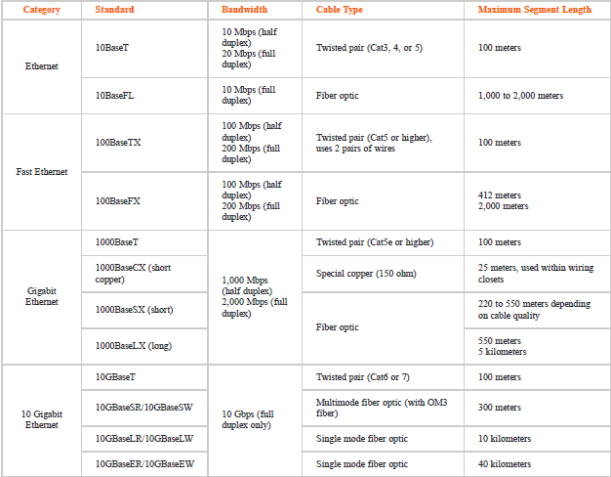**4.2 Ethernet Specifications**

Base10 is a naming convention used in Ethernet speeds. Fast Ethernet is measured at 100 Mbps. Ethernet allows for 1024 hosts on each subnet.

As CAT numbers rise, generally the speeds they support and their EMI resistance grows. Single mode fiber is often able to support much greater transmission distances (LR=long range/ER=extended range). Any Standard ending with a W supports SONET implementations.

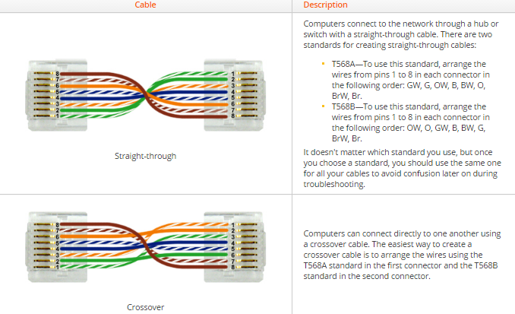**4.3 Connecting Network Devices**

Switches automatically direct RX to TX lines on specified devices, generally use straight through cables. Uplink port is used to connect switches, if no uplink port exists, crossover cable must be used. To connect routers together, a crossover cable is also required. Modern hubs and switches have features called MDI or MDIX that identifies the type of cable used, and enables/disables crossing. Rollover cables have RJ45 and RS232 serials connectors.

**4.4 Troubleshooting Physical Connectivity**

Physical bus topology is when a long segment is terminated on both ends with hosts all connected on same bus cable. If cable or system fails at any point, signal and communication will fail.

Physical star topology is when all hosts are connected by a central switch, where host failures do not cause any network damage. This topology is generally more fault tolerant. Physical ring topology is when data moves from device to device downstream. A broken connection breaks down connections downstream. Works in a loop and less fault tolerant than a star topology. Physical Mesh Topology is only commonly used in wireless standards as it is extremely expensive to use in physical settings.