**CHAPTER 6 IS FOCUSED ON CISCO DEVICES**

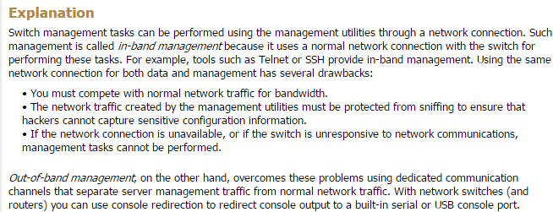**6.1 Switch Access:**

Out of band management is using a computer with a console to configure the switch for the first time. In band management is when you configure the switch, and then use remote access in order to configure and manage the switch. Console cables == Rollover cable.

There are no default passwords for Cisco Switches. There are two passwords that are important on Cisco devices: User mode pass and Enable mode pass. To change passwords on Cisco switches and routers, first use ‘configure terminal’. Enable mode has two passwords: enable password and ‘enable secret password’.

Make sure to use enable to get to enable mode. Use ‘enable password secret’ to set a password for the enable mode. Use ‘enable password supersecret’ to set a password for the secret password within enable mode. Supersecret password is encrypted, but secret is not automatically secret.

**6.2 Switch IP Config:**

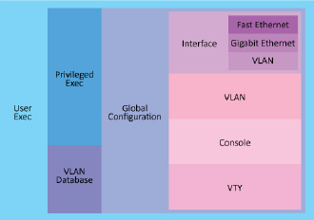Configuring IP connections on switches involves an interface, generally VLAN Config, and then a general router default gateway configuration. By configuring IP settings, administrators are able to configure devices remotely, and are able to allow devices connected to the switch to access greater networks. Use ip address dhcp in order to allow a connected DHCP server to configure the switch’s ip information and the devices that are connected to the switch.

**6.3 Switch Interface Config:**

By default, all Cisco switches come out of the box with all ports active. By default there are no passwords configured on Cisco switches.

* Passwords (should configure)
  + Console and VTY and enable mode passwords
* IP addresses (must configure)
  + Telnet, SSH IP addresses and ports, as well as the Default gateway.

Switch interface configuration: First enter enable to do any configuration. Use show version to show version. Use *show ip interface brief* to show all interfaces. Use *show run* to show configuration.

Configure each port to its supported speed using ‘speed x’ to assign its speed in mbps. Then set duplex to full.

PROTIP: Use question mark to see what commands are available. Use do before a command to force it to work on Cisco routers.

**6.4 VLANs:**

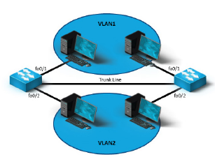VLANs allow for the logical division of a network even as devices are connected to the same switch physically. This allows for an increase in the number of broadcast addresses, and a significant increase in security and ease in management.

**6.5 Trunking:**

Trunking is the procedure by which VLAN’s can span multiple switches. This allows for a wider scope of members of the same logical group. Trunk ports can access all VLANs, but access ports can only exist within a single VLAN. When frames are passed from switch to switch designated for the same VLAN, switches use VLAN IDs to identify the frames that travel across switches. The first switch appends the proper VLAN ID, and the second switch accepts the frame and removes the VLAN ID, passing it to the intended hosts.

**6.6 Spanning Tree Protocol:**

Root bridges are the master/controlling bridge. They are the logical center of the spanning tree. The lowest bridge ID determines the root bridge, and root bridges are enumerated by counts of 4096. Designated bridges are devices that are manually configured to act as bridges on the STP.

The spanning tree protocol:

* Eliminates loops.
* Provides redundant paths between devices.
* Enables dynamic role configuration.
* Recovers automatically from a topology change or device failure.
* Identifies the optimal path between any two network devices.

**6.7 Switch Troubleshooting:**

After troubleshooting process leading error to the switch, the issue may reside with one of many different issues. Often times, the issue lies in misconfiguration somewhere along the topology.

1. Collisions occur when two or more devices that share a medium, and TX data at the same time. Switches are meant to reduce or remove the issues of collisions by creating direct paths between devices.
2. Duplex mismatches occur when switches assign imbalanced duplex values to each port, and cause extremely slow speeds. Best solution is to allow for auto negotiation between devices on the switch.
3. Slow link speeds often occur when devices do not support the speed that is offered by the infrastructure, or if the infrastructure is aged, and the device is expecting a higher speed. Auto configuration of the speed value may solve this issue.
4. Switching loops occur when redundant loops are generated between devices, and can be solved with a spanning tree protocol that guarantees that only one path between devices exists.
   1. Broadcast storms are when broadcast messages overload the network medium.
5. VLAN membership is another issue that may come up as switches are misconfigured where devices exist on incorrect ports.
6. Frame errors are generally rare and are caused by faulty NICs that ‘jabber’, frames that are too short, CRC errors due to TX corruption. All frame errors can be caused by network infrastructure at the Physical level.