**7.1 Router Basics**

Routing is the process by which packets are moved between networks.

Routing tables are used to identify network addresses, interfaces, and cost for travel on route, timeout value, and next hop address.

Routing tables can be configured manually, or can learn about networks by sharing information with other routers. Routing protocols determine the information in the routing table, how messages are routed from on network to another, and how topology changes are communicated between routers.

Default routes are similar to the default gateway in that they are predefined and used to forward packets to networks that do not appear in the routing table. If a packet is received that is addressed with a destination that is currently unknown, then the packet will be sent along the default route, otherwise (if a default route is not configured), the packet will be dropped.

Loopback addresses are software based, and are used to emulate a physical interface.

**7.2 Routing Protocols**

Scope, Metric, Type and VLSM support generally define a routing protocol.

Autonomous systems or AS are assigned network addresses from ISPs.

IGP shares data within an autonomous system. EGP shares data between autonomous systems.

The hop count is a commonly used metric in order to identify the best path for data to travel on. Bandwidth and latency can also be used in order to determine the cost of a data path. By default, routers use hop count in order to identify the best route to travel.

In the distance vector method, routers share all data with one another. Once a router receives information about a new network from a router upstream, it will increment the hop count. **Convergence occurs when all routers know about all paths.**

Link state method is when routers only share information about their paths that are directly connected using LinkStateAdvertisements or LinkStatePackets. Hybrid methods use both distance vector and link-state methods to fill routing tables.

VLSM allows for routers to use addresses that are different from the default subnet mask. Classless is when addresses are used when default subnet mask values are included in advertisements. Classless protocols support CIDR and VLSM.

RIP (Routing Information Protocol) is the oldest standard for routing protocols. EIGRP. OSPF requires an area 0 where all devices must be connected.

Wildcard masks are essentially inverse subnet masks, with all full (255) changed to zeroes, and 0s to 255.

**7.3 Network Address Translation:**

Uses ports and

Many to one NAT, uses same registered IP address and uses dynamic ports that are saved in the router’s PAT(port address table).

Static NAT or one to one, also known as port forwarding to allow an address to be accessed from the internet using a single port.

NAT is not a firewall, but acts in similar fashions to one by limiting access to any single host.

**7.4 Routing Optimization**

**7.5 Routing Troubleshooting**

When a device cannot connect to the internet, first make sure that it is in fact a routing issue, then check that the default gateway is properly configured. Check other devices that are on the same router to see if the problem exists on other hosts. Neighbor Discovery issues come about when two routers are unable to communicate with one another.

MTU Black holes occur when packets are larger than the MTU standard used by the router, and packets are dropped without confirmation or messages that the packet was in fact dropped. Routing loops may form when multiple loops.

Best way to address routing issues is to use the map of the network topology to properly identify and track errors that may exist within your network. Remote access client issues may occur when remote access servers are unable to create links from the client to the base network.

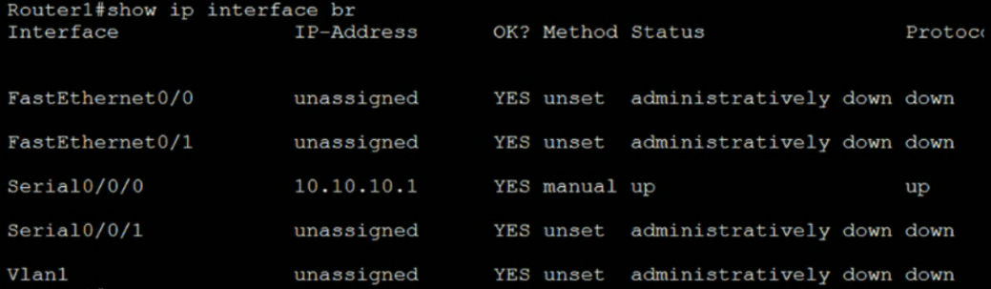Routing can be configured from the command line to troubleshoot WAN or LAN connections. Always check if interfaces that are required are shutdown or not. Check the encapsulation that is configured for the interface. Check show ip interface brief ^^ (want to see up up). Check show ip route in order to see how the routing table is configured.