7/05/2023

MACHINE LEARNING FOR UIC STUDENT PREDICTION
____________________________________________________________________________

INTRODUCTION
In this project, we extensively explored various machine learning models, target variable labeling methods, and aggregation techniques. The key findings of our analysis revealed that the most effective approach involved aggregating data on a yearly basis, considering the most recent term snapshot for each student in that year, as it resulted in more accurate predictions for the next term. Moreover, adopting a binary target variable that classified next term fall enrollment based on discontinuation yielded the best results. By subtracting the total number of students predicted to discontinue from the known enrollment count for that year and accounting for graduated students, we could determine the number of continuing students.

Stratified sampling was employed to balance the dataset, and the attributes used were determined through feature selection (please refer to the feature selection folders for more details). The data was segregated based on student level description, creating subsets for undergraduates, graduates, professional students, law, non-credit, and SCALES. Notably, SCALES represents a discontinued level type, while the enrollment for non-credit was too low to be included. Additionally, the classification reliability for law is limited as we only had three years of data collection. The professional students' trends exhibited volatility, making them unreliable for current classifications. Despite these limitations, the classifications for these subsets are included in the analysis.

When reviewing the performance metric of our compared model we see that while we have high overall accuracy of the classification, however the accuracy for discontinuation is poor. This could be an indication that there is an imbalance dataset or a specific issue with that particular class. Here are a few possible explanations of what the cause of the issues may be and a few suggestions on next steps to remedy this problem.

Class-specific challenges: The class with poor accuracy may have inherent complexities or characteristics that make it harder to classify correctly. It could be due to similarities with other classes, insufficient training examples, or insufficient representation of important features for that class. In these cases, it may be necessary to focus on improving the model's performance specifically for that class through techniques such as collecting more data, data augmentation, or adjusting the training strategy.

The data had undergone prior preparation to incorporate an aggregated version, focusing on the most recent snapshot of each student's academic year. This step aimed to ensure that predictions were made exclusively for individual students, avoiding multiple predictions for various terms in which a student was enrolled. The training data assigned labels to the target variable based on the most recent snapshot for each student per year. A value of 1 was assigned if a student enrolled in the subsequent fall term of the following year, while a value of 2 denoted graduation. Students who discontinued their studies were labeled as 0.

To enhance the model's ability to recognize patterns within the features of students who discontinued, the three original labels were simplified into a binary classification system, distinguishing between successful (labeled as 1) and unsuccessful (labeled as 0) outcomes. Continuing students and graduating students were both considered successful and assigned the label 1, whereas all discontinued students were labeled as 0.

Through extensive experimentation, it became evident that the probability of dropout varied significantly depending on the population within a specific term. Notably, students whose last term occurred in the fall exhibited substantial differences compared to those whose last term took place in the spring or summer. Treating all these populations as one cohesive unit within a year hindered the machine learning model's ability to accurately identify predictive patterns across the entire student population. Consequently, significant disparities in biases emerged between different groups of populations.

It is plausible that a student's last term being in the fall, combined with their non-enrollment in subsequent terms, strongly indicates that the student has already dropped out and is unlikely to return. The probability of dropout by term is illustrated below

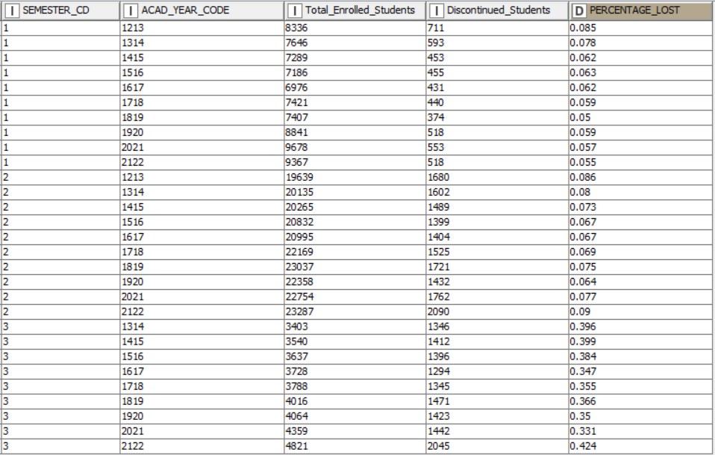
Table showing the percentage of student lost by academic year and semester

All of our previous models were trained on a dataset that exhibited a notable bias, resulting in performance discrepancies across different classes. When the training data fails to represent the real-world distribution of classes adequately, the model's ability to classify underrepresented classes accurately can be compromised. To address this issue, meticulous data collection and preprocessing are necessary to ensure a balanced and diverse set of training samples. Our previous analysis revealed a left-skewed classification threshold with a non-normal probability distribution. Even with adjustment ratio-based threshold tuning, the potential for uneven classifications and issues of under- or over-prediction remained.

Instead of attempting to adjust the threshold's sensitivity for classifying students based on their probability measures, we have opted to train separate models for each term. This approach allows the models to be trained on the inherent probability distribution specific to each term. By dividing the data into fixed-length windows and training a classifier for each window, the models can effectively capture the evolving patterns present in the data over time. The final label for a given instance can then be determined through majority voting or other appropriate aggregation methods.

Prior to implementing the term based training approach, we observed that the model was unable to accurately capture the probability of a student discontinuing in the fall term (labeled as 3), as depicted in the following analysis.

This is the predicted percentage lost using a single tree ensemble model over the whole populations

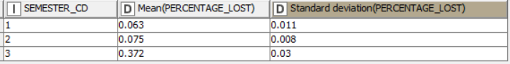
The actual average percentage lost for the whole population broken up by semester.

Here you can see that the predicted percentage is nearly half of what it should be for the fall term, nearly a quarter of what it should be for the spring term, and much less than it should be for the summer term as well.

Subsets of Data for Term Based Model Training
Subsequently, we developed three separate models, each trained on data specific to different semester terms. The first model focused on the fall semester and aimed to predict whether students would return for the subsequent fall term. The second model incorporated data from the spring term, considering all students within this period and predicting their likelihood of returning for the fall term. Finally, the third model was designed for summer students, specifically targeting their probability of returning for the fall term.

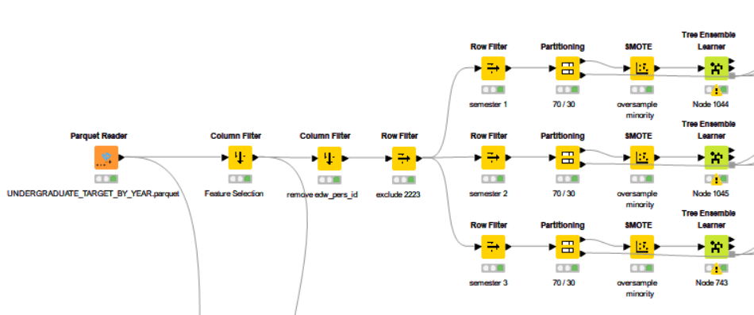

In this particular case, we have utilized preprocessed data to train the model on subsets of the data. The data is organized based on the description of student levels, including undergraduates, graduates, professional, and law students. Each group of students is further divided according to the semester code.

To simplify the semester codes, we have relabeled them from their original values. The original codes were 8, 1, and 5, representing the start months for each term. The relabeling was done as follows: the fall term (code 8) was relabeled as 3, the spring term (code 1) was relabeled as 2, and the summer term (code 5) was relabeled as 1.

This relabeling process was implemented to facilitate the aggregation method, specifically to retain the most recent term in an academic year. By selecting the minimum value of the semester code during aggregation, we ensure that only the most recent term is retained. This aids in the overall analysis and interpretation of the data.

The previous model had shown biases possibly due to the imbalance nature of the data set. The class with poor accuracy was the discontinued students, which has significantly fewer instances compared to the other classes. As a result, the model may prioritize accuracy on the majority class while struggling to perform well on the minority class. Due to this we implemented the following methods to oversample the minority class.

After partitioning the data by a 70/30 split we have oversampled the minority class by implementing the knime node SMOTE. The purpose of this node is to enhance the training data by oversampling the input data, which involves adding artificial rows. This technique, known as SMOTE (Synthetic Minority Over-sampling Technique), was developed by Chawla et al.
Certain supervised learning algorithms, such as decision trees and neural networks, perform better when the class distribution is balanced. However, if the input data is unbalanced, meaning there are only a few instances of the "active" class but many instances of the "inactive" class, this node addresses the issue by adjusting the class distribution. It achieves this by introducing synthetic rows, specifically for the "active" class, in the example provided. It generates synthetic rows by extrapolating between a real object belonging to a specific class (e.g., "active") and one of its nearest neighbors within the same class. In our case we have used “5” nearest neighbors. By using the 5 nearest neighbors, SMOTE ensures that the synthetic samples generated are within the local neighborhood of the minority instances. This helps to preserve the underlying distribution and structure of the minority class while expanding its representation in the dataset.

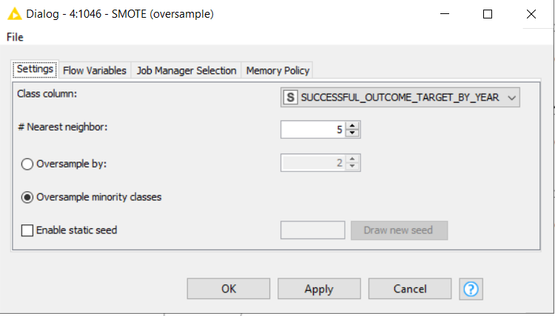

The utilization of the term-based training approach significantly enhanced the accuracy of the data and enabled the model to rely on more reliable probabilities regarding a student's likelihood to discontinue within a specific time frame. It became evident that the features associated with student dropout lacked strong predictive power. Consequently, our focus shifted towards emphasizing the features that displayed a higher correlation, such as our time-based variables including the number of terms completed, accumulated credit hours, and the number of years remaining until the expected graduation.

By placing greater emphasis on these correlated features during training, we were able to improve the model's ability to effectively learn from them and incorporate them into the prediction process. This approach helped capture the underlying patterns and dynamics that contribute to student attrition, leading to enhanced predictive performance and a more accurate understanding of the factors influencing dropout behavior.

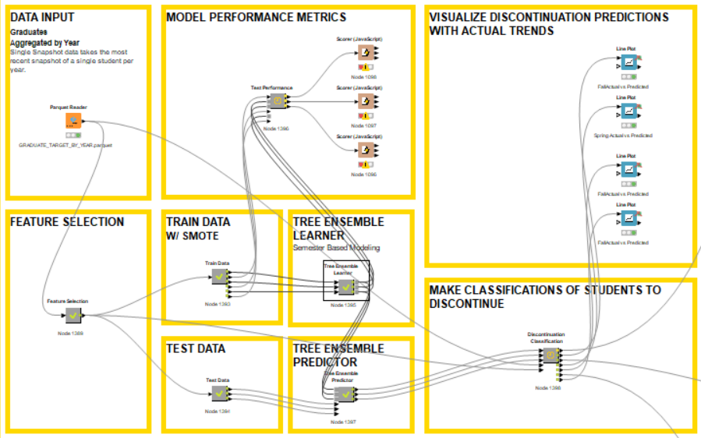

The KNIME workflow incorporates four distinct training processes based on student level, each containing three separate models corresponding to different semesters. Consequently, a total of 12 models are utilized to classify subsets of data based on student level type and term code.

To facilitate the training process, the dataset has undergone prior preparation in the provided Jupyter notebook titled "Python Data Preparation and Feature Engineering." The prepared dataset, stored as a Parquet file, is read into the workflow. A column filter is applied to select the specific columns to be used in the training procedure. The column selection is based on manual input, as recommended by the previous work on feature selection available in the "Python Data Exploration & Feature Importance" folder.

The training data excludes the academic year 2223 and the "edw-pers_id" column. Additionally, it is divided into three subsets of data based on the semester code. Each subset undergoes a 70/30 random sample partition, ensuring a balanced distribution. Furthermore, the SMOTE (Synthetic Minority Oversampling Technique) algorithm is employed on each subset to oversample the minority class. This technique employs k-nearest neighbors with k set to 5 to generate synthetic samples and address the class imbalance issue.

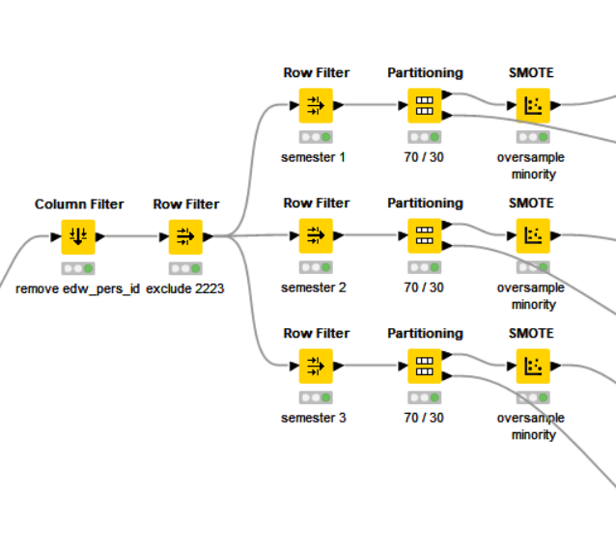

Subsequently, we proceed to train three models on the aforementioned data and evaluate their performance metrics, as indicated in the "Model Performance Metrics" section. The obtained metrics are provided below. Once we have validated that the models perform well, we utilize the test data, which includes the academic year 2223.

Term Based Training Performance Metrics

Semester 1: Summer Terms
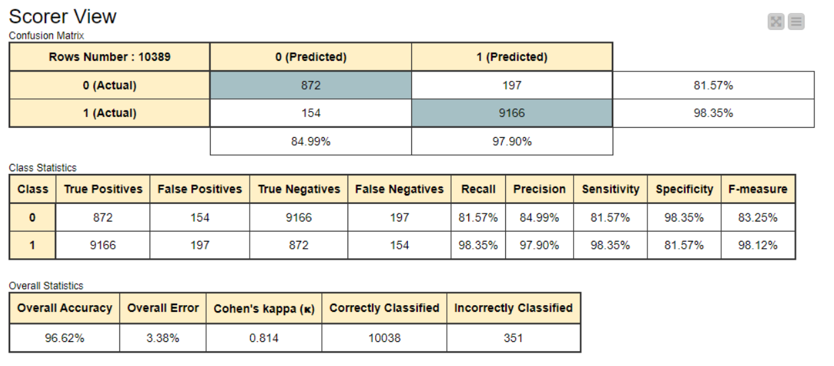

Semester 2: Spring Terms
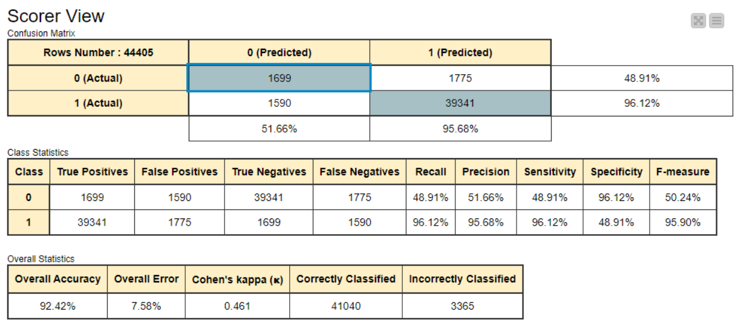

Semester 3: Fall Terms
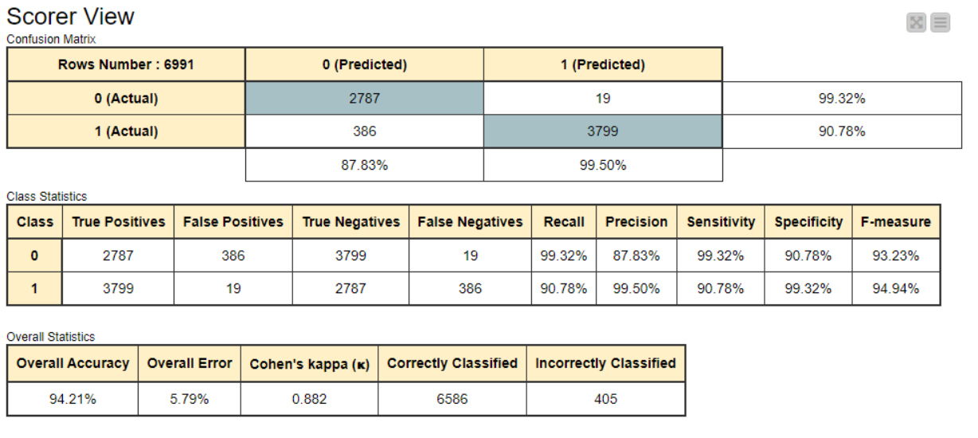

Using the tree ensemble model and applying various preprocessing steps to prepare the data, we make classifications and generate visualizations comparing the actual values to the predicted values specifically for Undergraduates based on the corresponding terms. A sample of this output is presented below.

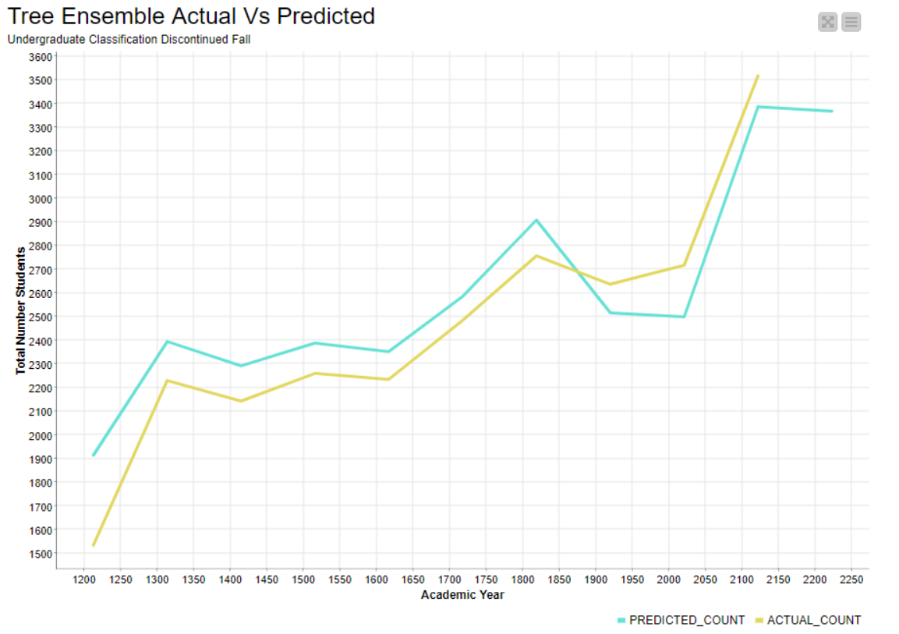

The graph presented displays a comparison between the actual and predicted number of discontinued students per academic year, focusing specifically on undergraduates. The blue line represents the predicted values for the subsequent fall term enrollment.

To access additional visualizations for predictions based on either Semester, please refer to the respective Excel output files:
- "Predicted_Discontinued_Students_by_Student_Level.xlsx" for predictions based on student level.

After all of the 12 models have made classifications that data is then merged back together in order to infer the insights into the data based on college. The data is then split by college level and visualized from actual vs predicted in order to validate the performance.

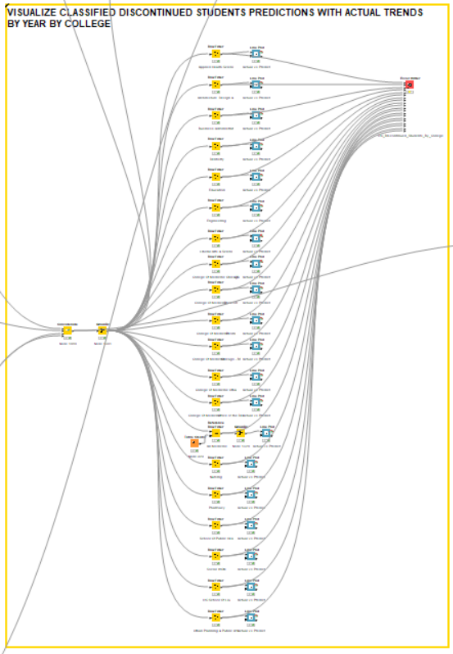
The provided image illustrates a section of the KNIME workflow that encompasses visualizations based on the college level of each student. These visualizations depict the predictions of the total number of students expected to enroll in the next fall term, categorized by their respective college level.

Below is a sample of visualization of the college for Liberal Arts & Sciences. This can be found inside the line plot node inside the knime workflow.

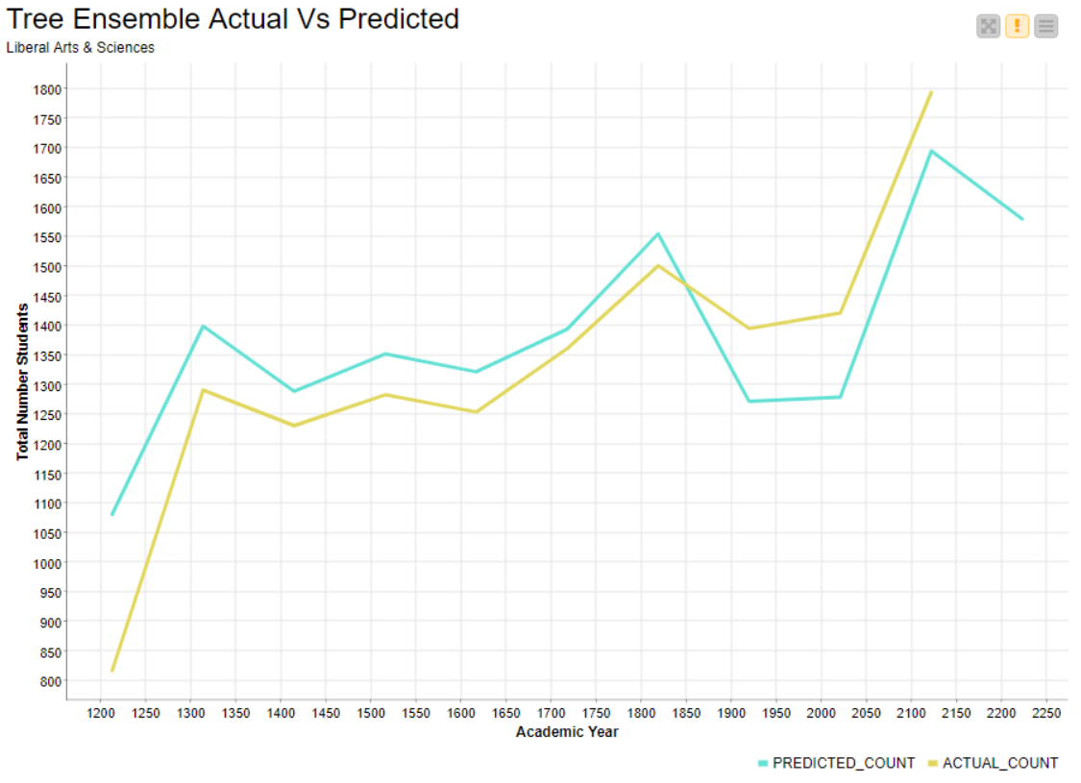
This data table used to generated each of these graphs has been exported as individual sheets to an excel file that can be used outside of the Knime platform.To access additional visualizations for predictions based on either College, please refer to the respective Excel output files:
- "UIC_Discontinued_Students_By_College.xlsx" for predictions based on college level.

After all of the classifications have been made the data has also been prepared in an excel format to be able to see the individual students that have been identified to discontinue based on both the student level and the college. This output is generated in the knime workflow here.
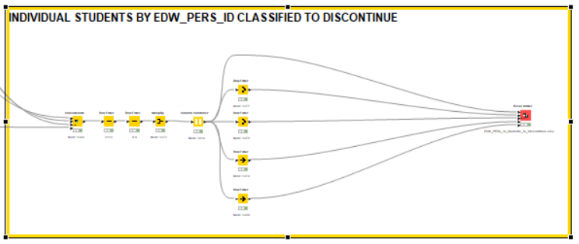
To access the report containing individual students classified as discontinuing, please locate the corresponding Excel output files available for download:

- “EDW_PERS_ID_Students_to_Discontinue.parquet”

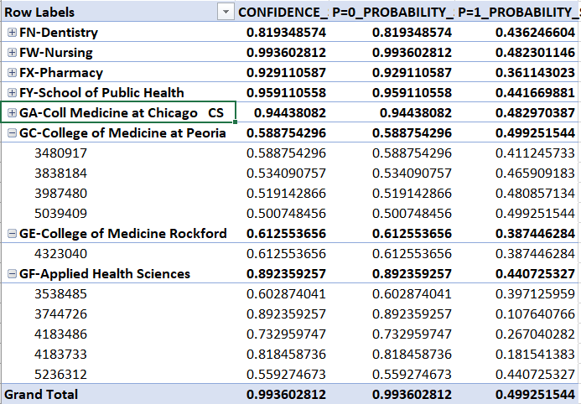

The Excel output has been transformed into a pivot table format for easy analysis of individual students who have been classified as discontinuing, categorized by student level and college level. This table includes the associated confidence scores and probability scores used to assign these classifications.
Confidence, in this context, refers to the level of certainty or reliability associated with the model's predictions. It is commonly expressed as a probability or score that indicates the model's belief in the accuracy of its prediction for a given instance.
The confidence value offers insights into the model's understanding of the data and the strength of its predictions. A higher confidence value suggests a higher level of certainty in the model's prediction, while a lower confidence value indicates a greater degree of uncertainty. This metric can be valuable in combination with other probability scores, allowing individual colleges to identify students at risk of dropping out while considering the attributed confidence scores as an indicator of classification accuracy.

FINAL RESULTS

The final results for the academic year 2222 can be derived by calculating various metrics using the following information: total enrollment numbers, total number of graduating students, and the predicted number of students expected to discontinue. By considering these numbers, we can evaluate the total count of continuing students for that academic year.

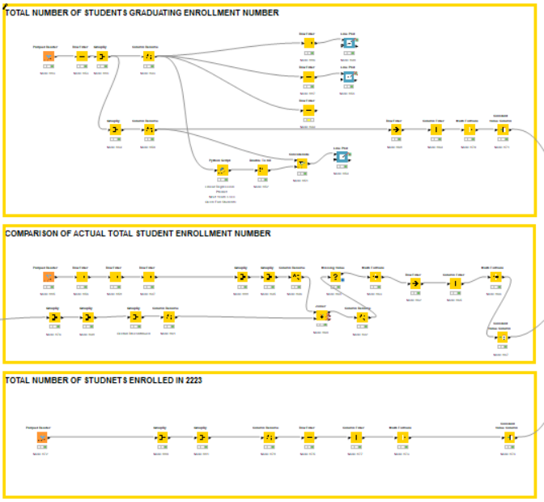
The provided image illustrates the specific section of the workflow dedicated to calculating various metrics, including the total number of enrolled students, the total number of students who have graduated, the total number of students predicted to discontinue, and the remaining count representing the number of continuing students.

To determine the total number of continuing students for the next fall term, we can identify graduate students by checking the "STUDENT_CURR_DEG_IND" attribute, where a value of "Y" indicates the awarding of a degree. Subtracting the count of these graduate students from the overall enrollment count for the academic year 2223, along with the predicted number of discontinued students, enables us to calculate the expected total number of students continuing into the next fall term based on the available data.

Here are the final results for the total number of continuing students for the next fall term.

