Assessment 2 Report
Design Progress and Requirements Specification
Group Name: Aletheia's Zetetes
Product Name: Paedia
CSIT321 - Project 37 - Group 19
University of Wollongong
Prepared for Prof. Jun Yan

Letter to Supervisor
7 May 2026
Prof. Jun Yan
Project Supervisor
University of Wollongong
Dear Prof. Yan,
Please find attached the Assessment 2 design progress report for EduRAG, our course assistant project, with Paedia as the proposed product name. This report brings together the Sprint 2 design baseline, Sprint 3 consultation evidence, and current scope validation into one document for supervisor review and assessment.
The report explains the proposed architecture, key technology decisions, development and deployment environments, and the requirements that will guide implementation. It separates the minimum viable product from additional requirements and stretch goals so that the scope is easier to review. More detailed interface tables, requirement tables, user stories, use case material, and traceability content are included in the appendices.
Where design choices still need confirmation, the report presents them as the team's current design direction rather than approved decisions. We would welcome feedback on the scope, feasibility, and level of difficulty before implementation work becomes more intensive in later sprints.
Yours sincerely,
Group 19
EduRAG Project Team

Executive Summary
EduRAG is a proposed AI-powered course assistant that lets students ask natural language questions about course materials and receive answers grounded in retrieved source content. The project addresses a clear problem in learning: students often struggle to find relevant explanations across slides, notes, and readings when basic keyword search does not match the meaning of their questions.
This report turns the Sprint 2 design outputs, refined through Sprint 3 consultation and prototype evidence, into a supervisor-facing Assessment 2 submission. The current design uses a Python-based modular monolith with LangChain for orchestration, SentenceTransformers for embedding generation, ChromaDB for vector retrieval, PostgreSQL for relational data and session persistence, a Streamlit prototype interface sitting above a lightweight Flask-based WebApplication layer, and Docker Compose for portable multi-container deployment (LangChain, 2026; SentenceTransformers, 2026; Chroma, 2026; PostgreSQL Global Development Group, 2026; Streamlit, 2026; Flask, 2026; Docker Inc., 2026).
The requirements specification defines a focused MVP centred on authentication, document ingestion, semantic retrieval, grounded answer generation, source citation, asynchronous indexing, and multi-course isolation. Additional requirements extend the product with multi-turn sessions, admin monitoring features, document management, and rate limiting, while stretch goals such as export, summarisation, and follow-up suggestions are kept separate to control scope.
The Sprint 2 design baseline is technically strong, and the Sprint 3 evidence strengthens its feasibility for the Assessment 2 submission. Student, Lecturer, and Admin use case material is now grouped more consistently, terminology is standardised around ChromaDB and PostgreSQL, and wording that could imply prior supervisor approval has been removed. The aim is to make the document clearer and easier to review before implementation accelerates.

Table of Contents
Letter to Supervisor 2
Executive Summary 3
Table of Contents 4
Introduction 7
Market Analysis and Project Rationale 7
Branding and Presentation Direction 10
Initial Interface Design Direction 11
Design Methodology 13
Supervisor Consultation, Scope Validation, and Meeting Evidence 14
Development Environment 15
Deployment Environment 16
Tools and Technology Decisions 17
Requirements Analysis 18
Acceptance Criteria and Validation Plan 19
Representative Base Requirements 20
Representative Additional Requirements 20
Representative Stretch Goals 20
Explicit Exclusions 20
Creativity, Innovation, and Project Difficulty 20
Project Difficulty Justification Matrix 21
Architecture Summary 21
Module Responsibilities 22
RAG Pipeline 24
RAG Evaluation Strategy 25
Technical Risk and Responsible Use Controls 26
Deployment Topology 27
Conclusion 29
References 29
Glossary 31
Appendix A. Technology Decision Matrix 33
Appendix B. Module Interface Specifications 35
Module 1 - DocumentProcessor 35
Module 2 - VectorRetriever 35
Module 3 - LLMResponseGeneration 36
Module 4 - WebApplication 37
Inter-module communication summary 38
Appendix C. Full Functional Requirements 39
Appendix D. Full Non-Functional Requirements 47
Appendix E. User Stories and Use Case Descriptions/Diagram 52
Student Use Cases 56
UC-01 Select Course Context 58
UC-02 Submit Question 58
UC-03 Receive AI-Generated Response 59
UC-04 View Source References 60
UC-05 Continue Multi-turn Conversation 61
UC-06 Resume Saved Session 62
UC-07 Review Conversation History 63
UC-08 View Confidence Indicator 64
Lecturer Use Cases 65
UC-09 Upload Course Materials 66
UC-10 Organise Materials by Topic 67
UC-11 Update Course Materials 68
UC-12 Delete Course Materials 69
UC-13 Preview Document Chunks 70
UC-14 View Student Query Logs 71
UC-15 Flag Inaccurate Responses 72
Admin Use Cases 74
UC-16 Manage User Accounts 75
UC-17 Assign Lecturers to Courses 76
UC-18 Reset User Passwords 77
UC-19 Configure LLM Settings 78
UC-20 Monitor System Metrics 79
UC-21 Export Audit Logs 80
UC-22 Trigger Vector Re-indexing 81
Appendix F. Traceability Matrix 82
Appendix G. Additional Diagrams 85
G1. Entity Relationship Diagram (ERD) 85
G2. Data Flow Diagram (DFD Level 1) 86
G3. Sequence Diagram (Upload exception and recovery) 87
Appendix H. Initial Interface Wireframes 88
H1. Login and Role Entry 88
H2. Student Q&A Interface 89
H3. Lecturer Document Upload 90
H4. Admin Dashboard 91
H5. Session History 92

Introduction
EduRAG is a capstone project in CSIT321 that applies Retrieval-Augmented Generation (RAG) to the problem of course-specific knowledge access. RAG was introduced by Lewis et al. (2020) as a technique that combines a dense retrieval step with a generative language model: the system first retrieves relevant passages from a knowledge base, then conditions its generated answer on those passages. Applied to an educational context, this means students can ask natural language questions and receive answers that are grounded in the actual materials their lecturer has uploaded, rather than in the model's general training knowledge.
The system is not intended to replace lecturers, learning management systems, or formal teaching materials. Instead, it is designed as a support tool that helps students navigate existing course resources through conversational search. The key design principle is transparency: every answer either carries a source citation traceable back to a specific course document, or states that the answer cannot be verified from the available course materials. This distinction directly addresses the hallucination risk that makes ungrounded language models unsuitable for academic support.
Assessment 2 requires a professional report that explains the project's development direction, requirements baseline, and design methodology. This report reorganises the Sprint 2 design baseline and later consultation evidence into a structured format for supervisor review, keeping detailed technical artefacts in the appendices. The report covers target users, development and deployment environments, technology decisions, system architecture, and full requirements analysis. It clearly separates what the minimum viable product must deliver, what improvements are desirable if time permits, and which features are out of scope.

Market Analysis and Project Rationale
Market context and scale. Paedia is aimed at a large, growing, and digitally dependent higher education environment, not a one-off classroom convenience problem. Australian higher education had 1,676,077 enrolled students in 2024, up 4.7% from 2023, so even a small improvement in how students retrieve course-specific information can affect a substantial learner population. For EduRAG, this market size matters because the product addresses a repeated study workflow: students ask questions, locate evidence, check source material, and prepare assessment work across several subjects.
Why now. The timing matters because student AI use has already moved faster than most institutional controls. Grand View Research (2024) projects the global AI-in-education market at USD 5.88 billion in 2024 and a 31.2% compound annual growth rate from 2025 to 2030. Chegg's 2025 global student survey found that 80% of surveyed students had used generative AI to support their studies, while 53% of GenAI users were concerned about receiving incorrect or inaccurate information from tools not built specifically for education. The opportunity is therefore not to convince students to try AI, but to give them a safer course-grounded option when they already expect AI-supported study help.
Student problem. Students face a practical information access problem. Course knowledge is distributed across lecture slides, PDFs, weekly readings, LMS announcements, rubrics, tutorial notes, and recorded sessions. Generic search is often too broad, LMS search is document-oriented rather than question-oriented, and general-purpose chatbots may answer confidently without being constrained to the subject material. This creates three recurring pain points: slow retrieval, uncertainty about whether an answer is based on the course, and weak traceability back to evidence.
Trust and accuracy gap. The strongest rationale for Paedia is not novelty; it is trust. HEPI reported that 92% of UK students had used AI in some form, while 51% identified false results or hallucinations as a factor putting them off using AI. That combination is important: students are using AI despite doubts about reliability. Paedia responds by narrowing the answer space to uploaded course materials, returning citations, preserving course isolation, and exposing confidence cues. These controls make the product more appropriate for academic study than an unconstrained chatbot.
Evidence area | Real figure / finding | Relevance to Paedia
Australian higher education scale | 1,676,077 students enrolled at higher education providers in 2024; up 4.7% from 2023. | Shows the addressable learner population is large enough for course-level AI support to matter beyond a single class.
AI-in-education growth | Global AI-in-education market estimated at USD 5.88 billion in 2024, with 31.2% CAGR forecast from 2025 to 2030. | Confirms the market is moving toward AI-supported learning tools and institutions need defensible, governed options.
Student AI adoption | Chegg reported that 80% of surveyed students had used generative AI to support their studies, while 53% of GenAI users were concerned about incorrect or inaccurate information from non-education-specific tools. | Indicates Paedia meets an existing behaviour rather than creating a new one.
Trust gap | HEPI reported that 92% of UK students had used AI in some form, and 51% said false results or hallucinations put them off using AI. | Supports the need for citations, source grounding, confidence indicators, and course-specific retrieval.
Institutional governance | Universities increasingly require transparent and responsible AI use in assessment contexts. | Supports Paedia's design focus on traceability, scoped retrieval, auditability, and role-based control.
Table 1. Market evidence supporting Paedia's rationale.
Target users. Paedia has two primary user groups and one enabling user group. Students need fast, cited explanations grounded in their subjects. Lecturers need a way to provide approved material to the retrieval system and review whether answers reflect the course. Administrators need account, course, and system controls so the tool can operate within an institutional environment.
User group | Current pain point | Paedia value proposition
Students | Study materials are scattered and generic AI may hallucinate or cite weak sources. | Ask natural-language questions and receive concise, cited answers grounded in enrolled-course materials.
Lecturers | Students repeatedly ask clarification questions and may rely on unsupported external AI answers. | Upload and manage course documents, support consistent responses, and review inaccurate answers through a feedback workflow.
Administrators | Institutional AI tools require control over users, access, configuration, and monitoring. | Manage accounts, course access, system metrics, audit logs, and re-indexing in a controlled environment.
Table 2. Target users and Paedia value proposition.
Competitive positioning. Paedia is positioned between three existing alternatives: generic AI chatbots, LMS search tools, and broad study platforms. Generic AI tools are flexible but weakly grounded in a specific subject. LMS search can find files but usually cannot synthesize an answer. Study platforms provide explanations but are not aligned to a university's exact weekly content. Paedia differentiates itself through course-scoped retrieval, source citations, lecturer-controlled content, and an assessment-aware design.
Alternative | Strength | Limitation | Paedia differentiation
Generic chatbots | Fast conversational answers and broad knowledge coverage. | Not constrained to local course materials and may produce unsupported answers. | Course-grounded RAG, citations, confidence cues, and fallback when evidence is insufficient.
LMS document search | Already connected to course files and institutional access. | Keyword search does not reliably answer natural-language study questions. | Question-answering layer over course documents with retrieval evidence.
General study platforms | Useful explanations and practice support. | May not match the exact subject, lecturer expectations, or assessment context. | Uses lecturer-provided material and course-specific indexing.
Manual lecturer support | High trust and direct alignment with course intent. | Limited availability and repetitive clarification workload. | Handles repeatable evidence-based questions while preserving lecturer oversight.
Table 3. Competitive positioning against key alternatives.
Project rationale. Paedia should exist because it addresses a clear gap between student behaviour and institutional trust requirements. Students are already using AI for study, but current options do not reliably prove that answers come from approved course sources. A RAG-based architecture is suitable because it separates retrieval from generation: the system first searches indexed course material, then generates an answer using retrieved evidence. This allows Paedia to deliver the convenience students expect while supporting the transparency, traceability, and governance that universities require.

Branding and Presentation Direction
Assessment 2 asks the team to begin applying a consistent project identity from this stage onward. For this report, the group name is `Aletheia's Zetetes` and the proposed product name is `Paedia`. The branding approach is still lightweight, but it is now explicit and consistent across the report.
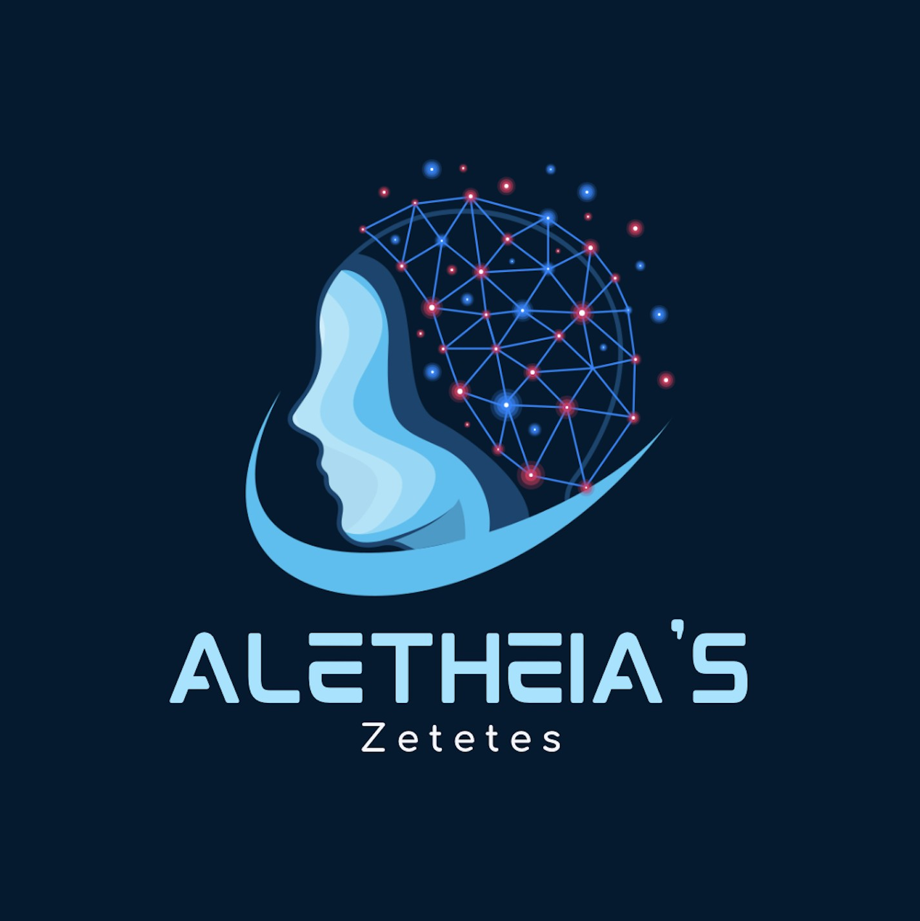
Figure 1. Aletheia's Zetetes group logo used for the current report identity.
Branding element | Current direction
Group name | Aletheia's Zetetes
Product name | Paedia
Project name | EduRAG
Identity style | Academic and professional presentation with the existing group logo and a simple product name
Primary colours | Navy for major headings, teal for secondary emphasis, gold for tertiary emphasis
Tone | Professional, educational, and technically grounded
Future carry-over | Use the same group name, product name, colour treatment, and figure styling in Sprint 4 presentation assets and the prototype UI
This level of branding is appropriate for the project's current maturity. It shows clear identity choices without spending too much effort on marketing assets before the core design and requirements have been validated.

Initial Interface Design Direction
The initial interface design translates the requirements baseline into visible user workflows without changing the Assessment 2 scope. The Sprint 3 UI package prepared by Anmoldeep Singh uses Paedia's navy, teal, and gold visual system to show how Students, Lecturers, and Administrators would interact with the same RAG-backed platform.
The design is intentionally requirements-led. It does not treat the interface as decoration; each screen demonstrates how a functional or non-functional requirement can be experienced by a real user.
Interface element | Requirement/design evidence
Student Q&A view with active course context | Supports natural-language questions, course_id-scoped retrieval, multi-turn sessions, and source-backed answers.
Source citation chips and confidence indicator | Makes answer grounding visible so students can verify course material references and judge retrieval confidence.
Fallback label for ungrounded answers | Protects academic trust by clearly stating when no grounded course-material answer can be verified, rather than presenting unsupported model knowledge.
Lecturer upload and indexing workflow | Shows how uploaded course files move into asynchronous processing, status tracking, and ChromaDB indexing.
Role-based navigation and admin dashboard | Separates Student, Lecturer, and Admin capabilities while supporting audit, metrics, and system monitoring needs.
Accessible colour and component rules | Uses consistent contrast, readable typography, status colours, and predictable controls to support usability requirements.
The three representative wireframes below show the main interaction paths: asking a grounded question, uploading course materials, and monitoring the system as an administrator. The complete five-screen wireframe set is included in Appendix H.
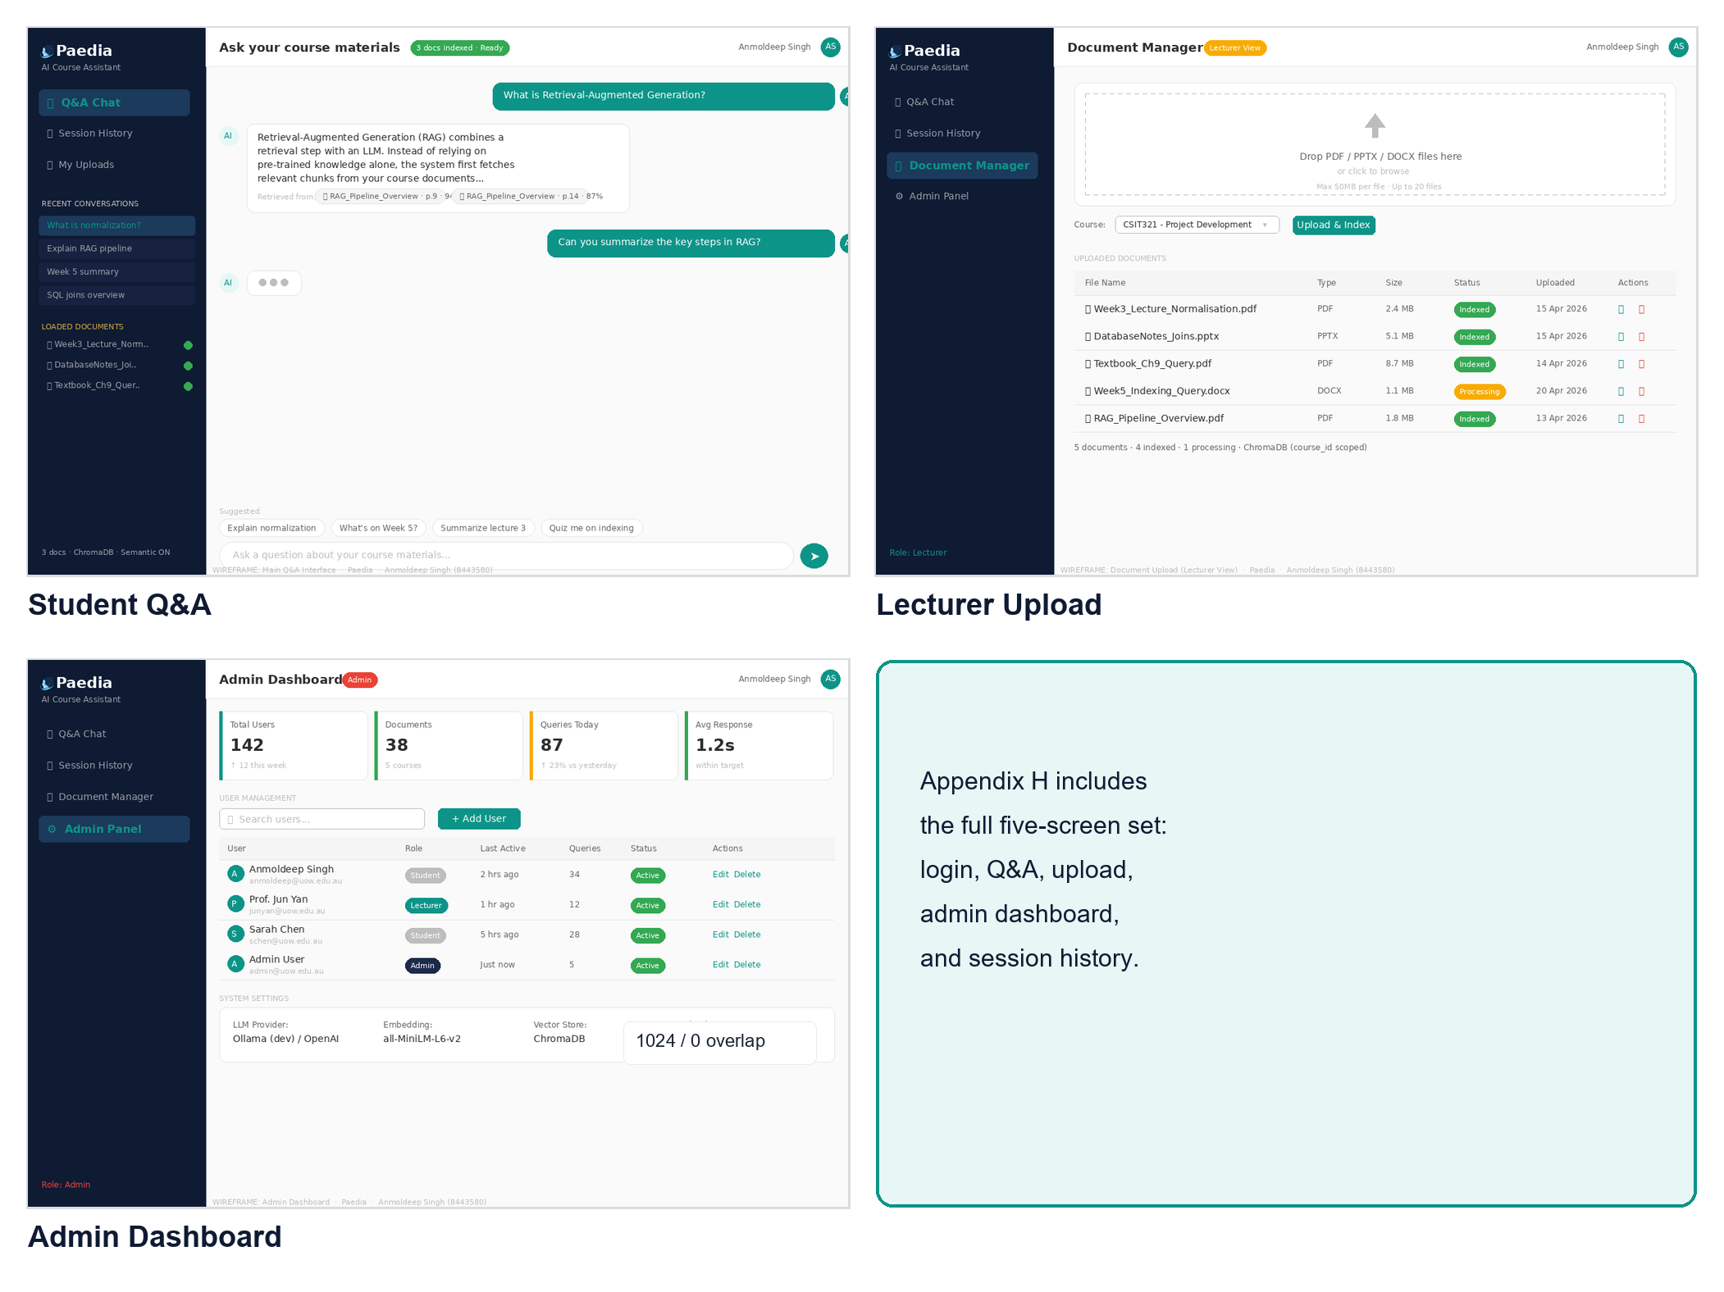
Figure 2. Interface contact sheet. Representative wireframes for Student Q&A, Lecturer Upload, and Admin Dashboard.

Design Methodology
The project follows an Agile/Scrum approach with two-week sprints (Schwaber and Sutherland, 2020), with Sprint 2 acting as the main design-definition phase. This approach suits the project because there is still technical uncertainty in areas such as document ingestion quality, embedding performance, and multi-provider LLM integration. An iterative process helps the team discover these risks early while still keeping a clear planning rhythm.
- User roles and likely interactions were identified first through stakeholder analysis and user stories.
- Those interactions were converted into use cases, then formalised into functional requirements using MoSCoW prioritisation.
- Quality, security, reliability, and maintainability targets were captured as measurable non-functional requirements.
- Architecture, interfaces, and deployment decisions were then selected to satisfy the resulting requirement set.
- Traceability was maintained so that requirements can be mapped back to stakeholder needs rather than appearing as isolated technical preferences.
This methodology is also appropriate for Assessment 2 because the report is expected to show a requirements specification shaped by the team's development process. The MoSCoW model fits the sprint plan well: Must-have requirements define the MVP, Should-have requirements support later enrichment, and Could-have requirements remain stretch work.

Supervisor Consultation, Scope Validation, and Meeting Evidence
The project scope was refined through sponsor meetings, coordinator check-ins, and internal sprint planning rather than treated as a fixed initial brief. The Sprint 3 meeting report set supplied by the team records six consultation and planning moments from 01 April to 01 May 2026; the Sprint 3/Sprint 4 evidence was documented by Tung Phuong Anh Huynh and gives a stronger chronological basis for explaining how EduRAG moved from concept to validated design direction.
The table below consolidates the previous supervisor-consultation narrative and evidence map into one evidence trail. It separates validated guidance from planned Sprint 4 work so the report does not overclaim results that still require implementation or benchmark evidence.
Meeting / date | Evidence from meeting report | Scope or design decision | How this report reflects it
Meeting 1 - Sponsor, 01 Apr 2026 | Project description treated as a starting point; team asked to clarify product thesis, user need, competitors, dependencies, milestones, and delivery process. | The product should be justified through requirements and market/user analysis, not copied directly from the initial brief. | Introduction, market rationale, requirements grouping, design methodology, and milestones explain why Paedia is needed and how the team will deliver it.
Meeting 2 - Sponsor, 15 Apr 2026 | Modular monolith, ChromaDB, PostgreSQL, Ollama, Streamlit MVP, and React stretch path were confirmed. Course isolation and source-referenced answers were identified as final-demo differentiators. | MVP should focus on course-scoped RAG, cited answers, and a practical Streamlit-first interface; advanced frontend work remains stretch. | Architecture, deployment, requirements, and RAG sections foreground course_id filtering, citations, role separation, Streamlit/Flask delivery, and React as stretch.
Meeting 3 - Coordinator check-in, 15 Apr 2026 | Coordinator check-in confirmed progress, surfaced attendance/coordination concerns, and recorded no other blockers at that point. | Progress tracking and blocker escalation were required controls for Sprint 3 delivery. | Design methodology and validation discussion present the report as sprint-shaped evidence, not a static design document.
Meeting 4 - Internal group, 15 Apr 2026 | Team confirmed the end-to-end RAG PoC as Sprint 3 success criterion, Docker verification, 31-question test corpus, sample materials, API specification, and UI/backend integration checkpoint. | Sprint 3 evidence should separate demonstrated PoC work from integration and evaluation still planned for Sprint 4. | RAG Pipeline, RAG Evaluation Strategy, acceptance criteria, and appendices distinguish PoC evidence, 31-query benchmarking, parser coverage, and integration validation.
Meeting 5 - Sponsor review, 01 May 2026 | Live RAG PoC and Streamlit UI were demonstrated. Public online course materials were accepted for demo-stage evidence; single ChromaDB course_id filtering was considered reasonable; A2 structure/length was acceptable if clear. | Current A2 scope is appropriate, while richer subject-specific materials and broader feature expansion remain future work after core stability. | Report keeps demo-corpus constraints visible, preserves the accepted 1024/0 chunking baseline, and marks richer test data, API integration, and expanded validation as Sprint 4 or later work.
Meeting 6 - Sprint 4 internal planning, 01 May 2026 | Team identified A2 submission as the critical path, prioritising Appendix G/proofread, missing Sprint 3 meeting deliverables, Moodle readiness, and Flask API wrapper work. | A2 readiness and evidence consistency should be resolved before broader implementation acceleration. | Final report consolidates consultation evidence, aligns Appendix G and interface/architecture evidence, and positions Flask WebApplication/API work as Sprint 4 direction.
Taken together, the meeting reports validate the direction of Paedia as a course-specific RAG assistant rather than a general AI chatbot. The most important product evidence is that students need grounded answers from course materials, while the most important technical evidence is that the team has a feasible path for course isolation, source citation, role separation, and local demonstration. The report therefore treats the Streamlit/Flask MVP, ChromaDB/PostgreSQL storage split, Ollama-first development path, and 31-query evaluation plan as the current design baseline, while keeping React migration, richer personalisation, broader material types, and deeper subject-specific validation as later-sprint expansion.
Validation status. Sponsor and coordinator meetings support the design direction, scope boundaries, and readiness priorities. They do not prove every Sprint 4 feature has already been implemented. Items such as Flask endpoint completion, full UI/backend integration, rerun benchmark results, and richer subject-specific corpus validation remain implementation and validation tasks that must be evidenced separately.

Development Environment
The proposed development environment is a Python-centred local setup designed to reduce onboarding friction for a student team while still reflecting professional engineering practice. Core application logic is expected to live in a single repository with Git-based version control, structured branching, and incremental integration through pull requests. For the MVP, the team plans to use a Streamlit prototype interface on top of a lightweight Flask-based WebApplication layer so the UI can evolve quickly without losing a clean backend boundary.
Area | Proposed environment
Programming language | Python for all core prototype modules
RAG orchestration | LangChain as the selected framework; LlamaIndex retained as a considered alternative
User interface | Streamlit prototype UI for rapid MVP development
Application service | Flask-based WebApplication layer for authentication, query handling, and document actions
Embeddings | SentenceTransformers with all-MiniLM-L6-v2
Vector store | ChromaDB, initially local and persistent
Relational data | PostgreSQL for users, sessions, and audit data
Local model option | Ollama for cost-controlled development and local testing
Project coordination | Sprint-based task planning and meeting documentation
This environment fits the team's educational constraints well. Developers can work productively with one language, one main application codebase, and a small number of infrastructure services. At the same time, the chosen stack still exposes the team to realistic patterns such as vector retrieval, structured persistence, role-based access control, containerisation, and evaluation-oriented requirements.

Deployment Environment
EduRAG is designed to run as a multi-container Docker application on a single host for development and demonstration. This environment is intentionally pragmatic: it is portable enough to run on team laptops or a dedicated demo machine, but not so complex that the project becomes dependent on cloud infrastructure before the core pipeline is validated.
The proposed deployment uses Docker Compose to run the application container, PostgreSQL container, and ChromaDB container on a single host. Ollama is treated as the primary local LLM service during development and PoC demonstration, while the same generation module can switch to the OpenAI API through environment configuration if a controlled demonstration requires it. Persistent Docker volumes store uploaded files, relational data, and vector indexes so restarts do not erase key system state (Docker Inc., 2026; PostgreSQL Global Development Group, 2026; Chroma, 2026; Ollama, 2026).
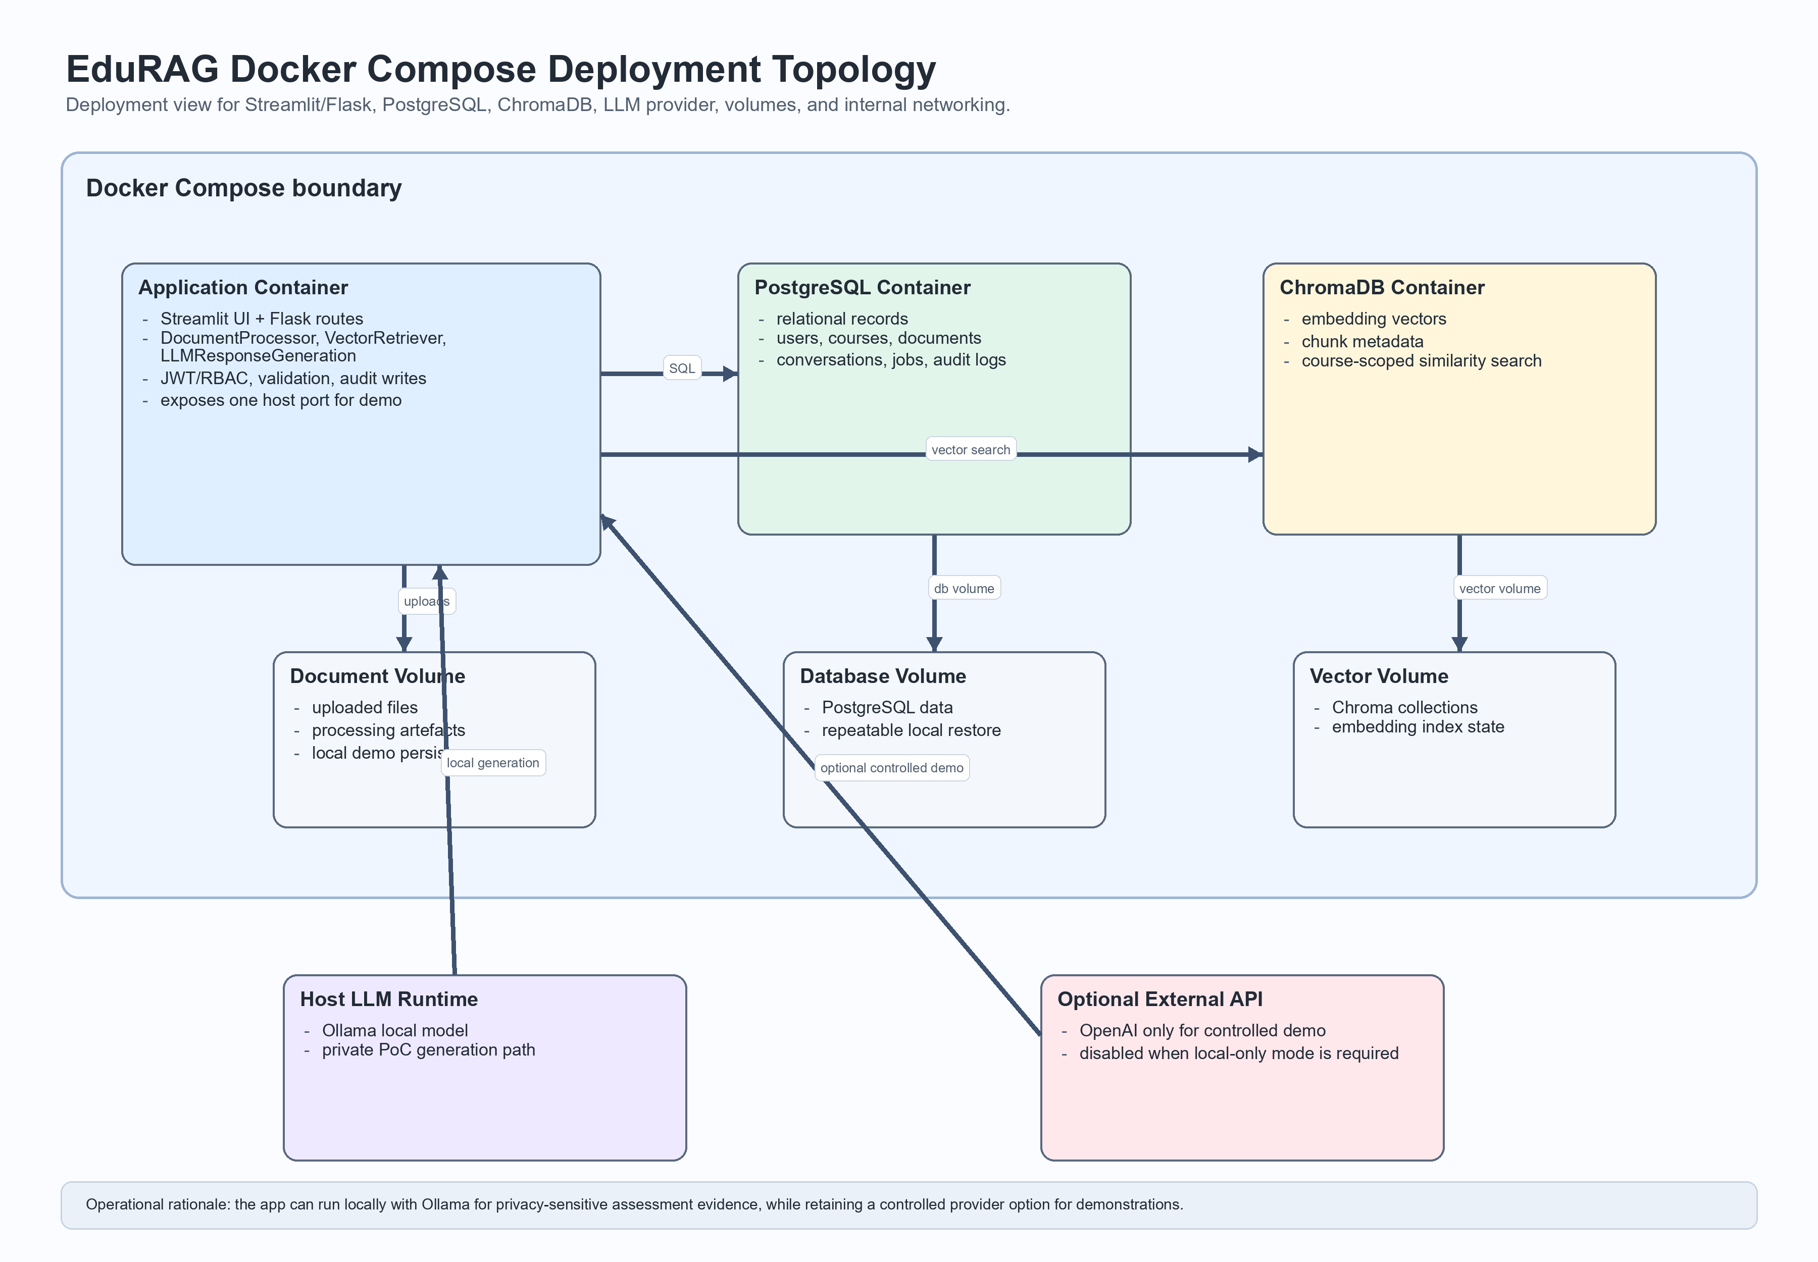
Figure 3. Docker Compose deployment topology and service boundaries.
This deployment strategy also preserves a clear migration path. If the MVP succeeds early, the Streamlit prototype interface can later be replaced by a dedicated React frontend and a FastAPI service layer without changing the document processor, retriever, or response-generation modules. That future option is one reason the modular monolith pattern was selected.

Tools and Technology Decisions
The current technology stack was selected by comparing alternatives against project scope, team capability, prototype cost, and operational simplicity. The resulting decisions are intentionally conservative: where two options were technically viable, the design favoured the option that reduced integration overhead while still providing clear educational value.
Component | Decision | Primary Rationale
LLM Provider | Ollama primary + OpenAI optional controlled-demo fallback | Cost-controlled local development and PoC demonstration, with hosted-model option only if demo quality or availability requires it.
Vector Database | ChromaDB | Native course_id metadata filtering; built-in persistence
Embedding Model | all-MiniLM-L6-v2 | Lightweight 384-dim; fast; well-supported
Prototype stack (MVP) | Streamlit UI + Flask WebApplication layer (Sprint 4 API direction) | Fast feedback for the prototype while preserving a clean application boundary; Sprint 3 used a generic Python app service concept, while Sprint 4 tasks specify Flask route implementation.
Web Framework (Stretch) | FastAPI + React | Production-grade migration path
Relational Database | PostgreSQL | RBAC support; JSONB for conversation history
Authentication | JWT + RBAC (3 roles) | Industry standard; works with both MVP and stretch
Deployment | Docker + docker-compose | Multi-container; portable; professional
Architecture | Modular Monolith | Microservices discipline without operational overhead
Document Formats | PDF + PPTX + DOCX | Broad coverage of course materials
Course Scoping | Multi-course (course_id) | Real-world ready; matches Module 2 spec
Conversation Mode | Multi-turn + saved sessions | Persistent history via PostgreSQL JSONB
LangChain is the selected orchestration framework because it provides a practical abstraction over prompt templates, retrieval chains, and multiple LLM providers, which is useful for using Ollama locally while retaining an OpenAI API option for a controlled demonstration if required (LangChain, 2026; OpenAI, 2026; Ollama, 2026). LlamaIndex remains a credible alternative and was considered during evaluation because of its strong support for context augmentation over private data, but it was not chosen as the primary framework for the MVP (LlamaIndex, 2026).
The most important Sprint 2 refinement was the shift from FAISS to ChromaDB and the formal commitment to PostgreSQL. This change is defensible because course-specific retrieval, session persistence, JWT-based role handling, and audit-oriented relational data are core parts of the proposed product rather than optional extras.
Hybrid retrieval and reranking remain plausible future enhancements, but they are intentionally deferred until the single-vector baseline has been benchmarked on real course materials. BEIR shows that lexical retrieval and reranking can be strong baselines, yet they also introduce extra pipeline and evaluation complexity that is difficult to justify before the MVP corpus and curated query set have stabilised (Thakur et al., 2021).

Requirements Analysis
The requirements specification is the main focus of Assessment 2, so the report explicitly distinguishes between the minimum viable product, additional requirements, and stretch goals. This structure is derived from the Sprint 2 MoSCoW prioritisation and is intended to give the supervisor a clear view of project difficulty, delivery realism, and scope boundaries.
Delivery layer | Source priority | What it means in this project | Examples
Base requirements | Must have | Capabilities required for EduRAG to function as a usable RAG assistant | authentication, PDF upload, chunking, embeddings, ChromaDB indexing, semantic retrieval, grounded answers, citations, async indexing, multi-course isolation
Additional requirements | Should have | Important quality and management features that strengthen the MVP if delivery remains on track | multi-turn sessions, saved conversations, admin dashboard, audit log review, rate limiting, document management, confidence scoring, retrieval benchmarks
Stretch goals | Could have | Enhancements that improve polish or usability but are not necessary for the prototype to demonstrate value | conversation export, topic summarisation, follow-up question suggestions, dark mode, usage analytics export
The base requirement set is appropriately challenging for a capstone prototype because it requires the team to integrate document processing, semantic retrieval, grounded LLM generation, security controls, and basic observability into one coherent system. It is also contained enough to remain feasible within the annual session.

Acceptance Criteria and Validation Plan
The following plan summarises how the current requirement set should be validated during Sprint 4. It is a design-stage validation plan, not a claim that all checks have already been executed. Detailed FR and NFR definitions remain in Appendices C and D; this matrix groups the most important acceptance areas for integration testing and A3 evidence capture.
Validation area | Related requirement focus | Acceptance direction | Planned evidence
Source citations | Grounded answers and citation display | Grounded answers should expose source references such as filename, page number, chunk metadata, and similarity score where available. | Chat screenshot and response payload showing source_references.
Confidence indicator | Retrieval confidence and user trust | Confidence should be visibly derived from retrieval strength, not from the model tone alone. | High, medium, and low confidence examples using the design-system colours.
Course selection | Course-scoped retrieval | Changing the active course should change course_id and prevent cross-course retrieval leakage. | Same query tested in two course contexts with different scoped evidence.
Upload and indexing status | Document upload, parsing, chunking, and indexing | Lecturer uploads should show pending, processing, indexed, or failed states for PDF/PPTX/DOCX inputs. | Upload flow screenshots and indexing status response.
Role-based navigation | Student, Lecturer, and Admin access separation | Each role should see only the relevant navigation items and protected views. | Role walkthrough screenshots or fixture-based UI evidence.
Fallback label | Unsupported or weak-retrieval answers | Unsupported questions should show the approved fallback label and avoid false course-grounded citations. | Off-topic query result with is_fallback=true.
Accessibility and colour consistency | Basic accessibility and visual consistency | Text contrast, focus indicators, status colours, and UI states should follow the design system. | Manual accessibility checklist and visual consistency screenshots.

Representative Base Requirements
- Students can submit natural language questions and receive grounded answers with source citations.
- Lecturers can upload course materials for asynchronous processing and indexing.
- The system stores embeddings in ChromaDB scoped by course_id to avoid cross-course leakage.
- Authentication and role-based access control separate Student, Lecturer, and Admin capabilities.
- The retrieval and generation path is measurable through latency, citation rate, precision, recall, and hallucination targets.

Representative Additional Requirements
- Conversation sessions persist across logins so users can continue prior discussions.
- Administrators can inspect metrics and audit logs to review system behaviour.
- Rate limiting and confidence indicators improve robustness and user trust.

Representative Stretch Goals
- Conversation export to PDF for revision or record-keeping.
- Topic summarisation and suggested follow-up questions to deepen learning support.
- Visual enhancements such as dark mode once core functionality is stable.

Explicit Exclusions
The report also preserves the Sprint 2 Won't-have boundary to prevent scope creep. The current prototype does not include live lecture transcription, a multi-language user interface, LMS integration, native mobile applications, or automated grading.

Creativity, Innovation, and Project Difficulty
EduRAG is innovative in the context of this subject because it combines retrieval, generation, course scoping, and multi-role interaction into a single educational assistant rather than delivering only a chatbot, only a search tool, or only a document repository. The project is not attempting novelty for its own sake; its innovation lies in how established AI techniques are integrated into a realistic educational workflow.
Relative to simpler alternatives, the project is more challenging because it must solve several linked problems at once: reliable extraction from course documents, embedding and vector retrieval, grounded prompt construction, answer traceability through citations, role-based security, and persistent session management. This makes the project difficult enough to justify capstone-level assessment while still remaining implementable within the annual sprint structure.
Assessment-facing innovation comparison. A generic chatbot would be easier to build but would not prove that answers come from approved course sources. An LMS keyword search would be easier to govern but would not synthesise explanations. A static document repository would store materials but would not help students ask contextual questions. Paedia is more valuable because it combines these paths into one course-scoped, cited, role-aware study workflow; it is more difficult because each answer must preserve retrieval quality, citation traceability, access control, and responsible fallback behaviour at the same time.

Project Difficulty Justification Matrix
The difficulty of Paedia comes from coordinating multiple technical constraints in one coherent prototype. The matrix below makes the difficulty explicit rather than relying only on a general statement that the project uses RAG.
Difficulty area | Why it is difficult | Design response in Paedia
Hallucination control | A fluent answer can be wrong if it is not grounded in course material. | Use course-scoped retrieval, citation display, safer fallback/refusal wording, and planned groundedness checks.
Retrieval quality | Useful answers depend on chunking, embeddings, top-k retrieval, similarity thresholds, and test coverage. | Adopt chunk_size=1024, chunk_overlap=0, top_k=5, threshold=0.65, all-MiniLM-L6-v2, and a 31-question labelled corpus for Sprint 4 validation.
Multi-role access | Students, lecturers, and admins need different permissions while sharing the same system. | Separate role-based navigation, protected endpoints, course enrolment scope, and admin-only audit/metrics views.
Persistence | The system must preserve users, courses, documents, sessions, messages, audit events, and indexing jobs across restarts. | Use PostgreSQL for relational state and ChromaDB for vector state, with Docker volumes for prototype portability.
Document parsing | PDF, PPTX, and DOCX files contain different structures and can fail in different ways. | Preserve source metadata and slide/document structure where possible while keeping the accepted chunking baseline consistent.
Auditability | Educational AI needs traceability for trust, debugging, and accountability. | Store source references, session history, indexing status, structured logs, and audit events where implemented.
Evaluation complexity | Success depends on retrieval relevance, citation accuracy, fallback behaviour, latency, and failure analysis rather than UI success alone. | Run the 31-question corpus during Sprint 4 and archive retrieved chunks, scores, citations, fallback flags, latency, and reviewer judgement.

Architecture Summary
EduRAG is organised as a modular monolith with four modules: DocumentProcessor, VectorRetriever, LLMResponseGeneration, and WebApplication. This keeps the MVP simple enough for a student team to implement and debug while preserving clean module boundaries for future expansion.
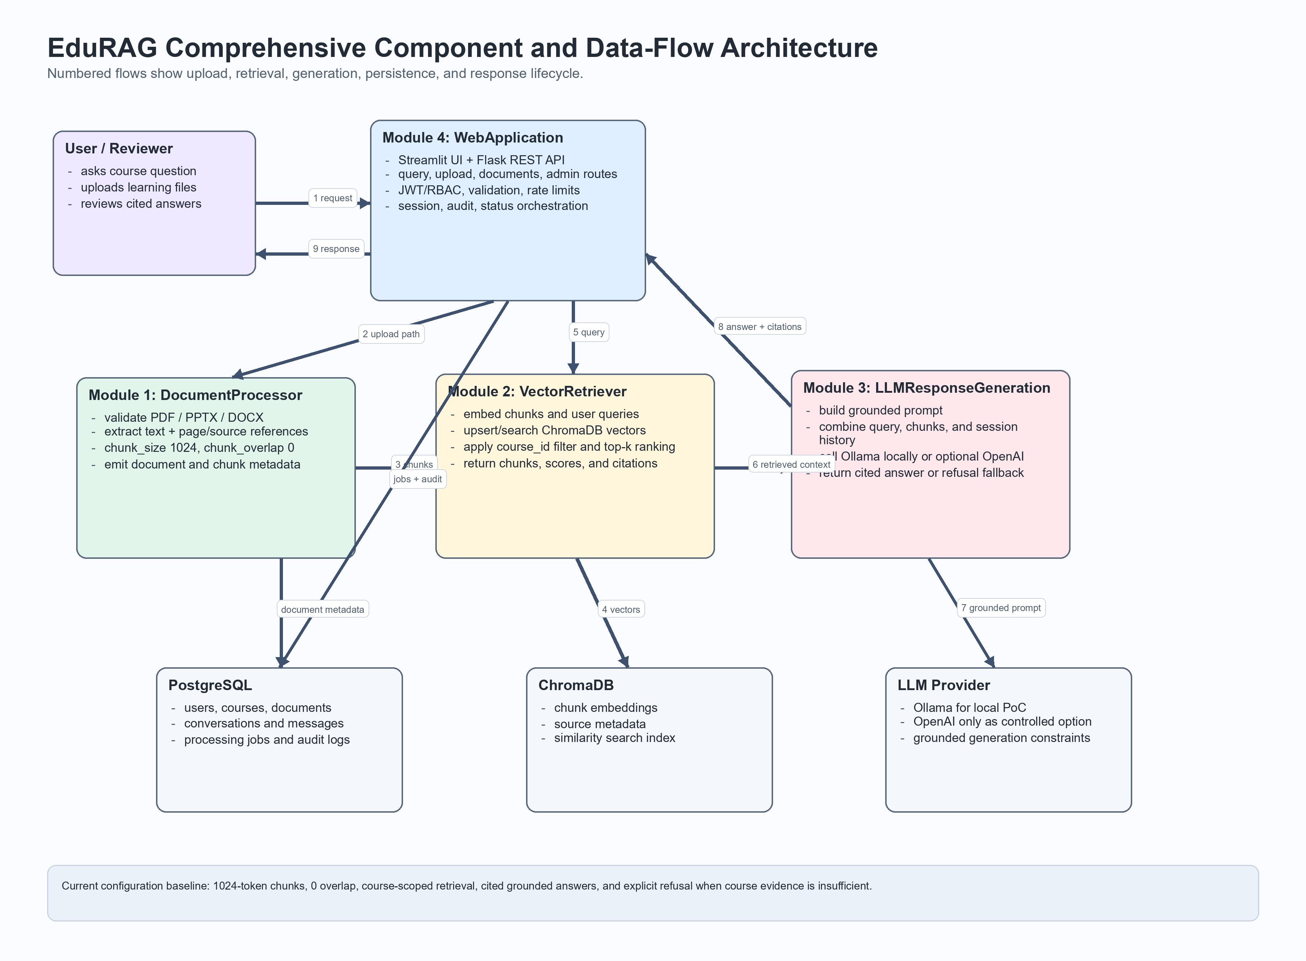
Figure 4. Comprehensive component and data-flow architecture.
The component design makes the system boundaries explicit. WebApplication is the only external entry point, while retrieval and generation remain internal modules. It also shows the complete data packages passed between modules: upload requests carry course and document metadata, query requests carry the original user question and session context, and the generation module receives both the user query and retrieved evidence before producing an answer.

Module Responsibilities
EduRAG is decomposed into four modules, each with a single responsibility. The full interface specifications are in Appendix B; the descriptions below convey the design intent at a level sufficient to understand the architecture as a whole.

DocumentProcessor
Responsible for the document ingest pipeline. When a Lecturer uploads a file, DocumentProcessor parses its text (supporting PDF, PPTX, and DOCX formats), applies the current implementation baseline of chunk_size=1024 with chunk_overlap=0, generates a vector embedding for each chunk using the SentenceTransformers all-MiniLM-L6-v2 model (Reimers and Gurevych, 2019), and writes the resulting embeddings to ChromaDB. Each record is tagged with a course_id metadata field so that subsequent retrieval can be scoped correctly to a single course.

VectorRetriever
Responsible for semantic search at query time. It receives the student's question, generates its embedding using the same model used during ingest, and performs a cosine similarity search against the ChromaDB collection filtered by the active course_id. It returns the top-k most relevant chunks together with their similarity scores, which the next module uses to assess grounding confidence.

LLMResponseGeneration
Responsible for answer generation. It receives the original question and the retrieved chunks, constructs a context-grounded prompt, and calls the configured language model to generate a response. The module attaches source citations derived from the chunk metadata. When no chunks exceed the similarity threshold, the module avoids presenting an unsupported course-grounded answer and returns a clear message that the answer cannot be verified from the available course materials. In the development and PoC demonstration environment this module calls Ollama by default; OpenAI remains only an optional controlled-demo provider if required.

WebApplication
The only externally exposed module, responsible for orchestrating the other three. In the current design it acts as a lightweight Flask-based application service layer sitting behind the Streamlit prototype interface, enforces JWT-based authentication (Jones et al., 2015), and applies role-based access control across three roles: Student (query only), Lecturer (upload and content management), and Admin (system configuration and user management). It also enforces per-user rate limits, manages conversation sessions stored in PostgreSQL JSONB columns, and writes all significant events to the audit log.
Because EduRAG is an LLM-enabled system, the security design also treats prompts, retrieved chunks, and uploaded files as untrusted input. Prompt templates therefore keep course-scoping and citation rules in the highest-priority system instructions, uploaded documents are validated for type and size before parsing, and suspicious model outputs can be blocked, relabelled, or logged for follow-up instead of being shown blindly to end users. This directly addresses prompt-injection and improper-output-handling risks highlighted in the OWASP guidance for LLM applications (OWASP Foundation, 2025).

RAG Pipeline
The core behaviour of EduRAG can be understood as two sequential phases that together constitute the retrieval-augmented generation pipeline (Lewis et al., 2020).

Phase 1 — Document Ingest
1. A Lecturer uploads a course document (PDF, PPTX, or DOCX) through the WebApplication module.
2. DocumentProcessor extracts raw text from the file using format-specific parsers.
3. The extracted text is split using the current accepted RAG baseline of chunk_size=1024 and chunk_overlap=0. This aligns with the Sprint 3 benchmarking plan's tested 1024 option and the corrected local repo/report baseline used for Assessment 2.
PPTX ingestion needs slightly different handling from PDF or DOCX because slide decks are usually composed of short bullet fragments rather than continuous prose. For that reason, the parsing step preserves slide boundaries, titles, and local bullet structure before chunk assembly so each chunk keeps enough presentation context for later citation. Chunk assembly should still use the accepted retrieval baseline of chunk_size=1024 and chunk_overlap=0; smaller slide-derived chunks may be retained only when combining slides would weaken citation traceability.
4. SentenceTransformers all-MiniLM-L6-v2 encodes each chunk as a 384-dimensional dense vector embedding.
5. Each embedding is written to ChromaDB together with metadata that includes the course_id, document name, and chunk index.
6. The system confirms the upload and indexing status to the Lecturer.

Phase 2 — Query Flow
1. A Student submits a natural language question and selects the relevant course context.
2. WebApplication validates the JWT, checks the rate limit, and forwards the request.
3. VectorRetriever embeds the question using the same encoding model and searches ChromaDB with a cosine similarity query scoped to the active course_id.
4. The top-k most relevant chunks (default k=5) are returned with their similarity scores.
5. LLMResponseGeneration builds a context-grounded prompt from the retrieved chunks and the original question.
6. The prompt is sent to the configured language model: Ollama for local development and PoC demonstration, with OpenAI available only as a configurable controlled-demo option if required.
7. The generated answer is returned to the Student with source citations. If no chunks exceed the similarity threshold, the response states that the answer cannot be verified from the available course materials and avoids unsupported citations.
8. The interaction is stored in the session record and the audit log.

The DFD Level 1 in Appendix G provides a complementary view of the same flows at context and internal decomposition levels. The upload exception/recovery sequence diagram in that appendix traces the individual service calls and data movements in chronological order.
The current retrieval thresholds should be read as initial prototype baselines rather than permanent production guarantees. Precision@5 and Recall@10 were selected because they are easy to interpret in supervisor review, align with common top-k retrieval evaluation practice, and can be measured repeatedly on a curated course-specific query set with manually labelled relevant chunks (Thakur et al., 2021). To complement those labelled IR metrics, the team also plans to use a lightweight RAG-specific framework such as Ragas to monitor answer faithfulness and context relevance while chunking, prompts, and thresholds are being tuned (Es et al., 2023).

RAG Evaluation Strategy
The RAG evaluation strategy is intended to validate whether Paedia answers student questions with relevant course evidence, accurate citations, and appropriate refusal/fallback behaviour when the knowledge base does not contain enough support. It is designed to complement functional testing because a RAG system can pass interface tests while still retrieving weak chunks or producing unsupported answers.
Retrieval edge-case taxonomy. The Sprint 3 evidence defines four retrieval edge cases that Sprint 4 validation should keep separate: no chunks above threshold, borderline similarity matches, nonsense or accidental messages, and coherent off-topic questions. Separating these cases improves the evaluation because a no-match course question, a low-confidence partial match, and an unrelated general question should not all receive the same system response.
Evaluation baseline. Sprint 4 validation should use the accepted retrieval baseline: chunk_size=1024, chunk_overlap=0, top_k=5, similarity distance threshold=0.65, all-MiniLM-L6-v2 embeddings with 384 dimensions, and ChromaDB metadata filtering by course_id. The 1024/0 chunking configuration is treated as the Assessment 2 standard because it is the current repo/report baseline, even though one exported meeting note contains an inconsistent 2,024-token reference.
Evaluation dataset. The current labelled corpus should be tests/test_queries.json, which contains 31 test questions across easy factual, hard reasoning, off-topic, and ambiguous categories. This is a strong starting point for Sprint 4 because it tests both normal course questions and cases where Paedia should avoid over-answering. The dataset should still be expanded before production use to include lecturer-approved expected citations, expected evidence pages or chunks, more subjects, and larger documents.
Evaluation area | What to test | Metric / evidence to collect | Acceptance direction
Groundedness | Whether generated answers are supported by retrieved chunks. | Manual judgement on the labelled corpus, supported by Ragas only if added and executed. | Answers should be based on retrieved course material, not unsupported model knowledge.
Citation accuracy | Whether each cited source corresponds to the retrieved evidence used in the answer. | Citation/source match rate and reviewer notes for incorrect or missing citations. | Citations should point to the correct document or chunk metadata.
Retrieval relevance | Whether top-k retrieved chunks are useful for the question. | Precision@5, Recall@10 where expected evidence is labelled, and qualitative review for hard reasoning cases. | Relevant chunks should appear in the top results often enough to support answer generation.
Fallback correctness | Whether no-match, borderline, nonsense, and off-topic cases trigger distinct safe behaviours instead of hallucinated answers. | Pass/fail count across off-topic, insufficient-evidence, accidental/nonsense, and borderline-similarity questions. | Unsupported questions should produce the configured fallback/refusal response; borderline matches should include a confidence caveat and verifiable sources.
Latency | Whether the query pipeline remains usable for student workflows. | End-to-end response time from API request to generated answer. | Prototype target should be responsive enough for iterative study use; slow cases should be logged.
Course isolation | Whether questions for one course can retrieve content from another course. | Cross-course negative tests using course_id metadata filters. | No retrieved evidence should come from unauthorised or unrelated course collections.
Table 4. RAG evaluation strategy for Sprint 4 validation.
Evidence status. This strategy should be reported as the planned Sprint 4 validation approach unless the team has executed the tests and archived the results. Final evidence should include the test corpus version, configuration values, retrieved chunks, similarity scores, generated answer, citations, fallback flag, latency, reviewer judgement, per-category results, failed-query examples, and any tuning decisions made after evaluation.

Technical Risk and Responsible Use Controls
The A2 risk view focuses on design risks that could weaken the prototype or reduce trust in its educational use. The mitigations are expressed as system controls and validation checks rather than named-person ownership, because Assessment 2 is primarily evaluating the design baseline.
Risk area | Potential impact | Mitigation or validation control
RAG quality | Weak retrieval or unsupported generation could produce misleading study answers. | Use thresholded retrieval, source citations, refusal/fallback labelling when evidence is insufficient, and planned Precision@5/Recall@10, citation accuracy, and groundedness checks.
Privacy and data scope | Uploaded materials, conversations, and logs may contain sensitive study or account data. | Collect only data needed for authentication, course-scoped retrieval, document management, session continuity, and prototype accountability.
Upload and indexing failure | Large files, unsupported formats, or parsing errors could block the knowledge base. | Expose indexing status, failed states, retry/error information, and format-specific parser checks.
Latency | Slow query or indexing performance could make iterative study use frustrating. | Measure API-to-answer latency, indexing throughput, and slow cases during Sprint 4 validation.
RBAC and course leakage | Incorrect access control could expose admin features or another course's material. | Validate JWT/RBAC enforcement, role navigation, course_id filtering, and cross-course negative tests.
PDF/export and submission readiness | Generated PDFs or final report exports could lose formatting or citation clarity. | Use final PDF review, visual render checks, and two-person submission review before upload.

Deployment Topology
EduRAG is deployed as a Docker Compose multi-container stack. Three containers run on the same host during development and sprint demonstration: the Flask application container (WebApplication + all Python modules), the ChromaDB container (vector store, accessed via its HTTP API), and the PostgreSQL container (relational state, sessions, and audit log). Requests from the student browser reach the Flask container on a single exposed port; all inter-service communication stays on an internal Docker network.

The LLM provider is the only external dependency. In development, Ollama runs as a locally installed service on the host machine and is accessed from within the Docker container over the Docker host network bridge. If a controlled demonstration requires a hosted model, the same module can switch to the OpenAI API endpoint by changing a single environment variable, which is how the hybrid LLM strategy is implemented without duplicating application code.

This topology keeps the stack portable across developer machines and reproducible for the supervisor demonstration. The full deployment specification, including service definitions and environment variable contracts, is documented in the project repository's docker-compose.yml.
The data model separates relational state from vector state. PostgreSQL stores users, roles, sessions, and audit-oriented records, while ChromaDB stores embeddings and metadata used for semantic retrieval. This separation is important because it supports both the system's security model and its retrieval workflow.
Storage sizing. The Sprint 3 storage estimate models a realistic prototype corpus of 10 courses, 50 documents per course, and 500 pages per document. With an assumed three chunks per page, this produces approximately 750,000 chunks. The estimate allocates about 2.5-3 GB for ChromaDB embeddings and metadata, 1-2 GB for PostgreSQL metadata, sessions, jobs, and audit state, and about 5 GB for raw uploaded documents. The resulting total of approximately 8.5-10 GB is manageable for the Docker-based prototype while still large enough to justify separating relational state from vector storage.

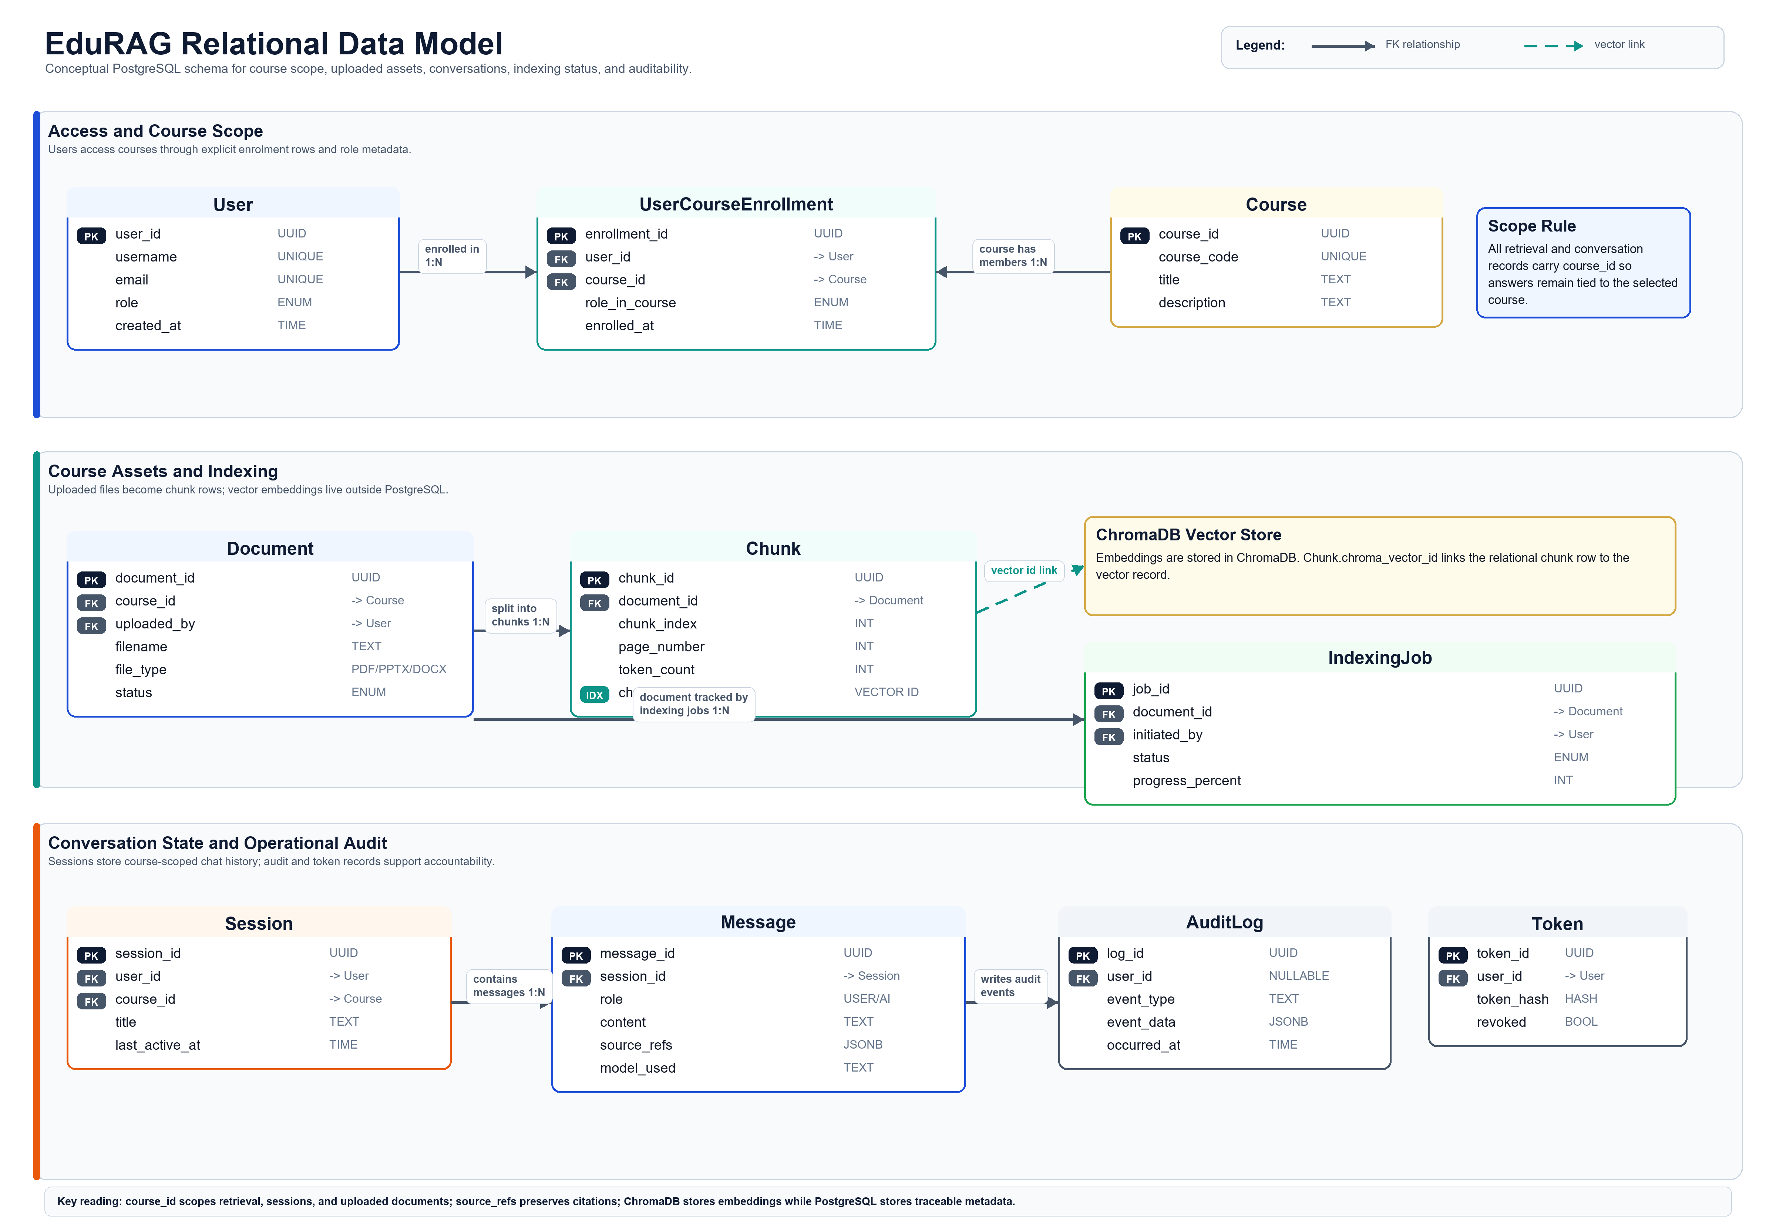
Figure 5. Conceptual data model for relational state, sessions, and course assets.
Appendix G contains the entity relationship diagram, DFD Level 1 internal process decomposition, and upload exception/recovery sequence diagram for the complete system. Appendix H adds the initial interface wireframes that show how the same requirements appear in Student, Lecturer, and Admin workflows.

Conclusion
The Sprint 2 design work, strengthened by Sprint 3 consultation and prototype evidence, establishes a coherent and implementable foundation for EduRAG. The system has a well-defined target context (course-specific student support), a clear architectural approach (RAG pipeline built on ChromaDB, SentenceTransformers, and a configurable LLM provider), and a requirements baseline that distinguishes what must be delivered from what is desirable and what is explicitly out of scope. Taken together, these artefacts give the implementation sprints a concrete starting point rather than an open-ended problem statement.
The requirements specification demonstrates that the project is appropriately difficult for a CSIT321 capstone. The must-have requirements alone span document ingestion, vector retrieval, grounded answer generation, role-based access control, and audit logging. Each of these involves genuine engineering decisions, particularly around chunking strategy, embedding model selection, similarity threshold tuning, and the integration of two LLM providers (Ollama for local development and PoC demonstration, with OpenAI retained only as an optional controlled-demo provider). The unsupported-answer handling mechanism adds an additional layer of epistemic honesty that distinguishes EduRAG from a generic chatbot wrapper.
The most important outcome of this Assessment 2 report is not simply that tools have been selected, but that those selections are now tied to a requirement-driven design. Every core technology in the stack is referenced in at least one functional or non-functional requirement, and the traceability matrix links each major user-facing requirement back to one or more user stories. This traceability is what makes the design reviewable and the implementation verifiable. The next practical step is further supervisor confirmation of the proposed scope, difficulty level, and Sprint 4 validation evidence, after which the team can move into implementation sprints with a shared understanding of what constitutes a complete and correct system.

References
Chroma (2026) Chroma documentation. Available at: https://docs.trychroma.com/ (Accessed: 14 April 2026).
Docker Inc. (2026) Docker Compose documentation. Available at: https://docs.docker.com/compose/ (Accessed: 14 April 2026).
LangChain (2026) LangChain documentation. Available at: https://python.langchain.com/docs/introduction/ (Accessed: 14 April 2026).
LlamaIndex (2026) LlamaIndex documentation. Available at: https://docs.llamaindex.ai/ (Accessed: 14 April 2026).
Ollama (2026) Ollama documentation. Available at: https://docs.ollama.com/ (Accessed: 14 April 2026).
OpenAI (2026) OpenAI API documentation. Available at: https://platform.openai.com/docs/introduction (Accessed: 14 April 2026).
PostgreSQL Global Development Group (2026) PostgreSQL documentation. Available at: https://www.postgresql.org/docs/ (Accessed: 14 April 2026).
Sentence Transformers (2026) Sentence Transformers documentation. Available at: https://sbert.net/ (Accessed: 14 April 2026).
Streamlit (2026) Streamlit documentation. Available at: https://docs.streamlit.io/ (Accessed: 14 April 2026).
Flask (2026) Flask documentation. Available at: https://flask.palletsprojects.com/ (Accessed: 14 April 2026).
Jones, M., Bradley, J. and Sakimura, N. (2015) RFC 7519: JSON Web Token (JWT). Internet Engineering Task Force (IETF). Available at: https://datatracker.ietf.org/doc/html/rfc7519 (Accessed: 14 April 2026).
Lewis, P., Perez, E., Piktus, A., Petroni, F., Karpukhin, V., Goyal, N., Küttler, H., Lewis, M., Yih, W., Rocktäschel, T., Riedel, S. and Kiela, D. (2020) 'Retrieval-Augmented Generation for Knowledge-Intensive NLP Tasks', Advances in Neural Information Processing Systems, 33, pp. 9459–9474. Available at: https://arxiv.org/abs/2005.11401 (Accessed: 14 April 2026).
Reimers, N. and Gurevych, I. (2019) 'Sentence-BERT: Sentence Embeddings using Siamese BERT-Networks', Proceedings of the 2019 Conference on Empirical Methods in Natural Language Processing (EMNLP), pp. 3982–3992. Available at: https://arxiv.org/abs/1908.10084 (Accessed: 14 April 2026).
Schwaber, K. and Sutherland, J. (2020) The Scrum Guide: The Definitive Guide to Scrum: The Rules of the Game. Scrum.org. Available at: https://scrumguides.org/scrum-guide.html (Accessed: 14 April 2026).
Siriwardhana, S., Weerasekera, R., Wen, E., Kaluarachchi, T., Rana, R. and Nanayakkara, S. (2023) 'Improving the Domain Adaptation of Retrieval Augmented Generation (RAG) Models for Open Domain Question Answering', Transactions of the Association for Computational Linguistics, 11, pp. 1–17. Available at: https://arxiv.org/abs/2210.02627 (Accessed: 14 April 2026).
Thakur, N., Reimers, N., Rueckle, A., Srivastava, A. and Gurevych, I. (2021) 'BEIR: A Heterogenous Benchmark for Zero-shot Evaluation of Information Retrieval Models'. Available at: https://arxiv.org/abs/2104.08663 (Accessed: 20 April 2026).
Es, S., James, J., Espinosa-Anke, L. and Schockaert, S. (2023) 'Ragas: Automated Evaluation of Retrieval Augmented Generation'. Available at: https://arxiv.org/abs/2309.15217 (Accessed: 20 April 2026).
OWASP Foundation (2025) 'LLM01:2025 Prompt Injection'. Available at: https://genai.owasp.org/llmrisk/llm01-prompt-injection/ (Accessed: 20 April 2026).
Australian Government Department of Education (2026) Key findings from the 2024 Higher Education Student Statistics. Available at: https://www.education.gov.au/higher-education-statistics/student-data/selected-higher-education-statistics-2024-student-data/key-findings-2024-higher-education-student-statistics (Accessed: 1 May 2026).
Chegg (2025) Chegg Global Student Survey 2025: 80% of undergraduates worldwide have used GenAI to support their studies - but accuracy a top concern. Available at: https://www.chegg.com/about/newsroom/press-release/chegg-global-student-survey-2025-80-of-undergraduates-worldwide-have-used-genai-to-support-their-studies-but-accuracy-a-top-concern (Accessed: 1 May 2026).
EDUCAUSE (2024) 2024 EDUCAUSE Action Plan: AI Policies and Guidelines. Available at: https://library.educause.edu/resources/2024/5/2024-educause-action-plan-ai-policies-and-guidelines (Accessed: 1 May 2026).
Freeman, J. (2025) Student Generative AI Survey 2025. HEPI Policy Note 61. Higher Education Policy Institute. Available at: https://www.hepi.ac.uk/reports/student-generative-ai-survey-2025/ (Accessed: 1 May 2026).
Grand View Research (2024) AI in Education Market Size to Reach $32.27 Billion by 2030. Available at: https://www.grandviewresearch.com/press-release/global-artificial-intelligence-ai-education-market (Accessed: 1 May 2026).
UNESCO (2023) Guidance for Generative AI in Education and Research. Available at: https://www.unesco.org/en/articles/guidance-generative-ai-education-and-research (Accessed: 1 May 2026).
University of Nebraska-Lincoln Center for Transformative Teaching (n.d.) Organize Content Well. Available at: https://teaching.unl.edu/resources/large-enrollment/organize-content-well/ (Accessed: 1 May 2026).
University of Wollongong (2025) Annual Report 2024. Available at: https://documents.uow.edu.au/content/groups/public/@web/@pmcd/@smc/documents/doc/uow279096.pdf (Accessed: 1 May 2026).
University of Wollongong (2026) New UOW Liverpool Campus expands university access in South Western Sydney. Available at: https://www.uow.edu.au/media/2026/new-uow-liverpool-campus-expands-university-access-in-south-western-sydney.php (Accessed: 1 May 2026).

Glossary
Term | Meaning in this project
RAG | Retrieval-Augmented Generation, where retrieved source content is provided to the language model before answer generation.
Embedding | A numeric vector representation of text used for similarity search.
Vector database | A storage system for embeddings that supports similarity-based retrieval.
ChromaDB | The selected vector store for course-scoped embedding persistence and retrieval.
JWT | JSON Web Token used for stateless authentication.
RBAC | Role-Based Access Control; used to separate Student, Lecturer, and Admin permissions.
MoSCoW | Prioritisation model dividing requirements into Must, Should, Could, and Won't have.
MVP | Minimum Viable Product; the smallest usable version of EduRAG that demonstrates core value.
Modular monolith | A single deployable application with explicitly separated internal modules.

Appendix A. Technology Decision Matrix
Component | Decision | Primary Rationale
Core web/API layer | Current Sprint 4 direction: Flask-based WebApplication module with documented REST-style endpoints for authentication, query, upload, documents, sessions, indexing status, and admin monitoring. | Keeps the MVP in one Python stack while still exposing clear module boundaries; Sprint 3 evidence validates the Python app-service direction, while Sprint 4 tasking names Flask as the API implementation path.
Frontend (MVP) | Streamlit prototype with role-based views for Student, Lecturer, and Admin. | Fastest path to a demonstrable interface; confirmed as appropriate for the PoC and Assessment 2 design stage.
Frontend (stretch) | React frontend after the core Streamlit prototype is stable. | Provides a production-grade migration path without risking the MVP schedule.
LLM provider | Ollama for local development and PoC demonstration; OpenAI API as an optional controlled-demo provider if required. | Aligns with supervisor-validated local inference while retaining a configurable hosted-model fallback for demonstration quality or availability.
Vector database | ChromaDB with course_id metadata filtering and persistence. | Supports scoped retrieval, citation traceability, and simple local deployment.
Embedding model | SentenceTransformers all-MiniLM-L6-v2, 384-dimensional embeddings. | Lightweight, fast, well-supported, and suitable for prototype-scale semantic retrieval.
Relational database | PostgreSQL for users, roles, courses, documents, sessions, messages, indexing jobs, and audit events. | Provides reliable persistence, relational integrity, JSONB flexibility, and RBAC-friendly data modelling.
Authentication | JWT-based authentication with role-based access control for Student, Lecturer, and Admin roles. | Separates user capabilities and protects administrative/course-management functions.
Deployment | Docker Compose with app, PostgreSQL, ChromaDB, and optional LLM service containers. | Improves portability across team machines and provides a clear demo/development environment.
Architecture | Modular monolith with DocumentProcessor, VectorRetriever, LLMResponseGeneration, and WebApplication modules. | Keeps integration simple while preserving clear technical ownership and module contracts.
Inter-module communication | Direct Python calls between internal modules, surfaced externally through WebApplication endpoints. | Reduces microservice overhead while still allowing API-driven UI integration.
File storage | Local Docker volume for uploaded prototype documents. | Sufficient for assessment-stage evidence without introducing cloud storage complexity.
Caching | Lightweight in-memory caching for repeated configuration/model lookups where appropriate. | Improves responsiveness without adding another infrastructure dependency.
Indexing jobs | Asynchronous upload/indexing status model with pending, processing, indexed, and failed states. | Prevents large documents from blocking the user interface and supports clear error recovery.
Logging and audit | Structured logs plus admin-facing audit/metrics views where implemented. | Supports debugging, accountability, and responsible educational-AI monitoring.
Error handling | Graceful user-facing errors with fail-fast internal validation for unsafe states. | Protects user trust while exposing developer-visible failures early.
Testing | Unit tests, integration checks, and RAG benchmark/evaluation corpus. | Matches the project risk profile: parsing, retrieval, citation, fallback, latency, and course isolation all need evidence.
Document formats | PDF, PPTX, and DOCX ingestion target. | Covers the most common course-material formats used by students and lecturers.
Course scoping | course_id filtering across retrieval, documents, sessions, and access control. | Prevents cross-course leakage and supports the supervisor-identified differentiation of course-level isolation.

Appendix B. Module Interface Specifications

Module 1 - DocumentProcessor
Interface Name | DocumentProcessor
Input | file_path (str): absolute path to the uploaded document (PDF, PPTX, or DOCX) file_type (str): MIME type, e.g. 'application/pdf' course_id (str): identifier of the course the document belongs to
Output | chunks (List[DocumentChunk]): list of text chunks, each containing: • chunk_id (str) • text (str) • source_file (str) • page_number (int) • course_id (str)
Methods | load_document(file_path, file_type) -> RawDocument extract_text(doc: RawDocument) -> str chunk_text(text: str, chunk_size=1024, overlap=0) -> List[str] process(file_path, file_type, course_id) -> List[DocumentChunk]
Dependencies | PyMuPDF (fitz) or pdfplumber for PDF extraction python-pptx for PPTX extraction python-docx for DOCX extraction LangChain RecursiveCharacterTextSplitter for chunking
Error Handling | Raises FileNotFoundError if file path is invalid Raises UnsupportedFileTypeError if file type is not PDF, PPTX, or DOCX Returns empty list and logs a warning if no extractable text is found
Called By | Module 4 (WebApplication) upon document upload event; triggers Module 2 downstream

Module 2 - VectorRetriever
Interface Name | VectorRetriever
Input (Indexing) | chunks (List[DocumentChunk]): output from Module 1 course_id (str): scope the embeddings to the relevant course knowledge base
Input (Retrieval) | query (str): the student's natural-language question course_id (str): scope the search to a specific course top_k (int, default=5): number of most relevant chunks to return
Output (Indexing) | IndexResult: object containing chunk_count (int), success (bool), errors (List[str])
Output (Retrieval) | retrieved_chunks (List[RetrievedChunk]): each chunk includes: • text (str) • source_file (str) • page_number (int) • similarity_score (float)
Methods | generate_embeddings(chunks: List[DocumentChunk]) -> List[EmbeddingVector] add_to_index(embeddings, chunks, course_id) -> IndexResult search(query: str, course_id: str, top_k: int) -> List[RetrievedChunk] delete_from_index(course_id: str, source_file: str) -> bool
Dependencies | SentenceTransformers (all-MiniLM-L6-v2) for embedding generation ChromaDB for vector storage and similarity search NumPy for vector operations
Error Handling | Raises IndexNotFoundError if course_id has no existing index and retrieval is attempted Returns empty list with warning log if no chunks exceed similarity threshold Raises EmbeddingGenerationError if the embedding model fails to produce vectors
Called By | Module 3 (LLM Response Generation) for retrieval Module 1 output triggers indexing after document upload

Module 3 - LLMResponseGeneration
Interface Name | LLMResponseGeneration
Input | query (str): the original student question retrieved_chunks (List[RetrievedChunk]): context from Module 2 conversation_history (List[Message], optional): prior turns for multi-turn support config (LLMConfig): model name, temperature, max_tokens
Output | response (GeneratedResponse): contains: • answer (str) • source_references (List[SourceRef]) • model_used (str) • token_count (int)
Methods | build_prompt(query, chunks, history) -> str generate(query, chunks, config, history) -> GeneratedResponse format_sources(chunks: List[RetrievedChunk]) -> List[SourceRef]
Dependencies | LangChain for prompt management and chain execution. Ollama or OpenAI API as configurable LLM providers. python-dotenv for secure API key management.
Error Handling | Raises APIConnectionError if the LLM provider is unreachable. Raises TokenLimitExceededError if prompt exceeds the model context window and truncates oldest history first. Returns a clear unsupported-answer message if no relevant chunks are retrieved; no fabricated citations are attached.
Called By | Module 4 (WebApplication) on each student query submission

Module 4 - WebApplication
Interface Name | WebApplication
Current interaction handlers / future API endpoints | POST /api/query — accepts { query, course_id }; returns GeneratedResponse POST /api/upload — accepts multipart file + course_id; triggers Module 1 DELETE /api/document/{doc_id} — removes document and its embeddings GET /api/metrics — returns system usage statistics (Admin only) GET /api/logs — returns audit log entries (Admin only) POST /api/auth/login — issues JWT on valid credentials
Input (Query Flow) | HTTP POST request body: { query: str, course_id: str, session_id: str (optional) }
Output (Query Flow) | HTTP 200 JSON response: { answer: str, sources: List[SourceRef], session_id: str }
Authentication | JWT-based authentication with Role-Based Access Control Roles: Student, Lecturer, Admin Tokens expire after 8 hours; refresh tokens stored in PostgreSQL for revocation support
Dependencies | Flask for the current application service layer, with Streamlit as the MVP UI client. Module 1, Module 2, and Module 3 via direct Python imports. PostgreSQL for session management, user data, and audit logging.
Error Handling | Returns HTTP 400 for malformed requests. Returns HTTP 401 for unauthenticated requests. Returns HTTP 403 for authenticated requests lacking the required role. Returns HTTP 429 when rate limits are exceeded. Returns HTTP 500 with a safe error message for internal pipeline failures.
Calls | Module 1 on document upload Module 2 for retrieval Module 3 for response generation

Inter-module communication summary
From Module | To Module | Trigger | Data Passed
Module 4 WebApplication | Module 1 DocumentProcessor | User uploads a document | file_path, file_type, course_id
Module 1 DocumentProcessor | Module 2 VectorRetriever | Document processing complete | List[DocumentChunk], course_id
Module 4 WebApplication | Module 2 VectorRetriever | Student submits a query | query, course_id, top_k
Module 2 VectorRetriever | Module 3 LLM Generation | Retrieval complete | List[RetrievedChunk], query
Module 3 LLM Generation | Module 4 WebApplication | Response generated | GeneratedResponse (answer + sources)

Appendix C. Full Functional Requirements
ID | Name | Description | Priority | Module | Acceptance Criterion
FR-001 | User Authentication | The system shall authenticate users via username and password, issuing a JWT upon successful login. | Must | M4 | Valid credentials receive a signed JWT; invalid credentials receive HTTP 401.
FR-002 | Role-Based Access Control | The system shall enforce three distinct roles (Student, Lecturer, Admin) with different permissions per endpoint. | Must | M4 | Role enforcement verified by unit tests on all protected endpoints.
FR-003 | Document Upload (PDF) | Lecturers shall be able to upload PDF course materials through the web interface. | Must | M1, M4 | A valid PDF of up to 100 MB uploads successfully and returns a job ID.
FR-004 | Text Extraction | The system shall extract text content from uploaded PDF documents. | Must | M1 | Extracted text is non-empty for a non-scanned PDF; warnings logged for scanned PDFs.
FR-005 | Document Chunking | The system shall split extracted text using the current RAG baseline of chunk_size=1024 and chunk_overlap=0. | Must | M1 | Default processing uses chunk_size=1024 and chunk_overlap=0, with chunk metadata retained for source citation and retrieval.
FR-006 | Embedding Generation | The system shall generate 384-dimensional vector embeddings for each chunk using all-MiniLM-L6-v2. | Must | M2 | Every chunk has a non-null embedding vector of length 384.
FR-007 | Vector Indexing | The system shall store embeddings in ChromaDB indexed by course_id metadata. | Must | M2 | Stored chunks retrievable by course_id filter; count matches chunks generated.
FR-008 | Semantic Search | The system shall retrieve the top-K most similar chunks for a given query, scoped to a specific course. | Must | M2 | search() returns a list of length top_k with non-decreasing similarity scores.
FR-009 | Natural Language Query | Students shall be able to submit natural language questions through the web interface. | Must | M4 | Query input accepts strings up to 1000 characters and returns HTTP 200 on valid input.
FR-010 | LLM-Grounded Answers | The system shall generate answers using an LLM, conditioned on the retrieved chunks. | Must | M3 | Answers contain information present in retrieved chunks on the curated test set.
FR-011 | Source Citation Display | Every generated answer shall include references to the source document(s) and page number(s). | Must | M3, M4 | ≥ 95% of answers include at least one valid source reference.
FR-012 | Async Indexing with Status | Document indexing shall run asynchronously; clients shall poll a status endpoint for progress. | Must | M1, M4 | Upload returns HTTP 202 with job_id; status endpoint reflects progress and final state.
FR-013 | Multi-Course Support | The system shall maintain separate, isolated knowledge bases per course_id. | Must | M2 | A query against course A does not return chunks from course B.
FR-014 | Single-Turn Q&A | The system shall answer individual questions without requiring prior context. | Must | M3, M4 | Standalone queries return sensible answers without conversation history.
FR-015 | Structured Logging | All significant events (login, upload, query, error) shall be logged in structured JSON format. | Must | M4 | Log entries parseable as JSON; include timestamp, level, event type, user_id.
FR-016 | Graceful Fallback — No Course Material Found | When no chunks exceed the similarity threshold, the system shall avoid presenting an unsupported course-grounded answer and return a clear message that the answer cannot be verified from the available course materials. | Must | M2, M3 | Queries with no relevant course content return an unsupported-answer message; no fabricated citations or raw error is exposed to the user.
FR-017 | Secrets Management | API keys and secrets shall be loaded from environment variables, never hardcoded or committed to git. | Must | All | Static analysis confirms no hardcoded secrets; .env file is in .gitignore.
FR-018 | Password Hashing | User passwords shall be hashed with bcrypt before storage in PostgreSQL. | Must | M4 | Database inspection shows no plaintext passwords; bcrypt cost factor ≥ 12.
FR-019 | Document Upload (PPTX) | The system shall also accept PPTX files as course material input. | Should | M1 | A valid PPTX of up to 100 MB uploads and indexes successfully.
FR-020 | Document Upload (DOCX) | The system shall also accept DOCX files as course material input. | Should | M1 | A valid DOCX of up to 100 MB uploads and indexes successfully.
FR-021 | Multi-Turn Conversations | The system shall support follow-up questions that reference prior turns in the same session. | Should | M3, M4 | Conversations with up to 5 prior turns produce contextually appropriate answers.
FR-022 | Saved Conversation Sessions | Users shall be able to save and revisit prior conversation sessions. | Should | M4 | Saved sessions persist across logins and display in chronological order.
FR-023 | Admin Usage Dashboard | Admins shall see a dashboard displaying total queries, average response time, and active users. | Should | M4 | Dashboard loads in under 3 seconds and displays metrics for the last 30 days.
FR-024 | Audit Log Review | Admins shall be able to view an append-only audit log of significant events. | Should | M4 | Audit log queryable by user, date range, and event type; log entries immutable.
FR-025 | Rate Limiting | The system shall limit the number of queries per user per minute to prevent abuse. | Should | M4 | Exceeding the limit returns HTTP 429; limit configurable per role.
FR-026 | Document Management | Lecturers shall be able to view, list, and delete their uploaded documents. | Should | M4 | Delete operation removes the document file, chunks, and embeddings atomically.
FR-027 | Confidence Scoring | The system shall display a confidence indicator with each answer based on similarity scores. | Should | M2, M3, M4 | Confidence shown as Low / Medium / High derived from mean top-K similarity.
FR-028 | Retrieval Accuracy Benchmarks | The system shall include an automated test suite measuring Precision@5 and Recall@10. | Should | M2 | Benchmark script runs in CI against a curated labelled query set; results archived per build.
FR-029 | Export Conversation to PDF | Users shall be able to export a conversation session as a PDF document. | Could | M4 | Exported PDF contains all Q&A pairs with source citations preserved.
FR-030 | Topic Summarisation | Users shall be able to request a topic summary by specifying a document or chapter. | Could | M3 | Summaries are under 500 words and reference the source material accurately.
FR-031 | Query Suggestions | The system shall suggest follow-up questions after each answer. | Could | M3, M4 | At least 3 relevant suggestions shown with each response.
FR-032 | Dark Mode | The web interface shall support a user-selectable dark theme. | Could | M4 | Toggle switches all UI elements to a dark color scheme; preference persisted.
FR-033 | Usage Analytics Export | Admins shall be able to export usage metrics as CSV. | Could | M4 | Export produces a valid CSV file with all visible dashboard metrics.
FR-034 | Real-Time Lecture Transcription | The system will not transcribe live lecture audio into course materials. | Won't | — | Out of scope; may be considered in a future iteration.
FR-035 | Multi-Language UI | The system will not offer a multi-language user interface for the MVP. | Won't | — | English-only UI; multilingual support documented as future work.
FR-036 | LMS Integration | The system will not integrate with Moodle or other Learning Management Systems. | Won't | — | Out of scope for the prototype.
FR-037 | Mobile Native App | The system will not be distributed as a native iOS or Android application. | Won't | — | Web interface only; mobile access via responsive web design only.
FR-038 | Automated Grading | The system will not grade student assignments or assessments. | Won't | — | Educational tool only; grading is explicitly excluded.

Priority | Count | Targeted Delivery
Must | 18 | Sprints 5 — 8 (core MVP development)
Should | 10 | Sprints 8 — 10 (feature enrichment)
Could | 5 | Sprints 10 — 12 (stretch, if capacity permits)
Won't | 5 | Out of scope — not planned for this project

Appendix D. Full Non-Functional Requirements
ID | Category | Name | Target | Priority | Verification
NFR-001 | Performance | Query Response Time | Under 5 seconds for the 95th percentile of queries against a corpus of typical size. | Must | Load test with 100 sample queries; measure p95 latency.
NFR-002 | Performance | Document Upload Limit | Support upload and indexing of documents up to 100 MB or 500 pages. | Must | Upload a 100 MB / 500-page test PDF; confirm successful indexing.
NFR-003 | Performance | Concurrent Users | Support 10 to 20 simultaneous users without significant degradation. | Should | Load test with 20 concurrent virtual users for 5 minutes.
NFR-004 | Performance | Indexing Throughput | Process at least 50 pages per minute during background indexing. | Should | Benchmark indexing on a 100-page document; compute pages/min.
NFR-005 | Quality | Retrieval Precision | Precision@5 >= 0.7 on the curated course-specific pilot query set. | Must | Run retrieval benchmark on a labelled pilot set; compute precision over top-5 results.
NFR-006 | Quality | Retrieval Recall | Recall@10 >= 0.8 on the curated course-specific pilot query set. | Must | Run retrieval benchmark on a labelled pilot set; compute recall over top-10 results.
NFR-007 | Quality | Citation Rate | At least 95% of generated answers shall include at least one source citation. | Must | Sample 100 answers; compute percentage with citations.
NFR-008 | Quality | Hallucination Rate | Less than 5% of answers shall contain information not present in retrieved chunks. | Must | Manual review of 100 sampled answers against retrieved chunks.
NFR-009 | Quality | User Satisfaction | Average user satisfaction score ≥ 4 out of 5 in User Acceptance Testing. | Should | UAT session with at least 10 participants; post-session survey.
NFR-010 | Security | Authentication | All API endpoints except /api/auth/login shall require a valid JWT. | Must | Automated security scan; attempt unauthorized access to each endpoint.
NFR-011 | Security | Password Storage | Passwords shall be hashed with bcrypt (cost factor ≥ 12) before storage. | Must | Code review; database inspection confirms no plaintext passwords.
NFR-012 | Security | Transport Security | All client-server communication shall use HTTPS in production. | Must | Deployment configuration mandates TLS certificates.
NFR-013 | Security | Input Validation | All user input shall be validated for type, length, and format before processing. | Must | Unit tests cover invalid input cases for all endpoints.
NFR-014 | Security | SQL Injection Prevention | All database queries shall use parameterised statements. | Must | Code review; static analysis with bandit or similar tool.
NFR-015 | Security | Rate Limiting | API endpoints shall enforce per-user rate limits to prevent abuse. | Must | Load test exceeds limit; confirms HTTP 429 response.
NFR-016 | Security | Audit Logging | All authentication events and data modifications shall be logged to an append-only audit log. | Must | Inspect audit log after performing test operations.
NFR-017 | Security | Secrets Management | Secrets shall be loaded from environment variables; .env files shall be excluded from version control. | Must | Static scan confirms no hardcoded secrets; .gitignore verified.
NFR-018 | Privacy | Minimal Data Collection | The system shall collect only username, email, role, hashed password, last login, and conversation history. | Must | Database schema review; confirm no extraneous columns.
NFR-019 | Privacy | Access Control by Role | Users shall only be able to access their own conversation history. | Must | Unit tests verify user A cannot access user B's sessions.
NFR-020 | Usability | Browser Support | The web interface shall function correctly on the latest versions of Chrome, Firefox, and Safari. | Should | Manual cross-browser test on all three browsers.
NFR-021 | Usability | Basic Accessibility (MVP) | The MVP shall support keyboard navigation, sufficient colour contrast, and alt text on all images. | Must | Manual accessibility audit against a basic checklist.
NFR-022 | Usability | Full Accessibility (Stretch) | The stretch React version shall comply with WCAG 2.1 AA. | Could | Automated WCAG scan with axe-core or similar tool.
NFR-023 | Usability | Response Feedback | The UI shall display loading indicators during any operation taking longer than 1 second. | Should | Manual UI review; confirm loading states on all long operations.
NFR-024 | Reliability | Graceful LLM Failure | If the LLM provider is unreachable, the system shall return retrieved chunks with an explanatory notice. | Must | Simulate LLM outage; confirm fallback response is returned.
NFR-025 | Reliability | System Availability | The system shall make a best effort to be available during scheduled demo periods. | Should | Manual verification; no formal uptime SLA.
NFR-026 | Reliability | Graceful Restart | A container restart shall not lose user session data or uploaded documents. | Must | Restart test with active sessions; confirm data persistence.
NFR-027 | Maintainability | Module Boundaries | Each of the four modules shall be a self-contained Python package with a documented public interface. | Must | Code review; confirm __init__.py exports only the documented interface.
NFR-028 | Maintainability | Test Coverage | Unit test coverage shall be at least 70% for core business logic modules. | Should | Run coverage.py; generate report.
NFR-029 | Maintainability | Configuration Externalisation | All environment-specific configuration shall be externalised to environment variables or config files. | Must | Code review; no hardcoded URLs, paths, or credentials.
NFR-030 | Portability | Dockerised Deployment | The entire system shall deploy via a single docker-compose up command on any Docker-capable host. | Must | Fresh install test on at least two different machines.

Appendix E. User Stories and Use Case Descriptions/Diagram
Role | ID | User story
Student | US-S1 | As a Student, I want to ask natural language questions about my course materials so that I can find answers without remembering exact keywords.
Student | US-S2 | As a Student, I want to see source citations with each answer so that I can verify where the information came from.
Student | US-S3 | As a Student, I want to ask follow-up questions in the same conversation so that I can explore a topic in more depth without repeating context.
Student | US-S4 | As a Student, I want to save and revisit previous conversations so that I can continue studying from where I left off.
Student | US-S5 | As a Student, I want to select the relevant course before asking a question so that the system searches the correct knowledge base.
Student | US-S6 | As a Student, I want to see a confidence indicator with each answer so that I know when I should double-check the response more carefully.
Student | US-S7 | As a Student, I want the system to tell me clearly when no relevant material is found so that I do not rely on a made-up answer.
Student | US-S8 | As a Student, I want to review my past questions and answers so that I can use the assistant as part of my revision process.
Lecturer | US-L1 | As a Lecturer, I want to upload course materials (PDFs, slides) so that students can query them through the assistant.
Lecturer | US-L2 | As a Lecturer, I want to organise uploaded materials by subject or topic so that the assistant retrieves contextually relevant content.
Lecturer | US-L3 | As a Lecturer, I want to delete outdated materials from the knowledge base so that the assistant does not produce answers based on stale content.
Lecturer | US-L4 | As a Lecturer, I want to preview how my documents are chunked and indexed so that I can verify the quality of text extraction.
Lecturer | US-L5 | As a Lecturer, I want to view usage analytics for my course materials so that I can see which documents students reference most and identify knowledge gaps.
Lecturer | US-L6 | As a Lecturer, I want to flag inaccurate responses generated by the assistant so that the development team can investigate and improve retrieval.
Admin | US-A1 | As an Admin, I want to create and manage user accounts so that only authorised users can access the system.
Admin | US-A2 | As an Admin, I want to assign Lecturers to courses so that uploaded materials remain scoped correctly.
Admin | US-A3 | As an Admin, I want to reset passwords so that I can help locked-out users regain access.
Admin | US-A4 | As an Admin, I want to configure LLM settings so that the system can use the selected response provider.
Admin | US-A5 | As an Admin, I want to monitor usage metrics so that I can detect performance issues early.
Admin | US-A6 | As an Admin, I want to review and export audit logs so that system changes remain traceable.
Admin | US-A7 | As an Admin, I want to trigger re-indexing after bulk content changes so that embeddings stay current.

Student Use Cases
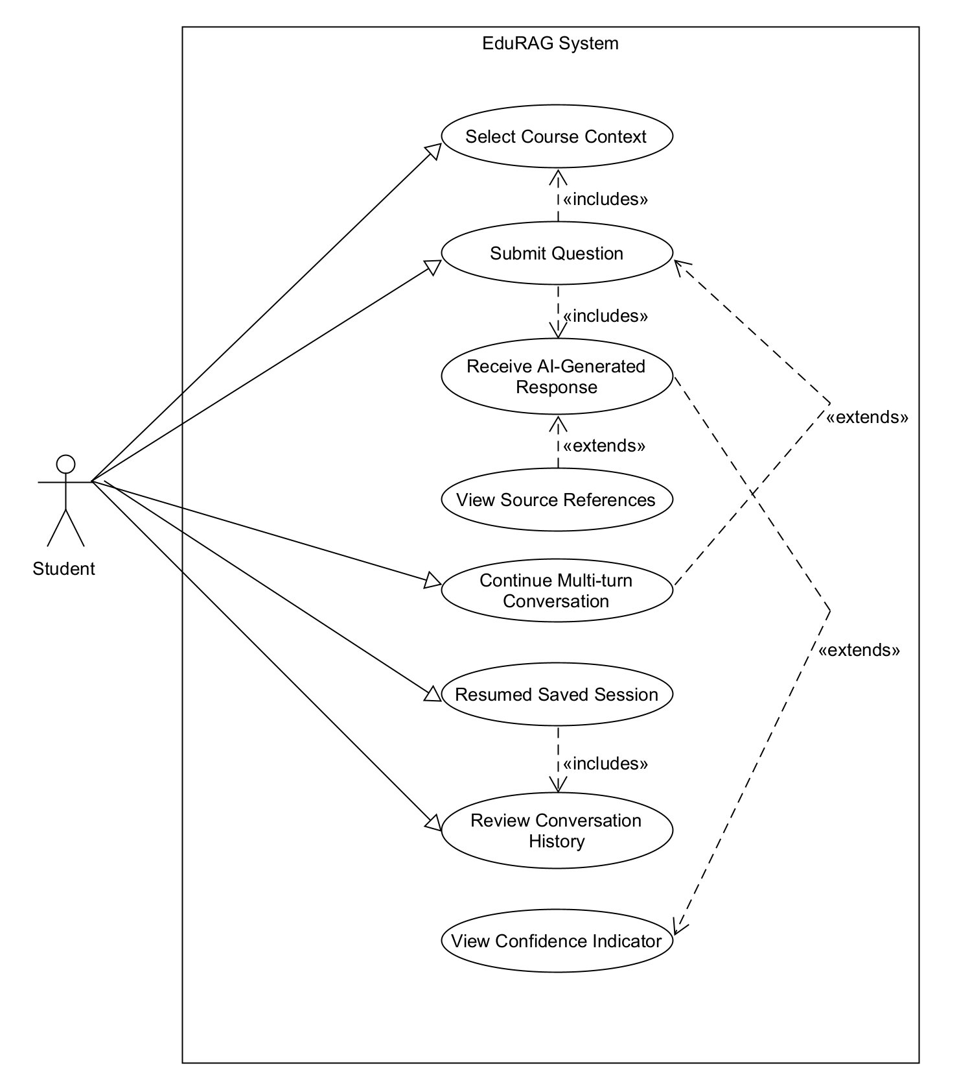

UC-01 Select Course Context
Description
A Student selects the course that their question belongs to so that the system searches the correct course knowledge base.
Actor
Student (Primary)
Trigger
Student opens the Q&A interface and chooses a course before asking a question.
Preconditions
Student is authenticated. Student has access to one or more courses.
Postconditions
The selected course becomes the active query context for the Student's current interaction.
Normal Flow
1. Student navigates to the Q&A interface.
2. System displays the list of available courses.
3. Student selects a course from the list.
4. System sets the selected course as the active context.
5. Student proceeds to ask a question within that course scope.
Alternative Flows
1a. If the Student does not select a course, system prompts the Student to choose one before submitting a question.
2a. If no courses are available, system displays a message that no accessible course context exists.

UC-02 Submit Question
Description
A Student submits a natural language question about the selected course and requests an answer from the system.
Actor
Student (Primary)
Trigger
Student enters a question in the Q&A interface and clicks Submit.
Preconditions
Student is authenticated. A course context has already been selected.
Postconditions
The question is accepted by the system and passed into the response-generation process.
Normal Flow
1. Student opens the Q&A interface.
2. Student types a natural language question.
3. Student submits the question.
4. System validates the Student session and request.
5. System processes the question within the selected course context.
6. System forwards the request for retrieval and answer generation.
Alternative Flows
1a. If the Student submits an empty question, system prompts the Student to enter valid text.
2a. If the question exceeds the allowed input length, system displays a validation error and prevents submission.

UC-03 Receive AI-Generated Response
Description
A Student receives an AI-generated answer based on relevant course materials retrieved by the system.
Actor
Student (Primary)
Trigger
System finishes processing the Student's submitted question.
Preconditions
Student has submitted a valid question. Relevant course materials are indexed in the selected course knowledge base.
Postconditions
A grounded answer is displayed to the Student and stored in the current conversation session.
Normal Flow
1. System retrieves relevant material from the selected course knowledge base.
2. System generates an answer using the retrieved material.
3. System displays the answer to the Student.
4. System attaches source citations to the answer.
5. System stores the interaction in the conversation history.
Alternative Flows
1a. If no relevant material is found, system displays a fallback message explaining that no grounded answer could be generated.
2a. If answer generation fails, system displays an error notice and asks the Student to try again later.

UC-04 View Source References
Description
A Student opens a citation attached to an answer to inspect the original supporting material.
Actor
Student (Primary)
Trigger
Student clicks a source citation shown with an answer.
Preconditions
Student has received an answer containing at least one citation.
Postconditions
Student can inspect the cited source material used to support the answer.
Normal Flow
1. Student reads the answer displayed by the system.
2. Student clicks a source citation.
3. System retrieves the referenced source information.
4. System displays the document name, page number, and relevant excerpt.
5. Student reviews the source to verify the answer.
Alternative Flows
1a. If the source content is unavailable, system displays a message that the reference cannot be opened.
2a. If the citation metadata is incomplete, system displays the available source information only.

UC-05 Continue Multi-turn Conversation
Description
A Student asks follow-up questions within the same session so that the system can preserve short conversational context.
Actor
Student (Primary)
Trigger
Student enters a follow-up question in an existing conversation session.
Preconditions
Student is authenticated. An active conversation session exists.
Postconditions
The conversation continues in the same session and the new interaction is saved.
Normal Flow
1. Student opens an existing conversation or remains in the current session.
2. Student reviews the previous answer.
3. Student enters a follow-up question.
4. System loads the recent session history.
5. System uses the recent context together with the new question.
6. System generates and displays the next answer.
7. System stores the new interaction in the same conversation thread.
Alternative Flows
1a. If the session has expired, system prompts the Student to start a new session.
2a. If the previous conversation history cannot be loaded, system continues with the new question only and notifies the Student.

UC-06 Resume Saved Session
Description
A Student reopens a previously saved conversation so that they can continue studying from earlier work.
Actor
Student (Primary)
Trigger
Student selects a saved session from the session history panel.
Preconditions
Student is authenticated. At least one saved session exists.
Postconditions
The selected session is restored and available for continued interaction.
Normal Flow
1. Student opens the session history panel.
2. System displays previously saved sessions.
3. Student selects one saved session.
4. System loads the conversation history for that session.
5. Student reviews earlier questions and answers.
6. Student continues the session if needed.
Alternative Flows
1a. If no saved sessions exist, system displays an empty-state message and prompts the Student to start a new session.
2a. If the selected session cannot be loaded, system displays an error and returns the Student to the session list.

UC-07 Review Conversation History
Description
A Student reviews previous questions and answers from an active or saved conversation session for study and revision purposes.
Actor
Student (Primary)
Trigger
Student opens an active or saved conversation session.
Preconditions
Student is authenticated. A conversation session exists.
Postconditions
Student can review earlier questions, answers, and citations in the selected session.
Normal Flow
1. Student opens the current or saved conversation session.
2. System displays the sequence of previous questions and answers.
3. Student scrolls through the conversation history.
4. Student reviews earlier explanations and citations for revision.
Alternative Flows
1a. If the selected session contains no previous messages, system displays a message indicating that no conversation history is available.

UC-08 View Confidence Indicator
Description
A Student checks the confidence indicator attached to an answer to judge how reliable the response may be.
Actor
Student (Primary)
Trigger
System displays an answer with an associated confidence indicator.
Preconditions
Student has received an answer that includes a confidence indicator.
Postconditions
Student gains an additional signal to help judge whether the answer should be trusted or verified further.
Normal Flow
1. Student submits a question and receives an answer.
2. System displays a confidence indicator alongside the answer.
3. Student reviews the confidence level.
4. Student uses the confidence level to decide whether to trust the answer or inspect citations more carefully.
Alternative Flows
1a. If confidence scoring is unavailable, system displays a notice that confidence could not be calculated for the response.

Lecturer Use Cases
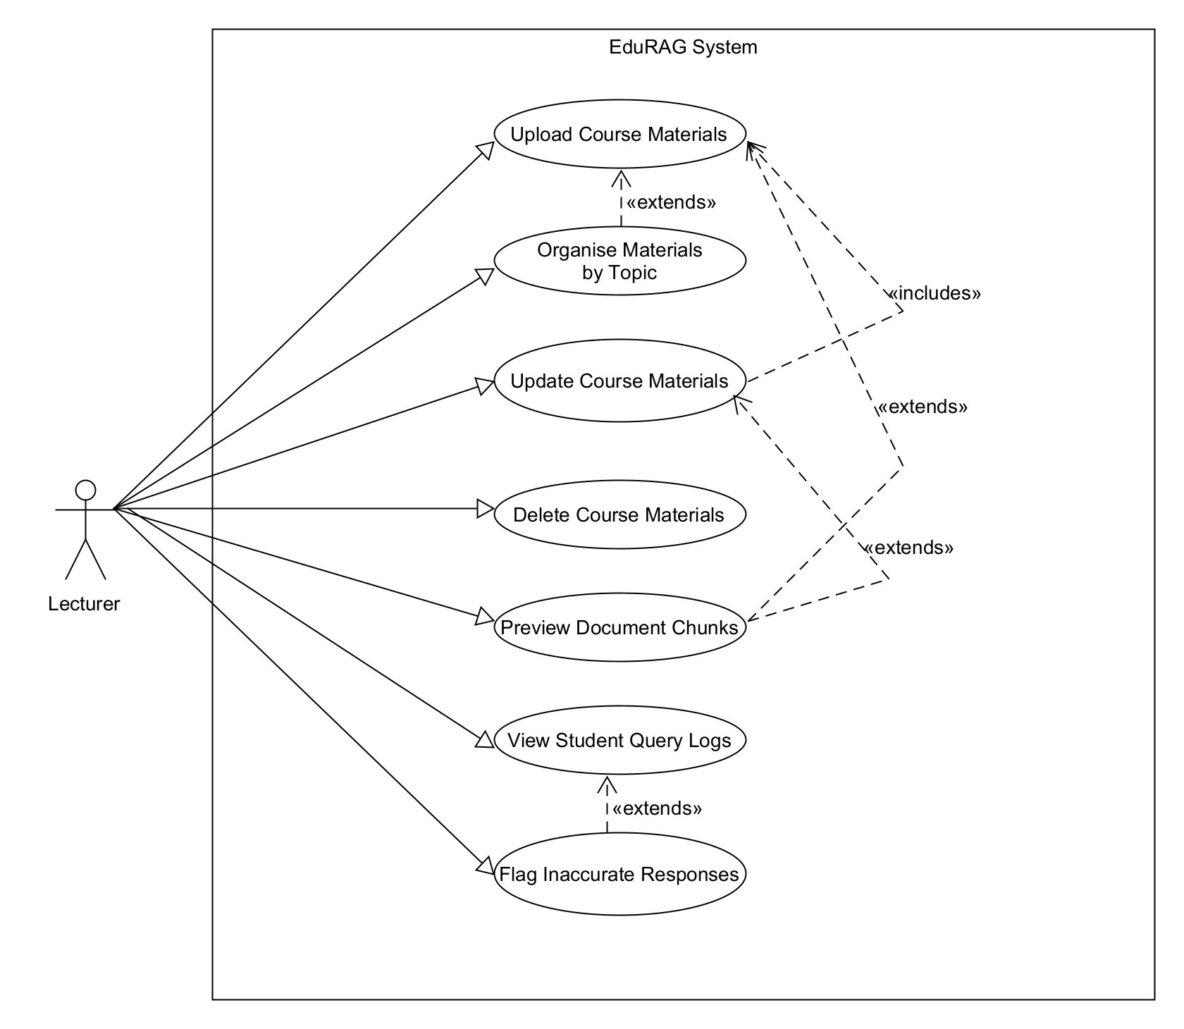
ID | Use case | Description
UC-09 | Upload course materials | Lecturer uploads new course files for ingestion into the knowledge base.
UC-10 | Organise materials by topic | Lecturer applies topic or week tags to improve content organisation.
UC-11 | Update course materials | Lecturer replaces an existing document with a newer version.
UC-12 | Delete course materials | Lecturer removes outdated or incorrect content and its related embeddings.
UC-13 | Preview document chunks | Lecturer checks chunking output to validate extraction quality.
UC-14 | View student query logs | Lecturer reviews query patterns to identify confusion points in course content.
UC-15 | Flag inaccurate responses | Lecturer reports suspicious answers for later review.

UC-09 Upload Course Materials
Description
A Lecturer uploads PDF, PPTX, or DOCX course materials to the EduRAG system so that students can query them through the course knowledge base.
Actor
Lecturer (Primary)
Trigger
Lecturer navigates to Content Management and selects Upload Material.
Preconditions
Lecturer is authenticated. Lecturer is assigned to the target course. File is in a supported format and within the allowed size limit.
Postconditions
The uploaded document is stored, queued for indexing, and becomes retrievable after successful processing.
Normal Flow
1. Lecturer navigates to the Content Management section.
2. Lecturer selects Upload Material and chooses a file.
3. System validates file type and size.
4. System stores the file and starts text extraction, chunking, and embedding generation.
5. System indexes the document data in ChromaDB using the correct course_id metadata.
6. System confirms that the upload has been accepted and shows indexing status information.
Alternative Flows
1a. If file type is unsupported, system displays an error and prompts the Lecturer to upload a valid file type.
2a. If the file exceeds the maximum size, system rejects the upload and displays the allowed size limit.
3a. If indexing fails after upload, system marks the document as failed and shows a retry option.

UC-10 Organise Materials by Topic
Description
A Lecturer assigns topic tags or categories to uploaded documents so that retrieval can be filtered more precisely for student questions.
Actor
Lecturer (Primary)
Trigger
Lecturer selects one or more uploaded documents and opens the topic-tagging controls.
Preconditions
Lecturer is authenticated. At least one document has already been uploaded for the course.
Postconditions
The selected documents are tagged and can be used in topic-aware retrieval workflows.
Normal Flow
1. Lecturer navigates to the Content Management section and views the uploaded documents list.
2. Lecturer selects one or more documents.
3. Lecturer assigns topic tags from an existing list or creates new tags.
4. System stores the tag associations in document metadata.
5. System confirms the tag update with a success notification.
6. Tagged documents become available for topic-scoped retrieval.
Alternative Flows
1a. If the Lecturer enters a duplicate tag name, system suggests using the existing tag.
2a. If the Lecturer exceeds the allowed number of tags per document, system displays the limit and prevents the excess tag from being saved.

UC-11 Update Course Materials
Description
A Lecturer replaces an existing document with a newer version so that the knowledge base stays aligned with the latest teaching material.
Actor
Lecturer (Primary)
Trigger
Lecturer selects Replace for an existing document in Content Management.
Preconditions
Lecturer is authenticated. The original document exists in the system and belongs to the Lecturer's assigned course.
Postconditions
The new document version becomes active and the old indexed content is removed or archived.
Normal Flow
1. Lecturer navigates to the Content Management section and locates the existing document.
2. Lecturer selects Replace and uploads the new version.
3. System validates the replacement file.
4. System extracts text, chunks the content, and generates updated embeddings.
5. System removes the old embeddings from ChromaDB for the replaced document.
6. System indexes the new content under the same document record.
7. System confirms that the replacement was completed successfully.
Alternative Flows
1a. If re-indexing fails, system notifies the Lecturer and retains the original version as the active document.
2a. If the replacement file is invalid, system rejects the update and keeps the existing version unchanged.

UC-12 Delete Course Materials
Description
A Lecturer permanently removes an outdated or incorrect document from the EduRAG knowledge base so that students no longer receive answers grounded in stale content.
Actor
Lecturer (Primary)
Trigger
Lecturer clicks Delete on a selected document in Content Management.
Preconditions
Lecturer is authenticated. The target document exists and belongs to the Lecturer's assigned course. No conflicting indexing job is running for the document.
Postconditions
The document and its associated embeddings are removed from the active knowledge base and the deletion is recorded in the audit log.
Normal Flow
1. Lecturer navigates to Content Management and locates the document to delete.
2. Lecturer clicks Delete on the selected document.
3. System displays a confirmation dialog explaining that the file and its indexed content will be removed.
4. Lecturer confirms the deletion.
5. System removes the document file, metadata, and associated embeddings from ChromaDB.
6. System logs the deletion event and displays a success confirmation message.
Alternative Flows
1a. If the Lecturer cancels the confirmation dialog, no changes are made.
2a. If the deletion fails because of a system error or active background job, system displays an error and retains the document intact.

UC-13 Preview Document Chunks
Description
A Lecturer reviews how a document has been split into chunks so that extraction and indexing quality can be checked before relying on retrieval output.
Actor
Lecturer (Primary)
Trigger
Lecturer selects Preview Chunks for an uploaded document.
Preconditions
Lecturer is authenticated. The selected document has been processed successfully.
Postconditions
Lecturer can inspect chunk boundaries and decide whether the document is suitable for retrieval as indexed.
Normal Flow
1. Lecturer opens the uploaded documents list.
2. Lecturer selects a processed document.
3. Lecturer clicks Preview Chunks.
4. System retrieves the stored chunks for the selected document.
5. System displays chunk text, chunk order, and basic metadata.
6. Lecturer reviews the chunking output for quality and completeness.
Alternative Flows
1a. If the document has not finished processing, system displays a message that chunk preview is not yet available.
2a. If no chunks were generated, system displays a processing warning and suggests re-uploading or replacing the document.

UC-14 View Student Query Logs
Description
A Lecturer reviews student query logs and usage patterns for their course so that common confusion points and knowledge gaps can be identified.
Actor
Lecturer (Primary)
Trigger
Lecturer opens the query log or analytics view for a course.
Preconditions
Lecturer is authenticated. Lecturer has access to the selected course. Query logging is enabled.
Postconditions
Lecturer has visibility into common question patterns and can use that information to refine teaching material or document coverage.
Normal Flow
1. Lecturer navigates to the course analytics or query log page.
2. System displays recent student queries and related usage metrics for that course.
3. Lecturer filters the logs by date range, topic, or document.
4. Lecturer reviews repeated questions and areas with frequent query activity.
5. System allows the Lecturer to inspect selected query records in more detail.
Alternative Flows
1a. If no logs exist for the selected period, system displays a No data available message.
2a. If the Lecturer attempts to access logs for an unassigned course, system denies access and shows an authorisation message.

UC-15 Flag Inaccurate Responses
Description
A Lecturer flags a response that appears inaccurate, misleading, or poorly grounded so that it can be reviewed by the team or administrators.
Actor
Lecturer (Primary)
Trigger
Lecturer selects a flag or report option on a questionable system response.
Preconditions
Lecturer is authenticated. A response record exists for the selected interaction.
Postconditions
The flagged response is recorded for follow-up review and linked to the relevant course and conversation context.
Normal Flow
1. Lecturer reviews a system response.
2. Lecturer selects the flag or report action.
3. System prompts the Lecturer to provide a reason or category for the issue.
4. Lecturer submits the report.
5. System records the flagged response, associated metadata, and Lecturer comments.
6. System confirms that the issue has been logged for review.
Alternative Flows
1a. If the Lecturer cancels the report before submission, system discards the draft and makes no change.
2a. If the response record cannot be found, system displays an error and prevents the flagging action.

Admin Use Cases
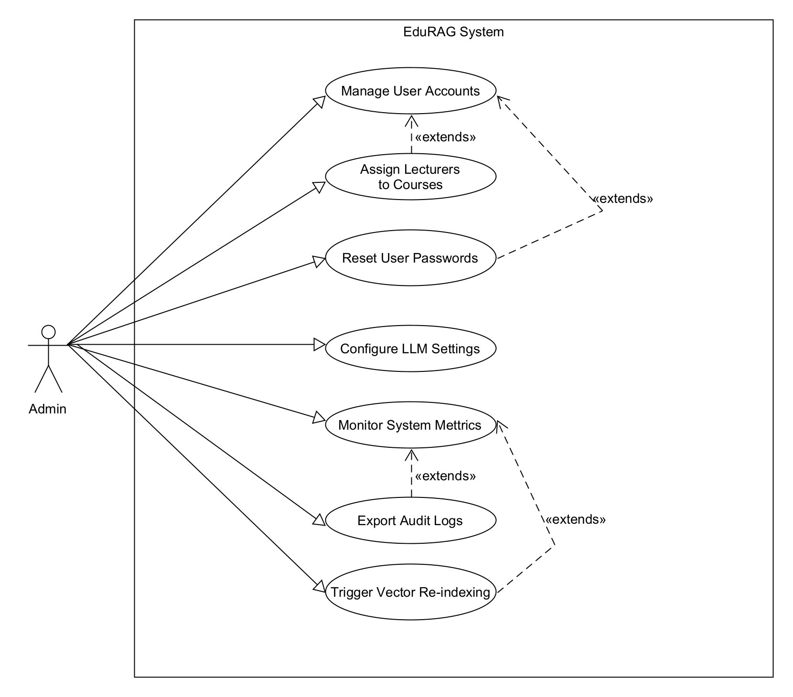
ID | Use case | Description
UC-16 | Manage user accounts | Admin creates, updates, or deactivates Student and Lecturer accounts.
UC-17 | Assign lecturers to courses | Admin links lecturers to the correct course ownership scope.
UC-18 | Reset user passwords | Admin assists users who need credential recovery.
UC-19 | Configure LLM settings | Admin manages provider, key, and model configuration.
UC-20 | Monitor system metrics | Admin reviews usage and performance indicators.
UC-21 | Export audit logs | Admin accesses audit records for traceability and compliance.
UC-22 | Trigger vector re-indexing | Admin refreshes vector data after large content changes.

UC-16 Manage User Accounts
Description
An Admin creates, edits, activates, or deactivates user accounts for Lecturers and Students within the EduRAG platform.
Actor
Admin (Primary)
Trigger
Admin opens the User Management area and creates or edits a user record.
Preconditions
Admin is authenticated with Admin-level privileges.
Postconditions
The selected user account is created or updated correctly and the action is recorded in the audit log.
Normal Flow
1. Admin navigates to User Management.
2. Admin selects Create New User or opens an existing user record.
3. Admin enters or edits user details such as name, email, and role.
4. System validates the supplied information.
5. System saves the user record.
6. System sends any required welcome or update notification.
7. System confirms successful account creation or update and displays the updated user record in the list.
Alternative Flows
1a. If the email already exists, system prompts the Admin to resolve the duplicate before saving.
2a. If the Admin selects Deactivate, system suspends login access while retaining user data.

UC-17 Assign Lecturers to Courses
Description
An Admin assigns a Lecturer to one or more courses so that content ownership and permissions are scoped correctly.
Actor
Admin (Primary)
Trigger
Admin opens a course assignment control for a Lecturer or course.
Preconditions
Admin is authenticated. The Lecturer account and course record both exist.
Postconditions
The Lecturer is linked to the selected course and gains the correct course-level permissions.
Normal Flow
1. Admin navigates to the course assignment interface.
2. Admin selects a Lecturer account.
3. Admin selects one or more courses to assign.
4. System validates that the assignment is permitted.
5. System stores the course assignment mapping.
6. System confirms the assignment and updates the Lecturer's course access.
Alternative Flows
1a. If the Lecturer is already assigned to the selected course, system displays a message that the mapping already exists.
2a. If the target course does not exist or is inactive, system prevents the assignment and displays an error.

UC-18 Reset User Passwords
Description
An Admin resets a password for a user who is locked out or requires credential recovery.
Actor
Admin (Primary)
Trigger
Admin selects Reset Password for a user account.
Preconditions
Admin is authenticated. The target user account exists.
Postconditions
A password reset is issued and the action is recorded for audit purposes.
Normal Flow
1. Admin navigates to User Management.
2. Admin searches for the target user account.
3. Admin selects Reset Password.
4. System generates a reset workflow or temporary credential according to system policy.
5. System sends the password reset instruction to the user or displays the temporary reset result to the Admin.
6. System records the reset action in the audit log.
Alternative Flows
1a. If the target account is inactive, system warns the Admin before proceeding.
2a. If the reset notification cannot be delivered, system logs the failure and prompts the Admin to retry or use another recovery path.

UC-19 Configure LLM Settings
Description
An Admin configures the model, provider, API key, and response parameters used by the EduRAG response generation module.
Actor
Admin (Primary)
Trigger
Admin opens the LLM Configuration panel in System Settings.
Preconditions
Admin is authenticated. A valid provider configuration or API key is available.
Postconditions
The approved model configuration is stored securely and becomes active for subsequent query responses.
Normal Flow
1. Admin navigates to System Settings.
2. Admin selects the LLM Configuration panel.
3. Admin enters or updates the provider, model, API key, and response parameters.
4. System validates the configuration by performing a test request or connection check.
5. System stores the approved settings securely.
6. System confirms that the updated configuration is active.
Alternative Flows
1a. If API key validation fails, system alerts the Admin and does not save the invalid configuration.
2a. If the selected model is unavailable for the provider, system prompts the Admin to choose another configuration.

UC-20 Monitor System Metrics
Description
An Admin views a monitoring dashboard showing usage statistics, response time metrics, and system health indicators.
Actor
Admin (Primary)
Trigger
Admin navigates to the Monitoring Dashboard.
Preconditions
Admin is authenticated. System is online and metrics collection is enabled.
Postconditions
Admin has reviewed system health and any detected performance issues are available for follow-up.
Normal Flow
1. Admin navigates to the Monitoring Dashboard.
2. System displays daily or weekly query counts, average response times, and active users.
3. Admin filters metrics by date range or course.
4. Admin reviews flagged alerts if any thresholds have been exceeded.
5. System updates the dashboard view based on the selected filters.
Alternative Flows
1a. If no data exists for the selected range, system shows a No data available message.
2a. If the monitoring service is temporarily unavailable, system displays an error and provides the latest cached metrics if available.

UC-21 Export Audit Logs
Description
An Admin views and exports audit logs for system activities such as user logins, document uploads, deletions, and indexing actions.
Actor
Admin (Primary)
Trigger
Admin opens the audit log view and selects an export action.
Preconditions
Admin is authenticated. Audit logging is enabled and log data exists for the selected period.
Postconditions
The requested audit data is displayed or exported for compliance, review, or investigation purposes.
Normal Flow
1. Admin navigates to the Audit Logs page.
2. System displays available audit records with filtering controls.
3. Admin filters logs by date, actor, event type, or course.
4. Admin reviews the filtered audit records.
5. Admin selects Export Logs.
6. System generates and downloads the export file in the supported format.
Alternative Flows
1a. If no audit records match the selected filters, system displays a No matching logs message.
2a. If export generation fails, system displays an error and keeps the filtered logs visible for manual review.

UC-22 Trigger Vector Re-indexing
Description
An Admin triggers a re-indexing process after bulk content changes so that the vector store remains aligned with the latest course materials.
Actor
Admin (Primary)
Trigger
Admin opens the maintenance controls and selects a re-index action.
Preconditions
Admin is authenticated. Content exists for the selected course or indexing scope.
Postconditions
A re-indexing job is started or scheduled and the system tracks its status until completion.
Normal Flow
1. Admin navigates to the maintenance or indexing controls.
2. Admin selects the course or content scope to re-index.
3. Admin confirms the re-index action.
4. System queues the re-indexing job.
5. System regenerates embeddings and refreshes the relevant ChromaDB records.
6. System records the operation in the audit log and reports job status to the Admin.
Alternative Flows
1a. If a re-index job is already running for the selected scope, system prevents a duplicate job and shows the current status instead.
2a. If the re-index operation fails, system marks the job as failed and provides diagnostic information.

Appendix F. Traceability Matrix
FR ID | Module(s) | Source User Story | Notes
FR-001 | M4 | US-A1, US-S1, US-L1 | Foundation for all user-facing features
FR-002 | M4 | US-A1, US-S1, US-L1 | Enables Lecturer and Admin roles
FR-003 | M1, M4 | US-L1 | Primary document ingestion path
FR-004 | M1 | US-L1 | Prerequisite for chunking
FR-005 | M1 | US-L1, US-L4 | Enables embedding stage
FR-006 | M2 | US-L1 | Prerequisite for semantic search
FR-007 | M2 | US-L1, US-S5 | Enables multi-course scoping
FR-008 | M2 | US-S1, US-S5 | Core RAG retrieval step
FR-009 | M4 | US-S1 | Primary user interaction
FR-010 | M3 | US-S1, US-S2 | Core RAG generation step
FR-011 | M3, M4 | US-S2 | Trust and verification for users
FR-012 | M1, M4 | US-L1, US-L4 | Required by 100 MB document size target
FR-013 | M2 | US-S5, US-A2 | Real-world course isolation
FR-014 | M3, M4 | US-S1 | Baseline Q&A mode
FR-015 | M4 | US-A6 | Supports audit and debugging
FR-016 | M2, M3 | US-S7 | Graceful handling of edge cases
FR-017 | All | (security foundation) | Derived from security NFRs
FR-018 | M4 | US-A1 | Derived from NFR-011
FR-019 | M1 | US-L1 | Broader format coverage
FR-020 | M1 | US-L1 | Broader format coverage
FR-021 | M3, M4 | US-S3 | Enables follow-up questions
FR-022 | M4 | US-S4, US-S8 | Persistent conversation history
FR-023 | M4 | US-A5 | Admin feature
FR-024 | M4 | US-A6 | Admin feature
FR-025 | M4 | (platform protection) | Derived from NFR-015
FR-026 | M4 | US-L1, US-L3 | Lecturer content management
FR-027 | M2, M3, M4 | US-S6 | Confidence indicator
FR-028 | M2 | US-L6, US-A5 | Derived from NFR-005, NFR-006
FR-029 | M4 | US-S8 | Export feature
FR-030 | M3 | US-S8 | Summary feature
FR-031 | M3, M4 | US-S3 | Enhanced UX
FR-032 | M4 | (UI enhancement) | Cosmetic enhancement
FR-033 | M4 | US-A5 | Admin feature

Appendix G. Additional Diagrams
This appendix presents one clear version of each key diagram type.

G1. Entity Relationship Diagram (ERD)
Function: defines core relational entities and relationships for users, sessions, logs, and course assets. Technique used: normalized ERD mapping for relational schema design.
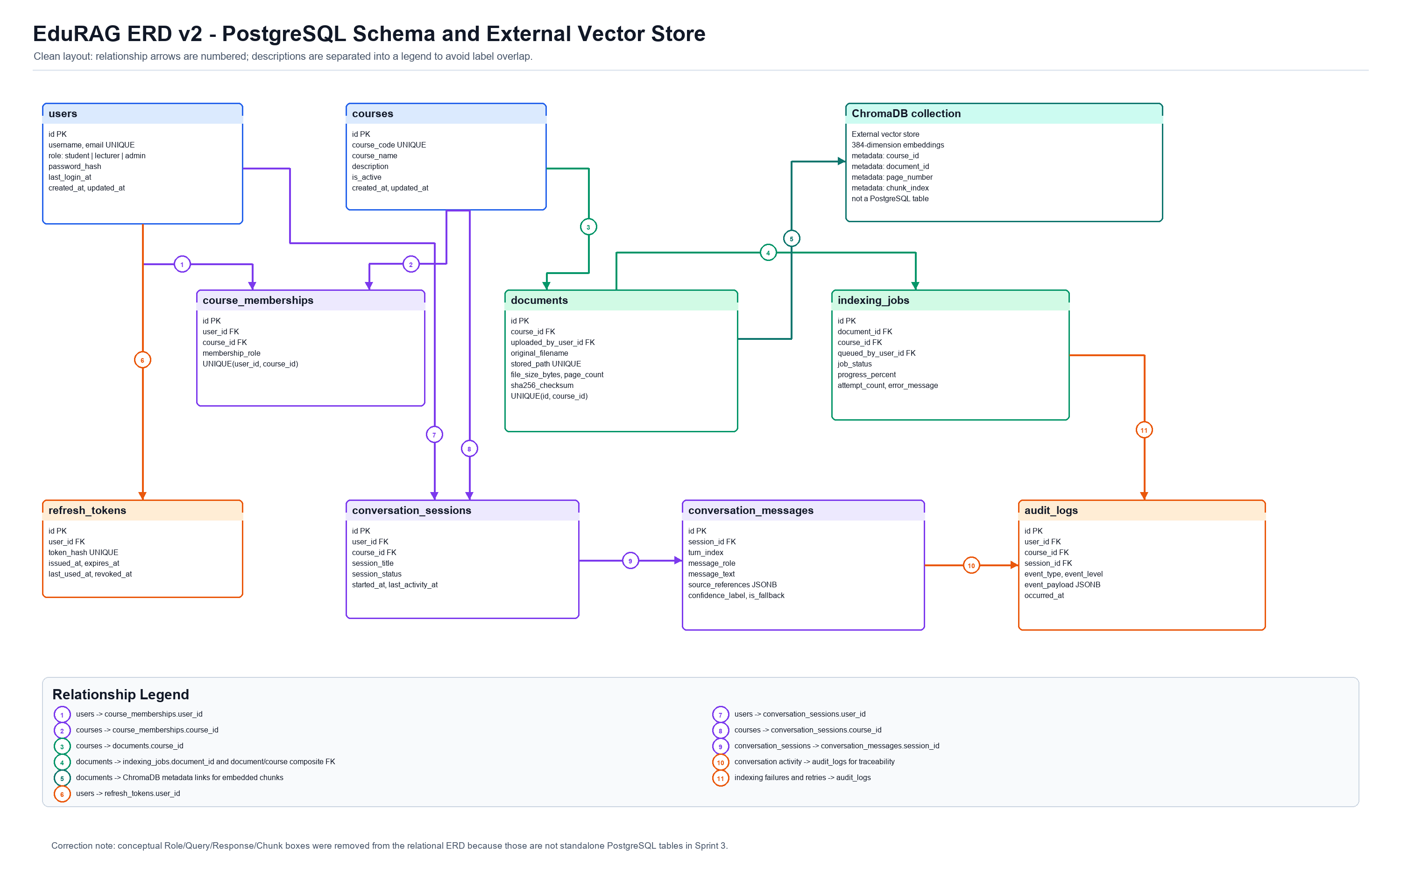

G2. Data Flow Diagram (DFD Level 1)
Function: shows module-level data movement across web application, document processing, retrieval, and response generation. Technique used: Level 1 data-flow decomposition.
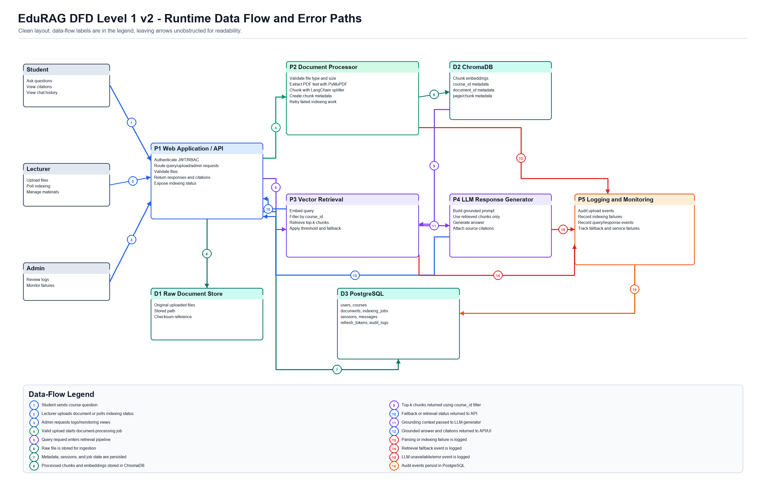

G3. Sequence Diagram (Upload exception and recovery)
Function: traces error-path orchestration for upload and indexing failure handling. Technique used: UML sequence diagram for operational recovery flow.
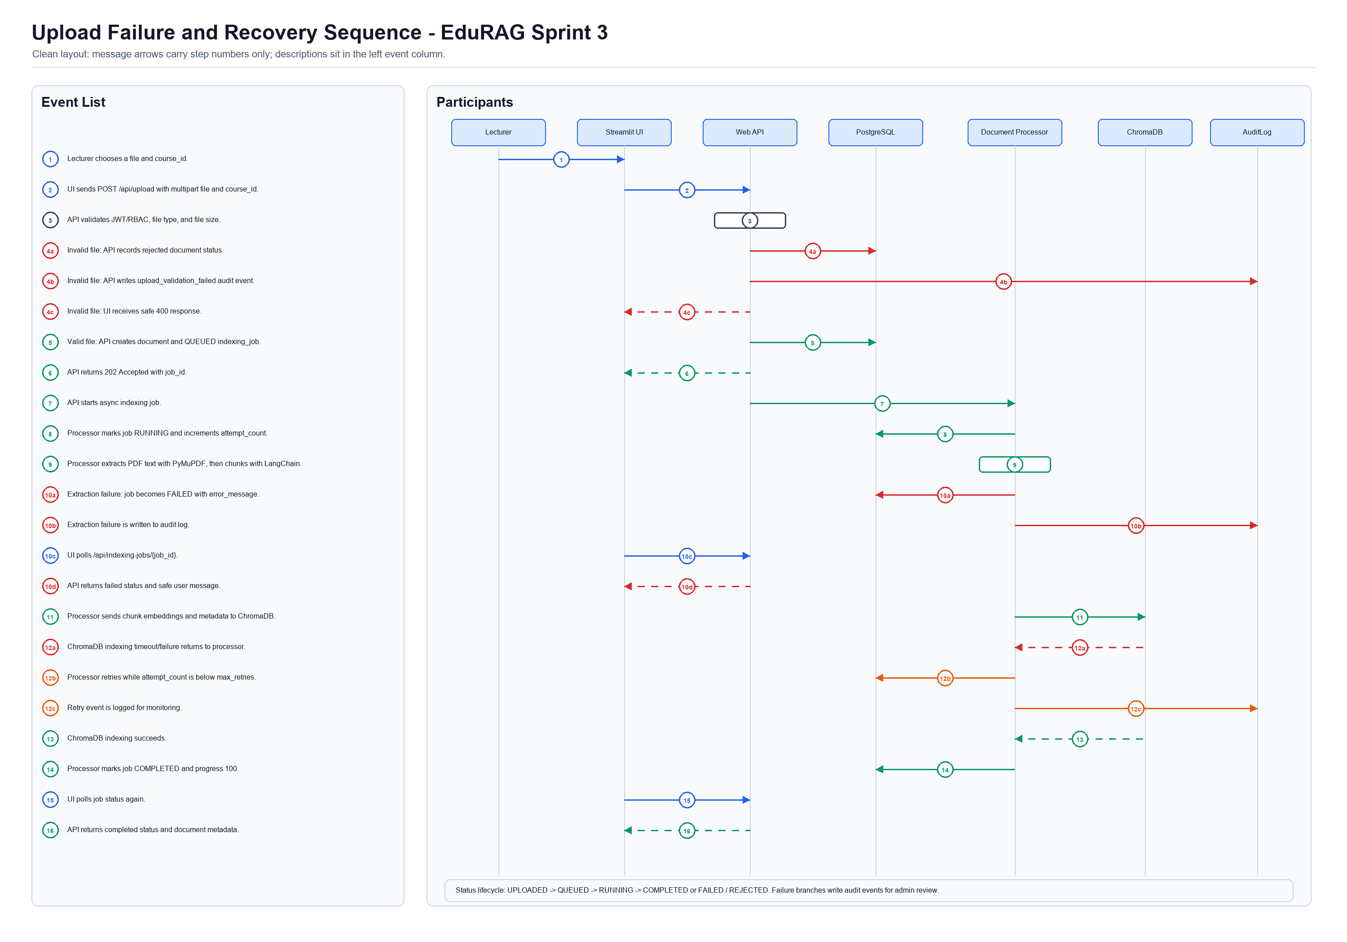

Appendix H. Initial Interface Wireframes
This appendix records the full Sprint 3 interface design set. The wireframes are included as design evidence, not as a final UI lock-in. They show how the current requirements can be realised through role-based navigation, course-scoped Q&A, upload and indexing status, citation visibility, confidence display, fallback labelling, and consistent visual treatment.

H1. Login and Role Entry
Shows product identity, role entry, and authentication entry point.
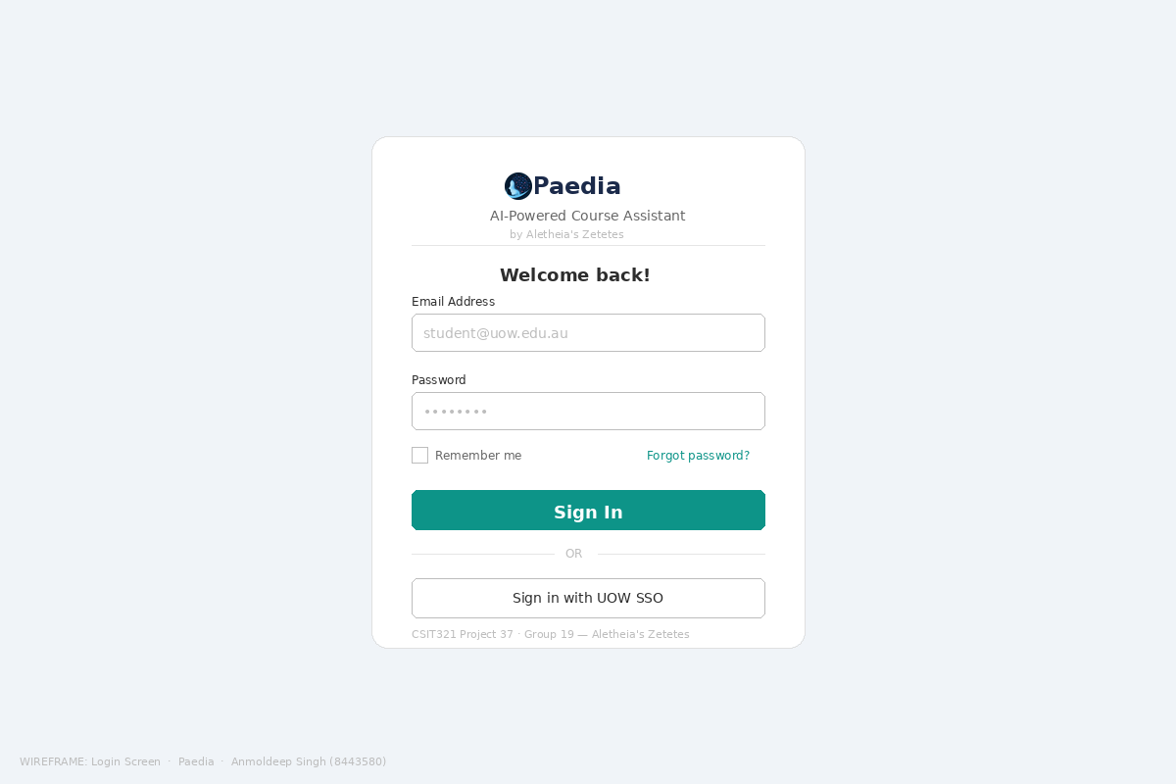
Wireframe H1. Shows product identity, role entry, and authentication entry point.

H2. Student Q&A Interface
Shows course-scoped chat, source citations, confidence display, and suggested prompts.
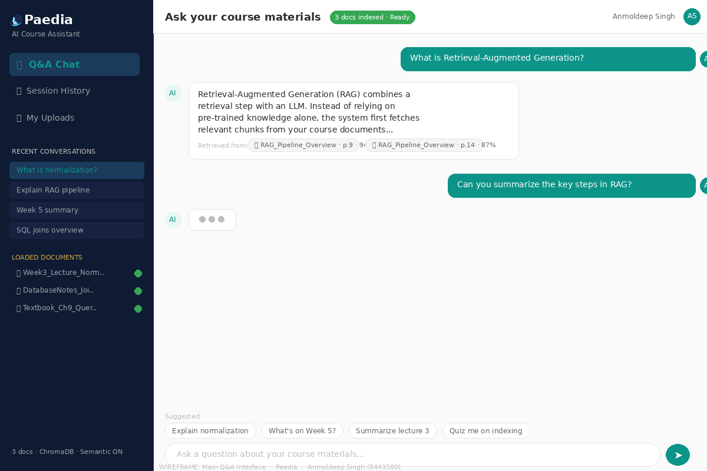
Wireframe H2. Shows course-scoped chat, source citations, confidence display, and suggested prompts.

H3. Lecturer Document Upload
Shows upload, document-management, and indexing-status expectations for lecturer workflows.
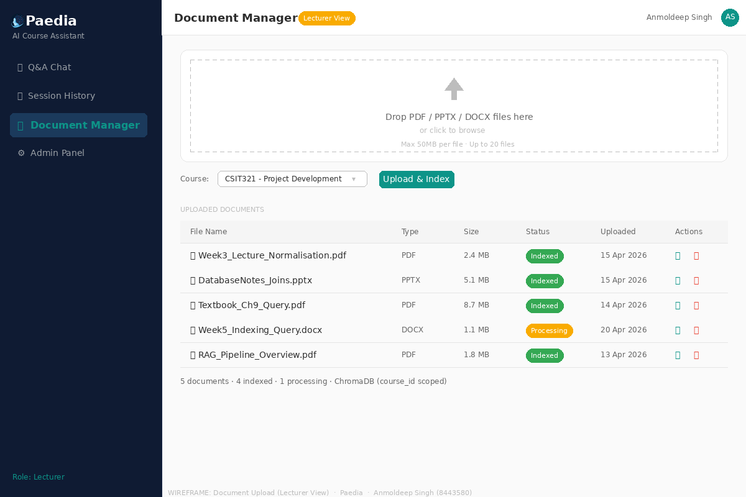
Wireframe H3. Shows upload, document-management, and indexing-status expectations for lecturer workflows.

H4. Admin Dashboard
Shows role-aware monitoring, system metrics, and administrative oversight.
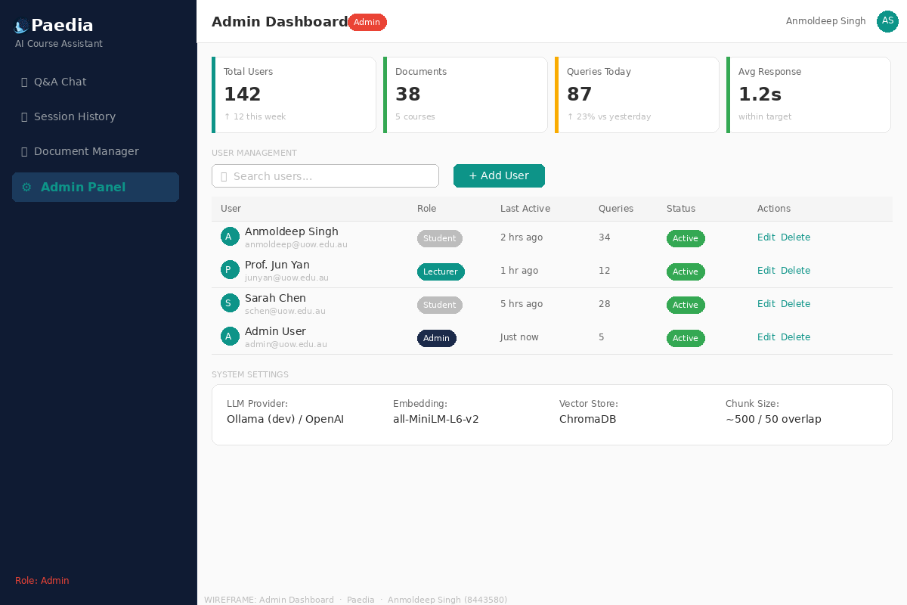
Wireframe H4. Shows role-aware monitoring, system metrics, and administrative oversight.

H5. Session History
Shows saved conversations and continuity for multi-turn learning sessions.
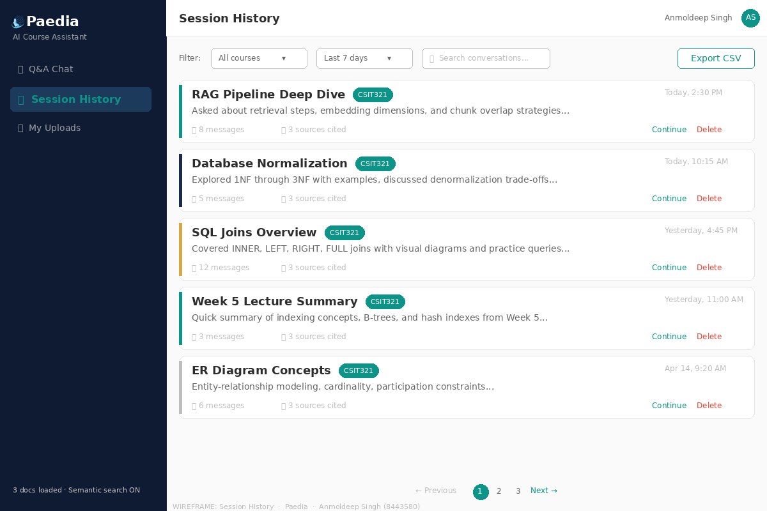
Wireframe H5. Shows saved conversations and continuity for multi-turn learning sessions.

